root@compliance-node:~$ ./init_report.sh
========================================
SCA LICENSE COMPLIANCE
AUTOMATION WORKFLOW
========================================
[ SYSTEM ] n8n Workflow Engine :: Jira Cloud API :: SBOM Scanner
USER : Abhishek Hirve
TIMESTAMP : 2026-07-03
STATUS : REPORT_COMPILED_OK
_

[ 01 ] OVERVIEW
This report documents the design, build, and deployment of an automated Software Composition Analysis (SCA) License Compliance workflow. The workflow reads a project's Software Bill of Materials (SBOM), scans each dependency's license, compares it against a company license policy, automatically raises a Jira ticket for any restricted license found, and generates a compliance report — removing the need for manual dependency-by-dependency review.
The automation was built in n8n, an open-source workflow automation tool, and integrated with Jira Cloud for ticket creation.
[ 02 ] BACKGROUND CONCEPTS
>> What is SCA License Compliance?
Modern software projects depend on many open-source libraries (e.g. React, Express, Axios, Bootstrap, OpenSSL). Each library carries a license (MIT, Apache-2.0, BSD, GPL, LGPL, AGPL, etc.). Some licenses are safe for commercial use; others carry restrictions a company's policy may not permit. SCA license compliance automatically checks every dependency's license against that policy.
>> What is an SBOM?
A Software Bill of Materials (SBOM) is an inventory of every dependency in a project, along with its version and license — an ingredients list for software.
>> Scanning Tools
> Trivy — open-source scanner covering containers, source code, SBOMs, and file systems: vulnerabilities, secrets, misconfigurations, licenses.
> FOSSology — scanning tool focused specifically on identifying software licenses within packages.
>> Role of Jira
Jira is the task-tracking destination: instead of manually notifying a developer about a restricted license, the workflow automatically creates a ticket describing the violation and the recommended remediation.
[ 03 ] WORKFLOW DESIGN
Execution sequence:
[01] Trigger the workflow (manual, or on a schedule).
[02] Receive the SBOM (list of packages and versions).
[03] Scan each package to determine its license.
[04] Compare each license against the company's allowed policy.
[05] Aggregate results into a compliance summary.
[06] If restricted licenses are found, auto-create a Jira ticket.
[07] Generate a final compliance report.

root@sca-workflow:~$ cat n8n_canvas_—_full_workflow_diagram.png
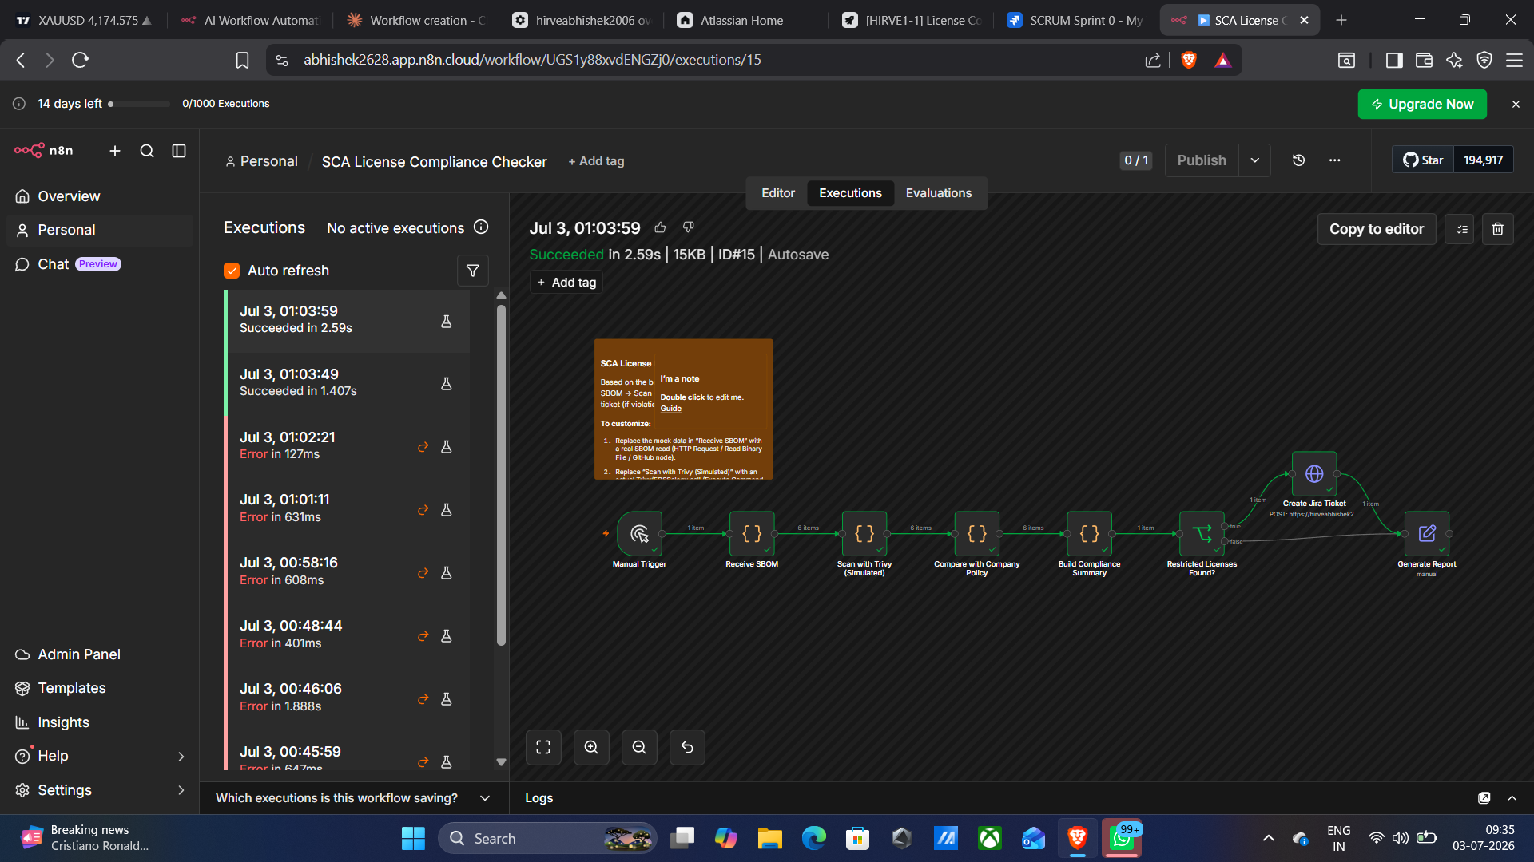

[ 04 ] IMPLEMENTATION STEPS
>> 4.1 Setting Up the n8n Workflow
> Created workflow "SCA License Compliance Checker" in n8n.
> Added a Manual Trigger for on-demand execution during development.
> Added "Receive SBOM" Code node returning mock packages: React, Axios, Bootstrap, Express, OpenSSL, plus a deliberately restricted "Library XYZ" (GPL-3.0) to validate the violation path.
>> 4.2 License Scanning (Simulated Trivy Step)
A Code node maps each package to its license via a lookup table, standing in for a real Trivy/FOSSology call. Swap for an Execute Command node running Trivy CLI, or an HTTP Request to a scanning service.
>> 4.3 Policy Comparison
A Code node compares each license against the allowed list — MIT, Apache-2.0, BSD, BSD-3-Clause — tagging each item Allowed or Restricted.
>> 4.4 Compliance Summary & Branch Logic
Results aggregate into one summary object (project, packages scanned, allowed/restricted counts, status, violations list). An IF node checks violationsFound and branches: violations → create Jira ticket; none → skip to report.

[ 05 ] JIRA INTEGRATION
>> 5.1 Jira Site & Project Setup
> Created an Atlassian Cloud site.
> Found the default "Projects" tracker (key HIRVE1) does not support issue creation via the Jira Software REST API.
> Used the existing Jira Software (Team-managed Scrum) project "My Team" — key SCRUM — which supports Task-type issue creation.

root@sca-workflow:~$ cat jira_project_settings_—_key_confirmation.png
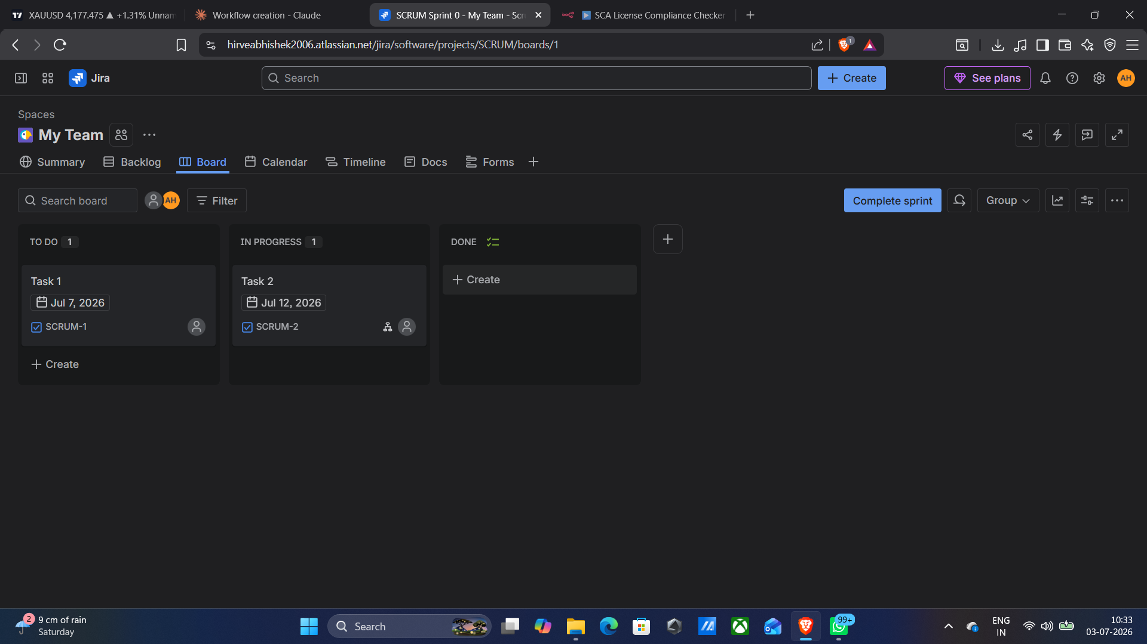

>> 5.2 API Credential Setup
[01] Generated an Atlassian API token.
[02] Created a "Jira SW Cloud API" credential in n8n (email + API token + domain).
[03] Attached the credential to the "Create Jira Ticket" HTTP Request node.

root@sca-workflow:~$ cat n8n_jira_credential_configuration.png
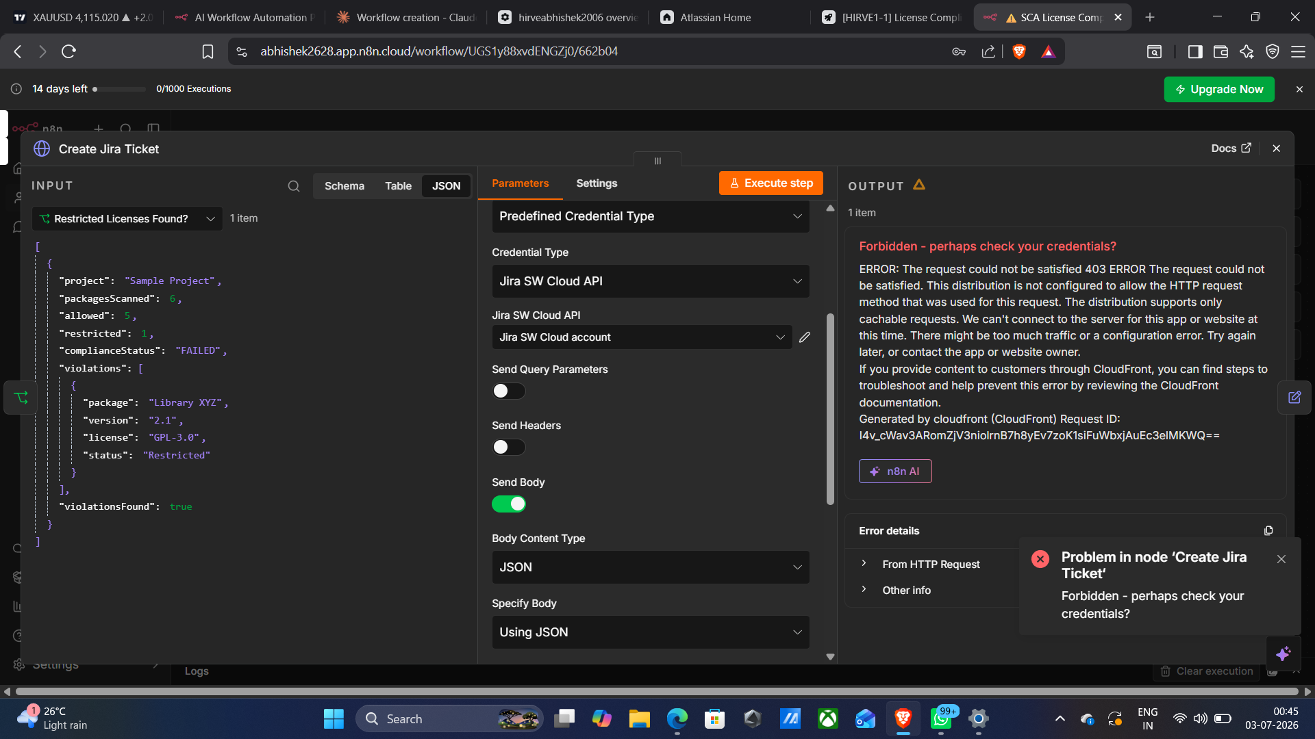

>> 5.3 Ticket Creation Node
The node POSTs to /rest/api/3/issue with project key SCRUM, issue type Task, a summary, and a description. The description required conversion to Atlassian Document Format (ADF) — a nested doc/paragraph/text structure — since Jira Cloud rejects plain-string descriptions.

[ 06 ] TESTING & VALIDATION
The workflow was executed repeatedly during development to resolve URL, credential, project-key, and ADF formatting issues. Final successful runs created real Jira tickets:
> SCRUM-5 — "License Compliance Violation - Sample Project"
> SCRUM-6 — "License Compliance Violation - Sample Project"
Both appeared in the Backlog with To Do status and full violation details in the description.

root@sca-workflow:~$ cat jira_backlog_—_created_tickets.png
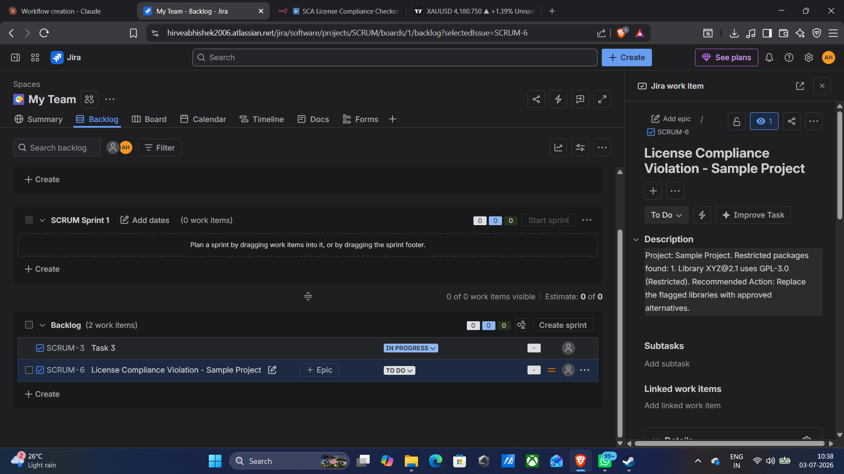

PROCESS | STATUS
SBOM ingestion | [ SUCCESS ]
Simulated license scan | [ SUCCESS ]
Policy comparison logic | [ SUCCESS ]
Violation branch (IF node) | [ SUCCESS ]
Jira ticket creation | [ SUCCESS ]
Compliance report generation | [ SUCCESS ]

[ 07 ] DEPLOYMENT
>> 7.1 Replacing the Manual Trigger
The Manual Trigger was swapped for a Schedule Trigger so the workflow runs unattended. Set a deliberate interval (e.g. daily) rather than leaving a short default.

root@sca-workflow:~$ cat schedule_trigger_configuration.png
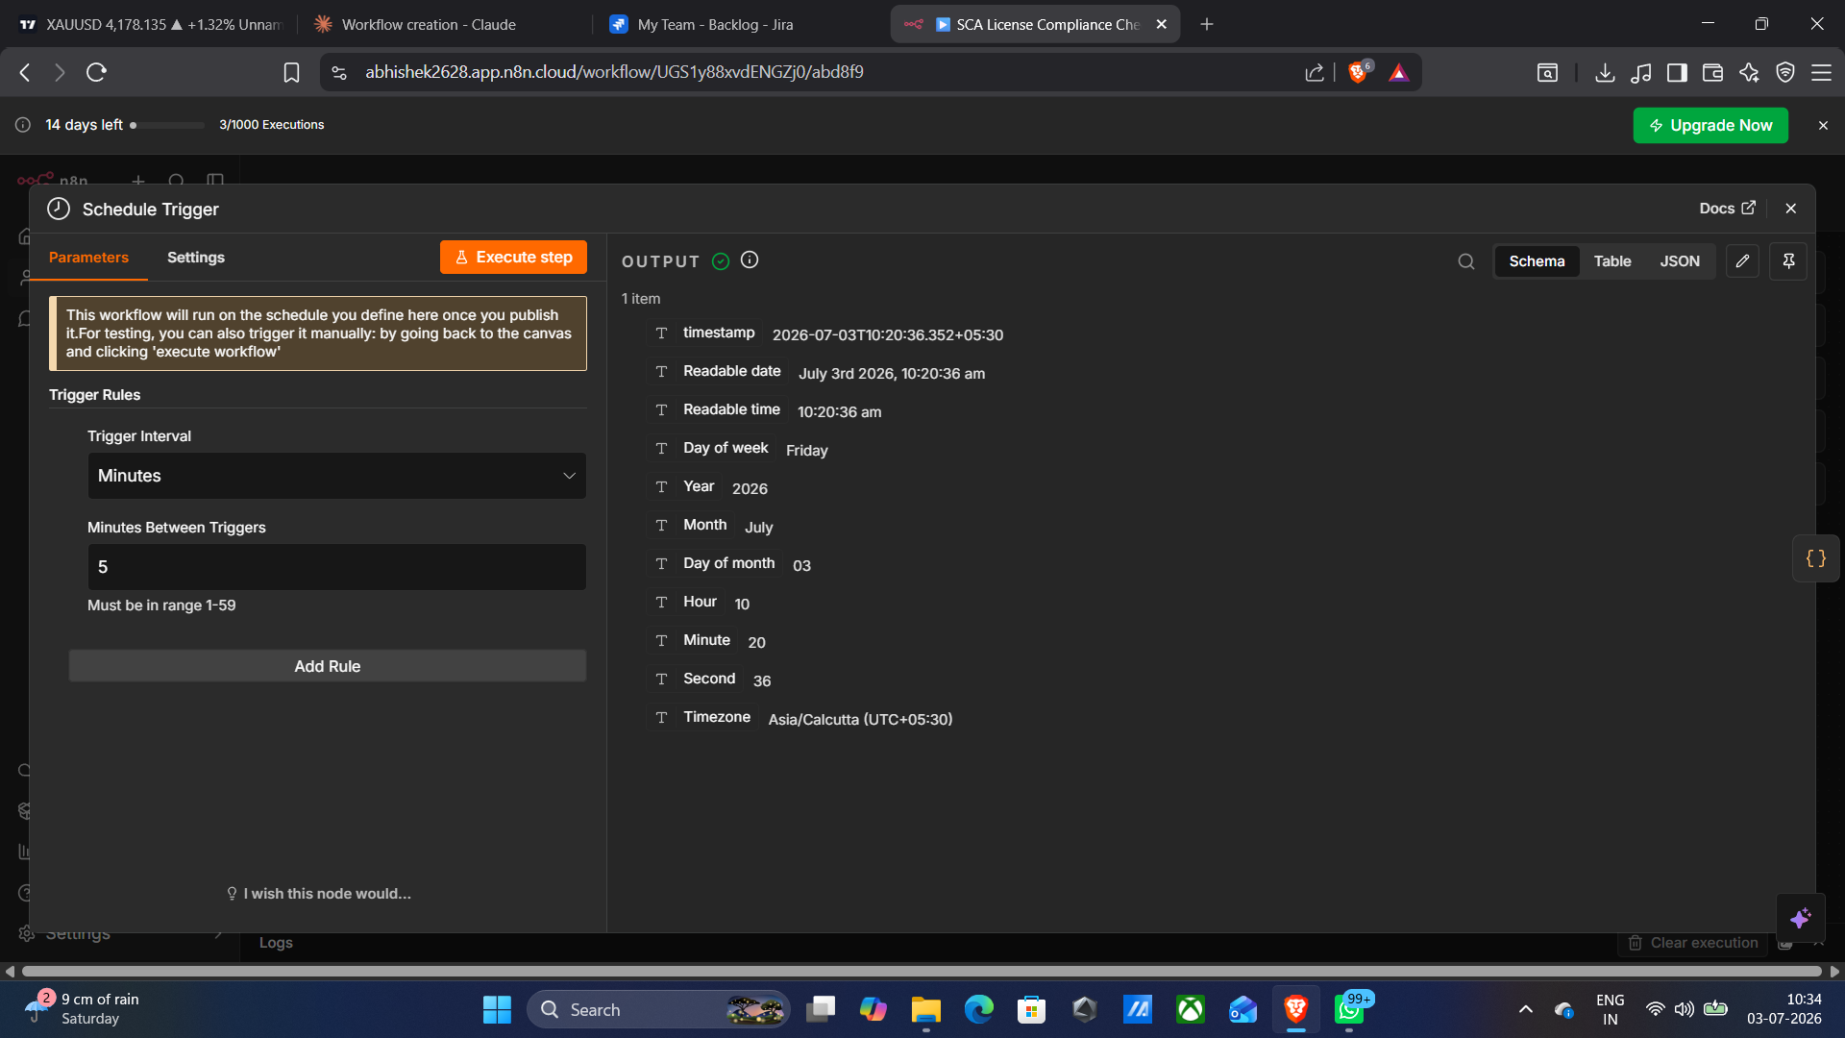

>> 7.2 Publishing the Workflow
> Removed a stray disconnected trigger node left over from editing.
> Connected the Schedule Trigger to "Receive SBOM".
> Clicked Publish — status badge flipped to a solid green "Published" indicator.

root@sca-workflow:~$ cat published_workflow_—_editor_view.png
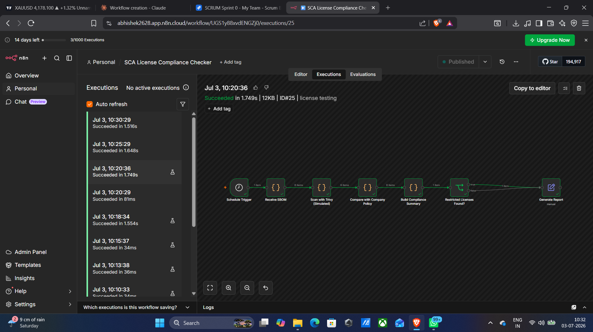

>> 7.3 Execution Log Verification
The Executions tab confirmed the workflow firing on its own on schedule, with consistent "Succeeded" status across runs.

root@sca-workflow:~$ cat executions_log_—_automatic_runs.png
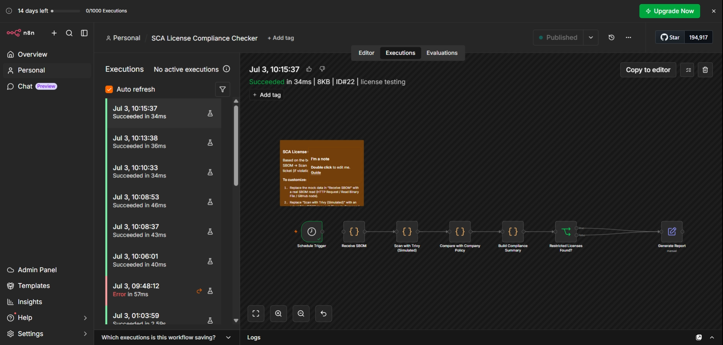

[ 08 ] RECOMMENDATIONS
[01] Replace mock "Receive SBOM" with a real source (HTTP Request, Read Binary File, or GitHub Trigger tied to CI/CD).
[02] Replace the simulated Trivy step with a real scanner call.
[03] Add duplicate-ticket prevention: check for an existing open ticket before creating a new one.
[04] Set the Schedule Trigger to a sensible cadence (e.g. daily, or per CI build).
[05] Finalize the allowed-license list with Legal/Security before relying on this for compliance decisions.
[ 09 ] CONCLUSION
The SCA License Compliance workflow successfully automates SBOM ingestion, license-violation detection, and Jira ticket creation — validated through multiple successful executions and live tickets (SCRUM-5, SCRUM-6). With production data sources wired in, this workflow is ready for unattended operation.
[ END OF REPORT :: CONNECTION CLOSED ]

