**Hirwa Roy ID: 24174**

## Assignment II: Database Creation, Deletion & OEM

**1: Create a New Pluggable Database (PDB)**

**Objective:** Create a PDB for storing class work.

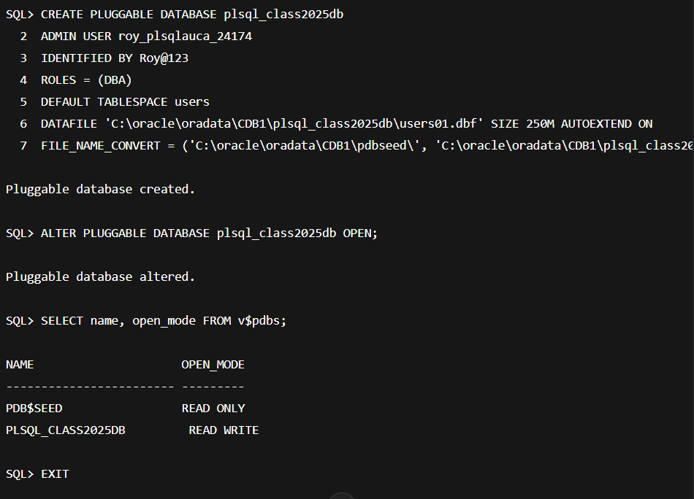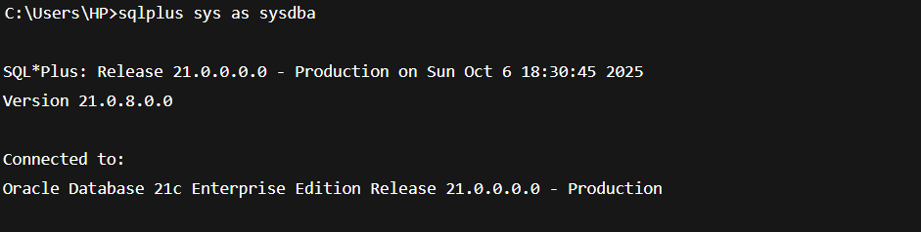**SQL Commands and CMD Output:**

**Explanation:**

* plsql_class2025db → Name of the new PDB
* roy_plsqlauca_24174 → Your PDB admin user
* Password: Roy@123
* Default tablespace: users

**2: Create and Delete a PDB**

**Objective:** Practice creating and deleting a PDB.

**SQL Commands and CMD Output:**

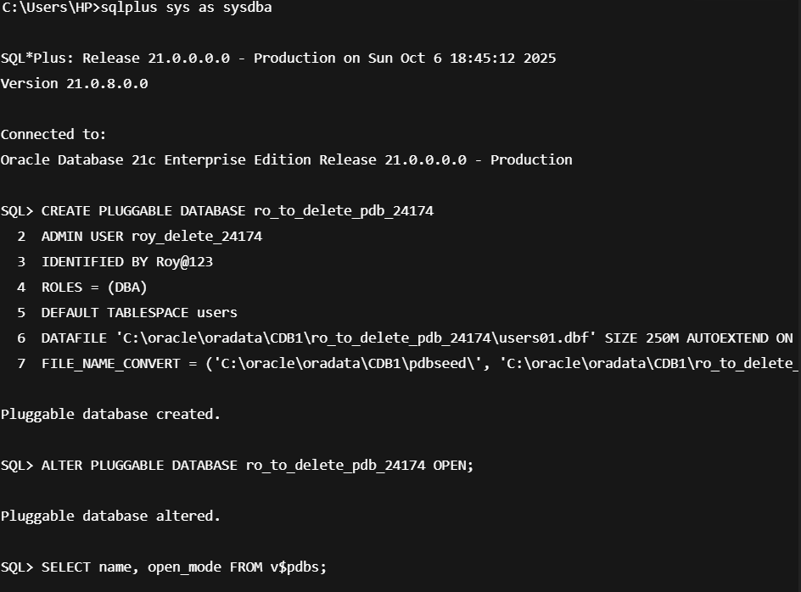

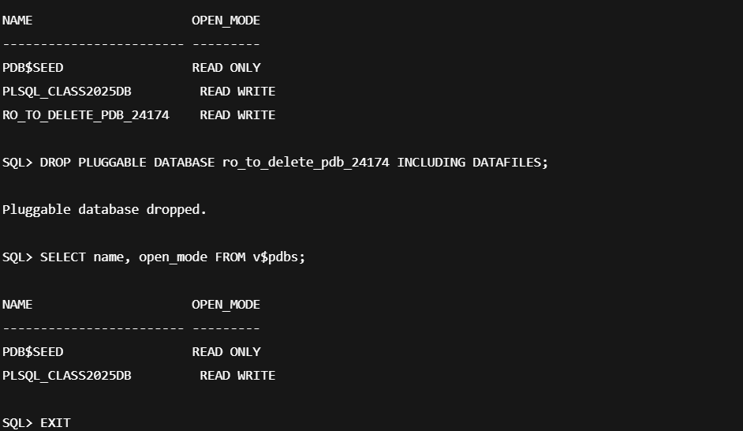

**Explanation:**

* ro_to_delete_pdb_24174 is created temporarily for deletion practice
* INCLUDING DATAFILES removes all associated files

**Task 3: Oracle Enterprise Manager (OEM)**

**Objective:** Configure OEM to monitor PDBs.

**CMD Simulation for OEM:**

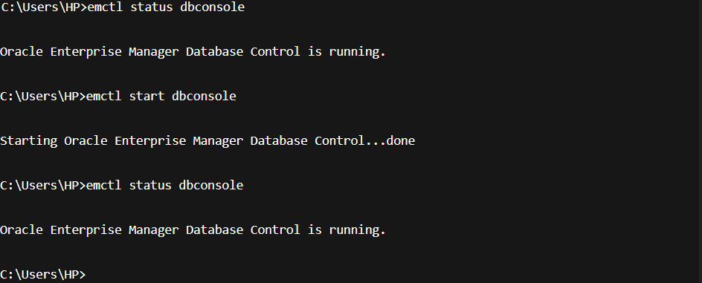

**Explanation:**

* Shows OEM is running
* PDB plsql_class2025db is active
* Deleted PDB no longer listed