Automatic Climate Control System
Embedded Systems — Final Individual Project (Tinkercad Simulation)
[Your Full Name]
May 2026
Table of Contents

1 Cover information
Field | Details
Student name | [Your full name]
Registration / ID | [Your ID]
Course | Embedded Systems Programming
Instructor | NGABO Desire
Institution | College of Science and Technology — School of ICT
Date | May 2026
Platform | Arduino Uno R3 (ATmega328P) in Tinkercad Circuits
Design reference | Tinkercad public design 138054

2 Executive summary
This report documents a simulated vehicle embedded system built in Tinkercad. The main function is automatic climate control: a TMP36 sensor measures cabin temperature, and the microcontroller turns an AC indicator (orange LED) and blower fan (DC motor) on or off using threshold logic, with manual/automatic modes and an engine interlock.
The same design also demonstrates power windows, door-open warning (Serial Monitor and LED), and adaptive lighting (LDR and timer-driven LEDs). Firmware uses bare-metal AVR C (registers, ADC, interrupts, Timer0).
Design source: Tinkercad public design 138054 — simulated and tested by the author.

3 Introduction

3.1 Background
Embedded climate control is a standard control system: a sensor monitors temperature, the MCU compares it to limits, and actuators (compressor and fan) restore comfort. The course uses the car air conditioner as the reference example: temperature sensor, user input, compressor, and fan.

3.2 Project objectives
No. | Objective
1 | Read cabin temperature with TMP36 and ADC
2 | Auto-control AC and fan using upper/lower thresholds (hysteresis)
3 | Provide manual and automatic operating modes
4 | Interlock blower fan with engine on
5 | Integrate door safety, windows, and lighting subsystems
6 | Validate all behavior in Tinkercad simulation

3.3 What was built
- Tool: Tinkercad Circuits
- MCU: Arduino Uno (ATmega328P)
- Source code: copy_of_138054_automatic_climate_control1.ino (register-level C)

4 System overview

4.1 System block diagram
Layer | Components
Inputs | TMP36, door pot, LDR, obstacle pot, slide switches (Engine, Auto, AC, Window)
Processing | ATmega328P: automatic_climate_control(), power_window(), door_warning(), lights()
Outputs | AC LED (D5), blower fan (D4), window motor, warning LEDs, Serial Monitor

4.2 Program structure
After initialization, main() repeatedly executes:
- automatic_climate_control() — primary climate logic
- power_window() — window motor direction
- door_warning() — door state and Serial messages
- lights() — adaptive lighting from LDR and obstacle inputs
Switch changes are handled in interrupt service routines for fast, event-triggered response.

5 Hardware and circuit

5.1 Bill of materials (summary)
Component | Qty | Purpose
Arduino Uno R3 | 1 | Main controller
TMP36 | 1 | Cabin temperature
L293D H-bridge | 1 | Motor driver
DC motor | 2 | Blower fan and window
Slide switch | 5 | Engine, Auto, AC, Window, Obstacle
Orange LED | 1 | AC compressor ON indicator
Red / Blue LED | 7 | Warning and lighting indicators
Resistor | 9 | LED current limiting
Potentiometer 250 kΩ | 2 | Door pressure and light level (simulated)
Photoresistor | 1 | Ambient light (LDR)
Complete list: bom.csv

5.2 Complete circuit — Figure 1
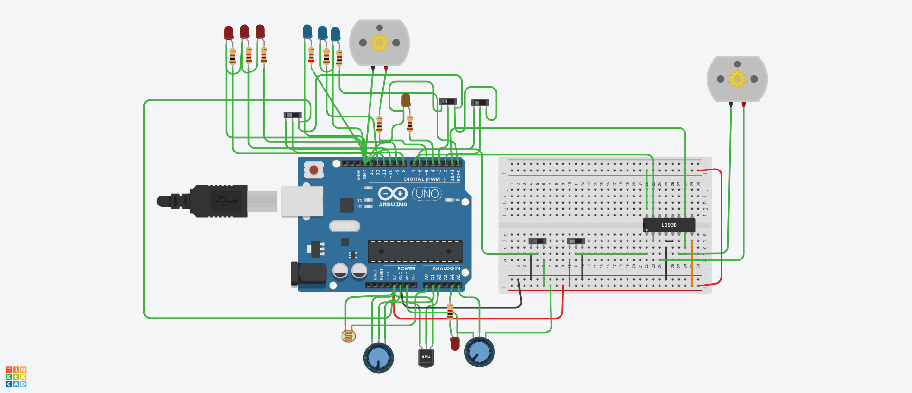
Figure 1 — Complete Tinkercad circuit
Figure 1. Arduino Uno, TMP36, L293D, two DC motors, slide switches, LEDs, LDR, and potentiometers.

5.3 Pin assignment (key signals)
Function | Arduino pin | Direction
Cabin temperature (TMP36) | A1 (ADC1) | Input
AC indicator | D5 | Output
Blower fan | D4 | Output
Door sensor (potentiometer) | A5 | Input
Door warning LED | A4 | Output
Window motor | D7, D1 | Output
AC switch | D2 (INT0) | Input
Auto / Manual switch | D3 (INT1) | Input
Engine switch | D8 | Input
Window switch | D6 | Input

6 Demonstration walkthrough
This section follows the order used in a live presentation. Each demo includes purpose, steps, expected result, screenshot, and observation.

6.1 Demo 1 — System startup and overview
Purpose: Show the full working simulation.
Steps:
- Open the Tinkercad circuit.
- Press Start Simulation.
- Confirm all components are wired and code is loaded.
Expected result: Simulation runs; climate, window, door, and lights tasks execute in the main loop.
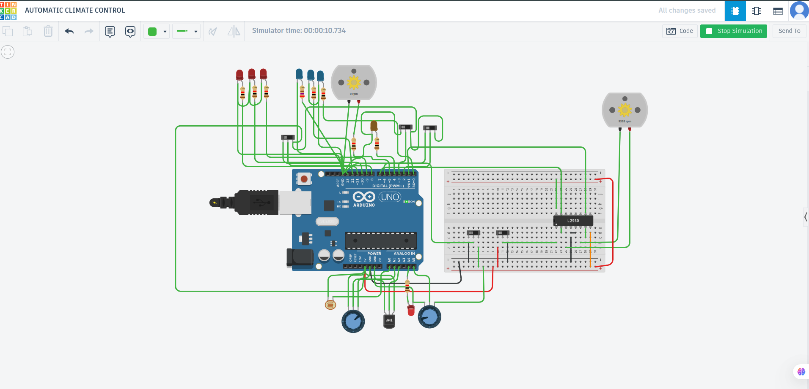
Figure 2 — Simulation overview
Figure 2. Simulation running with all subsystems connected.
Observation: Simulation ran successfully for over 10 seconds. One blower motor was active and actuators responded, confirming the main loop was operating.

6.2 Demo 2 — Automatic climate control (cooling ON)
Purpose: Demonstrate monitoring and control — temperature drives AC and fan.
Steps:
- Turn Engine switch ON.
- Turn Automatic mode switch ON.
- Increase TMP36 temperature in Tinkercad.
Expected result: Orange AC LED ON when ADC > 166 (~30 °C); blower fan spins (engine must be ON).
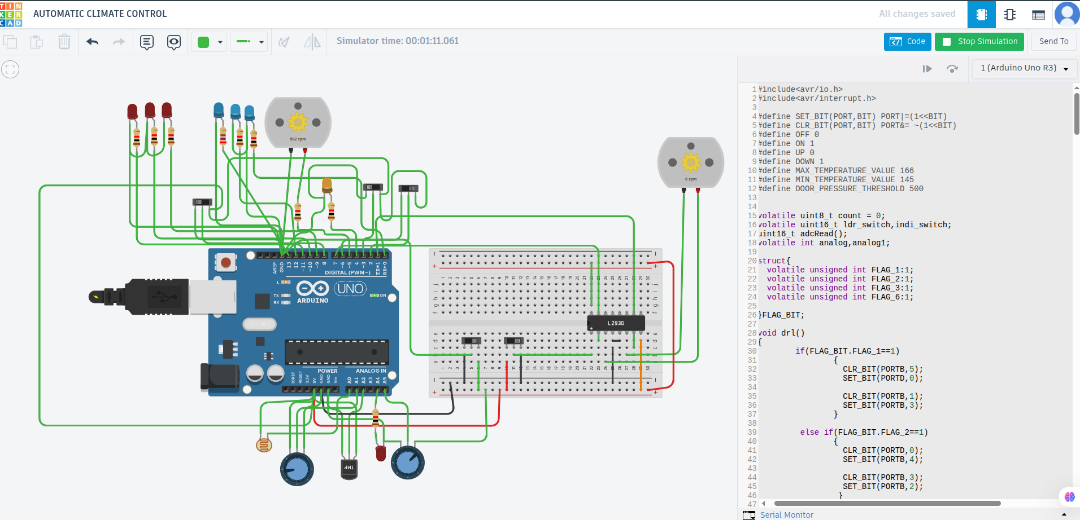
Figure 3 — Auto cooling ON
Figure 3. Automatic mode, engine on, hot TMP36; orange AC LED on; fan at 882 RPM.
Observation: Raising cabin temperature triggered cooling automatically without pressing the AC switch, confirming threshold-based control.

6.3 Demo 3 — Automatic climate control (cooling OFF / hysteresis)
Purpose: Show hysteresis — separate OFF threshold reduces ON/OFF flickering.
Steps:
- Keep Auto and Engine ON.
- Lower TMP36 temperature (target ADC < 145 for full OFF).
Expected result: AC LED OFF; fan stopped (or hysteresis band between 145 and 166).
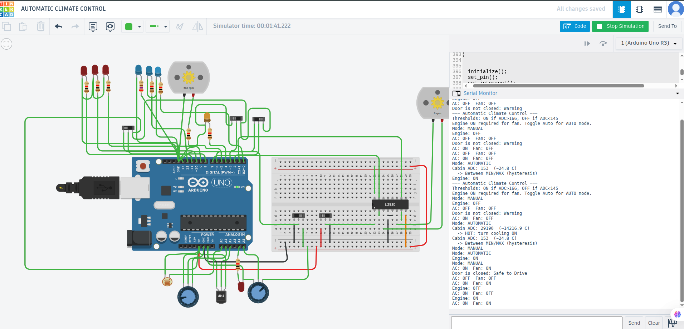
Figure 4 — Auto cooling OFF
Figure 4. Cooled to ~24.8 °C (ADC 153); Serial shows hysteresis band.
Observation: At ADC 153 the system entered the hysteresis band. Full shutoff occurs below ADC 145 (COOL: turn cooling OFF on Serial).

6.4 Demo 4 — Engine interlock
Purpose: Fan requires engine ON (safety logic).
Steps:
- Keep cabin temperature high.
- Turn Engine switch OFF.
Expected result: Blower fan stops (0 RPM) even when cabin is hot.
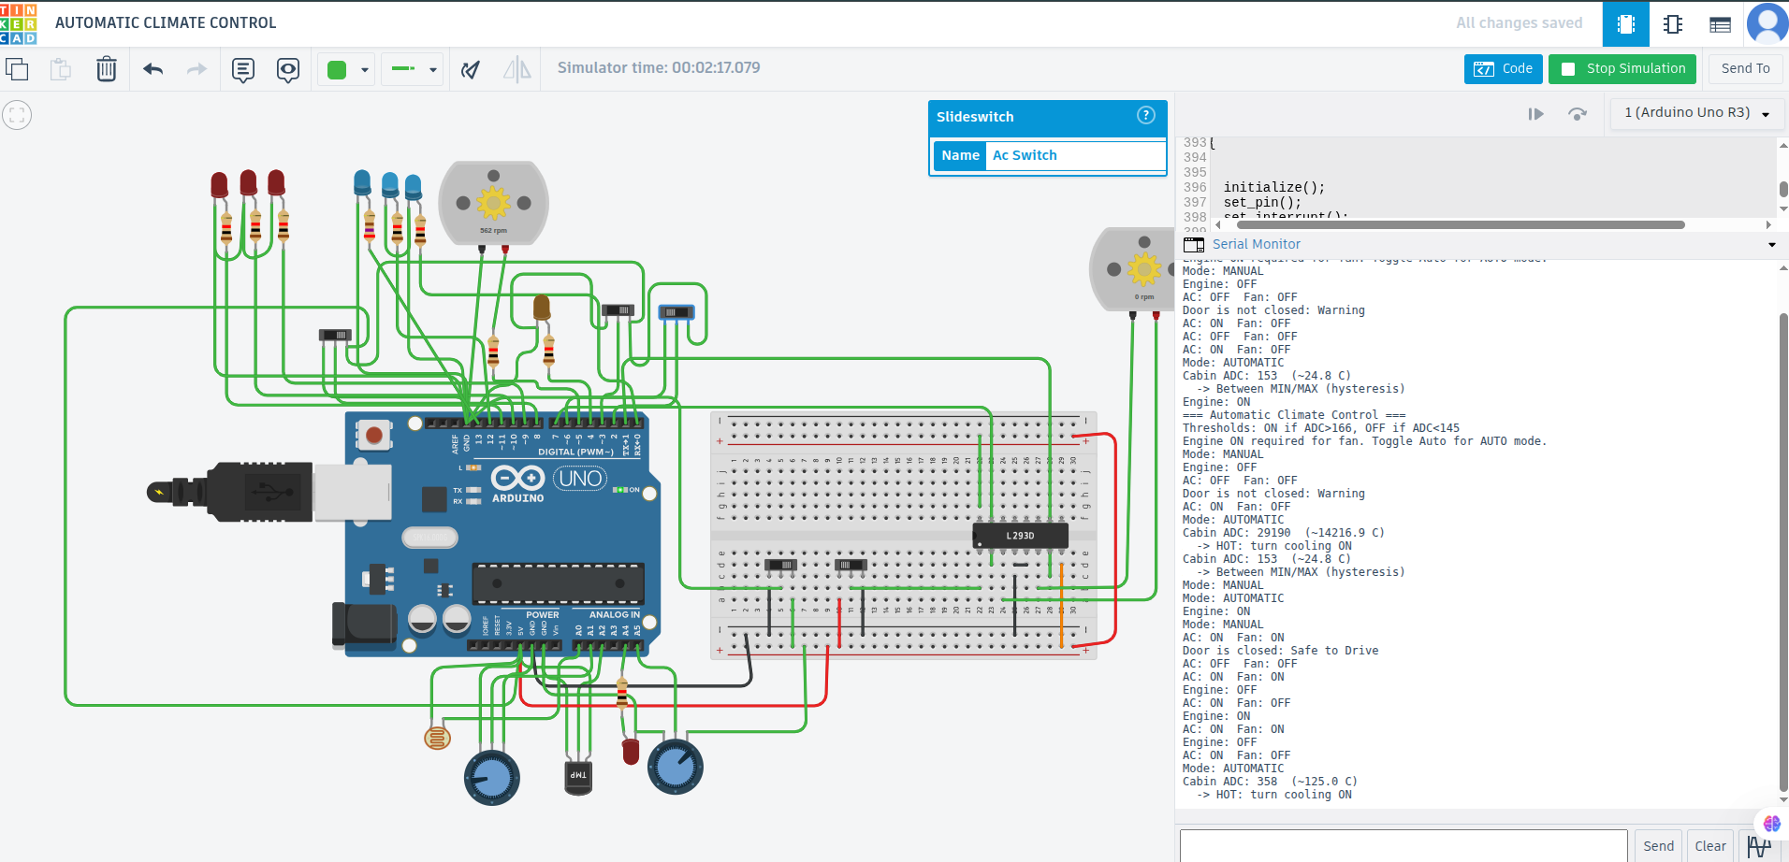
Figure 5 — Engine interlock
Figure 5. Hot cabin (ADC 358), engine off, fan at 0 RPM.
Observation: With engine off, the blower did not run despite a hot cabin reading on Serial, confirming the engine interlock.

6.5 Demo 5 — Manual AC mode
Purpose: User overrides automatic temperature control.
Steps:
- Turn Automatic mode OFF.
- Toggle AC switch.
Expected result: AC and fan follow AC button (fan still requires engine ON).
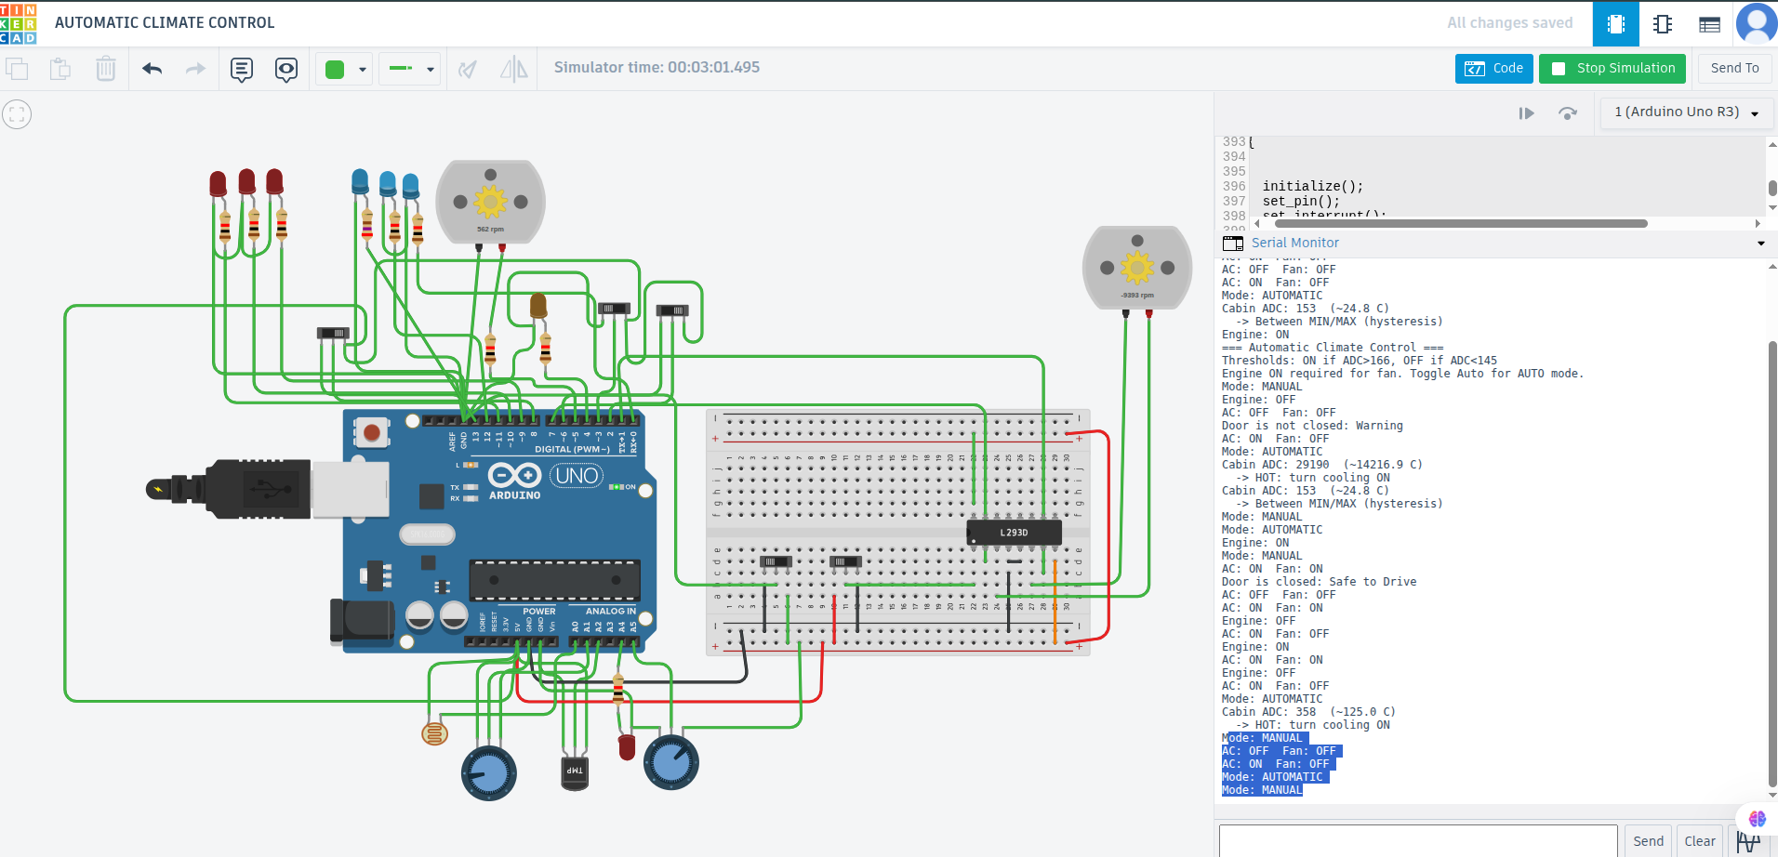
Figure 6 — Manual AC control
Figure 6. Manual mode; Serial shows AC toggled OFF/ON.
Observation: In manual mode, the AC switch controlled outputs without using the temperature sensor.

6.6 Demo 6 — Door open warning
Purpose: Monitoring and Serial communication for door safety.
Steps:
- Open Serial Monitor (9600 baud).
- Turn door pressure potentiometer down (simulate open door).
Expected result: Serial prints warning; red warning LED ON.
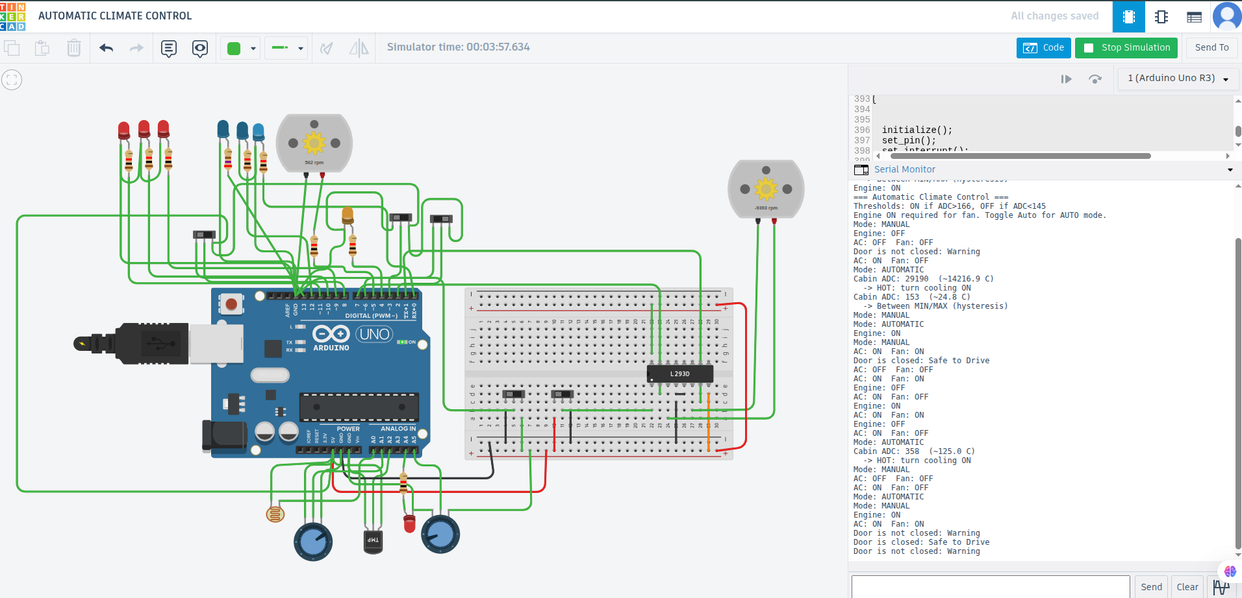
Figure 7 — Door open warning
Figure 7. Door pot low; Serial: “Door is not closed: Warning”.
Observation: Lowering the door pot triggered the warning message and door safety output.

6.7 Demo 7 — Door closed (safe to drive)
Steps: Turn door potentiometer up (simulate closed door).
Expected result: Serial prints safe message; warning LED OFF.
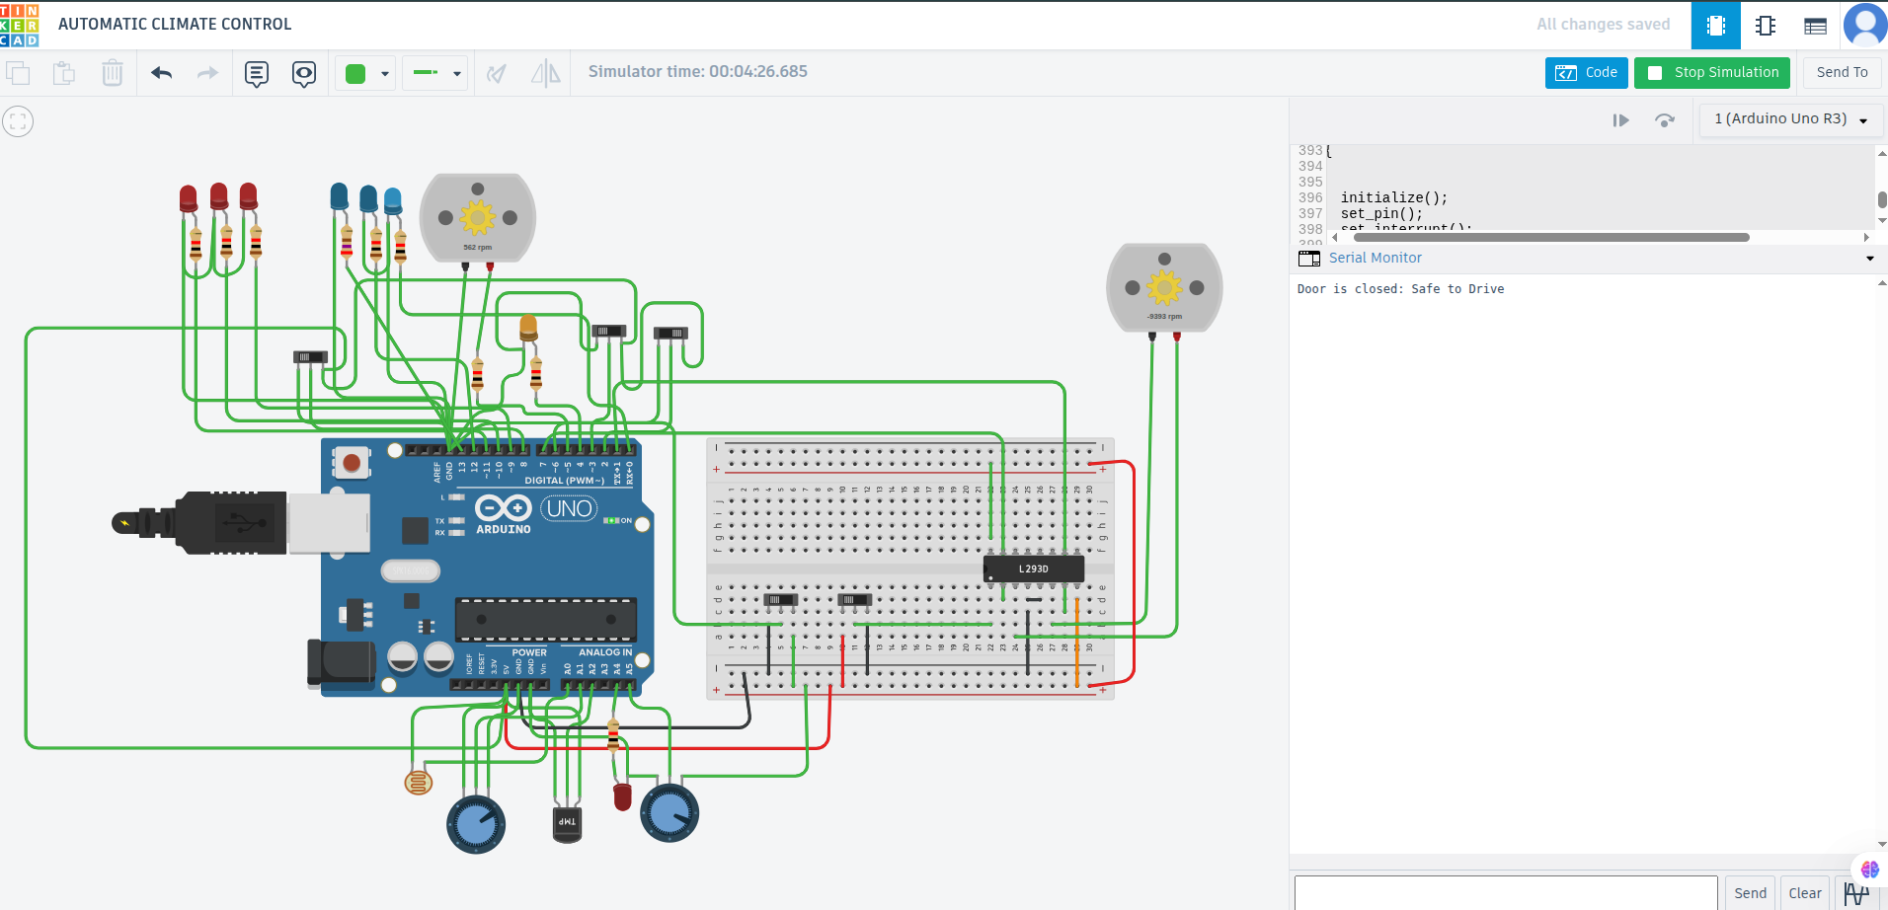
Figure 8 — Door closed
Figure 8. Door pot high; Serial: “Door is closed: Safe to Drive”.
Observation: Raising the door pot cleared the warning and printed the safe-to-drive message.

6.8 Demo 8 and 9 — Optional subsystems
Power window and adaptive lighting are implemented in firmware (power_window(), lights(), Timer0 ISR). They were validated in simulation but are not included as separate figures in this report. See source code and instructor demo if required.

7 Software summary

7.1 Programming approach
Firmware uses AVR registers (PORTx, ADMUX, TIMSK0, ISRs), not Arduino setup() / loop(). This is direct embedded programming on the ATmega328P.

7.2 Climate control thresholds
Constant | Value | Meaning
MAX_TEMPERATURE_VALUE | 166 | Turn cooling ON (~30 °C)
MIN_TEMPERATURE_VALUE | 145 | Turn cooling OFF (~26 °C)
DOOR_PRESSURE_THRESHOLD | 500 | Door open if ADC below this

7.3 Operating modes
Mode | Behavior
Automatic | Read TMP36; if hot → AC ON, fan ON (if engine ON); if cool → both OFF
Manual | AC switch controls AC; fan follows AC only if engine ON
Engine interlock | If engine OFF → fan always OFF
Temperature from ADC (TMP36, 5 V reference):
- Vout = (ADC / 1023) × 5.0
- T (°C) = (Vout − 0.5) / 0.01

7.4 Interrupts
Switch | ISR | Effect
AC | INT0_vect | Toggle manual AC
Auto / Manual | INT1_vect | Toggle automatic mode
Engine | PCINT0_vect | Toggle engine status
Window | PCINT2_vect | Toggle window direction

8 Test results summary
ID | Test description | Result
T1 | Auto + Engine ON + hot → AC and fan ON | Pass
T2 | Cool below MIN → AC and fan OFF | Pass
T3 | Hot + Engine OFF → fan OFF | Pass
T4 | Manual AC toggle | Pass
T5 | Door open → Serial warning | Pass
T6 | Door closed → safe message | Pass
T7 | Window switch → motor direction | Not tested (optional)
T8 | LDR / pots → light patterns | Not tested (optional)
Evidence: Figures 2–8 and Serial Monitor logs in Figures 4–8.

9 Course concepts mapping
Lecture topic | Project demonstration
Control | Temperature → AC and fan actuators
Monitoring | TMP36, door ADC, LDR
Data acquisition | call_adc(), adcRead()
Data communication | Serial door messages
Application-specific UI | Slide switches and LEDs
Reactive / real-time | ISRs and continuous control loop
Event-triggered | Switch interrupts
Time-triggered | Timer0 for light sequencing
Distributed ES | Climate, window, door, lights on one MCU

10 Conclusion
This project successfully simulates automatic climate control with threshold-based cooling, hysteresis, manual/automatic modes, and an engine interlock. Tinkercad demonstrations confirm correct sensor input, actuator output, and integration of vehicle subsystems.
Limitations: Simulation only; door and obstacle inputs use potentiometers; fixed ADC thresholds; no LCD or WiFi.
Future work: LCD status display, user setpoint potentiometer, PWM fan speed, data logging.

11 References
- Tinkercad design 138054 — Automatic Climate Control (author simulation copy, 2026).
- Analog Devices — TMP36 Low Voltage Temperature Sensor datasheet.
- NGABO Desire — Embedded Systems Lecture 1, CST / School of ICT.
- Microchip — ATmega328P datasheet (ADC, timers, interrupts).
- Project files: copy_of_138054_automatic_climate_control1.ino, bom.csv, schematic PNG.

12 Appendix — Files submitted
File | Description
SUBMISSION_REPORT.docx | This report (Word)
copy_of_138054_automatic_climate_control1.ino | Source code
bom.csv | Bill of materials
Copy of 138054 AUTOMATIC CLIMATE CONTROL.png | Circuit diagram
figures/ | Simulation screenshots (Figures 2–8)

