25RP18082 – IZERE HIRWA Roger
RP Tumba College

Module Name: Machine Learning Level 8
Learning Outcome 1

Data Preprocessing for house.csv
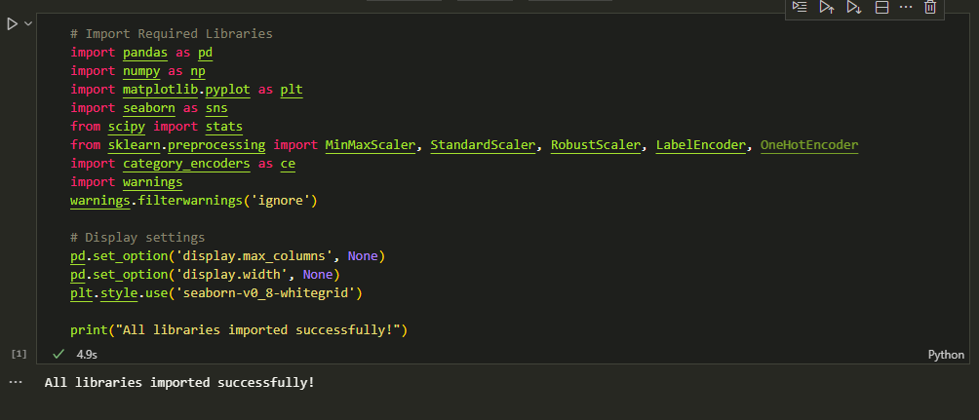
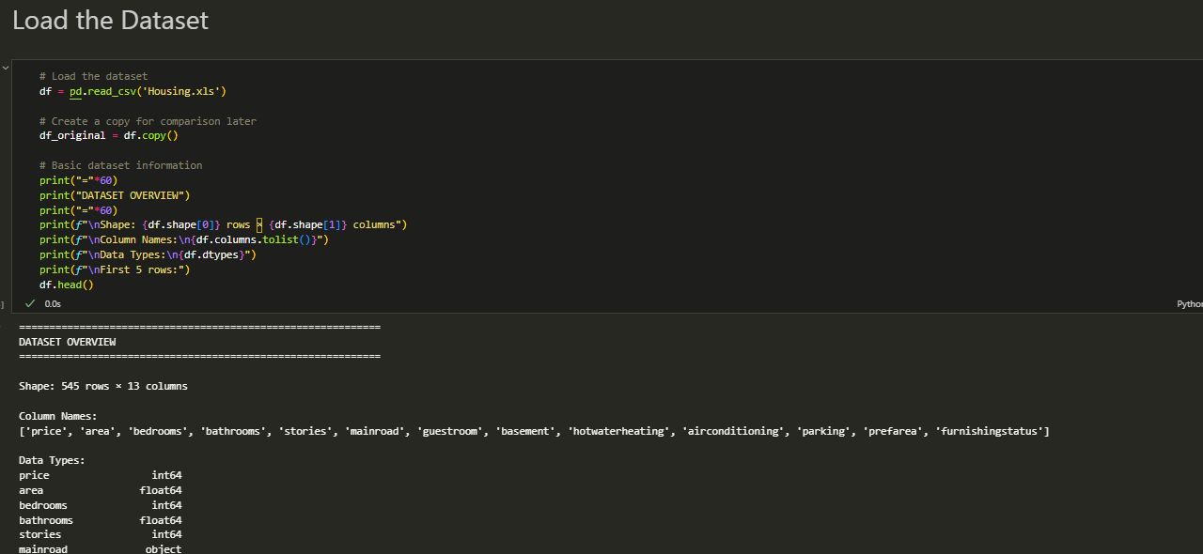

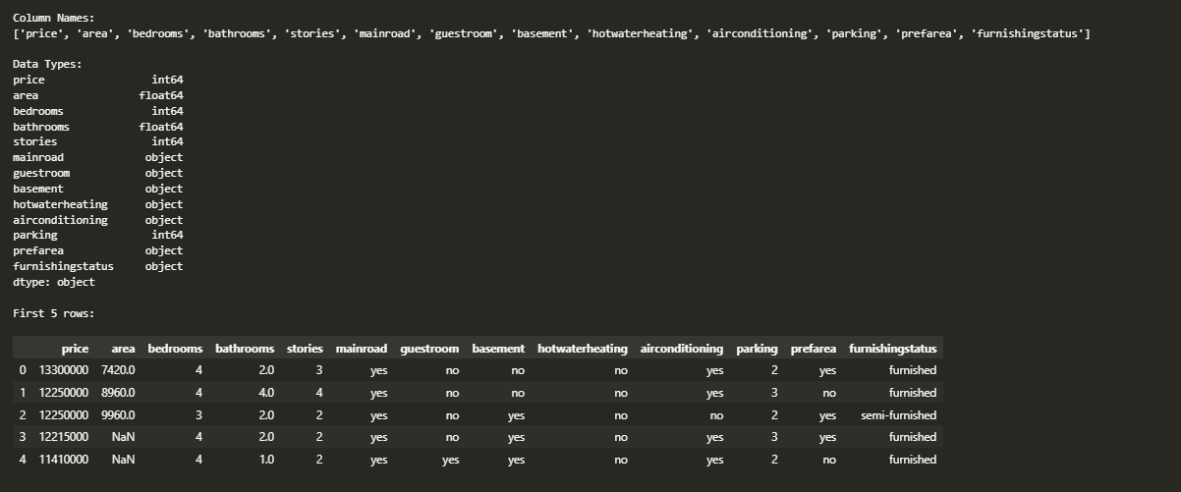

- Statistical Summary of Numerical Variables

  - Generate and interpret a statistical summary (mean, median, min, max, standard deviation, percentiles, etc.) for all numerical variables.
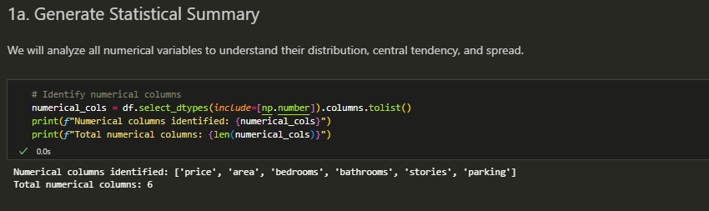
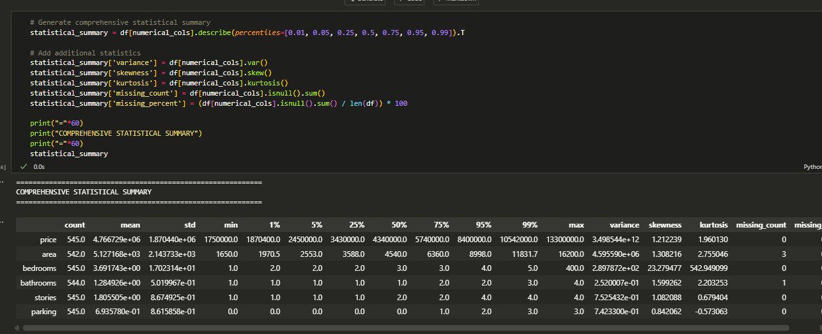
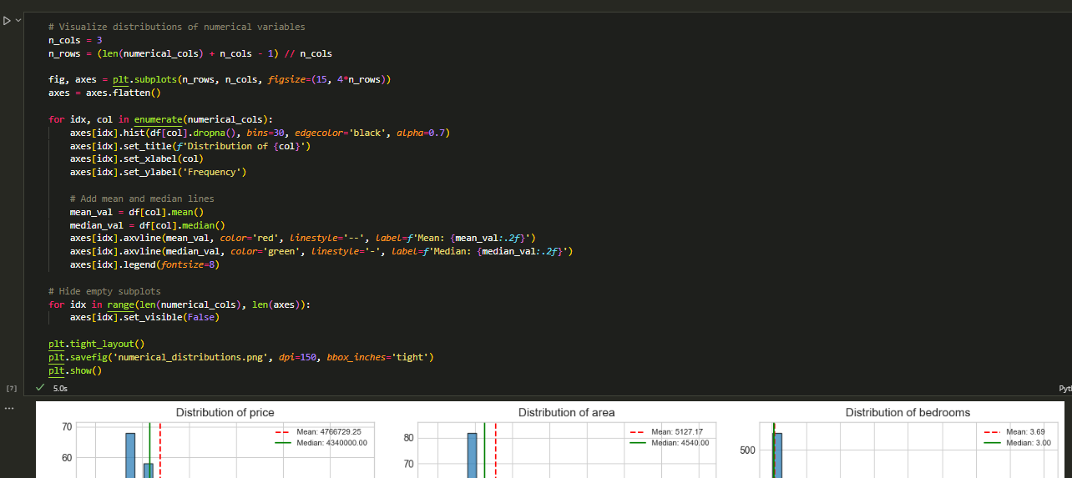

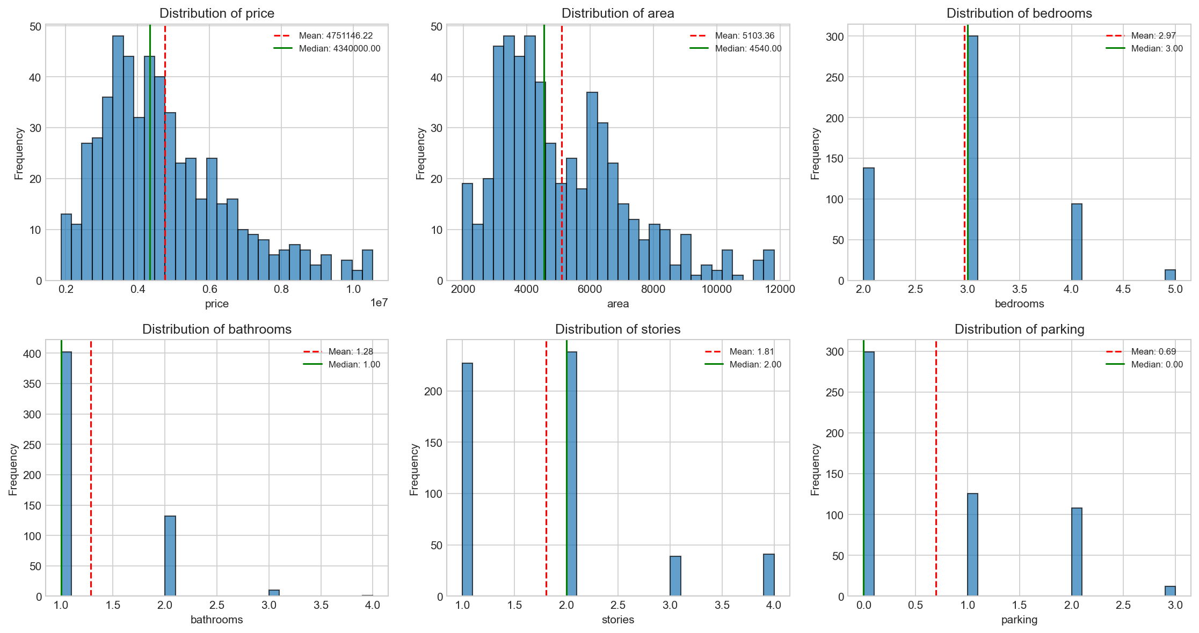
  - Explain what the summary reveals about the distribution and characteristics of each variable.

Interpretation of Statistical Summary
Interpretation Notes: (Update these based on your actual data)
For each numerical variable, analyze:
- Central Tendency (Mean vs Median):
  - If mean ≈ median: Distribution is approximately symmetric
  - If mean > median: Right-skewed (positive skew)
  - If mean < median: Left-skewed (negative skew)
- Spread (Standard Deviation):
  - High std relative to mean indicates high variability
  - Low std indicates data points are clustered around the mean
- Skewness:
  - |skewness| < 0.5: approximately symmetric
  - 0.5 < |skewness| < 1: moderately skewed
  - |skewness| > 1: highly skewed
- Kurtosis:
  - kurtosis ≈ 0: normal distribution (mesokurtic)
  - kurtosis > 0: heavy tails, more outliers (leptokurtic)
  - kurtosis < 0: light tails, fewer outliers (platykurtic)

- Handling Missing Values

  - Detects missing values across the dataset.
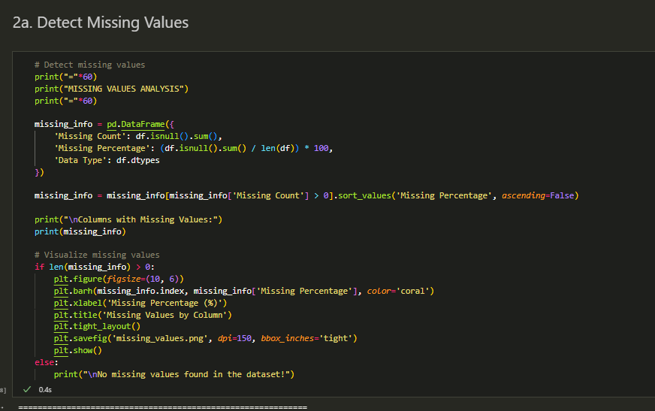
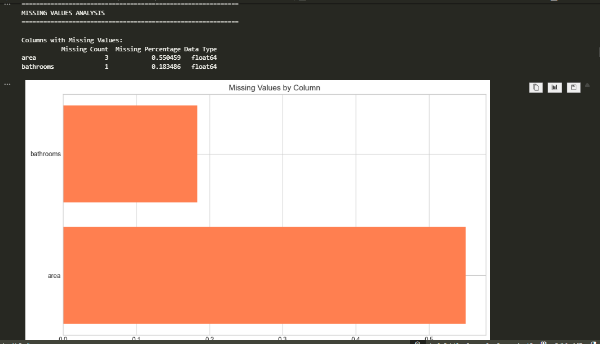
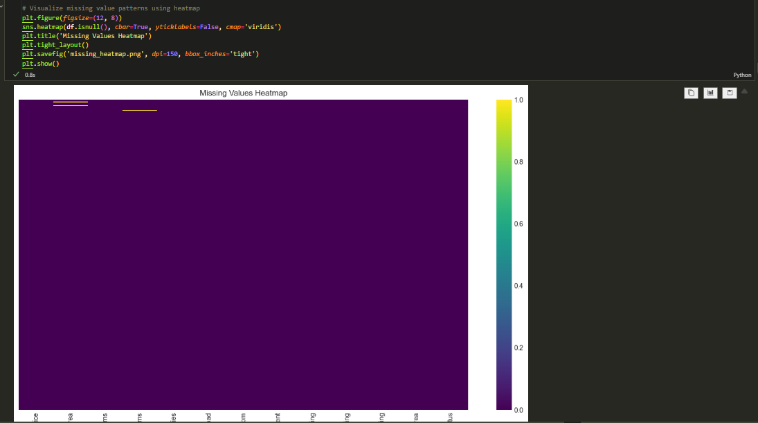

b. Apply appropriate imputation techniques (e.g., mean, median, mode, domain-based imputation).

  - Justify why each technique was chosen for each specific variable based on the nature of the data.

2b & 2c. Apply Imputation Techniques with Justification
Imputation Strategy Selection Guidelines:
Data Type | Distribution | Recommended Imputation
Numerical | Normal/Symmetric | Mean
Numerical | Skewed | Median
Categorical | Any | Mode
Special cases | Domain-specific | Domain knowledge
Justification for each technique:
- Mean: Best for normally distributed data without outliers
- Median: Robust to outliers, ideal for skewed distributions
- Mode: Appropriate for categorical data (most frequent value)
- Domain-based: When business logic dictates specific values
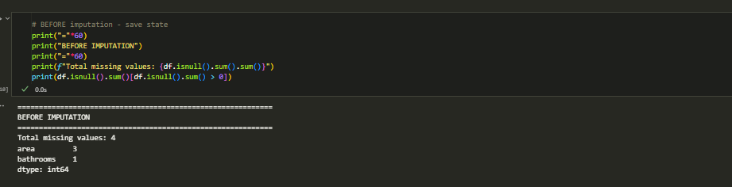

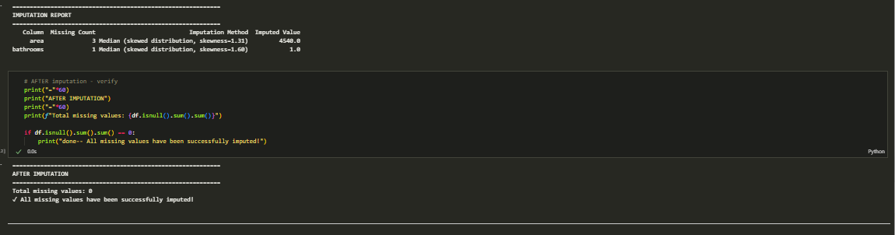

- Detecting and Handling Duplicate Records

  - Check for duplicate observations in the dataset.
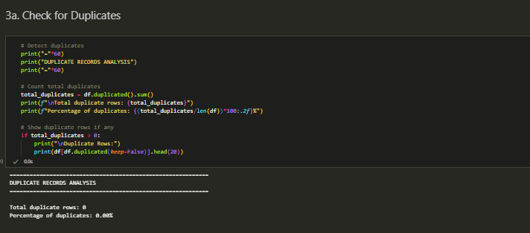
  - Decide whether to remove or retain duplicates.
  - Explain and justify your decision.
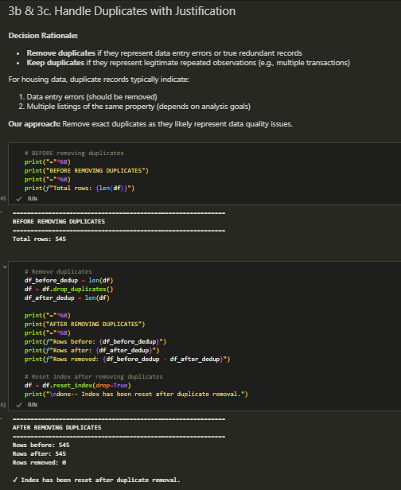

- Detecting and Handling Data Inconsistency

  - Identify any inconsistencies (e.g., incorrect data types, spelling variations in categorical values, unrealistic values, mixed units, format inconsistencies).
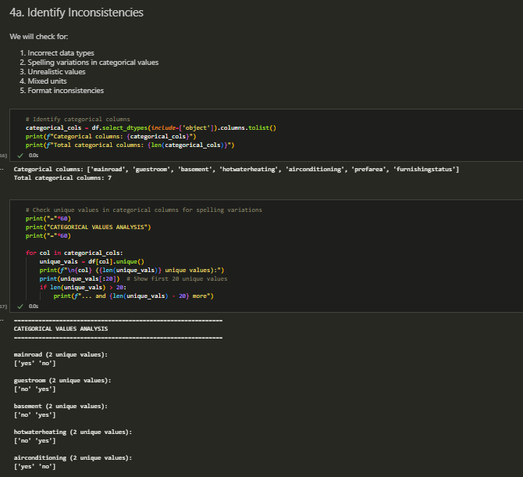
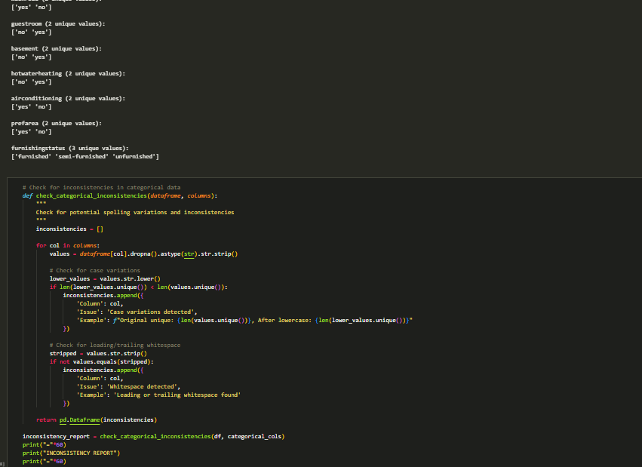
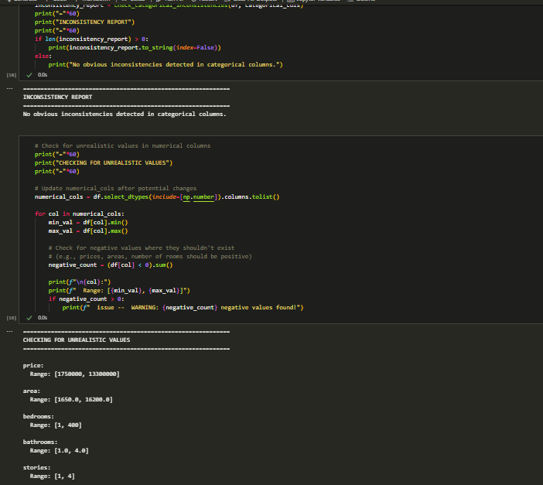
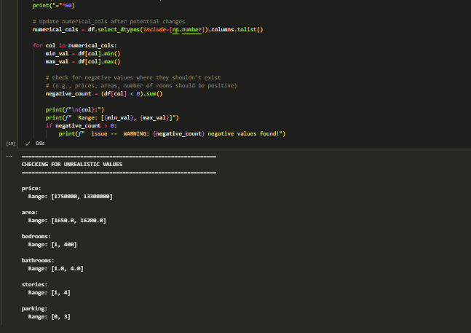
  - Clean, correct, or unify the inconsistent data.
  - Document the types of inconsistencies found and how they were resolved.
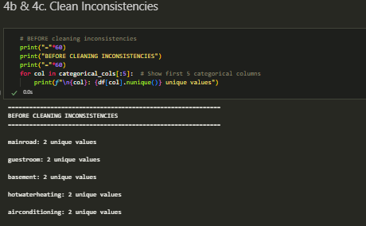
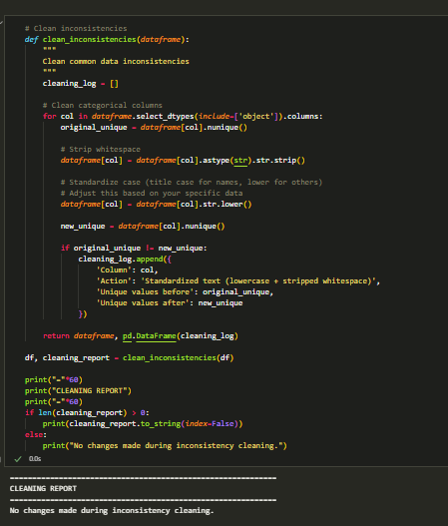
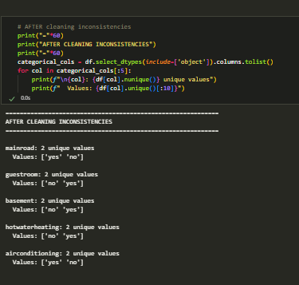

- Detecting and Handling Outliers

  - Use appropriate outlier detection methods (IQR, Z-Score, visualization techniques, or domain rules).
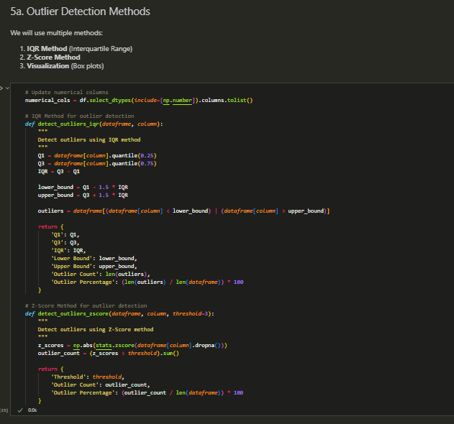
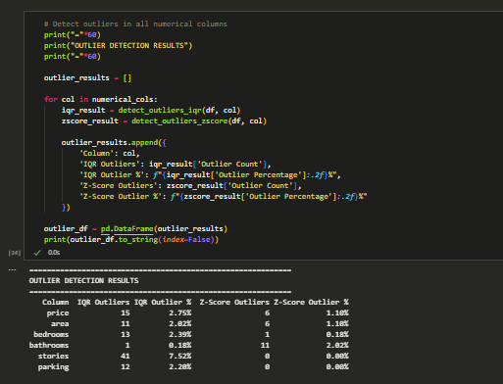
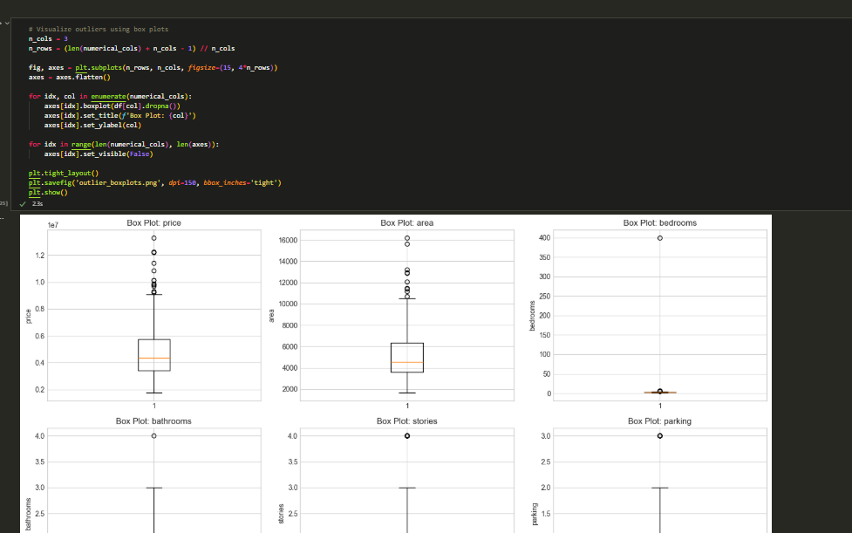
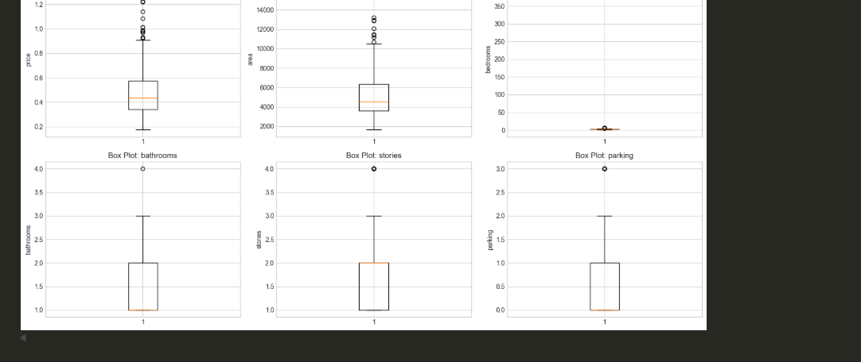
  - Decide whether to remove, winsorized, or keep outliers.
  - Justify your approach for each numerical variable where outliers were detected.

5b & 5c. Handle Outliers with Justification
Outlier Handling Strategies:
Strategy | When to Use
Remove | Clear data errors, extreme outliers that skew analysis
Winsorize | Want to reduce outlier impact while keeping data points
Keep | Outliers represent valid extreme cases (e.g., luxury houses)
Transform | Apply log transformation to reduce skewness
Our Approach: We will use Winsorization (capping at 1st and 99th percentiles) because:
- It preserves data points (important for small datasets)
- It reduces the impact of extreme values
- It's appropriate for housing data where extreme prices may be valid
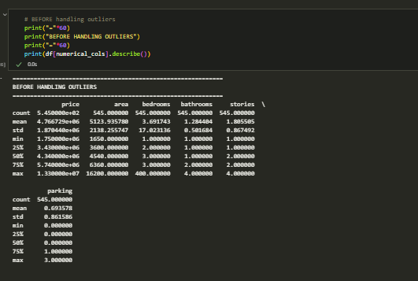
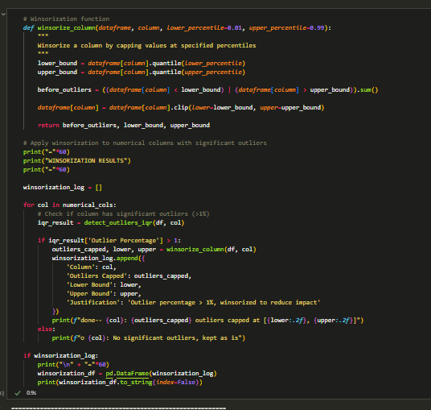
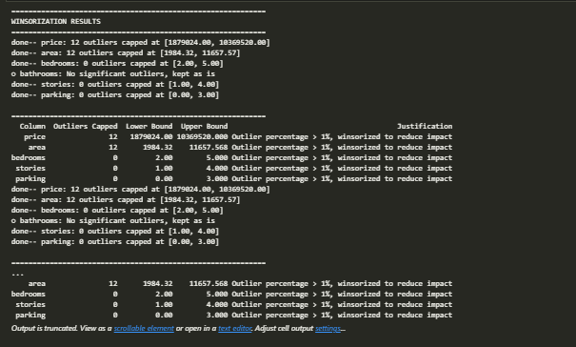
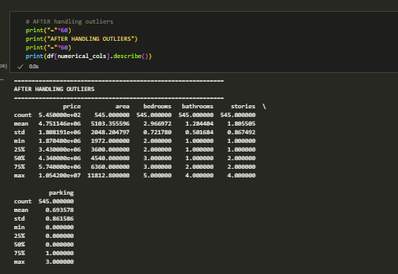
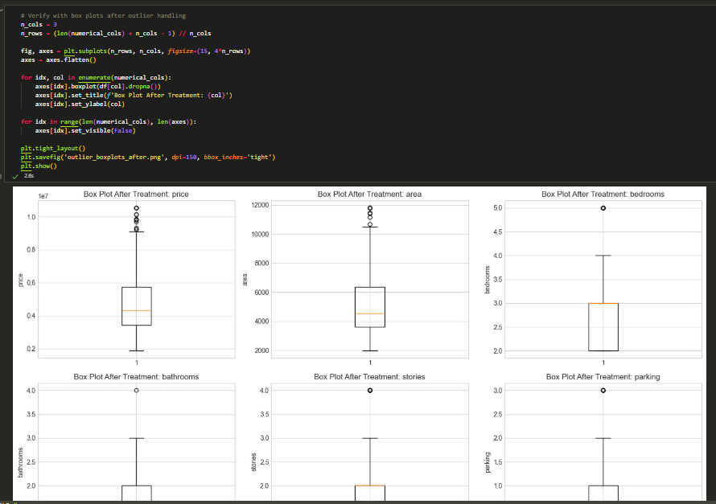
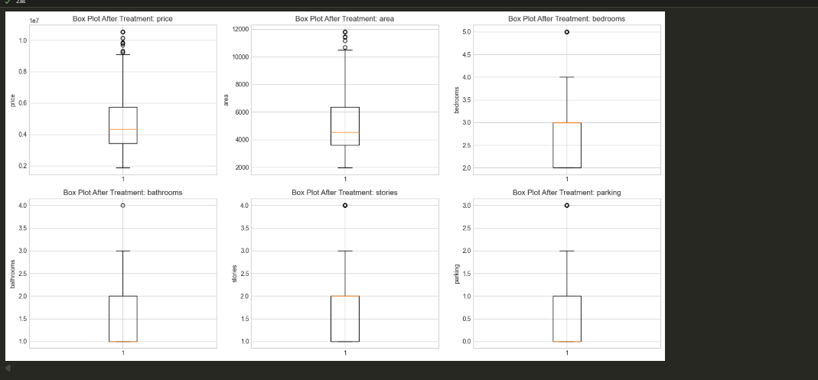

- Normalization and Scaling

  - Identify which variables require scaling or normalization.
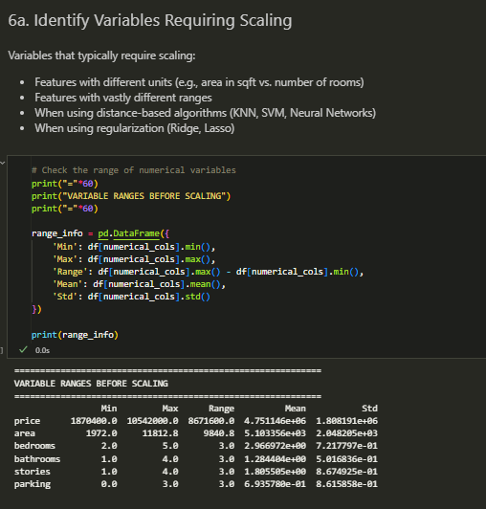
  - Apply appropriate techniques such as Min-Max Scaling, Standardization (Z-score scaling), Robust Scaling
  - Clearly explain why each chosen technique is suitable for the variable(s).

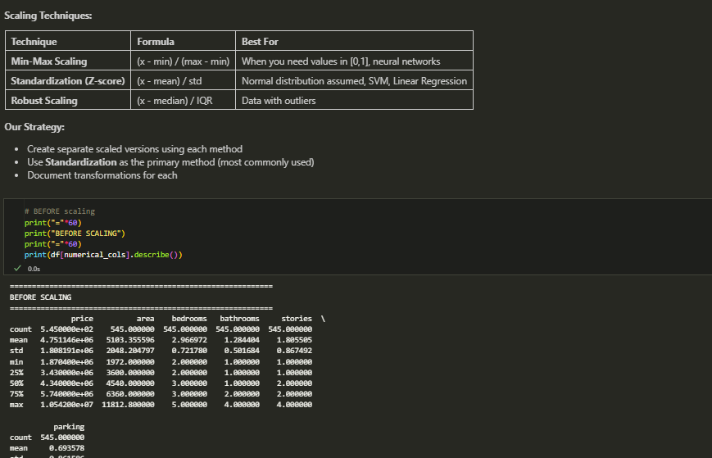

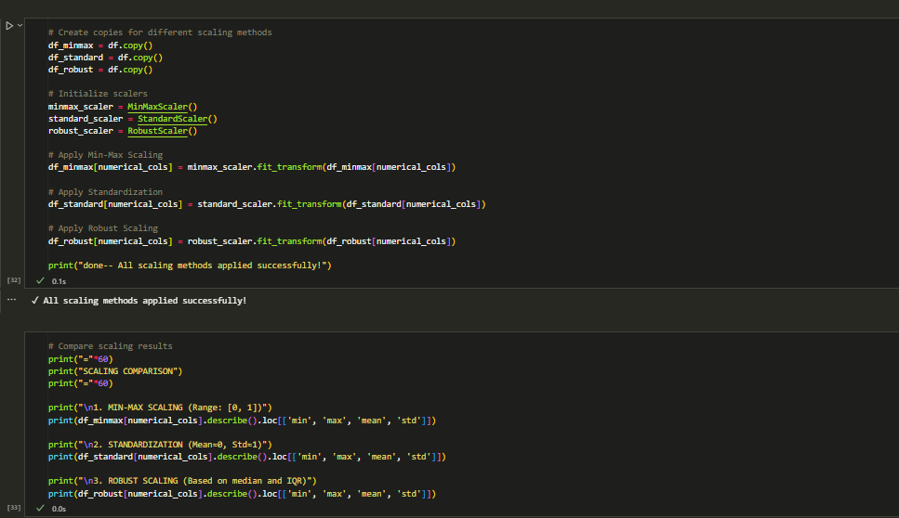

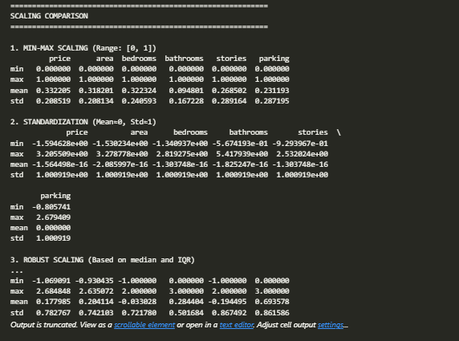

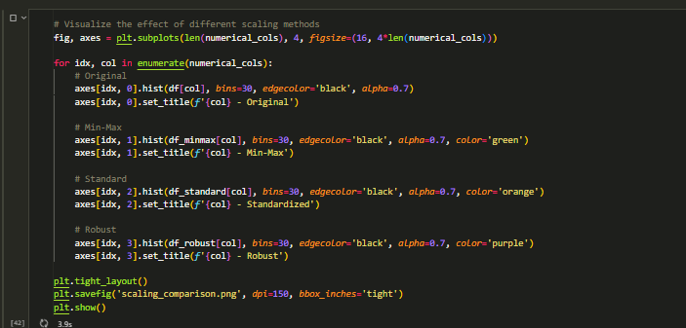

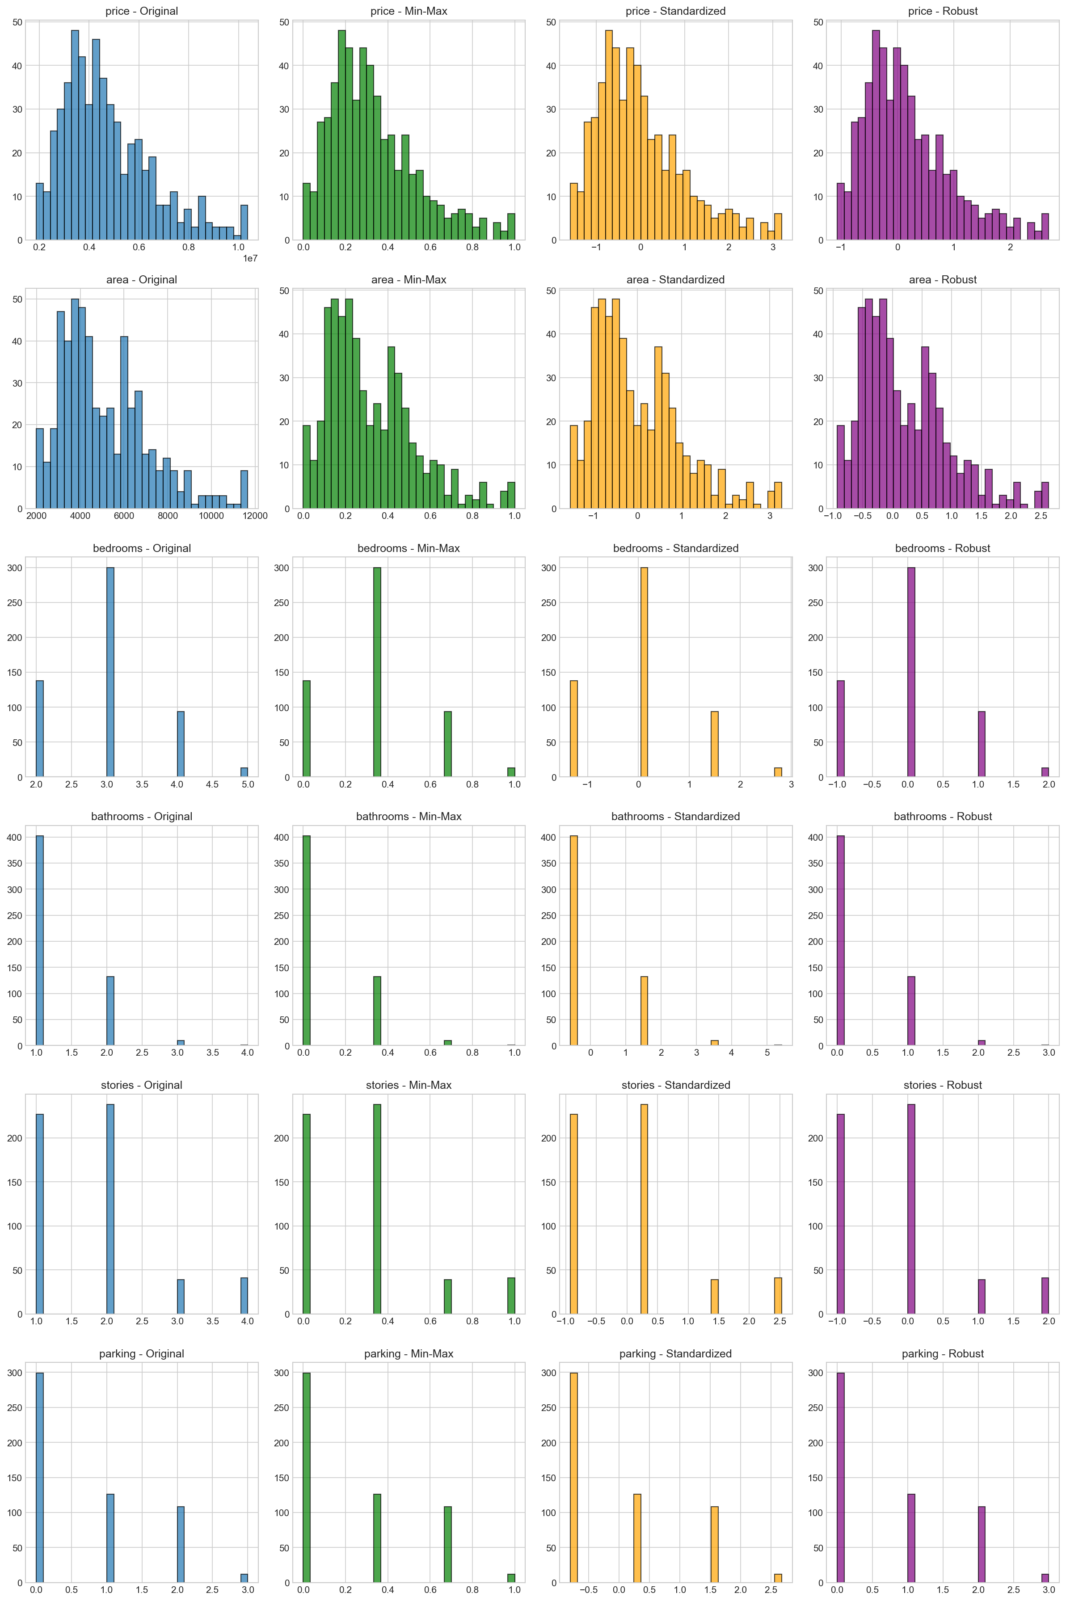

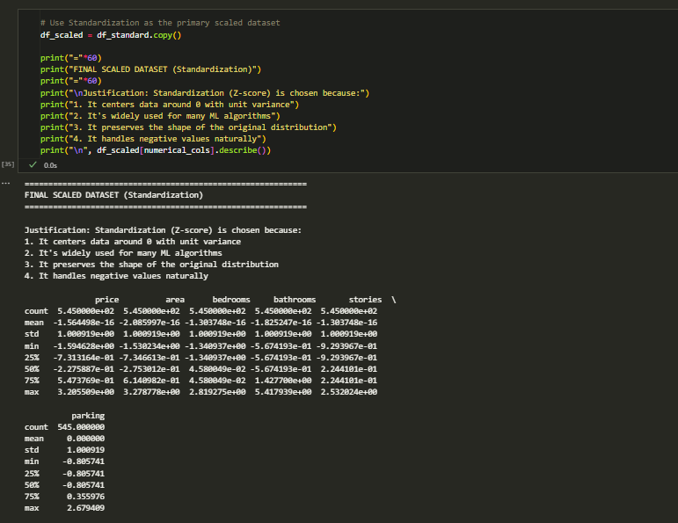

- Encoding Categorical Variables(uncovered yet in class)

Research, document them theoretically and apply different data encoding techniques to relevant categorical variables in the dataset, including but not limited to:

- Label Encoding
Description: Assigns integers (0, 1, 2, ...) to each unique category.
When to use:
- Ordinal variables with clear ranking
- Tree-based models (can handle label encoding well)
- When memory/dimensionality is a concern
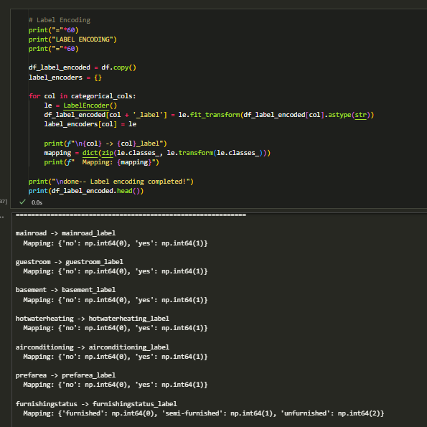
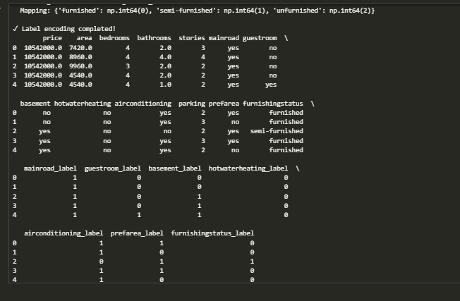

- One-Hot Encoding
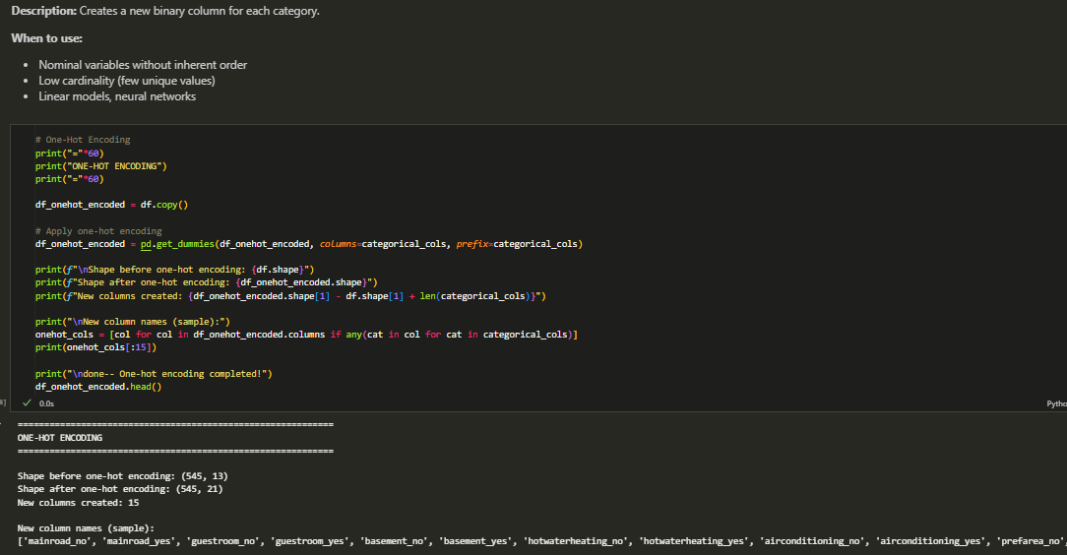
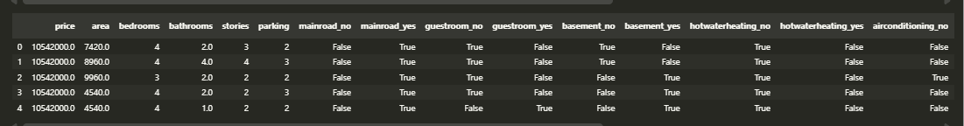
- Binary Encoding
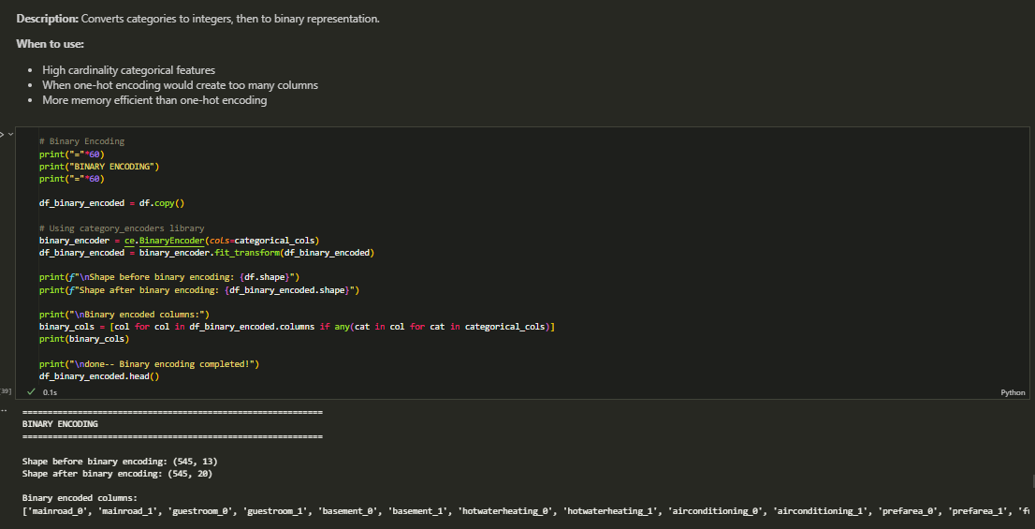
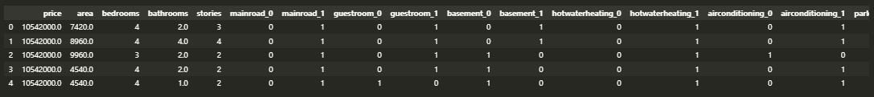
- Ordinal Encoding
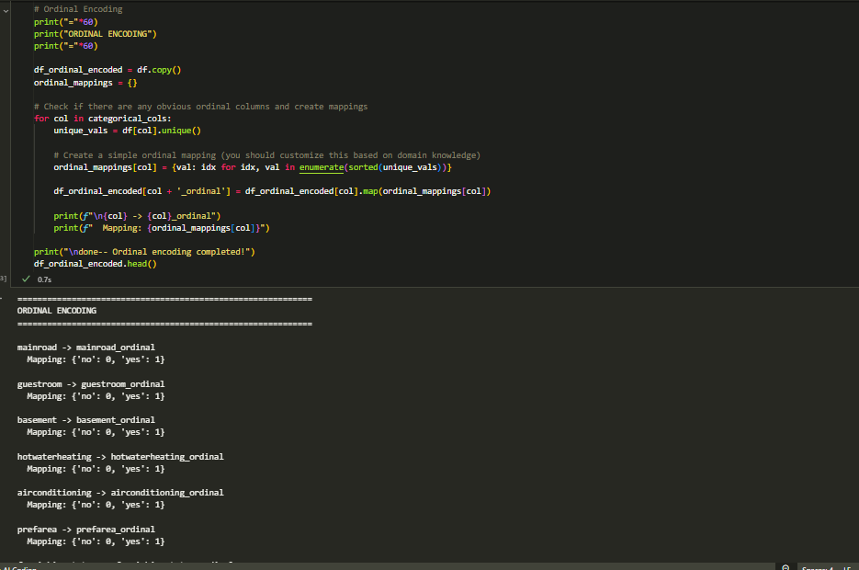
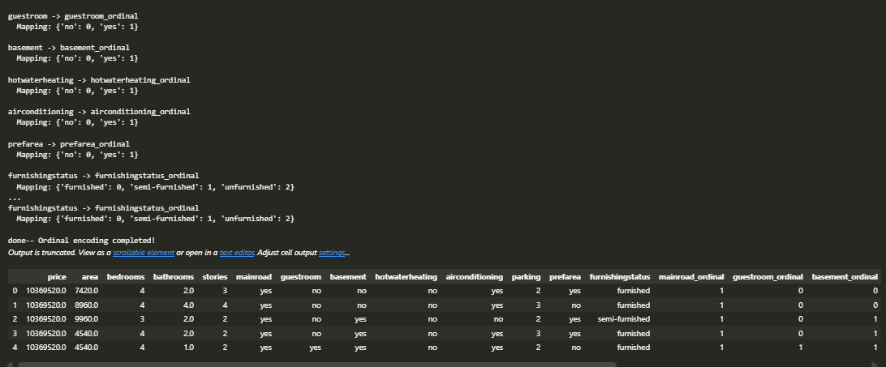

- Target Encoding (with and without smoothing)
