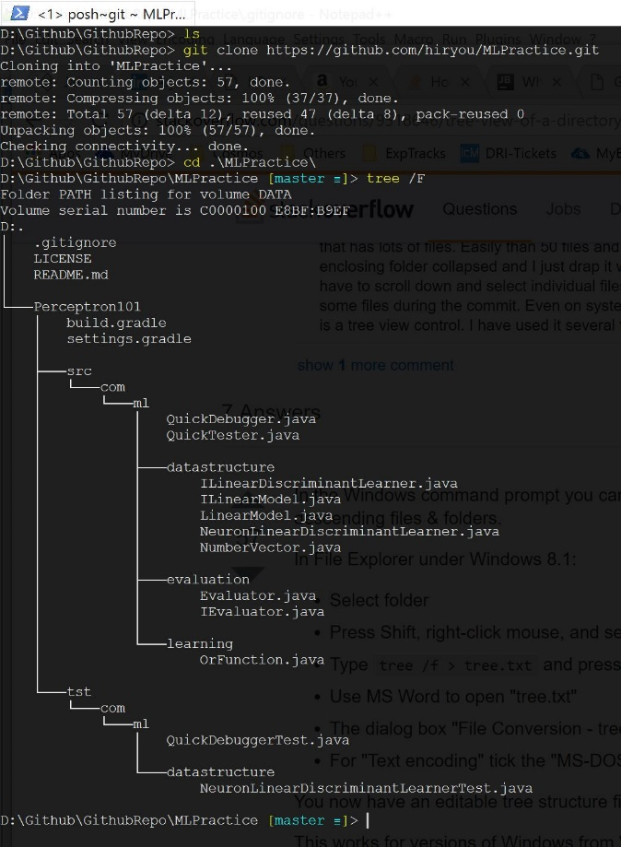<- Checkout a project from git as usual

Example on the left is an empty root project (MLPractice) with multiple modules (Perceptron101, etc).

Note that I don’t have any IDEA related files in the REPO. This is a purely Gradle-dependent project (i.e. workspace in IDEA terminology)

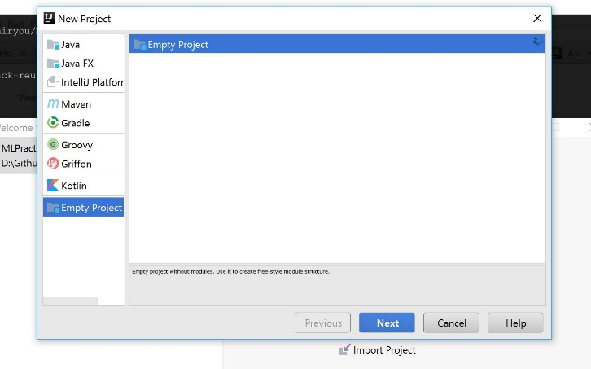

Intellij: Select “Create new project”, choose Empty Project

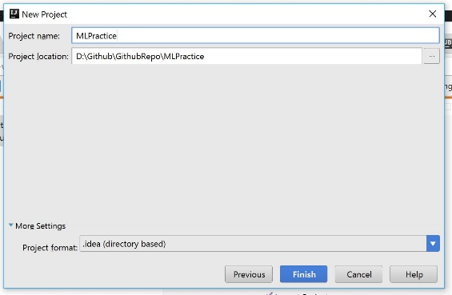

<- Select the existing project root directory

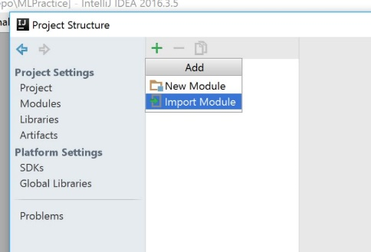

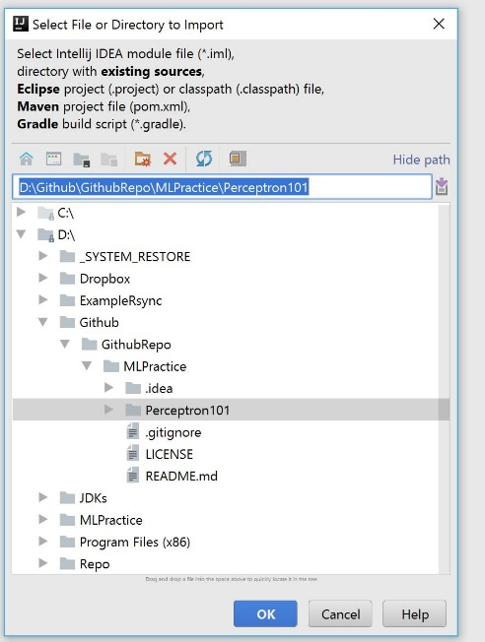Project Structure should pop up. Select “Import Module”

<- Browse to the existing module directory

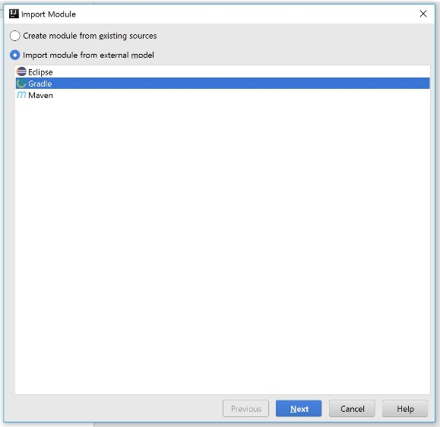<- Select Gradle as the external import mode

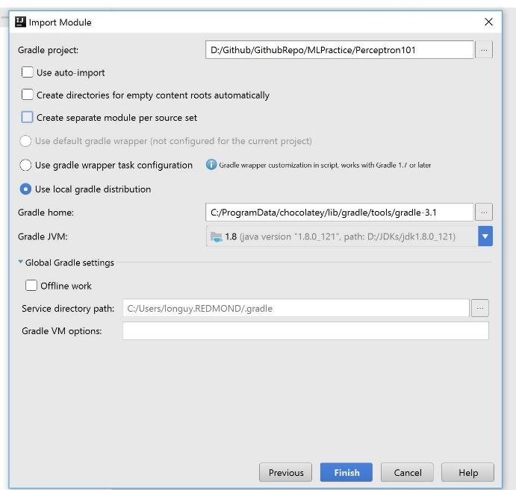

Module import **->** configs. Note that I unchecked “Create Seprate module per source set”.

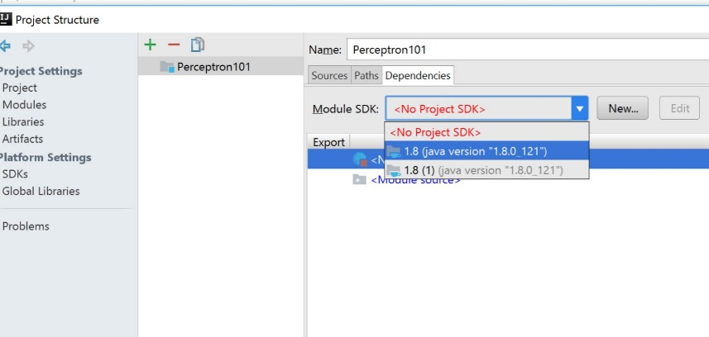

<- Select the preferred Java SDK

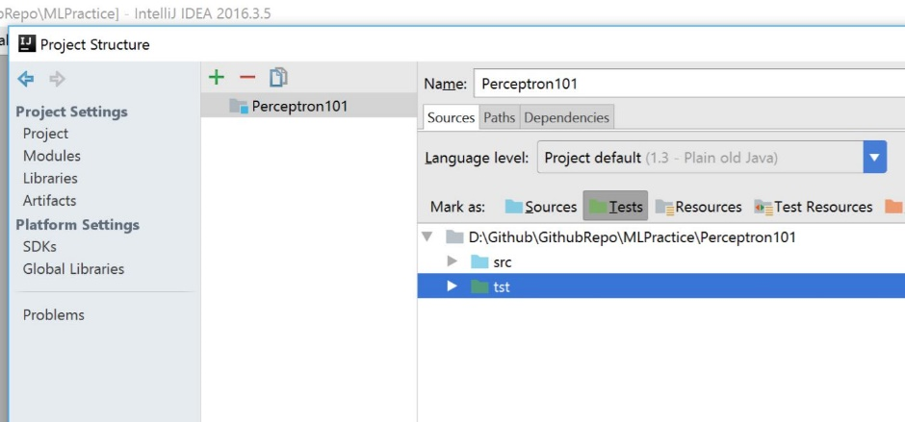

<- Mark Sources and Tests respectively

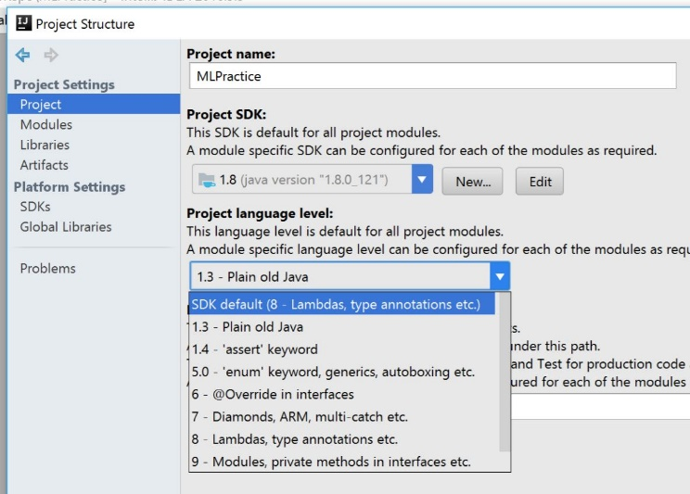

<- Config the same (consistent) Java SDK for the root project

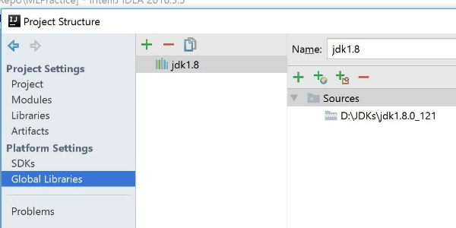<- Config the Java SDK as Global Libraries

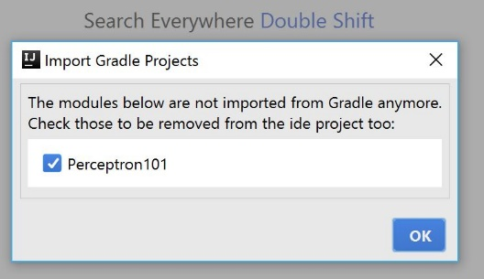

<- Not sure why this window pops up. I just clicked OK

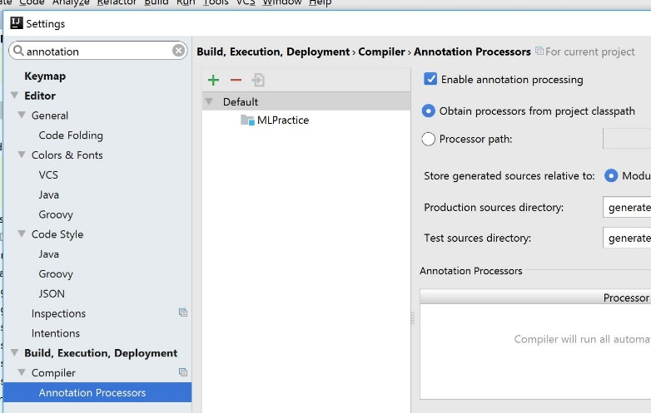

<- If you’re using Lombok, enable “Annotation processing”

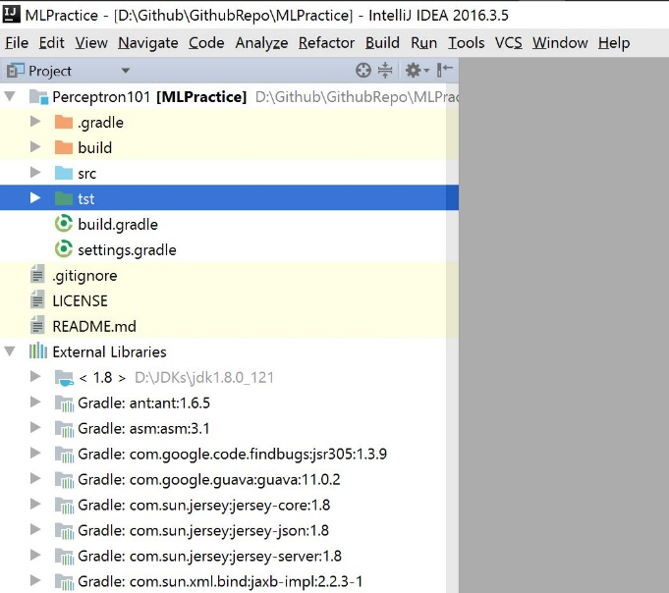

Project view when done ->

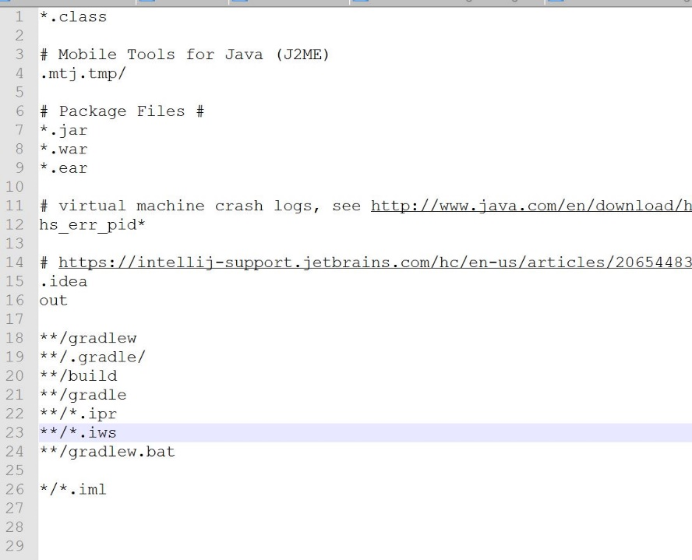

<- Content of my .gitignore