

**User GUIDE**Version 4.0

Isabelle LECOMTE & Kevin WOLZ

Last Updated: 7th November 2018

# Hi-sAFe overview

Hi-sAFe is a dynamic generic model simulating interactions between plants (trees and crops) in three dimensions, which account for the classical balance of materials and energy (water, nitrogen, light).

Hi-sAFe is implemented under the **CAPSIS** modelling platform (De Coligny et al, 2002) which is portable software, freely available under a GNU license (<http://capsis.cirad.fr/capsis/home>). The Capsis project aims at integrating several types of forest growth and dynamic models and providing forest management tools to establish and compare different silviculture scenarios.

Hi-sAFe is designed to simulate scenes such as:

* Mixtures of trees and crops, whether trees are aligned, dispersed or isolated
* Perennial row crops with ground cover
* Mixtures of herbaceous crops, foot, row or strip
* Multi-species forests
* Isolated trees (urban trees, hedges) with or without ground vegetation
* Plots of pure crops with spatial heterogeneity
* Precision agriculture (technical itineraries adapted to the spatial heterogeneity of the stand)

A tree model has been specifically developed with 6 main modules:

* Phenology
* Light interception
* Water demand calculation
* C allocation
* Fine root growth
* Coarse root topology growth

STICS(Brisson et al, 2001) is the crop model embedded in Hi-sAFe. It has been in development at INRA-Avignon (France) since 1996 (<http://www6.paca.inra.fr/stics>). STICS simulates crop growth as well as soil water and nitrogen balances driven by daily climatic data. It calculates both agricultural variables (yield, input consumption) and environmental variables (water and nitrogen losses). One of the key elements of STICS is its adaptability to various crops. This is achieved by the use of generic parameters relevant for most crops and with options in the model concepts concerning both physiology and management, which have to be chosen for each crop.

The water and nitrogen repartition module between trees and crop also has been specially designed for HisAFe with a **minimisation of energy approach**. This simply means that the resources will be extracted where it is the easiest (plants are lazy). The model should be able to describe the opportunism of plants in heterogeneous environments, and especially when heterogeneity results from plant competition.

# Hi-sAFe simulated scene

Usual agroforestry projects will take place at a variety of scales, but the Hi-sAFe belowground modules must operate at relatively small horizontal and vertical scales, over which local conditions can vary significantly. The following diagrams describe the process by which we move from the field scale through to the soil scale at which the Hi-sAFe belowground modules will operate.



Figure : Spatial resolution – from the field scale to the voxel scale

The Hi-sAFe soil resolution is not only based on structural characteristics (pedologic layers) but also on a *maximum* thickness of soil suitable for the water extraction and the cellular automata module (for tree root growth) being simultaneously developed. The decision was reached to call these intermediate sub-layers “*voxels”*. The term is a contraction of “volume element” (by analogy with ‘pixel’), and is commonly used in three-dimensional modelling. A voxel is defined as ‘”*the smallest distinguishable box-shaped part of a three-dimensional space*”. The voxels will differ in terms of their water content, even if they share similar soil structural parameters. Further discussions centred on whether to consider only voxels of uniform dimensions (*e.g.* 1m X 1m X 1m), or whether it was necessary to be able to have non-cubic voxels. Eventually it was decided that the horizontal X-Y dimensions of voxels in Hi-sAFe would be uniform (*i.e.* square), but that the depth (Z-dimension) could vary. This was necessary in order to be able to divide the compartments (of variable depth due to the heterogeneity of the soil pedological layers) into discrete voxels.

**CAPSIS cell:**

Considered for modelling purposes as the

cell into which the plot is divided and the soil

column lying beneath it

**Layers**

**:**

Defined as t

he intersection between the CAPSIS

cell (column) and one of the soil pedological layers

(shown here in different colours

)

**Voxel:**

Compartments consist of one or more

*voxels*

,

each of which will have the same soil properties.

Voxels have a maximum allowed dep

th

Figure : Definition of terms used in modules describing soil processes

Hi-sAFe includes toric symmetry algorithms that avoid generating artificial edge effects for heterogeneous stands (the scene is surrounded virtually by identical scenes)

Hi-sAFe can be used on simple scenes (for example centered on an average tree) or on complex scenes (eg including many trees with varying developments).

# Running Hi-sAFe

Hi-sAFe installation creates a **capsis_install_folder\capsis4\data\safe** folder on your computer containing:

* cropInterventions: containing 23 crop intervention input files (*.itk)
* cropSpecies: containing 23 crops species parameters files (*.plt)
* exportParameters: containing 10 export profiles (*.pro)
* generalParameters: containing STICS and Hi-sAFe general parameters file (*.par)
* plotDescription: containing 10 example of plot description input file (*.pld)
* simSettings: containing 1 batch simulation folder example
* treeSpecies: containing 3 tree species parameters files (*.tree)
* weather: containing 1 weather input file (*.wth)

**Each time you re-install or upgrade Hi-sAFe, this folder will be erased!**

**Copy this folder another part of your disk, and use this new folder to store your own simulation data.**

## Grafical User Interface (GUI) mode

GUI mode is convenient to check plot configuration and run small simulations (1 or 2 years), but most of the time, BATCH mode is much more appropriate for multi-years simulations.

To run Hi-sAFe GUI, click on the Capsis desktop shortcut or open a DOS prompt and execute

c:\my_capsis_folder\capsis4 > capsis (in French)

c:\my_capsis_folder\capsis4 > capsis –l en (in English)

A DOS window and Capsis GUI will open simultaneously.

|  |  |
| --- | --- |
|  |  |

Choose “Create a new project” and click on **OK**

Give a name to the project, choose **Hi-sAFe** model and click on **Initialise**

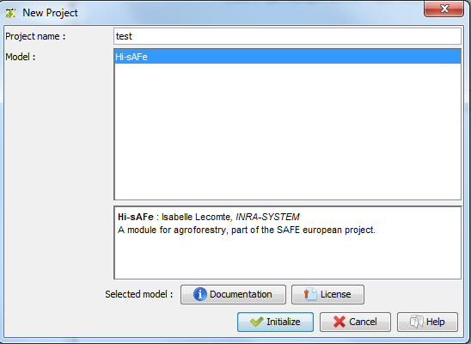

Initialise the project by giving a plot description file name. This file will contain all usefull information for designing the virtual scene (dimension, soil description and planted trees species). All details about the plot description file are in chapter 4.1.

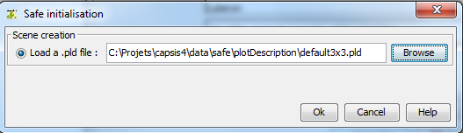

Click on the **Browse** buttonto choose a file on your computer, then **OK**

Click on the root step (**0/0/0a**) and then on **HiSAFE viewer** (on the left part of the screen)

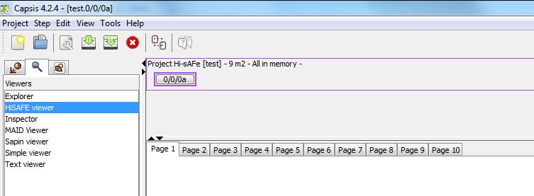

You can check the plot design

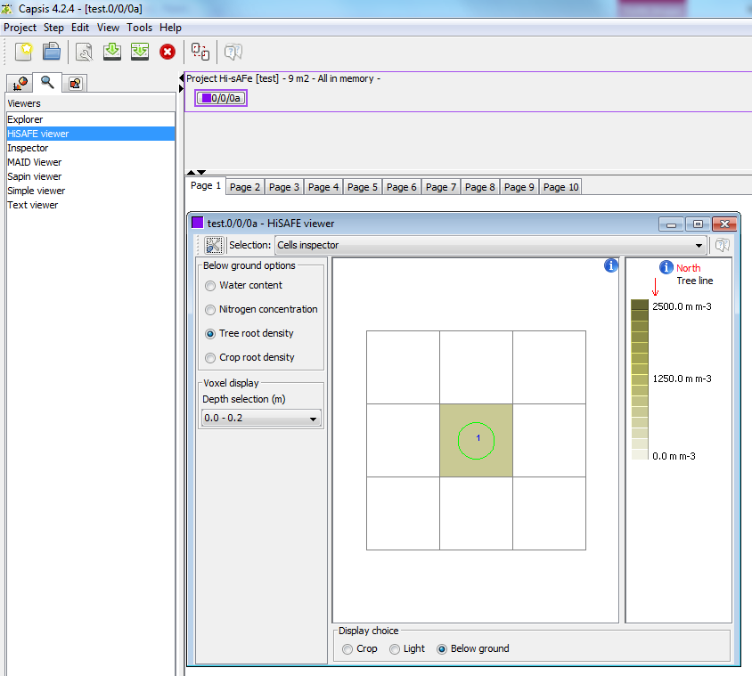

Before running the simulation, it is possible to change the memory option to reduce the step that will be memorised in the CAPSIS project. Right-click on root step and choose “C**onfigure**”

|  |  |
| --- | --- |
|  |  |

**Memory options:**

* All in memory : all steps are stored
* Compact : only the last step is stored
* Frequency : Only some steps are stored depending on the frequency defined

To run a Hi-sAFe simulation: right click on the root step (**0/0/0a**) of the project to choose “**Evolution**”

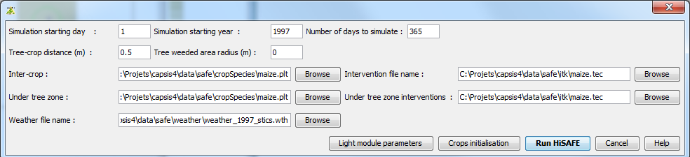

Fill in all simulation information:

* Simulation starting date (in DOY)
* Simulation starting year
* Number of days for the simulation (1-365 max)
* Inter-crop species name and intenvention file
* Under tree zone species name and intenvention file
* Weather file name

Then click on “**Run Hi-sAFe**”



The progress bar at the bottom of the screen shows the evolution of the simulation.

When the simulation is complete the last step appears next the root step. 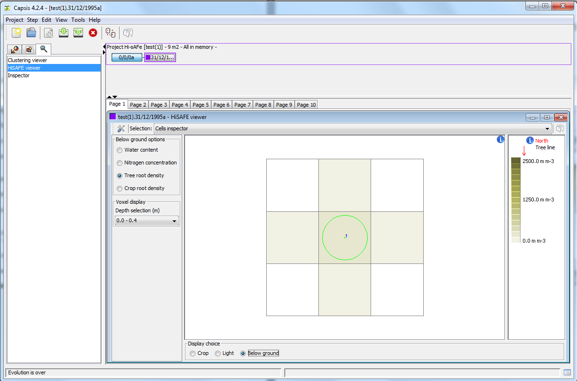

To see other steps, right-click on a step and choose “**Configure**”

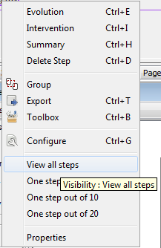

Results can be graphically explored using the **Inspector** or **HiSAFE viewer**

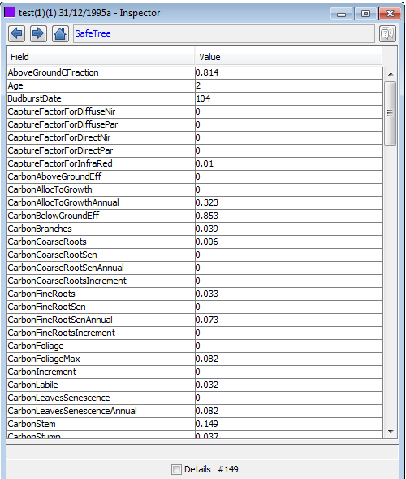

## BATCH mode

Copy the capsis4/data/safe/ in a user simulation folder with

* **cropInterventions :** folder with all crop management files needed for the simulation
* **cropSpecies** : folder with all crop species file used in the simulation
* **exportParameters :** folder with all export profiles needed for the simulation
* **generalParameters** : folder with the general parameter file
* **treeSpecies** : folder with all tree species parameters files needed for the simulation
* **test.sim :** simulation parameter file

Copy the **plot file** (*.pld) and the **weather file** (*.wth) in the simuation folder. Hi-sAFe will found them automatically thanks to their extension.

Be advised to choose a disk volume with enough space because a long simulation can generate large output files.

In this example simulation folder is **D:/simulations/test**

The simulation parameter file (test.sim) contains all information to run the simulation (this corresponding to the user entries in GUI mode)

Open a DOS prompt and execute

> capsis –p script safe.pgms.ScriptGen D:/simulations/test/test.sim

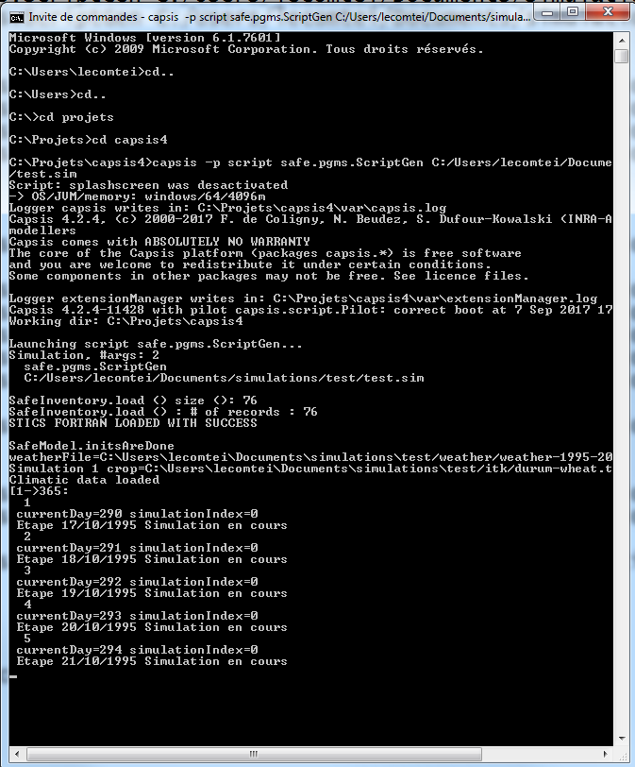

Starting messages for BATCH execution mode

Execution will automatically generate an output folder named **output-test.sim** containing**:**

* initialisation.sti : message from STICS initialisation
* mainplant.sti : message for STICS main plan initialisation
* secondplant.sti : message for STICS main plan initialisation
* one cvs file for each export described in the simulation parameter file

**Crop rotation examples :**

Simulation parameter file can integrate crop rotations like:

nbSimulations = 10

mainCropSpecies = durum-wheat(3), rape(2)

interCropSpecies = baresoil, weed

treeCropDistance = 0.5(5),1.0(5)

For 10 years of simulation the rotation will be:

Main crop: durum-wheat / durum-wheat / durum-wheat / rape / rape / durum-wheat / durum-wheat / durum-wheat / rape / rape

Inter crop: Baresoil / Weed / Baresoil / Weed / Baresoil / Weed / Baresoil / Weed / Baresoil / Weed

Tree Crop distance: 0.5 / 0.5 / 0.5 / 0.5 / 0.5 / 1.0 / 1.0 / 1.0 / 1.0 / 1.0

# Exporting Hi-sAFe results

## GUI mode

The best way to explore simulation results is to the export ASCII files output to be treated with EXCEL , R or any other data management software.

1) Right-click on the last step on the simulation and choose the “**Export**” option

2) Choose the **SafeExportation** format and give the ASCII file a name

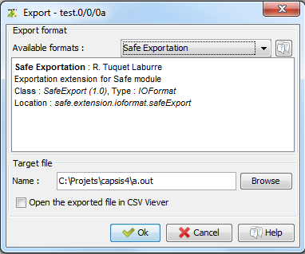

3) Choose an existing profile or create a new one if necessary

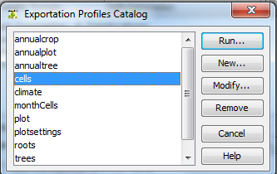

4) A profile contains all the information necessary to export data from the simulation.

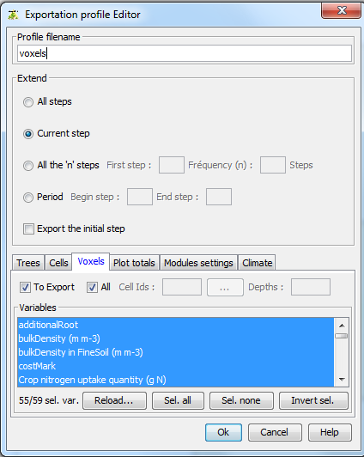

Depth selection

Cell selection

Profile name

Data selection

Step to export

5) A graphical selector is available for cell choice

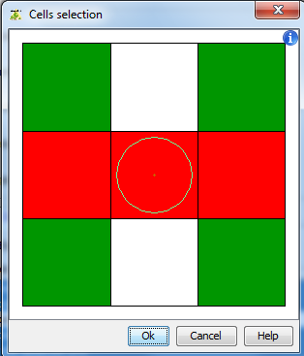

6) When exportation process is running, a progress bar is displayed

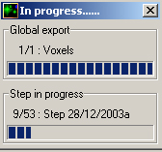

7) Export ASCII file example

Date stepNum id x y waterDemand reducedWaterDemand waterUptake rootDepth waterStress sticsWaterTurgescenceStress sticsWaterStomatalStress sticsWaterSenescenceStress

27/10/2003 1 0 0.0 0.0 0.0 0.0 0.0 0.0 1.0 1.0 1.0 1.0

27/10/2003 1 1 0.0 0.0 0.0 0.0 0.0 0.0 1.0 1.0 1.0 1.0

28/10/2003 2 0 0.0 0.0 0.0 0.0 0.0 0.0 1.0 1.0 1.0 1.0

28/10/2003 2 1 0.0 0.0 0.0 0.0 0.0 0.0 1.0 1.0 1.0 1.0

29/10/2003 3 0 0.0 0.0 0.0 0.0 0.0 0.0 1.0 1.0 1.0 1.0

29/10/2003 3 1 0.0 0.0 0.0 0.0 0.0 0.0 1.0 1.0 1.0 1.0

30/10/2003 4 0 0.0 0.0 0.0 0.0 0.0 0.0 1.0 1.0 1.0 1.0

30/10/2003 4 1 0.0 0.0 0.0 0.0 0.0 0.0 1.0 1.0 1.0 1.0

31/10/2003 5 0 0.0 0.0 0.0 0.0 0.0 0.0 1.0 1.0 1.0 1.0

31/10/2003 5 1 0.0 0.0 0.0 0.0 0.0 0.0 1.0 1.0 1.0 1.0

## Batch mode

In BATCH mode export files are automatically generated in the output folder according to rules written in the simulation file.

#EXPORTS

profileNames = annualplot,annualtree,climate,plot,trees,cells,voxels

exportFrequencies = 365,365,1,1,30,30

Be advised to create the export profile with the GUI interface and to copy the *.pro files in the simulation exportParameters folder.

More details about the export profile in chapter 5.4.

# Hi-sAFe input files description

All files are in **CSV ASCII** format that can be edited with standard editing software such as NotePad, TextPad or Microsoft Excel.

Comments are always preceded by the special character # and most of the times are in capital letters

#PLOT DESCRIPTION

Single data are formatted as keyword = value with only a space (not tabulation) between them.

elevation = 130

Numbers are in US format

latitude = 43.7

String doesn’t need to be notified with special quotation marks.

township = Montpellier

Boolean values are true or false

waterTable = true

List data are separated by tabulations with an identifying keyword in the first column. Lines of comment should always explain what the columns contain and their units.

#LAYER INITIALISATION

# waterContent n03Concentration nh4concentration

# % kg ha-1 kg ha-1

LayerInit 0.10 32.0 0.0

LayerInit 0.10 12.0 0.0

The Hi-sAFe model loads input files before running a simulation. If a modification is done in one file, the user doesn’t have to close Capsis and reload Hi-sAFe to take the modification into account. He or she will only need to run a new simulation.

These file names, extensions and physical locations can be changed but our advice is to give explicit names and extensions to easily recognise these files and their use.

## Plot description (*.pld)

The plot description will give all information about the virtual scene (dimensions, orientation, tree spacing, soil characteristics etc.). Name and extension can be changed, but our advice is to call these files with the real explicit name of your experimental plot and .pld extension (example: restincliere-A2.pld)

## Crop interventions (*.tec)

This file will give all information about interventions planed for a crop on the virtual scene (sowing date, soil management, irrigation, fertilisation etc.). Name and extension are free but one advice is to call these files with the name of the crop species - the real explicit name of your experimental plot with .tec extension (example: wheat-restincliere-A2.tec)

## Weather data (*.wth)

Hi-sAFe simulation in interactive mode cannot exceed 365 days, so weather data file doesn’t need to be more than 365 days either. It is sometimes necessary to store several years of weather data in the same file to run winter cropped plots simulations (for example durum wheat seeded in October and harvested in June the next year)

For batch execution a weather file covering the whole simulation duration have to be provided. By default Hi-sAFe provides capsis4\data\safe\weather\weather-1995-2035.wth corresponding to 40 years of French Mediterranean climate. Last 20 years have been randomly generated with previous ones. Name and extension are free but one advice is to call these files with the real explicit name of your weather station – start year – end year - with .wth extension (example: restinclieres-1996-2014.wth)

## Export profile (*.pro)

It is more convenient and secure to create and update the export profiles with the Hi-sAFe GUI interface. In BATCH mode, export profiles have to be in the exportProfile folder of the simulation.

Refer to the Excel file Hi-sAFe - V3-1 - Parameter Details to get all the export variable available.

# Hi-sAFe parameters files description

Name and location of the parameters files have been fixed by the authors and cannot be modified without a complete recompilation of the model. There is no graphical interface for visualizing or modifying them. However it is possible to modify data in these files (to test different parameters values) using standard editing software. Hi-sAFe loads these files once during the initialisation and all these data are unchanged as soon as Capsis is running. If a modification is made in a parameter file the user has to close Capsis and reload the whole Hi-sAFe model.

**Neither names nor physical location of these parameter files can be modified!**

## Tree species parameters (*.tree)

3 species are available in Hi-sAFe model, these species are poplar, wild cherry and walnut hybrid.

## 

## Crop species parameters (*.plt)

23 species are available in Hi-sAFe model, these species are:

* Alfalfa
* Banana
* Baresoil
* Barley
* Durum wheat
* Fescue
* Falx
* Grass
* Lettuce
* Maize
* Mustard
* Pea
* Potato
* Rape
* Ryegrass
* Sorghum
* Soybean
* Sugarbet
* Sugarcane
* Sunflower
* Tomato
* Vine
* Wheat

## 

## Hi-sAFe general parameters (hisafe.par)

Contains generic Hi-sAFe parameters.

## STICS General parameters (stics.par)

Contains generic STICS parameters.