Car Connection Box — Product User Manual

Product User Manual

Car Connection Box(CCB)
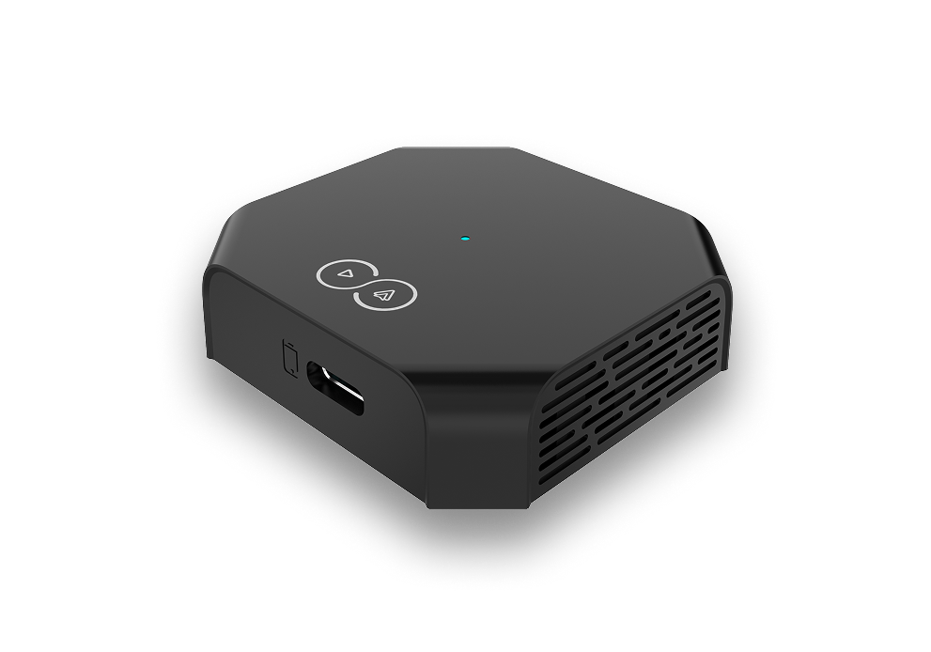
Version:1.0
Date:April 2026
Company:CCB

2. Important Notes ⚠️
⚠️ Please read before use
- Please carefully read the following important notes before using this product to ensure safe and proper operation.
⚠️ Usage security
- The operating voltage/current of the equipment isDC 5V/0.3A (MAX 5.2V/1A). It is strictly prohibited to connect to power sources beyond the rated range; otherwise, the core components will be damaged.
- It is strictly prohibited to disassemble the sealed casing without authorization.
- The product is designed for external use. It is not recommended to install it inside the vehicle body. Otherwise, there is a risk of electromagnetic compatibility issues and excessive temperature may leading to damage.
Key points:
- Read all safety warnings before installation
- Keep this manual for future reference
- Follow all local regulations and requirements
- Contact support if you have any questions

3. User Guide
Chapter Overview:

3.1 Connection Diagram
Box Connected to Car Unit
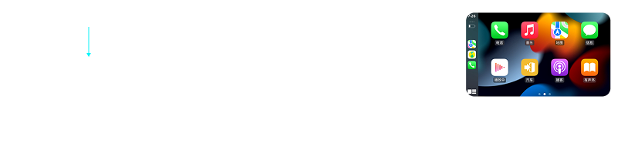
Phone Connected to Box


3.2 Data Cable Connection Instructions
- Insert the box into the car's USB port.
- Connect the box to the phone using a data cable, and you can now use the connectivity functions.

3.3 Wireless CarPlay/Android Auto Connection(optional)
- Insert the box into the car's USB port.
- Enter the application interface.
- Turn on WiFi and Bluetooth, find"CA_XXX"in the Bluetooth settings, tap to connect, and confirm to use CarPlay/Android Auto.
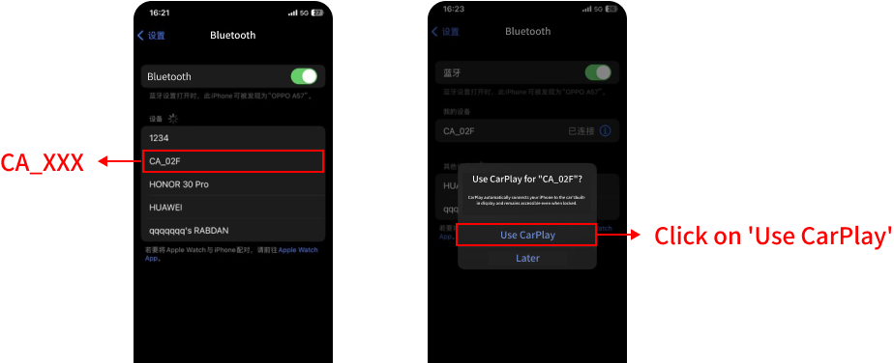

3.4 Video Connection Guide
If you still have questions, you can check the video tutorial below.
Your browser does not support the video tag.

4. Troubleshooting / FAQ
Chapter Overview:

4.1 Tip
If problems occur, you can first tryrestoring factory settings, which resolves most issues. If not resolved,check belowfor solutions to specific problems. If still unresolved, tryupgrading to the latest version.
Note:If you need to perform an upgrade, please refer to the following tutorials:1. Phone upgrade hardware tutorial:Download2. Debug page upgrade tutorial:Download

4.2 Connection Failures
⚠️ Interface shows "Please connect hardware first" (White Text)
- Data cable reversed: Ensure the cable is connected to the end with the car icon on the CCB.
- CCB not powered: Check if the data cable is plugged in correctly and if the CCB light is on green, and if screen frequently display the notification, please try replacing the data cable.
- CCB malfunction: Try replacing the CCB to verify.
⚠️ Interface shows "Please connect hardware first" (Red Text)
- Unplug and replug the CCB.
- Keep the CCB plugged in, click Settings (bottom right), scroll to the bottom and click "Restore Default Settings". Try multiple times.
- Restart the car head unit.
- CCB firmware is too old: Contact the dealer to upgrade the firmware.
CCB Bluetooth cannot connect
- Unplug and replug the CCB.
- On your phone, "Forget" the CCB's Bluetooth name.
- Reconnect the CCB Bluetooth.
iPhone shows "Accessory not supported" when connecting Bluetooth
- Try replacing the data cable.
- Restart the phone.
Note:If the above methods fail, please contact after-sales service.
Stuck on "Connecting" after Bluetooth connection
- Delete the CCB's Bluetooth and WiFi connections from phone and reconnect.
- For iPhone: Go to Phone Settings > General > CarPlay, delete the record, restart the phone, and reconnect.
- For Android phone: Go to Play Store > Android Auto > Delete it and re-install Android Auto app > Restart the phone.
Android phone can connect, but iPhone cannot connect
Check iPhone's side:
- Please check both of your Wi-Fi and Bluetooth remains open, and disconnect any devices that are already connected.
- Make sure your iPhone's personal hotspot is OFF.
- Please go to Settings > General > Carplay > My Car, make sure the device you recognized is ON.
- Change an iPhone to test.
Check CCB's side:
- Please re-plug the dongle, and try connection.
- Use your phone to forget dongle's bluetooth, and reconnect.
- Restart the vehicle.

4.3 Unexpected Disconnections
⚠️ Automatic disconnection in good signal areas
- Unplug and replug the CCB, then reconnect.
- Keep the CCB plugged in, click Settings (bottom right), scroll to bottom and click "Restore Default Settings", then try reconnecting.
- "Forget" the CCB Bluetooth from phone, turn off and on phone WiFi and Bluetooth, then reconnect.
- For iPhone: Go to Phone Settings > General > CarPlay, delete the record, restart the phone, and reconnect.
- For Android phone: Go to Play Store > Android Auto > Delete it and re-install Android Auto app > Restart the phone.
- Go to App Settings (bottom right) > Advanced Settings > Wireless Settings, change to a different WiFi frequency band.
Note:If the above methods fail, please contact after-sales service.
Disconnection on bumpy roads or when touching the CCB
- Check if the data cable is plugged in securely.
- Try replacing the data cable.
Note:If disconnections remain frequent, please contact after-sales service.
Disconnection in tunnels, mountains, or poor signal areas
- This is normal, reconnect after leaving the place.
- Refresh phone's cellular data.
Disconnection after making a phone call
- Unplug and replug the CCB and restart the phone.
- Keep the CCB plugged in, click Settings (bottom right), scroll to bottom and click "Restore Default Settings", then try reconnecting.
Note:If disconnections remain frequent, please contact after-sales service.

4.4 Installation Failure
⚠️ ADB Installation
- If the ADB address is not obtained, check with following lists:Computer should have Android Debug Bridge (ADB) environment, if not, please use installation package provided by importer.Vehicle's ADB mode should be ON.For company's computer with restrictions, please contact the IT department to unlock USB debugging mode.Change cable.
- If the ADB failed on installing software:Check CCB's software version, make sure using correct software package for vehicle.
Note:If unsolved, please contact after-sales service.
⚠️ Flash Drive Installation
- If flash drive installation failed:Check software's name, make sure the name iscom.bz.CA08.Adapter.apkCheck flash drive's type, only specific flash drive provided by importer can be used for installation, normal flash drive won't work.Update vehicle's IVI to the latest version.
Note:If unsolved, please contact after-sales service.

4.5 Screen Frozen
- Unplug and replug the CCB.
- Restart the phone.

4.6 Poor Quality of Sound
- Go to app's setting > Advanced settings > Change audio channel to bluetooth.
- Use phone to connect both vehicle's bluetooth and CCB's bluetooth.
Note:If unsolved, please contact after-sales service.

4.7 Music/Audio Problems
⚠️ Music/Audio unexpected stop
- Disconnect phone's bluetooth connection with vehicle.
- Go to App Settings (bottom right) > Advanced Settings > Wireless Settings, change to a higher WiFi frequency band.
Music/audio comes from phone not vehicle
- Switch channel to CarPlay/Android Auto from phone's Music/Audio settings.
- Disconnect phone's bluetooth connection with vehicle.
Music/audio delay
- Go to phone's website > Media delay > set to 500.
- Replug the CCB.
Music/audio notification doesn't pop up
- Go to phone's permission > change permission to 'Allow only while using the app'.
- Restart the phone.

4.8 GPS positioning is inaccurate
- Go to phone's Debug page > Settings > Turn off GPS.
- Restart the phone.

4.9 Problem Feedback
Download feedback template
For company's computer with restrictions, please contact the IT department to unlock USB debugging mode.
Download Problem Feedback
If the problem is not resolved, you can click the feedback button below or in the bottom right corner, and our engineers will contact you and coordinate the communication time.Business Hours: Monday to Friday UTC+8 9:00 AM - 5:30 PM
FEEDBACK

5. Installation & Settings
Chapter Overview:

5.1 Setup Operation Simulation
Application Settings
Automatic Startup
Auto-start function — choose whether the app starts automatically when the device powers on.
Device Connection
Display Settings
OEM icon
Default
Voice
OEM customization logo — no adjustment needed.
Language
Auto
Advanced Settings
Check update
OTA channel.
Software version
10.6.22
Tap the version number multiple times to enter Debug mode.
Password available from your distributor.
Non-professionals should not enter this mode.
Hardware Version
Please insert the CCB into the USB port of the car
Restore default settings
Device Connection
Automatic Connection
Choose whether the app automatically connects with phone after the vehicle starts.
Paired devices
Display Settings
Decoding Method
Hardware
Software
Hardware: uses hardware decoding, suitable for most vehicle models.
Software: uses software decoding — switch only if screen flickering or freezing occurs. May reduce smoothness.
Resolution
2560x1600
Higher resolution improves visual quality but increases hardware load and may affect stability.
Android Auto
720P
Adjusts the Android Auto display resolution — only change this if Android Auto displays abnormally.
Frame Rate
25FPS
30FPS
60FPS
Higher frame rate improves smoothness but increases hardware load and may affect stability. Default 30FPS is recommended.
Display Size
S
Adjusts the software display size — only change this if CarPlay/Android Auto displays abnormally.
Driving Position
Left
Right
Switch between left-hand and right-hand drive.
Render Mode
Default
Other
Default: H.265 code (compatible with most vehicles). Other: H.264 code.
Advanced Settings
Wireless Settings
Before configuring, consider local regulations. Incorrect settings can cause connection issues.
2.4GHz
5GHz
1. Default is 5GHz. If the local area does not support 5GHz, manually switch to 2.4GHz.
2. Default channel is 36. If call/music stutters, you can switch to a higher channel, but this may affect stability.
Key Learning
Steering wheel button learning function — generally no adjustment needed.
Quick ball
Floating ball feature — extends multi-function shortcut keys.
Audio Channel (Beta)
Default
Bluetooth
Audio channel switch. If call quality is poor, switch to 'Bluetooth'. The phone must connect to both the car Bluetooth and CCB Bluetooth simultaneously — audio will be routed to the car speaker.
Microphone Gain
0
Microphone gain function. If the microphone volume is too low, increase this value.
Key Learning(Beta)
Previous/Answer
Next/Hangup
Play/Pause
Voice Assistant
Home
Back
Play
Show/Hide
Pause
Previous
Up
Next
Left
Select
Right
Answer
Down
Hangup
Default
Debug
系统信息
ro.product.model
: HEY2-W09
ro.product.name
: HEY2-W09
ro.build.id
: HONORHEY2-W09
ro.board.platform
: parrot
ro.product.brand
: HONOR
ro.build.fingerprint
: HONOR/HEY2-W09/HNHEY2-Q:14...
ro.build.version.release(sdk)
: 14(34)
wh
2560x1600(2560x1600)
density
340(2.125,2.125)
Android Application
HiCar
Android Auto
Carlink
Mirror
Echo delay
300
Adjust this if there is significant echo during calls. Click the number to auto-adjust. Keep the car in absolute silence when using this feature.
启动延迟
16
Display Size
160 dpi
蓝牙通话
GL渲染
保存录音
Audio recording function. Enable this when audio issues occur and you need to upload logs.
保存视频
保存数据
应用版本
2025.10.23.57.1453V10.6.22
图像调节
缓存文件
应用详情
重置
音频调试
Upload logLog upload function. The car must be connected to the internet when using this feature.
share files
申请存储权限
SHARE
Select All
data
video
audio
音频调试
默认设置
低版本API
MIC录音
1 >
录音采样率
16000
48000
录音声道
单声道
立体声
声道索引
Notice
This will restore all settings, and restart the app?
Cancel
OK
Notice
Already up to date.
OK
Please input a password
CANCEL
OK
Language Settings
Auto
English
简体中文
繁體中文
日本語
العربية
Deutsch
Español
Français
Nederlands
Português
Русский
Türkçe
한국의
עברית
Italiano
ภาษาไทย
Indonesia
Melayu
Norsk
Cancel
OK
2560x1600
1920x1200
1408x880
480P
720P
1080P
Default
XS
S

5.2 App Operation Simulation
How to Access
- Connect your phone to the hardware's Wi-Fi (password:12345678)
- Open a browser and enter192.168.43.1to access the backend
- Video tutorial is provided below.
Your browser does not support the video tag.
The following is an interactive simulation of the mobile app interface. Use the bottom navigation to switch between different modules.
🔍
⋮
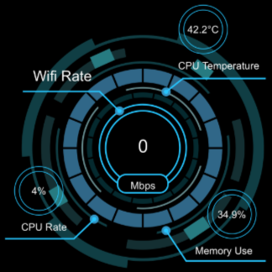
Bluetooth
CA_3E8
Wifi Name
CA_BBB8
Software Ver
2025.05.22.1356
Hardware Ver
AW3010
Initial Ver
20250225
UUID
69217d3c073971d72df51e21e2955785
iPhone
×
华年夜行的REDMI K80
×
iPhone
×
ZZZ
×
华为畅享 60 Pro
×
Food🍗流油
×
Car Brand
Car Model
Car Years
Submit

Check Update

Rollback
Feedback
Dongfeng
Shangyong
0
0/200
+
Cancel
Confirm
Please fill in the model information
OK
Please Fill In The Specified Version Number
Cancel
Confirm
Already The Latest Version
OK
No Fallback Version
OK
Sync Mode
Background
Auto Connect
Category
CD
DVD
CallQuality
Clear›
AutoPlay
MouseMode
Display Style
Auto›
Video Bit Rate
Mbps
Frame
FPS
Media Delay
MS
Start Delay
S
DPI
GPS
GPS
Device Language
›
Wi-Fi
5GHz / 44
Background Recording
Call Navigation
0›
Volume
Car Logo
🚗
›
From the Album
Restore Default
Modify Wi-Fi Name
›
Modify Device Name
›
Reset
›
Restore App factory settings
›
Cancel
Confirm
CallQuality
Norm
Clear
HD
Display Style
Auto
S
M
2.4GHz
5GHz
1
2
3
4
5
6
7
36
40
44
48
149
157
161
Please understand your local laws and regulations before setting this parameter.Please select the appropriate frequency band to use.Selecting will result in failure to establish a connection.
Cancel
Confirm
Call Navigation
0
Cancel
Confirm
Modify Wi-Fi Name
Bluetooth:
Wi-Fi Name:
Cancel
Confirm
Modify Device Name
Cancel
Confirm
Erase all data (factory reset)
Are you sure you want to erase all data?
Cancel
Confirm
Erase all data (factory reset)
Are you sure you want to erase all data?
Cancel
Confirm
This Operation is Not Supported
Confirm
Category
CD
DVD
Home
Home
Devices
Devices
Help
Help
Settings
Settings

6. Daily Maintenance & Care
Maintenance recommendations
- It is suggested to re-connect the hardware each week to refresh the hardware connection ports.
- The hardware and cables are not waterproof. Do not pour liquids directly into the hardware.
- The accessory wiring harness is a vulnerable component. It is recommended to replace one every three months to ensure stability, it is not suggested to use tape or glue to secure the CCB, it may influence the heat dissipation.

7. Software Updates
Chapter Overview:

7.1 Installation Guide
Note:The following installation download links only provide CCB software. For specific installation steps and tutorials, please consult your importer to obtain the download links.

Method 1: ADB Installation
- Enter theHead Unit Settingsinterface and enable theADB switch(method to access ADB settings depends on the car model).
- Open theplatform-toolsdirectory on your computer, typecmdin the address bar, and pressEnter.
- Connect the Head Unit and Computer using aUSB Male-to-Male Cable.
- Check if the Head Unit address is obtained:📋 Copyadb devices
- Execute the following commands sequentially:📋 Copyadb root📋 Copyadb remount
- Install the APK (ensure APK is in the correct path):📋 Copyadb install com.bz.CA08.Adapter.apk
- Launch the software main interface:📋 Copyadb shell am start -n com.bz.CA08.Adapter/cn.manstep.phonemirrorBox.MainActivity
- If you need to enable the software floating ball: ClickSettings(bottom right) →Advanced Settings→Quick ball.
- Enter the Head Unit Settings interface anddisable the ADB switch.
- Plug in the CCB to use.
Note:Due to local legal and regulatory confidentiality restrictions, installation manuals for certain vehicle models are available upon request from your importer.

Method 2: USB Drive Installation
- Insert the installation USB drive into your computer. Copy the installation file into the USB drive and rename it to:com.bz.CA08.Adapter.apk
- Insert the USB drive into the corresponding USB port on the Head Unit.
- Wait for installation to complete. The software icon will appear on the Head Unit desktop.
- Remove the USB drive, plug in the CCB, and it is ready to use.

⚠️ Flash Drive Installation Troubleshooting
If flash drive installation failed
- Check software's name, make sure the name iscom.bz.CA08.Adapter.apk
- Check flash drive's type, only specific flash drive provided by importer can be used for installation, normal flash drive won't work.
- Update vehicle's IVI to the latest version.
- If unsolved, please contact after-sales service.

7.2 Hardware Upgrade
Download the hardware upgrade package below:
Download
Note:This version is valid until August 21, 2025. Customers who purchased the hardware before this date are recommended to use this upgrade package.
If you are unsure how to perform the Hardware Upgrade, you can watch this video first:
Your browser does not support the video tag.

7.3 Software Update

7.3.1 Why Perform Software Upgrade
Because many problems stem from outdated software versions, the most common solution is: first restore factory settings, then update the software to the latest version, and the problem will be resolved.
Note:If your computer does not have an ADB installation environment, download the compressed package, extract the APK file together with the package,then open cmd in the root directory to proceed.Download (ADB Environment)

7.3.2 How to Perform Software Upgrade

Method 1: USB Drive Upgrade
- Restore factory settings.
- Insert the USB drive to install the APK. (Please download the APK from section 7.3.3. Do not rename the APK file.)
- If you are still unsure, you can refer to the video tutorial below.Your browser does not support the video tag.

Method 2: Computer Upgrade
- Restore factory settings.
- Connect the computer to the head unit and push the APK package via ADB. (Please refer to the corresponding tutorial for your vehicle model in section 7.3.3.)

7.3.3 Vehicle Details

Huge
Version Code | Market Name | CCB' Software | Installation Instruction | Minimum IVI Required | Notes
G59 | HUGE | Download | Download | Vehicle System Version:V3.2Software Version:DFTC_G59_MPU_S20332_20231009_OverSea_E2MCU Version:DFTC_G59_MCU_S19732_20230708
G59B | HUGE | Download | Download | Vehicle System Version:V4.0.00Software Version:10.0.0.20250328153145.rc9.f7500h.userMCU Version:G59BOLK202503281

Mage
Version Code | Market Name | CCB' Software | Installation Instruction | Minimum IVI Required | Notes
M57-4G | MAGE | Download | Download | Vehicle System Version:V2.1Software Version:DFTC_M57_MPU_S10631_20250718_4g_overseaMCU Version:DFTC_M57_MCU_O10631_20250718
M57-5G | MAGE | Download | Download | Vehicle System Version:V2.2Software Version:DFTC_M57_MPU_S10831_20250814MCU Version:DFTC_M57_MCU_O10531_20250508
P57 | MAGE PHEV | Download | Download | Vehicle System Version:V3.0.03Software Version:1.130.29.98-20251126202105MCU Version:02.07.00

Shine
Version Code | Market Name | CCB' Software | Installation Instruction | Minimum IVI Required | Notes
C652023 version | SHINE | Download | Download | Vehicle System Version:V2.0Software Version:1.0.0.20230818062907.rc1.f0511h.userMCU Version:C65OB8M202308151
C652024 version | SHINE | Download | Download | Vehicle System Version:V2.0Software Version:1.0.0.20240923092822.rc1.f0511h.userMCU Version:C65OB8M202407091
S012024version | MAGE EV | Download | Download | Vehicle System Version:V2.0Software Version:2.0.0.20240923063142.rc9.fo513h.userMCU Version:S31OZB8M202409181

Nammi
Version Code | Market Name | CCB' Software | Installation Instruction | Minimum IVI Required | Notes
S31European Version | DONGFENG BOX | Download | Download | Vehicle System Version:V1.0Software Version:2.0.0.20241205030127.rc4.f0512h.userMCU Version:S31OB8M202412041
S31Non-European Version | DONGFENG BOX | Download | Download | Vehicle System Version:V1.0Software Version:2.0.0.20240822135955.rc4.f0512h.userMCU Version:S31OU8M202408221
S31China Version | DONGFENG BOX | Download | Download
S31OOverseas | DONGFENG BOX | Download | Download | Vehicle System Version:V1.0Software Version:DFRD_S31O_MPU_V02411_20250912MCU Version:DFRD_S31O_MCU_V02411_20250912
S32OOverseas | VIGO | Download | Download | Vehicle System Version:11Software Version:DFRD_S32O_MPU_V011_20251015MCU Version:DFRD_S32O_MCU_V02111_251015DT

Voyah Free
Version Code | Market Name | CCB' Software | Installation Instruction | Minimum IVI Required | Notes
H97X | VOYAH FREE | Download | Download | Vehicle System Version:V1.0Software Version:AE.01.20241202101256.rc5.1.user.f6811MCU Version:H97XP8M202411251
H97Y | VOYAH FREE | Download | Download | Vehicle System Version:V1.0Software Version:AE.01.20240918125630.rc5.1.user.f6805hMCU Version:H97YP8M202408301
H97Z | VOYAH FREE | Download | Download | Software Version:EE.00.20240412194823.rc.19.1.user.f6801f

Voyah Dreamer
Version Code | Market Name | CCB' Software | Installation Instruction | Minimum IVI Required | Notes
H56X | VOYAH DREAM | Download | Download | Vehicle System Version:V1.0Software Version:AE.01.20241202101256.rc5.1.user.f6811MCU Version:H56XP8M202411251
H56Y | VOYAH DREAM | Download | Download | Vehicle System Version:V1.0Software Version:AB.01.2024.0311192009.rc2.1.user.f6806MCU Version:H56YP8M202403111
H56Z | VOYAH DREAM | Download | Download | Vehicle System Version:V1.0Software Version:BF.01.20241021093949.rc6.1.user.f6809MCU Version:H56ZP8M202410141

eπ
Version Code | Market Name | CCB' Software | Installation Instruction | Minimum IVI Required | Notes
007 | DONGFENG 007 | Download | Download | Vehicle System Version:V3.0.00Software Version:1.130.100.273-20260204012918MCU Version:02.09.00

M-Hero
Version Code | Market Name | CCB' Software | Installation Instruction | Minimum IVI Required | Notes
817 | MHERO Ⅱ | Download | Download | Software Version:M18-3_EX_rc11.0.0_20251221060001MCU Version:M18-3_PB202512191

Dongfeng Liuzhou Motor
Version Code | Market Name | CCB' Software | Installation Instruction | Minimum IVI Required | Notes
T5 EVO | T5 EVO | Download | Download
Note:Version Code can be found on MCU version or IVI Software version. If not clear, please refer your importer for instruction.

8. Disclaimer & Legal Terms
ℹ️ Legal Notice:
Please read the following terms carefully before using this product. Using this product indicates that you have read, understood, and agree to be bound by all terms below.
1. Data Loss Disclaimer
1.1 The company is not responsible for data recovery or any losses resulting from data loss, damage, or inability to recover due to product repair, upgrade, reset, or failure.
1.2 Users should regularly backup important data. Risks of data loss due to failure to backup are borne by the user.
1.3 It is recommended to backup data before sending for repair, or choose the company's data protection service (if available).
2. Indirect Loss Disclaimer
2.1 Indirect losses such as business interruption, profit loss, or reputation damage caused by product failure, downtime, repair, or upgrade are not within the company's compensation scope.
2.2 The company's maximum liability shall not exceed the product purchase price or repair cost.
2.3 For critical business scenarios, users are advised to configure redundant systems or backup solutions to reduce risks.
3. Product Usage Risks
4.1 Users should use the product correctly according to this manual. Damage caused by improper operation, misuse, or abuse is not covered under warranty.
4.2 Unauthorized modification, disassembly, or repair may cause product damage or safety hazards. Consequences are borne by the user.
4.3 This product is not suitable for critical scenarios involving personal safety. Please contact the company separately for such use cases.
4. Policy Change Rights
4.1 The company reserves the final right to interpret and modify after-sales service policies, warranty terms, fee standards, etc.
4.2 Policy changes will be notified to users through official website, email, or other methods. Changed policies take effect from the date of publication.
4.3 If users disagree with the changed policies, they may stop using the product or service. Continued use indicates acceptance of changes.
5. Intellectual Property
5.1 All trademarks, patents, copyrights, trade secrets, and other intellectual property rights involved in this manual and product belong to the company.
5.2 Without written permission, users may not copy, distribute, or modify the content of this manual.
5.3 The content of this manual is for reference only. Please refer to the latest version for updates.
6. Third-Party Links Disclaimer
6.1 This manual may contain links to third-party websites or services. The company is not responsible for the accuracy, legality, or security of third-party content.
6.2 Users access third-party links at their own risk. It is recommended to read third-party privacy policies and terms of use.
7. Force Majeure
7.1 The company is not responsible for service interruption or data loss caused by force majeure factors such as natural disasters, war, strikes, government actions, cyber attacks, or power outages.
7.2 After a force majeure event, the company will make every effort to reduce losses and restore services promptly.
8. Applicable Law & Jurisdiction
8.1 This disclaimer and related legal terms are governed by the laws ofChina.
8.2 Any disputes arising from this product or service shall be resolved through friendly negotiation. If negotiation fails, submit to the competent people's court inWuhanfor litigation.
8.3 If any provision of this disclaimer is deemed invalid or unenforceable, it does not affect the validity of other provisions.
⚠️ Important Notice
This template is for reference only. Before formal use, please have it reviewed by the company's legal department and adjust according to local laws and company circumstances.

9. Appendix
Chapter Overview:
Supported Phones And Car Models
- CarPlay:Support iPhone 6 and above, iOS 10 and above system
- Android Auto:Support Android 10.0 and above, some require Android 11.0 and above
- Compatible Car:Android 4.2 and above system versions
Product specifications (CA-08)
Specification | Details
Input | DC 5V±0.2V 0.5A
Output | DC 5V±0.2V 1.0A
Power | 0.75W
WiFi Frequency | 5150-5250MHz, 5725-5850MHz / 2412-2472MHz
Upgrade Method | OTA Online Upgrade
Product Size | 50 x 46.6 x 13.6 mm
Package Size | 115 x 80 x 34 mm
Net Weight | 0.033 kg
Gross Weight | 0.106 kg
Interface | USB Female Port, USB Male Port
Material | ABS + PC
System architecture
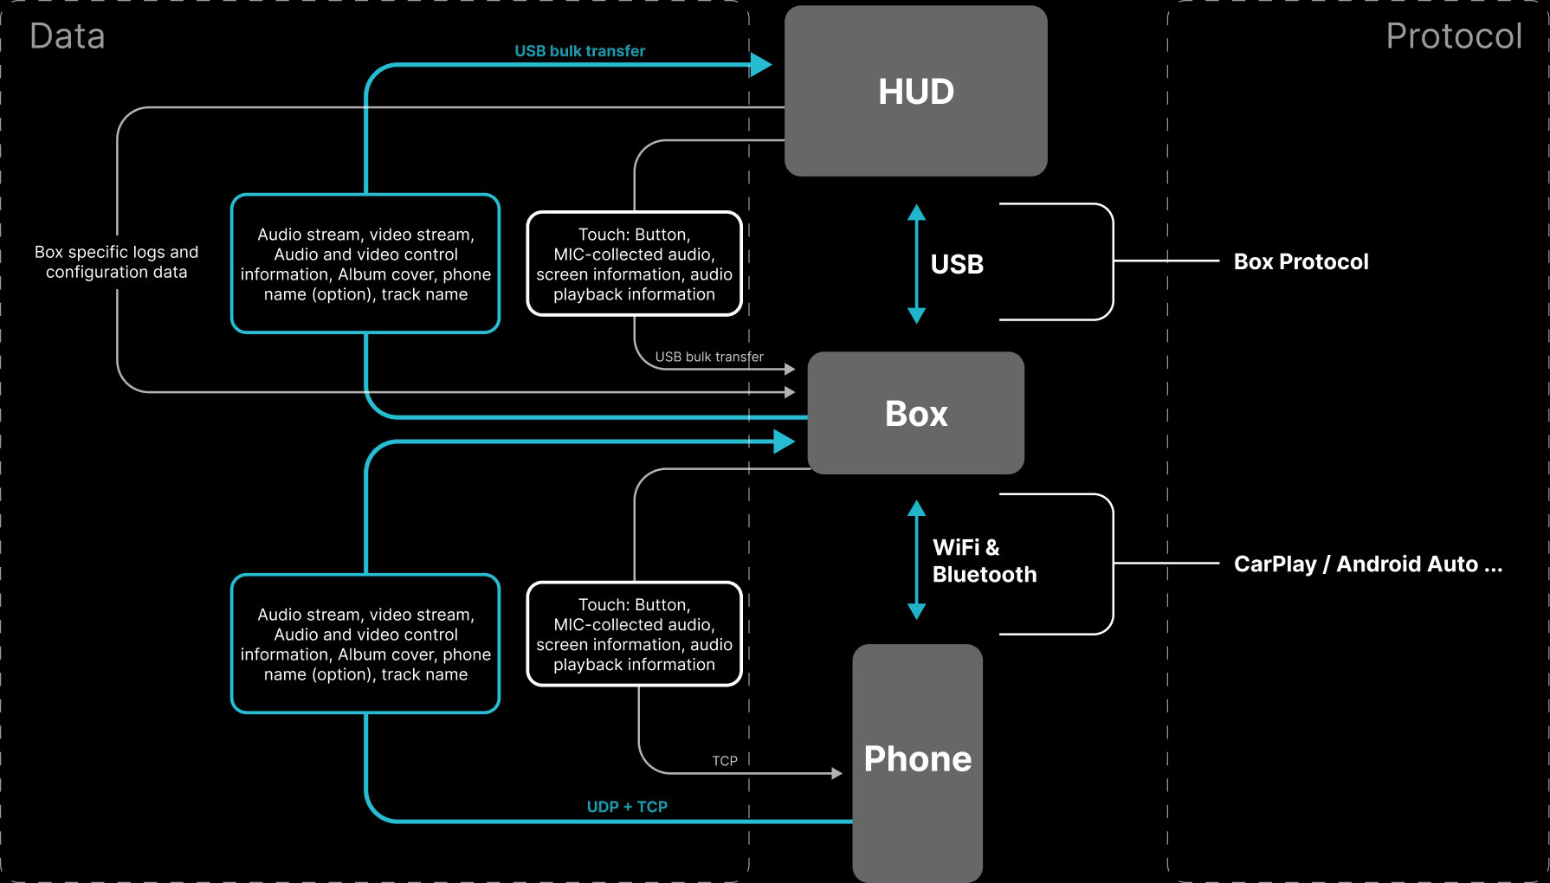
Product function overview
The following table lists all available functions and operations of the product.
No. | Category | Function | Description
1-4 | Basic Functions | Software Installation/Uninstallation | ADB Installation, USB Installation
Wake Up CCB | Head Unit Main Interface, Floating Ball
First Phone Connection | -
Auto Phone Connection | -
5 | Multimedia | Music Control | Previous Track, Next Track, Play, Pause, Favorite
6-7 | Phone | Phone Call | Answer, Hang Up
Phone Operation_Call | -
8-10 | Steering Wheel Control | Multimedia | Previous Track, Next Track, Play, Pause
Call | Answer, Hang Up
Voice | -
11-15 | Voice Control | Wake Up | Main Interface
Music | -
Navigation | -
Phone | -
App Switch | -
16-17 | Map | Map Navigation | -
Phone Operation_Map Navigation | -
18-21 | Others | Other Applications | Information Broadcast, Settings, Mini Games, etc.
Floating Ball | Drag Floating Ball, Floating Ball Main Interface Button, Disconnect Button
Floating Ball_Music | Previous Track, Next Track, Play, Pause
Exit to Main Interface | -
Note:Functions may vary depending on the vehicle model. Please consult your importer for details.

