TASK 1 FINAL REPORT
Modular Battery Management Engine Design

Platform: ESP32 + Wokwi
Architecture: Scalable array-based BMS analysis
Student: Noorbasha Sameera
Date: 05 October 2026
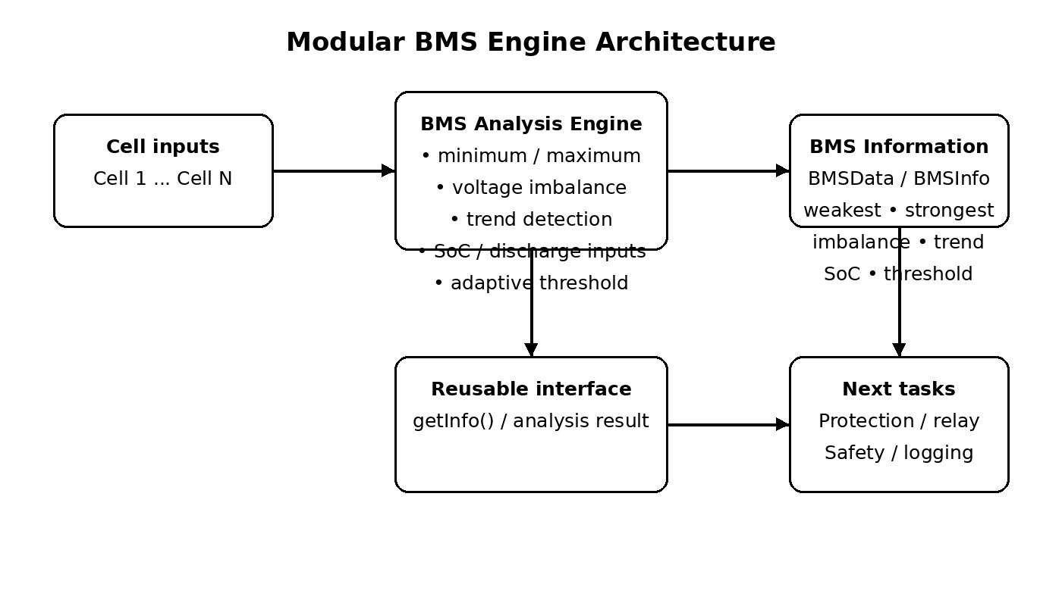
Figure 1. Modular BMS architecture and reusable analysis interface.

1. Introduction
This project implements a modular Battery Management System (BMS) analysis engine for an array of battery cells. The design uses a single compile-time constant, NUM_CELLS, to control the number of cells processed by the same algorithm. For the Wokwi demonstration, four simulated cell voltages are provided using potentiometers connected to ESP32 ADC inputs. Additional potentiometers represent State of Charge (SoC) and discharge rate.
The engine continuously determines the weakest and strongest cells, calculates the voltage imbalance, compares the current imbalance with the previous sample to determine its trend, and calculates an adaptive imbalance threshold from SoC and discharge rate. The result is stored in a common BMS data structure so later protection and safety tasks can reuse the same analysis.

2. Objectives
- Operate on an array of battery cells.
- Change the number of cells through one compile-time constant.
- Identify the weakest and strongest cells continuously.
- Calculate voltage imbalance as strongest voltage minus weakest voltage.
- Track whether imbalance is increasing, decreasing, or stable.
- Use an adaptive threshold based on SoC and discharge rate rather than one fixed limit.
- Expose battery information through a reusable data interface.
- Explain scaling from 4 to 16 cells in memory, execution time, and data structures.

3. System Architecture
The analysis engine is deliberately separated from the user interface. Cell measurements enter the analysis module; the module produces a single battery-information structure. OLED, Serial Monitor, protection logic, logging, and future tasks can consume this structure without duplicating cell-analysis calculations.

4. Wokwi Hardware / Simulation Design
Input | Purpose | ESP32 pin
POT 1 | Cell 1 simulated voltage | GPIO 32
POT 2 | Cell 2 simulated voltage | GPIO 33
POT 3 | Cell 3 simulated voltage | GPIO 34
POT 4 | Cell 4 simulated voltage | GPIO 35
POT 5 | State of Charge | GPIO 36
POT 6 | Discharge rate | GPIO 39
Each potentiometer is powered from the ESP32 3.3 V rail and ground, with its wiper connected to the corresponding ADC input. The simulation maps ADC readings to a demonstration cell-voltage range of approximately 3.0–4.2 V.
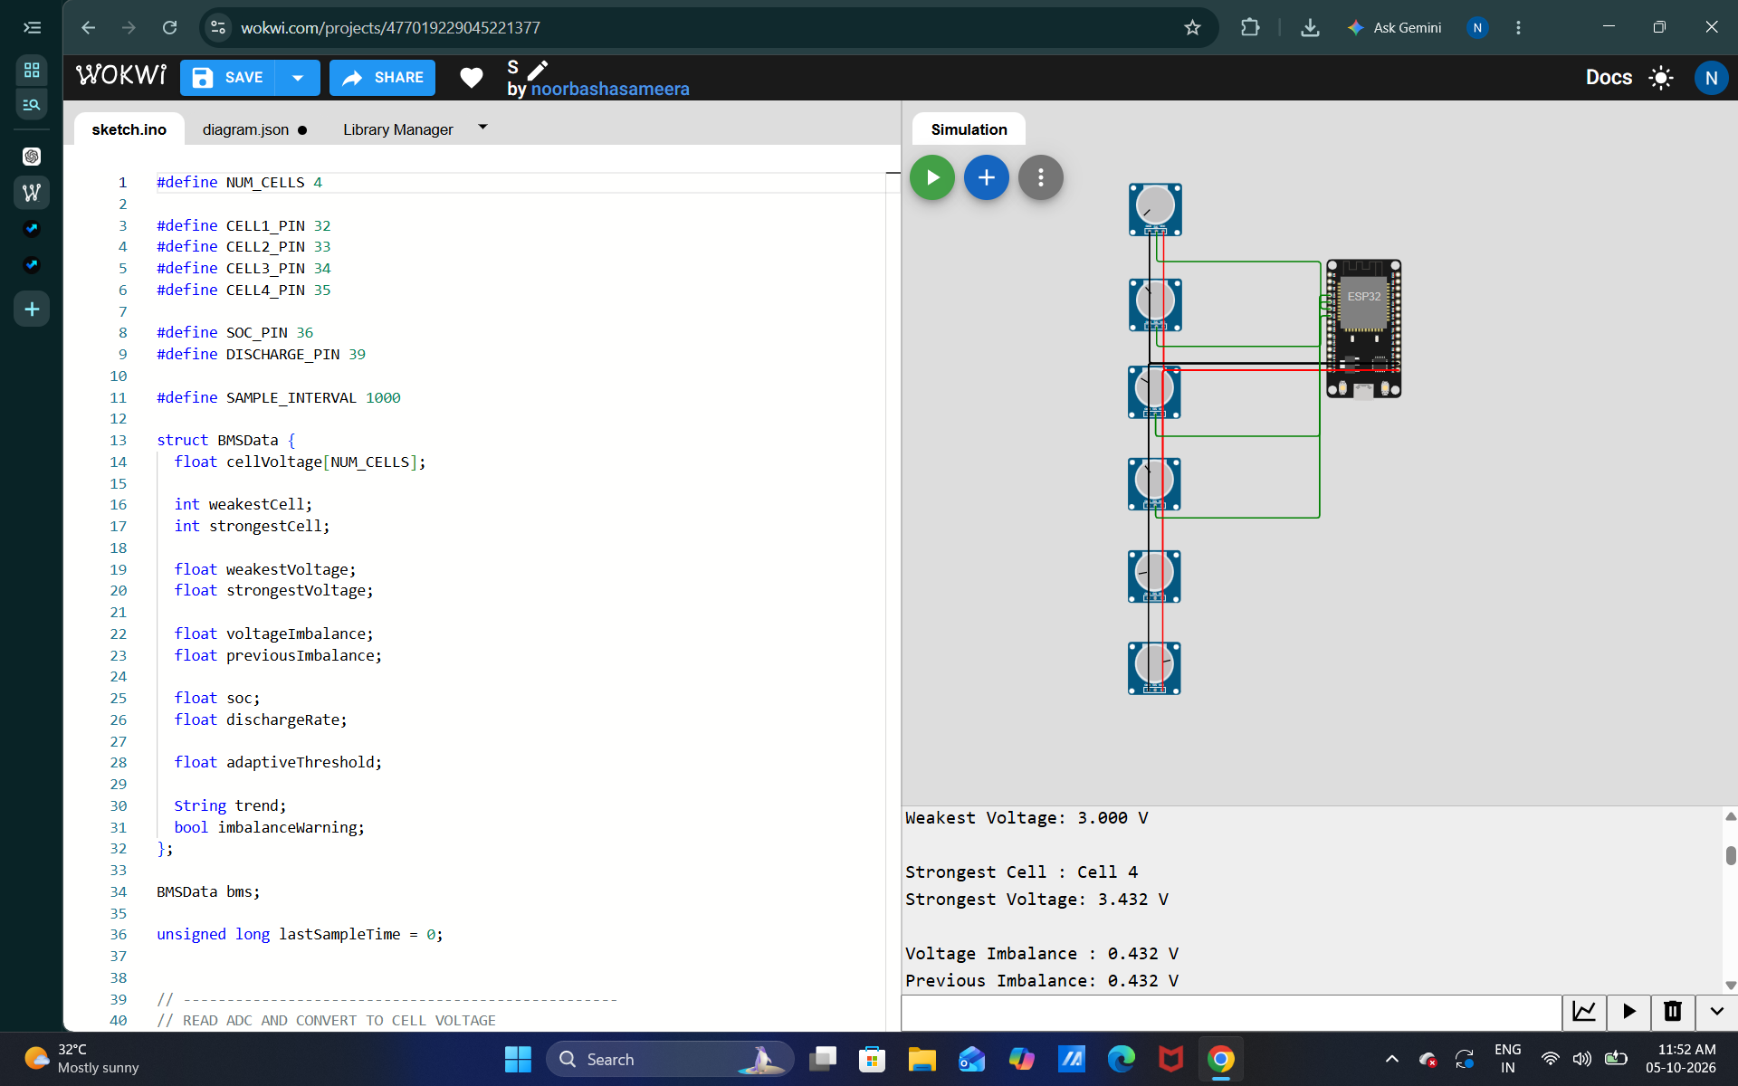
Figure. Weakest/strongest cell and voltage-imbalance test.
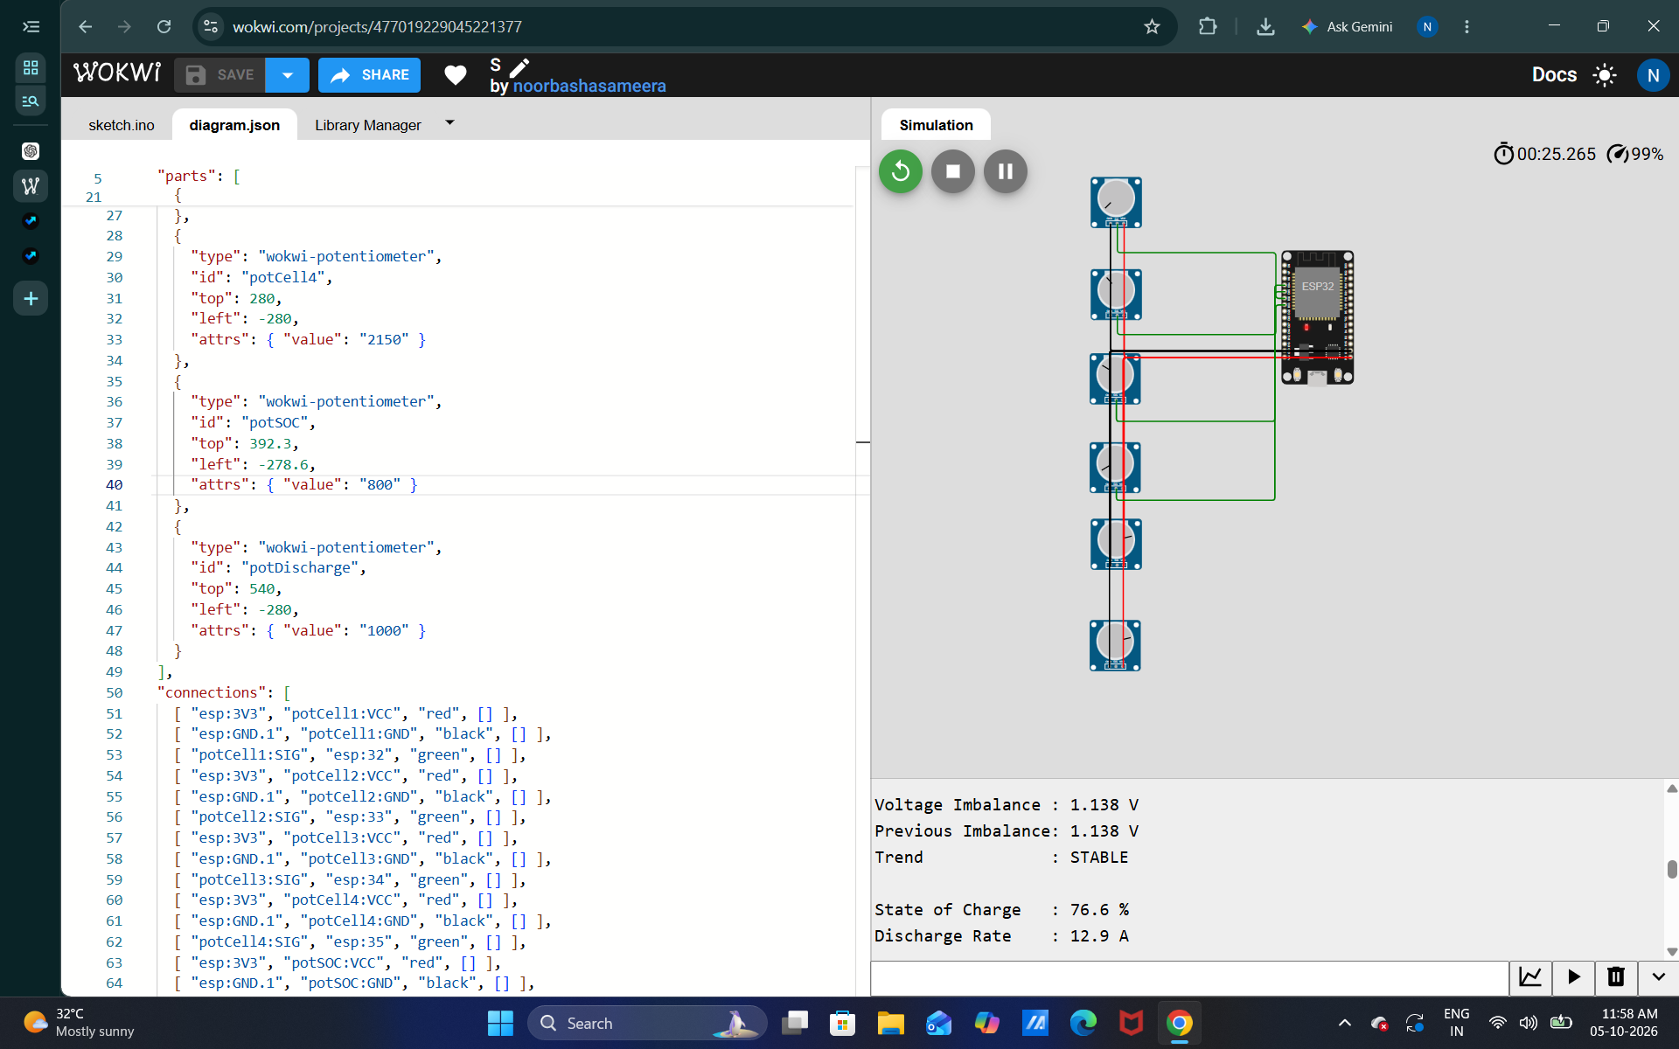
Figure. Wokwi circuit and six-potentiometer wiring in diagram.json.
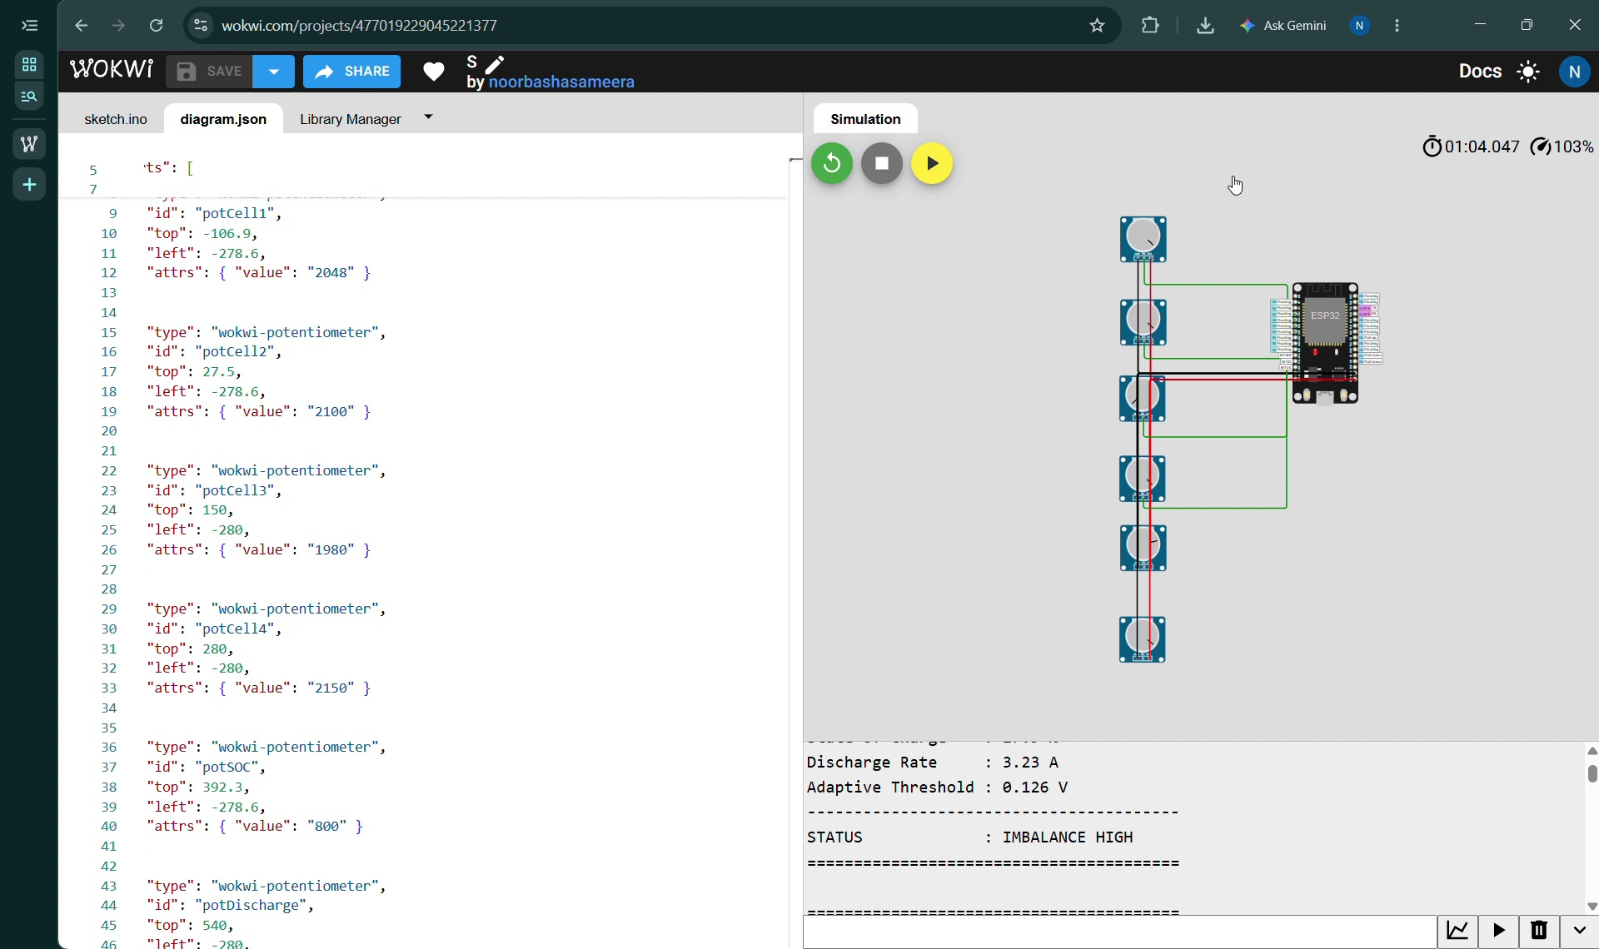
Figure. Adaptive-threshold and imbalance-high output evidence.

5. Software Design
The main compile-time scalability mechanism is:
#define NUM_CELLS 4
float cellVoltage[NUM_CELLS];
All cell-processing loops use NUM_CELLS. Therefore, changing NUM_CELLS from 4 to 8, 12, or 16 changes the array size and the number of iterations without rewriting the minimum/maximum analysis algorithm.

5.1 Core data structure
The BMSData structure stores cell voltages, weakest/strongest indices and voltages, current and previous imbalance, SoC, discharge rate, adaptive threshold, trend, and warning state. This gives subsequent tasks a single source of analyzed battery information.
struct BMSData {
float cellVoltage[NUM_CELLS];
int weakestCell;
int strongestCell;
float weakestVoltage;
float strongestVoltage;
float voltageImbalance;
float previousImbalance;
float soc;
float dischargeRate;
float adaptiveThreshold;
String trend;
bool imbalanceWarning;
};

5.2 Weakest/strongest cell algorithm
The engine scans the cell array once. It keeps the index of the minimum voltage and the index of the maximum voltage. The voltage imbalance is then calculated as:
Voltage imbalance = strongest-cell voltage − weakest-cell voltage

5.3 Trend detection
The previous imbalance is stored before calculating the new imbalance. The difference between the two samples determines the trend. A positive change above the configured small deadband is reported as INCREASING, a negative change below the deadband as DECREASING, and a small change as STABLE. The deadband prevents insignificant ADC fluctuations from being treated as a real trend.

5.4 Adaptive threshold
Instead of comparing imbalance against one fixed value, the demonstration calculates a threshold from SoC and discharge rate. The example implementation uses SoC bands and adds a small discharge-rate-dependent term. These values are simulation parameters, not universal lithium-ion safety limits; a production BMS must use limits validated for the specific cell chemistry and pack design.

6. Test Results
Test | Action | Expected result | Evidence/status
Balanced cells | Set all four cell pots near the same voltage | Small imbalance; STABLE; BALANCED | Implemented
Weak cell | Lower Cell 3 | Weakest Cell = Cell 3 | Demonstrated
Strong cell | Raise one cell above others | That cell is reported as strongest | Demonstrated
Increasing trend | Gradually lower a cell | Trend = INCREASING | Run and capture final screenshot
Decreasing trend | Raise the weak cell toward the others | Trend = DECREASING | Run and capture final screenshot
Adaptive threshold | Change SoC/discharge rate | Adaptive threshold changes | Run and capture final screenshot
Observed Wokwi evidence includes a case where Cell 3 is identified as the weakest cell, Cell 1 as the strongest cell, and the imbalance is 1.200 V from 4.200 V − 3.000 V. The same run reports an adaptive threshold and an IMBALANCE HIGH status. For a polished submission, additional screenshots should show the increasing/decreasing trend and the threshold changing when SoC or discharge rate is adjusted.

7. Scalability: 4 to 16 Cells
Cells | Voltage-array memory | Minimum/maximum comparisons | Algorithmic complexity | Architecture change
4 | 16 bytes (float array) | 3 | O(N) | None
8 | 32 bytes (float array) | 7 | O(N) | None
12 | 48 bytes (float array) | 11 | O(N) | None
16 | 64 bytes (float array) | 15 | O(N) | None
Assuming a 4-byte float, the cell-voltage array itself grows from 16 bytes for four cells to 64 bytes for sixteen cells. The BMSData fields other than the voltage array are effectively constant-size. The analysis loop is O(N), so execution work grows approximately linearly with the number of cells. The design avoids sorting because only the minimum and maximum are required.
At 16 cells, the scan requires 15 comparisons after initialization. This is still lightweight for an ESP32. Exact microsecond execution times depend on compiler optimization, ADC access, serial printing, and the sampling configuration; therefore this report uses algorithmic scaling rather than claiming an unmeasured timing number.

8. Reusability and Interface
The analysis result should be treated as the public interface of the module. A subsequent task can consume the already-computed values instead of implementing minimum/maximum searches again. A clean final architecture can expose a method such as:
BMSInfo info = bms.getInfo();
The next protection/relay task can then use info.weakestCell, info.strongestCell, info.voltageImbalance, info.adaptiveThreshold, and info.trend without duplicating the analysis logic.

9. Limitations and Engineering Notes
- Wokwi potentiometers are simulation inputs, not real battery-cell measurement hardware.
- Real packs require appropriate ADC scaling, isolation/measurement topology, protection, calibration, and cell-specific safety limits.
- The adaptive-threshold coefficients used here are demonstration parameters and must be validated before real hardware use.
- Serial printing is useful for demonstration but should be separated from the analysis engine in a production implementation.

10. Conclusion
The Task 1 design demonstrates a scalable, array-based BMS analysis engine. The same minimum/maximum and imbalance logic works for different cell counts through the NUM_CELLS compile-time constant. The engine identifies the weakest and strongest cells, calculates imbalance, tracks its direction over time, and uses SoC/discharge information to derive an adaptive threshold. The data structure provides a reusable boundary between battery analysis and future protection functions. The 4-to-16-cell analysis shows linear memory and execution growth, making the approach appropriate for an ESP32-class embedded controller.

Appendix A — Submission Evidence Checklist
- Wokwi circuit with 4 cell inputs + SoC + discharge input.
- Balanced-cell Serial Monitor screenshot.
- Weakest/strongest cell and imbalance screenshot.
- Increasing trend screenshot.
- Decreasing trend screenshot.
- Adaptive threshold screenshot showing change with SoC/discharge rate.
- Final sketch.ino and diagram.json.
- Report with 4-to-16 cell memory/execution/data-structure analysis.

