XTREAM UTD

Product Orbit
Editable Product-Catalogue UI/UX Design System
3D product discovery · responsive catalogue · product details · Messenger-first ordering
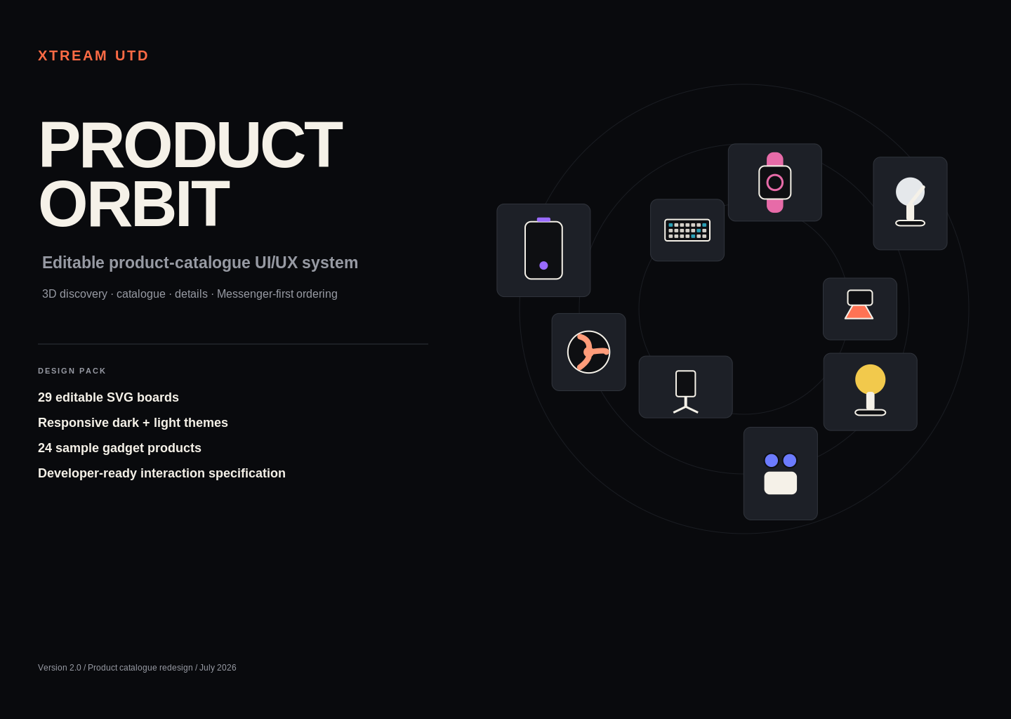
Design-only handoff. No production code is included.

1. Product direction
Xtream UTD is presented as a gadget and accessories business rather than a creative-agency portfolio. The experience combines an immersive 3D discovery homepage with a practical product catalogue, dedicated product-detail pages and editable order channels.

Primary customer goals
- Discover useful and trendy products.
- Understand price, discount and stock status immediately.
- Browse by category, search or filters.
- Open a dedicated product page from either the 3D world or catalogue card.
- Place an inquiry through Messenger, WhatsApp, phone or a configurable form.

Brand experience
Attribute | Design implication
Premium | Strong typography, restrained colour and spacious composition
Trendy | Product photography and subtle spatial motion create energy
Trustworthy | Clear prices, stock, delivery and support information
Usable | Grid fallback, search and predictable product routes
Mobile-first commerce | Large actions, bottom sheets and simple order flow

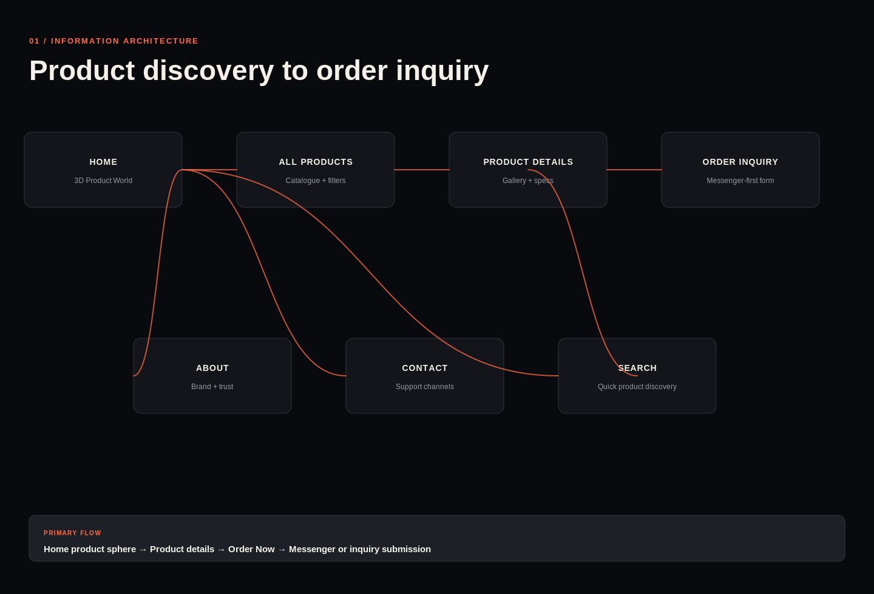
Sitemap and primary customer flow

2. Visual system and components
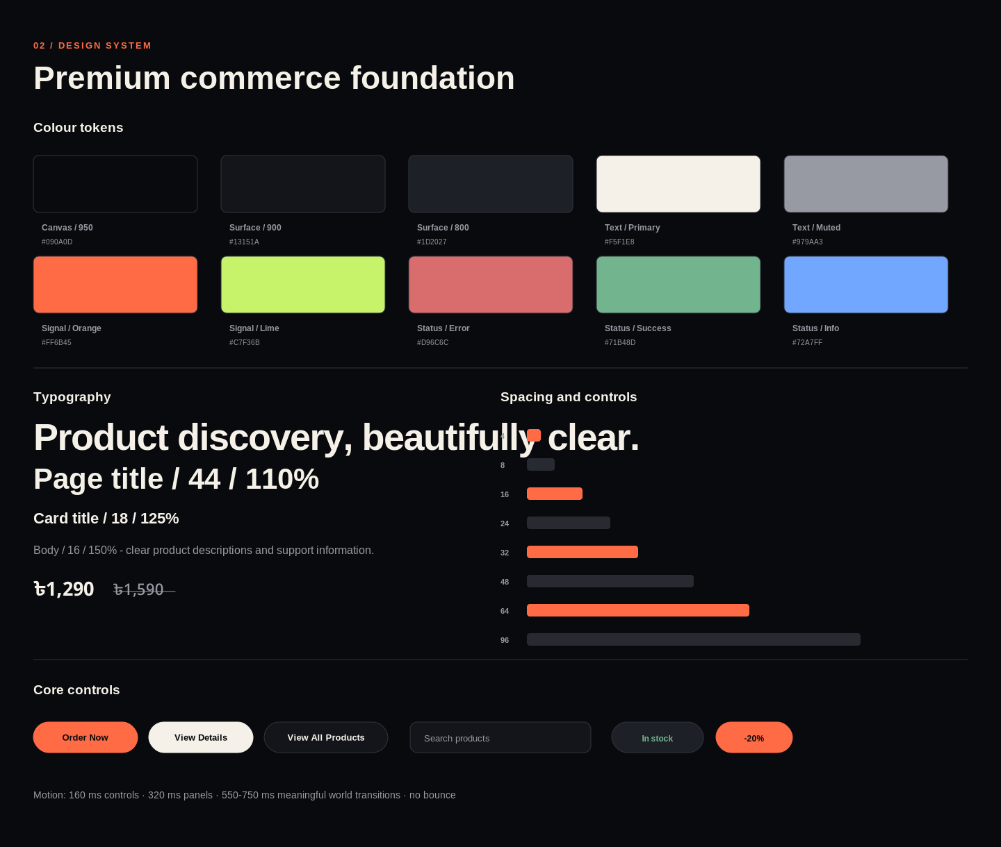
Dark-first product design tokens
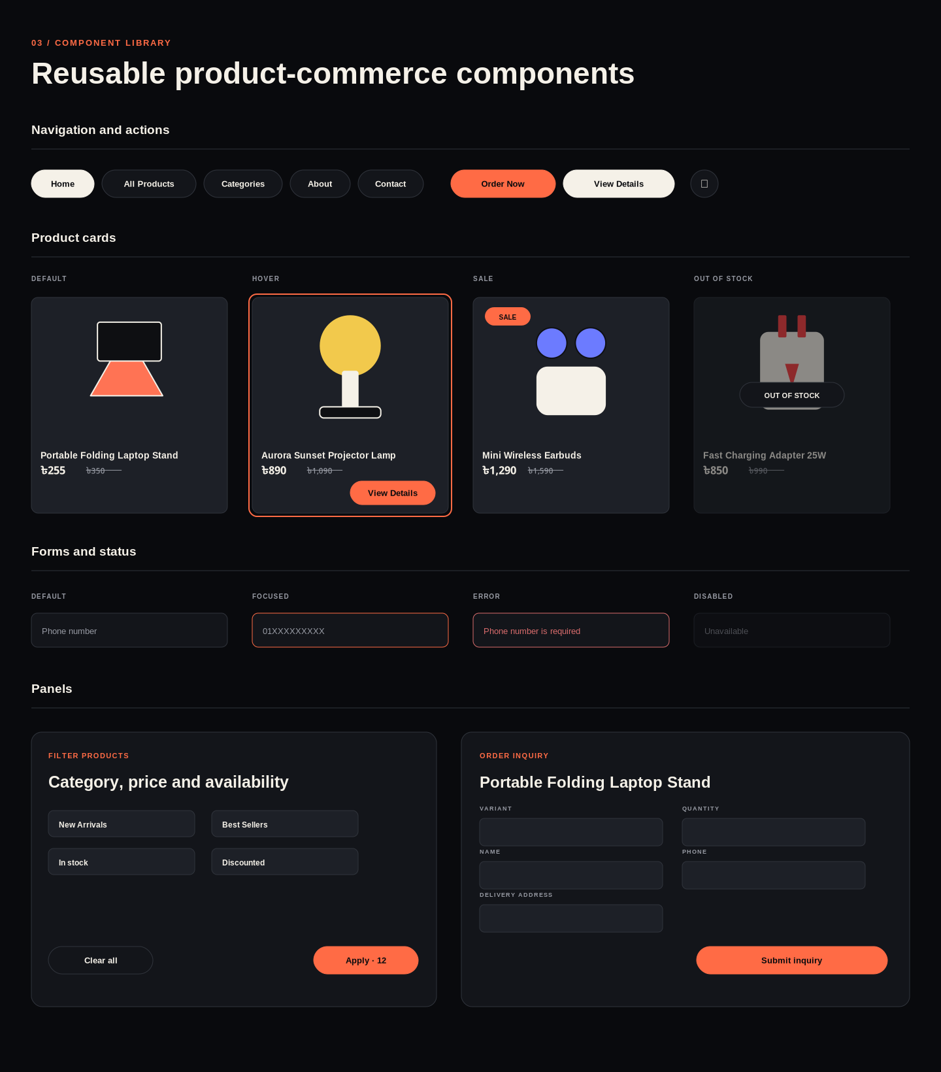
Editable navigation, cards, forms and panel states

Core tokens
Token | Value | Use
Canvas / 950 | #090A0D | Primary dark background
Surface / 900 | #13151A | Panels and cards
Surface / 800 | #1D2027 | Fields and art surfaces
Text / Primary | #F5F1E8 | Headings and important product data
Text / Muted | #979AA3 | Secondary copy
Signal / Orange | #FF6B45 | Selection, primary commerce actions
Signal / Lime | #C7F36B | Optional accent
Success | #71B48D | In-stock and confirmation states

3. Homepage: interactive product world
The homepage remains an immersive full-viewport experience. Actual product images replace project artwork. The header and bottom navigation remain fixed while products rotate and zoom in the world.
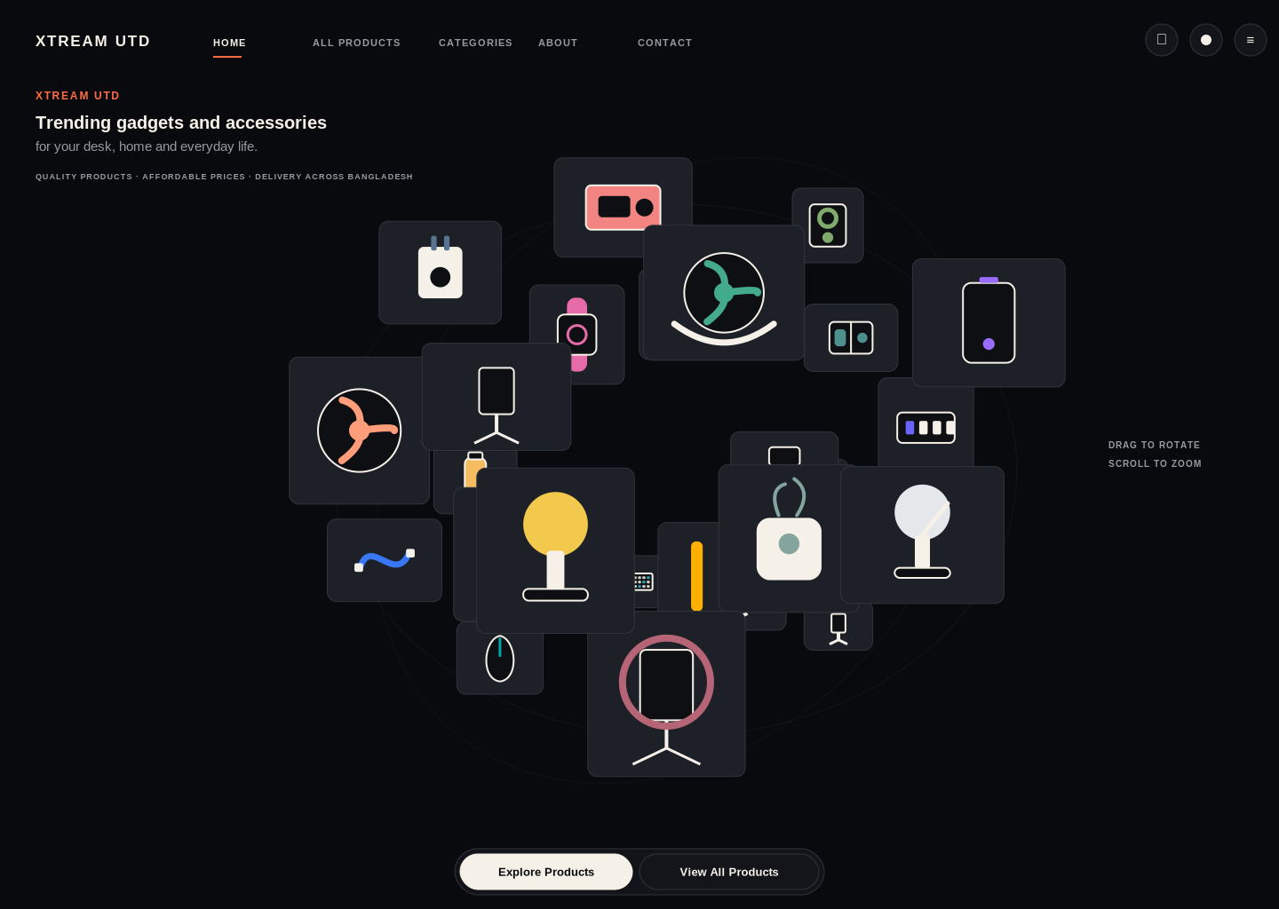
Default World view
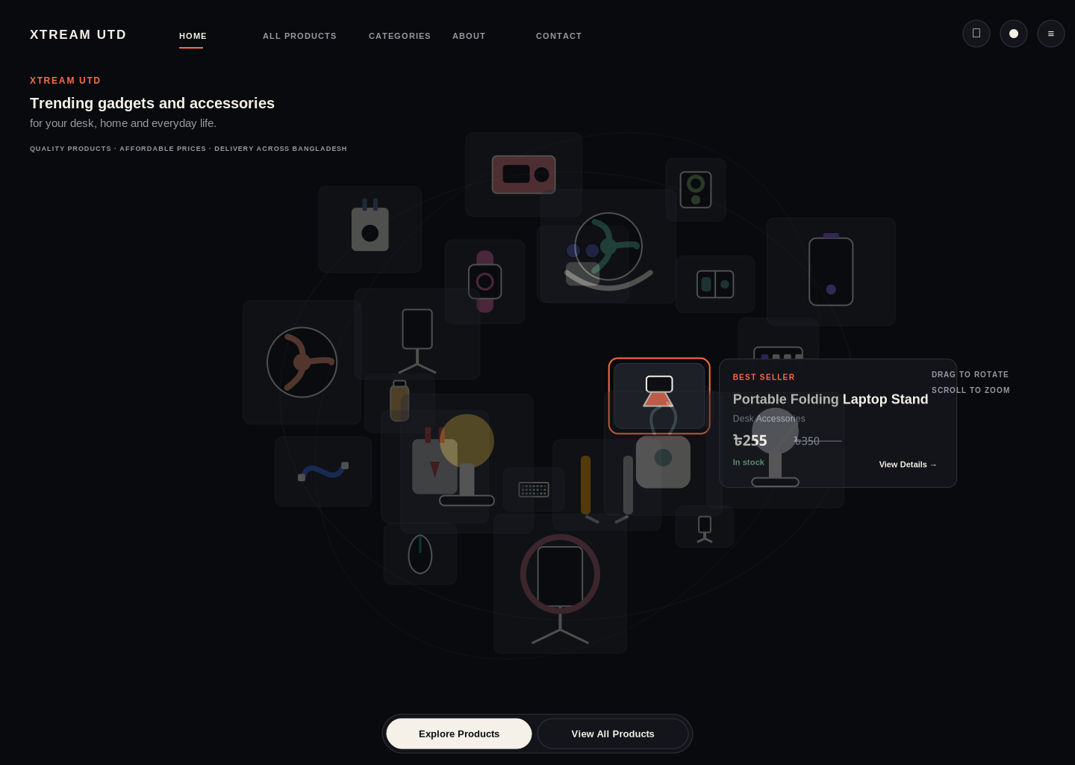
Hover preview with title, category, price, stock and View Details
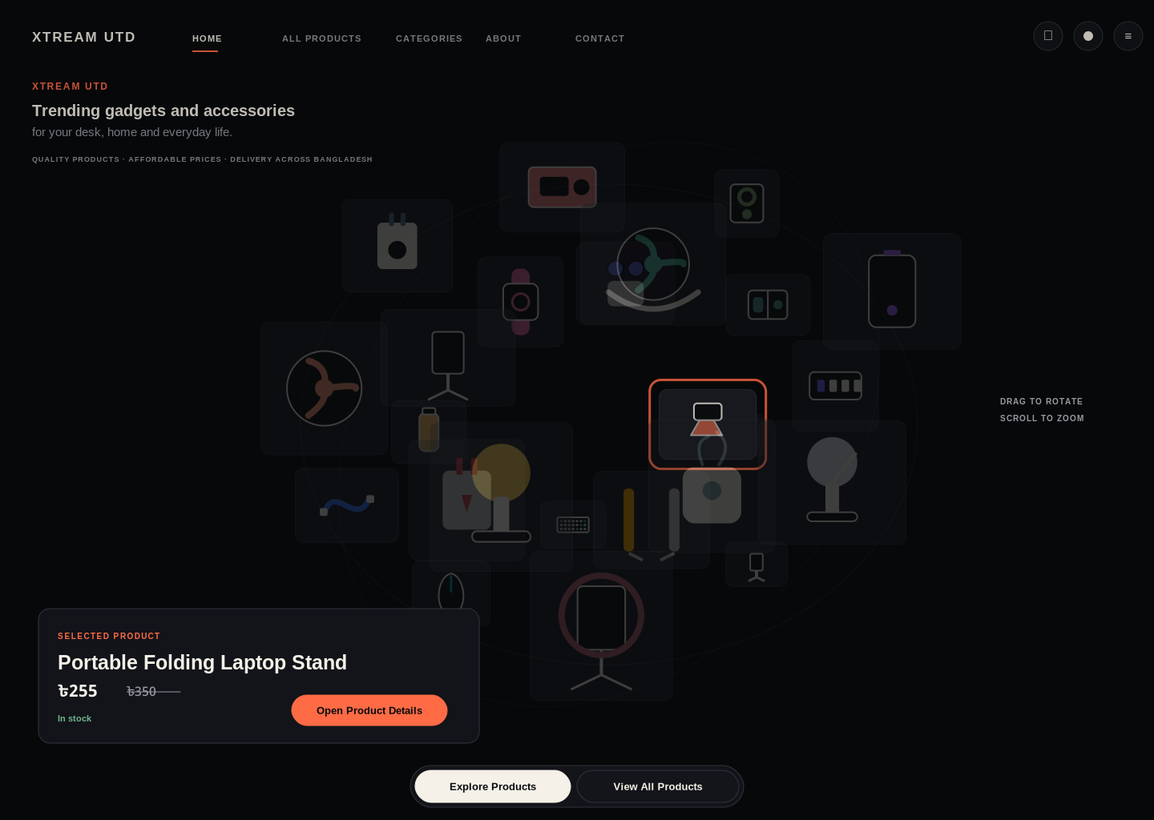
Selected product before route transition

4. World states and fallback
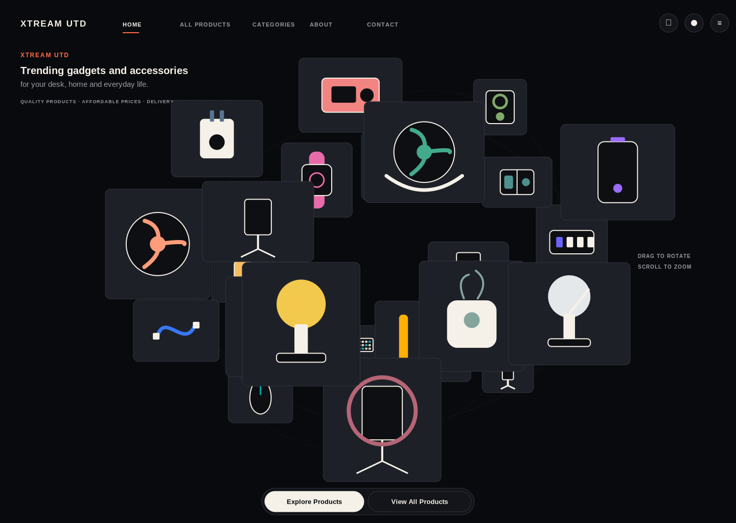
Zoomed state with controlled overlap
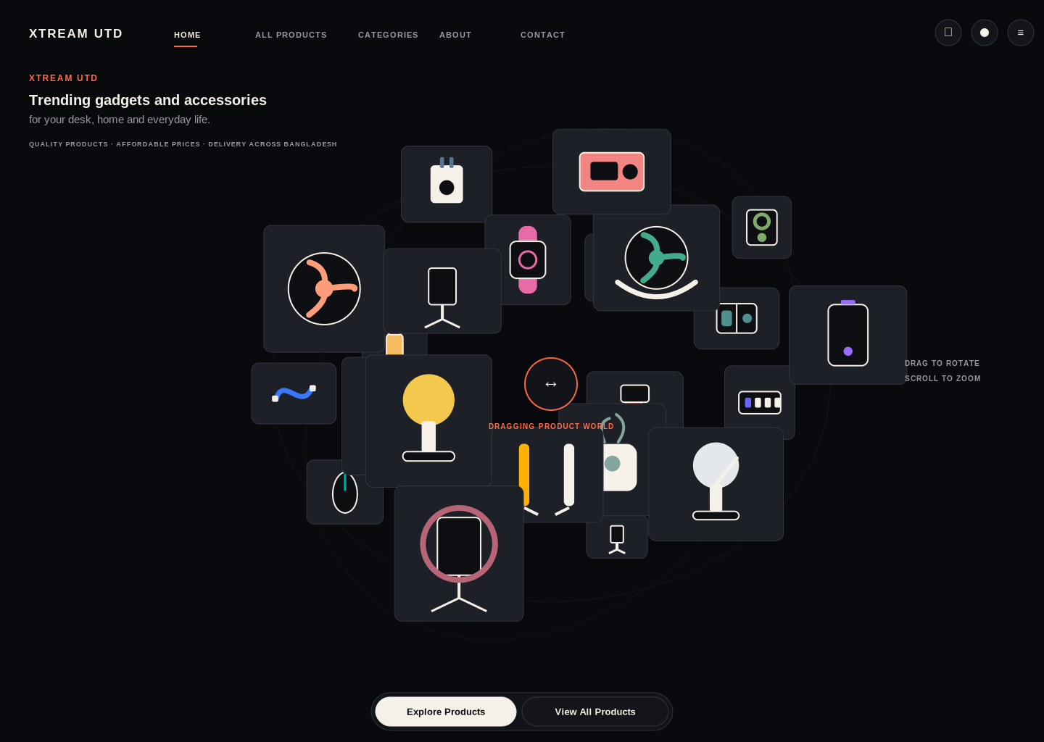
Dragging state separates rotation from click
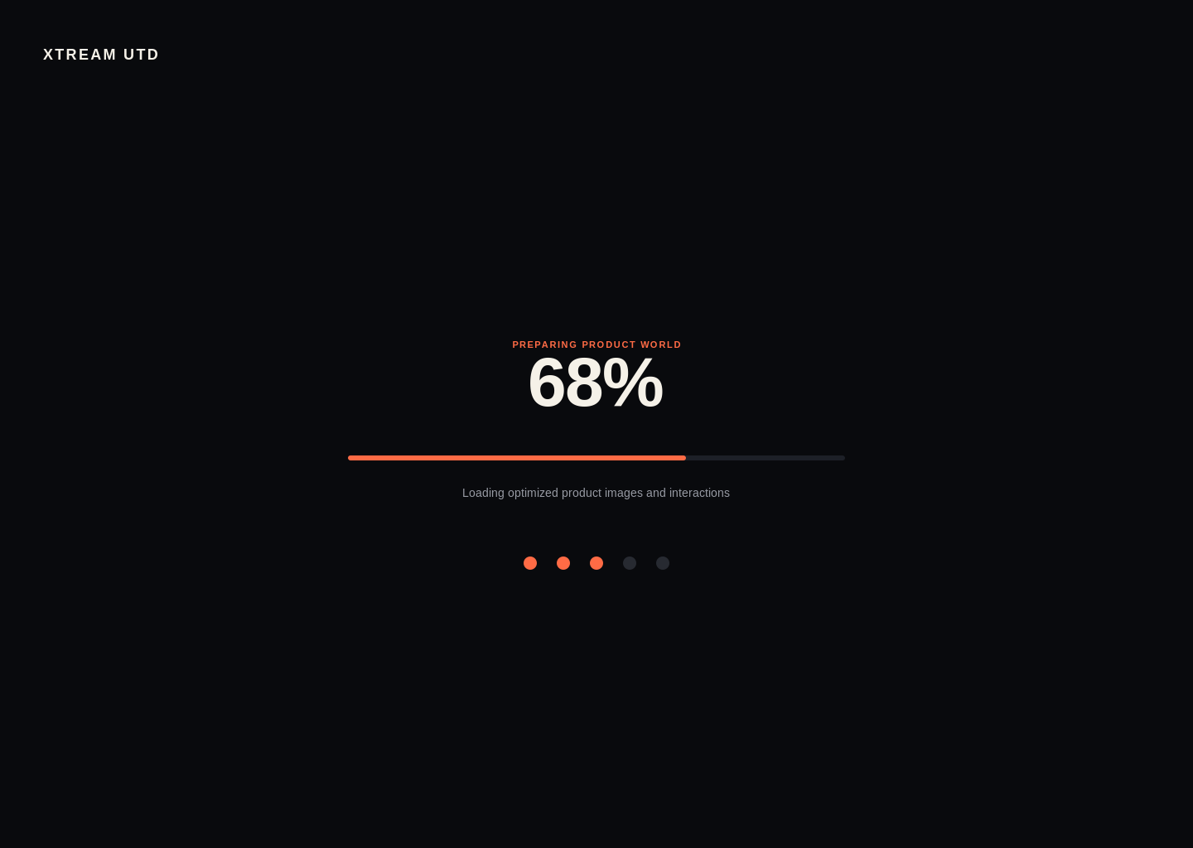
Short product-image loading experience
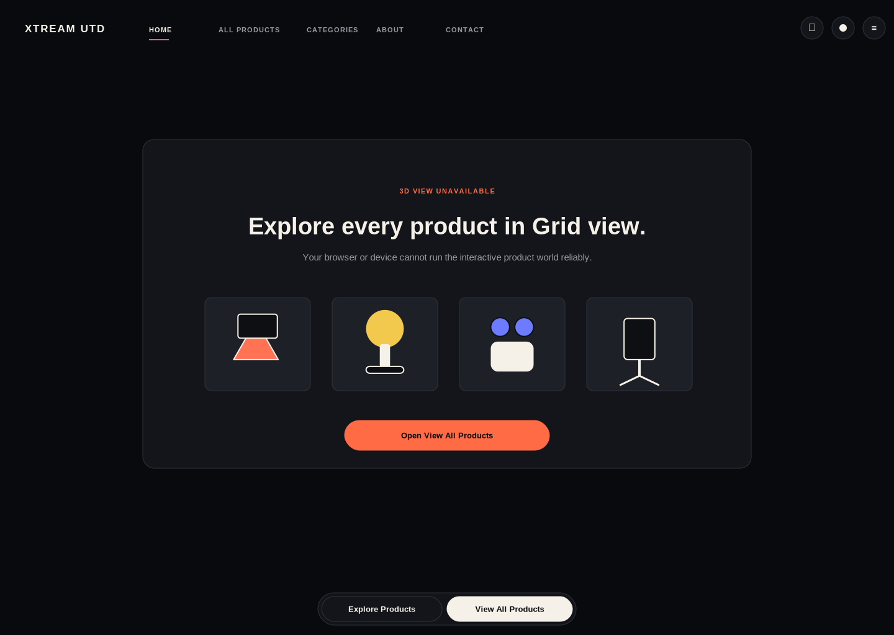
Accessible Grid fallback when WebGL is unavailable

Interaction rules
- Horizontal drag rotates the world horizontally; vertical drag is clamped.
- Pointer movement above approximately 6 px is treated as drag, not click.
- Wheel, trackpad and pinch control zoom within safe minimum and maximum values.
- Products face the viewer and preserve readable images.
- Back navigation restores the previous world rotation, zoom and filter where practical.
- Reduced-motion and low-performance experiences default to Grid.

5. All Products catalogue
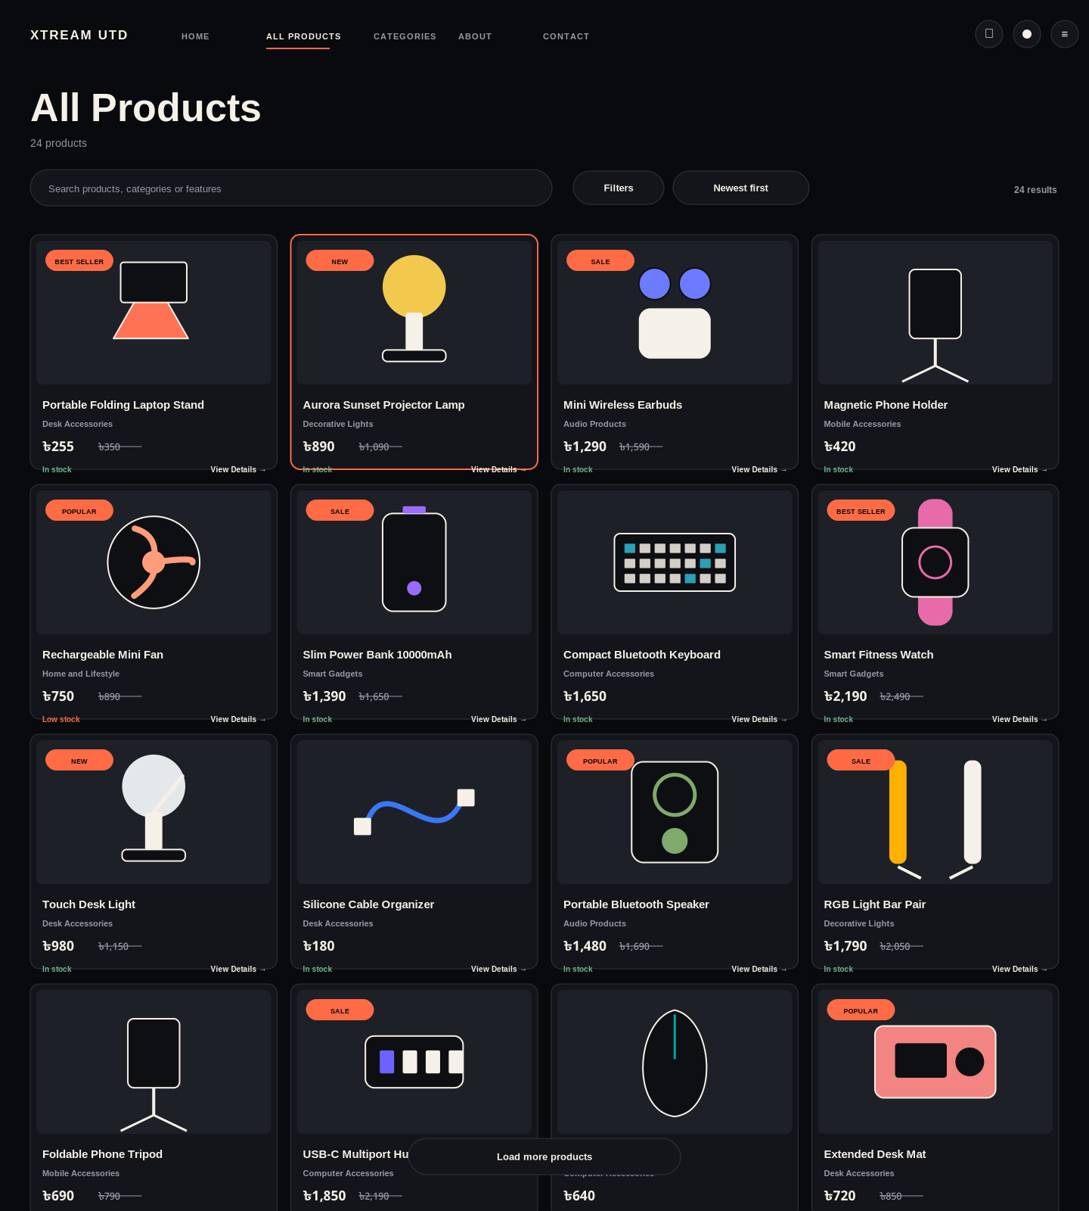
Responsive catalogue with title, current price, old price, category and stock
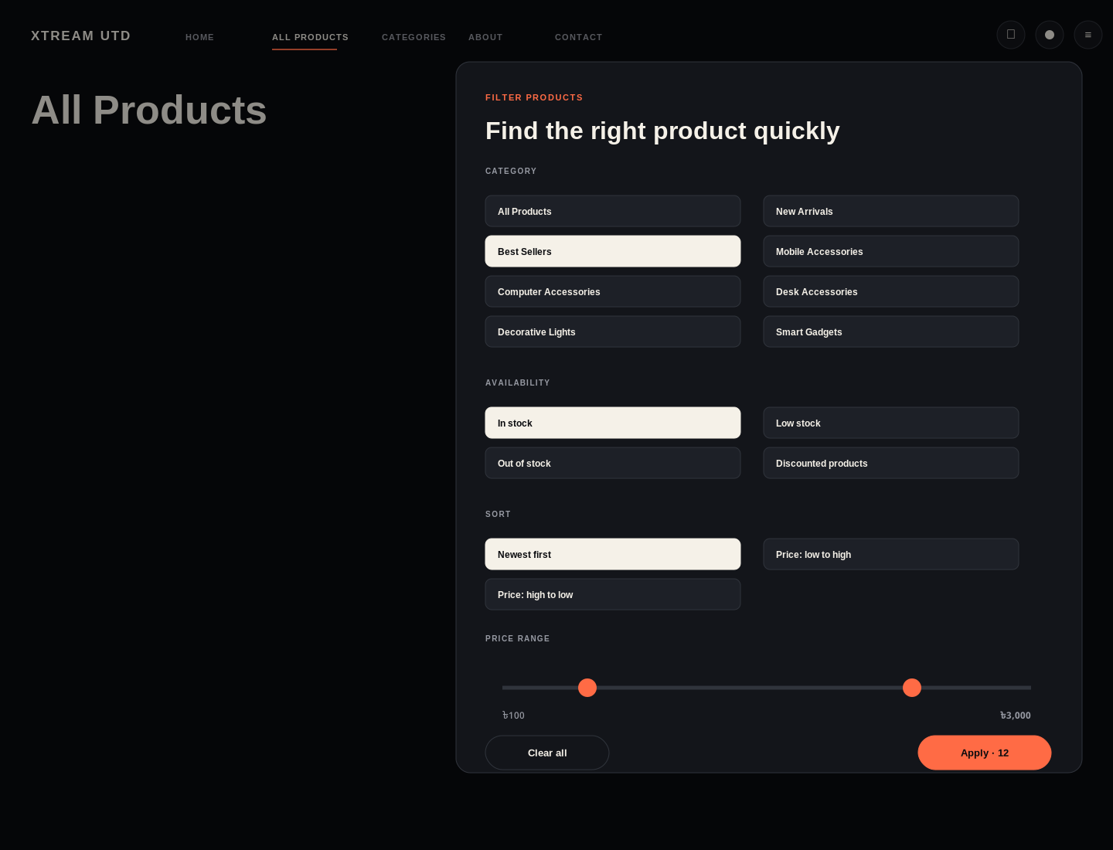
Desktop filter panel
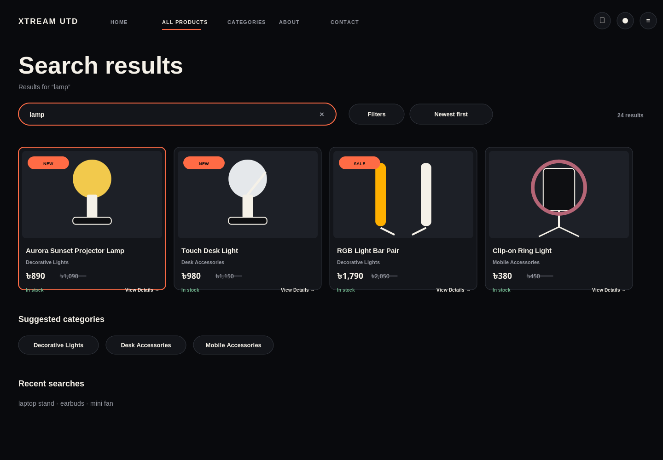
Search results and category suggestions
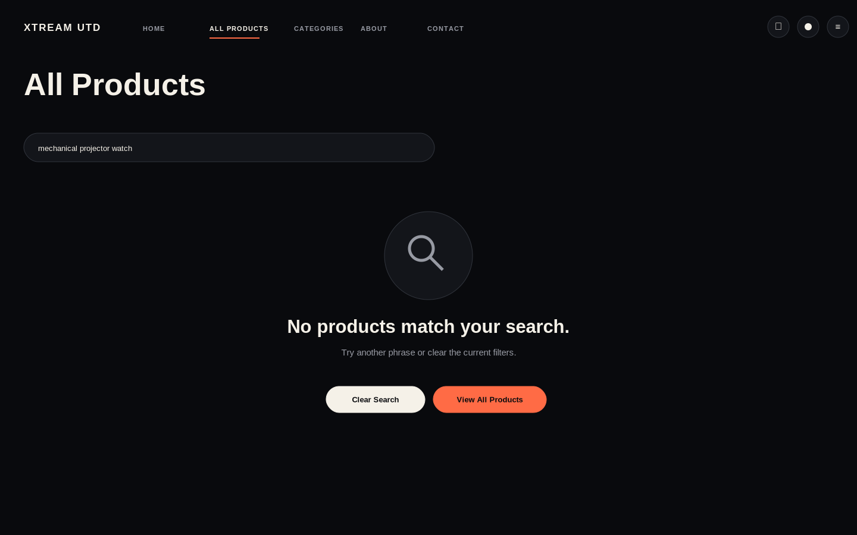
No-results recovery state

5A. Catalogue behaviour
- Four columns large desktop, three small desktop, two tablet, one or two mobile.
- Every card is one semantic link to `/products/[slug]`.
- Search matches title, category, description, features and tags.
- Filter state can be reflected in URL query parameters.
- Price is formatted in Bangladeshi taka and previous price is shown only when valid.

6. Product card and product details
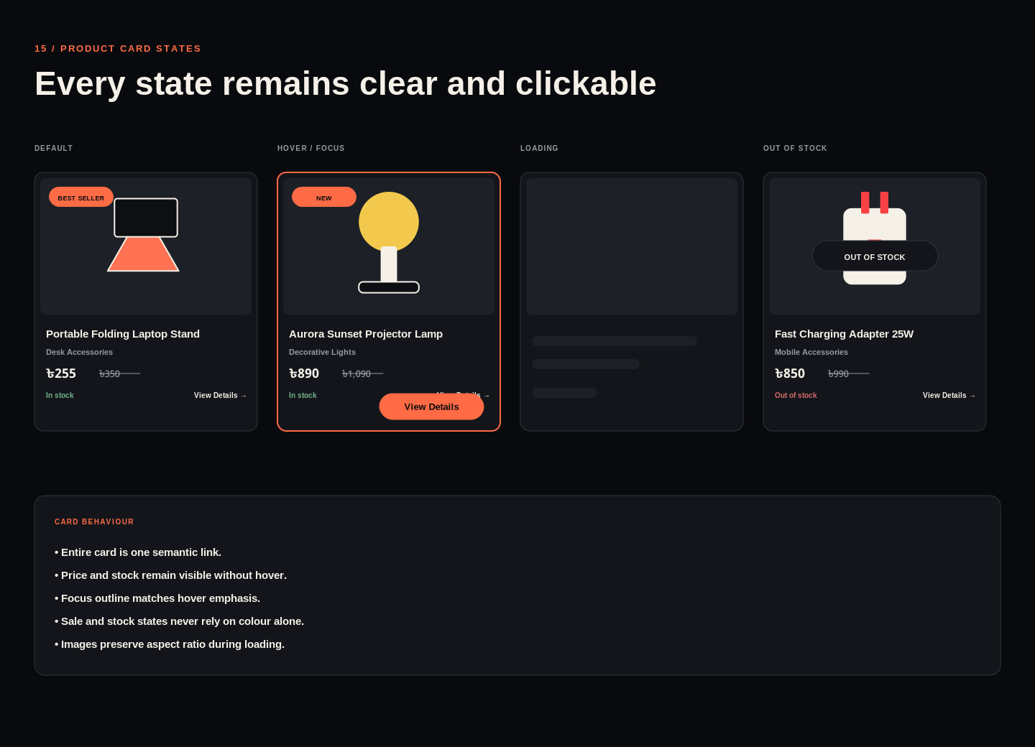
Default, hover/focus, loading and out-of-stock states
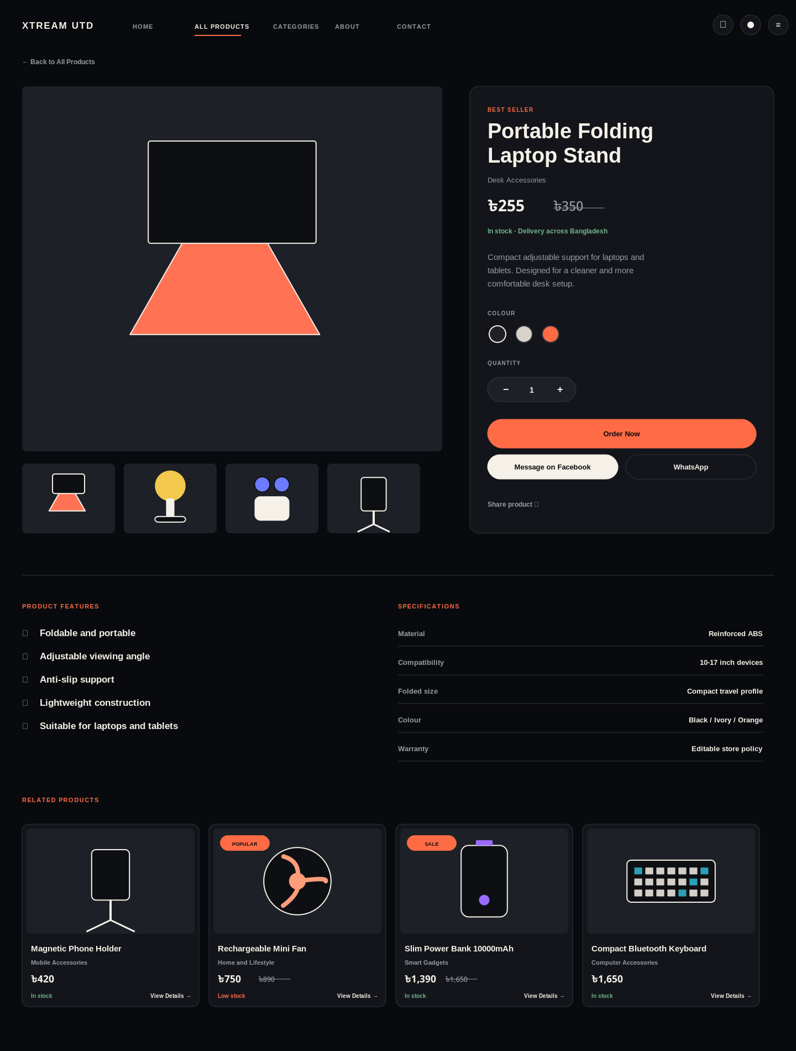
Desktop product details
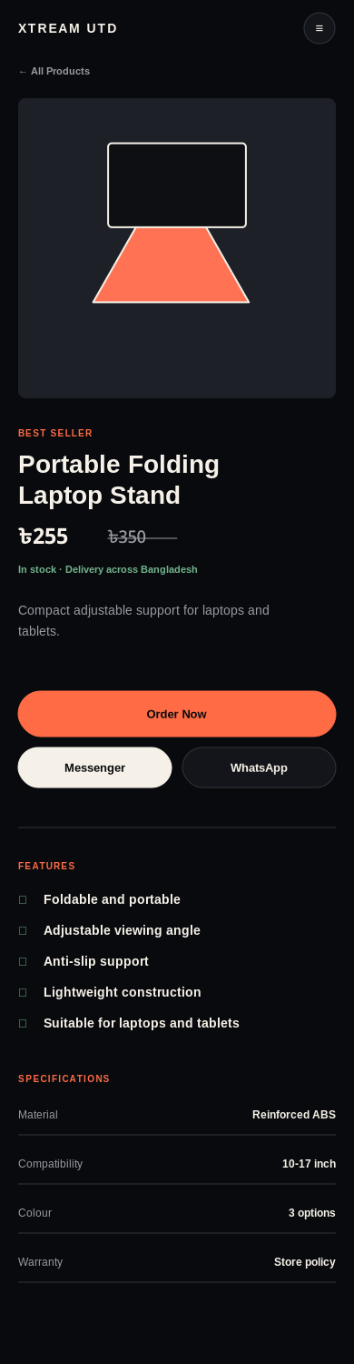
Mobile product details

Product-page content model
Content group | Required information
Identity | Title, category, subcategory, slug
Commerce | Current price, old price, discount, stock, quantity
Media | Main image, gallery, optional video
Selection | Colour, size or variant, quantity
Decision support | Summary, features, specifications, delivery, return/replacement
Actions | Order Now, Messenger, WhatsApp, share
Discovery | Related products and recently viewed

7. Order inquiry and support
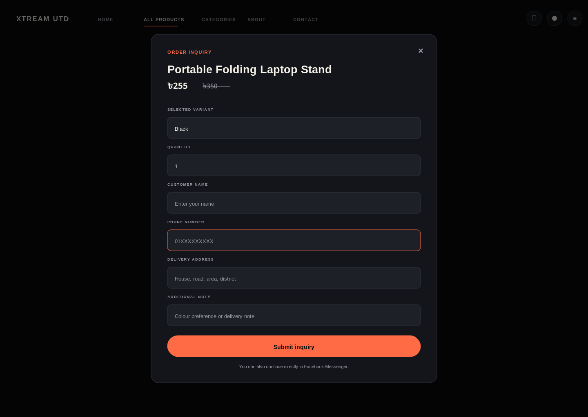
Messenger-first order inquiry
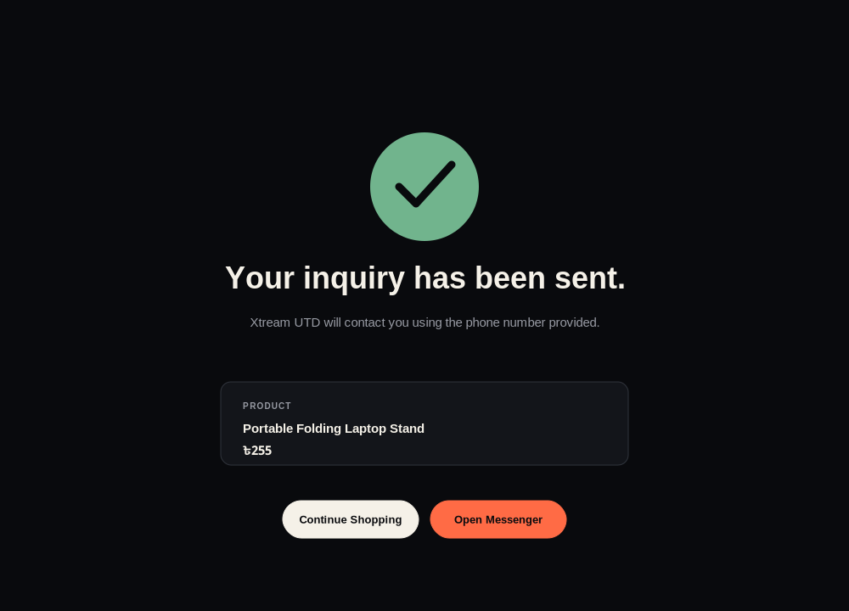
Success confirmation and next actions
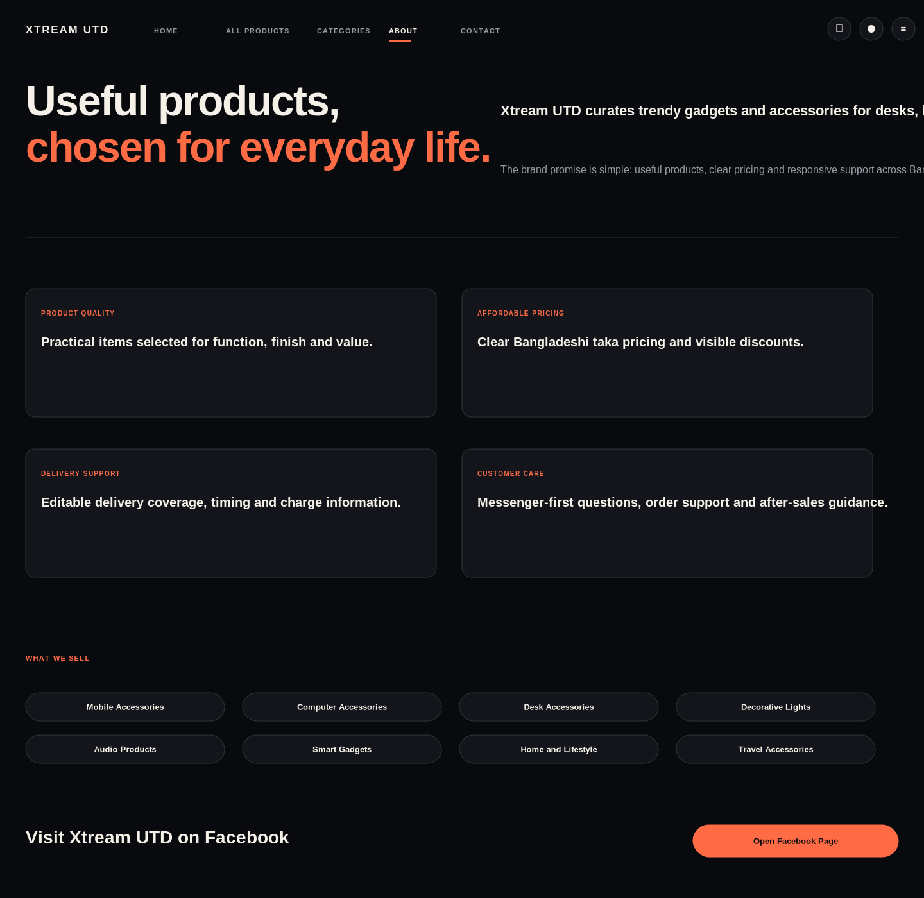
About and trust content
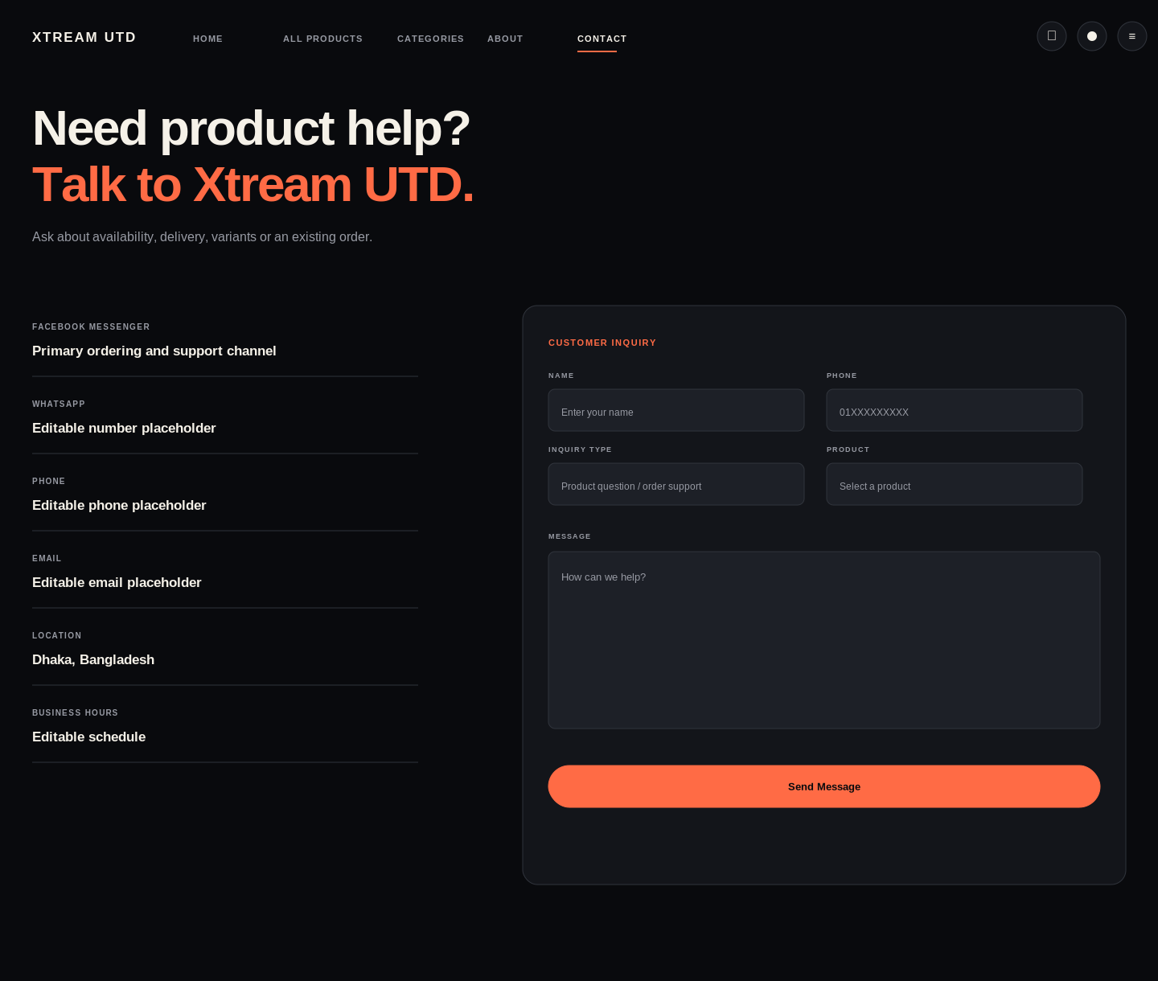
Contact and customer-support page

Order-channel rule
The primary action is labelled Order Now. Its destination remains configurable: Facebook Messenger, WhatsApp, phone, inquiry form or a future checkout. The current design prioritizes Messenger without hard-coding unverified contact details.

8. Mobile experience
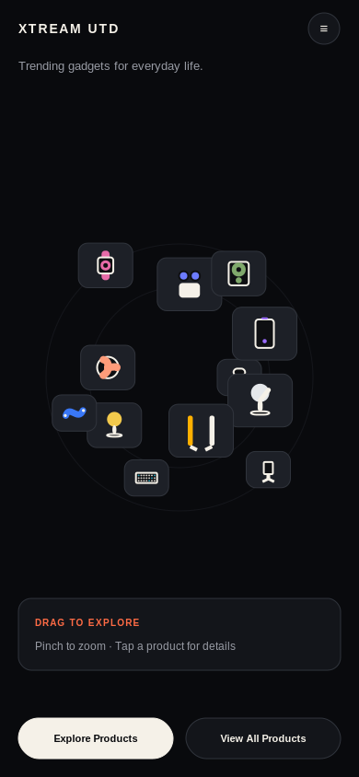
Touch-first mobile World view
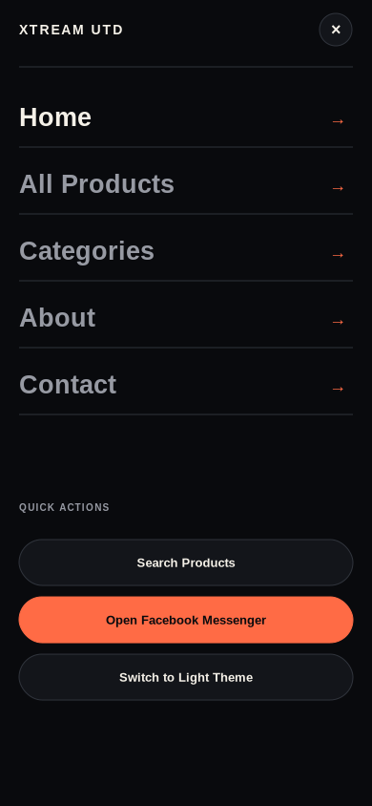
Mobile navigation
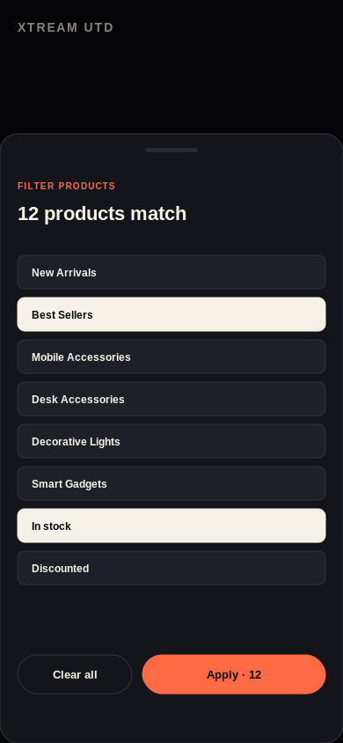
Mobile product filters
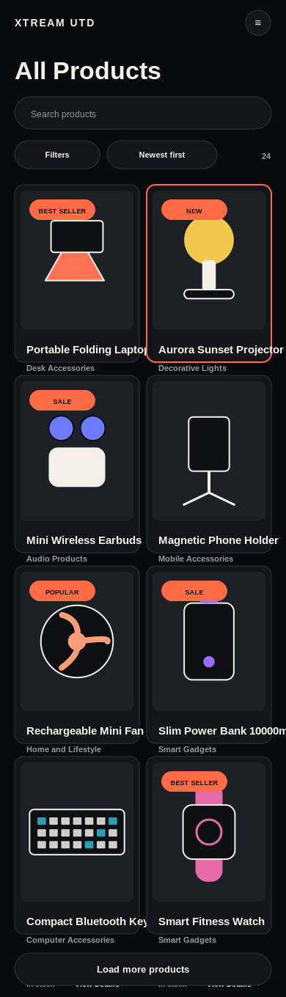
Mobile product catalogue

Mobile rules
- Use large 44 px minimum controls and safe-area spacing.
- Use fewer visible products and smaller image textures in World view.
- Replace hover with tap preview or direct details navigation.
- Use bottom sheets for filters.
- Keep View All Products easy to reach.
- Prevent horizontal page scrolling and keep price/order actions visible.

9. Themes, errors and offline behaviour
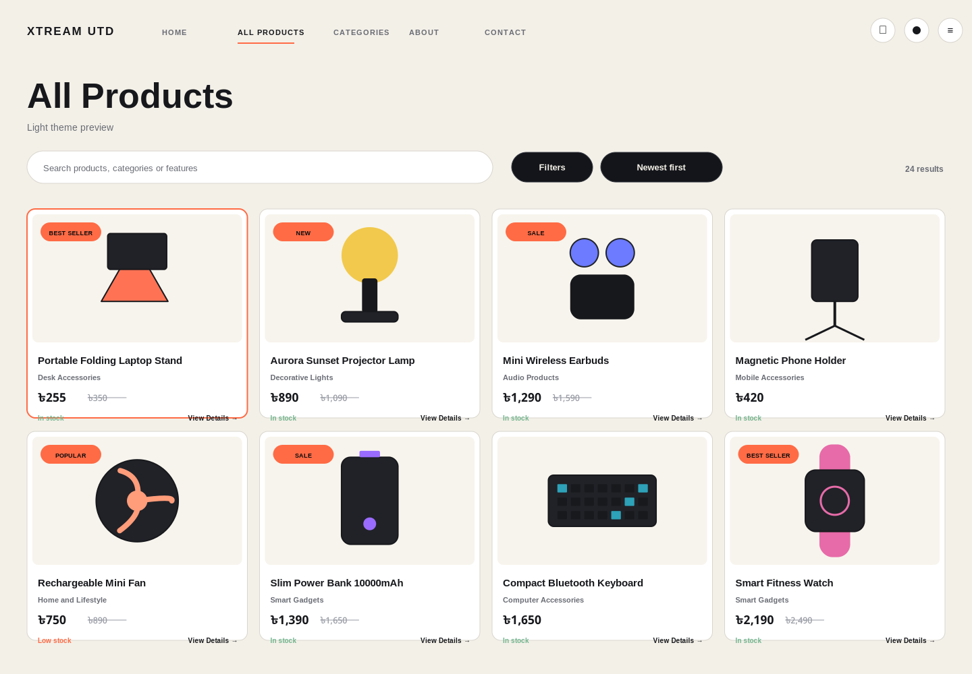
Editable light-theme token preview
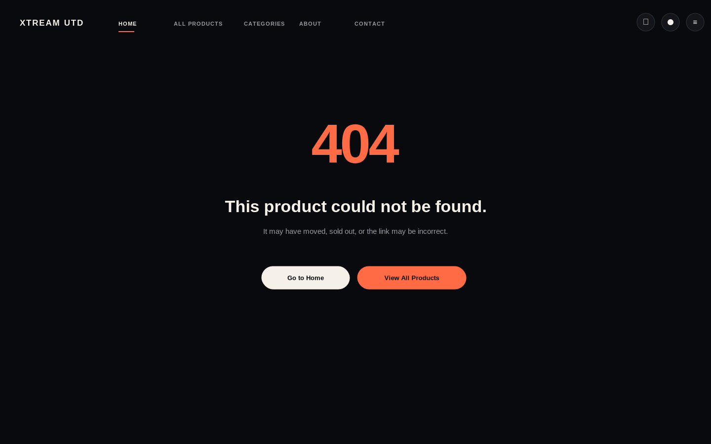
Product-not-found error
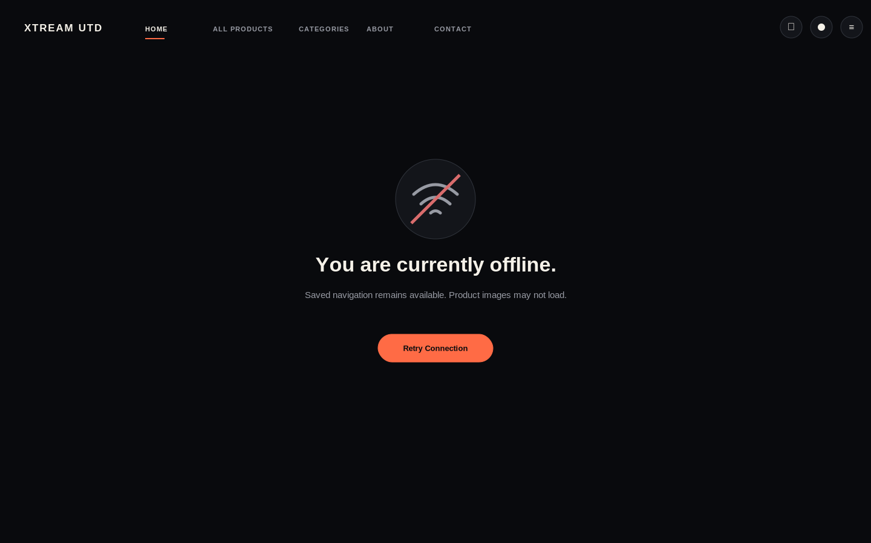
Offline state

Fallback hierarchy
Condition | Response
WebGL unavailable | Open Grid with the same products and filters
Low performance | Reduce products, texture quality and motion, then fall back to Grid
Reduced motion | Remove inertia and prefer Grid
Image failure | Keep card dimensions and show a neutral placeholder
Product unavailable | Show out-of-stock state or contextual 404
Offline | Keep cached navigation and provide retry

10. Routes and data contract
Route | Purpose
/ | 3D product-discovery homepage
/products | Complete product catalogue
/products/[slug] | Individual product details
/about | Brand, trust and product categories
/contact | Support and inquiry channels

The included `data/sample_products.json` contains 24 editable records with product identity, pricing, stock, media placeholders, features, variants, tags, related products and editable order/Facebook links.

Required data fields
Field | Type
id, slug, title | string
category, subcategory | string
short, full description | string
price, old_price, discount_percentage | number
currency | BDT
stock, quantity_available | status / number
main_image, gallery_images, video | media
features, colours, variants, tags | arrays
specifications | object
featured, new_arrival, best_seller | boolean
order_link, facebook_post_link | editable URL

Pricing rules
- Use the ৳ symbol with thousands separators.
- Show old price only when greater than current price.
- Calculate discount percentage from valid prices.
- Do not hide out-of-stock products unless the selected filter requires it.

11. Accessibility and motion

Accessibility
- Every product is available as a semantic HTML link outside or alongside WebGL.
- Visible focus outline matches the hover state and does not rely on colour alone.
- Escape closes menus, search, filters and inquiry modals.
- Enter or Space activates focused products and actions.
- Touch targets are at least 44 x 44 px.
- Grid is always available as an accessible fallback.
- Product images require descriptive alt text.
- Text and controls target WCAG AA contrast.

Motion
Interaction | Target duration | Behaviour
Control hover | 150-180 ms | Simple ease out
Menu/filter panel | 280-340 ms | Restrained slide/fade
World entrance | 600-900 ms | Controlled deceleration
Product hover | 180-240 ms | Small scale/forward movement
Product selection | 450-700 ms | Focus and route transition
Filter redistribution | 450-650 ms | Smooth no-bounce motion
Reduced motion | 0-150 ms | No inertia or large zoom

Development acceptance criteria
- Header and bottom navigation match approved screens.
- Clicking a World product or catalogue card opens its matching details route.
- Back navigation restores prior browsing context where practical.
- Search and filters work with the same normalized dataset.
- Responsive layouts have no horizontal overflow.
- Keyboard and screen-reader paths reach every product and action.
- WebGL failures never block access to products.

12. Editing and handoff notes
- Import SVG boards into Figma, Penpot, Sketch or Illustrator.
- Replace original vector placeholders with real Xtream UTD product photography.
- Change brand copy, categories, pricing and product records without redesigning components.
- Use variables for dark/light theme colours and shared typography.
- Keep Messenger, WhatsApp, phone, delivery and policy values editable until verified.
- Do not flatten important interface content into raster images.
The design is intentionally original and uses the reference video only for the spatial discovery interaction. It does not reproduce the source website’s identity, content or layout.

