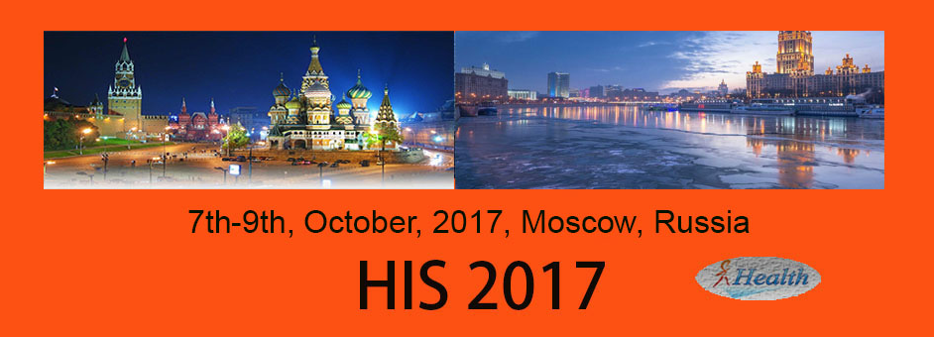

The 6th International Conference on
Health Information Science (HIS 2017)

7-9, October 2017
Ararat Park Hyatt Moscow , Moscow, Russia, Oct 7-9, 2017

Organizers:
 | 
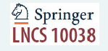
Supported by：

TABLE OF THE CONTENTS

Table of Contents ……………………………………………………………………………………… 02
Welcome Message from the HIS2017 Chairs ……………………………………….. 03-04
Conference Officers ………………………………………………………………………………….. 05
Program Committees …………………………………………………………………………… 06 -07
HIS2017 Detailed Program …………………………….……………………………………… 8-11
HIS2017 Keynote speeches .……..……………………………………………………………. 11-15
Conference Venue ……………………………………………………………………………….. 16-17
Acknowledgement.......................................................................................18

WELCOME MESSAGE FROM THE HIS2017 CHAIRS

Welcome to HIS2017! This is the sixth Health Information System Conference. Since the first HIS conference started in 2012, HIS evolves with the time to lead the frontier of data driven information technology research. The International Conference Series on Health Information Science (HIS) provides a forum for disseminating and exchanging multidisciplinary research results in computer science/information technology and health science and services. It covers all aspects of health information sciences and systems that support health information management and health service delivery. Previous HIS conferences were held in Shanghai, China (2016), Melbourne, Australia (2015), Shenzhen, China (2014), London, UK (2013), and Beijing, China (2012).

HIS2017 is held from 7th to 9th October in the beautiful city of Moscow, Russia. The host organization of HIS2017 is Moscow Institute of Physics and Technology, Russia and Victoria University, Melbourne, Australia. Moscow Institute of Physics and Technology (MIPT) is located in Moscow, known informally as PhysTech which is a leading Russian university, originally established during the Soviet Union. MIPT is famous in the countries of the former Soviet Union. Australian Victoria University is one of the largest and most culturally diverse education institutions in Australia, and one of only five multi-sector universities offering vocational education (TAFE) and higher education courses.

The conference has solicited and gathered technical research submissions related to all aspects of the conference scope. All the submitted papers in the proceeding were peer reviewed by the reviewers drawn from the Program Committee. After the rigorous peer review process, the submitted papers were selected on the basis of originality, significance,
and clarity for the purpose of the conference. A total of 16 full papers and 7 short papers were accepted for publication in the proceeding. The authors were from 8 countries, including Australia, Russia, China, Japan, Bulgaria, Netherlands, Pakistan, Colombia. Some papers will be invited to submit the extended versions of their papers to a special issue of the Health Information Science and System Journal, published by Springer.

The high quality of the program - guaranteed by the presence of an unparalleled number of
internationally recognized top experts - can be assessed when reading the contents of the proceeding. The conference will therefore be a unique event, where attendees will be able to appreciate the latest results in their field of expertise, and to acquire additional knowledge in other fields. The program has been structured to favour interactions among attendees coming from many different horizons, scientifically, geographically, from academia and from industry.

The success of HIS2017 is not possible without the hard work by a great team of people, including the Conference Organisation Chair Hua Wang (Victoria University, Australia), Publicity Chair Grazziela Figueredo (The University of Nottingham, UK) and Yan Li (University of Southern Queensland, Australia), Publication & Website Chair Rui Zhou (Swinburne University of Technology, Australia), Local Arrangement Chair Maria Berberova (Moscow Institute of Physics and Technology, Russia) and Webmasters Jiannan Li (The University of Adelaide, Australia) and Weikang Wang (The University of Adelaide, Australia).
We would like to sincerely thank our keynote speakers:
- Professor James Jhing-fa Wang, President, Tajen University, Pingtung, Taiwan and Chair Professor, National Cheng Kung University, Tainan, Taiwan
- Dr. Nadezhda E. Zvartau, Senior Researcher in Hypertension department and Head of Biomedical Drug Research Department, Almazov National Medical Research Centre; Senior Researcher in Translational Medicine Institute, ITMO University, Saint-Petersburg

Our thanks also go to the host organization, Moscow Institute of Physics and Technology (MIPT) and Victoria University, Australia; Finally, we acknowledge all those who contributed to the success of HIS 201 7 but whose names were not listed here.

Enjoy HIS2017 and Moscow!

General Chairs: Stanislav V. Klimenko and Yanchun Zhang
Program Committee Chair: Siuly Siuly,
Uwe Aickelin and
Zhisheng Huang

CONFERENCE OFFICERS

General Co-chairs
Stanislav V. Klimenko, Moscow Institute of Physics and Technology, Russia
Yanchun Zhang, Victoria University, Australia & Fudan University, China

Program Co-chairs
Siuly Siuly, Victoria University, Australia
Uwe Aickelin, The University of Nottingham, UK
Zhisheng Huang, Vrije Universiteit Amsterdam, The Netherlands

Conference Organization Chair
Hua Wang, Victoria University, Australia

Publicity Co-chairs
Grazziela Figueredo, The University of Nottingham, UK
Yan Li, University of Southern Queensland, Australia

Publication & Conference Website Chair
Rui Zhou, Swinburne University of Technology, Australia

Local Arrangement Chair
Maria Berberova, Moscow Institute of Physics and Technology, Russia

Webmasters
Jiannan Li, The University of Adelaide, Australia
Weikang Wang, The University of Adelaide, Australia

PROGRAM COMMITTEES
Ömer faruk Alçin, Bingol University, Turkey
Varun Bajaj, Indian Institute of Information Technology, Design and Manufacturing, Jabalpur, India
Mathias Baumert, The University of Adelaide, Australia
Jiang Bian, University of Florida, USA
David Buckeridge, McGill University, Canada
Song Chen, University of Maryland, Baltimore County, USA
Fei Chen, Southern University of Science and Technology, China,
James J Cimino, National Institutes Health, USA
Zhiyuan Luo, Royal Holloway, University of London, UK
Bridget Mcinnes, Virginia Commonwealth University, USA
Fleur Mougin, ERIAS, INSERM U1219 - Université de Bordeaux, France
Abdulkadir Sengur, Firat University, Turkey
William Song, Dalarna University, Sweden
Weiqing Sun, University of Toledo, USA
Hongyan Wu, Shenzhen Institutes of Advanced Technology, China
Fengfeng Zhou, Jilin University, China
Soon Ae Chun, City University of New York, USA
Licong Cui, University of Kentucky, USA
Xuan-Hong Dang, University of California, Santa Barbara, USA
Ling Feng, Tsinghua University, China
Zhe He, Florida State University, USA
Du Huynh, The University of Western Australia, Australia
Xia Jing, Ohio University, USA
Gang Luo, University of Washington, USA
Nigel Martin, Birkbeck, University of London, UK
Fernando Martin-Sanchez, Weill Cornell Medicine, Cornell University, USA
Bo Shen, Donghua University, China
Xiaohui Tao, University of Southern Queensland, Australia
Hao lan Zhang, Zhejiang University, China
Xiaolong Zheng, Chinese Academy of Sciences, China
Juanying Xie, Shaanxi Normal University, China
Enamul Kabir, University of Southern Queensland, Toowoomba, Australia

HIS2017 DETAILED PROGRAM

Conference Location: Conference Hall Schepkin 2nd floor Park Hyatt Moscow, Russia

Day 1 (7th October 2017): Arrival and Free Activities
Day 2 (8th October 2017): Registrtion & Program

Registration
8:00-8:30am
Location: outside conference room, 2nd floor Park Hyatt Moscow, Russia

Opening and Keynote1
Time: 8.30:00-9:00, Sunday 8th October 2017

Welcome Speech: Stanislav V. Klimenko, Moscow Institute of Physics and Technology, Russia
Opening Address & Program Introduction: Yanchun Zhang, Victoria University, Australia and Fudan University, China

Keynote Speech 1:

Location: Park Hyatt Moscow, Russia
Time: 9:00-9:40, Sunday 8th October 2017

Title: Orange Technology & AI Robot for Smart Hospital & Health Care
Speaker: Professor James Jhing-fa Wang

President, Tajen University, Pingtung, Taiwan and

Chair Professor, National Cheng Kung University, Tainan, Taiwan

Keynote Speech 2:

Location: Park Hyatt Moscow, Russia
Time: 9:40-10:10, Sunday 8th October 2017

Title: Big data analysis and decision support systems in hypertension
Speaker: Dr. Nadezhda E. Zvartau
Senior Researcher in Hypertension department and Head of Biomedical Drug Research Department, Almazov National Medical Research Centre;
Senior Researcher in Translational Medicine Institute, ITMO University, Saint-Petersburg

Tea break
Time: 10:10-10:30, Sunday 8th October 2017
Session 1: Medical/Health/Biomedicine information domain
Location: Park Hyatt Moscow, Russia
Time: 10:30-12:20, Sunday 8th October 2017
Chair: Jiuyong Li, University of South Australia, Australia

- Software for full-color 3D reconstruction of the biological tissues internal structure (Regular paper)
Alexander V. Khoperskov, Mikhail E. Kovalev, Alexander S. Astakhov, Valeriy V. Novochadov, Alexey A. Terpilovskiy, Kharlampiy P. Tiras and Dmitry A. Malanin

- Epileptic seizure detection using EEGs based on kernel radius of intrinsic mode functions (Regular paper)
Qiang Li, Meina Ye, Jiangling Song and Rui Zhang
- The Application of a New Pharmacy Service System Based on Data Center (Regular paper)
Yanke Hu, Bin Zhou, Jiaqiang Xu, Weijing Tang, Hao Wang, Wei Zhuang and Wei Liu

- Some directions of medical informatics (Regular paper)
Nikita Shklovskiy-Kordi and Mishael Shifrin

- Appointment Lead-Time in Outpatient Perinatology Departments: A Case Study in a Maternal-child Hospital (short paper)
Miguel Angel Ortiz Barrios, Genett Jimenez and Jeferson De Avila Villalobos

- Engaging Patiens, Empowering Doctors In Digitalisation Of Healthcare (short paper)
Nikita Shklovskiy-Kordi, Boris Zingerman, MishaelShifrin, Andrei Vorobiev and Rostislav Borodin

Lunch
Time: 12:20-13:20, Sunday 8th October 2017
Session 2: Artificial intelligence for computer-aided diagnosis
Location: Park Hyatt Moscow, Russia
Time: 13:20-15:20, Sunday 8th October 2017
Chair: Yan Li, University of Southern Queensland, Australia

- Supporting Breast Cancer Decisions Using Formalized Guidelines and Experts Decision Patterns – Prototype & Evaluation (Regular paper)
Dennis Andrzejewski, Michael Fellmann, Rüdiger Breitschwerdt and Eberhard Beck.

- Granular computing combined with support vector machines for diagnosing erythemato-squamous diseases (Regular paper)
Yongchao Wang and Juanying Xie

- A Semantically-enabled System for Inflammatory Bowel Diseases (Regular paper)
Lei Xu, Zhisheng Huang, Hao Fan and Siwei Yu

- Building Diversified Multiple Trees for Classification in High Dimensional Noisy Biomedical Data (Regular paper)
Jiuyong Li, Lin Liu, Jixue Liu and Ryan Green

- Early Classification of Multivariate Time Series based on Piecewise Aggregate Approximation (short paper)
Chaohong Ma, Xiaoqing Weng and Zhongnan Shan

- Constructing Knowledge Graphs of Depression (Regular paper)
Zhisheng Huang, Jie Yang, Frank Van Harmelen and Qing Hu

Tea break
Time: 16:00-16:20, Sunday 8th October 2017

Session 3: Data management, data mining, and knowledge discovery

Location: Park Hyatt Moscow, Russia
Time: 16:20-17:00, Sunday 8th October 2017
Chair: Zhisheng Huang, VU University Amsterdam, the Netherlands

- Mining Comorbidity Patterns Using Retrospective Analysis of Big Collection of Outpatient Records (Regular paper)
Svetla Boytcheva, Galia Angelova, Zhivko Angelov and Dimitar Tcharaktchiev

- Developing a Tunable Q-Factor Wavelet Transform Based Algorithm for Epileptic EEG Feature Extraction (Regular paper)
Hadi Ratham Al Ghayab, Yan Li, Siuly Siuly, Shahab Abdulla and Paul Wen

- Generation of Semantic Patient Data for Depression (short paper)
Yanan Du, Shaofu Lin and Zhisheng Huang

- Numerical modeling of the internal temperature in the mammary gland (Short paper)
Maxim Polyakov, Alexander Khoperskov and Tatyana Zamechnic

- Constructing three-dimensional models for surgical training simulators (short paper)
Klimenko, Marina Gavrilova and ArkadiyChernetskiy

Session 4: Development of new architectures and applications
Location: Park Hyatt Moscow, Russia
Time: 17:00-18:00, Sunday 8th October 2017
Chair: Hua Wang, Victoria University

- Analyses of the Dual Immune Roles Cytokines Play in Ischemic Stroke (short paper)
Yingying Wang, Jianfeng Liu, YunpengCai and Haibo Yu
- Research on Multidimensional Modelling for Personal Health Record (Regular paper)
Hao Fan, Jianping He and Gang Liu
- Multidimensional Analysis Framework on Massive Data of Observations of Daily Living (Regular paper)
Jianhua Lu, Baili Zhang, Xueyan Wang and Ningyun Lu
- A Framework for Automated Knowledge Graph Construction towards Traditional Chinese Medicine
Heng Weng, Shixing Yan, Ziqing Liu, Meiyu Fan and Tianyong Hao
- A Data-driven Approach for Discovering the Recent Research Status of Diabetes in China (Regular paper)
Xieling Chen, Heng Weng and Tianyong Hao

Contacts:
Rashid Zalyalov: +7 915 009 60 48, rashid.zalyalov@gmail.com
Alexey Mashkunov & TA "Lansere" +7916-6036649, almash@inbox.ru

Banquet Time: 18:30 - 21:00
Location: Tsargrad Hotel (WISE17 Conference Hotel)

Day 3 (9th October 2017): Discussion/Tour

HIS2016 KEYNOTE SPEECH TALKS

Keynote Speech 1: Orange Technology & AI Robot for Smart Hospital & Health Care

Professor James Jhing-fa Wang
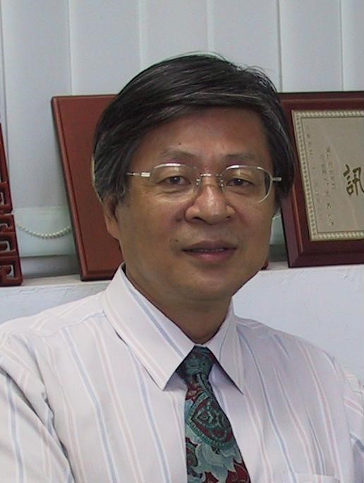
IEEE Fellow
President, Tajen University, Pingtung, Taiwan
Chair Professor, National Cheng Kung University, Tainan, Taiwan
Abstract
The first ever World Happiness Report has been published recently by the United Nations, it reflects a new worldwide demand for more attention to health and happiness as criteria for government policy. This also calls upon science and technology in both natural and social domains to be developed for promoting a happy and healthy lifestyle in our modern society.
To meet such a world trend, the Orange Technology research has been first proposed in National Cheng Kung University in Taiwan in 2008. The Orange Technology refers to a newly evolved interdisciplinary research area for integration and innovation of health, happiness, and care technologies. The research scope includes computer science, electrical engineering, biomedical engineering, psychological/physiological science, cognitive science, and social science. The representative color of Orange Technology originates from a harmonic fusion of red (representing brightness of health and happiness) and yellow (representing warming care). Instead of emphasizing the relations between environments and humans, as proposed by green technology, the objective of Orange Technology will explore the innovative technologies to bring more health, happiness, warming care, and more mental wellness to the society. Henear e will inevitably work closely with bots.
Concerning about the AI robot applied in smart hospital, if we take the necessary steps now to gain better understanding of how they work, then the transition could be easier and simpler. For this reason, some interesting examples of robots in healthcare are presented such as Da vinci surgical robot, blood-drawing robot, robotic assistance for a better life, tele medical network system, disinfectant Robots in Healthcare, and TUG hospital robot, etc.
In addition to health informatics, the Happiness Informatics Research is also newly proposed accompanying with Orange technology. It will first sense the happiness behavior of the human being to get the happiness signals such as EEG brain signals, smiling sound signals & smiling face images etc. Then the information technology such as pattern recognition technique will be applied to detect & measure the happiness degree of the behavior based on the input signals. Finally, the system will give the suitable positive feedback to improve the happiness degree of the user.
In summary, the outline of this talk is shown below:
1. Introduction to Orange Technology
2. AI Robots for Smart Hospital and Health Care
3. From health informatics to Happiness Informatics
4. Conclusion and Future works

About the speaker
Prof. Jhing-Fa Wang is currently the President in Tajen University, Chair & Distinguished Professor in the Department of Electrical Engineering, National Cheng Kung University (NCKU). He got his bachelor and master degree from NCKU in Taiwan and Ph. D. from Stevens Institute of Technology USA in 1973, 1979 and 1983 respectively. He is the formal chair of IEEE Tainan Section in 2005-2009, the Coordinator of Section/Chapter, IEEE Region 10 in 2011-2012 & the Industry Liaison-Coordinator of IEEE Region 10 in 2009-2011. He was elected as IEEE Fellow in 1999 for his contribution on: "Hardware and Software Co-design on Speech Signal Processing", He was also the general Chair of ISCAS 2009.
He received Outstanding Research Awards and Outstanding Researcher Award from National Science Council in 1990, 1995, 1997, and 2006 respectively. He also received Outstanding Industrial Awards from ACER and Institute of Information Industry and the Outstanding Professor Award from Chinese Engineer Association, Taiwan in 1991 and 1996 respectively. He also received the culture service award from Ministry of Education, Taiwan in 2008, Distinguished Scholar Award of KT Li from NCKU in 2009, IEEE Tainan Section Best Service Award in 2011, Innovation Education Award in 2013 Seoul International Invention Fair & special award from 2017 Kuwait International Invention Fair.
Prof. Wang's research area is mainly on multimedia signal processing including speech signal processing, image processing, VLSI system design and AI robots. Concerning about the publication, he has published about one hundred & forty journal papers on IEEE, SIAM, IEICE, IEE and about three hundreds international conference papers since 1983. Prof. Wang recently has explored the research on Orange Technology. Orange Technology refers to a newly evolved interdisciplinary research area for integration and innovation of health, happiness, and care technologies. The objective of Orange Technology is to bring more health, happiness and warming care to the society.
Keynote Speech 2: Big data analysis and decision support systems in hypertension

Dr Nadezhda Zvartau
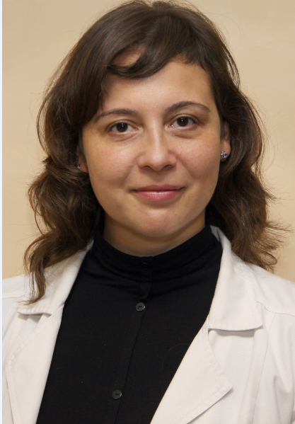
Senior Researcher in Hypertension Department;
Head of Biomedical Drug Research Department, Almazov National Medical Research Centre;
Senior Researcher in Translational Medicine Institute, ITMO University, Saint-Petersburg.

Abstract
Healthcare is characterized by high speed of digitalization with accumulation of real-world big medical data. Despite earlier predictions, application of big data technology in healthcare is still far from being our routine because of complex challenges.
The presentation provides a brief overall perspective why to deal with Big data analysis in health-care, emphasizing open questions: a gap between efficacy and effectiveness of treatments, limitations of clinical data, shifting paradigm to patient-centered and value-based approaches. Describes support at industry and governmental levels of eHealth technology development and invasion, opportunities and challenges of using available sources of Big healthcare data.
The second part of the presentation deals with 2 years’ experience of joint research project on applying IT technologies in medicine of IT specialists from ITMO University, Saint-Petersburg, Russia and medical specialists from Almazov National Medical Research Centre, Saint-Petersburg, Russia. Explains why hypertension is an attractive model for chronic disease modelling and presents first preliminary results on prediction and modelling of high-risk or high-cost patients and treatment results based on individual characteristics as well as trends over time.
Conclusions: despite numerous and complex challenges of application of Big data analysis in healthcare, it is well worth trying, because patients’ need, clinical and research opportunity remain significant.

About the speaker
Nadezhda E. Zvartau, MD, PhD is currently a Senior Researcher in Hypertension department and Head of Biomedical Drug Research Department, Almazov National Medical Research Centre; Senior Researcher in Translational Medicine Institute, ITMO University, Saint-Petersburg.

Dr. Nadezhda Zvartau received degrees: MD - at Saint-Petersburg Pavlov State Medical University (2002), cardiologist certificate (2004, 2009, 2014), PhD (Candidate of Medical Sci) - at Almazov National Medical Research Centre (2005), clinical pharmacologicst (2012 2016) at Pavlov State Medical University, Masters degree in management of medical organization (ongoing) at Peter the Great St.Petersburg Polytechnic University.
Nadezhda Zvartau works as a cardiologist at Almazov National Medical Research Centre and has been involved in international double degree master’s program “Computional biomedicine”. Since 2015 actively involved in the joint eHealth project with ITMO University, Saint-Petersburg as a medical specialist. The first results were recognized by Russian Science Foundation. The joint IT and medical team received a grant on “Value-oriented approach to predictive modeling of diagnosis and treatment of cardiovascular diseases based on Big Data analysis” for 2017-2019 years.
She has lectured on national and international meetings and published on the different topics, including telemonitoring and big data analysis in healthcare.

CONFERENCE VENUE
HIS 2017 will take place at ARARAT PARK HYATT MOSCOW in Russia. Ararat Park Hyatt Moscow is located in the very heart of the capital of Russia and is one of the best situated 5 star hotels in Moscow. Just a few minutes’ walk from the iconic landmarks such as the Kremlin, Red Square and Saint Basil’s Cathedral.
Address:
Ararat Park Hyatt Moscow
4 Neglinnaya Street
Moscow, Russia, 125009
Tel: +7 495 783 1234

The Hotel Website: https://moscow.park.hyatt.com/en/hotel/home.html

Location of ARARAT PARK HYATT MOSCOW hotel:
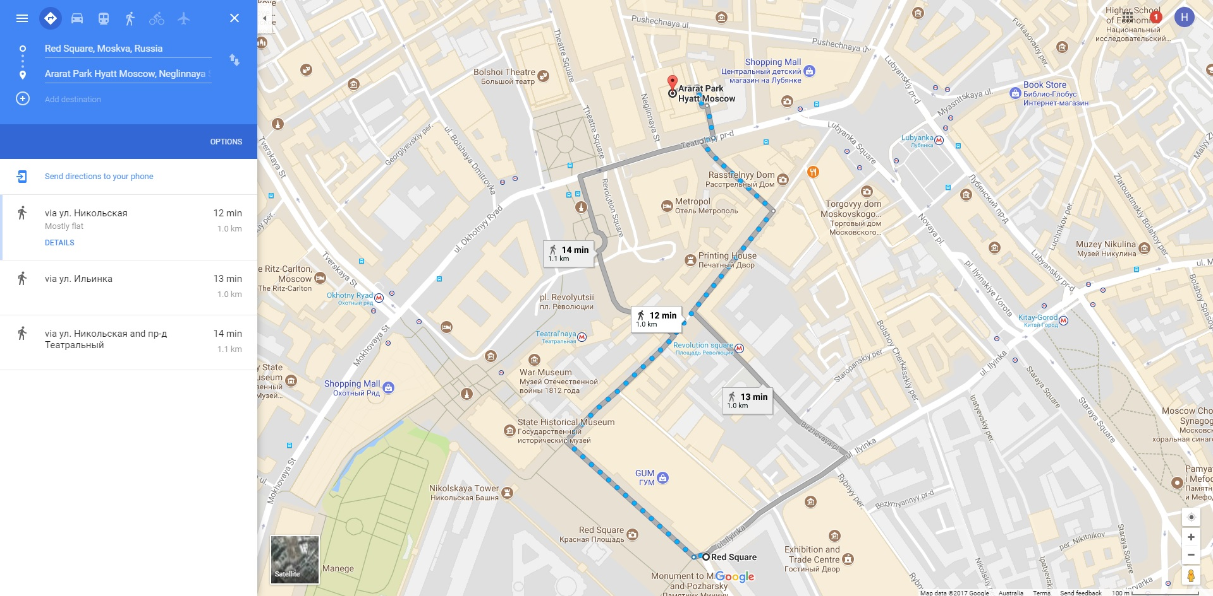

Transport to the Hotel:
Distances to/ from airports
Sheremetyevo (MOW) - 35 km, 1 hour by car
Domodedovo (DME) - 55 km, 1 hour and 30 minutes by car
Vnukovo (VKO) - 45 km, 1 hour and 20 minutes by car
Bykovo (BKA) - 50 km, 1 hour and 40 minutes by car
Train
Belarus Station - 3 km, 10 minutes by car
Kiev Station - 4 km, 10 minutes by car
Leningrad Station - 3 km, 10 minutes by car
Metro Subway
Lubyanka - 200 metres, 5 minutes' walk
Kuznetskiy Most - 200 metres, 5 minutes' walk
Teatralnaya - 200 metres, 5 minutes' walk
Okhotny Ryad - 400 metres, 10 minutes' walk
Distances to Ararat Park Hyatt Moscow hotel
Red Square – 1 km, 12 minutes’ walk
Kremlin – 1.2 km, 15 minutes’ walk
Saint Basil's Cathedral – 1.2 km, 15 minutes’ walk
The State Duma (Parliament building) – 500 metres, 5 minutes’ walk
Bolshoi Theatre – 300 metres, 5 minutes’ walk
Gostiniy Dvor Exhibition Center – 3 km, 10 minutes by car
TSUM Department Store – 400 metres, 5 minutes’ walk
GUM Department Store – 3 km, 10 minutes by car
Gorky Park – 8.5 km, 20 minutes by carAirports

Acknowledgement:

Supporters:
Moscow Institute of Physics and Technology, Russia; Victoria University, Australia

Sponsors:
Springer Publishers；

