
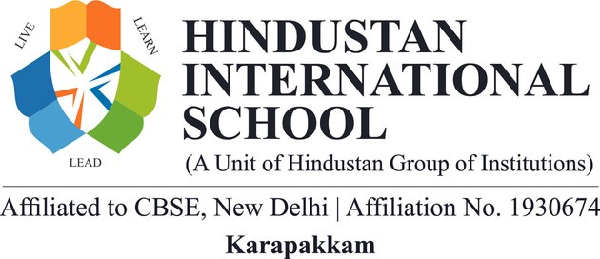

INVITATION BROCHURE
M
O
D
E
L

U
N
I
T
E
D

N
A
T
I
O
N
S
H
I
S

G
L
O
B
A
L

C
O
N
C
L
A
V
E
:

E
D
I
T
I
O
N

2
H
I
S

G
L
O
B
A
L

C
O
N
C
L
A
V
E
:

E
D
I
T
I
O
N

3
“
F
o
s
t
e
r
i
n
g

G
l
o
b
a
l

D
i
a
l
o
g
u
e

f
o
r

a

B
e
t
t
e
r

F
u
t
u
r
e
”
NOVEMBER 06,

2026
Dear Esteemed Institution,
The HIS GLOBAL CONCLAVE: EDITION 3 is an intellectually stimulating Model United Nations (MUN) conference hosted by Hindustan International School. This prestigious event brings together young leaders to deliberate on pressing global issues, framed around the United Nations Sustainable Development Goals (SDGs).
H
I
S

G
L
O
B
A
L

C
O
N
C
L
A
V
E
:

E
D
I
T
I
O
N

2
Through structured Committee Sessions, delegates will engage in debate, negotiation, and collaboration to design innovative solutions and policy frameworks. The Conclave aspires to nurture Leadership, Diplomacy, Critical Thinking, and Problem-Solving skills, empowering participants to become catalysts for positive global change.

COMMITTEES
- WHO – World Health Organization
- UNSC – United Nations Security Council
H
I
S

G
L
O
B
A
L

C
O
N
C
L
A
V
E
:

E
D
I
T
I
O
N

2
- ECOSOC – Economic and Social Council

- DISEC – Disarmament and International Security
- UNHRC – United Nations Human Rights Council
- TNLA – Tamil Nadu Legislative Assembly
- G20 – Group of Twenty

Event Details
Date of the Event: 06th November 2026
Location: Hindustan International School
Registration Commences: 17th October 2026
Last Date for Registration: 4th October 2026
H
I
S

G
L
O
B
A
L

C
O
N
C
L
A
V
E
:

E
D
I
T
I
O
N

2
Registration Fee: Rs. 1200/- Per Delegate
Teacher in Charge –
Ms. Josephine Mirunalini P: +91 9659798932 Ms. Kayalvizhi K: +91 9176150294
Students in Charge –Ashwanth S, Priyadharshini Panneerselvam

