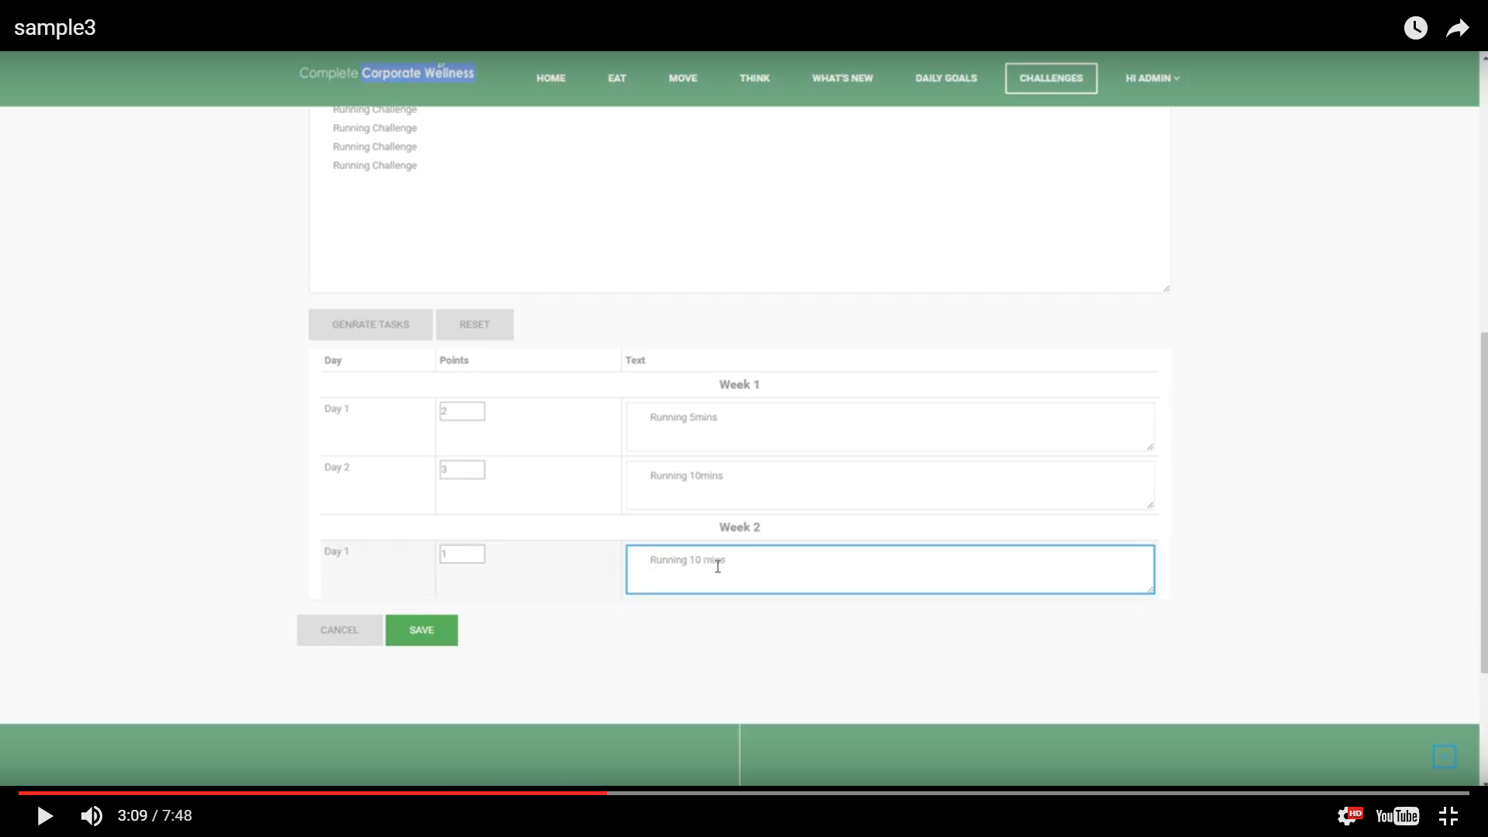

1. Why has this changed? I want the tab Challenges it like the one below with the picture I provided you.

and the one above should be in another TAB or drop down menu from login, called “my programs”

Challenges have all the programs that they can choose with picture and description (like sample 2 below)

Once they join program then in My programs they added it the information as above.

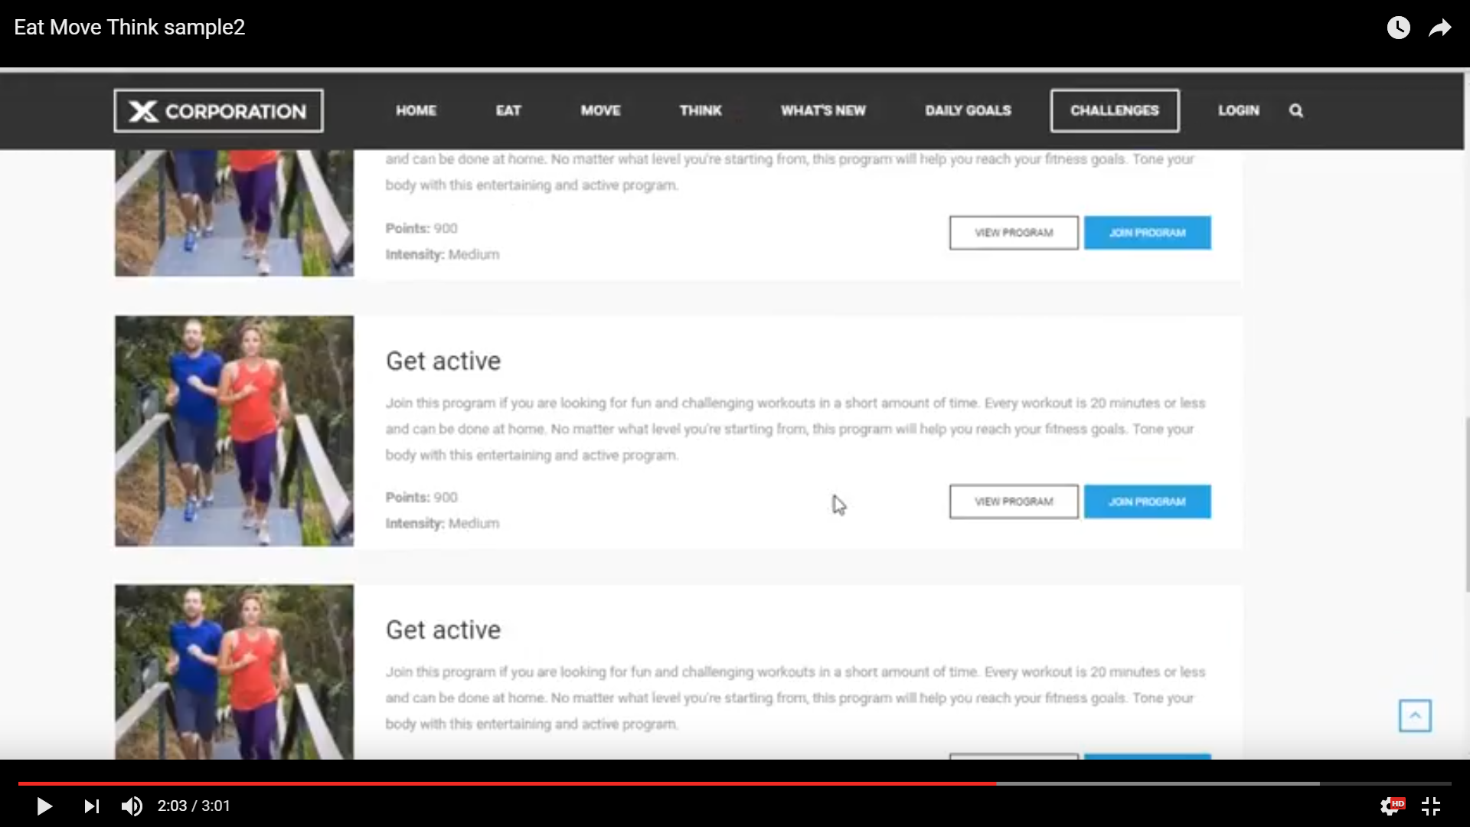

This should be in My program and leave challenges like sample 2.

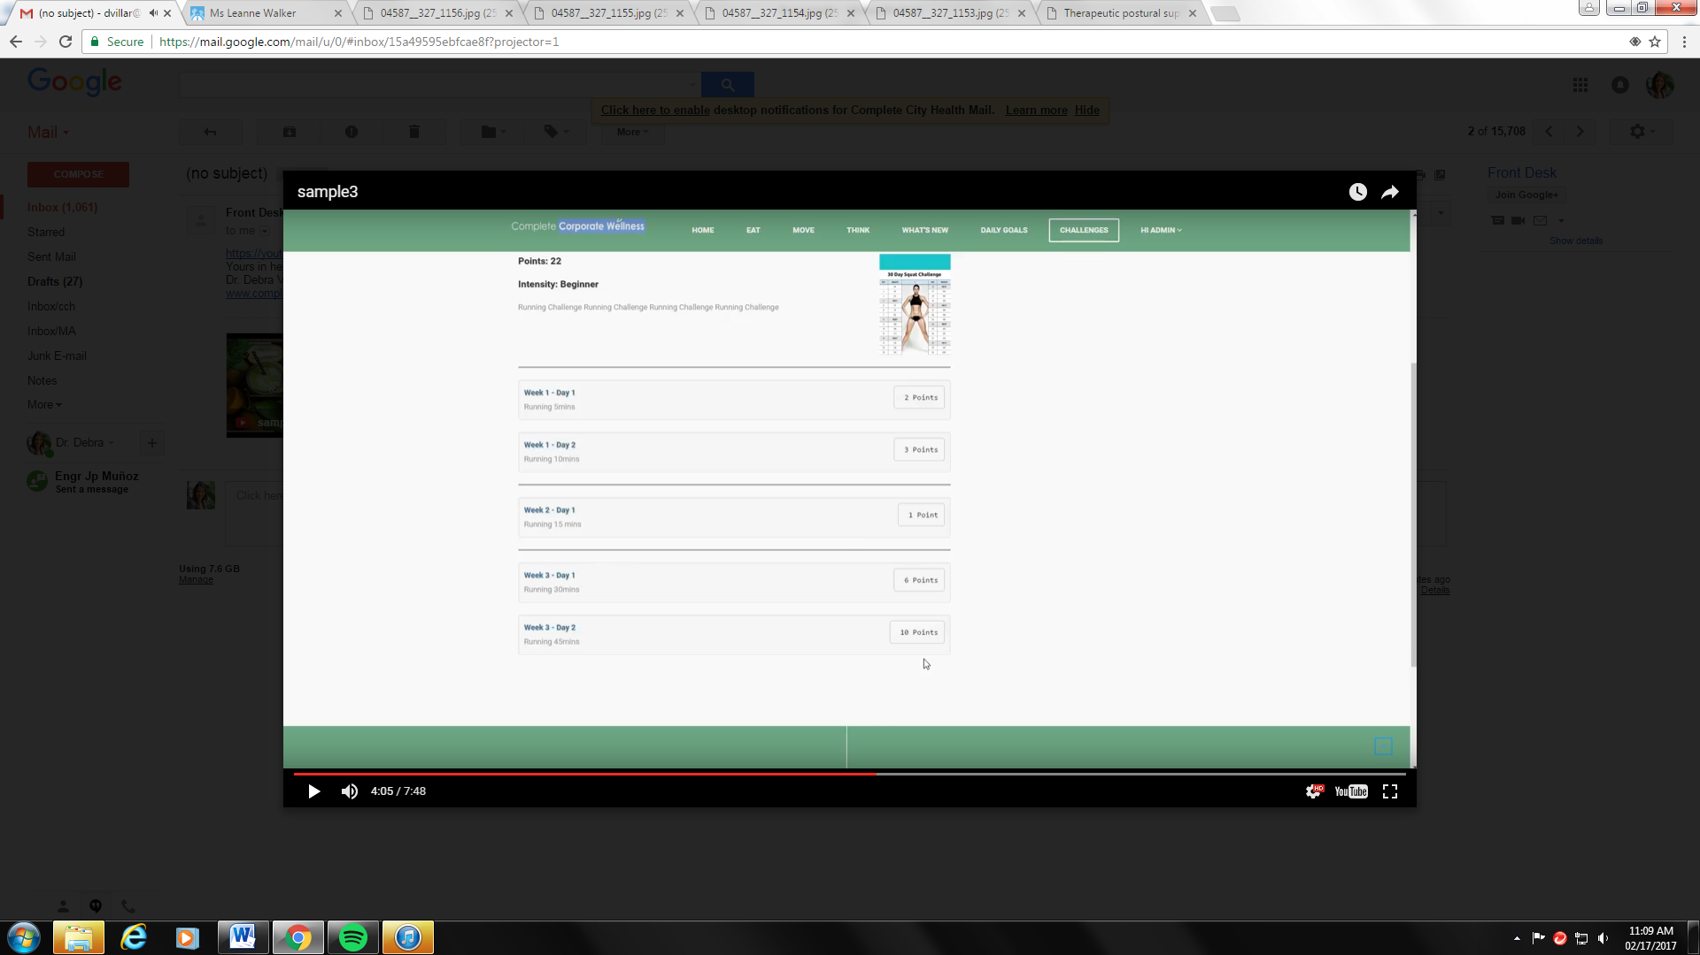

This information should be in daily goals tab. Like the sample before.

