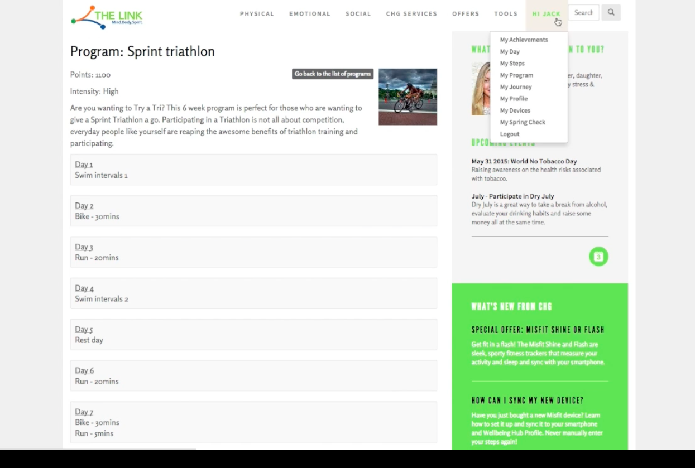

This pic is demonstrate the drop down menu for their profile:

My Achievements

EAT MOVE THINK goals

My programs

Book an Expert

1. My Achievements page

This will be the page that records each point that will record a point for each daily entry and for programs/challenges they complete.

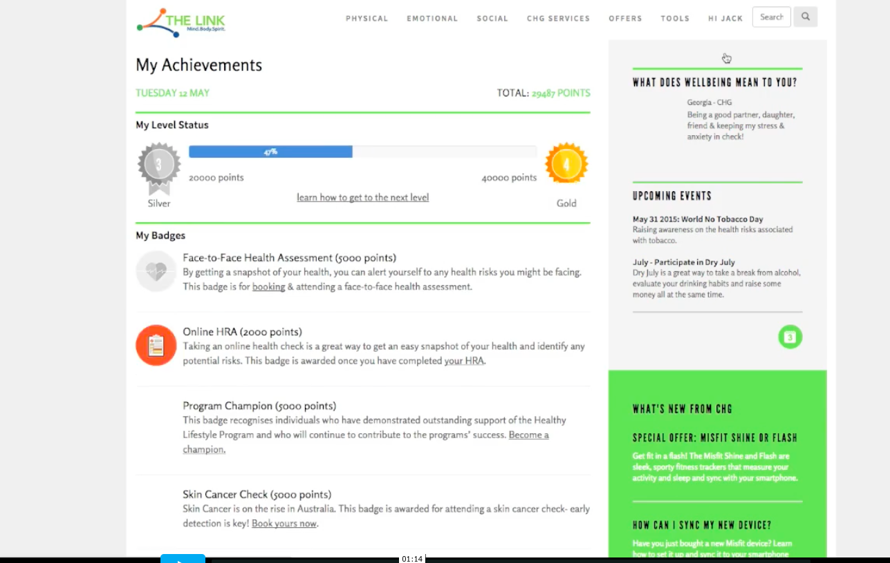

1. Eat Move Think Goals

This will be the drop down menu of daily achievements , if they do the entries it gives them one point for each

EAT ( 10 points total)

My water intake today was between 1and 3 litres - yes ( 1 point)

I have 4-7 servings of veggies (1 point)

I did not consume any processed foods ( 1 point)

My caffeine intake was one or less a day ( one point)

Breakfast dropdown ; Yes I made a healthy choice today (one point)

No, today I did not make a healthy choice

Snacks same as above 1 point

Lunch same as above 1 point

Dinner same as above 1 points

Alcohol Drop down menu Yes I had one or less glasses of Alcohol today (this is worth 2 points)

I had 2 or more glasses of alcohol today

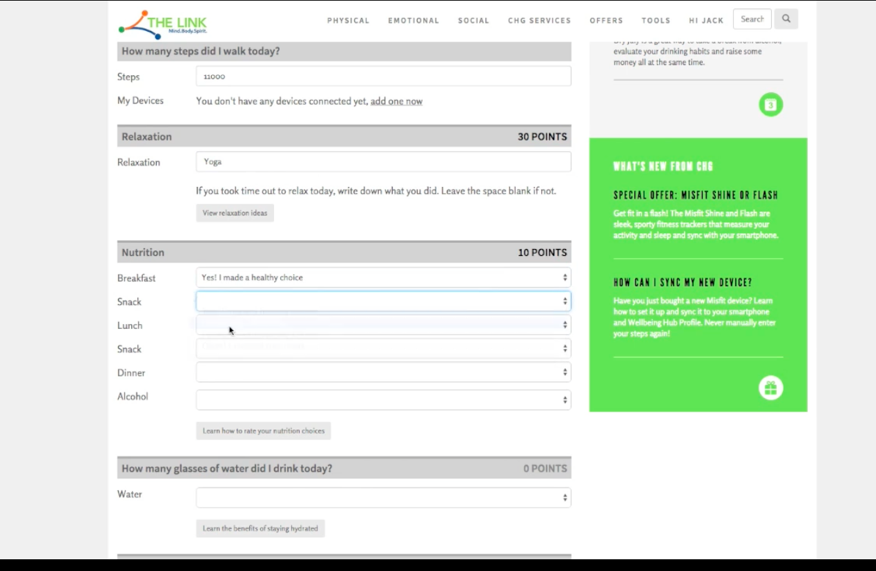

MOVE goals ( 10 Points)

I got up and walked from my desk every 30 minutes ( 2 points)

I exercises for more than 30 minutes today ( 2 points)

I stretched my body today ( 2 points)

I did some form of weight bearing exercises (squats, weights, push ups etc) ( 2 points)

I maintained good posture throughout my working day ( 2 points)

THINK GOALS ( 10 points)

I practiced deep diaphragmatic breathing today ( 2 points)

Today I meditated for 10 or more minutes ( 2 points)

I did something that I enjoy today ( 2 points)

I laughed and smiled today ( 2 points)

Today I said positive affirmations to start my day ( 2 points)

1. My Programs/Challenges

Records the programs they are working on at the moment

These are all from the EAT MOVE THINK tabs

1. Book an Expert

Will be a form that gets emailed to us

With

Name :

Surname:

Email:

Phone number:

Company Name:

Day and Time for appointment wanted:

Practitioner needed : dropdown - - General Practitioner

-Chiropractor

- Podiatrist

-Nutritionist

- Life coach

- Psychologist

- Personal trainer

THE MAIN TABS ON HOME PAGE WILL BE AS FOLLOWS:

HOME EAT MOVE THINK CCW OFFERS DAILY GOALS PROGRAMS/CHALLENGES LOGIN HI JACK

EAT TAB

THIS WILL CONTAIN INFORMATION THAT WILL BE UPDATED FORNIGHTLY BY ME

MOVE

PICTURES OF EXERCISES AND ARTICLES UPDATED FORTNIGHTLY BY ME

THINK

PICTURS AND ARTICLES UPDATED BY ME FORNIGHTLY

CCW OFFERS

GENERAL INFO UPDTAED FORNIGHTLY

DAILY GOALS

AS ABOVE OUTLINES

PROGRAMS/CHALLENGES TAB

THIS PAGE WILL HAVE PROGRAMS AND CHALLENGES THAT THE USER CAN CHOOSE AS PART OF A CHALLENGE I SET OR A PROGRAM THEY WANT TO DO

BEGINNER RUNNING PROGRAM -

FUNCTIONAL TRAINING PROGRAM-

IMPROVE YOUR POSTURE-

GET FIT TONE UP

MARATHON TRAINING

STRENGTHEN YOUR CORE

SQUAT CHALLENGE

PLANK CHALLENGE

FLEXIBILITY CHALLENGE

YOGA MOVES

PILATES MOVES

THEN THESE ARE CLICKED AND OPEN TO ANOTHER PAGE FOR EACH

WHERE THEY WILL RECORD IF THEY DO IT DAILY ( CARRIES 5 POINTS PER DAY)

EXAMPLE

BEGINNER RUNNING PROGRAM 5 KM RUN

|  |
| --- |
|  |
| WEEK 1  Walk fiffteen minutes three times a week for one week  DAY 1 WALK 15 MINUTES ( 2 POINTS)  DAY 2 WALK 15 MINUTES (2 POINTS)  DAY 3 WALK 15 MINUTES (2 POINTS) |
| WEEK 2  Walk fiffteen mins, with a five minute jog at the end of the walk, three times a week  DAY 1 WALK 15MINS JOG 5 MINUTES ( 2 POINTS)  DAY 2 WALK 15MINS JOG 5 MINUTES ( 2 POINTS)  DAY 3 WALK 15MINS JOG 5 MINUTES ( 2 POINTS) |
| ◊ Walk fifteen mins, with a ten minute jog at the end of the walk, three times a week |
| ◊ Walk fifteen minutes, then fifteen minute jog, three times a week |
| ◊ Walk ten minutes, then jog twenty minutes, three times a week |
| ◊ Walk FIve minutes, then jog thirty minutes, three times a week |

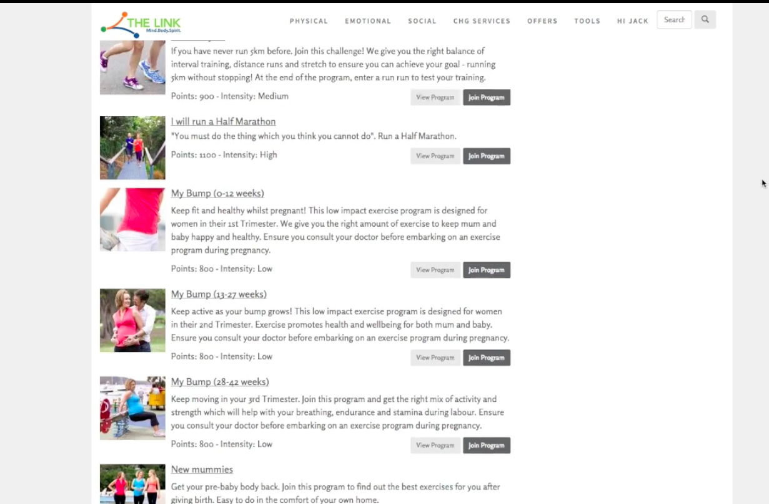

THESE WILL HAVE STATIC PICTURES OF THEM SO PLEASE ALLOW THAT IN LAYOUT

FUNCTIONAL TRAINING PROGRAM-

IMPROVE YOUR POSTURE-

GET FIT TONE UP

STRENGTHEN YOUR CORE

SQUAT CHALLENGE

PLANK CHALLENGE

FLEXIBILITY CHALLENGE

YOGA MOVES

PILATES MOVES