MAIN PAGE:

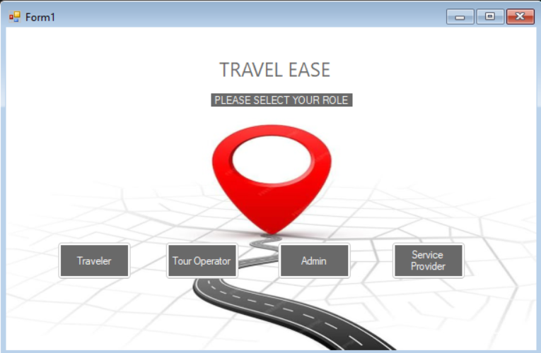

ADMIN LOGIN:

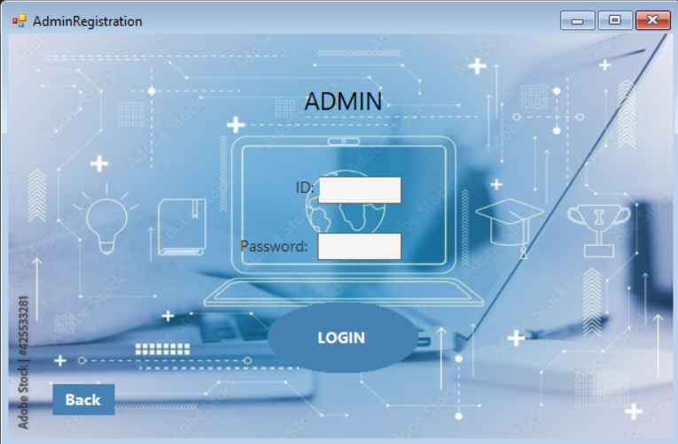

ADMIN MAIN PAGE:

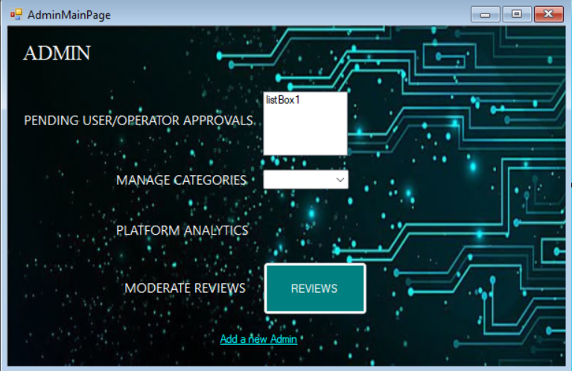

ADMIN - ADD NEW ADMIN:

OPERATOR LOGIN:

OPERATOR MAIN PAGE:

OPERATOR REGISTRATION

SERVICE PROVIDER

SERVICE PROVIDER MAIN PAGE:

SERVICE PROVIDER REGISTRATION:

TRAVELER LOGIN:

TRAVELER MAIN PAGE:

TRAVELER REGISTRATION:

