

PROJECT REPORT

Course: **Database Systems**

Instructor: **Mr. Majid Hussain**

**BY:**

Ruhab Ahmad **(23I-0559)**

Abdullah Salman **(23I-0597)**

Hisham Abdullah **(23I-0693)**

**ERD:**

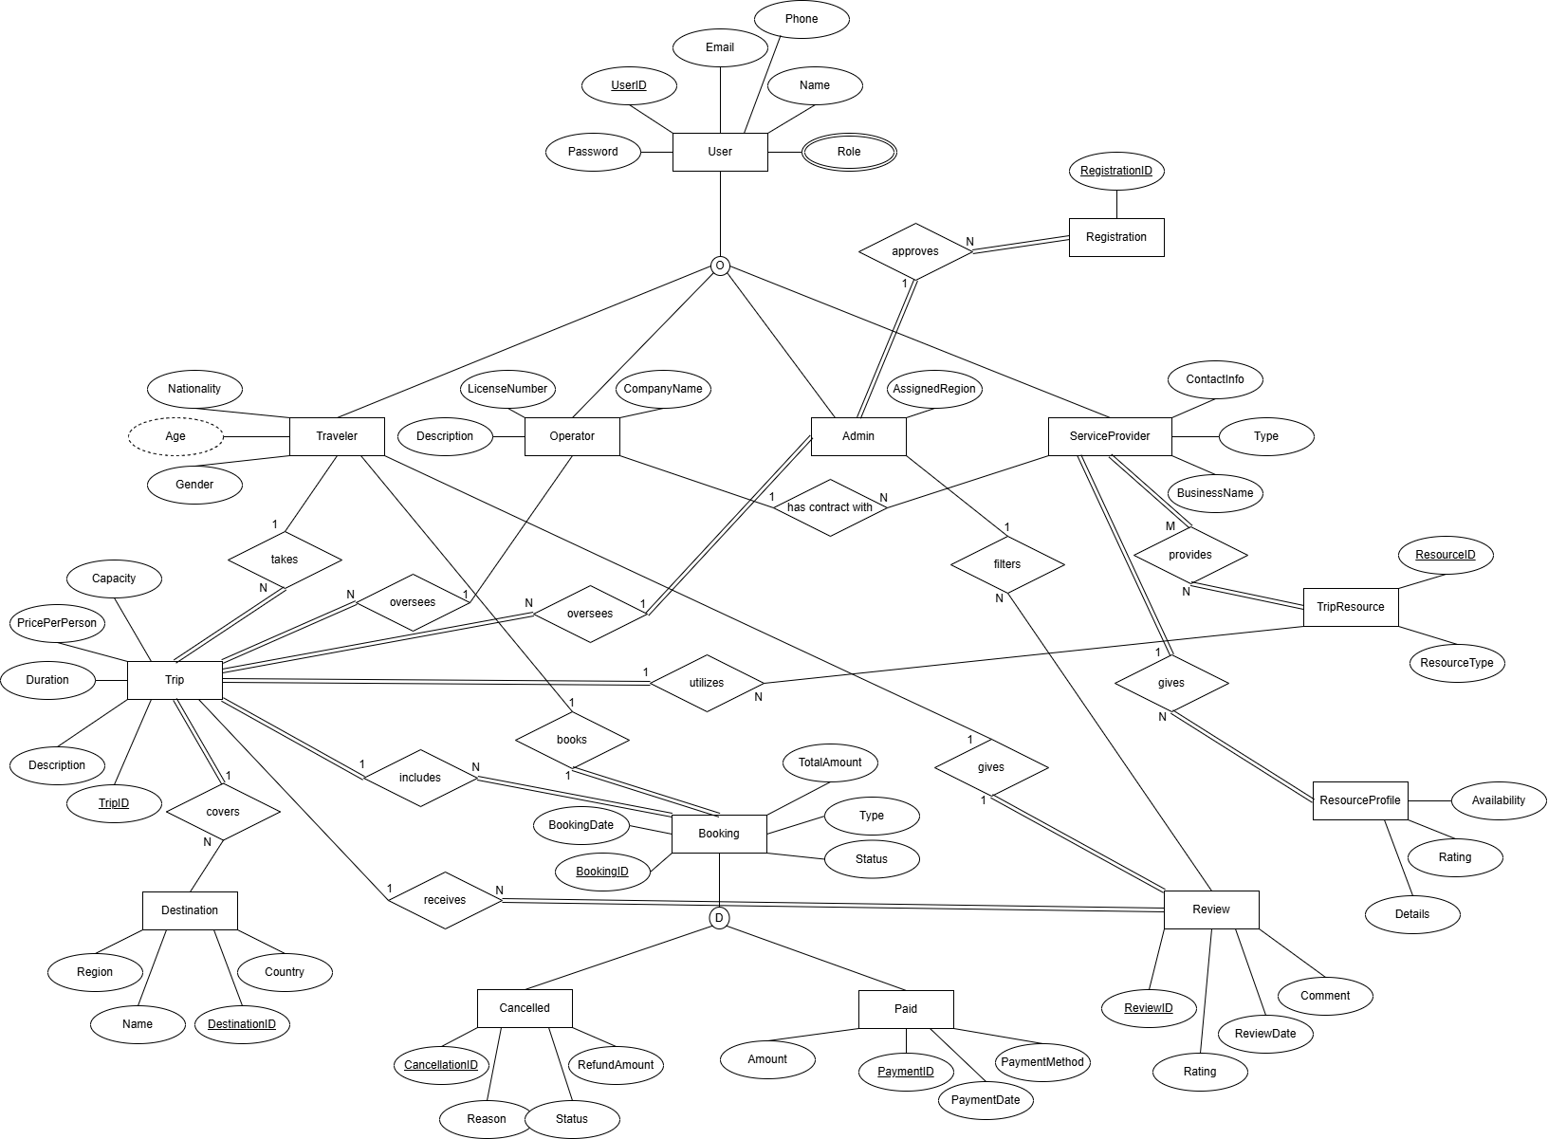

**TABLES:**

1. User(UserID, Name, Email, Phone, Password, Role)
2. Traveler(TravelerID*, Age, Gender, Nationality)
3. Operator(OperatorID*, LicenseNumber, CompanyName, Description)
4. Admin(AdminID*, AssignedRegion)
5. ServiceProvider(ProviderID*, ContactInfo, Type, BusinessName)
6. Trip(TripID, Capacity, Description, Duration, PricePerPerson, OperatorID*, DestinationID*)
7. Review(ReviewID, Rating, ReviewDate, Comment, TripID*, UserID*)
8. Booking(BookingID, BookingDate, Status, TotalAmount, TripID*, UserID*)
9. Paid(PaymentID, PaymentDate, PaymentMethod, Amount, TripID*, ProviderID*, UserID*)
10. Cancelled(CancellationID, RefundAmount, Reason, BookingID*)
11. Destination(DestinationID, Name, Country, Region)
12. TripResource(ResourceID, ResourceType, ProviderID*, TripID*)
13. ResourceProfile(ProviderID*, Availability, Details, Rating)
14. Registration(RegistrationID, AdminID*, TravelerID*)

**RELATIONS:**

1. **Traveler — Trip**
   * Traveler **takes** Trip (1 to N)
2. **Traveler — Booking**
   * Traveler **books** Booking (1 to N)
3. **Traveler — Review**
   * Traveler **gives** Review (1 to 1)
4. **Operator — Trip**
   * Operator **oversees** Trip (1 to N)
5. **Operator — ServiceProvider**
   * Operator **has contract with** ServiceProvider (1 to N)
6. **Trip — Destination**
   * Trip **covers** Destination (1 to N)
7. **Trip — Booking**
   * Trip **includes** Booking (1 to N)
8. **Trip — TripResource**
   * Trip **utilizes** TripResource (1 to N)
9. **Trip — Review**
   * Trip **receives** Review (1 to N)
10. **ServiceProvider — TripResource**
    * ServiceProvider **provides** TripResource (M to N)
11. **ServiceProvider — ResourceProfile**
    * ServiceProvider **gives** ResourceProfile (1 to N)
12. **Admin — Review**
    * Admin **filters** Review (1 to N)
13. **Admin — Registration**
    * Admin **approves** Registration (1 to N)

**SPECIALIZATION/GNERALIZATION:**

1. **Booking — Cancelled**
   * Booking **may be** Cancelled (Disjoint sub-relationship)
2. **Booking — Paid**
   * Booking **may be** Paid (Disjoint sub-relationship)
3. **User — Traveler**
   * User **is a** Traveler (Specialization/Generalization)
4. **User — Admin**
   * User **is a** Admin (Specialization/Generalization)
5. **User — Operator**
   * User **is a** Operator (Specialization/Generalization)
6. **User — ServiceProvider**
   * User **is a** ServiceProvider (Specialization/Generalization)