Exp No. 3 Date : 28-07-2019
BASIC SQL QUERIES - I

AIM:
To study basic SQL queries such as
1. SELECT
2. INSERT
3. UPDATE
4. DELETE

QUESTIONS:
Create a table named Employee and populate the table as shown below.

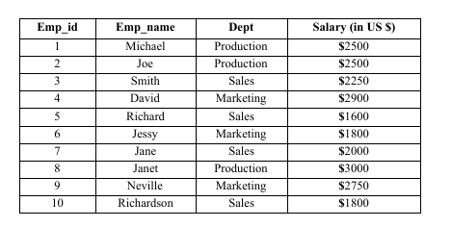

1. Create a database
Syntax: CREATE DATABASE <database_name>;

2. Connect to newly created database
Syntax: \c[onnect] <database_name>;

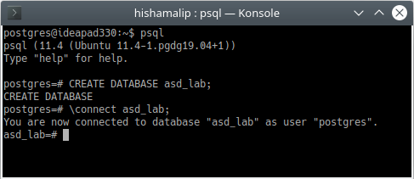

3. Create a table named Employee and populate the table.
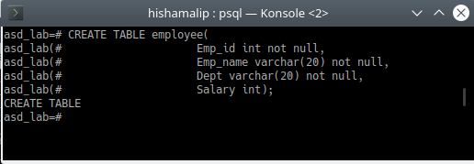

4. Inserting data into table
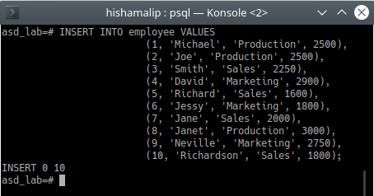

5. Display the details of all the employees.
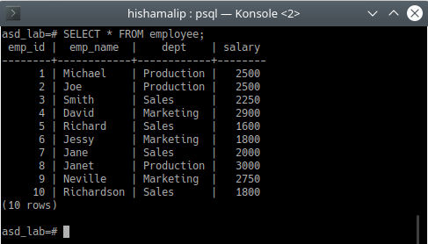

6. Display the names and id’s of all employees.
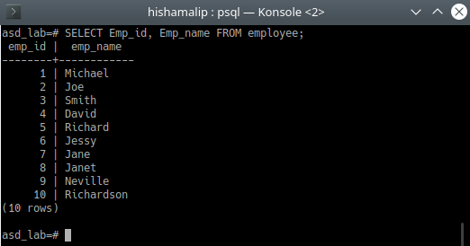

7. Delete the entry corresponding to employee id:10.
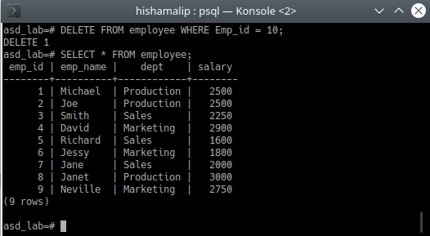

8. Insert a new tuple to the table. The salary field of the new employee should be kept NULL.
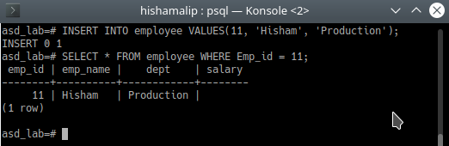

9. Find the details of all employees working in the marketing department.
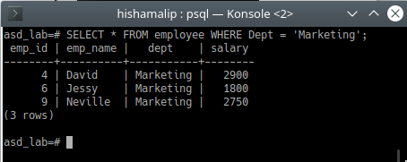

10. Add the salary details of the newly added employee.
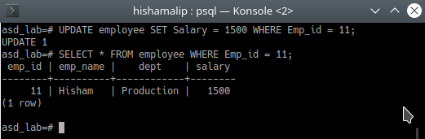

11. Update the salary of Richard to 1900$.
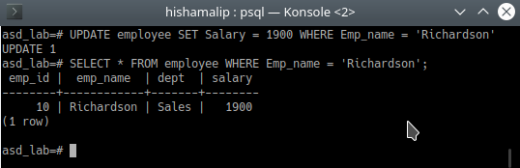

12. Find the details of all employees who are working for marketing and has a salary greater than 2000$.
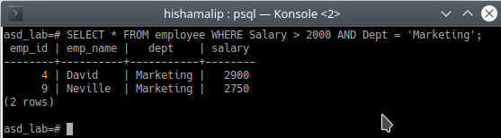

13. List the names of all employees working in the sales department and marketing department.
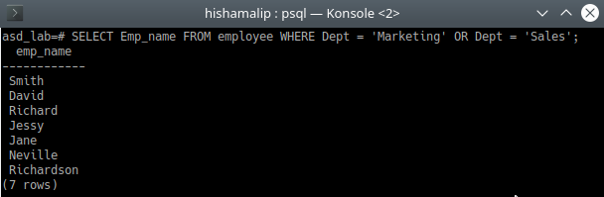

14. . List the names and department of all employees whose salary is between 2300$ and 3000$.
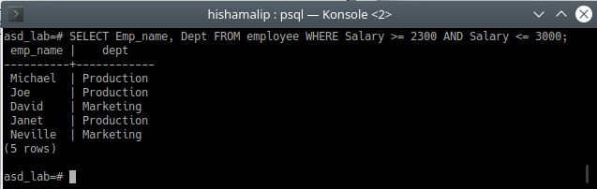

15. Update the salary of all employees working in production department 12%.

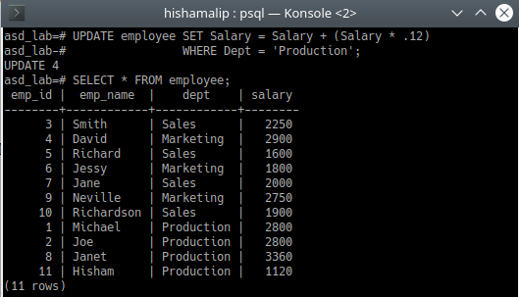

16. Display the names of all employees whose salary is less than 2000$ or working for sales department.
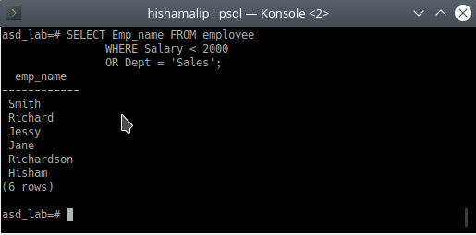

Result :
The query was executed and the output was obtained.

