Exp No: 8 Date : 14-08-2019

JOIN STATEMENTS, SET OPERATIONS,
NESTED QUERIES AND GROUPING

AIM:
To get introduced to
-UNION - JOIN
-INTERSECTION - NESTED QUERIES
-MINUS - GROUP BY & HAVING

QUESTION:
Amazon is one of the largest online stores operating in the United States of America. They are maintaining four tables in their database. The Items table, Customers table, Orders table and Delivery table. Each of these tables contains the following attributes:

Items: itemid (primary key)
Itemname(type =varchar(50))
category
Price
Instock (type=int, greater than or equal to zero)

Customers: custid (primary key)
Custname
Address
state

Orders: orderid (primary key)
Itemid( refers to itemid of Items table)
Quantity (type=int)
Orderdate (type=date)

Delivery:- delivery id (primary key)
Custid (refers to custid in customers table)
Orderid (refers to ordered in orders table)

Create the above tables and populate them with appropriate data.

- items
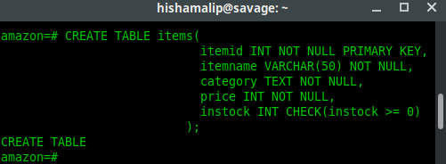

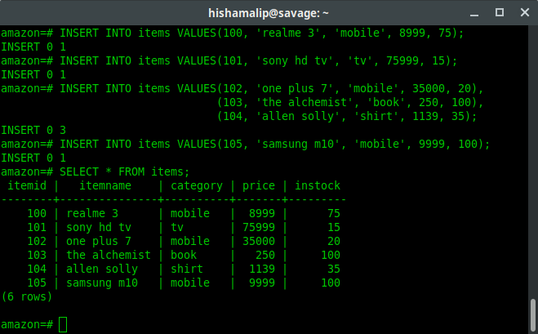

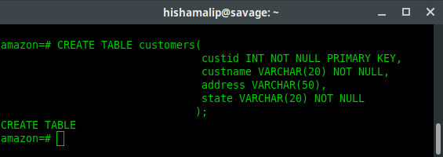
- customers

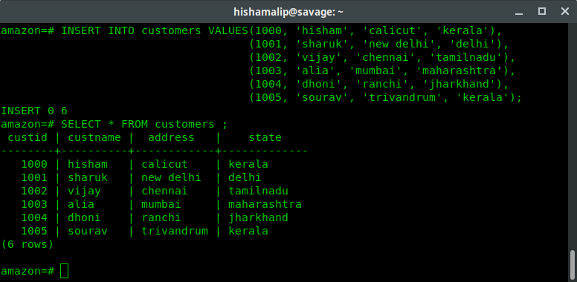

- orders

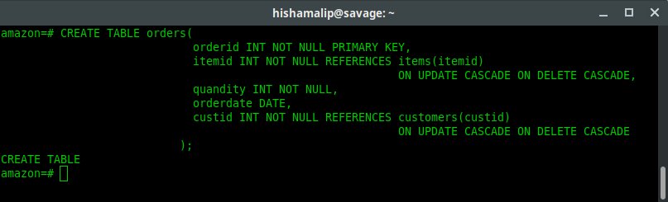

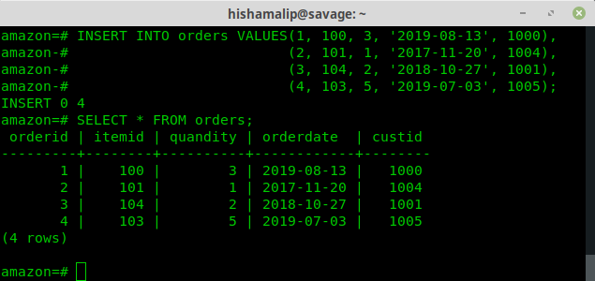

- delivary

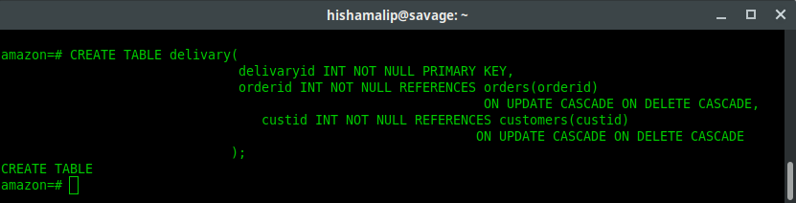

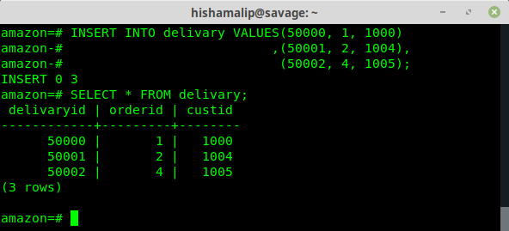

1. List the details of all customers who have placed an order
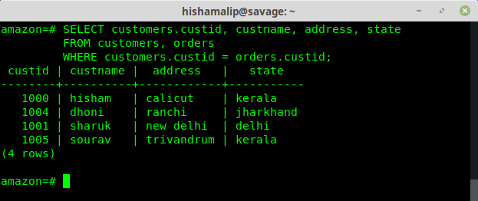

2. List the details of all customers whose orders have been delivered
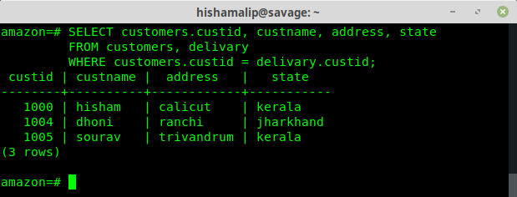

3. Find the order date for all customers whose name starts in the letter ‘S’
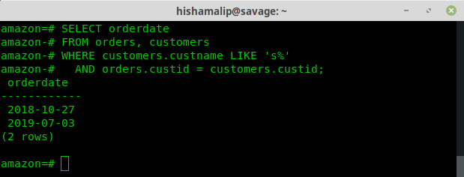
4.Display the name and price of all items bought by the customer ‘hisham’
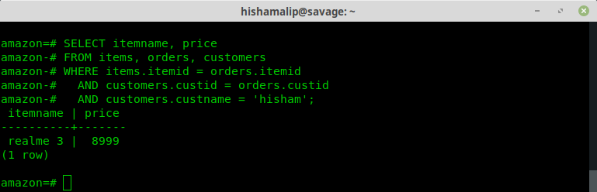

5. List the details of all customers who have placed an order after January 2013 and not received delivery of items.
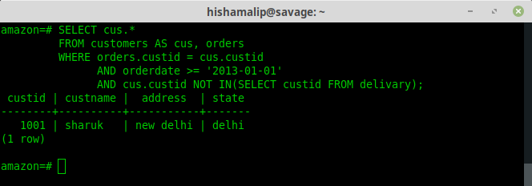

6.Find the itemid of items which has either been ordered or not delivered. (Use SET UNION)

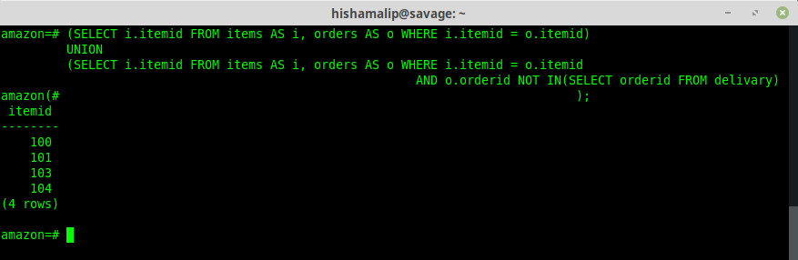

7. Find the name of all customers who have placed an order and have their orders delivered.(Use
SET INTERSECTION)
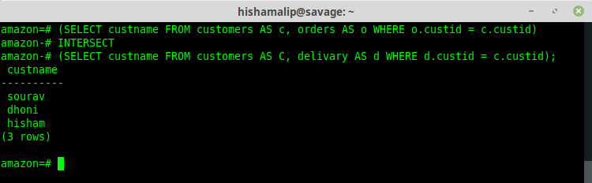

8. Find the custname of all customers who have placed an order but not having their ordersdelivered. (Use SET MINUS)
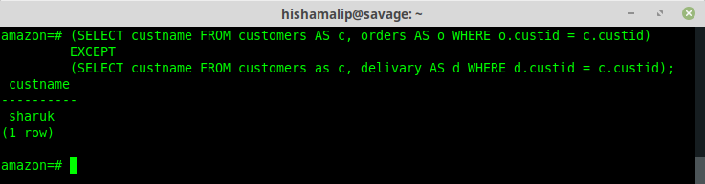

9. Find the name of the customer who has placed the most number of orders.
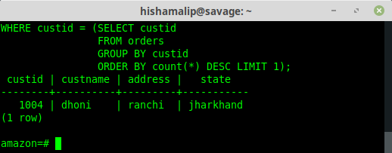

10. Find the details of all customers who have purchased items exceeding a price of 5000 $.
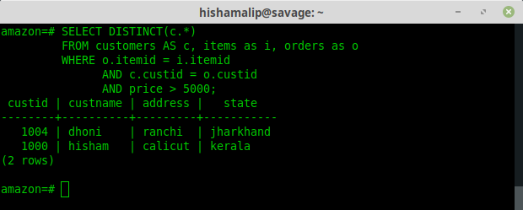
11. Find the name and address of customers who has not ordered a ‘sony hd tv’
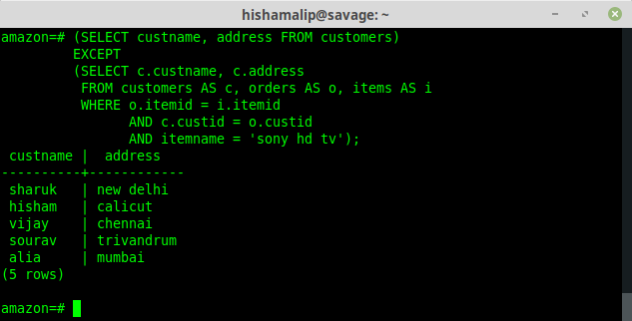
12. Perform Left Outer Join and Right Outer Join on Customers & Orders Table.
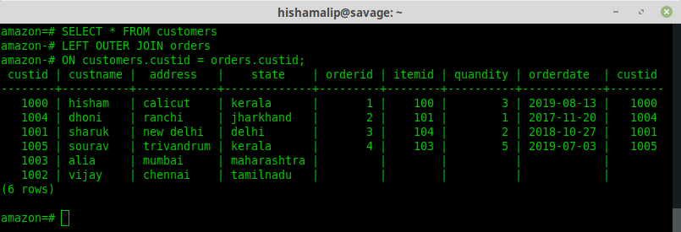
13. Find the details of all customers grouped by state

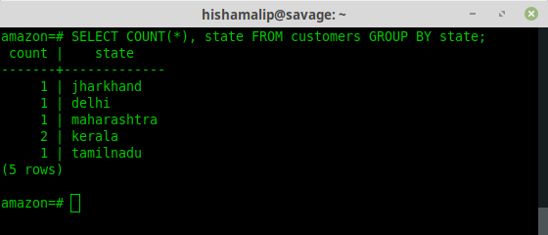
14. Display the details of all items grouped by category and having a price greater than the average price of all items.

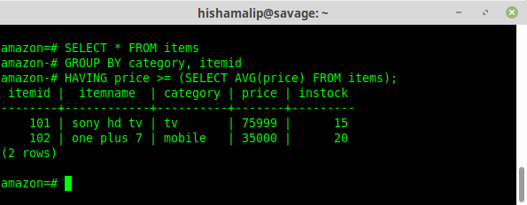

RESULT: The given set of queries are executed and output is obtained.

