Exp No. 6 Date : 14-08-2019

STRING FUNCTIONS AND PATTERN MATCHING

AIM:
String Functions & Pattern Matching
- SUBSTR - RPAD - INITCAP
- INSTR - LPAD - CONCAT
- LTRIM - UPPER - LENGTH
- RTRIM - LOWER - REVERSE

QUESTION:

Create a table named acct_details and populate the table as shown below.
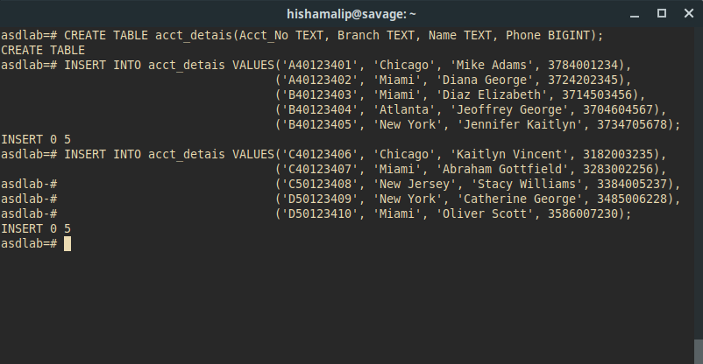
1. Find the names of all people starting on the alphabet ‘D’

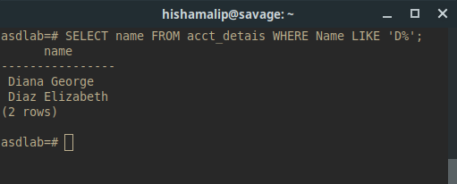

2. List the names of all branches containing the substring ‘New’
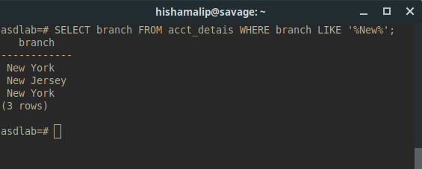

3. List all the names in Upper Case Format

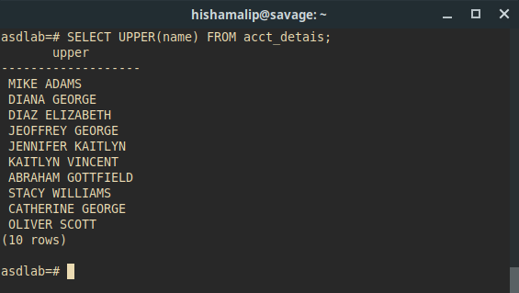

4. List the names where the 4th letter is ‘n’ and last letter is ‘n’

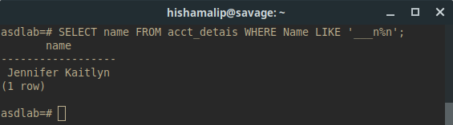
5. List the names starting on ‘D’ , 3​ rd​ letter is ‘a’ and contains the substring ‘Eli’
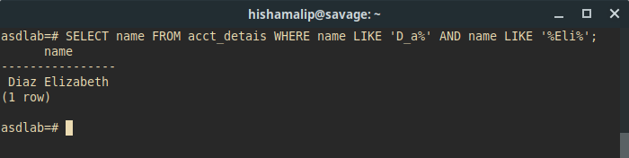

6. List the names of people whose account number ends in ‘6’
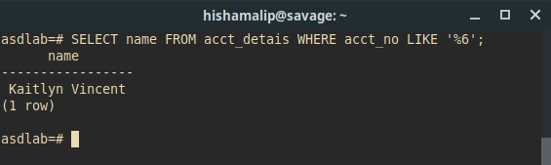

7. Update the table so that all the names are in Upper Case Format

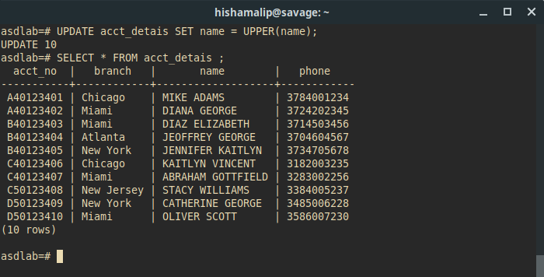

8. List the names of all people ending on the alphabet ‘t’

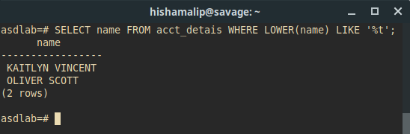

9. List all the names in reverse

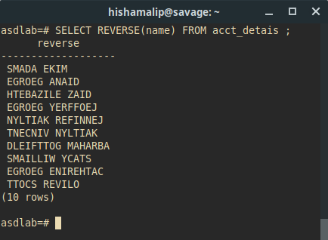

10. Display all the phone numbers including US Country code ( +1). For eg: (378)400-1234should
be displayed as +1(378)400-1234. Use LPAD function

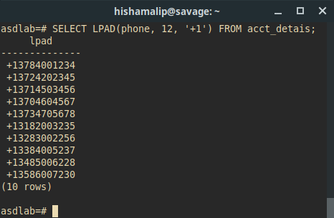

11. Display all the account numbers. The starting alphabet associated with the Account_Noshould
be removed. Use LTRIM function.

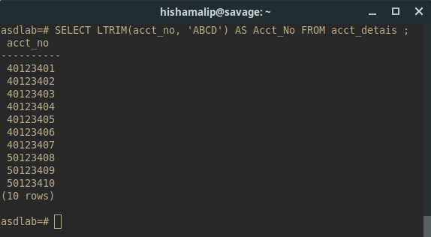

12. Display the details of all people whose account number starts in ‘5’ and name contains the substring ‘Williams’.
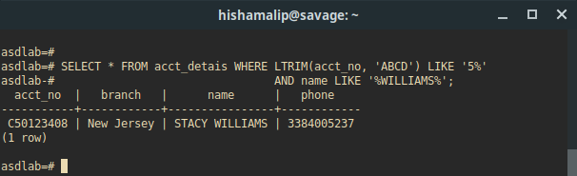

B. Use the system table DUAL for the following questions:

1. Find the reverse of the string ‘ nmutuAotedOehT’

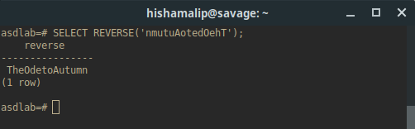

2. Use LTRIM function on ‘123231xyzTech’ so as to obtain the output ‘Tech’

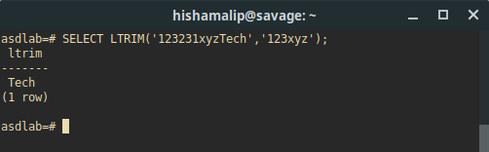

3. Use RTRIM function on ‘Computer ‘ to remove the trailing spaces.

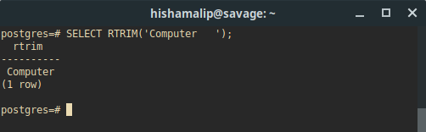

4. Perform RPAD on ‘computer’ to obtain the output as ‘computerXXXX’

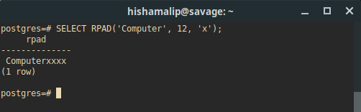

5. Use INSTR function to find the first occurrence of ‘e’ in the string ‘Welcome to Kerala’
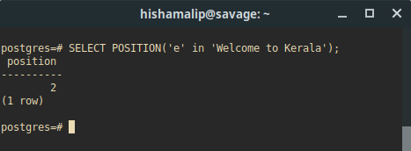

6. Perform INITCAP function on ‘mARKcALAwaY’
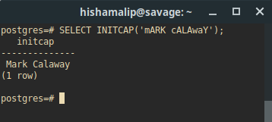

7. Find the length of the string ‘Database Management Systems’.

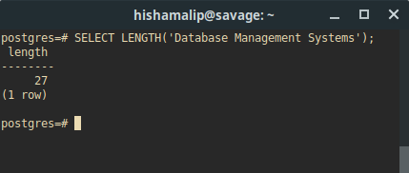

8. Concatenate the strings ‘Julius’ and ‘Caesar’
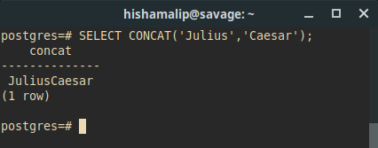

9. Use SUBSTR function to retrieve the substring ‘is’ from the string ‘India is my country’.

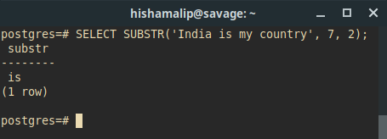

RESULT:
The query was executed and the output was obtained.

