Exp No. 10 Date : 19-08-2019
CURSOR

AIM:
To study the use and implementation of cursors in PL/SQL.

QUESTIONS:
1. Create table student (id, name, m1, m2, m3, grade). Insert 5 tuples into it. Find the total, calculate grade and update the grade in the table.

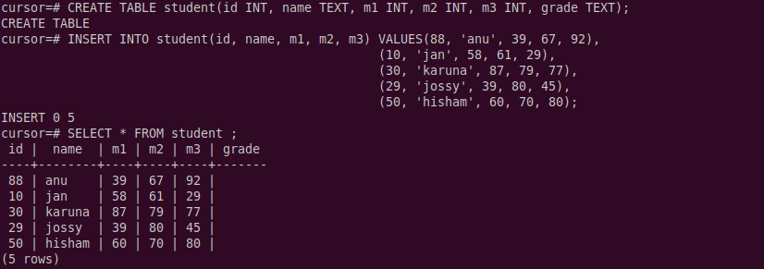
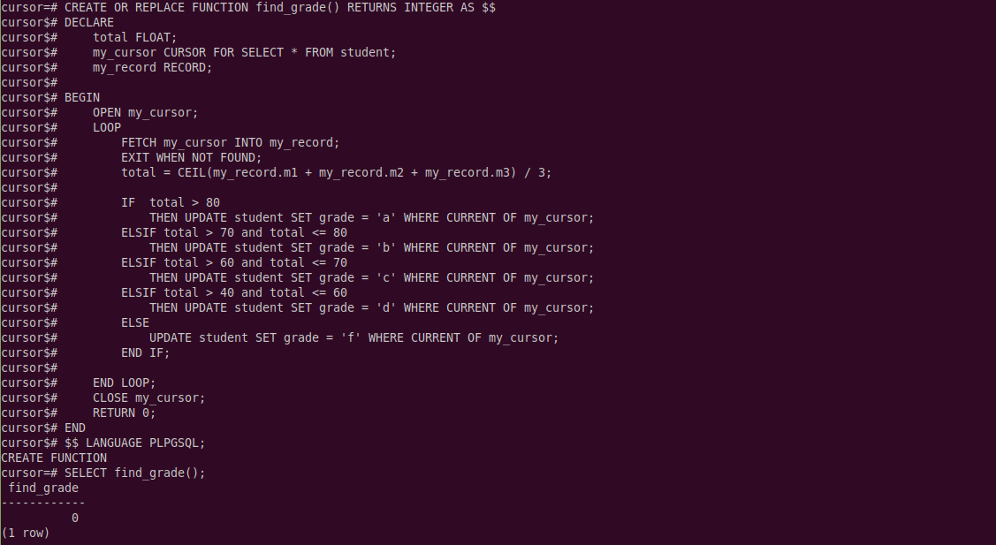
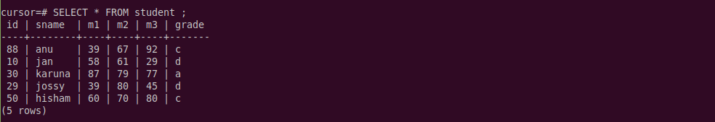

2. Create bank_details (accno, name, balance, adate). Calculate the interest of the amount and insert into a new table with fields (accno, interest). Interest= 0.08*balance.
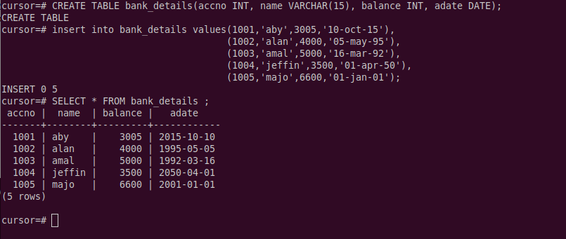

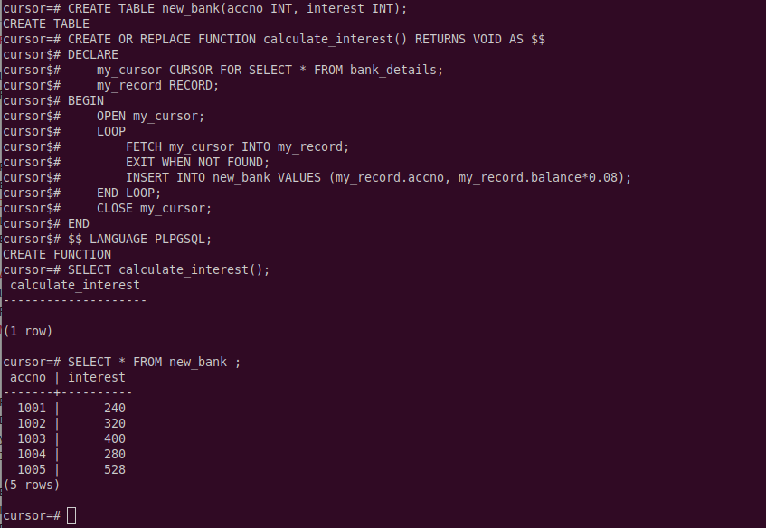

3. Create table people_list (id, name, dt_joining, place). If person’s experience is above 10 years, put the tuple in table exp_list (id, name, experience).
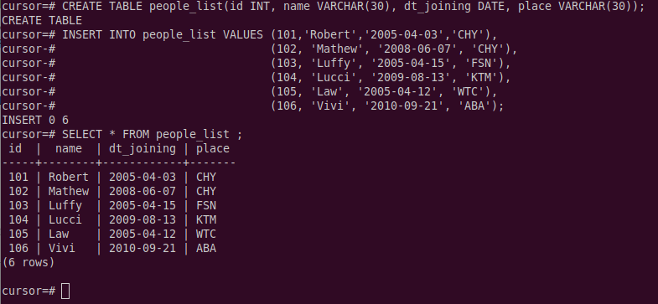
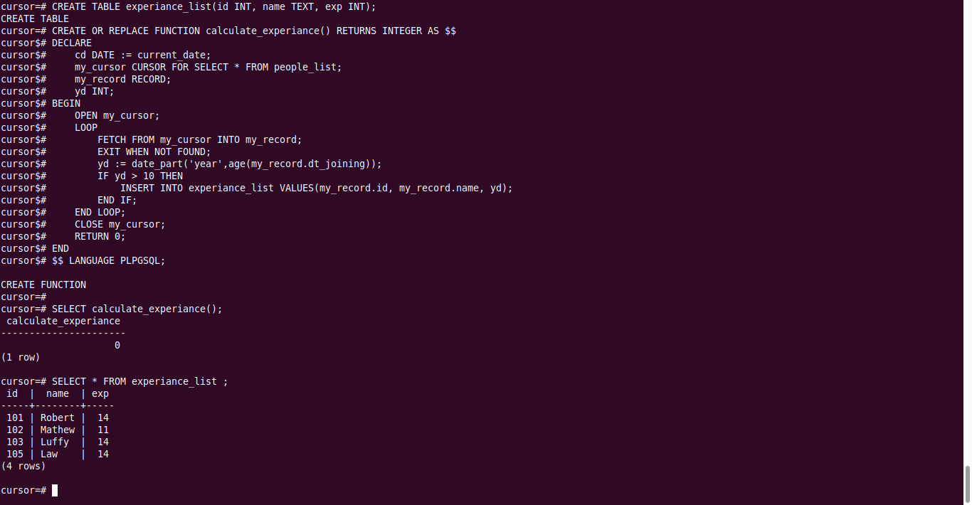

4. Create table employee_list(id, name, monthly salary).
If: annual salary < 60000, increment monthly salary by 25%
between 60000 and 200000, increment by 20%
between 200000 and 500000, increment by 15%
annual salary>500000, increment monthly salary by 10%
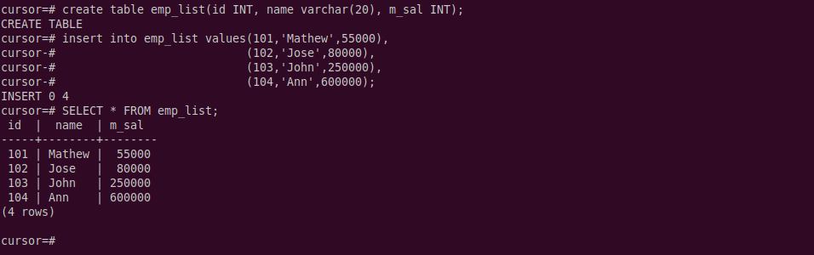
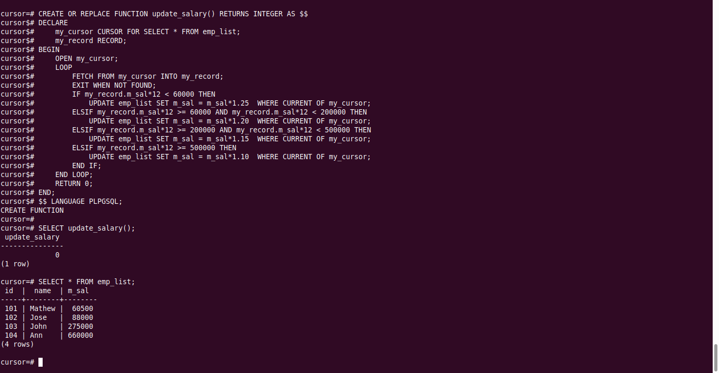

RESULT:
The cursor programs was executed successfully and the output was obtained.

