Exp No. 9 Date : 19-08-2019
PL/SQL AND SEQUENCE

AIM:
To study the basic pl/sql and sequence queries.

QUESTIONS:

1. To print the first ‘n’ prime numbers.

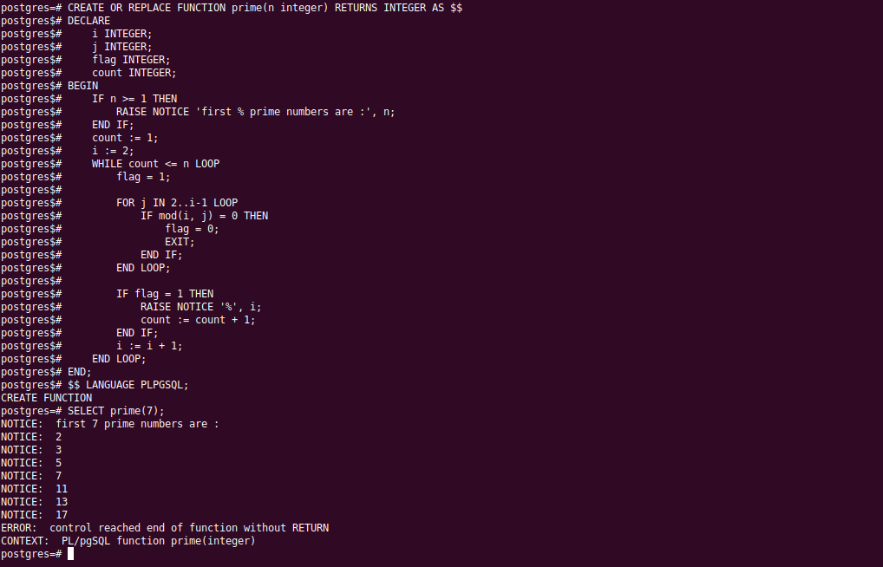

2. Display the Fibonacci series up to ‘n’ terms

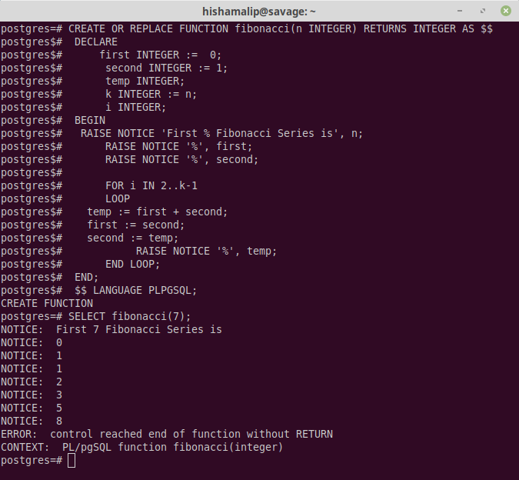

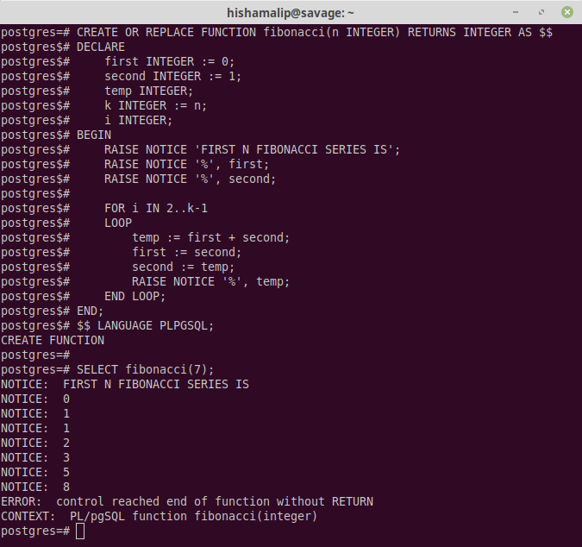

3. Create a table named student_grade with the given attributes:
roll, name ,mark1, mark2, mark3, grade. Read the roll, name and marks from the user.
Calculate the grade of the student and insert a tuple into the table using PL/SQL.
(Grade= ‘PASS’ if AVG >40, Grade = ‘FAIL’ otherwise)

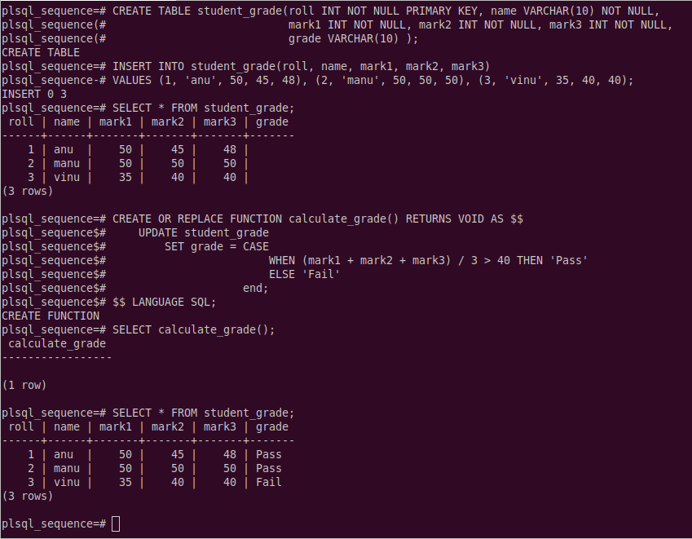

4. Create table circle_area (rad, area). For radius 5,10,15,20 &25., find the area and insert the corresponding values into the table by using loop structure in PL/SQL.
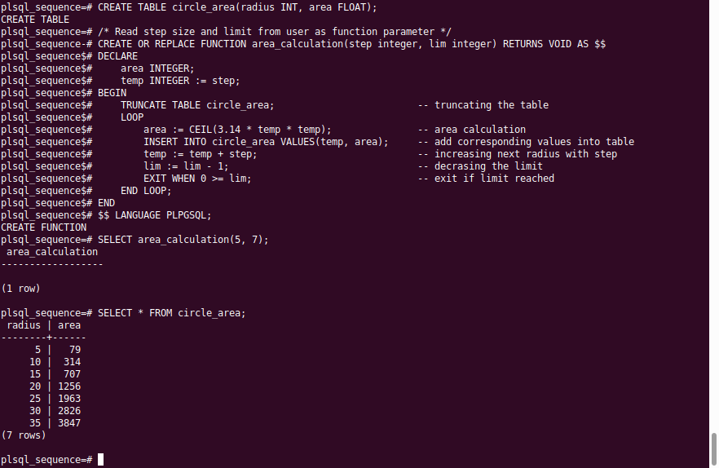

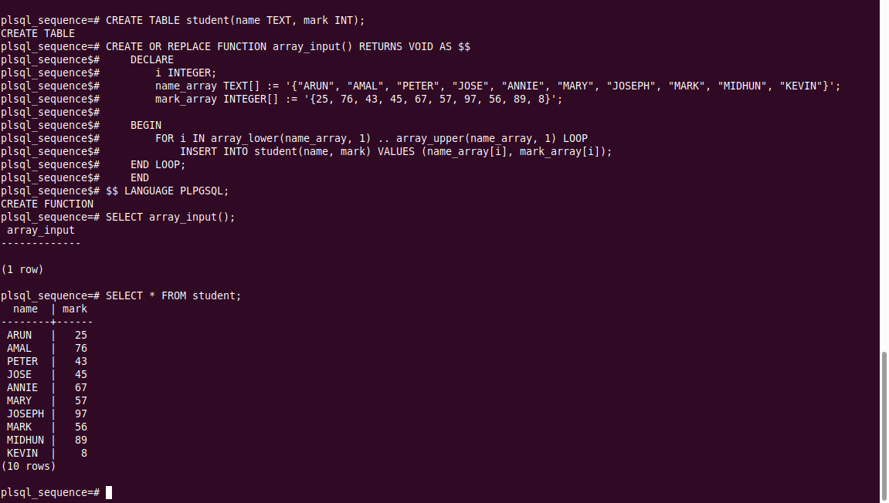
5. Use an array to store the names, marks of 10 students in a class. Using Loop structures in PL/SQL insert the ten tuples to a table named student
6. Create a sequence using PL/SQL. Use this sequence to generate the primary key values for a table named class_cse with attributes roll,name and phone. Insert some tuples using PL/SQL programming.

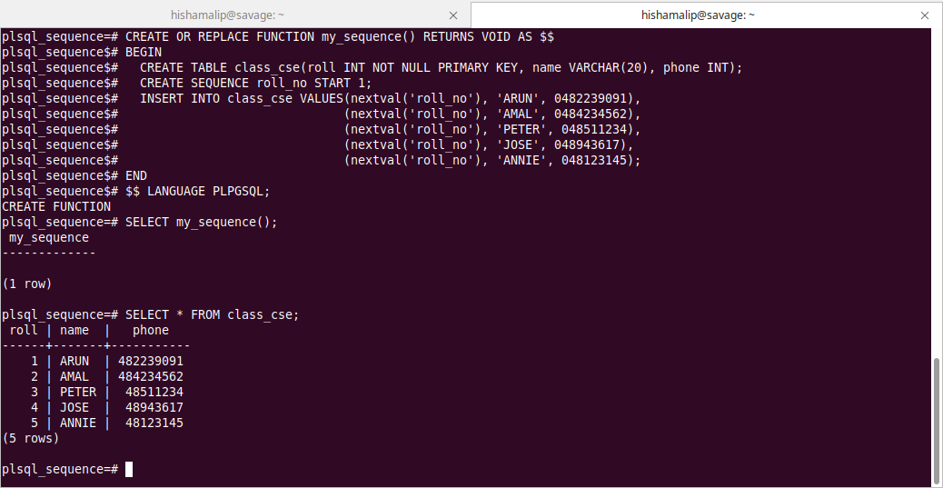

RESULT:
The PL/SQL program was executed successfully and the output was obtained.

