Exp No. 4 Date : 28-07-2019
BASIC SQL QUERIES - II

AIM:
Introduction to SQL statements
1. ALTER
2. RENAME
3. SELECT DISTINCT
4. SQL IN
5. SQL BETWEEN
6. SQL ALIASES
7. SQL AND
8. SQL OR

QUESTION:
Create a table named car_details and populate the table as shown below.
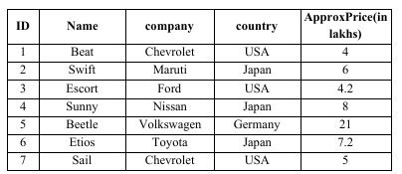

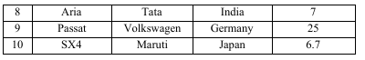

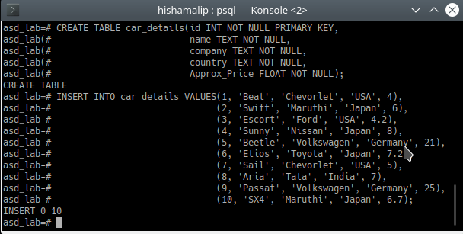

1. List the names of all companies as mentioned in the database

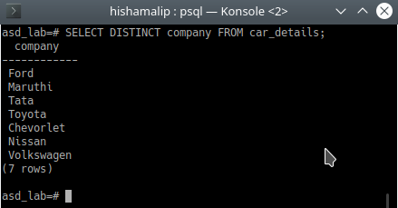

2. List the names of all countries having car production companies
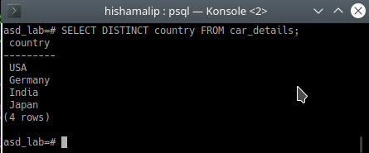

3. List the details of all cars within a price range 4 to 7 lakhs
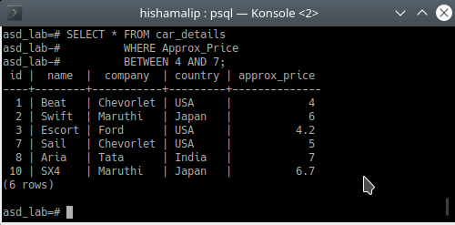

4. List the name and company of all cars originating from Japan and having price <=6 lakhs.

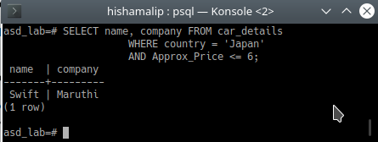

5. List the names and the companies of all cars either from Nissan or having a price greater than 20 lakhs.

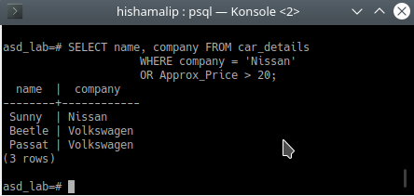

6. List the names of all cars produced by (Maruti, Ford).Use SQL IN statement.
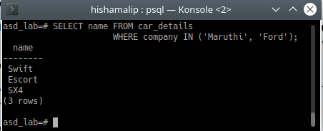

7. Alter the table cars to add a new field year (model release year). Update the year column for all the rows in the database.
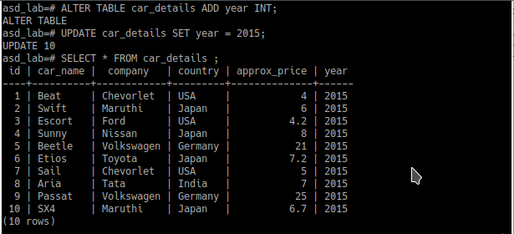
8. Display the names of all cars as Car_name (while displaying the name attribute should be listed as car_aliases)
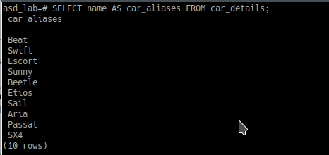

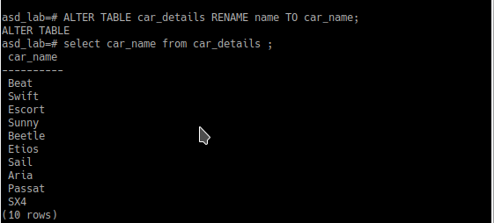
9. Rename the attribute name to car_name

10. List the car manufactured by Toyota(to be displayed as cars_Toyota)
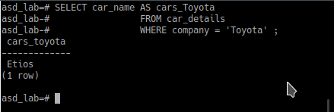

11. List the details of all cars in alphabetical order.
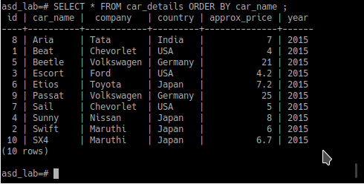

12. List the details of all cars from cheapest to costliest.

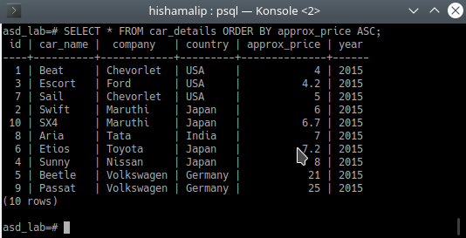

RESULT :
The query was executed successfully and output was verified.

