Exp No. 5 Date : 29-07-2019
DATA CONSTRAINTS AND VIEWS

AIM:
To study about various data constraints and views in SQL.

QUESTION:

1. Create the following tables with given constraints
a. Create a table named Subjects with the given attributes
* Subid (Should not be NULL)
* Subname (Should not be NULL)

Populate the database. Make sure that all constraints are working properly.
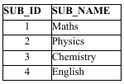

i) Alter the table to set subid as the primary key.

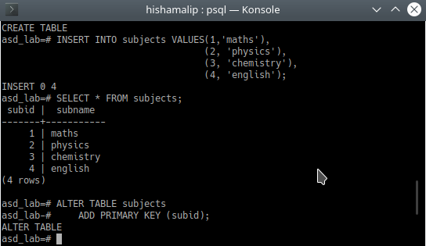

b. Create a table named Staff with the given attributes
- staffid (Should be UNIQUE)
- staffname
- dept
- Age (Greater than 22)
- Salary (Less than 35000)

Populate the database. Make sure that all constraints are working properly.
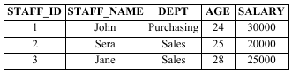

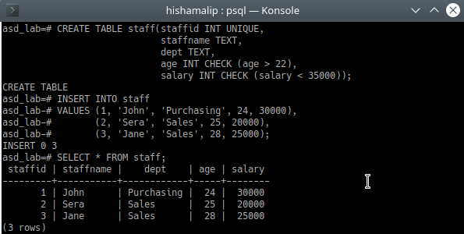

i) Delete the check constraint imposed on the attribute salary
ii) Delete the unique constraint on the attribute staffid
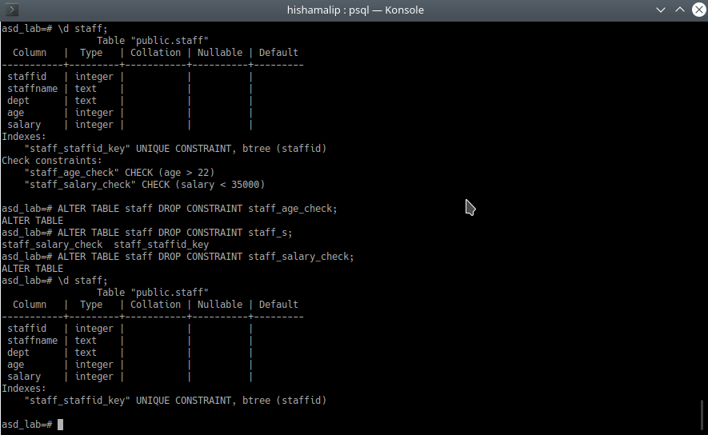

c. Create a table named Bank with the following attributes
-bankcode (To be set as Primary Key, type = varchar(3) )
-bankname (Should not be NULL)
-headoffice
-branches (Integer value greater than Zero)

Populate the database. Make sure that all constraints are working properly. All constraints have to be set after creating the table.

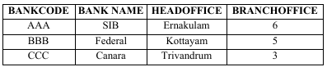

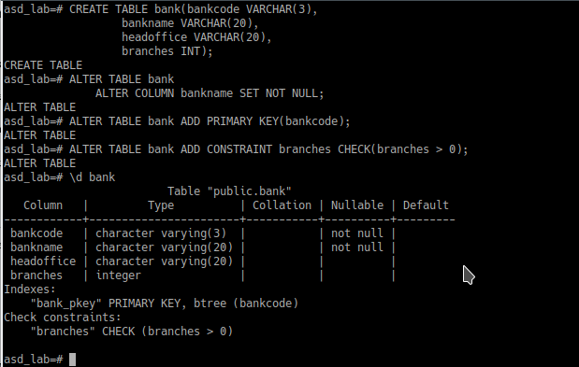

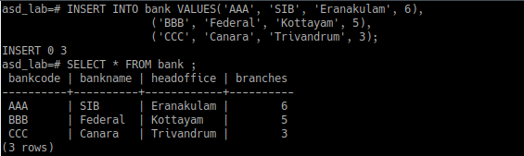

d. Create a table named Branch with the following attributes
-branchid (To be set as Primary Key)
-branchname (Set Default value as ‘New Delhi’)
-bankid (Foreign Key:- Refers to bank code of Bank table)

i) Populate the database. Make sure that all constraints are working properly.
ii) During database population, demonstrate how the DEFAULT Constraint is satisfied.
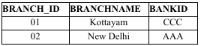

i)
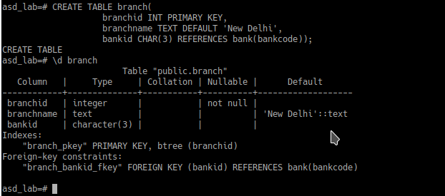

ii)
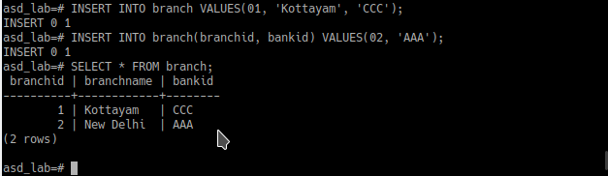
iii) Delete the bank with bank code ‘SBT’ and make sure that the corresponding entries are getting deleted from the related tables.

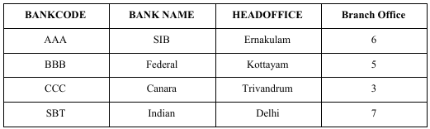

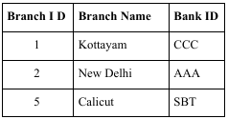

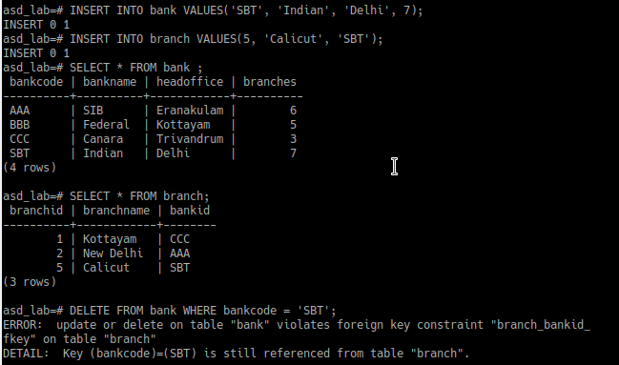

When trying to delete bankcode = ‘SBT’ from “bank” table, we got an error because it is still referenced from table “branch” . We can’t delete a foreign key if it still references another table.

To make the corresponding entries are getting deleted from the related tables we need to add ‘ON DELETE CASCADE’ to the existing foreign key. In order to do this, drop the existing constraint and recreate it with addition of the ‘ON DELETE’ clause.

After deletion


iv) Drop the Primary Key using ALTER command
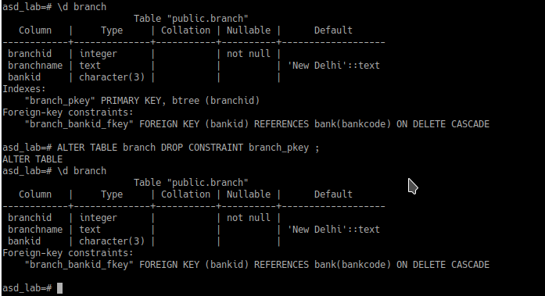
2. Create a View named sales_staff to hold the details of all staff working in sales Department
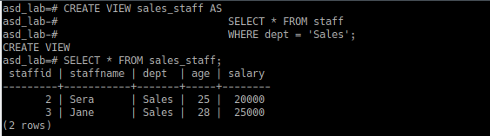

3. Drop table branch. Create another table named branch and name all the constraints as given below:
Constraint name Column Constraint
Pk branch_id Primary key
Df branch_name Default : ‘New Delhi’
Fk bankid Foreign key/References
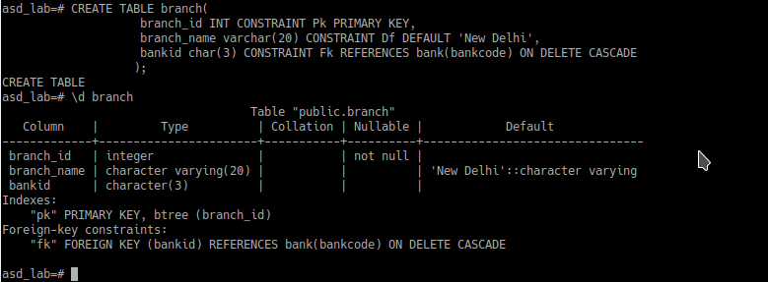

i) Delete the default constraint in the table
ii) Delete the primary key constraint
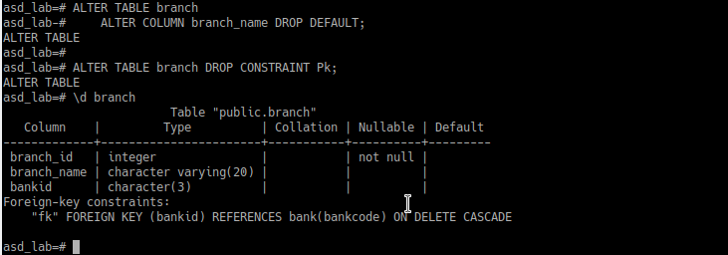
4. Update the view sales_staff to include the details of staff belonging to sales department whose salary is greater than 20000.
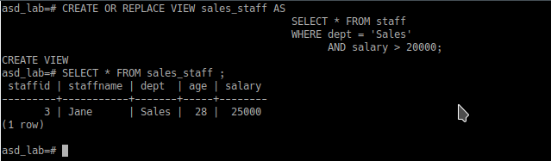

5. Delete the view sales_staff.
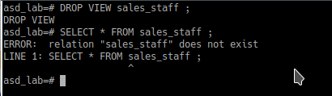

RESULT:
The query was executed and the output was obtained.

