Exp No. 12 Date : 23-08-2019 PROCEDURES, FUNCTIONS AND PACKAGES

AIM:
To study Procedures, Functions and Packages

QUESTIONS:
1. Create a function factorial to find the factorial of a number. Use this function in a PL/SQL Program to display the factorial of a number read from the user

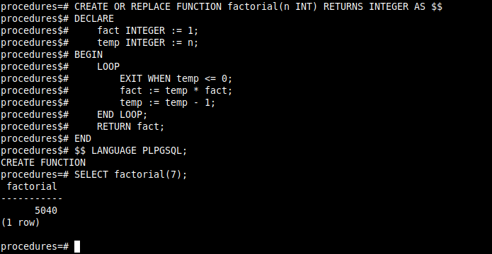

- Create a table student_details(roll int, marks int, phone int). Create a procedure pr1 to update all rows in the database. Boost the marks of all students by 5%
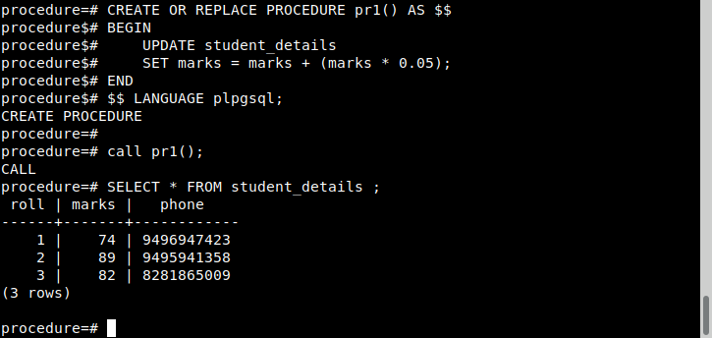
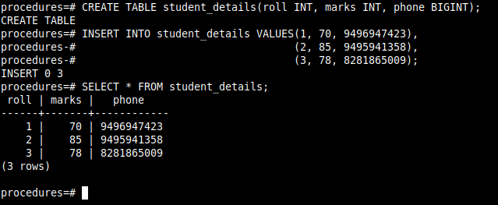

3. Create table student (id, name, m1, m2, m3, total, grade). Create a function f1 to calculate grade. Create a procedure p1 to update the total and grade
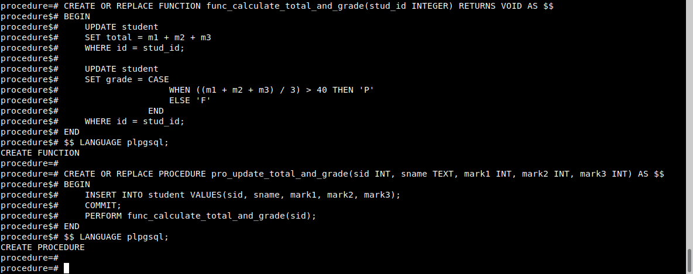

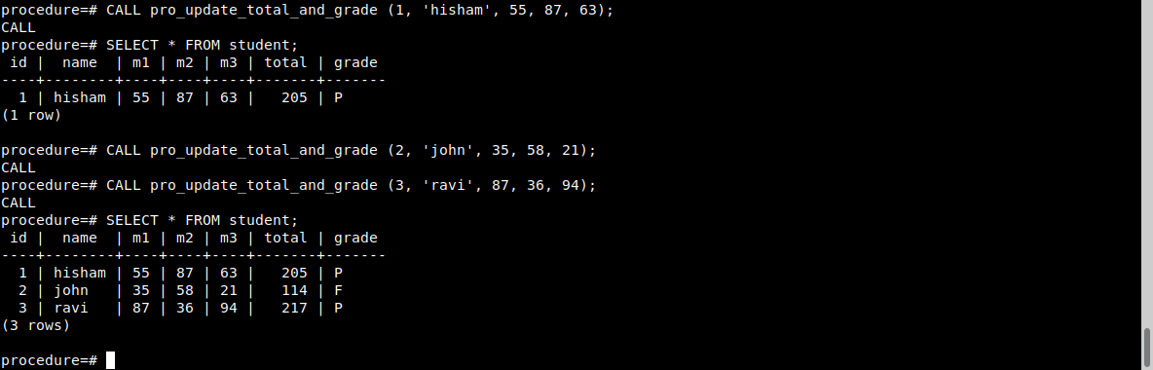

4 .Create a package pk1 consisting of the following functions and procedures
Procedure proc1 to find the sum, average and product of two numbers
Procedure proc2 to find the square root of a number
Function named fn11 to check whether a number is even or not
A function named fn22 to find the sum of 3 numbers
Use this package in a PL/SQL program. Call the functions f11, f22 and procedures pro1, pro2 within the program and display their results.

Creating schema pk1 procedures

Creating procedures

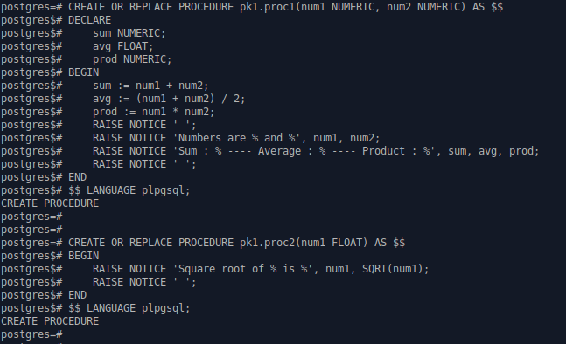

Creating functions

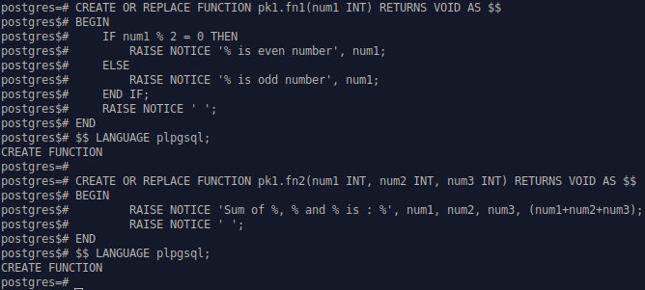

Creating procedure to call functions and procedures inside schema

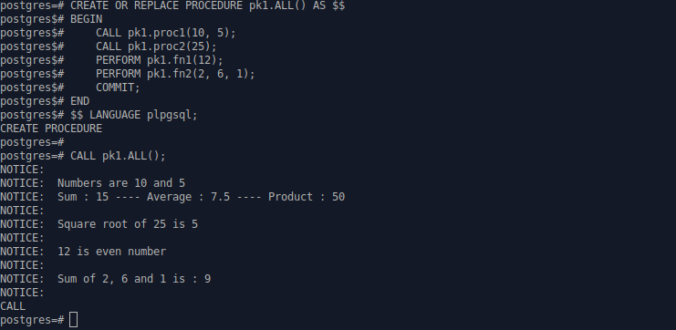

RESULT:

The PL/SQL program was executed successfully and the output was obtained.

