Assignment – 3

Aim : To learn to set up a complete network interface by configuring services such as gateway, DNS, IP tables etc. using ifconfig.

1. ifconfig – configure a network interface
Purpose : Ifconfig is used to configure the kernel-resident network interfaces. It is used at boot time to set up interfaces as necessary. After that, it is usually only needed when debugging or when system tuning is needed.
Options :
-a : display all interfaces which are currently available, even if down
-s : display a short list

# Viewing the configuration of all interfaces
Input : ifconfig -a
Output :
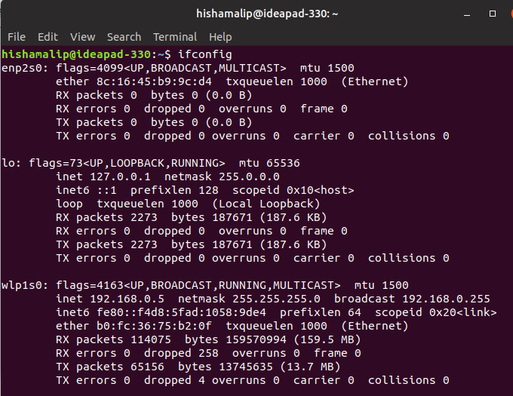

#Viewing the configuration of specific interfaces
Input : ifconfig wlp1s0
Output :
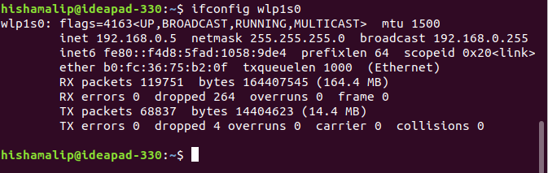

2. Up and Down
Purpose : To enabling and disabling an Interface

#To enable down an interface
Usage : sudo ifconfig <interface_name> down
Input : sudo ifconfig enp2s0 down
Output :
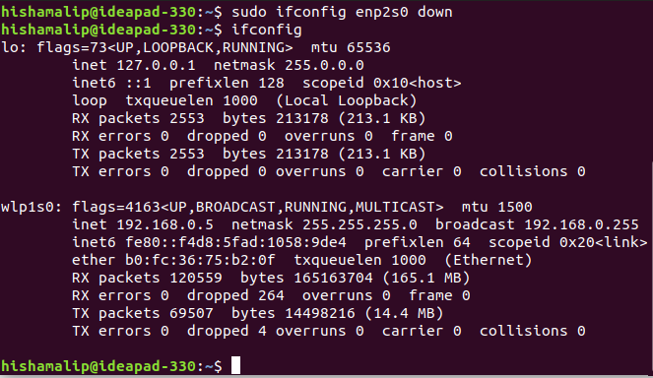
#To enable up an interface
Usage : sudo ifconfig <interface_name> up
Input : sudo ifconfig enp2s0 up
Output :
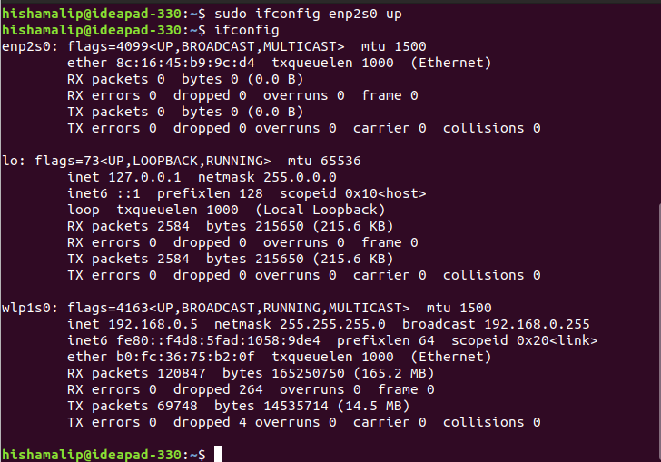
3. Configuring an Interface
Purpose : To configure (or re-configure) a network interface. This is often unnecessary, since this configuration is typically handled by a script when you boot the system.
#Assign an ip address to interface
Usage : sudo ifconfig <inteface_name> <ip_address>
Input : sudo ifconfig enp2s0 69.72.169.1
Output :
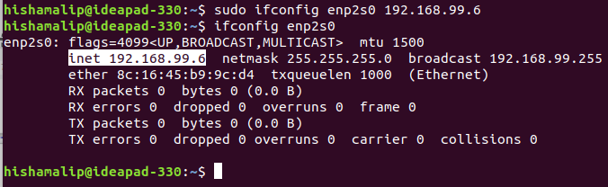
4. Assign the IP and the netmask
Usage : sudo ifconfig <interface> <ipaddress> netmask <netmask adress> up
Input : sudo ifconfig enp2s0 10.1.1.60 netmask 255.255.255.0 up
Output :
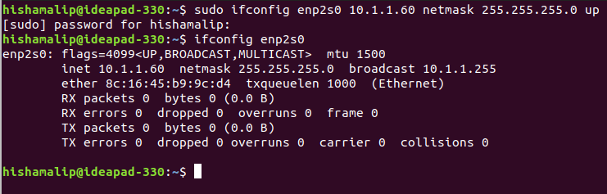
5. To add the default Gateway
Usage : sudo route add default gw <gateway address>
Input : sudo route add default gw 10.1.1.1
Output :
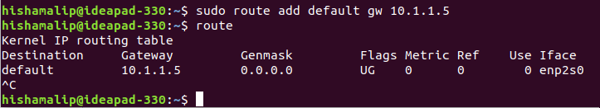
6. To assign a DNS server
Usage :

