Assignment – 4
Version Control System setup and usage using GIT

Date : 23-02-2019

Aim
Version Control System setup and usage using GIT. Try the following features
1. Creating a repository
2. Checking out a repository
3. Adding content to the repository
4. Committing the data to a repository
5. Updating the local copy
6. Comparing different revisions
7. Revert
8. Conflicts and a conflict Resolution

GIT
Git is the most commonly used version control system today and is quickly becoming the standard for version control. Git is a distributed version control system, meaning your local copy of code is a complete version control repository. These fully-functional local repositories make it is easy to work offline or remotely. You commit your work locally, and then sync your copy of the repository with the copy on the server. This paradigm differs from centralized version control where clients must synchronize code with a server before creating new versions of code.

Git-Hub
GitHub is a Web-based Git version control repository hosting service. It provides all of the distributed version control and source code management (SCM) functionalities of Git while topping it with a few of its own features. It is a heaven for the developers where they can store their projects and get connected with like-minded people.

1. Creating a repository
By using GitHub - GitHub is a code hosting platform for version control and collaboration

#Create a new repository on GitHub.

Steps

(a) In github profile, on the upper right corner click ‘+’ and then select New repository.
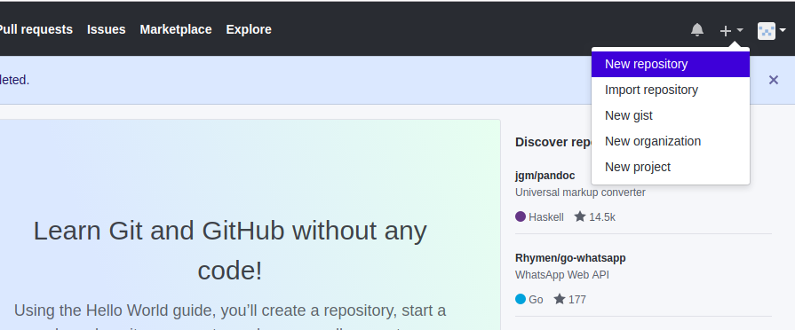

(b) Write a name for repository, write a short description about repository and click create repository.
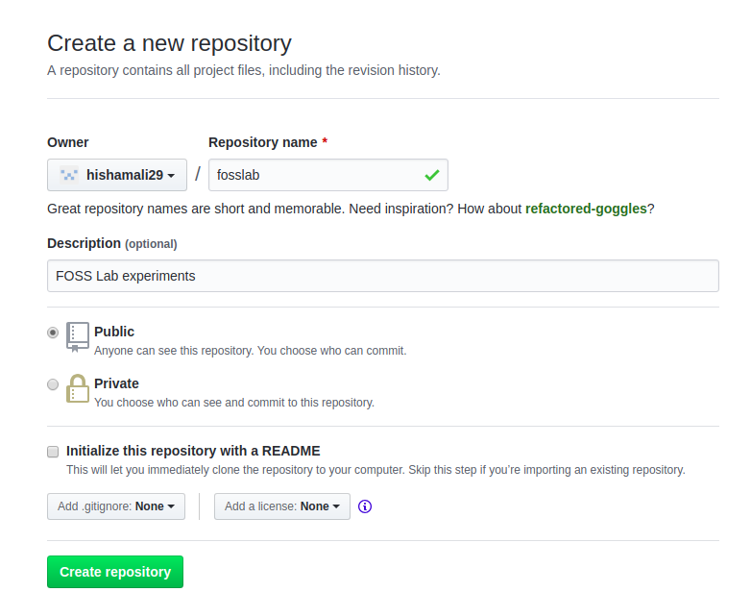

2. Checking out a repository
Checkout is the act of switching between different versions of a target entity. ‘git checkout’ command lets us navigate between the branches created by git branch

#To create a new branch and change into a that branch
Command : git checkout -b <brach_name>

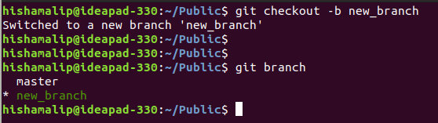
3. Adding content to the repository
To add content to remote repository which is located in GitHub, we need to first initialize our local repository with git and upload our files to remote repository

Steps
(a) Create a new directory in local computer with the same name of the remote repository
Command : mkdir <directory_name>

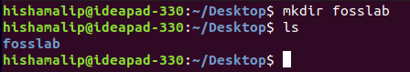

(b) Initialize local directory with git
To do this go to created directory and initialize with git

# Change the current working directory to your local project.
Command : cd <local_directory_name>

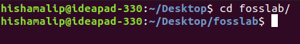

#To initialize local directory as Git repository
Command : git init (This creates a new subdirectory named ‘.git’ that contains necessary repository files)
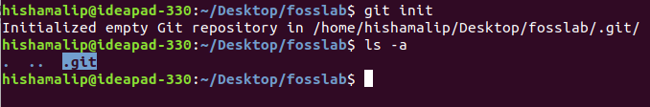
(c) Add the files in your new local repository

# First check if there is any untracked files present before adding files
Command : git status
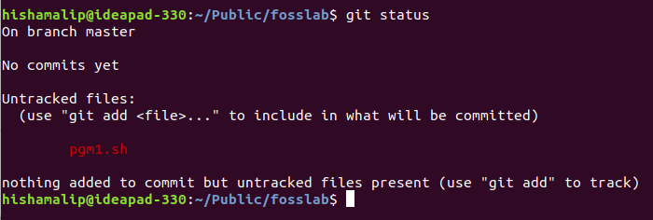
# To add untracked files to local repository
Command : git add . ( . is used to add all files )
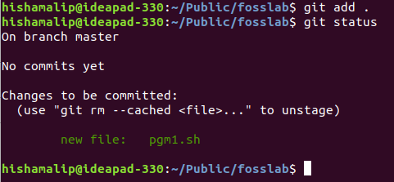

4. Committing the data to a repository
Stores the current contents of the index in a new commit along with a log message from the user describing the changes.

#To commit files that are added in local repository
Command : git commit -m “commit message”
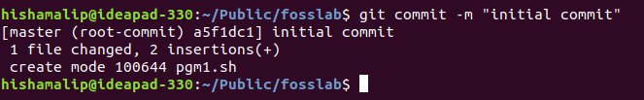

5. Updating the local copy
The git push command is used to upload local repository content to a remote repository. Pushing is how you transfer commits from your local repository to a remote repository.

Steps
(a) To add a new remote, use the git remote add on the directory where repository is stored at
Command : git remote add origin <url address of remote repository>

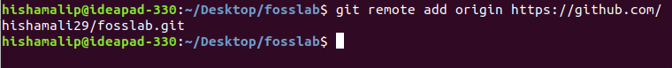

(b) To add files in local repository to remote repository
Command : git push origin <branch_name> (Here branch is master)

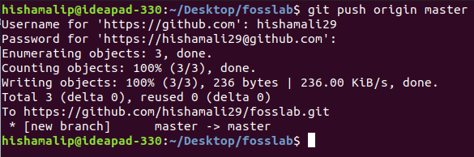

6. Comparing different revisions
Comparing different version allow us to see changes we have made on same file. For comparing revisions we need to get the hash value

Steps
(a) Check the changes we have made
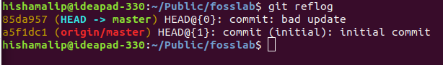
Command : git reflog (this will return list of files we have made changed with an id for corresponding changes)

(b) Comparing diffrent versions
Command : git diff <first commit id> <second commit id>
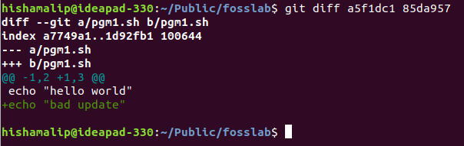

7. Revert
Revert some existing commits. Revert command rollback changes we have committed. It create new commit from a specified commit by inverting it. Hence adds a new commit history to the project, but it doesn’t modify the existing one.

Command : git revert <commit id we want to revert>
# This will revert the changes specified by the last commit to the first commit

# Then we will get a prompt of revert that we are going to do. Save it if we want to revert.
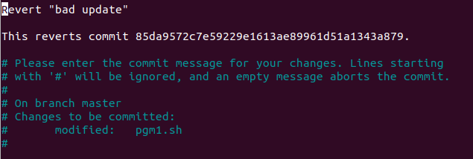
# Output after revert
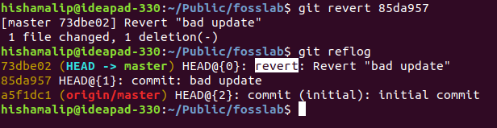

8. Conflicts and a conflict Resolution
If we changed file in remote repository directly we will use a command pull, to pull in the remote changes to local computer. But if we forgot to pull the changes there will be conflict if we tries to push our files after changing local file.

# So i manually changes file in remote repository
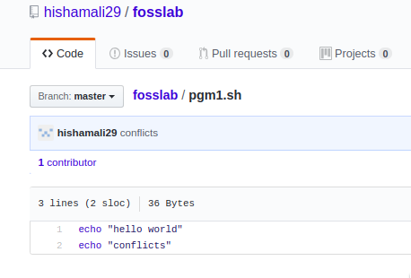

# Now im going to edit file in local repository and push it to remote repository.
Command : nano filename



# Now pushing chnged file to remote repository
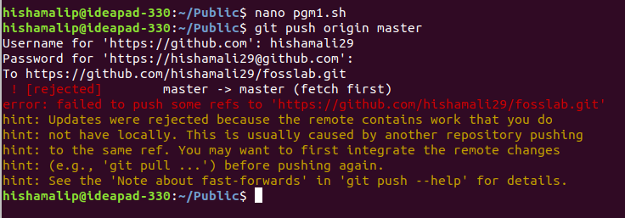
Command : git push origin <brach name>
If the content of a file in GitHub website and local computer doesn’t match, there will be conflict. Here we ended up in a conflict. To fix the conflict pull the changes first.

Command : git pull origin <branch name>
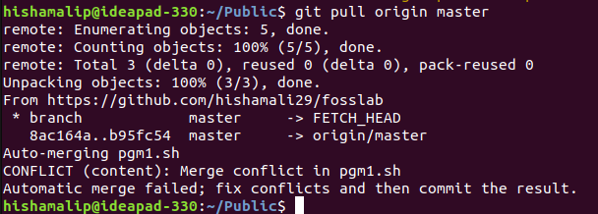

Then we will result in conflict error message like “merge conflict in <brach-name>

# Now check the file
Command : nano filename

And we can see conflict markers which shows us where the conflict occured. And there will be different version of the file seperated by equel (=) sign. Head will be most recent commit and the other will be the changes made on remote repository.
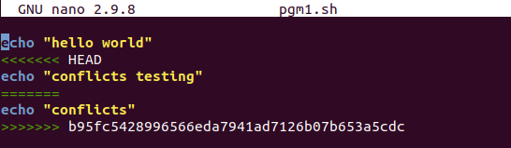
We can select which version to choose. Delete all other version and conflict marker. Then add the files and commit message and push it to required branch.

# So im choosing changes made in website and deleting changes made from local repository and save file

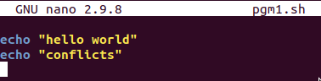

# Now go back to terminal and add, commit and push new file

Command : git add <filename>
git commit -m “commit message”
git push origin <branch name>

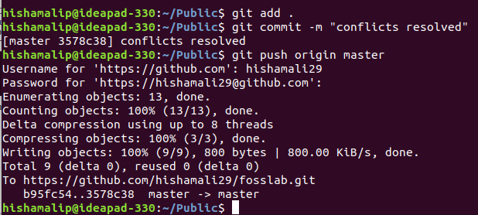

And go to the pull request tab in remote repository and click “Merge Pull Request” and confirm the merge. It will be resulted with a message “Pull request successfully merged and
closed”. This is how to fix conflicts.

Result
Studied about Version Control System setup and usage using GIT and its various uses and commands

