Exp No : 3 Date : 21-02-2019
Network Interface Configuration

Aim :
Set up the complete network interface by configuring services such as gateway, DNS, IP tables etc. using ifconfig.

Program :

1. View network settings of network interfaces in system
Purpose : Ifconfig is used to configure the kernel-resident network interfaces. It is used at boot time to set up interfaces as necessary. After that, it is usually only needed when debugging or when system tuning is needed.

Command : ifconfig
Input : ifconfig
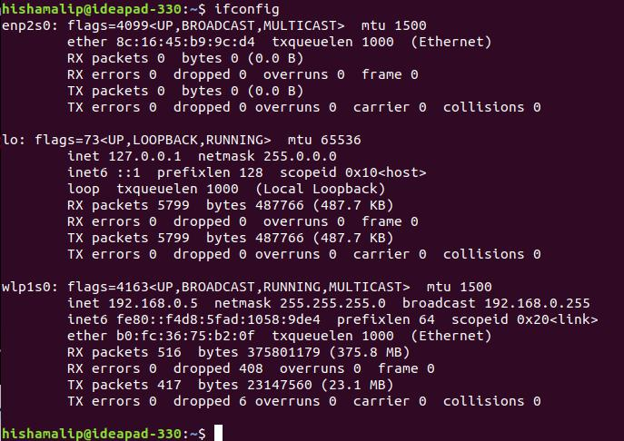
Output :

2. View details of all interafces including disabled interfaces
Command : ifconfig -a
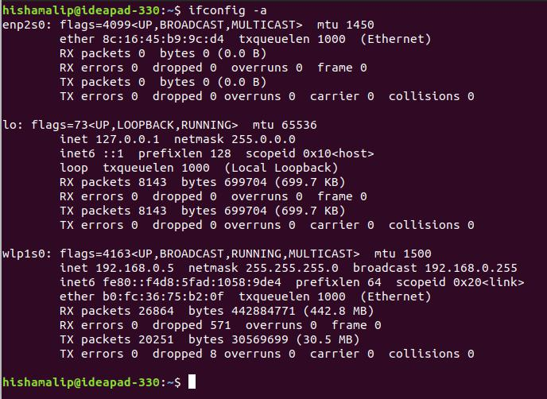
Output :
3. View settings of a specific interface
Command : ifconfig <interface_name>
Input : ifconfig enp2s0
Output :
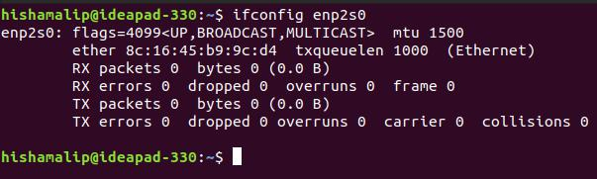

4. To enable or disable an interface
# To disable an inteface
Command : sudo ifconfig <interface_name> down

Input : sudo ifconfig enp2s0 down
Output :

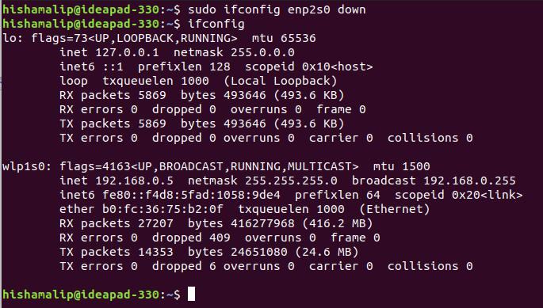

# To enable an inteface
Command : sudo ifconfig <interface_name> up

Input : sudo ifconfig enp2s0 up
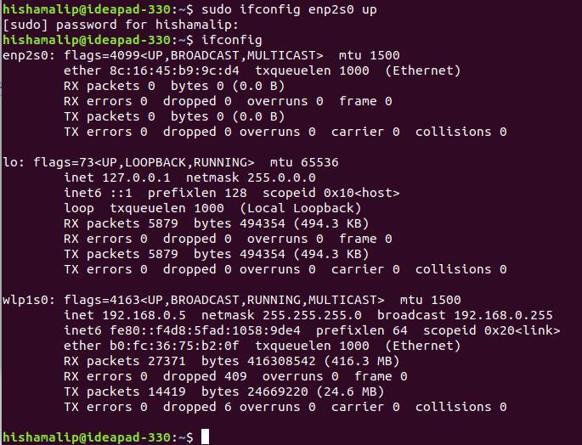
Output :

5. To assign an IP address to an inteface
Command : sudo ifconfig <interface_name> <ip_address>
Input : sudo ifconfig enp2s0 192.168.1.1
Output :
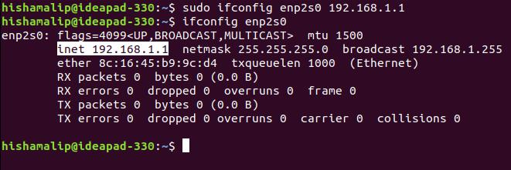

6. To change subnet mask of an inteface
Command : sudo ifconfig <inteface_name> netmask <subnetmask_address>

Input : sudo ifconfig enp2s0 netmask 255.255.0.0
Output :
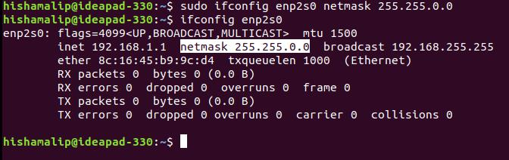

7. To change broadcast address of an inteface
Command : sudo ifconfig <inteface_name> broadcast <broadcast_address>

Input : sudo ifconfig enp2s0 broadcast 192.168.1.255
Output :
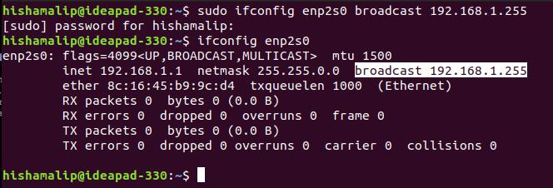
8. To change MTU (Maximum Transmission Unit) network for an interface

Purpose : MTU is the size (in bytes) of the largest datagram that a given layer of a communications protocol can pass at a time.

Command : sudo ifconfig <inteface_name> mtu <size in bytes>
Input : sudo ifconfig enp2s0 mtu 1450
Output :

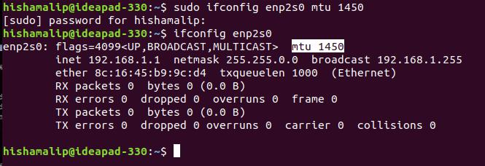

9. To display default route

Purpose : The route command manipulates the kernel’s IP routing tables. Its primary use is to set up static routes to specific hosts or networks via an interface after it has been configured with the ifconfig program.

Command : route
Input : route
Output :

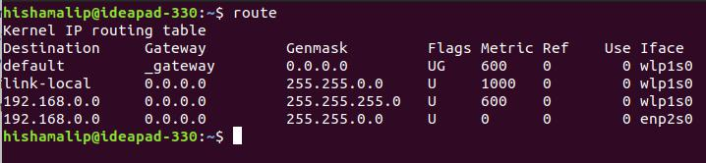

10. To setup default gateway

Command : route add default gw <ip_address> <interface_name>
Input : route add default gw 192.168.99.4 enp2s0
Output :
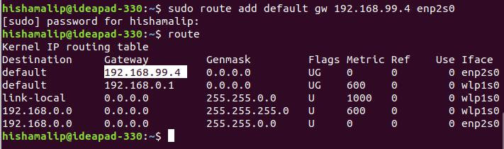
11. IP Tables

Purpose : To allows system administrators to manage incoming and outgoing traffic via a set of configurable table rules.

#Check all IPtables Firewall Rules
Input : iptables -L -n -v
Output :

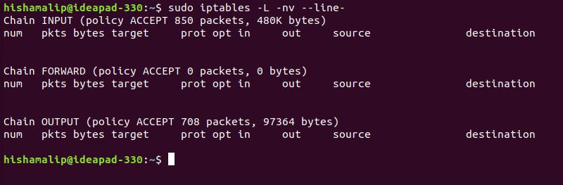

12. DNS
To change DNS settings
The name servers are prioritized in the order the system finds them in the file. Use the Internet Protocol (IP) addresses of the name servers when you enter them into the configuration file because the system doesn’t know what to do with domain names until after it knows how to get to the DNS servers.

DNS servers that the system uses for name resolution are defined in the /etc/resolv.conf file. To cause your machine to consult with a particular server for name lookups you simply add their addresses to/etc/resolv.conf

# To open /etc/resolv.conf
Input : nano /etc/resolv.conf
Output :
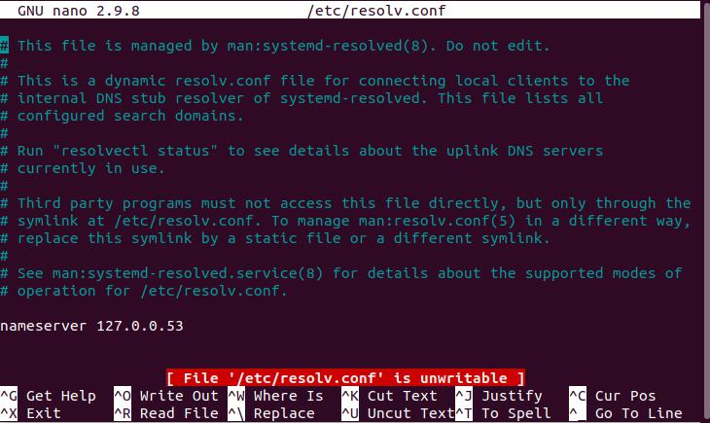

#Add a name server to /etc/resolv.conf
input : cat >> /etc/resolv.conf
nameserver 120.136.32.62
Output :

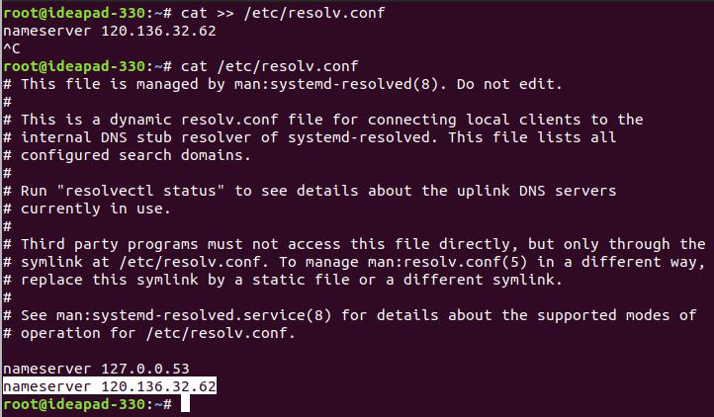

13. Host

Purpose : To get the domain name of the server

Command : host <domain_name>
Input : host “www.google.com”
Output :

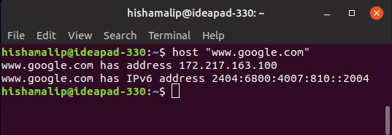

14. Ping

Purpose : The ping command is a Command prompt command used to test the ability of the source computer to reach a specified destination computer.

Command : ping -c 3 <ip_address/domain_name>
Input : ping -c 3 google.com
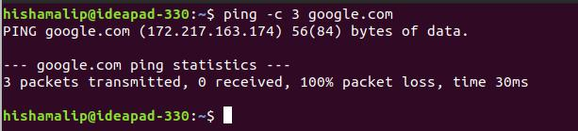
Output :

15. iwconfig

Purpose : Iwconfig is similar to ifconfig(8), but is dedicated to the wireless interfaces. It is used to set the parameters of the network interface which are specific to the wireless operation.

Input : iwconfig
Output :

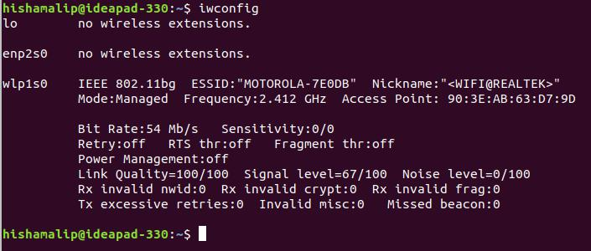

Result :
Studied about the network interface commands configuring services such as gateway, DNS, IP tables etc. using ifconfig

