ASSIGNMENT – 3
Practice Questions – Cycle 1 [Answers]

1. Display your current directory.
Command : pwd
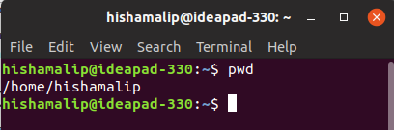
Output :

2. Change to the /etc directory.
Command : cd /etc
Output : (directory changed to /etc directory)
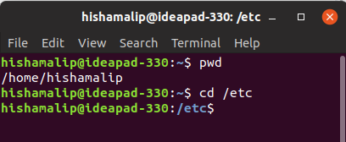

3. Now, change to your home directory using a single command.
Command : cd ~
Output : (directory changed to home directory)
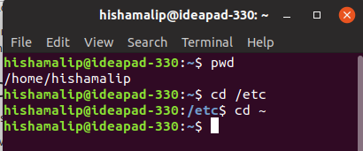

4. Change to the parent directory of the current directory.
Command : cd ..
Output : (directory changed to parent directory)

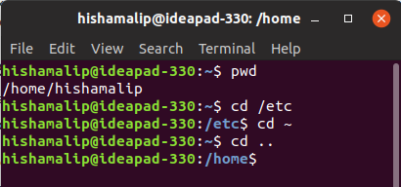

5. Go to the root directory.
Command : cd /
Output : (directory changed to root directory)
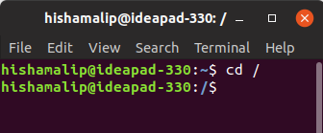

6. Give a long listing of the root directory.
Command : ls -l /
Output :

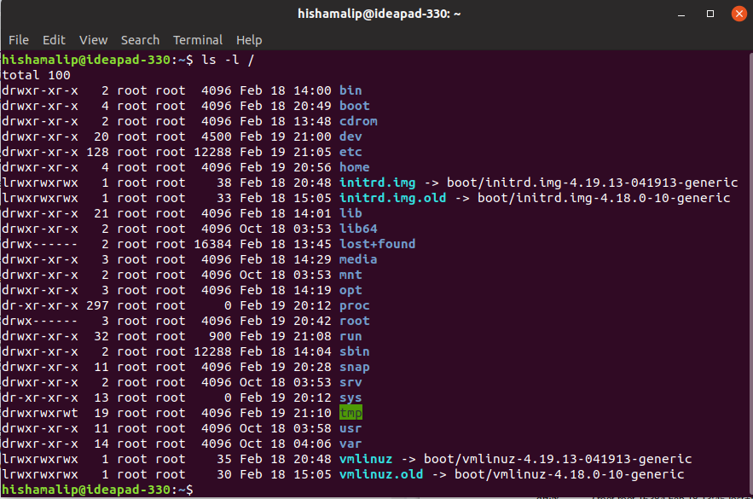
7. Give a listing of the last 10 files in the root directory.
Command : ls / | tail
Output :

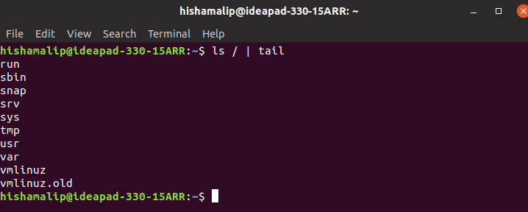

8. Stay where you are, and list the contents of /etc.
Command : ls /etc
Output :
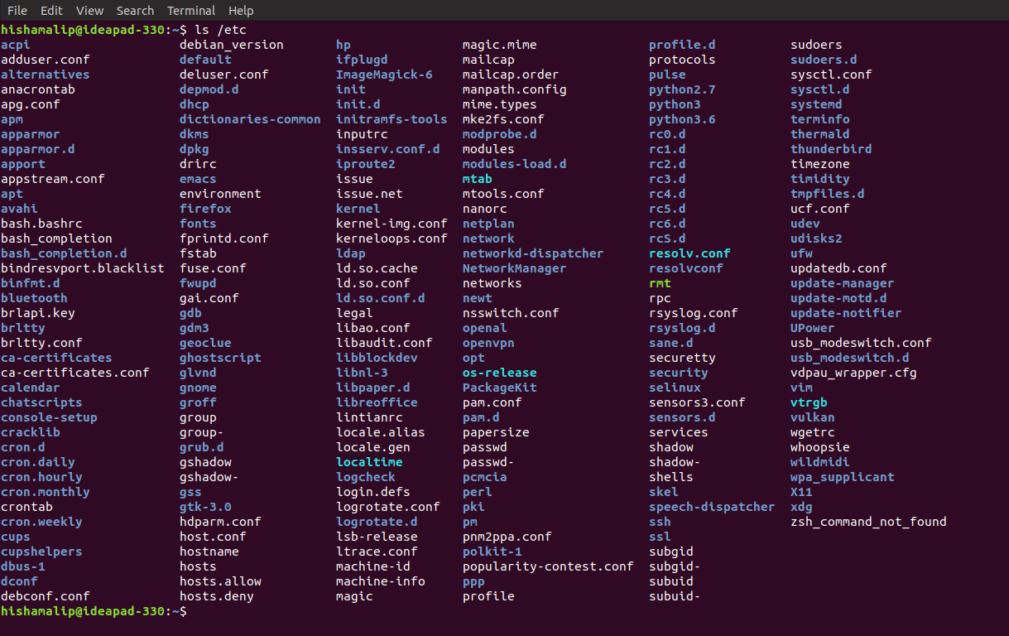
9. Create a directory testdir in your home directory.
Command : mkdir ~/testdir
Output : (a directory named testdir is created in home directory)

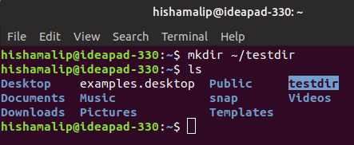

10. Change to the /etc directory, stay there and create a directory newdir in your home
directory(using a single command).
Command : cd etc
Output : (a directory named testdir is created in home directory from /etc directory)
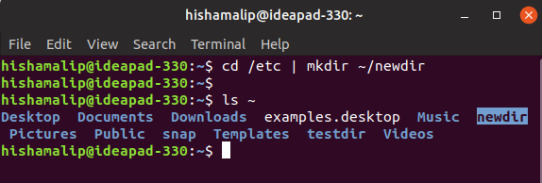

11. Create in one command the directories ~/dir1/dir2/dir3 (dir3 is a subdirectory from
dir2, and dir2 is a subdirectory from dir1).
Command : mkdir -p ~/dir1/dir2/dir3
Output : (directories are created as dir3 is subdirectory of dir2 and dir2 is subdirectory of dir1 )
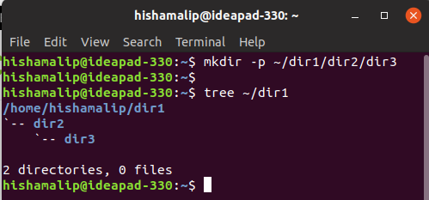

12. Display the calendar for April 2019.
Command : cal April 2019
Output :

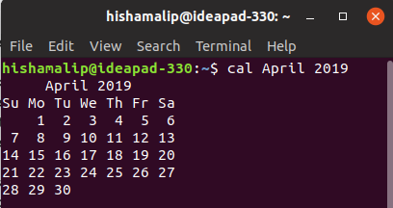

13. Display that ‘There are ....... files in my current directory’ . The ...... should be
filled with the count of the files.
Command : echo "There are `find | wc -w` in my directory"
Output :
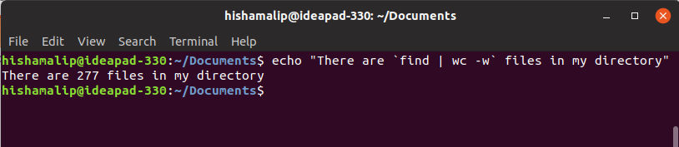

14. List all the files (including hidden files) in your home directory.
Command : ls -a ~
Output :

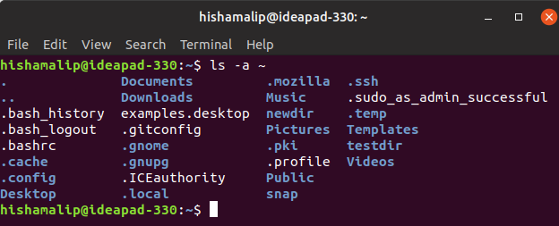

15. Redirect the output of the above command to a new file FileList.txt
Command : ls -a ~ >> FileList.txt
Output : (Output of ‘ls -l’ is saved into a file named FileList.txt
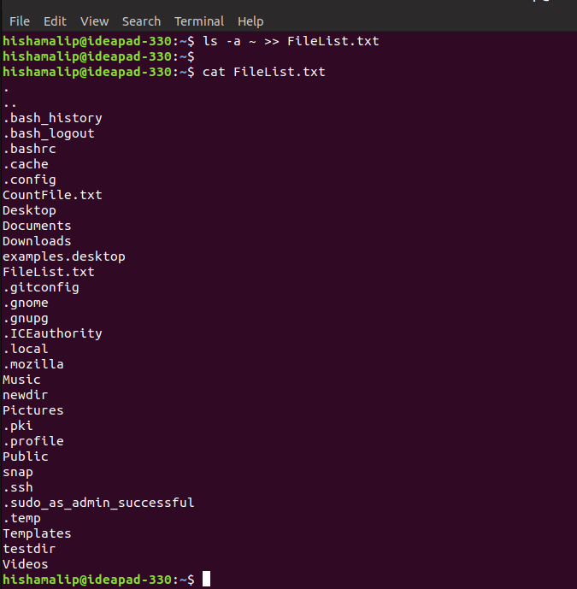
16. Redirect the number of lines of FileList.txt to CountFile.txt.
Command : cat FileList.txt | wc -w | cat >> CountFile.txt
Output : (Number of lines of FileList.txt is saved into a file named CountFile.txt)
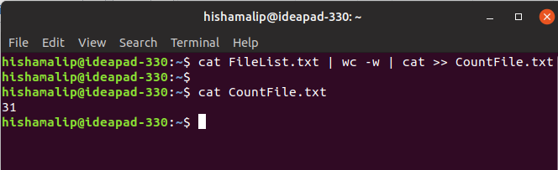
17. List all the files in your home directory starting with ‘s’ .
Command : ls -pd s*
Output :

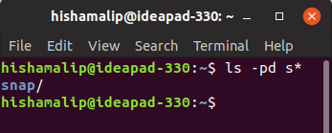

18. List all the file-names starting with “a”, “b” or “s”
Command : ls -pd [abs]*
Output :

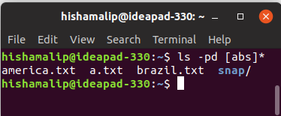

19. Create two files ‘Countries.txt’, containing country names and their corresponding
capital cities and ‘Story.txt’ contains some arbitrary lines of text.
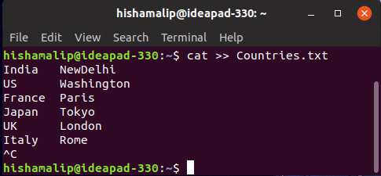
#To create Countries.txt
Command : cat >> Countries.txt
India NewDelhi
US Washington
France Paris
Japan Tokyo
UK London
Italy Rome
#To create Story.txt
Command : cat >> Story.txt
There Is A Car
Its Colour Is Black
The Car Is Owned By Hisham

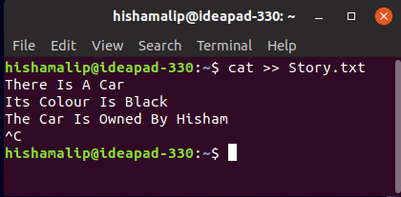

20. Convert all lowercase characters from ‘Story.txt’ to uppercase and store it in a file ‘Capstory.txt’.
Command : cat Story.txt | tr '[:lower:]' '[:upper:]' | cat > Capstory.txt
Output : (All lowercase characters from Story.txt is changed into uppercase and stored in a file named Capstory.txt)
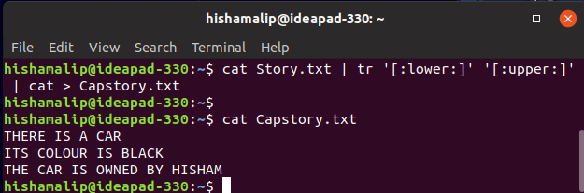
21. Toggle the cases in ‘Story.txt’ and store it in a file ‘Togglestory.txt’.
Command : cat Story.txt | tr '[:lower:][:upper:]' '[:upper:][:lower:]' | cat > Togglestory.txt
Output : (All charachers in Story.txt is toggled its case and output is stored in a file named Togglestory.txt)
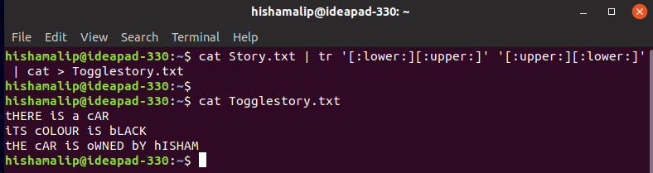

22. Sort the contents of ‘Countries.txt’with Capital as the primary sort key and write the
sorted output to ‘SortCountry.txt’ .
Command : sort -k2 Countries.txt
#(-k2 will select column two as sorting criteria)
Output : (The content of Countries.txt is sorted with Capitals as primary sort key and output is stored in SortCountry.txt)
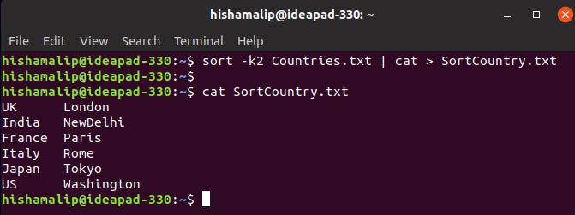

23. Display only the capital cities from ‘Countries.txt’.
Command : awk '{print $2}' Countries.txt (mawk select a particular column)
Output :
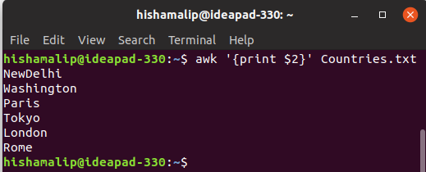

24. Locate all ‘.txt’ and ‘.doc’ files in the current directory .
Command : ls *.txt *.doc
Output :
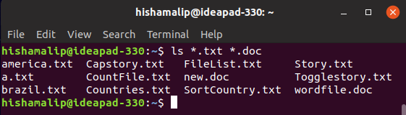
25. Count the number of occurence of ‘the’ in ‘Story.txt’
Command : grep -i --count “the” Story.txt (-i will ignore case and --count will count the occurence of specified string)
Output : ( ‘the’ is ocuuring 2 times in Story.txt)
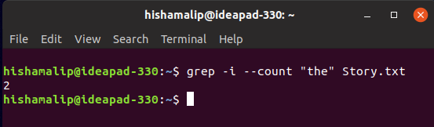

Result :
The usage of certain bash commands are understood and output is obtained.

Submitted by :
Hisham Ali P
Roll No : 67
S4 CSE

