Exp No : 8 Date : 11-04-2019
PERL SCRIPTING

Aim :
To perform simple text processing using Perl Scripting.
Create a text file and answer the following queries :
a) Search for the pattern ‘apple’ in the file and display the number of occurrences.
b) Count the number of words that ends with ‘e’
c) Count the number of words that starts with ‘ap’
d) Search for words containing ‘a’ or ‘s’
e) Search for words containing zero or more occurrence of ‘e’
f) Search for words containing one or more occurrence of ‘e’
g) Search for words containing the letters ‘l’ and ‘m’, with any number of characters in between
Program :

Algorithm :
1 start
2 read file
3 if file not exists, exit programs
4 else
5 count no of word ‘apple’
6 count no of word end with ‘e’
7 count the number of words tarts with ‘ap’
8 print words containing ‘a’ or ‘s’
9 print words containing zero or more occurrence of ‘e’
10 print words containing one or more occurrence of ‘e’
11 print words containing the letters ‘l’ and ‘m’, with any number of characters in between

Program :
print "Enter file name : ";
$file = <>;
$word = "apple";
$counta = 0;
$countb= 0;
$countc= 0;
open (FHR, $file) or die "Cant open file: $file";
while(<FHR>)
{
chomp;
@line = split(' ');
foreach my $word (@line)
{
push @word_as, $word if $word =~ /\w*(a|s)\w*/;
push @word_ezero, $word if $word =~ /\w*()\w*/;
push @word_eone, $word if $word =~ /\w*(e)\w*/;
push @word_lm, $word if $word =~ /\w*l\w*m\w*/;
}
$count++ if $word =~ /\w*(a|s)\w*/;
$counta += () = $_ =~ /\w*$word\w*/gi;
$countb += () = $_ =~ /\w*e\b/gi;
$countc += () = $_ =~ /\bap\w*/gi;
}
print "\nOccurance of 'apple' in file $file = ";
print $counta;
print "\n";
print "\nNumber of words that ends with ‘e’ = $countb\n";
print "\n";
print "Number of words that starts with ‘ap’ = $countc\n";
print "\n";
print "Words containing ‘a’ or ‘s’ \n", join ", ", @word_as;
print "\n\n";
print "Words containing zero or more occurrence of ‘e’ = \n", join ", ", @word_ezero;
print "\n\n";
print "Words containing one or more occurrence of ‘e’ = \n", join ", ", @word_eone;
print "\n\n";
print "Words containing the letters ‘l’ and ‘m’, with any number of characters in between = \n", join ", ", @word_lm;
print "\n";
close $file;

Output :

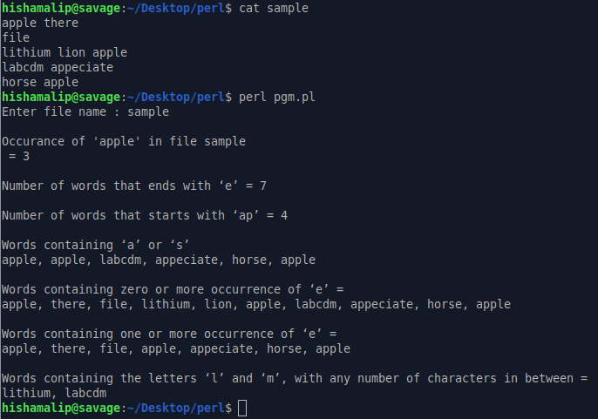

Result :
Perl Scripting questions are familiarized and output is obtained successfully

