EXP NO : 5 Date : 04/04/2019
SHELL PROGRAMMING - Set 2 – Part 2

Aim :
To practice various shell scripting programs

Question 6 :
Write a shell script that will take an input file and remove identical lines.

Algorithm :
1 Read file
2 Remove identical lines and save result into a temporary file.
3 Copy temporary file to original file
4 Remove temporary file

Program :
fread -p "Enter file name : " file1
if [ ! -f $file1 ]; then
echo "File not found!"
else
awk '!seen[$0]++' $file1 > temp
cp templog $file1
rm temp
fi

Output :
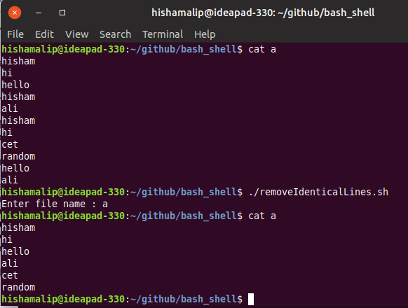
Question 7 :
Write a shell script that displays a list of all the files in the current directory to which the user has read, write and execute permissions.

Algorithm :
1 Save permission of all files to a temporary file
2 while read i from temporary file
3 copy properties of files into variable x
4 if x is file with read, write and execute permission
5 set flag = 1
6 print file name
7 end if
8 end while
9 if flag != 1
10 print “No files with read, write and execution permission”
11 end if

Program :

ls -l > temp
while read i ; do
x="$(echo $i | cut -b 1-4)"
if [ $x = "-rwx" ] ; then
flag=1;
echo $i | awk {'print $9'}
fi
done < temp
rm temp
if [ "$flag" != 1 ] ; then
echo "No files with read,write and execute permission"
fi

Output :

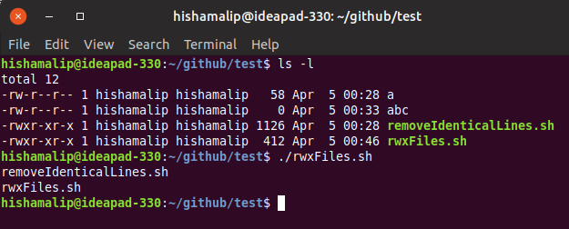

Question 8 :
Write a shell script that folds long lines into 40 columns. Thus any line that exceeds 40 characters must be broken after 40th, a ‘\’ is to be appended as the indication of folding and the processing is to be continued with the residue. The input is to be through a text file created by the user.

Algorithm :
1 Read file
2 n = total no. of lines in the file
3 set i = 1
4 while i <= n
5 read 1st line of file to variable named line
6 length = length of the line
7 while length >= 40
8 x = first 40 charchters of line
9 print x/
10 y = charchters of line from 41th column
11 line = y
12 length = length of line
13 end while
14 print line
15 i++
15 end while

Program :

read -p "Enter file name : " file
n=$(wc -l $file | awk '{print $1}')
i=1
while [ $i -le $n ] ; do
line=$(sed -n "$i p" $file)
length=$(echo $line | awk '{print length}')
while [ $length -ge 40 ] ; do
x=$(echo $line | cut -b 1-40)
echo "$x\\"
y=$(echo $line | cut -b 40-)
line=$y
length=$(echo $line | awk '{print length}')
done
echo $line
i=$(expr $i + 1)
done

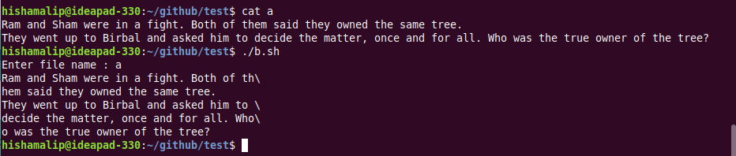
Output :
Question 9 :
Write a shell script to delete all lines containing a specific word in one or more file supplied as argument to it.

Algorithm :
1 Read file names from arguments
2 Read the word to delete
3 for file name in arguments
4 delete line with specific word and redirect output to temporary file
5 move temporary file to origial file
6 end for

Program :

if [ $# -eq 0 ] ; then
echo "Please enter one or more filenames as argument"
else
read -p "Enter the word : " word
for file in $* ; do
sed "/$word/d" $file > temp
mv temp $file
done
echo "Lines with word $word is deleted from all files"
fi

Output :
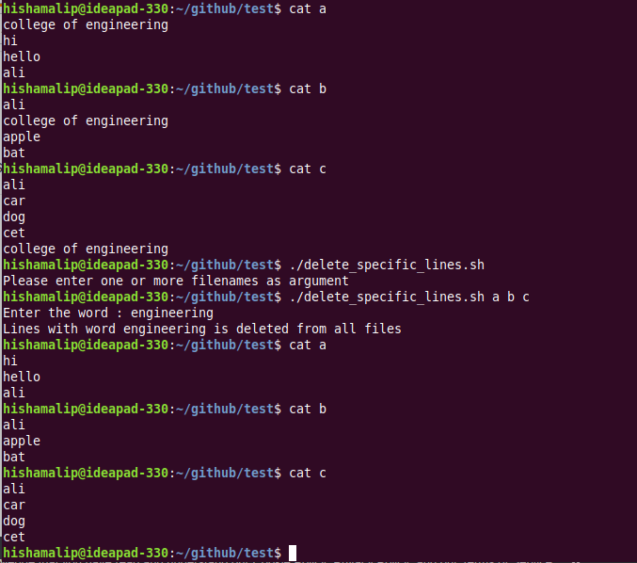

Result :
Practiced various shell scripting programs and output is verified.

