Kingdom of Saudi Arabia  Ministry of Education  King Abdulaziz University  Faculty of Computing and  Information Technology |  | المملكة العربية السعودية  وزارة التعليم  جامعة الملك عبدالعزيز  كلية الحاسبات وتقنية المعلومات

CPCS499 – Project II
Project Report Part I
QISTAS
Intelligent Legal Assistant for Saudi Labor Law Cases
Group_C03
Student Name | Student ID
Adnan Abdulgader Baothman | 2339973
Salim Ahmed Hamdan | 2343152
Hisham Abdullah Aljefri | 2343199

Supervisors: Prof. Ameen Yousef Noaman, Prof. Asaad Ahmad
Department of Computer Science
Date of Submission: 11/10/2026

Table of Contents
1. Summary of Previous Work
1.1 Problem Definition
1.2 Aims and Scope
1.3 Literature Review
1.4 Design Outcomes
2. Methods and Approaches
2.1 Development Methodology
2.2 Development Phases
2.3 Core Technical Approaches
2.3.1 Retrieval-Augmented Generation instead of Fine-Tuning
2.3.2 Knowledge-Base Construction and Verification
2.3.3 Retrieval
2.3.4 Privacy by Design
2.3.5 Grounded Generation and Deterministic Calculation
2.3.6 Verification Strategy
2.4 Changes from the CS498 Design
3. Activities and Actions
3.1 Completed Stages
3.2 Work Not Yet Completed
3.3 Challenges Encountered and How They Were Resolved
4. Implementation
4.1 Tools and Technologies
4.2 System Architecture
4.3 Interface Types and Rationale
4.4 Results: Working Interfaces
4.4.1 Accounts
4.4.2 Submitting a Case with Documents
4.4.3 Analysis Results
4.4.4 Downloadable Report
4.4.5 Statement of Claim Draft
4.4.6 Case Management
4.4.7 Law Search and Articles
4.4.8 Administration
4.4.9 REST API and Command Line
4.5 Implementation Completeness
4.6 Statistics of Results
4.6.1 Knowledge Base
4.6.2 Retrieval Accuracy
4.6.3 Case Analyses
4.6.4 Automated Testing and Performance
4.7 User Manual
4.7.1 Creating an Account and Signing In
4.7.2 Analyzing Your Case
4.7.3 Reading the Result
4.7.4 Preparing a Statement of Claim
4.7.5 Managing Your Cases
4.7.6 Searching the Law
4.7.7 For Administrators
5. References
Additional Bibliography
Appendix A: Statement on the Use of AI Tools
Appendix B: Running the Prototype

List of Figures
Figure 1: Semester 2 timeline: completed phases and planned work 9
Figure 2: Case analysis pipeline 11
Figure 3: QISTAS system architecture 17
Figure 4: Login and registration pages (FR1, FR2) 18
Figure 5: Case submission form: description, gender, optional names (FR3) 18
Figure 6: A scanned image requires consent before it is sent for OCR 19
Figure 7: Scanned contract read by OCR after consent; the text is shown for review (FR4, FR5) 19
Figure 8: A text PDF is read locally on the server without OCR 19
Figure 9: Progress state while the case is analyzed 20
Figure 10: Saved case: title, actions, expected outcome with likelihood, and entitlements (FR6, FR8) 21
Figure 11: Entitlements computed in code with the formula of each article 21
Figure 12: Cited articles with the reason each applies; the full text expands on demand 22
Figure 13: “What was sent to the AI”: the masked text the model received 22
Figure 14: Downloaded analysis report in Arabic PDF (FR13); the missing-information list and the analysis are on page 2 23
Figure 15: Claim draft form: party details are inserted by code and never sent to the AI (FR10) 23
Figure 16: Generated claim draft: parties, facts, legal grounds, requests with computed amounts, notes 24
Figure 17: Downloaded claim draft as PDF and as an editable Word document (FR13) 25
Figure 18: My Cases: the user's saved cases with likelihood, total and claim status (FR12) 25
Figure 19: Editing a case description and re-analyzing it; rename, download and delete actions (FR12) 26
Figure 20: Searching the Labor Law in everyday Arabic (FR11) 26
Figure 21: A repealed article shows its status and the repealing decree 27
Figure 22: Administrator page: roles and account activation (FR14) 27
Figure 23: Interactive REST API documentation (excerpt) 28
Figure 24: Command-line tools: knowledge-base loader, automated tests and search 28
Figure 25: Status of the CS498 functional requirements 29
Figure 26: Retrieval accuracy by method (37 questions) 31

List of Tables
Table 1: Development phases in Semester 2 8
Table 2: Design changes from CS498 and their justification 11
Table 3: Completed stages and evidence 13
Table 4: Remaining work and completion plan 14
Table 5: Challenges and resolutions 14
Table 6: Tools and technologies with justification 16
Table 7: Interfaces developed and why 17
Table 8: Functional requirements status (CS498 FR1–FR15) 29
Table 9: Non-functional requirements status 29
Table 10: Security requirements status 30
Table 11: Knowledge-base statistics 30
Table 12: Hand-checked case analyses 31
Table 13: Blind test results (12 unseen cases) 32
Table 14: Automated tests (all passing) 32
Table 15: Performance measurements 32

List of Abbreviations
Abbreviation | Meaning
API | Application Programming Interface
FR / NFR / SR | Functional / Non-Functional / Security Requirement (as numbered in the CS498 report)
GUI | Graphical User Interface
HRSD | Ministry of Human Resources and Social Development
JWT | JSON Web Token
KB | Knowledge Base
LLM | Large Language Model
MRR | Mean Reciprocal Rank
OCR | Optical Character Recognition
PII | Personally Identifiable Information
RAG | Retrieval-Augmented Generation
REST | Representational State Transfer
RTL | Right-to-Left

1. Summary of Previous Work

1.1 Problem Definition
Access to legal assistance in Saudi Arabia is constrained by the cost of professional consultation and the complexity of labor-law procedures. Workers involved in labor disputes often struggle to identify the relevant articles of the Labor Law, to know which entitlements they can claim, to recognize missing information or documents, and to structure a legally sound claim. Labor disputes are among the most frequently litigated matters in Saudi courts, and the problem falls hardest on people who cannot afford a lawyer.
The non-trivial computing challenge lies in Arabic legal language processing. Arabic is morphologically rich and context-dependent, and statutory Arabic encodes obligations through specific modal expressions that generic models can misinterpret. Retrieving the correct provisions from Arabic statutes and grounding a language model's answer in them, without hallucinated legal references, is a genuine research and engineering problem.

1.2 Aims and Scope
CS498 proposed QISTAS (Qanuni Intelligent System for Analyzing Saudi Labor Law), an AI-powered web application with five aims: (1) accept Arabic descriptions of labor cases and supporting documents; (2) analyze them with an AI pipeline (NLP, semantic search and retrieval-augmented generation) that extracts key legal elements, identifies missing elements and retrieves relevant provisions and precedents; (3) produce a complete system design with full requirements; (4) evaluate privacy-preserving deployment of Arabic large language models (LLMs) for legal reasoning; and (5) deliver a design ready for implementation in CPCS499.
Following supervisor feedback, the scope was narrowed to Saudi labor law only. Out of scope: criminal, commercial and family law; binding legal advice; and integration with court systems. The target users are members of the public who cannot afford consultation, junior lawyers, and lawyers working outside their specialization.

1.3 Literature Review
The review (Google Scholar, IEEE Xplore, arXiv, ACL Anthology, SSRN; 2024–2026) was organized into three themes:
- Linguistic complexity of Arabic legal text. Al-Qahtani (2026) showed that Arabic modal verbs in the Saudi Labor Law encode strict obligations; ALLaM (Bari et al., 2025) is aligned to the Saudi context; ALARB (Shairah et al., 2025) showed that models adapted to Saudi court data outperform general multilingual models.
- Retrieval-augmented generation (RAG) for legal accuracy. ArabLJP (Mohamed et al., 2026) reduced hallucination by grounding Arabic legal answers in retrieved text, and SmartLaw Advisor (Almutairy et al., 2026) reported 98.67% accuracy for Saudi legal consultation with RAG.
- Multi-agent reasoning and privacy. LegalMALR (Li et al., 2025) decomposes vague legal queries to find missing elements; DeepSeek-OCR (Wei et al., 2025) reads complex scanned documents; LegalGuardian (Demir et al., 2025) masks personal data before LLM processing.
The identified gap was the absence of a single Arabic assistant for Saudi labor law that combines retrieval of verified provisions, missing-element detection, privacy protection and claim drafting.

1.4 Design Outcomes
CS498 followed a hybrid waterfall methodology with iterative design reviews and produced: 15 functional requirements (FR1–FR15), 7 non-functional requirements (NFR1–NFR7) and 9 security requirements (SR1–SR9), with a traceability matrix; use-case diagrams (general/registered user, lawyer, administrator and the AI engine); a class diagram; two sequence diagrams (case submission and analysis, and login); an entity-relationship diagram; level-0 and level-1 data-flow diagrams; and a system flowchart. The proposed stack was Next.js, FastAPI, PyArabic, ChromaDB, LlamaIndex, a locally deployed LLM (ALLaM or Qwen 3), DeepSeek-OCR and PostgreSQL, with an anonymization layer that replaces personal data with placeholders such as [EMPLOYEE_1] before AI processing.
Supervisor feedback narrowed the scope to labor law, requested detailed non-functional and security requirements, clearer ER cardinalities, a second sequence diagram and a traceability matrix, and advised starting dataset identification immediately for Semester 2. The design was approved at the end of CS498.

2. Methods and Approaches

2.1 Development Methodology
CS498 used a hybrid waterfall, which suited a design-only project with fixed deliverables. For implementation we adopted an iterative, evaluation-driven approach: the system was built in short increments, and each increment was measured on test data before the next design decision was taken. The main reason is that an LLM-based system carries uncertainties that cannot be resolved on paper: how well Arabic retrieval works on colloquial questions, how the model behaves on real cases, and what the free API tier allows. For example, the plan to combine keyword and semantic search was dropped after measurement showed the combination reduced accuracy (Section 4.6.2).
Every increment was verified at the appropriate level: automated unit and API tests, a retrieval benchmark, hand-checked sample cases, a blind test on unseen cases, and an automated end-to-end browser test.

2.2 Development Phases
Table 1 lists the phases followed in Semester 2 and Figure 1 places them on the semester timeline.
Table 1: Development phases in Semester 2
Phase | Main activities | Output | Verification
P1 Environment and data verification | Development environment (Linux/WSL, Python, Node.js, PostgreSQL + pgvector); collection of official texts; verification of the knowledge-base file against official sources | Working environment; verified data | Every gap traced to an official repeal or merger
P2 Knowledge-base engineering | Database schema with versioning; loader with change detection; structure-based chunking | 497 provisions, 535 searchable chunks | Coverage check: all Labor Law articles 1–245 present
P3 Retrieval and evaluation | Gemini embeddings in pgvector; article-number lookup; keyword search; benchmark of 37 questions | Search service | Hit@1, Hit@5, MRR per method
P4 Case-analysis pipeline | Privacy masking; prompt and JSON schema; grounding check; companion-article expansion; entitlement calculator | REST analysis endpoint | Unit tests; 3 hand-checked cases
P5 Blind testing and refinement | 12 unseen cases with an answer key; fixes for gender masking, arithmetic, vague cases | Prompt v2–v4; calculator | Re-test of affected cases
P6 Web interface | Arabic RTL Next.js interface: analysis, search, articles | Prototype GUI | Headless-browser test
P7 Accounts and case management | Registration/login, roles, My Cases, document upload + OCR, claim draft, PDF/Word export, encrypted vault | FR1–FR5, FR10, FR12–FR14 | 42 automated tests; end-to-end test
P8 Integration and documentation | Real-API end-to-end run, statistics, this report | Report Part I | —

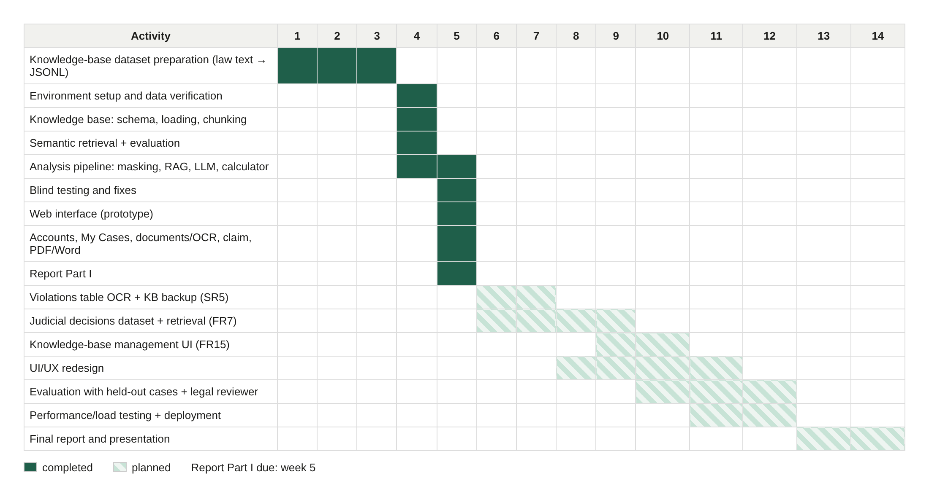
Figure 1: Semester 2 timeline: completed phases and planned work

2.3 Core Technical Approaches

2.3.1 Retrieval-Augmented Generation instead of Fine-Tuning
No labeled dataset of Saudi labor cases (case description → correct analysis) was available, so fine-tuning a model was not feasible. We therefore used RAG (Lewis et al., 2020): for every case the system retrieves the relevant articles from a verified knowledge base and instructs the LLM to answer only from them, citing article identifiers. This needs only the official law text, keeps answers traceable, and lets the knowledge base be updated without retraining.

2.3.2 Knowledge-Base Construction and Verification
The knowledge base contains the Saudi Labor Law, its Implementing Regulations (Ministerial Decision 115921) and five annexes: 456 records extracted from the official publications, one record per article. We checked the file against the official Bureau of Experts text and the HRSD regulations PDF. 38 Labor Law article numbers and 3 regulations articles were absent; each was traced to an official repeal or merger (for example, Chapter 14, articles 210–228, repealed by Royal Decree M/1 of 22/1/1435H) and stored as a short record stating its status and the responsible decree. The file reflects the 2025 amendments (e.g., 12-week maternity leave, article 151).
Chunking is structure-based: one article is one chunk, because the law is already divided by topic and answers must cite articles. The nine articles longer than 1,500 characters are split at paragraph, line or sentence boundaries, and every chunk carries a header (source, article, chapter) so it is understandable on its own.

2.3.3 Retrieval
Each chunk is embedded with Gemini gemini-embedding-001 (768 dimensions) and stored in PostgreSQL with pgvector and an HNSW index (Malkov & Yashunin, 2020). A question is embedded the same way and the nearest chunks are returned. Explicit references such as “المادة 77” are resolved directly. Two expansion mechanisms add articles that a correct analysis needs even when the user does not mention them: companion rules written from the law's structure (e.g., any termination article brings in the end-of-service award, art. 84) and the implementing-regulation article linked to each retrieved Labor Law article. Sources are weighted by legal hierarchy (Law and Regulations above annexes).

2.3.4 Privacy by Design
Before any text leaves the server, personal data is replaced by placeholders: national ID/iqama numbers, phone numbers, IBANs, e-mails, labelled contract or case numbers, names entered in the form (including their short forms) and company names introduced by words such as “شركة” or “مؤسسة”. The database stores masked text only; the real values are encrypted (Fernet) per case and decrypted only for the case owner, implementing SR9. PDFs with a text layer are read locally; scanned documents are sent for OCR only after explicit user consent. The blind test showed that masking a woman's name also hid her gender, which some articles depend on; the form therefore asks for the worker's gender explicitly (Section 3.3).

2.3.5 Grounded Generation and Deterministic Calculation
The LLM receives a strict system prompt (use only the supplied articles, cite them by identifier, state when information is insufficient, never invent articles or amounts) and must answer in a fixed JSON schema: facts, legal issues, cited articles with reasons, analysis, missing information, expected outcome with likelihood, recommended steps and the inputs of each financial entitlement. A grounding check removes any citation that was not retrieved. Money is never calculated by the LLM: it only extracts facts (wage, service dates, contract type), and code applies the formulas of the Labor Law (arts. 75–77, 84–85, 87, 91, 107, 117, 137), showing each formula to the user. Figure 2 summarizes the pipeline.
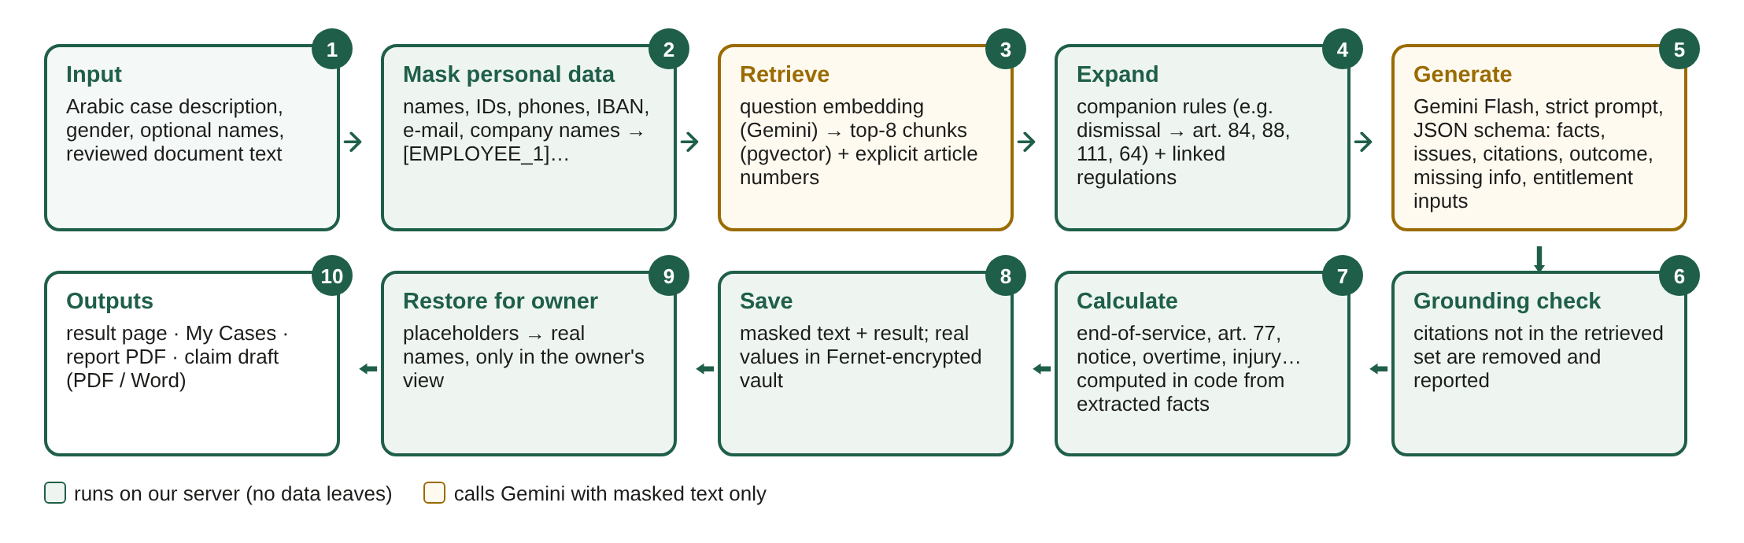
Figure 2: Case analysis pipeline

2.3.6 Verification Strategy
Correctness-critical logic is covered by automated tests that run on a separate test database with the AI service replaced by a fake, so they are repeatable and consume no API quota: masking, the entitlement calculator (hand-checked amounts), grounding, accounts and roles, ownership of cases, document handling, claim drafting and file exports. Retrieval quality was measured with a 37-question benchmark, answer quality with sample and blind cases, and the complete user journey with an automated headless-browser test against the real AI service.

2.4 Changes from the CS498 Design
Implementation led to several justified changes, listed in Table 2.
Table 2: Design changes from CS498 and their justification
CS498 design | Implemented | Reason
Locally deployed LLM (ALLaM or Qwen 3 72B) on a 16 GB RAM + 8 GB GPU workstation | Google Gemini API (Flash family) with masked input, automatic fallback between models | No suitable GPU or budget; a 72B model cannot run on the available hardware. Privacy is preserved by sending only masked text
ChromaDB vector store + relational database | PostgreSQL 18 with the pgvector extension | One database for law, vectors, users and cases; transactions and migrations; one less service to operate
LlamaIndex orchestration | Custom pipeline in Python | Full control over masking, expansion, grounding and calculation; fewer dependencies
DeepSeek-OCR for all uploads | Local PDF text extraction; Gemini OCR for scans with consent | Most digital PDFs need no OCR; consent makes the privacy trade-off explicit
Four roles (user, lawyer, data manager, admin) | Two roles (user, admin) | Prioritized for the 70% milestone; lawyer and data-manager roles are planned
Outputs: analysis report, missing elements, draft claim | Same, plus expected outcome with likelihood and a code-computed entitlement table | Directly answers the users' main question (what am I owed?) with verifiable amounts
Similar judicial decisions retrieval | Not yet implemented | No accessible dataset of Saudi labor rulings yet (Section 3.2)

3. Activities and Actions

3.1 Completed Stages
Table 3 lists the design and development stages that are complete, with the evidence for each.
Table 3: Completed stages and evidence
Stage | Status | Evidence
Requirements and system design (CS498) | Complete | CS498 final report, approved by the supervisors
Data collection and verification | Complete | 456 official records; 41 missing article numbers verified as repealed/merged
Knowledge-base database and loader | Complete | 497 provisions, 535 chunks, change detection, migrations
Semantic retrieval | Complete | Hit@5 = 100%, Hit@1 = 95% on 37 questions
Privacy layer and encrypted vault | Complete | Masking tests; no plain-text names stored (automated check)
Legal analysis (RAG + LLM) | Complete | Structured analysis with grounded citations; 3 hand-checked cases
Entitlement calculator | Complete | 15 calculator tests with hand-checked amounts
Accounts, roles and administration | Complete | Registration, login, 30-minute sessions, admin user management
Case management (My Cases) | Complete | List, view, rename, edit + re-analyze, delete
Document upload and text extraction | Complete | Text PDFs read locally; OCR with consent
Statement of claim draft | Complete | Claim with facts, legal grounds and requests; amounts from code
Downloads | Complete | Analysis report PDF; claim PDF and editable Word file
Prototype web interface | Complete (functional) | Arabic RTL GUI for all features; visual design to be refined
Testing | Partially complete | 42 automated tests, blind test, end-to-end test; expert evaluation pending

3.2 Work Not Yet Completed
Table 4 lists the remaining work, the reason it is not complete and the semester week by which we plan to complete it (Report Part I is due in week 5).
Table 4: Remaining work and completion plan
Item | Why not completed | Plan (week)
FR7: similar judicial decisions | No accessible, structured dataset of Saudi labor-court rulings was available during implementation | Collect published labor rulings (Ministry of Justice), index them with the same pipeline (weeks 6–9)
FR15: knowledge-base management UI and data-manager role | Prioritized user-facing features; the knowledge base is currently maintained with a script | Admin screens for articles and sources (weeks 9–10)
2026 Violations and Penalties Table | Official table is a scanned PDF; OCR output must be checked line by line | Extract, verify and load (weeks 6–7)
SR5: daily knowledge-base backup | Not needed for a local prototype | Scheduled database dump (week 6)
NFR1: response time ≤ 10 s for analysis | Free-tier LLM latency (15–90 s, frequent overload) | Progress feedback, caching, evaluate faster models or a paid tier (weeks 10–12)
NFR3 / NFR5: availability and 50 concurrent users | Prototype runs locally; not yet load-tested | Deployment and load testing (weeks 11–12)
SR6: malware scanning of uploads | Basic checks only (file signature, size, page limits, no embedded files) | Integrate an antivirus scanner (week 11)
UI/UX design | Prototype pages are deliberately minimal and replaceable | Full interface design and usability review (weeks 8–11)
Final evaluation | Current test cases were written by the team | Held-out cases written by others and reviewed by a legal practitioner (weeks 10–12)
Lawyer and data-manager roles | Deferred (see Table 2) | Weeks 9–10

3.3 Challenges Encountered and How They Were Resolved
Table 5 summarizes the main problems met during implementation.
Table 5: Challenges and resolutions
Challenge | Resolution
No labeled Saudi labor-case data for fine-tuning | Retrieval-augmented generation over the official law text
Limited hardware (~3.8 GB RAM for the development environment) and no budget | Cloud LLM free tier; open-source PostgreSQL + pgvector; no GPU needed
41 article numbers missing from the knowledge-base file | Each traced to an official repeal/merger and stored as a status record with its decree
Very long provisions (≈11,600 characters) | Structure-based chunking with boundary-aware splitting and context headers
Keyword search failed on colloquial Arabic (Hit@5 27%) and lowered accuracy when fused | Measured, then adopted semantic search + article lookup (Hit@5 100%)
Free-tier rate limits (HTTP 429) and model overload (HTTP 503); a model withdrawn (HTTP 404) | Automatic retry with back-off, fallback models, resumable embedding, configurable model names
Retrieval missed entitlements the user did not mention (e.g., end-of-service award) | Companion-article rules and linked implementing regulations
Masking a woman's name hid her gender, which art. 87 depends on (full end-of-service award for a woman resigning within six months of marriage) | The form asks for the worker's gender explicitly; anonymization must preserve legally relevant attributes
LLM arithmetic errors (right rule, wrong amount) | Amounts computed in code from extracted facts, formulas shown to the user
Users give dates instead of durations (“since March 2019”) | The LLM extracts dates; code computes years of service as of the analysis date
Over-confidence on vague cases | Prompt rule: insufficient facts → low likelihood and follow-up questions
Risk of cited articles that were never retrieved (hallucination) | Grounding check removes them; article text is always taken from the database
Short forms of names escaped masking | Name variants masked with the same placeholder
Some PDF generators store Arabic ligatures out of order, so extracted text is garbled | User reviews extracted text and can re-read the file with OCR
The LLM refuses to transcribe published text verbatim (RECITATION) | Detected and reported with a clear message
Evaluation bias: tests written by the same team that tuned the system | Reported transparently; held-out evaluation planned

4. Implementation

4.1 Tools and Technologies
Table 6 lists the tools and technologies used and the benefits that led us to choose them.
Table 6: Tools and technologies with justification
Tool / technology | Used for | Why chosen (benefits)
Python 3.12 + uv | Backend language; dependency and interpreter management | Richest ecosystem for AI and Arabic NLP; uv installs exact, reproducible versions in seconds
FastAPI | REST API | Fast, typed request validation (Pydantic), automatic interactive API documentation (OpenAPI)
PostgreSQL 18 | Relational database | Reliable, open source, full Arabic UTF-8 support, transactions; also hosts the vectors
pgvector (HNSW index) | Semantic search | Vector similarity search inside PostgreSQL: no separate vector database to run or synchronize
SQLAlchemy + Alembic | Data access; schema migrations | Database-independent models; versioned, repeatable schema changes for every team member
Google Gemini API (gemini-embedding-001, Gemini Flash family) | Embeddings; analysis, claim drafting, OCR | Strong Arabic quality, structured JSON output, image/PDF understanding, free tier; no GPU required
PyArabic | Arabic text normalization | Removes diacritics/tatweel and unifies letter forms for keyword matching (as planned in CS498)
PyMuPDF | Reading uploaded PDFs; building figures | Fast local text extraction, so text PDFs never leave the server
WeasyPrint | Arabic PDF reports and claims | HTML-to-PDF with correct Arabic shaping and right-to-left layout
python-docx | Editable Word claim | Generates .docx with right-to-left paragraphs that users can edit before filing
cryptography (Fernet), bcrypt, PyJWT | Encrypted vault; password hashing; session tokens | Standard, audited primitives satisfying SR1, SR2 and SR9
Next.js 16, React 19, TypeScript | Web interface | Component-based, type-safe GUI; built-in routing; strong right-to-left support
Tailwind CSS 4 with design tokens | Styling | All visual decisions in one token file, so the interface can be redesigned without touching logic
pytest, Playwright | Automated and end-to-end testing | Repeatable tests with a fake AI service; real-browser testing of the full user journey
Git / GitHub, VS Code + WSL (Fedora Linux) | Version control; development environment | Team collaboration and history; Linux tooling on Windows laptops
Claude Code (AI coding assistant) | Assistance with code, tests and documentation drafts | Faster implementation; all generated code was reviewed and tested by the team (see Appendix A)

4.2 System Architecture
QISTAS follows a three-layer architecture (Figure 3). The presentation layer is an Arabic right-to-left web application. The application layer is a FastAPI service organized in independent modules (authentication, privacy, document reading, retrieval, analysis, calculation, claim drafting and export). The data layer is a single PostgreSQL database holding the legal knowledge base with its vector index, user accounts, masked cases and the encrypted vault. Only masked text is sent to the external Gemini API.
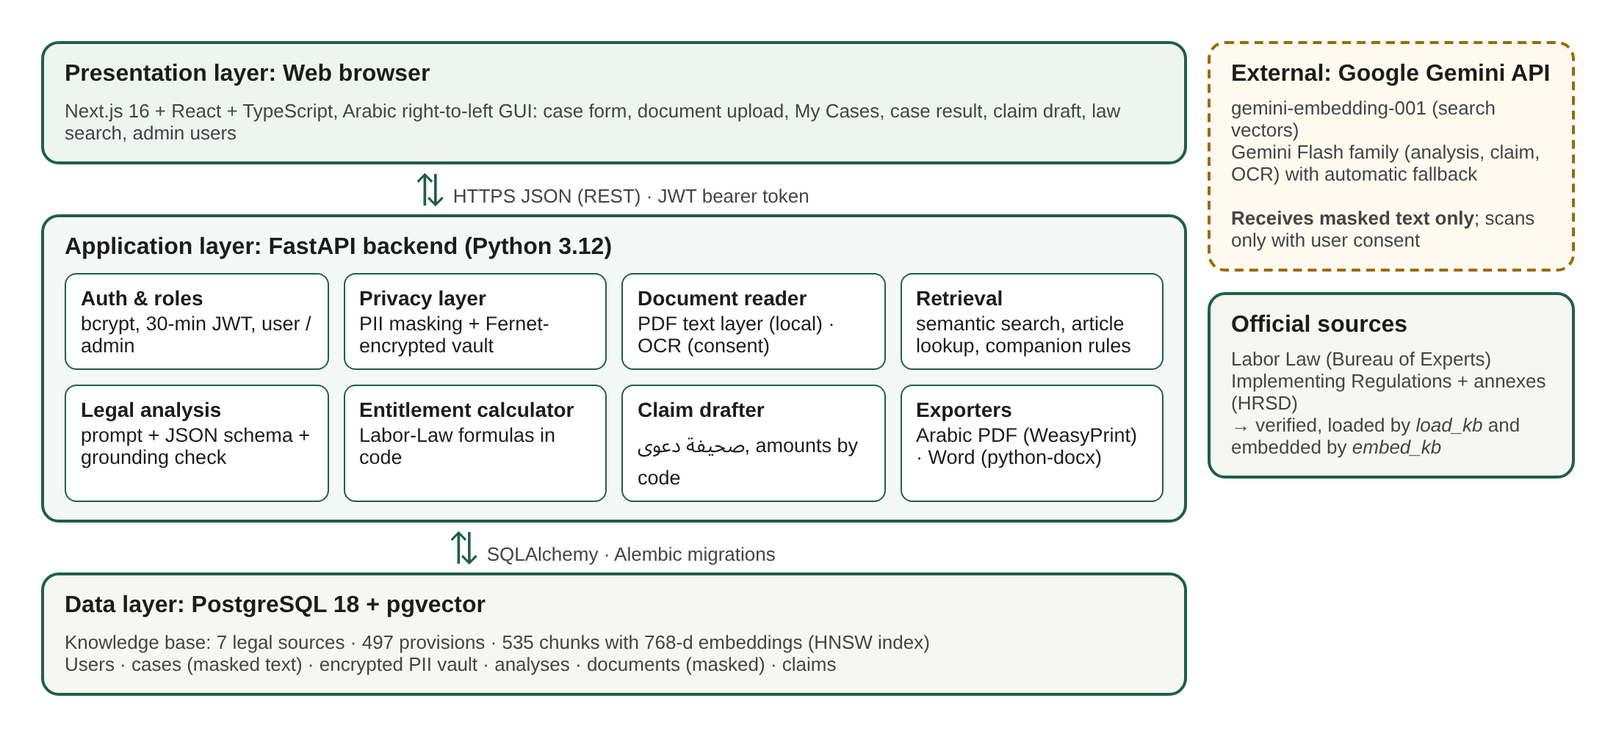
Figure 3: QISTAS system architecture

4.3 Interface Types and Rationale
Table 7: Interfaces developed and why
Interface | Users | Why
Graphical user interface (web, Arabic RTL) | Workers, lawyers, administrators | The target users are non-technical; a web GUI needs no installation, works on phones and computers, and presents long Arabic legal text, tables and downloads clearly
REST API with interactive documentation | Developers; future mobile application | Separates the interface from the logic; every feature is testable from the documentation page (Figure 23) and reusable by a future mobile app (CS498 future work)
Command-line tools | Developers and the data administrator | Loading and embedding the knowledge base, creating administrators, running benchmarks and tests are technical, repeatable tasks best done from scripts (Figure 24)

A menu-driven interface was not developed: the web GUI already provides menu-style navigation (analyze, my cases, search, administration) and suits the target users better.

4.4 Results: Working Interfaces
All screenshots below were taken from the running prototype with a fictitious case (a female accountant dismissed without notice after about 7.5 years of service). Names and numbers are invented.

4.4.1 Accounts
  (a) Login | 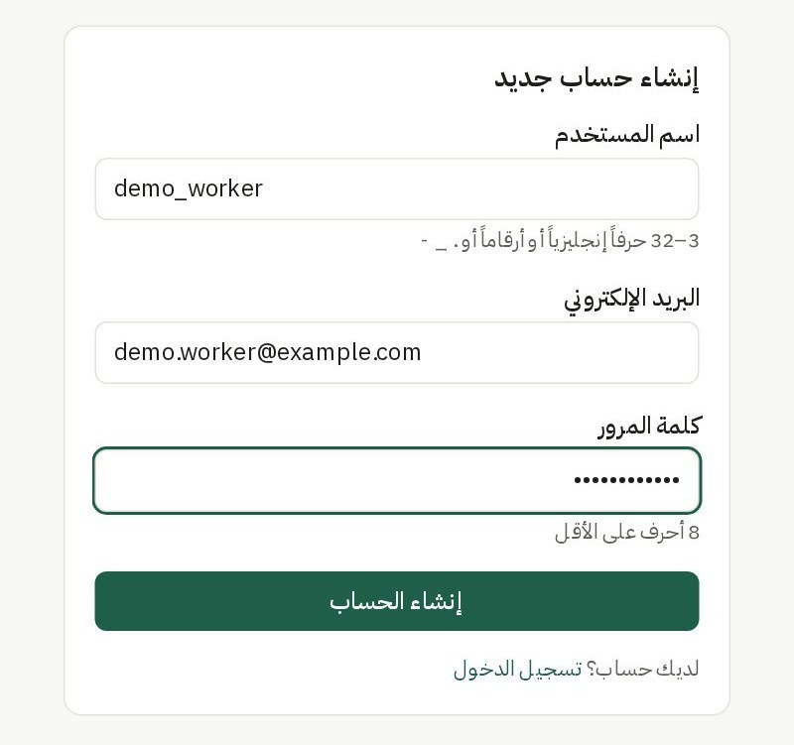  (b) Registration
Figure 4: Login and registration pages (FR1, FR2)

4.4.2 Submitting a Case with Documents
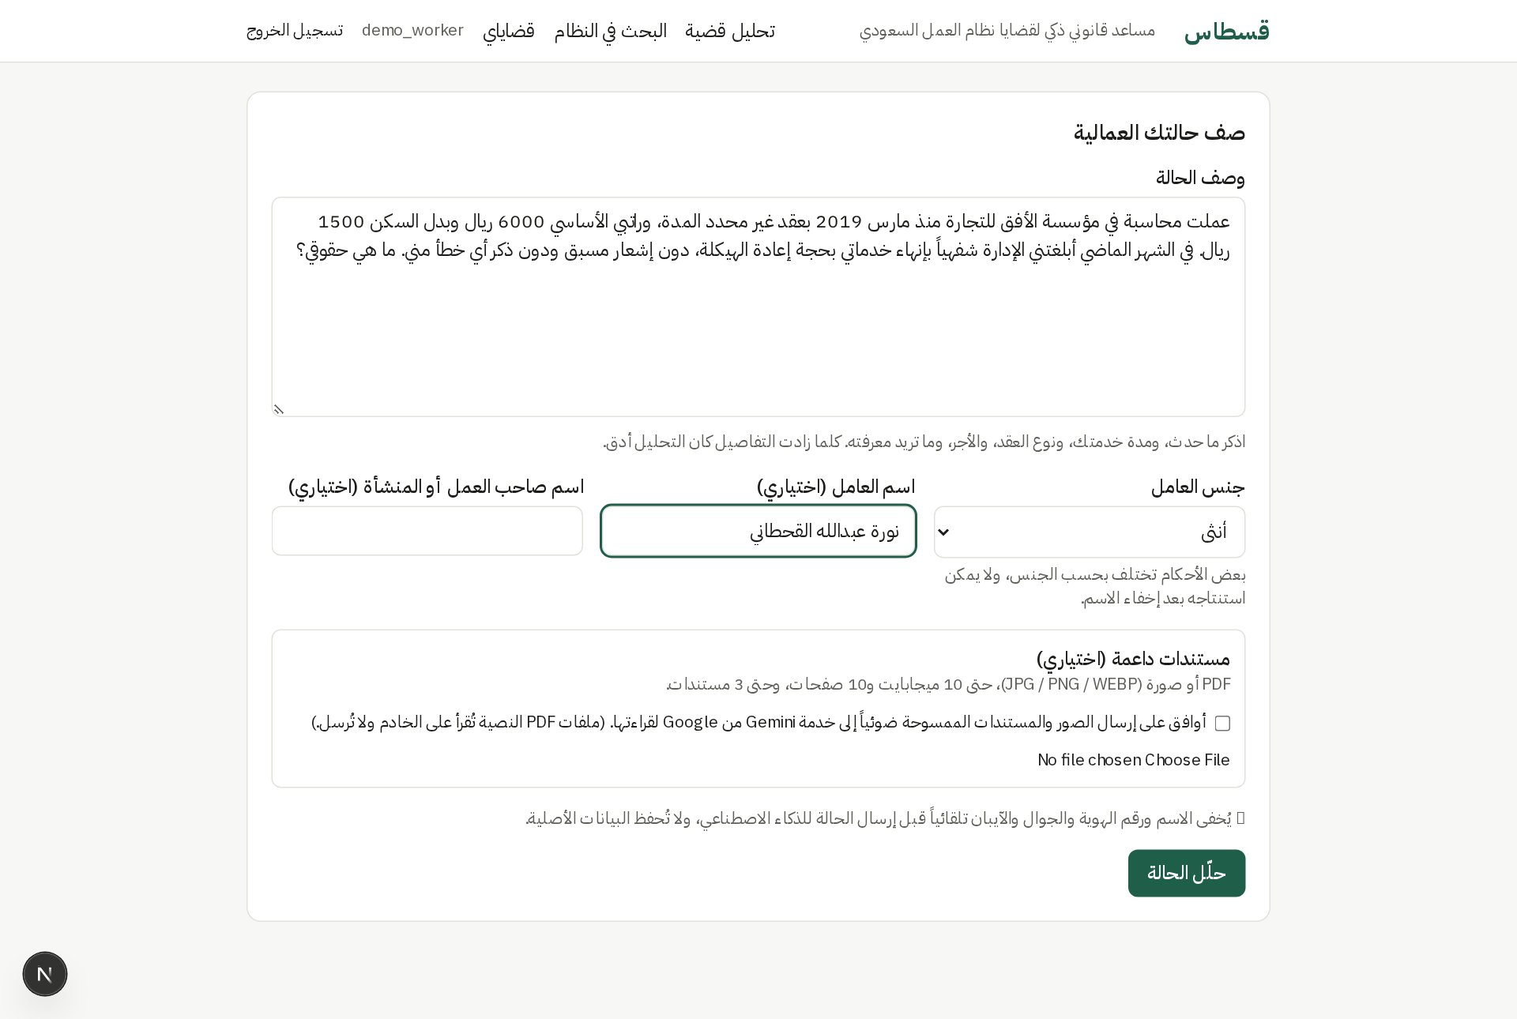
Figure 5: Case submission form: description, gender, optional names (FR3)
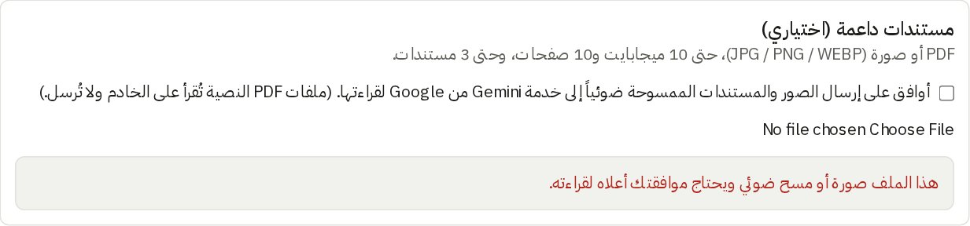
Figure 6: A scanned image requires consent before it is sent for OCR
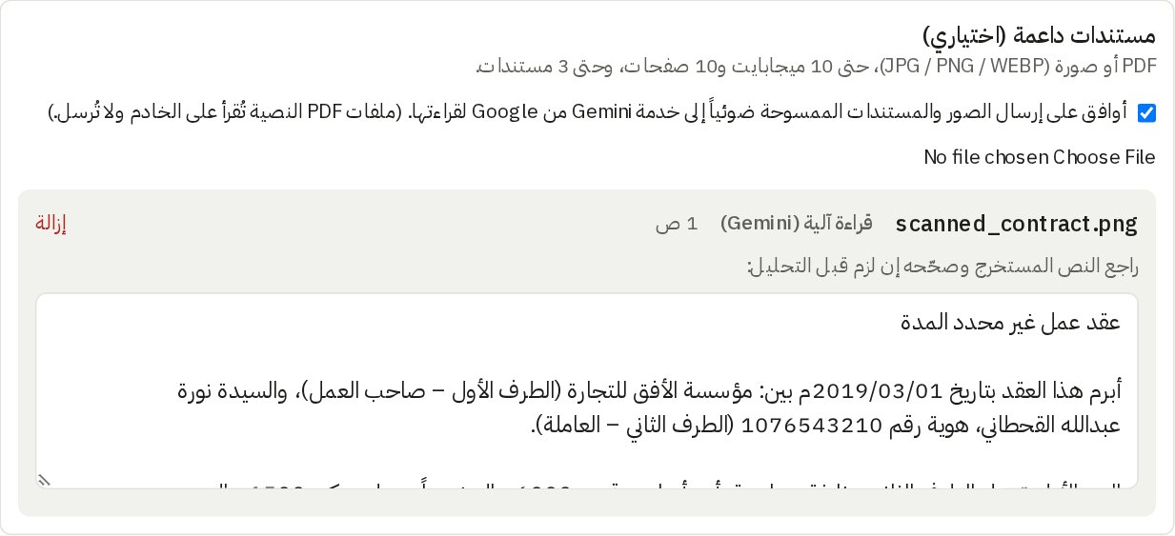
Figure 7: Scanned contract read by OCR after consent; the text is shown for review (FR4, FR5)
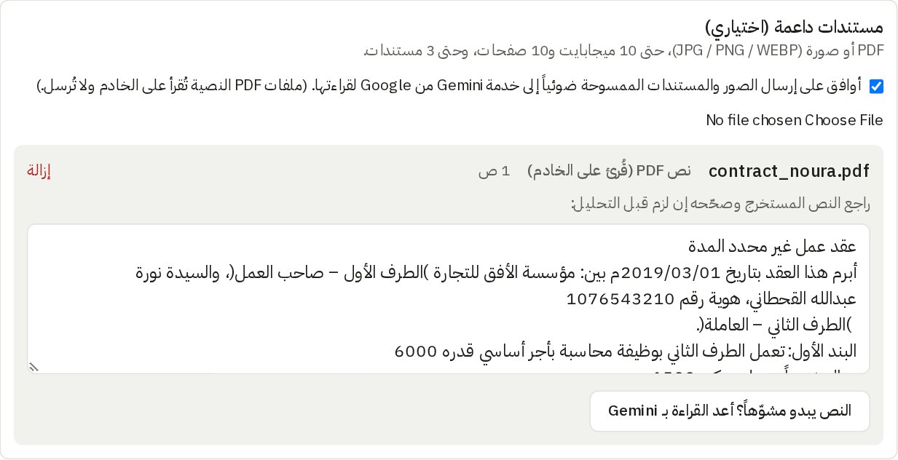
Figure 8: A text PDF is read locally on the server without OCR
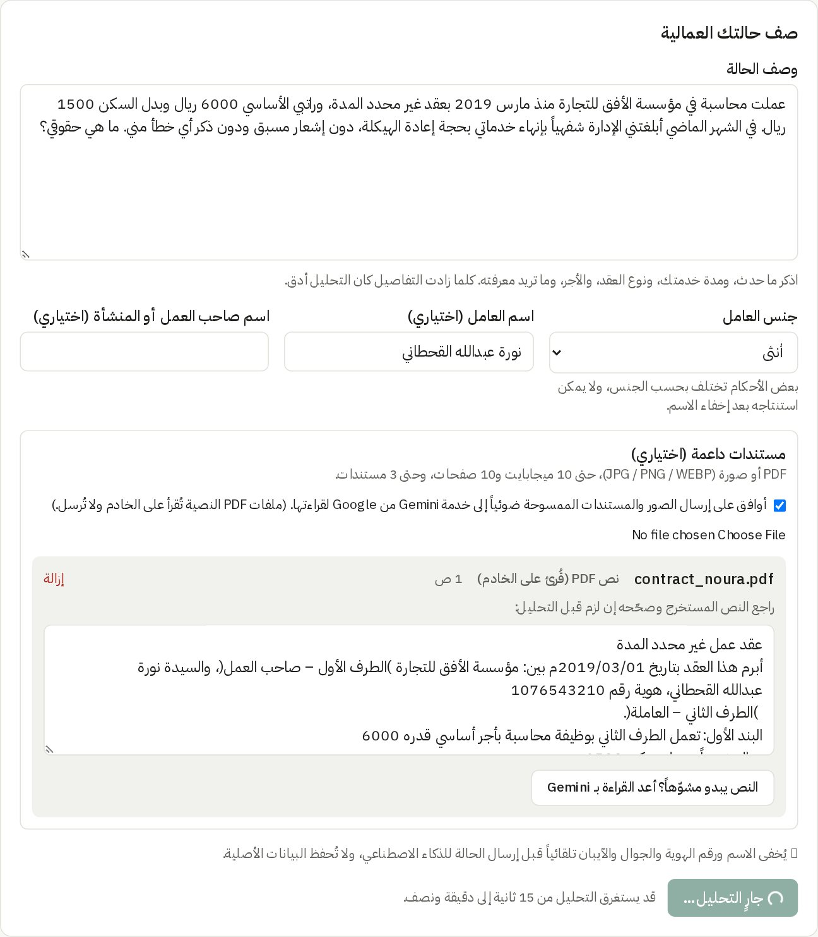
Figure 9: Progress state while the case is analyzed

4.4.3 Analysis Results
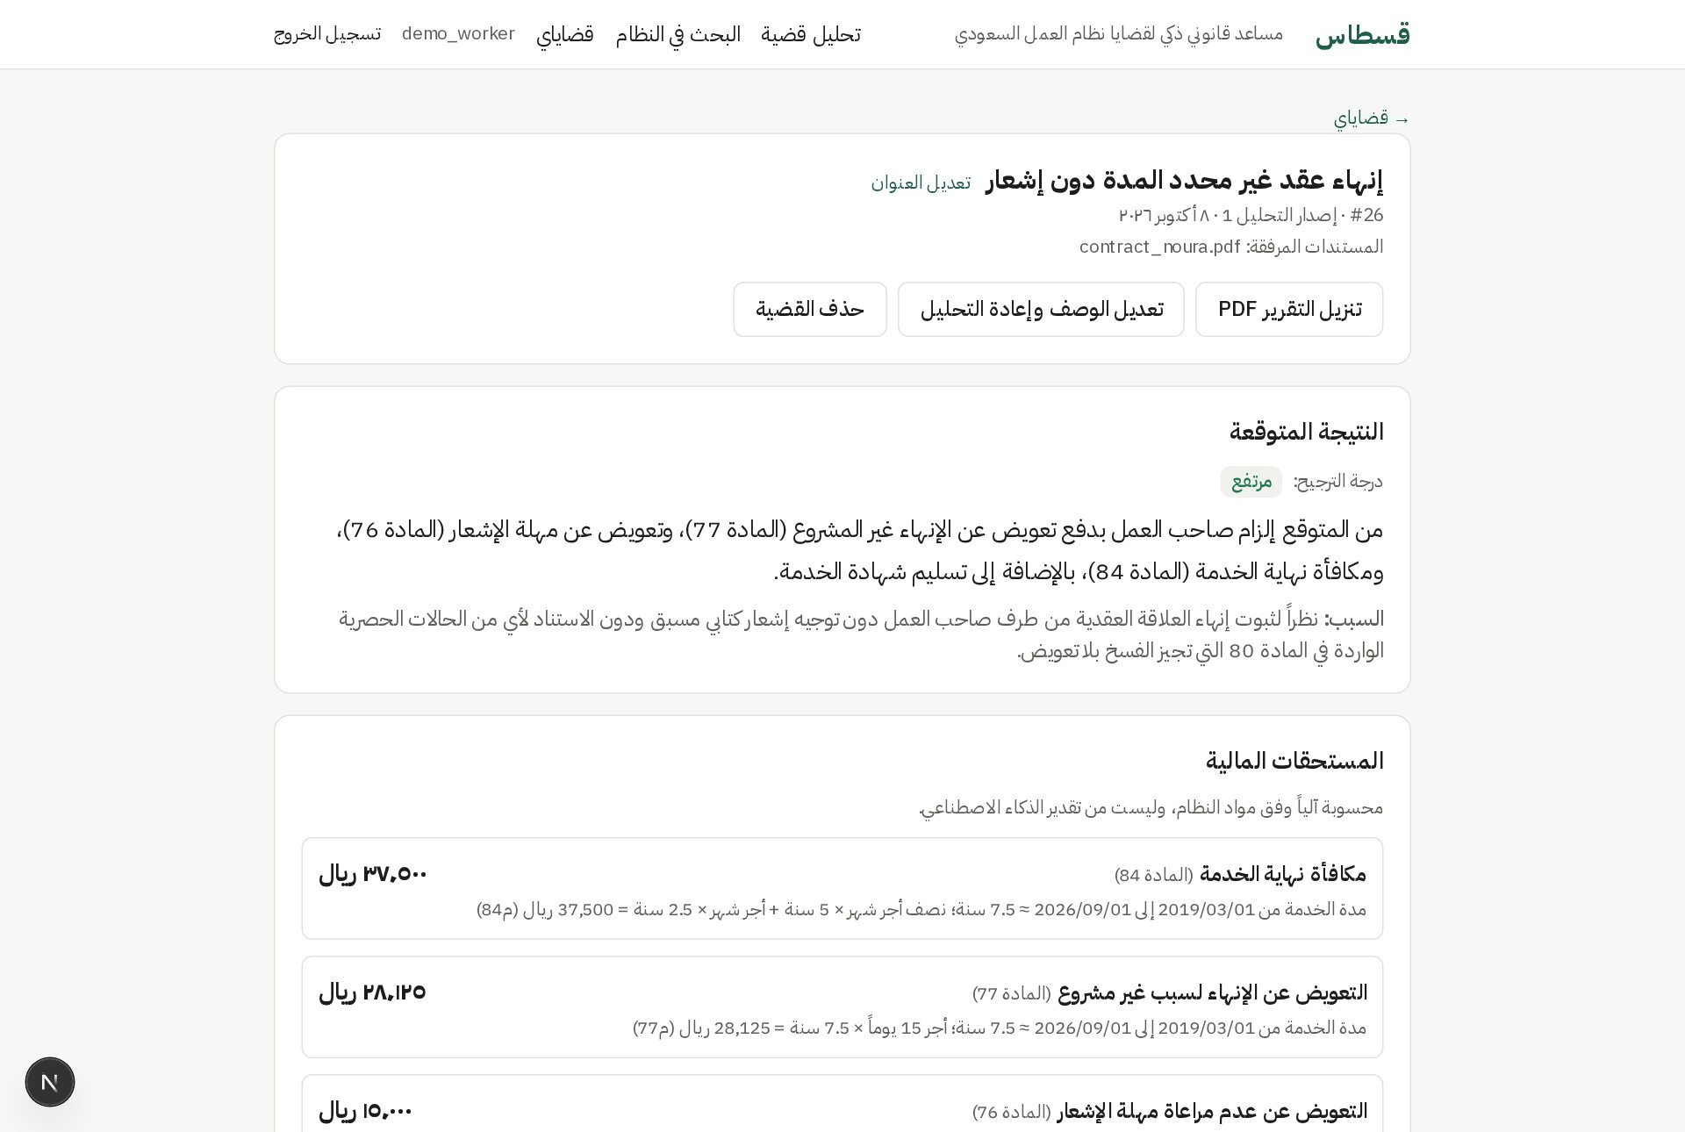
Figure 10: Saved case: title, actions, expected outcome with likelihood, and entitlements (FR6, FR8)
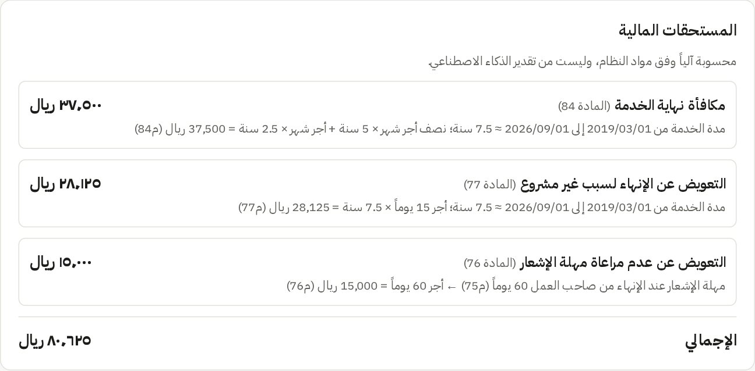
Figure 11: Entitlements computed in code with the formula of each article
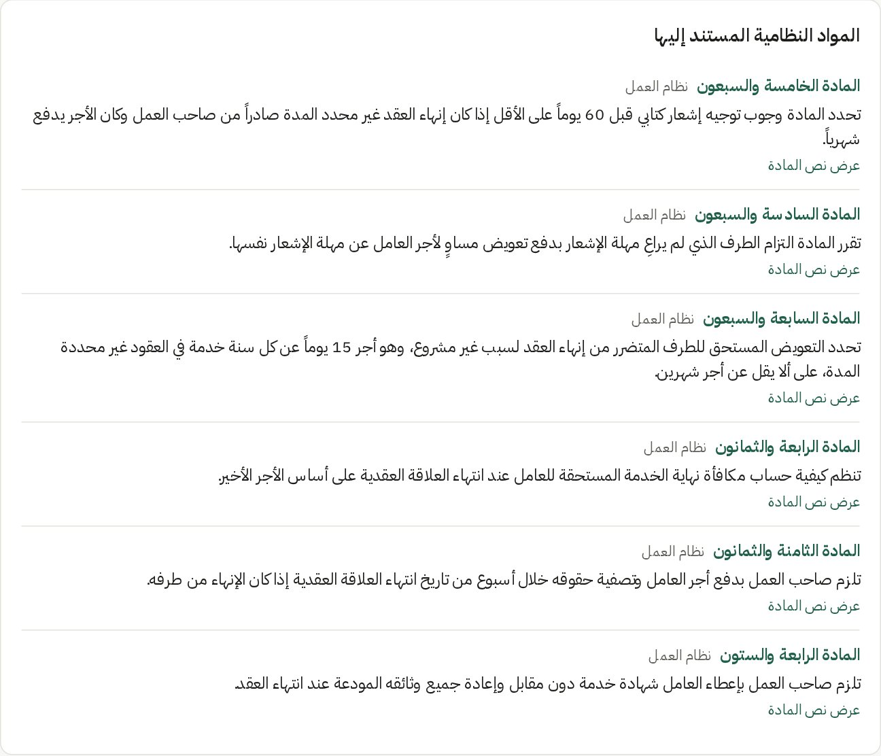
Figure 12: Cited articles with the reason each applies; the full text expands on demand

Figure 13: “What was sent to the AI”: the masked text the model received

4.4.4 Downloadable Report
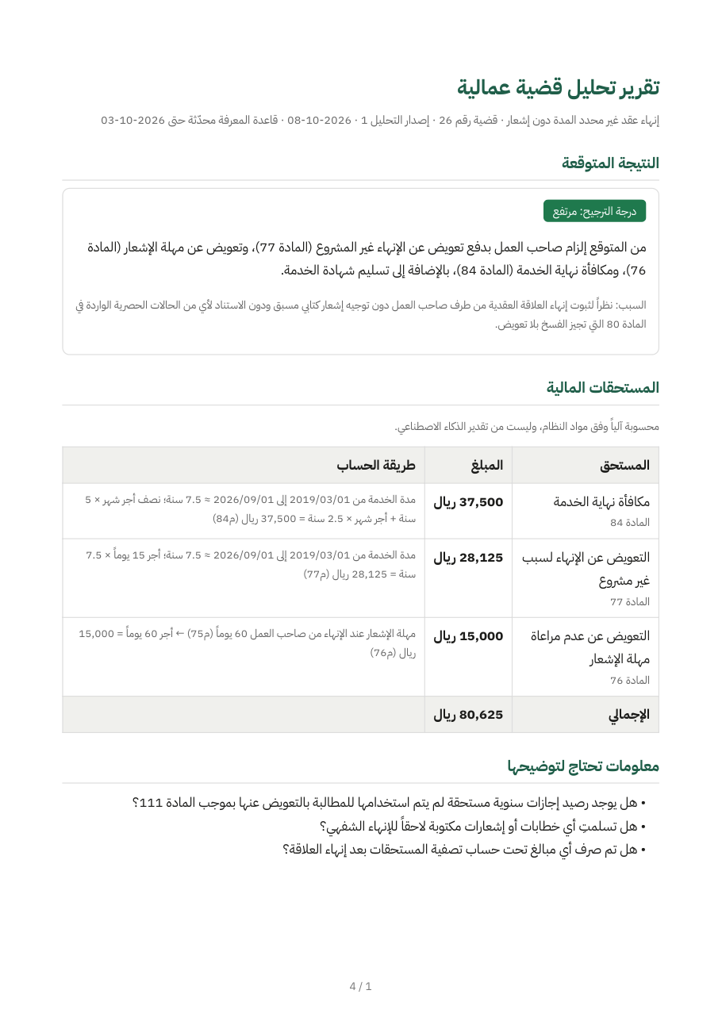  (a) Page 1 | 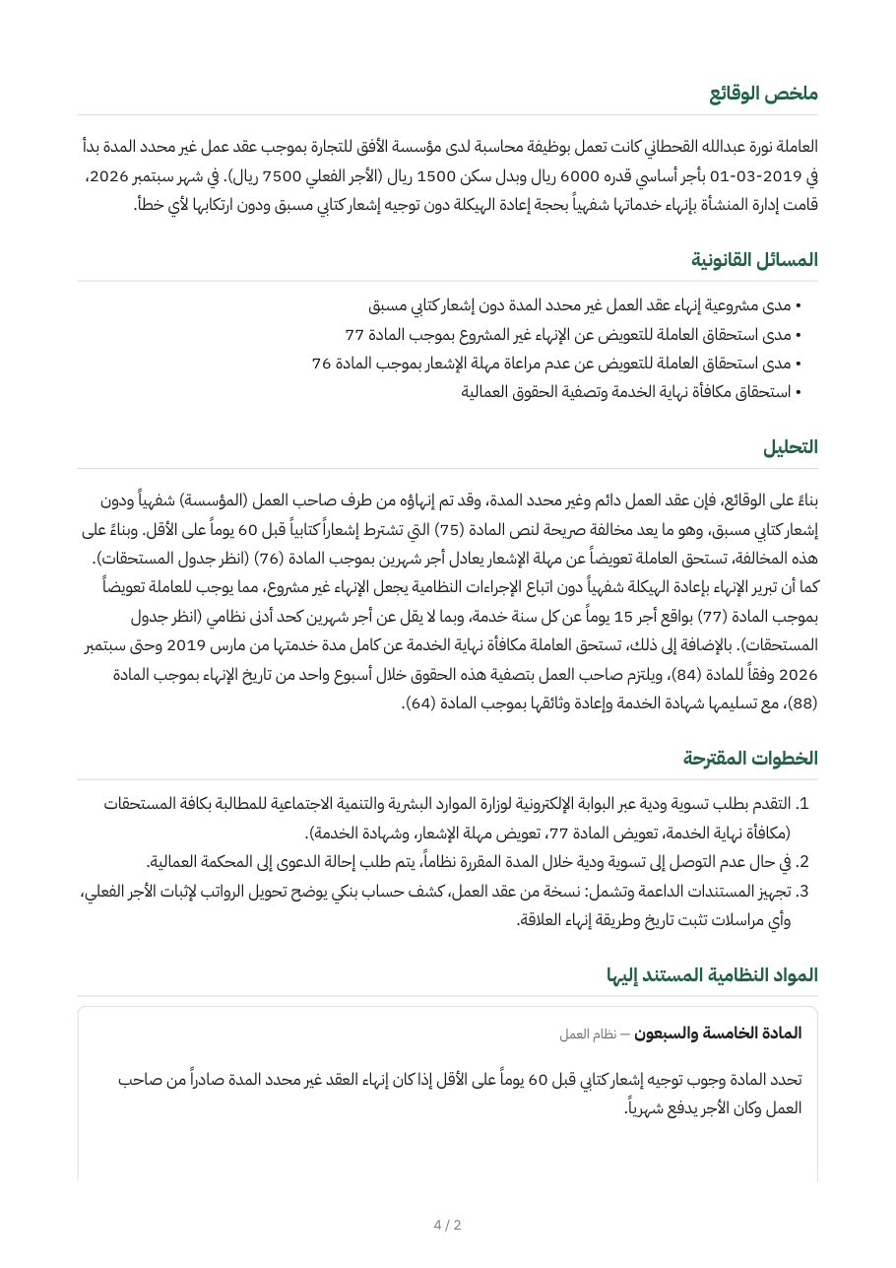  (b) Page 2
Figure 14: Downloaded analysis report in Arabic PDF (FR13); the missing-information list and the analysis are on page 2

4.4.5 Statement of Claim Draft
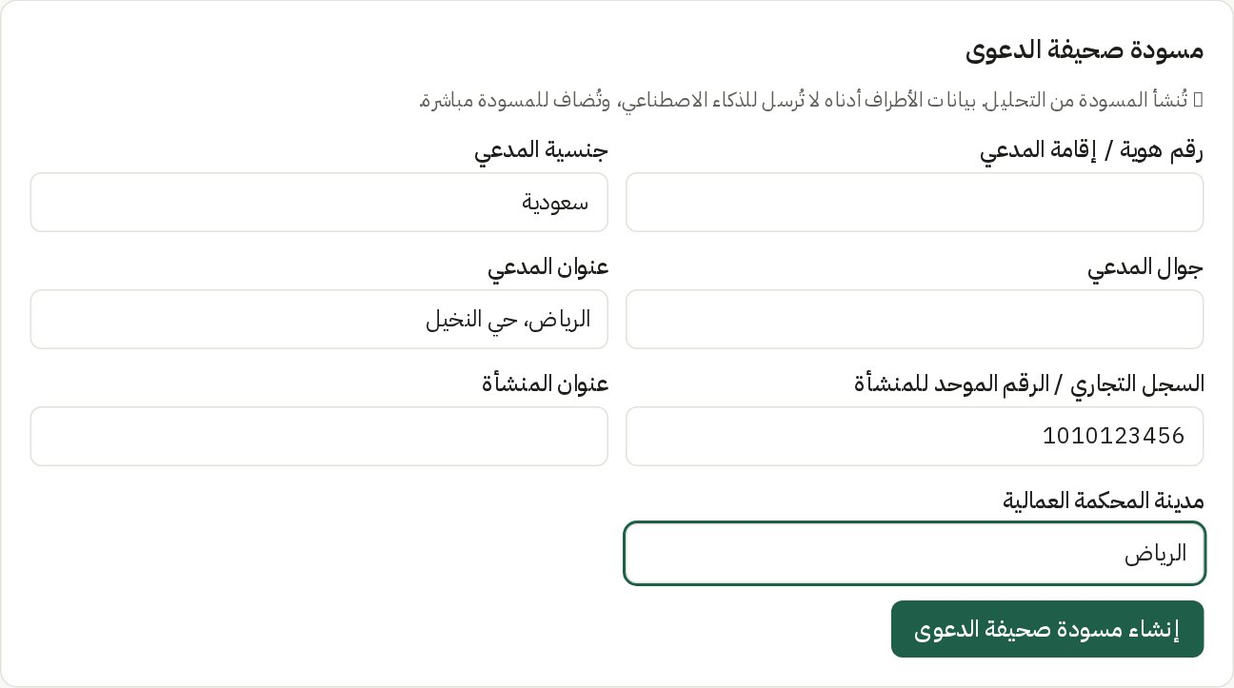
Figure 15: Claim draft form: party details are inserted by code and never sent to the AI (FR10)
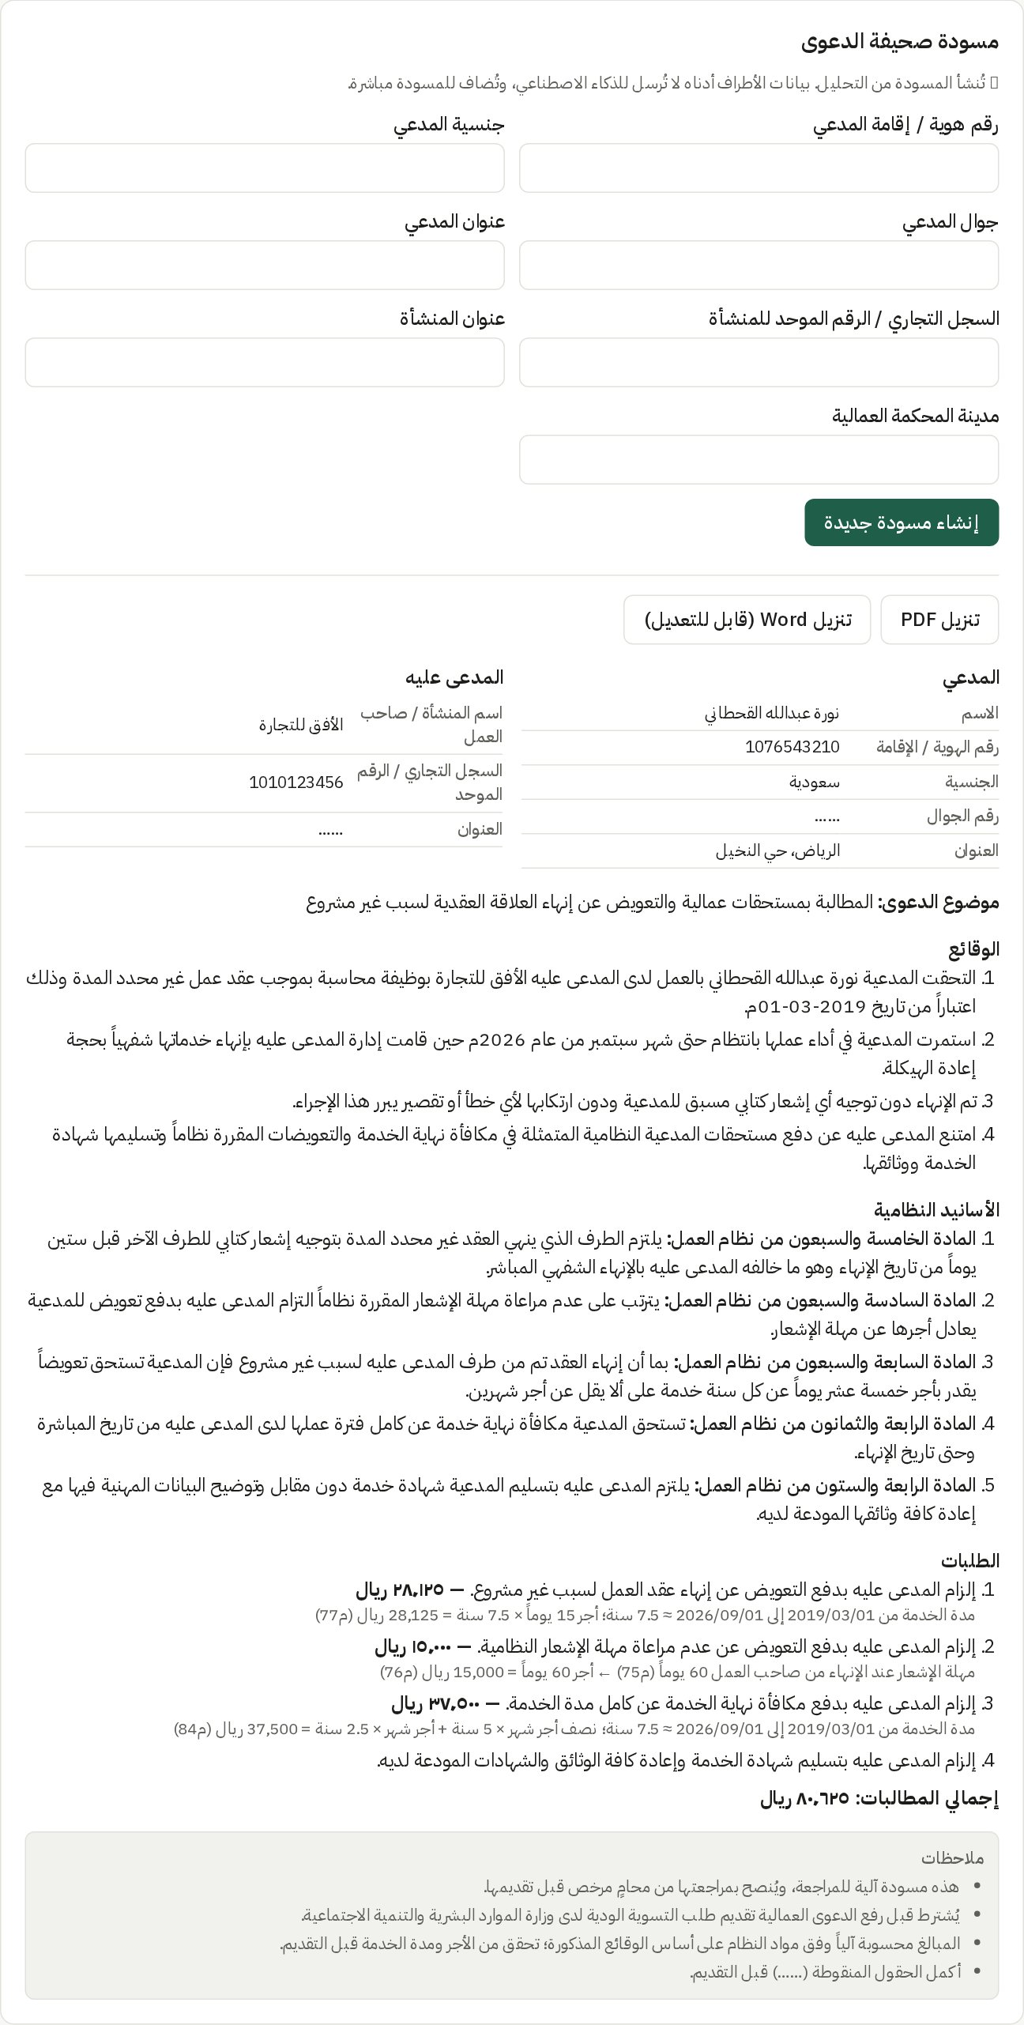
Figure 16: Generated claim draft: parties, facts, legal grounds, requests with computed amounts, notes
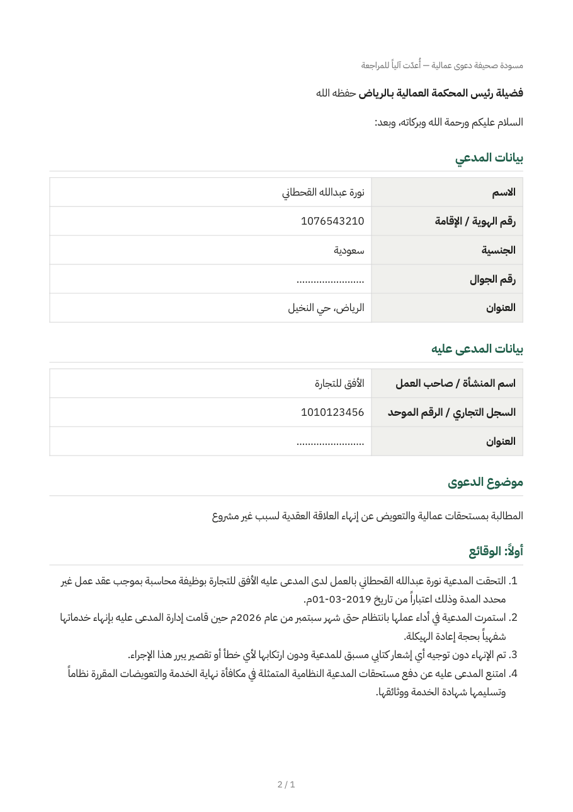  (a) PDF | 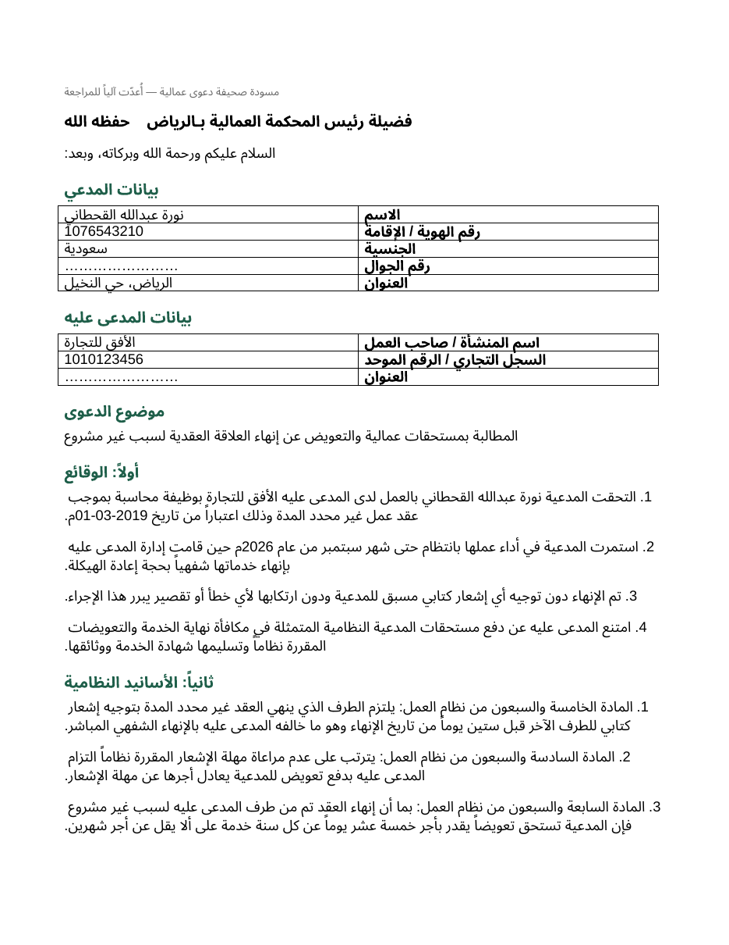  (b) Word (editable)
Figure 17: Downloaded claim draft as PDF and as an editable Word document (FR13)

4.4.6 Case Management
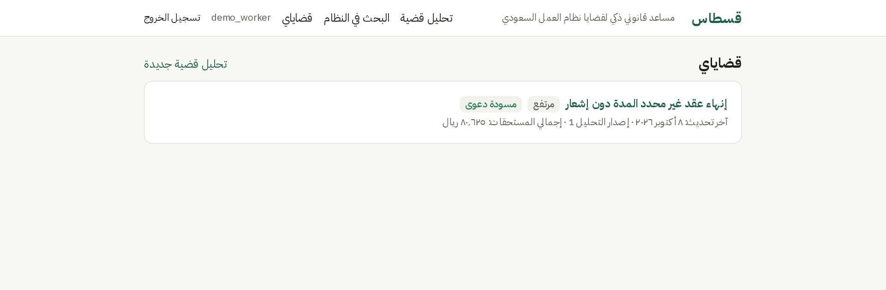
Figure 18: My Cases: the user's saved cases with likelihood, total and claim status (FR12)
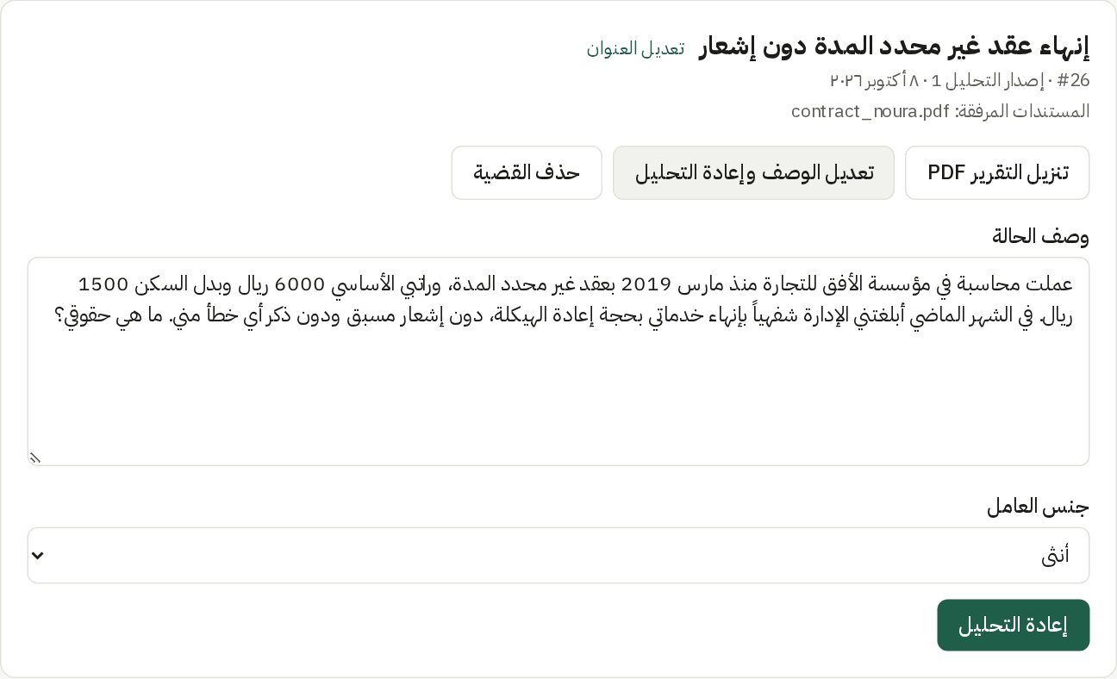
Figure 19: Editing a case description and re-analyzing it; rename, download and delete actions (FR12)

4.4.7 Law Search and Articles
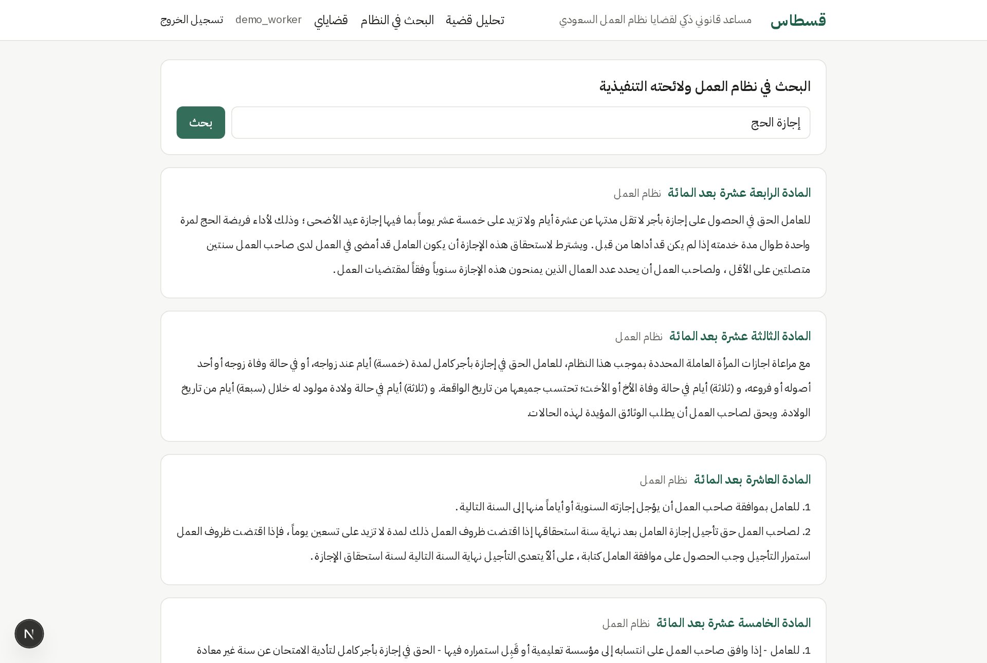
Figure 20: Searching the Labor Law in everyday Arabic (FR11)
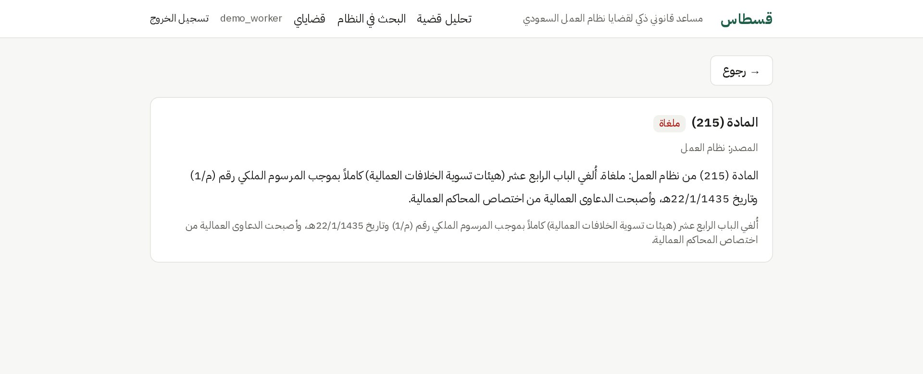
Figure 21: A repealed article shows its status and the repealing decree

4.4.8 Administration
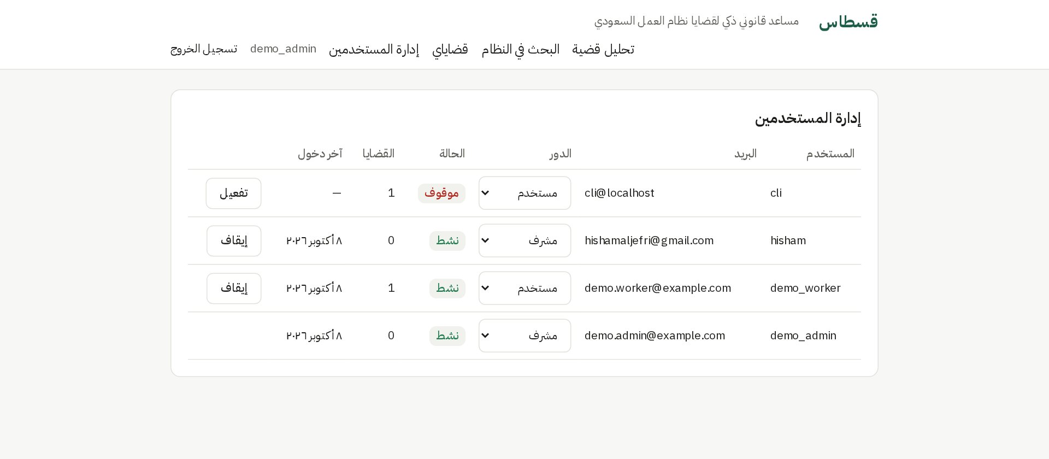
Figure 22: Administrator page: roles and account activation (FR14)

4.4.9 REST API and Command Line
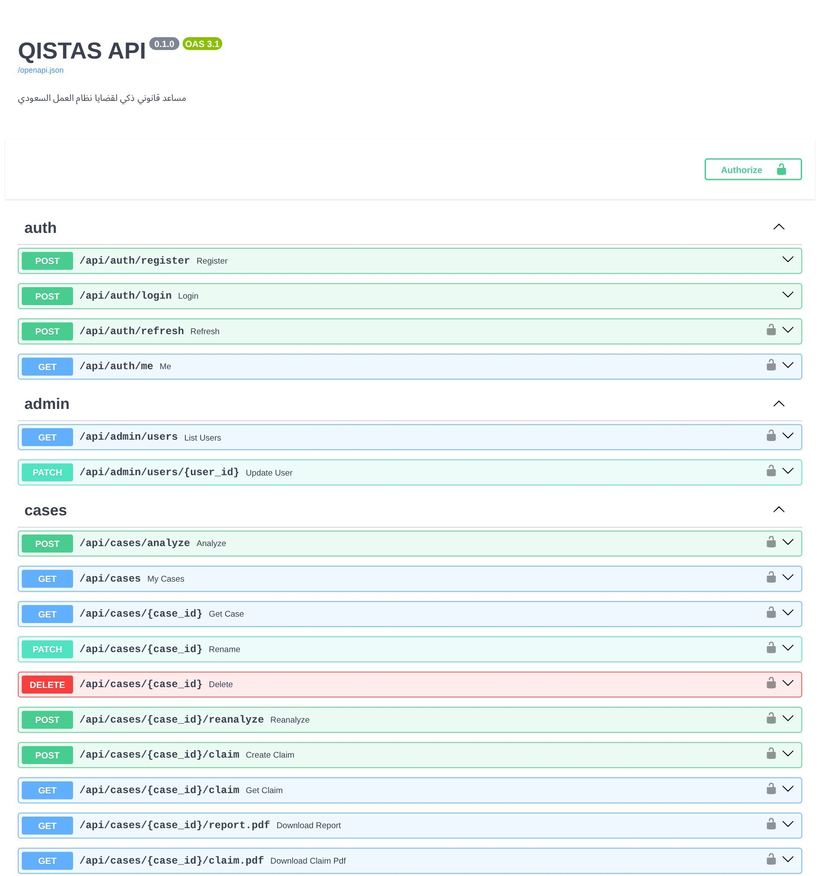
Figure 23: Interactive REST API documentation (excerpt)
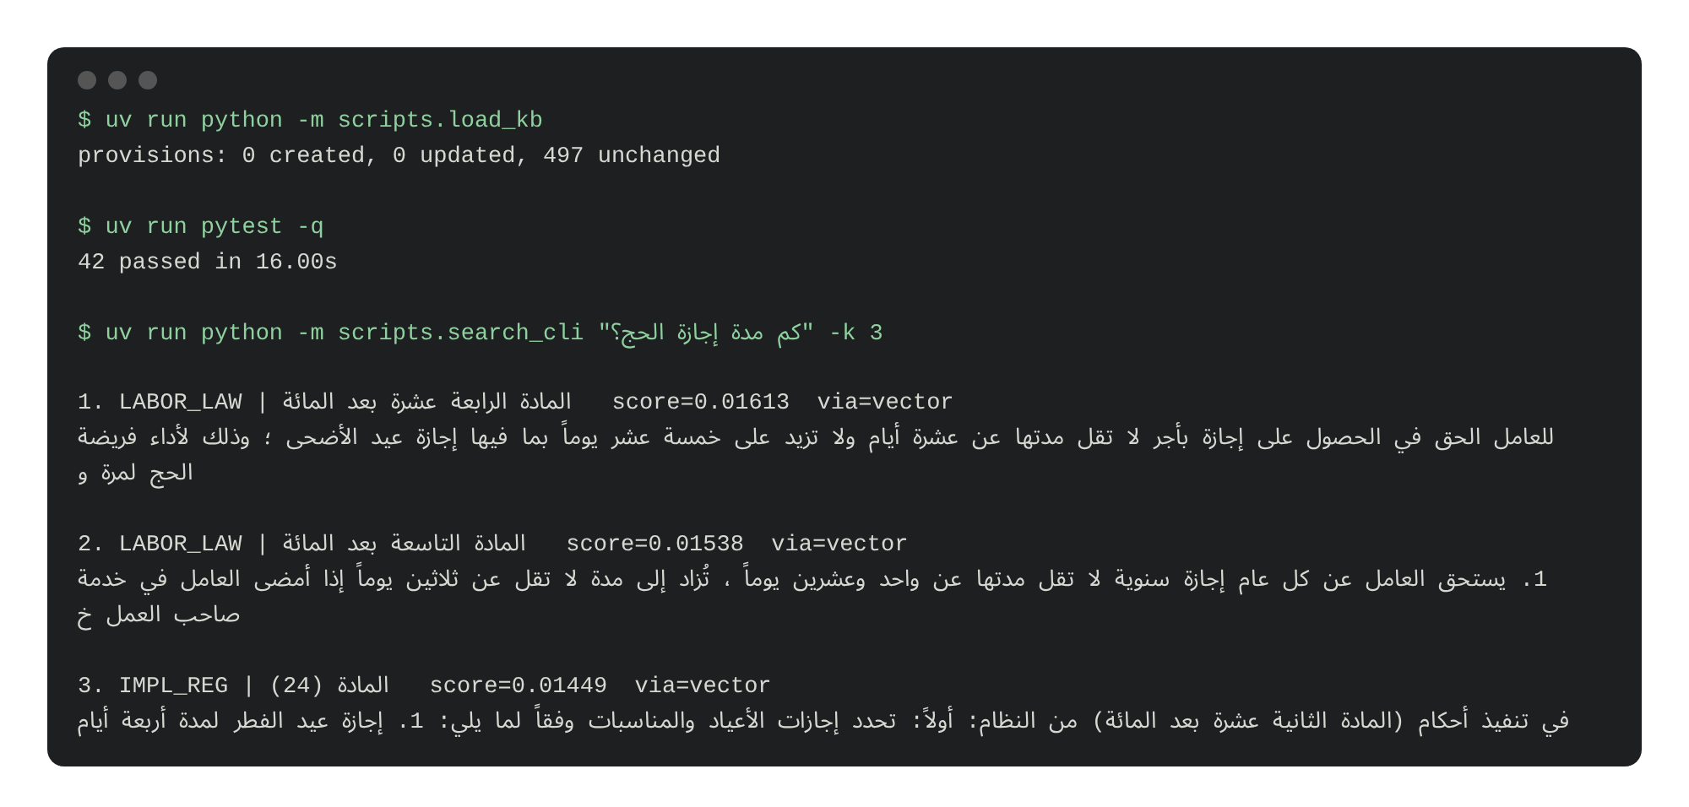
Figure 24: Command-line tools: knowledge-base loader, automated tests and search

4.5 Implementation Completeness
The template requires evidence that at least 70% of the implementation is done. Measured against the CS498 functional requirements, 13 of 15 are complete and one is partial (Figure 25 and Table 8): 87% complete (90% counting the partial requirement as half).
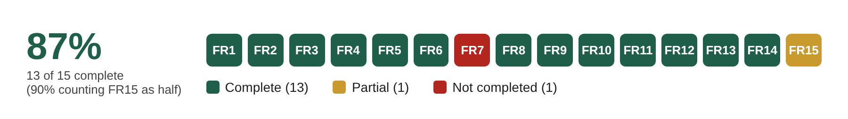
Figure 25: Status of the CS498 functional requirements
Table 8: Functional requirements status (CS498 FR1–FR15)
ID | Requirement | Status | Evidence
FR1 | Register with username, e-mail and password | Complete | Figure 4(b); register endpoint
FR2 | Secure login | Complete | bcrypt hashing; 30-minute tokens; tests for wrong, expired and forged tokens
FR3 | Authenticated users enter an Arabic case | Complete | Figure 5; analysis requires login
FR4 | Upload documents (PDF/image) | Complete | Figures 6–8; PDF, JPG, PNG, WEBP ≤ 10 MB
FR5 | Extract text with OCR | Complete | Local text extraction (Figure 8); OCR with consent (Figure 7)
FR6 | Extract key legal entities | Complete | Parties/IDs detected by masking (Figure 13); wage, dates, contract type extracted (Figure 11)
FR7 | Retrieve similar judicial decisions | Not completed | No dataset yet (Table 4)
FR8 | Retrieve relevant labor-law articles | Complete | Figure 12; Hit@5 100% (Section 4.6.2)
FR9 | Identify missing legal elements | Complete | Missing-information list (Figure 14)
FR10 | Generate a draft statement of claim | Complete | Figures 15–17
FR11 | Search the knowledge base | Complete | Figures 20–21
FR12 | View, edit and delete own cases | Complete | Figures 18–19
FR13 | Download reports and claims | Complete | Figures 14 and 17
FR14 | Admin manages accounts and roles | Complete | Figure 22
FR15 | Data manager maintains articles | Partial | Loader script with change detection; no UI yet

Tables 9 and 10 report the non-functional and security requirements.
Table 9: Non-functional requirements status
ID | Requirement | Status
NFR1 | Response within 10 s | Search: 0.09–0.34 s (meets). Full AI analysis: median 39.8 s (does not meet; see Table 4)
NFR2 | Arabic RTL input and output | Met: interface, PDF and Word outputs
NFR3 | 95% availability | Not yet measured (local deployment); automatic model fallback improves AI availability
NFR4 | Sensitive data processed locally | Changed by design: only masked text is sent to the LLM; text PDFs are read locally; scans only with consent
NFR5 | 50 concurrent users | Not yet tested
NFR6 | Deployable on 16 GB RAM + 8 GB GPU | Exceeded: runs on a laptop with ≈3.8 GB RAM and no GPU
NFR7 | Modular design, swappable LLM | Met: model names configurable; layered backend; replaceable interface

Table 10: Security requirements status
ID | Requirement | Status
SR1 | Passwords hashed with bcrypt | Met (verified by test)
SR2 | Sessions expire after 30 minutes of inactivity | Met: 30-minute tokens refreshed only while the user is active
SR3 | No sensitive data sent to external APIs | Changed: masked text only; scans with explicit consent
SR4 | Role-based access control | Met: non-admins blocked; users cannot access others' cases (tested)
SR5 | Daily knowledge-base backup | Planned
SR6 | Uploaded documents checked for malicious content | Partial: signature, size, page and embedded-file checks; files never stored
SR7 | Anonymization before AI processing | Met for typed text and text PDFs; scans with consent
SR8 | Generalized placeholders such as [EMPLOYEE_1] | Met
SR9 | Original values encrypted, owner/admin only | Met: Fernet-encrypted vault per case; no plain names in the database (tested)

4.6 Statistics of Results

4.6.1 Knowledge Base
Table 11: Knowledge-base statistics
Item | Value
Legal sources | 7 (Labor Law, Implementing Regulations, 5 annexes)
Provisions | 497 (456 official records + 41 repealed/merged status records)
Labor Law coverage | All articles 1–245 plus 4 “bis” (مكرر) articles
Searchable chunks | 535, each with a 768-dimension embedding
Knowledge base up to date as of | 3 October 2026

4.6.2 Retrieval Accuracy
A benchmark of 37 everyday Arabic questions, each with the correct Labor Law article verified against the official text, was used to compare retrieval methods. Hit@k is the share of questions whose correct article appears in the top k results; MRR is the mean reciprocal rank (Voorhees, 1999). Keyword search performs poorly because users rarely use the statute's wording, and fusing it with semantic results (reciprocal rank fusion; Cormack et al., 2009) lowered accuracy at every weight tested. The adopted configuration reaches Hit@5 = 100% and Hit@1 = 95% (Figure 26). Because the same questions were used to choose the configuration, these figures are optimistic; a held-out evaluation is planned.
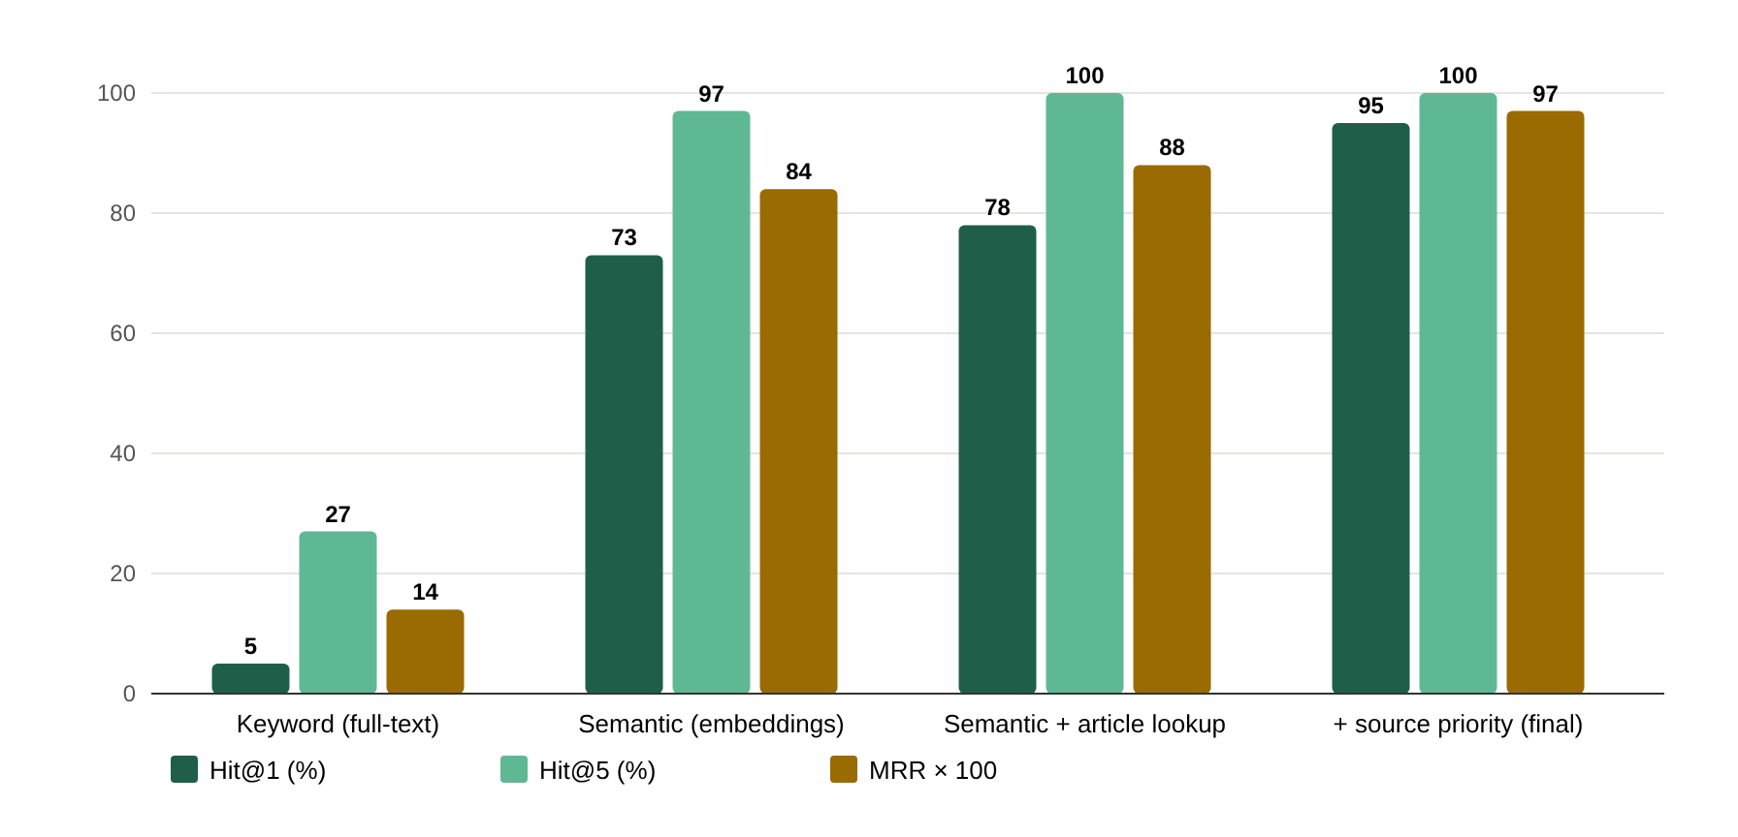
Figure 26: Retrieval accuracy by method (37 questions)

4.6.3 Case Analyses
Table 12: Hand-checked case analyses
Case | Cited articles | Amount computed | Manual check
Dismissal without reason or notice, 6 years, wage 10,000 SAR | 75, 76, 77, 84 (+ 80, 88, 64, 111) | 85,000 SAR (30,000 art. 77 + 20,000 art. 76 + 35,000 art. 84) | Correct
Wages unpaid for 3 months, 2 years of service | 81, 90, 94 (+ 84, 88, 111, 64) | 18,000 arrears + 6,000 end-of-service | Correct
Resignation after 4.5 years, wage 7,000 SAR | 84, 85, 88 | 5,250 SAR (one third of 15,750) | Correct
Demonstration case (Section 4.4): dismissal after ≈7.5 years, wage 7,500 SAR | 75, 76, 77, 84, 64 | 37,500 + 28,125 + 15,000 = 80,625 SAR | Correct

A blind test of 12 unseen cases (probation, fixed-term contracts, overtime, leave, sickness, pregnancy, work injury, non-compete clauses, transfers, resignation after marriage, deductions and a vague complaint) gave the following results before the fixes in Section 3.3:
Table 13: Blind test results (12 unseen cases)
Measure | Result
Required articles cited | 11 of 12 cases
Conclusion fully correct | 8 of 12 cases (4 partially correct)
Invented citations | 0
Notable correct behaviour | Told a worker dismissed during probation that nothing is owed (did not side with the user)
Problems found and fixed | Gender hidden by masking; arithmetic error; over-confidence on a vague case; a missing companion article

4.6.4 Automated Testing and Performance
Table 14: Automated tests (all passing)
Test suite | Tests | What is verified
API (accounts, roles, cases, documents, claim, downloads) | 16 | Authentication, role checks, ownership, encryption, masking end-to-end, uploads, claim grounding, PDF/Word output
Entitlement calculator | 15 | Every formula against hand-computed amounts, including service years from dates
Privacy masking | 9 | IDs, phones, IBAN, e-mail, names and short forms, consistent placeholders
Grounding check | 2 | Invented citations removed and reported
End-to-end browser test (real AI) | 12 steps | Register → upload → analyze → My Cases → rename → report → claim → logout → admin → delete; 0 browser errors

Table 15: Performance measurements
Measure | Value
Case analyses recorded | 25
Analysis time (median; interquartile range) | 39.8 s; 16.1–58.3 s
Analysis time (minimum – maximum) | 13.2 s – 88.0 s
Analyses answered by a fallback model | 22 of 25 (the primary model was frequently overloaded)
Law search time (5 queries) | 0.09–0.34 s (mean 0.17 s)

4.7 User Manual
This manual is written for users with no technical background. The interface is in Arabic; Arabic button names are given in quotation marks.

4.7.1 Creating an Account and Signing In
- Open the QISTAS website in a browser.
- Click “إنشاء حساب” (create account), enter a username (English letters or numbers), your e-mail and a password of at least 8 characters, then click “إنشاء الحساب”.
- Next time, click “تسجيل الدخول” (sign in) and enter your username or e-mail and password.
- For your security, you are signed out automatically after 30 minutes without activity.

4.7.2 Analyzing Your Case
- Click “تحليل قضية” (analyze a case).
- In “وصف الحالة” describe what happened in your own words: your job, when you started, your contract type, your salary and allowances, what the employer did, and what you want to know.
- Choose the worker's gender (“جنس العامل”); some rights differ for women. Your name and the employer's name are optional and are hidden before analysis.
- Optional: attach documents such as your contract (PDF or photo). PDF files with text are read on the server. For photos or scanned papers, tick the consent box first. Check the text that appears and correct it if needed.
- Click “حلّل الحالة” (analyze) and wait; this may take up to a minute and a half.

4.7.3 Reading the Result
- النتيجة المتوقعة (expected outcome): the likely result and how likely it is (high, medium or low).
- المستحقات المالية (entitlements): the amounts you may claim, each calculated by the system with the article and formula shown.
- معلومات تحتاج لتوضيحها (missing information): questions whose answers could change the result. You can add them later with “تعديل الوصف وإعادة التحليل” (edit and re-analyze).
- المواد النظامية (legal articles): the articles the analysis relies on; click “عرض نص المادة” to read each one.
- ما الذي أُرسل للذكاء الاصطناعي (what was sent to the AI): your text with personal data hidden.
- The result is for information only and is not legal advice.

4.7.4 Preparing a Statement of Claim
- On the case page, scroll to “مسودة صحيفة الدعوى” (claim draft).
- Fill in any details you want in the claim (ID number, nationality, phone, address, the employer's commercial registration number and the court city). These details are added directly and are not sent to the AI.
- Click “إنشاء مسودة صحيفة الدعوى” and review the draft.
- Click “تنزيل Word (قابل للتعديل)” to download an editable Word file, or “تنزيل PDF”. Complete any dotted fields, and remember that an amicable settlement request to the Ministry of Human Resources is required before filing at the labor court.

4.7.5 Managing Your Cases
- Click “قضاياي” (my cases) to see all your saved cases.
- Open a case to read it again, rename it (“تعديل العنوان”), download the report (“تنزيل التقرير PDF”), edit and re-analyze it, or delete it (“حذف القضية”).

4.7.6 Searching the Law
- Click “البحث في النظام” (search the law).
- Type a question or topic in Arabic (for example “إجازة الحج”) or an article number (for example “المادة 84”) and click “بحث”.
- Click a result to read the full article; repealed articles are marked “ملغاة” with the repealing decree.

4.7.7 For Administrators
- Sign in with an administrator account and click “إدارة المستخدمين” (user management).
- Change a user's role or click “إيقاف” to deactivate an account (“تفعيل” re-activates it).
Instructions for installing and running the prototype are given in Appendix B.

5. References
Al-Qahtani, A. (2026). Constructing compliance: Analyzing Saudi labor law through the lens of systemic functional linguistics. International Journal of Communication and Linguistic Studies. https://doi.org/10.18848/2327-7882/CGP/A216
Almutairy, F., Almutairi, S., Abdullah, M., & Salman, S. (2026). SmartLaw Advisor: AI-powered legal consultation and contract analysis for Saudi Arabia. IEEE Access. https://www.researchgate.net/publication/400892422
Bari, M. S., Alnumay, Y., Alzahrani, N. A., Alotaibi, N. M., Alyahya, H. A., AlRashed, S., & Al-Thubaity, A. (2025). ALLaM: Large language models for Arabic and English. In Proceedings of the International Conference on Learning Representations (ICLR). https://openreview.net/forum?id=MscdsFVZrN
Bureau of Experts at the Council of Ministers. (2005, as amended). Labor Law (Royal Decree No. M/51 of 23/8/1426H). https://laws.boe.gov.sa/BoeLaws/Laws/LawDetails/08381293-6388-48e2-8ad2-a9a700f2aa94/1
Cormack, G. V., Clarke, C. L. A., & Büttcher, S. (2009). Reciprocal rank fusion outperforms Condorcet and individual rank learning methods. In Proceedings of the 32nd International ACM SIGIR Conference on Research and Development in Information Retrieval (pp. 758–759). ACM.
Demir, M. M., Otal, H. T., & Canbaz, M. A. (2025). LegalGuardian: A privacy-preserving framework for secure integration of large language models in legal practice. arXiv. https://doi.org/10.48550/arXiv.2501.10915
Google. (2026). Gemini API documentation. https://ai.google.dev/gemini-api/docs
Jones, M., Bradley, J., & Sakimura, N. (2015). JSON Web Token (JWT) (RFC 7519). Internet Engineering Task Force. https://www.rfc-editor.org/rfc/rfc7519
Lewis, P., Perez, E., Piktus, A., Petroni, F., Karpukhin, V., Goyal, N., Küttler, H., Lewis, M., Yih, W., Rocktäschel, T., Riedel, S., & Kiela, D. (2020). Retrieval-augmented generation for knowledge-intensive NLP tasks. In Advances in Neural Information Processing Systems 33 (pp. 9459–9474).
Li, Y., Xie, M., Kang, G., & Yang, M. (2025). LegalMALR: Multi-agent query understanding and LLM-based reranking for Chinese statute retrieval. arXiv. https://arxiv.org/abs/2601.17692
Malkov, Y. A., & Yashunin, D. A. (2020). Efficient and robust approximate nearest neighbor search using hierarchical navigable small world graphs. IEEE Transactions on Pattern Analysis and Machine Intelligence, 42(4), 824–836.
Ministry of Human Resources and Social Development. (2025). Implementing Regulations of the Labor Law and its annexes (Ministerial Decision No. 115921). https://www.hrsd.gov.sa/ar/knowledge-centre/decisions-and-regulations/regulation-and-procedures/838894
Ministry of Human Resources and Social Development. (2026). Table of violations and penalties of the Labor Law and its Implementing Regulations (Ministerial Decision No. 112377). https://www.hrsd.gov.sa/sites/default/files/2026-02/qrar-wzary---112377.pdf
Mohamed, A., Shaban, K., & Elmahjub, E. (2026). ArabLJP: An evidence-grounded and retrieval-augmented LLM framework for reliable Arabic legal judgment prediction. SSRN. https://www.researchgate.net/publication/401707856
pgvector contributors. (2026). pgvector: Open-source vector similarity search for Postgres. https://github.com/pgvector/pgvector
PostgreSQL Global Development Group. (2026). PostgreSQL 18 documentation. https://www.postgresql.org/docs/18/
Provos, N., & Mazières, D. (1999). A future-adaptable password scheme. In Proceedings of the 1999 USENIX Annual Technical Conference, FREENIX Track. USENIX Association.
Ramírez, S. (2026). FastAPI documentation. https://fastapi.tiangolo.com
Shairah, H. A., Alharbi, S. S., AlHussein, A. A., Alsabea, S., Shaqaqi, O., Alshamlan, H. A., Knio, O., & Turkiyyah, G. (2025). ALARB: An Arabic legal argument reasoning benchmark. In Proceedings of the Third Arabic Natural Language Processing Conference (pp. 389–406). https://aclanthology.org/2025.arabicnlp-main.32.pdf
Vercel. (2026). Next.js documentation. https://nextjs.org/docs
Voorhees, E. M. (1999). The TREC-8 question answering track report. In Proceedings of the Eighth Text REtrieval Conference (TREC-8) (pp. 77–82). NIST.
Wei, H., Sun, Y., & Li, Y. (2025). DeepSeek-OCR: Contexts optical compression. arXiv. https://doi.org/10.48550/arXiv.2510.18234
Zerrouki, T. (2023). PyArabic: A Python package for Arabic text. Journal of Open Source Software, 8(84), 4886. https://doi.org/10.21105/joss.04886

Additional Bibliography
- Kozea / CourtBouillon. WeasyPrint documentation. https://doc.courtbouillon.org/weasyprint/
- Python Cryptographic Authority. Fernet (symmetric encryption) specification. https://cryptography.io/en/latest/fernet/
- SQLAlchemy. SQLAlchemy 2.0 and Alembic documentation. https://docs.sqlalchemy.org
- Anthropic. Claude Code documentation. https://docs.anthropic.com/en/docs/claude-code

Appendix A: Statement on the Use of AI Tools
An AI coding assistant (Claude Code) was used during implementation to help write and refactor code, tests and documentation drafts, and to automate screenshots. The team defined the requirements and design (CS498), made the design decisions reported here, reviewed the generated code, and verified behaviour through the automated tests, the retrieval benchmark, the hand-checked and blind case evaluations and the end-to-end test described in Section 4.6. Legal content in the knowledge base comes exclusively from the official sources listed in the references.
Note to the team: adapt this statement to the course's academic-integrity policy before submission.

Appendix B: Running the Prototype
The prototype runs on Linux (or Windows with WSL). Requirements: Python 3.12 (managed by uv), Node.js 22, PostgreSQL 18 with pgvector, and a Gemini API key in the project's .env file.
- Open a Linux terminal in the project folder.
- Run ./dev.sh, which starts the database, the backend (port 8000) and the website (port 3000).
- Open http://localhost:3000 in a browser; the API documentation is at http://127.0.0.1:8000/docs.
- To make an account an administrator: in the backend folder run uv run python -m scripts.create_admin --promote USERNAME.
- To run the automated tests: in the backend folder run uv run pytest.

