CIS 150-Lab (Section 2)
Winter 2017

Lab 6
Hisham Hussein

Question 1

1.1 source code
/*
main.cpp
Question 1_CIS 150 – Lab 06

Created by Hisham on 3/11/17.
Copyright © 2017 Hisham Hussein. All rights reserved.
Purpose: Ask the user to choose an opertion to find max or min and then ask him for the numbers after that we send the numbers to the function which he use the operation with. After all the function return the answer
*/

#include <iostream>
using namespace std;

//function prototype
int maximum(int,int);
int minimum(int,int);
void welcome(void);
void displayMune(void);
void bye(void);

int main(int argc, const char * argv[]) {

//varaibles
char pick;
int num1,num2,maxHolder,minHolder;

//display wecome message once only
welcome();
do {
//function to dsiplay the mune
displayMune();

//ask the user to choose operation
cout<<"Please select an operation: ";
cin>>pick;

//use switch statment to go to the correct operation
switch (pick) {
case 'A': case 'a':
//ask the user for 1st and 2nd number
cout<<"Please provide the first number: ";
cin>>num1;

cout<<"Please provide the second number: ";
cin>>num2;

//holder the the returned number of function maximum
maxHolder = maximum(num1, num2);

//show the result
cout<<"The maximum of "<<num1<<" and "<<num2<<" is " <<maxHolder<<endl;

break;
case 'B': case 'b':
//ask the user for 1st and 2nd number
cout<<"Please provide the first number: ";
cin>>num1;

cout<<"Please provide the second number: ";
cin>>num2;

//holder the the returned number of function minimum
minHolder = minimum(num1, num2);

//show the result
cout<<"The minimum of "<<num1<<" and "<<num2<<" is " <<minHolder<<endl;
break;
case 'C': case 'c':

bye();//function call to display message after the user exit
exit(0); //exit function
break;
default:
cout<<"\nYou choose the wrong operation\n";
break;
}

//keeps repated until the user click c or C
}while(pick !='c' || pick !='C');

system("pause")
return 0;
}

int maximum(int num1,int num2){

//compare numbers that was send by the user..passing by value
if(num1>num2){

return num1; //return the greater number
}
else

return num2; //return the smallest number
}

int minimum(int num1,int num2){

//compare numbers that was send by the user..passing by value

if(num1<num2){

return num1; //return the smallest number
}
else

return num2; //return the greater number
}

void welcome(){

//dsiplay welcome message to the user

cout<<"--------------------------------------------------------"<<endl;
cout<<" WELCOME "<<endl;
cout<<"--------------------------------------------------------"<<endl;

}
void displayMune(){
//display the wecome message to the user

cout<<"----------------------------------------"<<endl;
cout<< "A.) Maximum of two integers"<<endl;
cout<< "B.) Minimum of two integers"<<endl;
cout<< "C.) Quit"<<endl;
cout<<"----------------------------------------"<<endl;

}
void bye(){
//display the exit message to the user
cout<<"--------------------------------------------------------"<<endl;
cout<<" Thank you for using our programing "<<endl;
cout<<"--------------------------------------------------------"<<endl;

}

1.2 source code | 1.3 source code
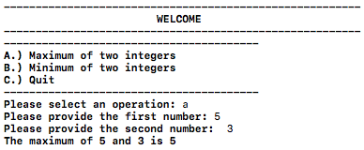 | 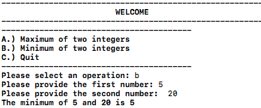
1.4 source code
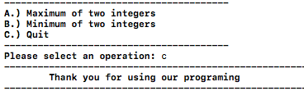

Question 2
2.1 source code

/*
main.cpp
Question 2_CIS 150 – Lab 06

Created by Hisham on 3/11/17.
Copyright © 2017 Hisham Hussein. All rights reserved.
Purpose: Ask the user for two players name with thier score and send it to function to determine who is the winnr and how is the loser and if the games is a tie
*/

#include <iostream>
using namespace std;

//function prototype
void winner(int, int,string,string);

int main(int argc, const char * argv[]) {

//viarables to hold values
string playerName1,playerName2;
int scorePlayer1,scorePlayer2;

//ask player one for the number name and score they get
cout <<"\nPlayer one name :";
cin>>playerName1;
cout <<"Enter your score: ";
cin>>scorePlayer1;

//ask player two for the number name and score they get
cout <<"\n\nPlayer two name :";
cin>>playerName2;
cout <<"Enter your score: ";
cin>>scorePlayer2;

//send the values to the function
winner(scorePlayer1,scorePlayer2,playerName1,playerName2);

system("pause");
return 0;
}

void winner(int playerScore1,int playerScore2,string namePlayer1,string namePlayer2){

//compare the score between user one and user two if player1 greater score then player two then player one is the winner
if (playerScore1 > playerScore2){

//display the result
cout<<endl<<namePlayer1<<" is the winner of score "<<playerScore1<<endl;
}
//if player to has greate socre then player one the player two is the winner
else if (playerScore2 > playerScore1){

//display the result
cout<<endl<<namePlayer2<<" is the winner of score "<<playerScore2<<endl;
//if player one socre == to player two then they are tie
}else{
//show the result
cout<<"\nThe score is tie"<<endl;

}

}

2.2 source code | 2.3 source code | 2.4 source code
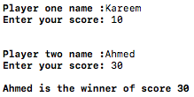 | 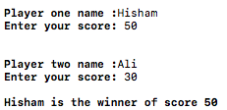 | 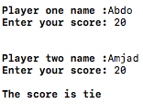

Question 3

3.1 source code

/*
main.cpp
Question 3_CIS 150 – Lab 06

Created by Hisham on 3/11/17.
Copyright © 2017 Hisham Hussein. All rights reserved.
Purpose: Ask the use for two numbers and determine the highest and lowest number by creating different function and return them to main
*/

//function prototype
int highest(int,int);
int lowest(int,int);

#include <iostream>
using namespace std;
int main(int argc, const char * argv[]) {

int num1,num2;

//ask the use the enter two different numbers
cout<<"Please provide the first number: ";
cin>>num1;

cout<<"Please provide the second number: ";
cin>>num2;

//send the values to the function
highest(num1, num2);//function call
lowest(num1, num2);//function call

//compare if they are equal to each other if not continues to else
if(num1 == num2){

//show the result
cout <<"\nThe are equal"<<endl;

}else{

//show the result
cout<<"The highest number is "<<highest(num1, num2)<<endl;
cout<<"The lowest number is "<<lowest(num1, num2)<<endl;

}

system("pause");
return 0;
}
int highest(int num1,int num2){

//compare numbers that was send by the user..passing by value
if(num1>num2){

return num1; //return the smallest number
}
else{

return num2; //retrun the smallest number

}

}

int lowest(int num1,int num2){

//compare numbers that was send by the user..passing by value
if(num2>num1){

return num1; //retrun the smallest number
}else{

return num2; //return the smallest number

}

}

}

3.2 source code | 3.3 source code
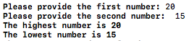 | 