CIS 150-Lab (Section 2)

Winter 2017

Lab 1
Hisham Hussein

Question 1

1.1 source code

// updated on 1/24/17.
// Created by Chapter 2 Big C++
// Copyright © 2017 Hisham Hussein. All rights reserved.
//

// coins.cpp
// From Ch2 of Big C++
// Takes number of different coins as input, computes, and prints total dollar value

#include <iostream>
using namespace std;
const double PENNY_VALUE = .01;
const double NICKEL_VALUE = .05;
const double DIME_VALUE = .1;
const double QUARTER_VALUE = .25;
int main()
{
// declaring variables corresponding to the number of different types of coins
int pennies, nickels, dimes, quarters, dollars;
double total=0.0;

// will print to screen asking how many pennies
cout << "How many pennies do you have? ";
// takes input and stores it in the variable pennies
cin >> pennies;
// update total now
total = total + pennies * PENNY_VALUE;
cout << "Current total is " << total << endl;

cout << "How many nickels do you have? ";
cin >> nickels;
// update total now
total = total + nickels * NICKEL_VALUE ;
cout << "Current total is " << total << endl;

cout << "How many dimes do you have? ";
cin >> dimes;
// update total now
total = total + dimes * DIME_VALUE ;
cout << "Current total is " << total << endl;

cout << "How many quarters do you have? ";
cin >> quarters;
// update total now
total = total + quarters * QUARTER_VALUE; //33
cout << "Current total is " << total << endl;

cout << "How many dollar coins do you have? ";
cin >> dollars;
// update total now
total = total + dollars ; //133
cout << "Current total is " << total << endl;

// Total value of the coins
cout << "Total value = " << total << "\n";

system("pause");

1.2 source code

Reason for Test Case | Input Values | Observed Output
To see what will happen if I put zeroes to all values | 0,0,0,0,0 | 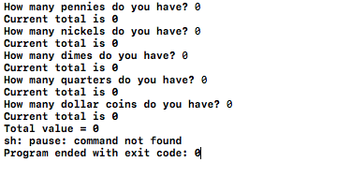
To see what will happen if I put 1 to all values | 1,1,1,1,1 | 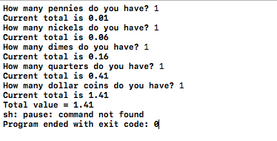
Check what will happen if I put decimal points | 2.0 | 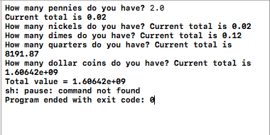
What will happen if the user enter negatives to all numbers | -3,-37,-10,-5,-40 | 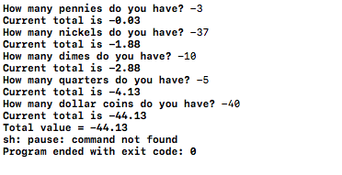

return 0;
}

Question 2

2.1 source code

//
// main.cpp
// Question 1_CIS 150 – Lab 01
// Purpose: Asking the user to enter two Integer numbers to add them and display the value
// Created by Hisham on 1/24/17.
// Copyright © 2017 Hisham Hussein. All rights reserved.
//

#include <iostream>

using namespace std;

int main()
{

// declare three variables x, y, and z of type int
int numOne,numTwo,sum=0;

//display a message using cout asking the user to enter a first integer
cout <<"Ente your first integer"<<endl;
cin >>numOne;

// display a message using cout asking the user to enter a second integer
cout <<"Ente your second integer"<<endl;
cin >>numTwo;

//statement that calculate the two numbers entered by the user
sum = numOne + numTwo;

//display a message using cout displaying the message
cout <<"The sum of the two integers is : "<< sum <<endl;

system("pause");
return 0;
}

2.2 source code
