CIS 150-Lab (Section 2)
Winter 2017

Lab 3
Hisham Hussein

Question 1

1.1 source code

/*
main.cpp
Question 1_CIS 150 – Lab 03

Created by Hisham on 2/7/17.
Copyright © 2017 Hisham Hussein. All rights reserved.
Purpose: Use the if statment to see what will the value 10 output or what the value 5 is going to output. It is all depends on the if statment and the value we put in it
*/

#include <iostream>
#include <iostream>

using namespace std;

int main() {
int x, y;

cout << "Please enter an integer value: ";
cin >> x;

if (x >= 9)
{
x = x + 1;
y = x * x;
}
else
{
x = x * 2;
y = x + x;
}

cout << "x = " << x << " y = " << y << endl;

system("pause");
return 0;
}

1.2 source code
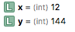

1.3 source code
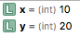

Question 2

2.1 source code

/*
main.cpp
Question 2_CIS 150 – Lab 03

Created by Hisham on 2/7/17.
Copyright © 2017 Hisham Hussein. All rights reserved.
Purpose: Ask the user for his name and his age, if his age is >=18 he is able to vote else he wont be able to vote if his age < 18
*/

#include <iostream>
#include <string>

using namespace std;

int main() {
string name; //user’s name
int age; //user’s age

//ask the user for name
cout << "Enter your name ";
cin>> name; //accept white sapce to enter his fist name and last name as one line

//ask for the age
cout << "Enter your age ";
cin>> age;

//if age greater than 18 it will let him pass to vote and if the vote is less than 18 it wont let him
if(age >=18){

cout <<"Congratulations "<< name <<" Your vote registration was successfully processed."<<endl;

}
else
{
cout <<"You are not eligible to vote "<<name<<endl;
}

system("pause");
return 0;
}

2.2 source code
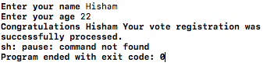

2.3 source code
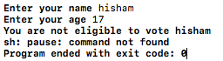

Question 3

3.1 source code

/*
main.cpp
Question 3_CIS 150 – Lab 03

Created by Hisham on 2/7/17.
Copyright © 2017 Hisham Hussein. All rights reserved.
Purpose: We should ask the user how many hours he/she worked per week and display the total pay check he/she gets if the hours is <=40 then it only hours times pay rate else if it is more than do the claculation for overtime and display it for the user
*/

#include <iostream>
#include <iostream>

using namespace std;

int main() {

double hoursWorked,payPerHour,totalPay;

//ask the user for input
cout <<"How many hours your worked this week (ex.40.0 ): ";
cin >>hoursWorked;

//ask the user for input
cout <<"What is your pay rate per hour (ex. 12.0): ";
cin >>payPerHour;

//check if the user worked less than or equal 40 hours per week if not then it will go to the else statemnt
if(hoursWorked <= 40){

totalPay = (hoursWorked * payPerHour);//calclating the total payments fi he worked <=40

cout <<"The weekly pay is $"<<totalPay<<endl;
}
else {
//calclate this 2nd calculate This 1st
totalPay = (payPerHour * 40) + (( hoursWorked - 40) * (payPerHour * 1.5));

cout <<"The weekly pay is $"<<totalPay<<endl;

}

system("pause");
return 0;
}

3.2 source code
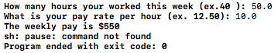

3.3 source code
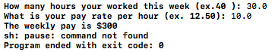

Question 4

4.1 source code

/*
main.cpp
Question 4_CIS 150 – Lab 03

Created by Hisham on 2/7/17.
Copyright © 2017 Hisham Hussein. All rights reserved.
Purpose: calculation for the quadratic equation if the user enter a 3 numbers and show him the asnwers
*/

#include <iostream>
#include <iostream>
#include<cmath>
using namespace std;

int main() {

int a,b,c; //the three varible for quadratic equation
double resultOne,resultTwo,calculation;

//ask the user for input
cout <<"Plese enter 3 numbers Which will represent the coefficients in the quadratic equation ax2 + bx + c = 0 (ex. 1 2 3) :";
cin >> a >> b >> c ;

//caluclate the number that the user entered to match the quadratic formula
calculation = pow(b, 2) - 4 * a * c;

if (a == 0 || calculation < 0){
cout <<"\nNo solution found"<<endl;
}

else if (calculation == 0){
resultOne = (-b - (sqrt(pow(b,2)-4* a * c))) / 2*a;
cout <<"T\nThe solution is : "<<endl;
cout<<resultOne<<endl<<endl;
}
else{

resultOne = (-b - (sqrt(pow(b,2)-4* a * c))) / 2*a;
resultTwo = (-b + (sqrt(pow(b,2)-4* a * c))) / 2*a;

cout <<"\nThe solution are : "<<endl;
cout<<resultOne<<endl<<resultTwo<<endl;

}

system("pause");
return 0;
}

4.2 source code

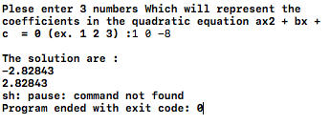

4.3 source code
