CIS 150-Lab (Section 2)
Winter 2017

Lab 4
Hisham Hussein

Question 1

1.1 source code

/*
main.cpp
Question 1_CIS 150 – Lab 04

Created by Hisham on 2/14/17.
Copyright © 2017 Hisham Hussein. All rights reserved.
Purpose: Asking the user of the temperature and determine what to do by if else statement
*/

#include <iostream>
using namespace std;

int main() {

int temp;

//ask the user for an input for temperature
cout <<"\n\nWhat is current temperature in Fahrenheit: ";
cin >>temp;

//check the heat of the temperature and show the correct result
if(temp>90){
cout <<"Visit a neighbor"<<endl;

}
else if (temp <=90 && temp >80){
cout <<"Turn on air conditioning."<<endl;

}
else if (temp <= 80 && temp >70){
cout <<"Do nothing."<<endl;

}
else if (temp <= 70 && temp >55){
cout <<"Turn on heat"<<endl;

}
else if (temp <= 55 && temp >30){
cout <<"Wear a heavy coat."<<endl;

}
else if (temp <=30 && temp >0){
cout <<"Wear gloves."<<endl;

}
else{
cout <<"Stay home"<<endl;

}

system("pause");

return 0;
}

1.2 source code

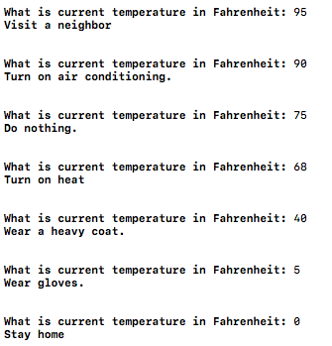

Question 2

2.1 source code

/*
main.cpp
Question 2_CIS 150 – Lab 04

Created by Hisham on 2/14/17.
Copyright © 2017 Hisham Hussein. All rights reserved.
Purpose: Ask the user for a grade letter and compare them with switch statement
*/

#include <iostream>
using namespace std;

int main() {

char gradeLetter;

//ask the user for an input for his grade
cout <<"Enter your letter grade: ";
cin >>gradeLetter;

//comparing the entered values by the user
switch (gradeLetter) {
case 'A': case 'a':
cout <<"Excellent"<<endl;
break;
case 'B':case'b':
cout <<"Good"<<endl;
break;
case 'C':case 'c':
cout <<"Average"<<endl;
break;
case 'D': case 'E':case 'd':case 'e':
cout <<"Below Average"<<endl;
break;
case 'F': case 'f':
cout <<"Fail"<<endl;
break;
default:
cout<<"Invalid Grade\n\n";
break;
}
system("pause");
return 0;
}
2.2 source code
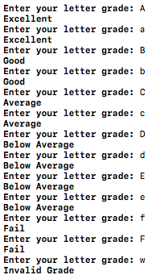

Question 3

3.1 source code

/*
main.cpp
Question 3_CIS 150 – Lab 04

Created by Hisham on 2/14/17.
Copyright © 2017 Hisham Hussein. All rights reserved.
Purpose: explane the different between ++z and z++
*/

#include <iostream>
using namespace std;

int main()
{
int w = 20, x = 20;
int y = 5, z = 5;
/*
the x at first will be 21 because it has the ++x which is increase first and then it add to the y which is going to by 26
*/
y = y + (++x);

/*
the letter w will be added to z first which is going to be 25 and then it will go back to the letter w and add one to itself because has w++ which add then increase one later
*/
z = z + (w++);

cout << "x=" << x << " and y=" << y << endl;
cout << "w=" << w << "and z=" << z << endl;

system("pause");
return 0;
}

3.2 source code
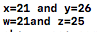

Question 4

4.1 source code

/*
main.cpp
Question 4_CIS 150 – Lab 04

Created by Hisham on 2/7/17.
Copyright © 2017 Hisham Hussein. All rights reserved.
Purpose: ask the user to enter 8 number using for loop and add them and output the sum of the eight numbers
*/

#include <iostream>
using namespace std;
int main(int argc, const char * argv[]) {

int numbers,total=0;

//for loop keep looping 8 times
for(int i =0; i<8;i++){

//ask the user for number and read the number
cout <<"Enter a number to add? ";
cin >>numbers;

total+=numbers; //adding the total

}

//sow the total
cout <<"The total: "<<total<<endl;

system("pause");
return 0;
}

4.2 source code
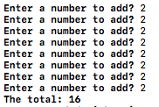

Question 5

5.1 source code

/*
main.cpp
Question 5_CIS 150 – Lab 04

Created by Hisham on 2/7/17.
Copyright © 2017 Hisham Hussein. All rights reserved.
Purpose: ask the user for a character and the height and printed within nisted loops
*/

#include <iostream>
using namespace std;

int main(int argc, const char * argv[]) {

char Keyboardchar;
int number;

//ask the user of the character type by the user
cout <<"Enter a character : ";
cin >>Keyboardchar;

//entering the height by the usr
cout <<"Enter a height : ";
cin >>number;

/*
doing nisted loops fist if the i < number it will go to the next loop
and in the second loop will keep contire til its true and will go back to the first loop

*/
for(int i = 0; i<number;i++){
for(int j=0; j<=i;j++){

cout<<Keyboardchar;
}
cout<<endl;
}

system("pause");
return 0;
}

5.2 source code
