CIS 150-Lab (Section 2)
Winter 2017

Lab 0
Hisham Hussein

Question 1

1.1 source code

// main.cpp
// Question 1_CIS 150 – Lab 00
//
// Created by Hisham on 1/17/17.
// Copyright © 2017 Hisham Hussein. All rights reserved.
// Purpose: First Lab introduction to display hell world on the // screen
//

#include <iostream>

using namespace std;

int main()
{
// using cout to display Hello World! And CIS 150 – Fall 2016
cout << "Hello World!" << endl;
cout << "CIS 150 – Fall 2016" << endl;

system("pause");
return 0;
}

1.2 source code

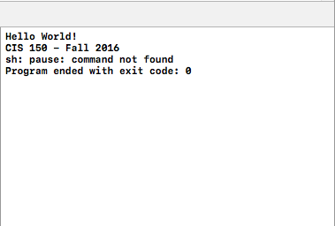

Question 2

2.1 source code

//
// main.cpp
// Question 2_CIS 150 – Lab 00
//
// Created by Hisham on 1/17/17.
// Copyright © 2017 Hisham Hussein. All rights reserved.
// Purpose: learning how to output the Christmas tree using cout

#include <iostream>
using namespace std;

int main() {

// using cout to build up the tree
cout <<" *"<<endl;
cout <<" ***"<<endl;
cout <<" *****"<<endl;
cout <<"*******"<<endl;
cout <<" ***"<<endl;

system("pause");
return 0;
}
2.2 source code
