Hisham Hussein

Online Student

02/16/2019

CIS 476

**Project One design patterns**

**Factory and singleton**

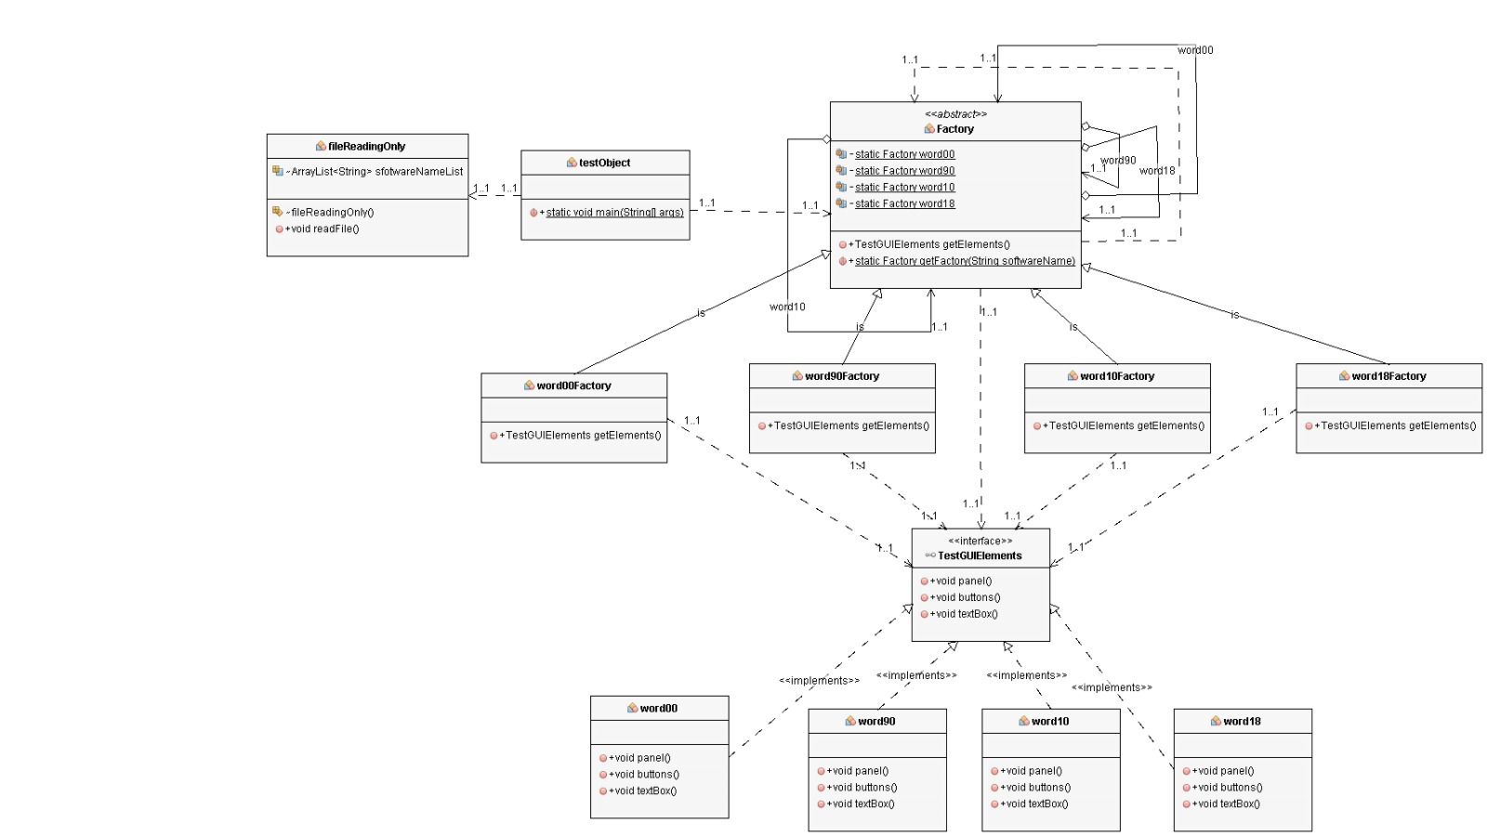**UML Class diagram:**

**Screenshot:**

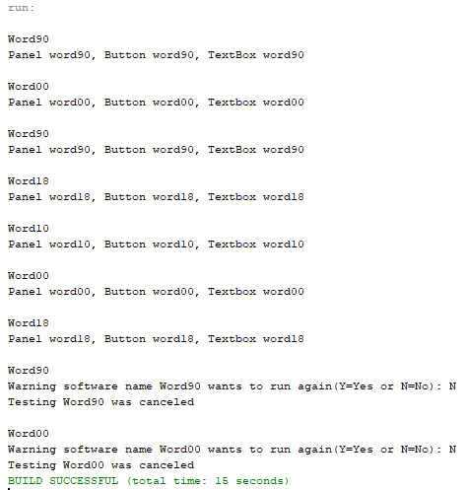 Output One Output Two

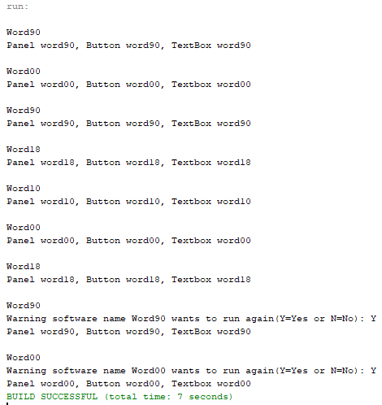

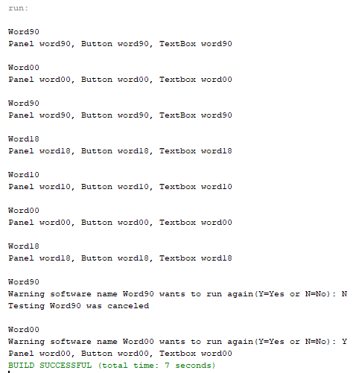 Output Three Output Four

