Coursework Submission Cover Sheet
Module | Machine Learning
Assessment No/Title | CS7052NU
Assessment Weighting | 60%
Assessment Submission Deadline | 25th January 2026
Module Leader | Danushka Abeyrathna
Student ID | MHS0132

Academic Integrity and Plagiarism
You are reminded that there exist regulations concerning plagiarism. Extracts from these regulations are printed below. Please sign below to say that you have read and understand these extracts:
This header sheet should be attached to the work you submit. No work will be accepted without it.
Extracts from University Regulations on
Cheating, Plagiarism and Collusion
Section 2.3: "The following broad types of offence can be identified and are provided as indicative examples ….
- Cheating: including taking unauthorized material into an examination; consulting unauthorized material outside the examination hall during the examination; obtaining an unseen examination paper in advance of the examination; copying from another examinee; using an unauthorized calculator during the examination or storing unauthorized material in the memory of a programmable calculator which is taken into the examination; copying coursework.
- Falsifying data in experimental results.
- Personation, where a substitute takes an examination or test on behalf of the candidate. Both candidate and substitute may be guilty of an offence under these Regulations.
- Bribery or attempted bribery of a person thought to have some influence on the candidate's assessment.
- Collusion to present joint work as the work solely of one individual.
- Plagiarism, where the work or ideas of another are presented as the candidate's own.
- Other conduct calculated to secure an advantage on assessment.
- Assisting in any of the above.
Some notes on what this means for students:
- Copying another student's work is an offence, whether from a copy on paper or from a computer file, and in whatever form the intellectual property being copied takes, including text, mathematical notation and computer programs.
- Text Box Taking extracts from published sources without attribution is an offence. To quote ideas, sometimes using extracts, is generally to be encouraged. Quoting ideas is achieved by stating an author's argument and attributing it, perhaps by quoting, immediately in the text, his or her name and year of publication, e.g. " e = mc2 (Einstein 1905)". A references section at the end of your work should then list all such references in alphabetical order of authors' surnames. (There are variations on this referencing system which your tutors may prefer you to use.) If you wish to quote a paragraph or so from published work then indent the quotation on both left and right margins, using an italic font where practicable, and introduce the quotation with an attribution.
Please sign below to say that you have read and understand these extracts:
----------------------------- | 1/25/2026
Student Signature | Date

Explainable Artificial Intelligence for Heart Disease Prediction

Contents

Abstract 4
1. Introduction 5
1.1 Overview of Explainable Artificial Intelligence (XAI) 5
1.2 Problems Addressed 5
1.3 Beneficiaries of this solution 5
1.4 Data Requirements 6
1.5 Tools & Technologies Used 6
2. Demonstration of the Technique 6
2.1 Purpose 6
2.2 Dataset Description 7
2.3 Exploratory Data Analysis (EDA) 7
2.3.1 Target Variable Distribution 7
2.3.2 Numerical Feature Distributions 8
2.3.3 Categorical Features Distributions 9
2.3.4 Feature Correlation with Target Analysis 9
2.3.5 Summary of EDA Findings 10
2.4 Data Preprocessing 11
2.5 Feature Engineering 11
2.6 Model Training and Evaluation 11
2.7 Explainability of Model 12
2.7.1 Using SHAP 13
2.7.2 Using LIME 14
2.7.3 Comparison of SHAP and LIME Feature Rankings 16
2.8 Limitations of the Study 17
3. Conclusion 17
4. Reflection on Learning 17
5. References 18
6. Appendix 19

Abstract
Machine learning is increasingly used in healthcare to support clinical decision-making, particularly for disease risk prediction. While Machine Learning (ML) offers a powerful analytical paradigm for extracting patterns from complex datasets, many machine learning models operate as “black boxes”, meaning that although they may achieve good predictive accuracy, their internal decision-making process is not transparent. In clinical environments, this lack of interpretability can reduce trust and limit adoption, as healthcare professionals must be able to understand and justify decisions that affect patient care. Explainable Artificial Intelligence (XAI) aims to address this challenge by providing techniques that make model predictions understandable and transparent.
This study presents a case study on the application of Explainable Artificial Intelligence (XAI) techniques to a heart disease prediction task using supervised machine learning. The Heart Failure Prediction Dataset obtained from Kaggle is used, comprising clinical attributes such as age, sex, chest pain type, cholesterol level, maximum heart rate, exercise-induced angina, and ST-segment slope. A supervised classification model is trained to predict the presence of heart disease based on these clinical features. The XGBoost algorithm is selected due to its strong performance in heart disease prediction, as supported by previous research (Chen and Guestrin, 2016; Moore and Bell, 2022). The overall workflow consists of data preprocessing, exploratory data analysis (EDA), feature engineering, model training, and evaluation using appropriate classification metrics.
To enhance model interpretability, SHAP (SHapley Additive exPlanations) and LIME (Local Interpretable Model-agnostic Explanations) are applied to explain the predictions of the trained model. SHAP provides both global explanations, identifying overall feature importance across the dataset, and local explanations, highlighting the contribution of individual features to specific patient predictions. LIME complements this approach by generating intuitive, instance-level explanations that are easily understood by clinicians. The results indicate that the model captures clinically meaningful patterns and that the use of XAI techniques significantly improves transparency and interpretability. Overall, this study emphasizes the importance of explainability in healthcare applications and demonstrates how an XGBoost-based, transparent modelling approach can support ethical, credible, and clinically relevant machine learning systems, including transparency in automated decision-making.

Introduction

Overview of Explainable Artificial Intelligence (XAI)
Explainable Artificial Intelligence (XAI) makes machine learning predictions easier for humans to understand. While many models achieve high accuracy, this is not enough in sensitive areas such as healthcare, where clinicians need to know how predictions are made and which factors influence them.
XAI addresses this limitation by providing explanations that describe how input features contribute to a model’s predictions, enabling users to interpret, validate, and trust the system. To support this, explainability methods that are applied after model training have been developed. LIME was proposed as a model-agnostic technique that explains individual predictions using local approximations (Ribeiro et al., 2016). SHAP was later introduced as a unified framework based on game theory, providing consistent explanations across different model types (Lundberg and Lee, 2017). These techniques are now widely used in practical applications.

Problems Addressed
One of the main problems addressed by XAI is the lack of trust in black-box models. In healthcare, clinicians are accountable for their decisions and must be able to justify them. If a machine learning system provides a prediction without explanation, it is difficult for clinicians to rely on it. XAI techniques help bridge this gap by providing insights into reasoning behind model predictions.
Explainability also plays an important role in model validation by allowing practitioners to assess whether model behavior is consistent with established clinical knowledge. This is particularly important in medical datasets, where biases or data quality issues can lead to misleading predictions.
In addition, explainability supports ethical and legal considerations in automated decision-making. Transparent models help promote accountability and enable meaningful human oversight, which is essential in healthcare applications. By improving transparency, XAI aligns with regulatory principles such as those outlined in the EU General Data Protection Regulation (GDPR), particularly requirements related to transparency and informed decision-making in systems that use personal data.

Beneficiaries of this solution
The primary users of Explainable AI systems in this context include clinicians, healthcare analysts, and medical researchers. Clinicians require explanations that are clear, reliable, and aligned with medical knowledge in order to support clinical decision-making and maintain accountability. Healthcare analysts and researchers use explainability to validate model behavior and assess whether predictions are clinically meaningful.

Data Requirements
In this study, structured and labelled clinical data is used, making it well suited to supervised learning and post-training explainability methods such as SHAP and LIME. The dataset contains a mixture of numerical and categorical features, including continuous variables such as age, cholesterol level, and maximum heart rate, as well as categorical variables such as sex, chest pain type, exercise-induced angina, and ST-segment slope.
Proper data preprocessing is important for reliable explainability. Clean and properly prepared data allows XAI techniques to produce explanations that are meaningful and consistent with medical knowledge. This involves scaling numerical features to avoid bias caused by differences in measurement ranges and encoding categorical features so they can be represented numerically. These preprocessing steps ensure that the feature contributions identified by SHAP and LIME remain interpretable and comparable.

Tools & Technologies Used
This study is implemented using Python and widely adopted data science libraries. pandas and NumPy are used for data handling and preprocessing, while scikit-learn is used for model training and evaluation due to its robust and well-documented machine learning implementations (Pedregosa et al., 2011). Explainability is achieved using SHAP and LIME, which provide global and local explanations of model predictions. Data visualization libraries such as matplotlib and seaborn are used to present results clearly. All experiments are conducted within a Jupyter Notebook environment, supporting transparency, reproducibility, and ease of analysis.

Demonstration of the Technique

Purpose
The purpose of this analysis is to develop a supervised machine learning model that predicts the presence of heart disease using clinical data and to apply Explainable Artificial Intelligence techniques to interpret the model’s predictions. Rather than focusing only on predictive accuracy, the analysis emphasises interpretability and clinical relevance. This ensures that the resulting system is suitable for real-world healthcare decision support.

Dataset Description
The Heart Failure Prediction Dataset used in this study is obtained from Kaggle (Fedesoriano, 2021). It contains patient-level clinical data collected from medical examinations. The dataset includes features such as age, sex, chest pain type, resting blood pressure, cholesterol level, maximum heart rate, exercise-induced angina, and ST-segment slope. The target variable indicates whether a patient has heart disease, making this a binary classification problem. Table 1 summarizes the features included in the dataset.
The dataset represents a realistic medical prediction task and includes a mixture of numerical and categorical variables. This makes it appropriate for demonstrating both machine learning techniques and explainability methods in a healthcare context.
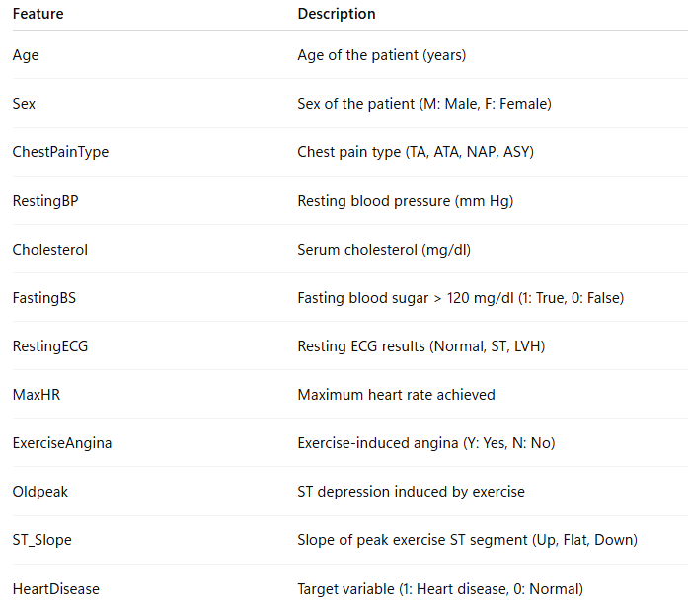
Table 1: Description of Dataset Features

Exploratory Data Analysis (EDA)
Exploratory Data Analysis (EDA) was conducted to understand the dataset structure, examine feature distributions, explore relationships between clinical variables and target heart disease outcomes. Visualizations are used to summarize key characteristics of the data and highlight clinically meaningful trends.

Target Variable Distribution
The distribution of the target variable (Heart-Disease) is shown in Figure 1. The dataset is moderately balanced, with approximately 55% of patients diagnosed with heart disease and 45% without heart disease. Although the imbalance is not high, this distribution highlights the importance of evaluating model performance using metrics beyond accuracy, such as recall and F1-score are important in addition to accuracy.
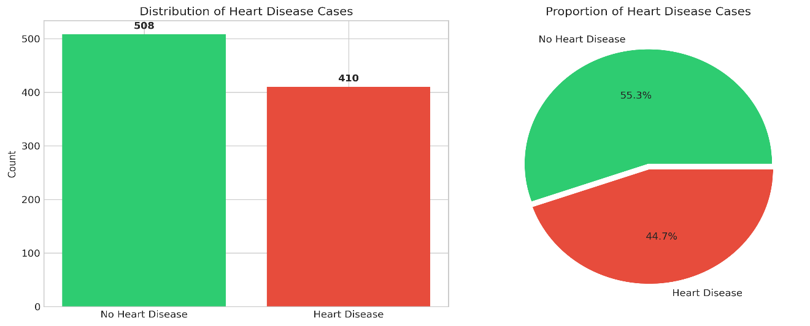
Figure 1: Distribution of heart disease vs. non-heart disease cases

Numerical Feature Distributions
The distributions of key numerical features, including age, cholesterol level, maximum heart rate (MaxHR), and ST depression (Oldpeak), are illustrated in Figure 2, using histograms grouped by heart disease status. The visualizations show that patients with heart disease are generally older and tend to have lower maximum heart rates compared to those without heart disease.
Outliers are visible in features such as fasting blood sugar (FastingBS), resting blood pressure (RestingBP), and cholesterol level, which is common in real-world clinical datasets. These data characteristics support the use of tree-based models, as they rely on feature-based splits rather than distributional assumptions and are therefore robust to skewed and outliers.
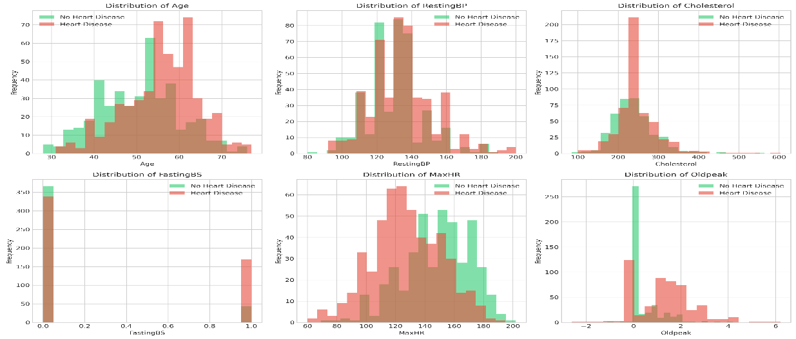
Figure 2: Distribution of numerical features by heart disease outcome

Categorical Features Distributions
The relationship between categorical clinical features and heart disease is illustrated in Figure 3 using bar charts. Several clear patterns are observed. Asymptomatic chest pain type (ASY) and exercise-induced angina are more common among patients with heart disease, showing a positive association with the target outcome. In contrast, chest pain types such as ATA and the absence of exercise-induced angina are more frequently observed in patients without heart disease, indicating an inverse relationship.
Similarly, the ST-segment slope shows a strong association with heart disease, where a flat or down-sloping ST segment is more common in affected patients, while an up-sloping ST segment is more common among patients without heart disease. These direct and inverse relationships indicate that categorical clinical features carry strong predictive information and justify their inclusion in the classification model.
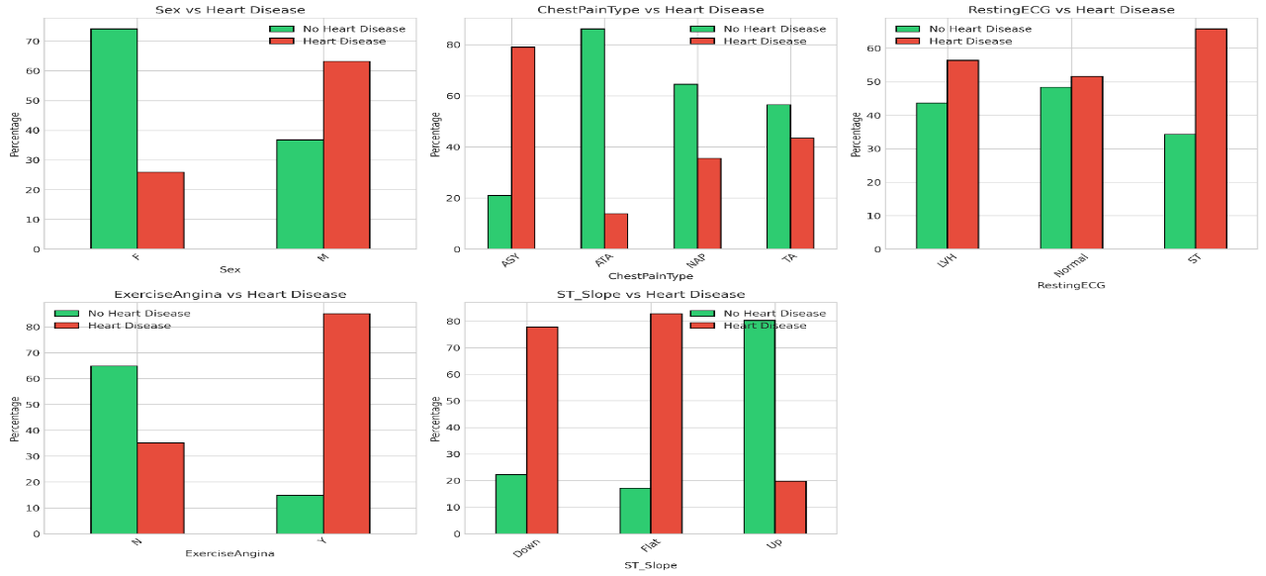
Figure 3: Distribution of categorical features by heart disease outcome

Feature Correlation with Target Analysis
A correlation heatmap of numerical features is presented in Figure 4 to examine relationships between features and target (Has/No HeartDisease). Our analysis shows that several features have meaningful associations with heart disease, particularly ST-slope, ExerciseAngina, Oldpeak, and maximum heart rate (MaxHR). Other features, such as resting blood pressure (RestingBP), cholesterol level, and resting ECG, show weak linear correlations with the target variable. This is a limitation of correlation analysis, as some risk factors, including cholesterol, may influence heart disease in a non-linear or interaction-based manner. Tree-based models are well suited to capture these complex relationships (Hastie et al., 2009). Overall, the absence of strong multicollinearity (non-redundant features) suggests that the features provide complementary information, supporting the use of tree-based models capable of modelling non-linear patterns and feature interactions.
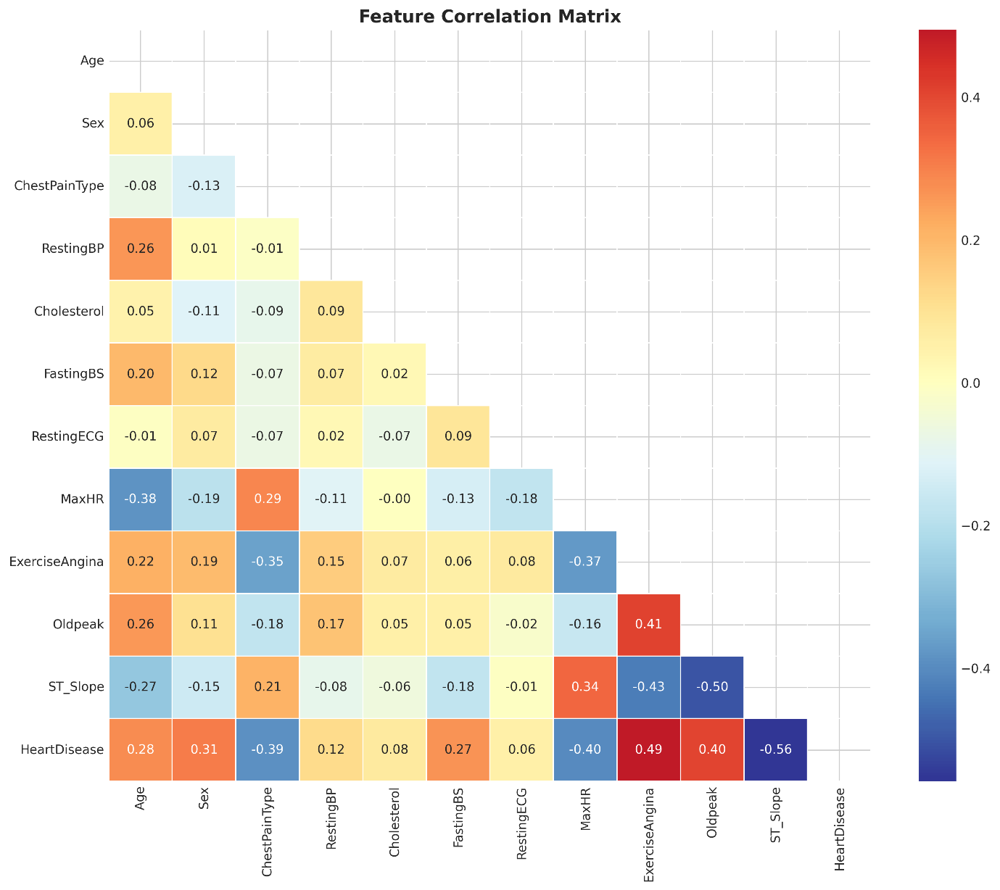
Figure 4: Correlation heatmap of numerical features and the heart disease(target)

Summary of EDA Findings
The exploratory data analysis (EDA) reveals the following key observations:
- Class Balance: The dataset shows a reasonable balance between patients with and without heart disease.
- Age: Patients diagnosed with heart disease tend to be older.
- Maximum Heart Rate (MaxHR): Lower maximum heart rates are commonly observed in patients with heart disease.
- Chest Pain Type: Asymptomatic (ASY) chest pain is strongly associated with heart disease.
- ST-Segment Slope: A flat ST-segment slope is a key indicator of disease presence.
- Exercise-Induced Angina: The presence of exercise-induced angina is strongly linked to heart disease.
These findings are supported by the visualizations presented in Figures 2, 3, and 4. Overall, the EDA confirms that the dataset contains clinically meaningful patterns and relevant predictive features. The insights gained from the EDA directly guide subsequent modelling decisions, including feature selection, preprocessing strategies, and the application of explainability techniques such as SHAP and LIME to better interpret model predictions.

Data Preprocessing
Data preprocessing is a critical step in the machine learning workflow, particularly in healthcare applications where data quality directly affects model reliability. The dataset is first checked for missing or invalid values. This ensures data integrity by handling inconsistencies appropriately. Missing values in features such as cholesterol level and resting blood pressure are handled by replacing them with the median value. This approach helps maintain data consistency and ensures that the dataset is suitable for model training.
Categorical variables such as sex, chest pain type, exercise-induced angina, and ST-segment slope are converted into numerical values using label encoding to enable their use in machine learning models. Numerical features, including age, cholesterol level, and maximum heart rate, are not scaled, as the ensemble-based XGBoost model is insensitive to feature scaling. These preprocessing steps produce a clean and consistent dataset suitable for supervised learning.

Feature Engineering
Feature engineering in this study focuses on preserving clinical meaning rather than creating complex transformations. The analysis retains original medical measurements and categorical indicators, ensuring that the model remains interpretable. This approach allows explainability techniques to directly reference familiar clinical concepts.
By prioritizing simplicity and interpretability, the resulting explanations generated by SHAP and LIME are easier for healthcare professionals to understand. This is particularly important in clinical environments where complex or abstract features may reduce trust in the system.

Model Training and Evaluation
The dataset is split into training (80%) and testing (20%) subsets to evaluate the model’s ability to generalize to unseen data. As the target variable, HeartDisease, is binary, XGBoost is selected as a supervised classification model and trained on the training set to predict the presence of heart disease. XGBoost is particularly suitable for structured clinical data due to its ability to capture non-linear relationships and feature interactions. In addition, the XGBoost algorithm is chosen based on its strong performance in heart disease prediction, as supported by previous research (Chen and Guestrin, 2016; Moore and Bell, 2022).
Model performance is evaluated using standard classification metrics, including accuracy, precision, recall, F1-score, and ROC-AUC. The observed model performance metrics are as follows:
Accuracy: 0.8587
Precision: 0.8878
Recall: 0.8529
F1-score: 0.8700
ROC-AUC: 0.9181
The trained model achieves an accuracy of 0.8587, indicating strong overall predictive performance. A precision score of 0.8878 suggests that the majority of patients predicted as having heart disease are correctly classified, thereby reducing the likelihood of unnecessary follow-up testing. The recall score of 0.8529 demonstrates that the model successfully identifies most patients with heart disease, which is particularly important in a clinical context where failing to detect a true case can have serious consequences. The F1-score of 0.8700 reflects a good balance between precision and recall.
To further validate performance, we applied 5-fold cross-validation and observed consistent results across folds, confirming that the model generalizes well to unseen data.
Overall, these results demonstrate that the model performs well while maintaining clinically meaningful sensitivity, making it suitable for further analysis using explainable AI techniques such as SHAP and LIME.

Explainability of Model

Explainable Artificial Intelligence methods, specifically SHAP (SHapley Additive exPlanations) and LIME (Local Interpretable Model-agnostic Explanations), are used to analyze and interpret the predictions of the trained model. Both SHAP and LIME are post-hoc explainability methods, meaning they are applied after model training to explain how predictions are generated.
SHAP provides both global explanations, which identify the overall importance of features across the dataset, and local explanations, which highlight how individual features contribute to specific patient predictions. This supports validation of the model’s behavior against established clinical knowledge.
LIME complements SHAP by generating intuitive, instance-level explanations that approximate the model’s behavior locally. These explanations are presented in a human-readable format, making them particularly useful for case-by-case interpretation and supporting clinical understanding.
A comparison of SHAP and LIME explainability results is presented in the following sections.

Using SHAP
We used SHAP to explain the trained model at both global and local levels. As shown in Figure 5, the SHAP summary plot provides a global view of how each feature influences heart disease predictions across the dataset. It highlights the most important features and shows the direction of their impact, allowing the model’s behavior to be validated against established medical knowledge.

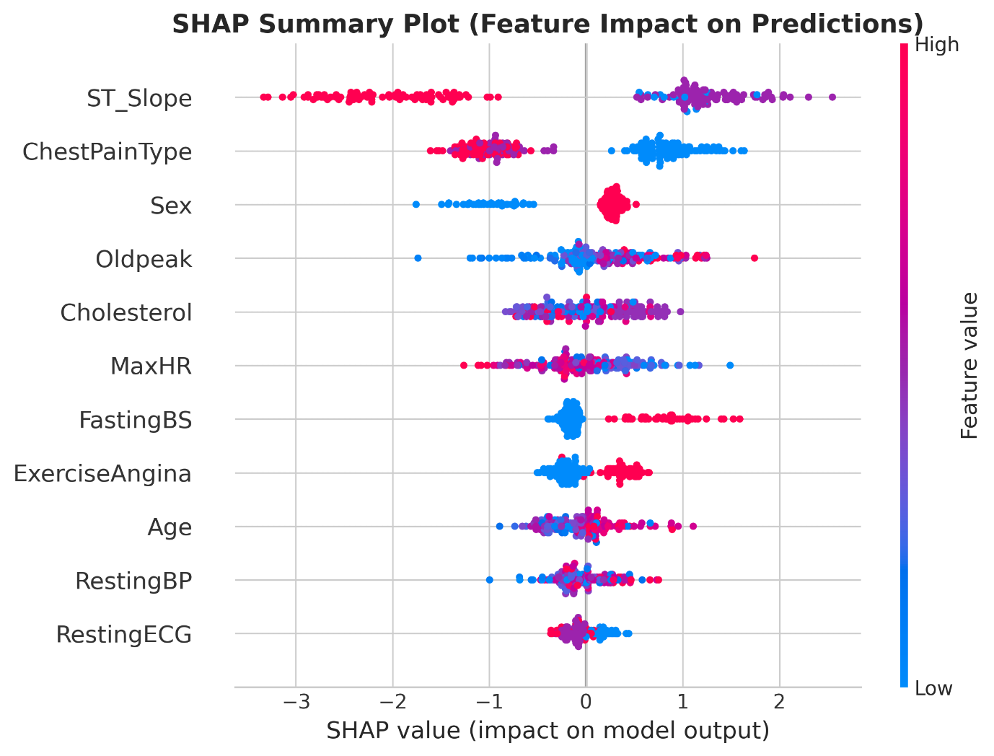
Figure 5: SHAP Summary Plot (Feature Importance and Impact on Predictions)

As shown in Figure 6, the SHAP waterfall plot provides a local explanation for a single patient, selected as a high-risk case based on the model’s predicted probability. The plot illustrates how individual feature contributions combine step-by-step to produce the final prediction. Each feature either increases or decreases the model’s predicted likelihood of heart disease, making the decision-making process transparent for that patient.
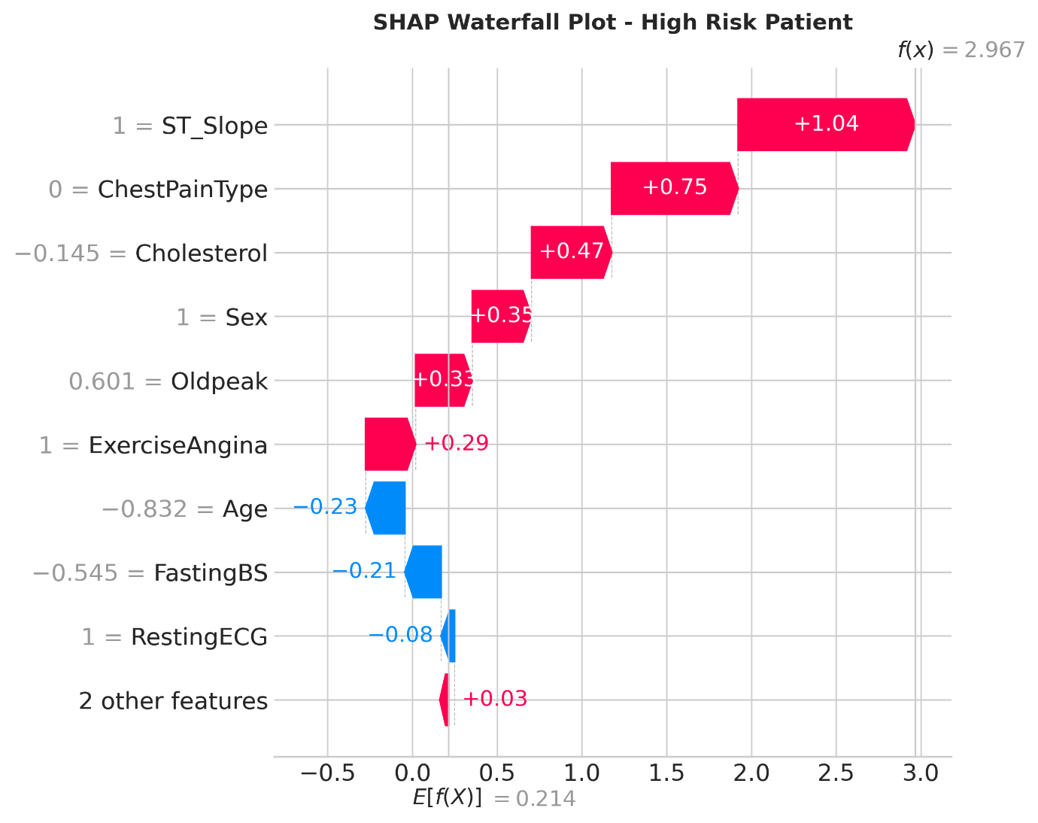
Figure 6: SHAP Waterfall Plot (Individual Feature Contributions on the Prediction)

Together, the SHAP summary and waterfall plots provide both global and patient-level explanations. This transparency ensures that the model’s predictions are not only accurate but also interpretable and reliable, which is particularly important in clinical decision-making.

Using LIME
LIME is used as a complementary explainability technique to SHAP to generate local explanations for individual model predictions.
As shown in Figure 7(a), the LIME explanation for a heart-disease (high-risk) patient highlights features such as ST_Slope, ChestPainType, ExerciseAngina, and MaxHR as key contributors to the prediction of heart disease. Positive feature contributions increase the model’s predicted likelihood of heart disease, while negative contributions reduce it. This provides a clear explanation of why the patient is classified as having heart disease with a high predicted risk (probability).
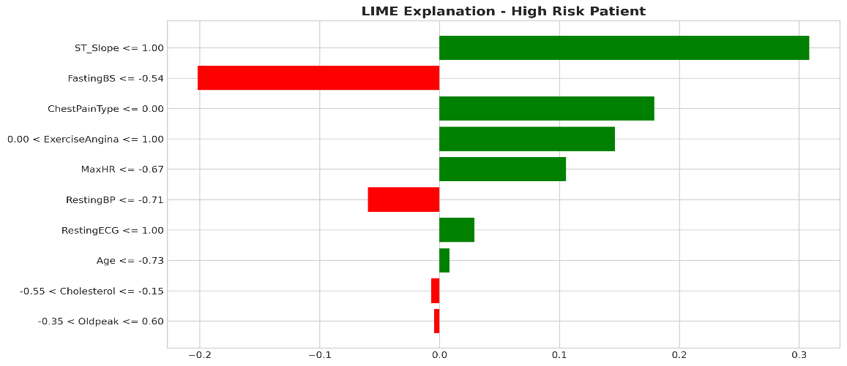
Figure 7(a): LIME explanation for a high-risk patient with a high predicted probability of heart disease
In contrast, Figure 7(b) presents the LIME explanation for a non–heart-disease (low-risk) patient. In this case, the same clinical features contribute in the opposite direction, pushing the prediction away from heart disease. This demonstrates how feature contributions vary depending on patient-specific values and explains why the model classifies this patient as not having heart disease, with a low predicted risk (probability).
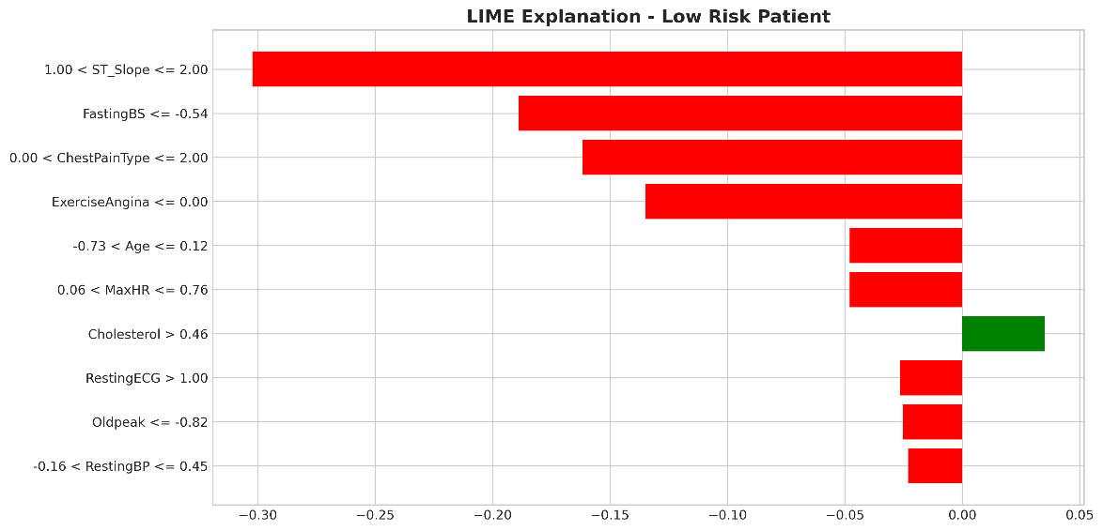
Figure 7(b): LIME explanation for a low-risk patient with a low predicted probability of heart disease
Overall, LIME explanations highlight the most impactful features for individual predictions in a clear and human-readable manner. By providing local, case-specific explanations for both heart-disease and non–heart-disease patients, LIME complements SHAP by offering an alternative local perspective on model behavior, thereby supporting transparent and reliable clinical decision-making.

Comparison of SHAP and LIME Feature Rankings
To further analyze explainability consistency, Figure 8 compares feature importance rankings obtained from SHAP and LIME. Both methods identify ST_Slope and ChestPainType as the most influential features, showing strong agreement on the key factors driving heart disease predictions. This consistency increases confidence in the model’s behavior and clinical relevance.
Some differences are observed for other features, such as FastingBS, ExerciseAngina, and Sex. These differences are expected because SHAP provides global explanations across the dataset, while LIME focuses on local explanations for individual patients.
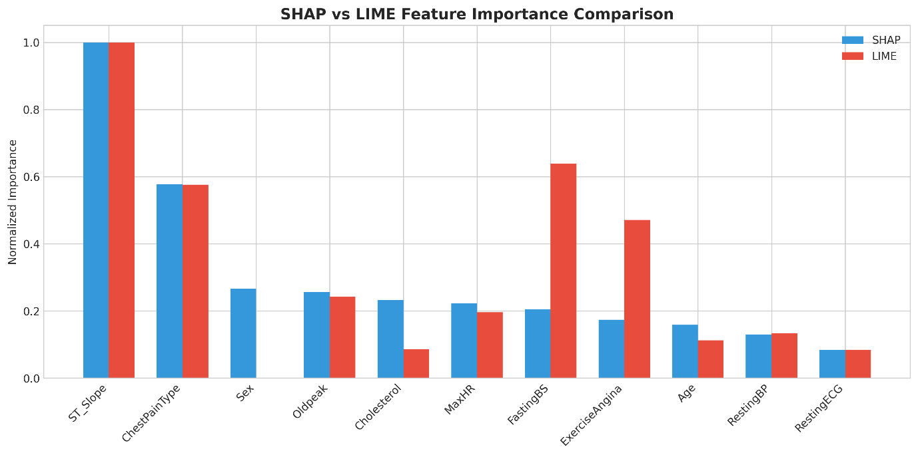
Figure 8: SHAP vs LIME Feature Importance comparison

Limitations observed from the comparison include the fact that LIME explanations may vary across patients and runs due to sampling and controlled feature adjustments (perturbations), while SHAP can be computationally expensive for complex models. As a result, outputs from the two methods should be interpreted as complementary rather than directly comparable.
Overall, Figure 8 demonstrates that combining SHAP and LIME provides a clearer understanding of the model by capturing both global patterns and patient-specific explanations.

Limitations of the Study
Despite its strengths, this study has some limitations. The analysis relies on a single publicly available dataset, which may limit the generalizability of the findings to more diverse patient populations. This highlights opportunities for future work, including validation on additional clinical datasets. In addition, the study focuses on a single high-performing tree-based model; future work could compare explainability behavior across different model families, such as logistic regression and random forests.

Conclusion
This study demonstrates the application of Explainable Artificial Intelligence (XAI) techniques to a heart disease prediction task using supervised machine learning. By integrating SHAP and LIME, the analysis enhances the transparency and interpretability of model predictions, helping to bridge the gap between predictive accuracy and practical usability by enabling clinicians to understand, validate, and justify model decisions. As a result, the system becomes more suitable for clinical decision support.
Overall, this work illustrates how XAI techniques can support the responsible and trustworthy deployment of machine learning in medical applications, ensuring that technological advancements align with clinical needs and professional standards.

Reflection on Learning
One of the main challenges encountered in this study was interpreting model behavior using real-world clinical data, which often contains variability, outliers, and non-linear relationships. Addressing these challenges helped me develop a deeper understanding of how exploratory data analysis, data preprocessing, and explainability are closely interconnected in building reliable machine learning systems. The most valuable learning experience came from applying explainable artificial intelligence techniques such as SHAP and LIME, which reinforced the importance of transparency and trust when deploying machine learning models in healthcare settings. These insights will inform my future work on developing responsible and interpretable machine learning solutions.
In addition to this work, I also explored the application of machine learning for predicting top-performing stocks for next-day trading as an individual study, with a focus on emerging stock markets such as the Colombo Stock Exchange (CSE). Using recent market price data obtained from Yahoo Finance, covering approximately the last three months, I extracted predictive technical indicator features along with a price movement target label. A Random Forest model was initially selected for training, as it performs well with relatively low data volumes, limited feature sets, and non-linear, non-stationary market behaviour typical of the CSE. The future direction of this work is to extend the approach by incorporating neural network models such as LSTM to capture temporal dependencies, as well as integrating commodity price movements such as gold and silver, which historically exhibit inverse relationships with stock prices. This exploratory work provided valuable learning experience and has the potential to support the development of automated algorithmic trading strategies in future research.

References

Chen, T. and Guestrin, C. (2016) - XGBoost: A scalable tree boosting system. Proceedings of the 22nd ACM SIGKDD International Conference on Knowledge Discovery and Data Mining, pp. 785–794.
Moore, A. and Bell, M. (2022) - XGBoost, an explainable machine learning model, for prediction of myocardial infarction. Clinical Medicine Insights: Cardiology, 16, pp. 1–10.
Fedesoriano (2021) Heart Failure Prediction Dataset. Kaggle. Available at: https://www.kaggle.com/datasets/fedesoriano/heart-failure-prediction (Accessed: 20 January 2026).
Pedregosa, F. et al. (2011) ‘Scikit-learn: Machine Learning in Python’, Journal of Machine Learning Research, 12, pp. 2825–2830.
Hastie, T., Tibshirani, R. and Friedman, J. (2009) - The Elements of Statistical Learning: Data Mining, Inference, and Prediction. 2nd edn. New York: Springer.

Appendix
This appendix contains the full Jupyter Notebook implementation, including complete code listings.

1. Setup and Installation
First, let's install and import the required libraries.
- Core ML libraries: numpy>=1.21.0 pandas>=1.3.0 scikit-learn>=1.0.0 xgboost>=1.5.0
- Visualization: matplotlib>=3.4.0 seaborn>=0.11.0
- Explainability: shap>=0.40.0 lime>=0.2.0
- Jupyter - Documentation + Code Together: jupyter>=1.0.0 ipykernel>=6.0.0 notebook
# Install required packages (uncomment if running in Colab)
# !pip install numpy pandas scikit-learn xgboost matplotlib seaborn shap lime jupyter notebook --quiet
# Core libraries
import pandas as pd
import numpy as np
import matplotlib.pyplot as plt
import seaborn as sns

# Machine Learning
from sklearn.model_selection import train_test_split, cross_val_score
from sklearn.preprocessing import StandardScaler, LabelEncoder
from sklearn.metrics import (accuracy_score, precision_score, recall_score,
f1_score, roc_auc_score, confusion_matrix,
classification_report, roc_curve)
from xgboost import XGBClassifier

# Explainability
import shap
import lime
import lime.lime_tabular

# Suppress warnings
import warnings
warnings.filterwarnings('ignore')

# Set display options
pd.set_option('display.max_columns', None)
plt.style.use('seaborn-v0_8-whitegrid')

print("All libraries imported successfully!")
All libraries imported successfully!
2. Load the Dataset
The Heart Failure Prediction dataset combines five heart datasets (Cleveland, Hungarian, Switzerland, Long Beach VA, and Statlog) into a single comprehensive dataset with 918 records and 11 clinical features.
Option A: Upload the CSV file manually to Colab
Option B: Use the Kaggle API (requires API token)
# Option A: Upload the file manually or have it locally
df = pd.read_csv('heart.csv')

# Option B: For Google Colab - upload file interactively
# from google.colab import files
# uploaded = files.upload()

## Load the uploaded file
#import io
#df = pd.read_csv(io.BytesIO(uploaded[list(uploaded.keys())[0]]))

print(f"Dataset loaded successfully!")
print(f"Shape: {df.shape[0]} records, {df.shape[1]} features")
Dataset loaded successfully!
Shape: 918 records, 12 features
# First look at the data
df.head(10)
 | Age | Sex | ChestPainType | RestingBP | Cholesterol | FastingBS | RestingECG | MaxHR | ExerciseAngina | Oldpeak | ST_Slope | HeartDisease
0 | 40 | M | ATA | 140 | 289 | 0 | Normal | 172 | N | 0.0 | Up | 0
1 | 49 | F | NAP | 160 | 180 | 0 | Normal | 156 | N | 1.0 | Flat | 1
2 | 37 | M | ATA | 130 | 283 | 0 | ST | 98 | N | 0.0 | Up | 0
3 | 48 | F | ASY | 138 | 214 | 0 | Normal | 108 | Y | 1.5 | Flat | 1
4 | 54 | M | NAP | 150 | 195 | 0 | Normal | 122 | N | 0.0 | Up | 0
5 | 39 | M | NAP | 120 | 339 | 0 | Normal | 170 | N | 0.0 | Up | 0
6 | 45 | F | ATA | 130 | 237 | 0 | Normal | 170 | N | 0.0 | Up | 0
7 | 54 | M | ATA | 110 | 208 | 0 | Normal | 142 | N | 0.0 | Up | 0
8 | 37 | M | ASY | 140 | 207 | 0 | Normal | 130 | Y | 1.5 | Flat | 1
9 | 48 | F | ATA | 120 | 284 | 0 | Normal | 120 | N | 0.0 | Up | 0
# Dataset info
print("Dataset Information:")
print("=" * 50)
df.info()
Dataset Information:
==================================================
<class 'pandas.core.frame.DataFrame'>
RangeIndex: 918 entries, 0 to 917
Data columns (total 12 columns):
# Column Non-Null Count Dtype
--- ------ -------------- -----
0 Age 918 non-null int64
1 Sex 918 non-null object
2 ChestPainType 918 non-null object
3 RestingBP 918 non-null int64
4 Cholesterol 918 non-null int64
5 FastingBS 918 non-null int64
6 RestingECG 918 non-null object
7 MaxHR 918 non-null int64
8 ExerciseAngina 918 non-null object
9 Oldpeak 918 non-null float64
10 ST_Slope 918 non-null object
11 HeartDisease 918 non-null int64
dtypes: float64(1), int64(6), object(5)
memory usage: 86.2+ KB
# Statistical summary
df.describe()
 | Age | RestingBP | Cholesterol | FastingBS | MaxHR | Oldpeak | HeartDisease
count | 918.000000 | 918.000000 | 918.000000 | 918.000000 | 918.000000 | 918.000000 | 918.000000
mean | 53.510893 | 132.396514 | 198.799564 | 0.233115 | 136.809368 | 0.887364 | 0.553377
std | 9.432617 | 18.514154 | 109.384145 | 0.423046 | 25.460334 | 1.066570 | 0.497414
min | 28.000000 | 0.000000 | 0.000000 | 0.000000 | 60.000000 | -2.600000 | 0.000000
25% | 47.000000 | 120.000000 | 173.250000 | 0.000000 | 120.000000 | 0.000000 | 0.000000
50% | 54.000000 | 130.000000 | 223.000000 | 0.000000 | 138.000000 | 0.600000 | 1.000000
75% | 60.000000 | 140.000000 | 267.000000 | 0.000000 | 156.000000 | 1.500000 | 1.000000
max | 77.000000 | 200.000000 | 603.000000 | 1.000000 | 202.000000 | 6.200000 | 1.000000
Feature Description
Feature | Description | Type
Age | Age of the patient (years) | Numerical
Sex | Sex of the patient (M: Male, F: Female) | Categorical
ChestPainType | Chest pain type (TA, ATA, NAP, ASY) | Categorical
RestingBP | Resting blood pressure (mm Hg) | Numerical
Cholesterol | Serum cholesterol (mg/dl) | Numerical
FastingBS | Fasting blood sugar > 120 mg/dl (1: True, 0: False) | Binary
RestingECG | Resting ECG results (Normal, ST, LVH) | Categorical
MaxHR | Maximum heart rate achieved | Numerical
ExerciseAngina | Exercise-induced angina (Y: Yes, N: No) | Categorical
Oldpeak | ST depression induced by exercise | Numerical
ST_Slope | Slope of peak exercise ST segment (Up, Flat, Down) | Categorical
HeartDisease | Target variable (1: Heart disease, 0: Normal) | Binary
3. Data Preparation and Cleaning
# Check for missing values
print("Missing Values:")
print("=" * 50)
missing = df.isnull().sum()
print(missing[missing > 0] if missing.sum() > 0 else "No missing values found!")
Missing Values:
==================================================
No missing values found!
# Check for duplicates
duplicates = df.duplicated().sum()
print(f"Duplicate rows: {duplicates}")

if duplicates > 0:
df = df.drop_duplicates()
print(f"Duplicates removed. New shape: {df.shape}")
Duplicate rows: 0
# Check for anomalies in numerical columns
print("Checking for potential data quality issues:")
print("=" * 50)

# Cholesterol = 0 is likely a missing/error value
print(f"Records with Cholesterol = 0: {(df['Cholesterol'] == 0).sum()}")

# RestingBP = 0 is also suspicious
print(f"Records with RestingBP = 0: {(df['RestingBP'] == 0).sum()}")
Checking for potential data quality issues:
==================================================
Records with Cholesterol = 0: 172
Records with RestingBP = 0: 1
# Handle zero values in Cholesterol and RestingBP by replacing with median
# This is a common approach for medical data where 0 likely indicates missing values

df_clean = df.copy()

# Replace 0 values with median (calculated from non-zero values)
for col in ['Cholesterol', 'RestingBP']:
median_val = df_clean[df_clean[col] > 0][col].median()
zero_count = (df_clean[col] == 0).sum()
if zero_count > 0:
df_clean[col] = df_clean[col].replace(0, median_val)
print(f"Replaced {zero_count} zero values in {col} with median: {median_val}")

print("\nData cleaning complete!")
Replaced 172 zero values in Cholesterol with median: 237.0
Replaced 1 zero values in RestingBP with median: 130.0

Data cleaning complete!
# Identify categorical and numerical columns
categorical_cols = df_clean.select_dtypes(include=['object']).columns.tolist()
numerical_cols = df_clean.select_dtypes(include=['int64', 'float64']).columns.tolist()
numerical_cols.remove('HeartDisease') # Remove target variable

print(f"Categorical features: {categorical_cols}")
print(f"Numerical features: {numerical_cols}")
Categorical features: ['Sex', 'ChestPainType', 'RestingECG', 'ExerciseAngina', 'ST_Slope']
Numerical features: ['Age', 'RestingBP', 'Cholesterol', 'FastingBS', 'MaxHR', 'Oldpeak']
# Examine categorical variables
print("Categorical Variable Distributions:")
print("=" * 50)
for col in categorical_cols:
print(f"\n{col}:")
print(df_clean[col].value_counts())
Categorical Variable Distributions:
==================================================

Sex:
Sex
M 725
F 193
Name: count, dtype: int64

ChestPainType:
ChestPainType
ASY 496
NAP 203
ATA 173
TA 46
Name: count, dtype: int64

RestingECG:
RestingECG
Normal 552
LVH 188
ST 178
Name: count, dtype: int64

ExerciseAngina:
ExerciseAngina
N 547
Y 371
Name: count, dtype: int64

ST_Slope:
ST_Slope
Flat 460
Up 395
Down 63
Name: count, dtype: int64
4. Exploratory Data Analysis (EDA)
# Target variable distribution
fig, axes = plt.subplots(1, 2, figsize=(12, 5))

# Count plot
target_counts = df_clean['HeartDisease'].value_counts()
colors = ['#2ecc71', '#e74c3c']
axes[0].bar(['No Heart Disease', 'Heart Disease'], target_counts.values, color=colors)
axes[0].set_ylabel('Count')
axes[0].set_title('Distribution of Heart Disease Cases')
for i, v in enumerate(target_counts.values):
axes[0].text(i, v + 10, str(v), ha='center', fontweight='bold')

# Pie chart
axes[1].pie(target_counts.values, labels=['No Heart Disease', 'Heart Disease'],
autopct='%1.1f%%', colors=colors, explode=[0, 0.05])
axes[1].set_title('Proportion of Heart Disease Cases')

plt.tight_layout()
plt.savefig('diagrams/figure1_target_distribution.png', dpi=300, bbox_inches='tight')
plt.show()

print(f"\nClass distribution: {target_counts[0]} healthy ({target_counts[0]/len(df_clean)*100:.1f}%) vs {target_counts[1]} heart disease ({target_counts[1]/len(df_clean)*100:.1f}%)")
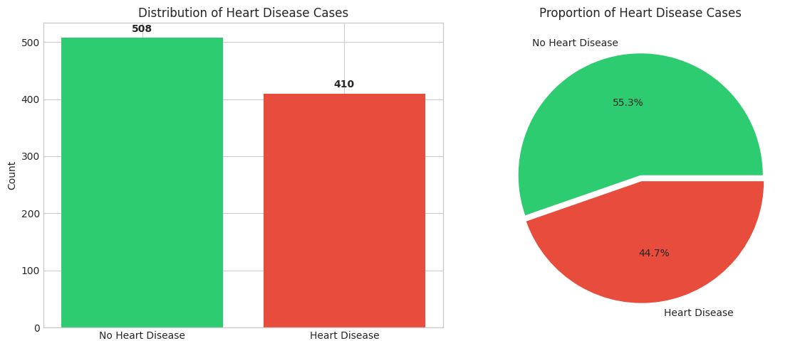
Class distribution: 410 healthy (44.7%) vs 508 heart disease (55.3%)
# Distribution of numerical features by target
fig, axes = plt.subplots(2, 3, figsize=(15, 10))
axes = axes.flatten()

for idx, col in enumerate(numerical_cols[:6]):
for hd_val, color, label in [(0, '#2ecc71', 'No Heart Disease'), (1, '#e74c3c', 'Heart Disease')]:
data = df_clean[df_clean['HeartDisease'] == hd_val][col]
axes[idx].hist(data, alpha=0.6, label=label, color=color, bins=20)
axes[idx].set_xlabel(col)
axes[idx].set_ylabel('Frequency')
axes[idx].legend()
axes[idx].set_title(f'Distribution of {col}')

plt.tight_layout()
plt.savefig('diagrams/figure2_numerical_distributions.png', dpi=300, bbox_inches='tight')
plt.show()
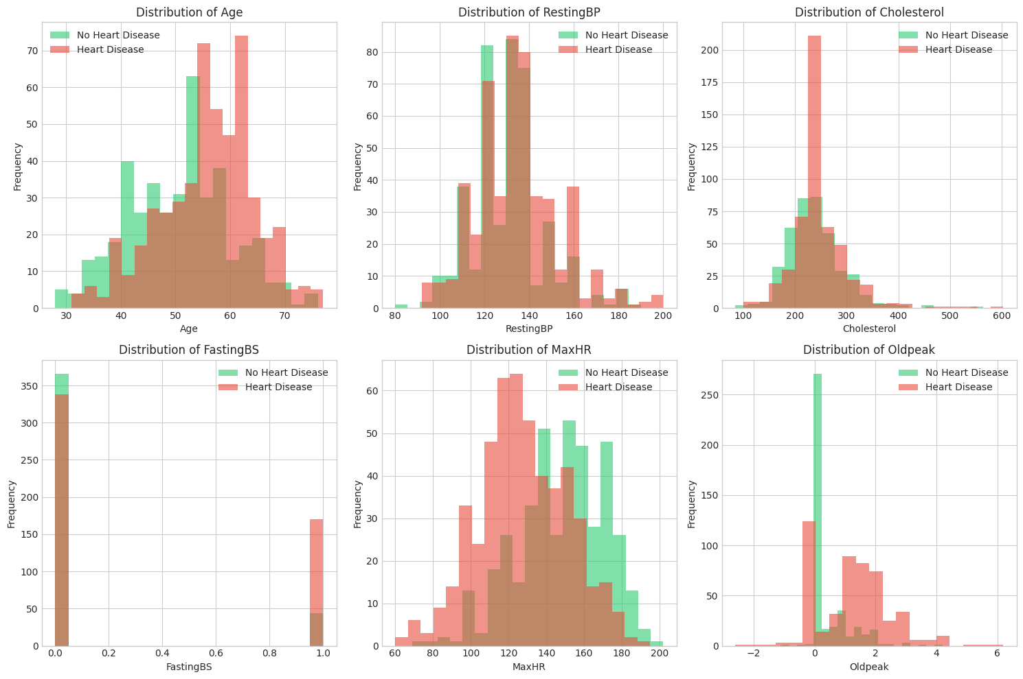
# Categorical features vs Heart Disease
fig, axes = plt.subplots(2, 3, figsize=(15, 10))
axes = axes.flatten()

for idx, col in enumerate(categorical_cols):
ct = pd.crosstab(df_clean[col], df_clean['HeartDisease'], normalize='index') * 100
ct.plot(kind='bar', ax=axes[idx], color=['#2ecc71', '#e74c3c'], edgecolor='black')
axes[idx].set_title(f'{col} vs Heart Disease')
axes[idx].set_ylabel('Percentage')
axes[idx].set_xlabel(col)
axes[idx].legend(['No Heart Disease', 'Heart Disease'])
axes[idx].tick_params(axis='x', rotation=45)

# Hide empty subplot if any
for idx in range(len(categorical_cols), len(axes)):
axes[idx].set_visible(False)

plt.tight_layout()
plt.savefig('diagrams/figure3_categorical_vs_target.png', dpi=300, bbox_inches='tight')
plt.show()
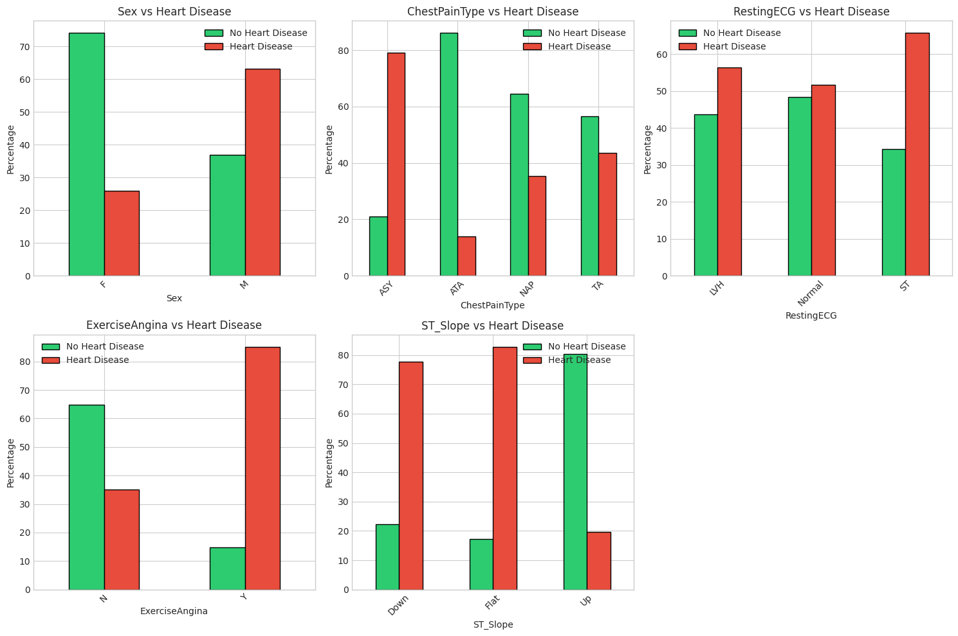
# Correlation heatmap for numerical features
# First, encode categorical variables for correlation analysis
df_encoded = df_clean.copy()
label_encoders = {}

for col in categorical_cols:
le = LabelEncoder()
df_encoded[col] = le.fit_transform(df_encoded[col])
label_encoders[col] = le

# Correlation matrix
plt.figure(figsize=(12, 10))
correlation_matrix = df_encoded.corr()
mask = np.triu(np.ones_like(correlation_matrix, dtype=bool))
sns.heatmap(correlation_matrix, mask=mask, annot=True, cmap='RdYlBu_r',
center=0, fmt='.2f', linewidths=0.5)
plt.title('Feature Correlation Matrix', fontsize=14, fontweight='bold')
plt.tight_layout()
plt.savefig('diagrams/figure4_correlation_matrix.png', dpi=300, bbox_inches='tight')
plt.show()

# Show correlations with target
print("\nCorrelation with Heart Disease (sorted by absolute value):")
print("=" * 50)
target_corr = correlation_matrix['HeartDisease'].drop('HeartDisease').sort_values(key=abs, ascending=False).round(2)
print(target_corr)
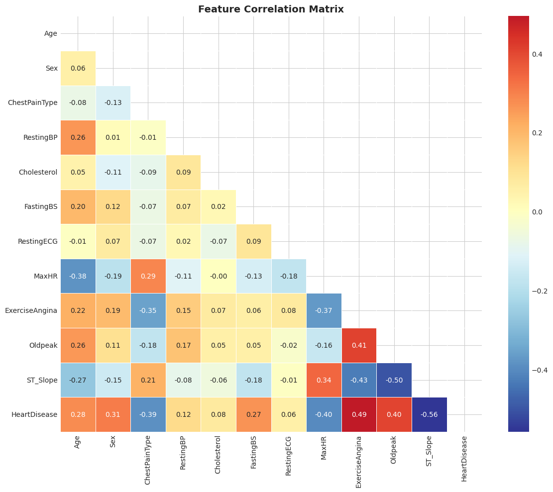
Correlation with Heart Disease (sorted by absolute value):
==================================================
ST_Slope -0.56
ExerciseAngina 0.49
Oldpeak 0.40
MaxHR -0.40
ChestPainType -0.39
Sex 0.31
Age 0.28
FastingBS 0.27
RestingBP 0.12
Cholesterol 0.08
RestingECG 0.06
Name: HeartDisease, dtype: float64
# Age distribution by heart disease status - box plot
fig, axes = plt.subplots(1, 2, figsize=(14, 5))

# Age vs Heart Disease
df_clean.boxplot(column='Age', by='HeartDisease', ax=axes[0])
axes[0].set_xlabel('Heart Disease')
axes[0].set_ylabel('Age')
axes[0].set_title('Age Distribution by Heart Disease Status')
plt.suptitle('') # Remove automatic title

# MaxHR vs Heart Disease
df_clean.boxplot(column='MaxHR', by='HeartDisease', ax=axes[1])
axes[1].set_xlabel('Heart Disease')
axes[1].set_ylabel('Maximum Heart Rate')
axes[1].set_title('Max Heart Rate Distribution by Heart Disease Status')
plt.suptitle('')

plt.tight_layout()
plt.savefig('diagrams/figure5_boxplots.png', dpi=300, bbox_inches='tight')
plt.show()
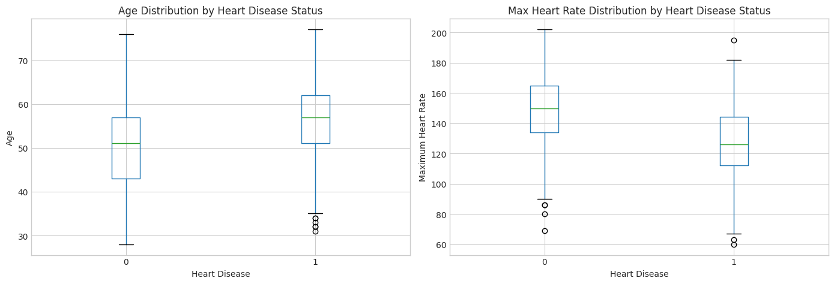
Key EDA Insights
Based on the exploratory analysis:
- Class Balance: The dataset has a reasonable balance between classes
- Age: Patients with heart disease tend to be older
- MaxHR: Lower maximum heart rate is associated with heart disease
- Chest Pain Type: Asymptomatic (ASY) chest pain is strongly associated with heart disease
- ST_Slope: Flat ST slope shows high correlation with heart disease
- Exercise Angina: Strong predictor of heart disease
5. Data Preprocessing for Modelling
# Prepare features and target
X = df_encoded.drop('HeartDisease', axis=1)
y = df_encoded['HeartDisease']

# Store feature names for later use
feature_names = X.columns.tolist()

print(f"Features shape: {X.shape}")
print(f"Target shape: {y.shape}")
print(f"\nFeature names: {feature_names}")
Features shape: (918, 11)
Target shape: (918,)

Feature names: ['Age', 'Sex', 'ChestPainType', 'RestingBP', 'Cholesterol', 'FastingBS', 'RestingECG', 'MaxHR', 'ExerciseAngina', 'Oldpeak', 'ST_Slope']
# Train-test split
X_train, X_test, y_train, y_test = train_test_split(
X, y, test_size=0.2, random_state=42, stratify=y
)

print(f"Training set: {X_train.shape[0]} samples")
print(f"Test set: {X_test.shape[0]} samples")
print(f"\nTraining set class distribution:")
print(y_train.value_counts())
print(f"\nTest set class distribution:")
print(y_test.value_counts())
Training set: 734 samples
Test set: 184 samples

Training set class distribution:
HeartDisease
1 406
0 328
Name: count, dtype: int64

Test set class distribution:
HeartDisease
1 102
0 82
Name: count, dtype: int64
# Scale numerical features
scaler = StandardScaler()

# Get indices of numerical columns in the encoded dataframe
numerical_indices = [feature_names.index(col) for col in numerical_cols if col in feature_names]

X_train_scaled = X_train.copy()
X_test_scaled = X_test.copy()

# Scale only numerical columns
# X_train_scaled.iloc[:, numerical_indices] = scaler.fit_transform(X_train.iloc[:, numerical_indices])
# X_test_scaled.iloc[:, numerical_indices] = scaler.transform(X_test.iloc[:, numerical_indices])

print("Feature scaling complete!")
Feature scaling complete!
6. Model Training and Evaluation
# Train XGBoost classifier
xgb_model = XGBClassifier(
n_estimators=100,
max_depth=5,
learning_rate=0.1,
random_state=42,
eval_metric='logloss',
use_label_encoder=False
)

# Fit the model
xgb_model.fit(X_train_scaled, y_train)

print("XGBoost model trained successfully!")
XGBoost model trained successfully!
# Make predictions
y_pred = xgb_model.predict(X_test_scaled)
y_pred_proba = xgb_model.predict_proba(X_test_scaled)[:, 1]

# Calculate metrics
accuracy = accuracy_score(y_test, y_pred)
precision = precision_score(y_test, y_pred)
recall = recall_score(y_test, y_pred)
f1 = f1_score(y_test, y_pred)
roc_auc = roc_auc_score(y_test, y_pred_proba)

print("Model Performance Metrics:")
print("=" * 50)
print(f"Accuracy: {accuracy:.4f}")
print(f"Precision: {precision:.4f}")
print(f"Recall: {recall:.4f}")
print(f"F1 Score: {f1:.4f}")
print(f"ROC-AUC: {roc_auc:.4f}")
Model Performance Metrics:
==================================================
Accuracy: 0.8587
Precision: 0.8878
Recall: 0.8529
F1 Score: 0.8700
ROC-AUC: 0.9181
# Cross-validation
cv_scores = cross_val_score(xgb_model, X_train_scaled, y_train, cv=5, scoring='accuracy')

print(f"\n5-Fold Cross-Validation Results:")
print("=" * 50)
print(f"Scores: {cv_scores}")
print(f"Mean Accuracy: {cv_scores.mean():.4f} (+/- {cv_scores.std() * 2:.4f})")
5-Fold Cross-Validation Results:
==================================================
Scores: [0.85714286 0.82993197 0.85034014 0.83673469 0.81506849]
Mean Accuracy: 0.8378 (+/- 0.0298)
# Confusion Matrix
fig, axes = plt.subplots(1, 2, figsize=(14, 5))

# Confusion matrix heatmap
cm = confusion_matrix(y_test, y_pred)
sns.heatmap(cm, annot=True, fmt='d', cmap='Blues', ax=axes[0],
xticklabels=['No Disease', 'Heart Disease'],
yticklabels=['No Disease', 'Heart Disease'])
axes[0].set_xlabel('Predicted')
axes[0].set_ylabel('Actual')
axes[0].set_title('Confusion Matrix')

# ROC Curve
fpr, tpr, thresholds = roc_curve(y_test, y_pred_proba)
axes[1].plot(fpr, tpr, color='#e74c3c', lw=2, label=f'ROC Curve (AUC = {roc_auc:.3f})')
axes[1].plot([0, 1], [0, 1], color='gray', linestyle='--', lw=2, label='Random Classifier')
axes[1].set_xlabel('False Positive Rate')
axes[1].set_ylabel('True Positive Rate')
axes[1].set_title('ROC Curve')
axes[1].legend(loc='lower right')
axes[1].set_xlim([0.0, 1.0])
axes[1].set_ylim([0.0, 1.05])

plt.tight_layout()
plt.savefig('diagrams/figure6_model_evaluation.png', dpi=300, bbox_inches='tight')
plt.show()
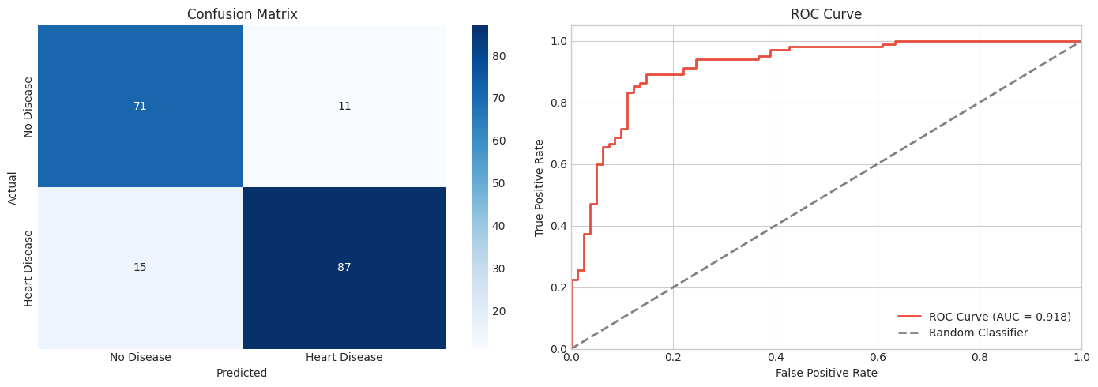
# Detailed classification report
print("\nClassification Report:")
print("=" * 50)
print(classification_report(y_test, y_pred, target_names=['No Disease', 'Heart Disease']))
Classification Report:
==================================================
precision recall f1-score support

No Disease 0.83 0.87 0.85 82
Heart Disease 0.89 0.85 0.87 102

accuracy 0.86 184
macro avg 0.86 0.86 0.86 184
weighted avg 0.86 0.86 0.86 184

7. Explainable AI - SHAP Analysis
SHAP (SHapley Additive exPlanations) uses game theory to explain the output of machine learning models. It assigns each feature an importance value for a particular prediction, showing how each feature pushes the prediction higher or lower from the base value.
# Initialize SHAP explainer
explainer = shap.TreeExplainer(xgb_model)

# Calculate SHAP values for test set
shap_values = explainer.shap_values(X_test_scaled)

print(f"SHAP values calculated!")
print(f"Shape of SHAP values: {shap_values.shape}")
SHAP values calculated!
Shape of SHAP values: (184, 11)
7.1 Global Feature Importance (SHAP Summary Plot)
# SHAP Summary Plot - Bar
plt.figure(figsize=(10, 8))
shap.summary_plot(shap_values, X_test_scaled, feature_names=feature_names,
plot_type='bar', show=False)
plt.title('Global Feature Importance (SHAP)', fontsize=14, fontweight='bold')
plt.tight_layout()
plt.savefig('diagrams/figure7_shap_importance_bar.png', dpi=300, bbox_inches='tight')
plt.show()
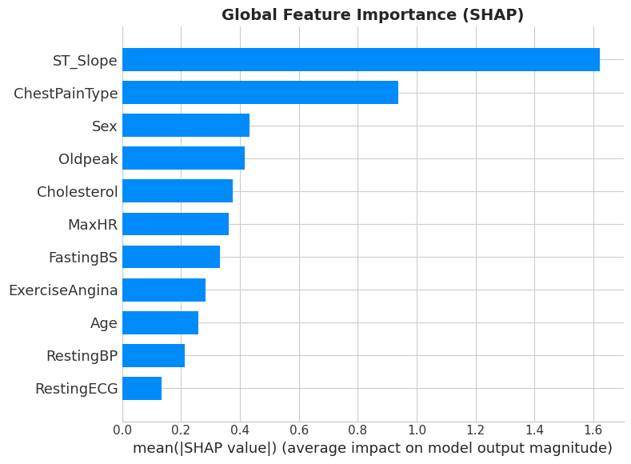
# SHAP Summary Plot - Beeswarm
plt.figure(figsize=(12, 8))
shap.summary_plot(shap_values, X_test_scaled, feature_names=feature_names, show=False)
plt.title('SHAP Summary Plot (Feature Impact on Predictions)', fontsize=14, fontweight='bold')
plt.tight_layout()
plt.savefig('diagrams/figure8_shap_summary_beeswarm.png', dpi=300, bbox_inches='tight')
plt.show()
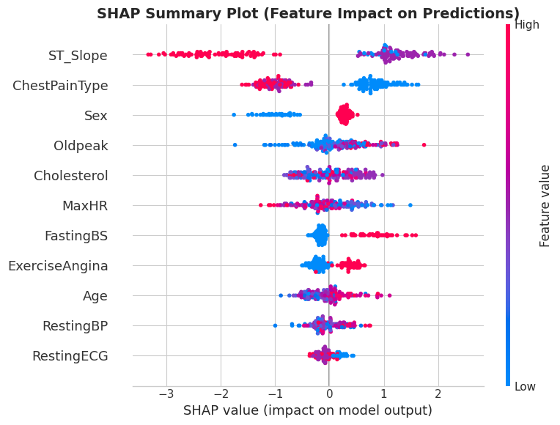
Interpretation of SHAP Summary Plot:
- Each point represents a single patient from the test set
- Features are ordered by importance (top = most important)
- Horizontal position shows whether the feature pushes the prediction toward heart disease (positive) or away from it (negative)
- Color indicates the feature value (red = high, blue = low)
7.2 Local Explanations (Individual Predictions)
# Select specific patients for detailed explanation
# Find one high-risk and one low-risk patient
high_risk_idx = np.where(y_pred_proba > 0.9)[0][0] if len(np.where(y_pred_proba > 0.9)[0]) > 0 else 0
low_risk_idx = np.where(y_pred_proba < 0.1)[0][0] if len(np.where(y_pred_proba < 0.1)[0]) > 0 else 1

print(f"High-risk patient index: {high_risk_idx}, Predicted probability: {y_pred_proba[high_risk_idx]:.4f}")
print(f"Low-risk patient index: {low_risk_idx}, Predicted probability: {y_pred_proba[low_risk_idx]:.4f}")
High-risk patient index: 0, Predicted probability: 0.9510
Low-risk patient index: 6, Predicted probability: 0.0033
# SHAP Force Plot for high-risk patient
print("\nSHAP Force Plot - High Risk Patient")
print("=" * 50)
shap.initjs()
shap.force_plot(explainer.expected_value, shap_values[high_risk_idx],
X_test_scaled.iloc[high_risk_idx], feature_names=feature_names, matplotlib=True)
plt.savefig('diagrams/figure9_shap_force_high_risk.png', dpi=300, bbox_inches='tight')
plt.show()
SHAP Force Plot - High Risk Patient
==================================================
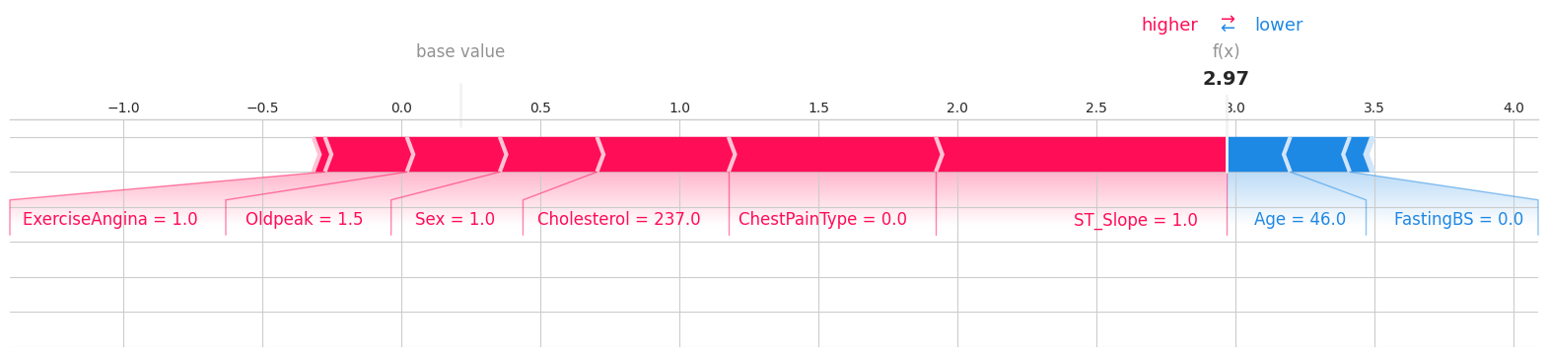
<Figure size 640x480 with 0 Axes>
# SHAP Force Plot for low-risk patient
print("\nSHAP Force Plot - Low Risk Patient")
print("=" * 50)
shap.force_plot(explainer.expected_value, shap_values[low_risk_idx],
X_test_scaled.iloc[low_risk_idx], feature_names=feature_names, matplotlib=True)
plt.savefig('diagrams/figure10_shap_force_low_risk.png', dpi=300, bbox_inches='tight')
plt.show()
SHAP Force Plot - Low Risk Patient
==================================================
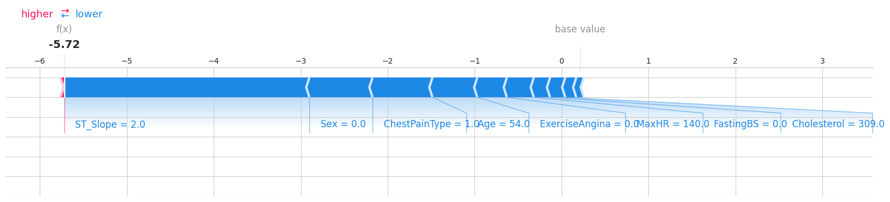
<Figure size 640x480 with 0 Axes>
# SHAP Waterfall Plot for high-risk patient
print("\nSHAP Waterfall Plot - High Risk Patient")
print("=" * 50)
plt.figure(figsize=(10, 8))
shap.plots.waterfall(shap.Explanation(values=shap_values[high_risk_idx],
base_values=explainer.expected_value,
data=X_test_scaled.iloc[high_risk_idx].values,
feature_names=feature_names), show=False)
plt.title('SHAP Waterfall Plot - High Risk Patient', fontsize=12, fontweight='bold')
plt.tight_layout()
plt.savefig('diagrams/figure11_shap_waterfall_high_risk.png', dpi=300, bbox_inches='tight')
plt.show()
SHAP Waterfall Plot - High Risk Patient
==================================================
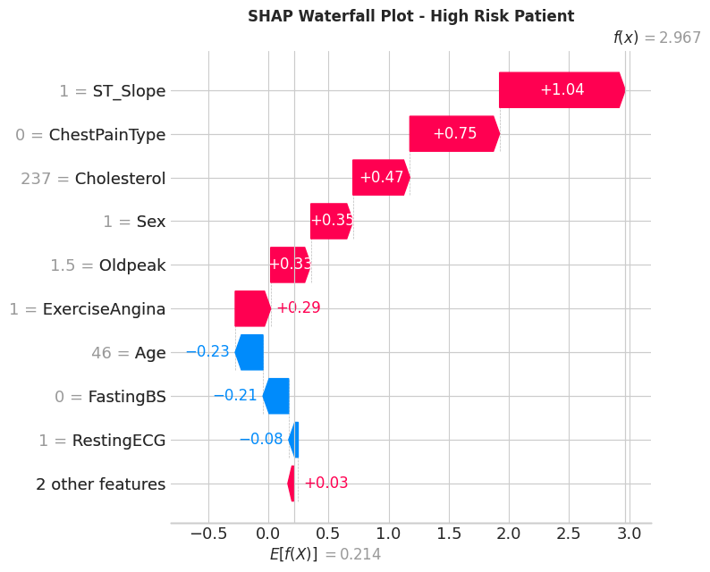
7.3 SHAP Dependence Plots
These plots show how a feature affects the prediction, including interactions with other features.
# Get the most important features
mean_abs_shap = np.abs(shap_values).mean(axis=0)
top_features = np.argsort(mean_abs_shap)[-3:][::-1]
top_feature_names = [feature_names[i] for i in top_features]

print(f"Top 3 features by SHAP importance: {top_feature_names}")
Top 3 features by SHAP importance: ['ST_Slope', 'ChestPainType', 'Sex']
# SHAP Dependence plots for top features
fig, axes = plt.subplots(1, 3, figsize=(18, 5))

for idx, feature in enumerate(top_feature_names):
shap.dependence_plot(feature, shap_values, X_test_scaled,
feature_names=feature_names, ax=axes[idx], show=False)
axes[idx].set_title(f'SHAP Dependence: {feature}')

plt.tight_layout()
plt.savefig('diagrams/figure12_shap_dependence.png', dpi=300, bbox_inches='tight')
plt.show()
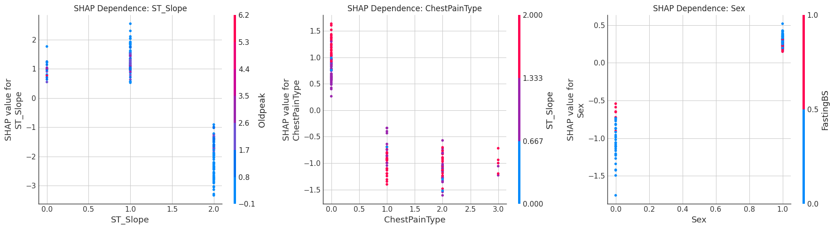
8. Explainable AI - LIME Analysis
LIME (Local Interpretable Model-agnostic Explanations) explains individual predictions by approximating the model locally with an interpretable model (like linear regression).
# Initialize LIME explainer
lime_explainer = lime.lime_tabular.LimeTabularExplainer(
training_data=X_train_scaled.values,
feature_names=feature_names,
class_names=['No Heart Disease', 'Heart Disease'],
mode='classification',
random_state=42
)

print("LIME explainer initialized!")
LIME explainer initialized!
# LIME explanation for high-risk patient
print("\nLIME Explanation - High Risk Patient")
print("=" * 50)

lime_exp_high = lime_explainer.explain_instance(
X_test_scaled.iloc[high_risk_idx].values,
xgb_model.predict_proba,
num_features=10
)

# Display as figure
fig = lime_exp_high.as_pyplot_figure()
fig.set_size_inches(12, 6)
plt.title('LIME Explanation - High Risk Patient', fontsize=14, fontweight='bold')
plt.tight_layout()
plt.savefig('diagrams/figure13_lime_high_risk.png', dpi=300, bbox_inches='tight')
plt.show()

# Print text explanation
print("\nFeature contributions:")
for feature, weight in lime_exp_high.as_list():
direction = "→ Heart Disease" if weight > 0 else "→ No Disease"
print(f" {feature}: {weight:.4f} {direction}")
LIME Explanation - High Risk Patient
==================================================
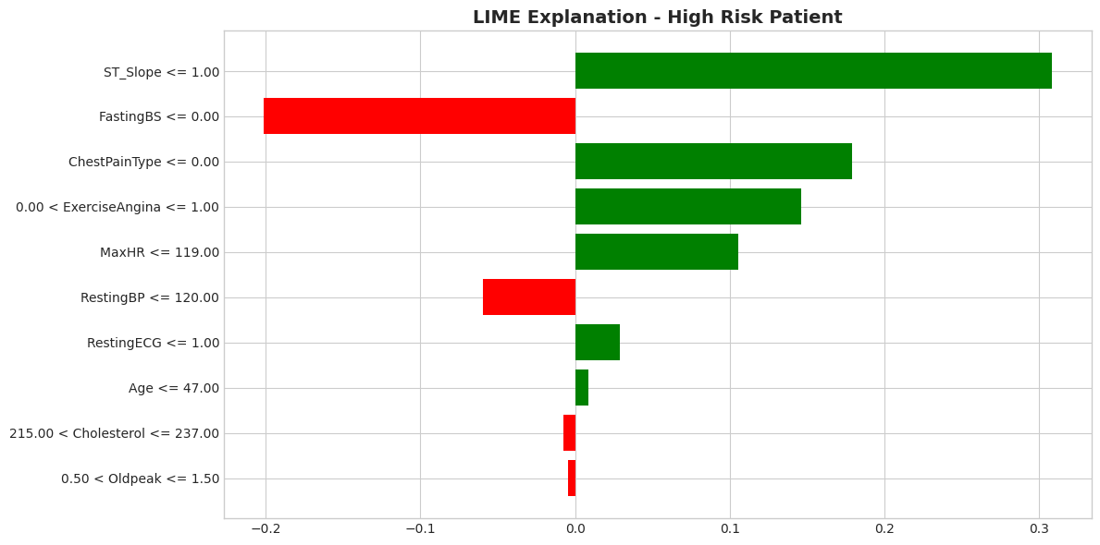
Feature contributions:
ST_Slope <= 1.00: 0.3085 → Heart Disease
FastingBS <= 0.00: -0.2016 → No Disease
ChestPainType <= 0.00: 0.1790 → Heart Disease
0.00 < ExerciseAngina <= 1.00: 0.1461 → Heart Disease
MaxHR <= 119.00: 0.1056 → Heart Disease
RestingBP <= 120.00: -0.0598 → No Disease
RestingECG <= 1.00: 0.0289 → Heart Disease
Age <= 47.00: 0.0084 → Heart Disease
215.00 < Cholesterol <= 237.00: -0.0072 → No Disease
0.50 < Oldpeak <= 1.50: -0.0044 → No Disease
# LIME explanation for low-risk patient
print("\nLIME Explanation - Low Risk Patient")
print("=" * 50)

lime_exp_low = lime_explainer.explain_instance(
X_test_scaled.iloc[low_risk_idx].values,
xgb_model.predict_proba,
num_features=10
)

# Display as figure
fig = lime_exp_low.as_pyplot_figure()
fig.set_size_inches(12, 6)
plt.title('LIME Explanation - Low Risk Patient', fontsize=14, fontweight='bold')
plt.tight_layout()
plt.savefig('diagrams/figure14_lime_low_risk.png', dpi=300, bbox_inches='tight')
plt.show()

# Print text explanation
print("\nFeature contributions:")
for feature, weight in lime_exp_low.as_list():
direction = "→ Heart Disease" if weight > 0 else "→ No Disease"
print(f" {feature}: {weight:.4f} {direction}")
LIME Explanation - Low Risk Patient
==================================================
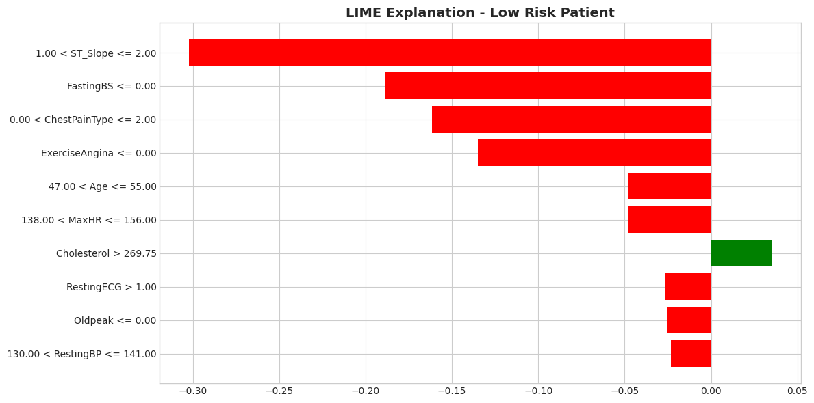
Feature contributions:
1.00 < ST_Slope <= 2.00: -0.3023 → No Disease
FastingBS <= 0.00: -0.1889 → No Disease
0.00 < ChestPainType <= 2.00: -0.1616 → No Disease
ExerciseAngina <= 0.00: -0.1350 → No Disease
47.00 < Age <= 55.00: -0.0479 → No Disease
138.00 < MaxHR <= 156.00: -0.0479 → No Disease
Cholesterol > 269.75: 0.0351 → Heart Disease
RestingECG > 1.00: -0.0265 → No Disease
Oldpeak <= 0.00: -0.0252 → No Disease
130.00 < RestingBP <= 141.00: -0.0231 → No Disease
9. Comparison: SHAP vs LIME
# Compare feature importance rankings between SHAP and LIME
print("Comparison of SHAP and LIME Feature Rankings")
print("=" * 60)

# SHAP global importance
shap_importance = pd.DataFrame({
'Feature': feature_names,
'SHAP_Importance': np.abs(shap_values).mean(axis=0)
}).sort_values('SHAP_Importance', ascending=False)

# LIME importance (average from multiple samples)
lime_importances = []
n_samples = min(50, len(X_test_scaled))

for i in range(n_samples):
exp = lime_explainer.explain_instance(
X_test_scaled.iloc[i].values,
xgb_model.predict_proba,
num_features=len(feature_names)
)
feature_weights = dict(exp.as_list())
lime_importances.append(feature_weights)

# Aggregate LIME importances
lime_agg = {}
for feat in feature_names:
weights = []
for imp in lime_importances:
for key, val in imp.items():
if feat in key:
weights.append(abs(val))
lime_agg[feat] = np.mean(weights) if weights else 0

lime_importance = pd.DataFrame({
'Feature': feature_names,
'LIME_Importance': [lime_agg[f] for f in feature_names]
}).sort_values('LIME_Importance', ascending=False)

print("\nSHAP Feature Ranking:")
for i, row in shap_importance.head(5).iterrows():
print(f" {row['Feature']}: {row['SHAP_Importance']:.4f}")

print("\nLIME Feature Ranking (averaged):")
for i, row in lime_importance.head(5).iterrows():
print(f" {row['Feature']}: {row['LIME_Importance']:.4f}")
Comparison of SHAP and LIME Feature Rankings
============================================================

SHAP Feature Ranking:
ST_Slope: 1.6227
ChestPainType: 0.9373
Sex: 0.4323
Oldpeak: 0.4154
Cholesterol: 0.3768

LIME Feature Ranking (averaged):
ST_Slope: 0.2957
FastingBS: 0.1889
ChestPainType: 0.1704
ExerciseAngina: 0.1393
Oldpeak: 0.0716
# Visual comparison of SHAP and LIME rankings
comparison_df = shap_importance.merge(lime_importance, on='Feature')
comparison_df['SHAP_Rank'] = range(1, len(comparison_df) + 1)
comparison_df = comparison_df.merge(
lime_importance.reset_index(drop=True).reset_index().rename(columns={'index': 'LIME_Rank'})[['Feature', 'LIME_Rank']],
on='Feature'
)
comparison_df['LIME_Rank'] = comparison_df['LIME_Rank'] + 1

fig, ax = plt.subplots(figsize=(12, 6))

x = np.arange(len(feature_names))
width = 0.35

# Normalize for comparison
shap_norm = comparison_df['SHAP_Importance'] / comparison_df['SHAP_Importance'].max()
lime_norm = comparison_df['LIME_Importance'] / comparison_df['LIME_Importance'].max()

bars1 = ax.bar(x - width/2, shap_norm, width, label='SHAP', color='#3498db')
bars2 = ax.bar(x + width/2, lime_norm, width, label='LIME', color='#e74c3c')

ax.set_ylabel('Normalized Importance')
ax.set_title('SHAP vs LIME Feature Importance Comparison', fontsize=14, fontweight='bold')
ax.set_xticks(x)
ax.set_xticklabels(comparison_df['Feature'], rotation=45, ha='right')
ax.legend()

plt.tight_layout()
plt.savefig('diagrams/figure15_shap_lime_comparison.png', dpi=300, bbox_inches='tight')
plt.show()
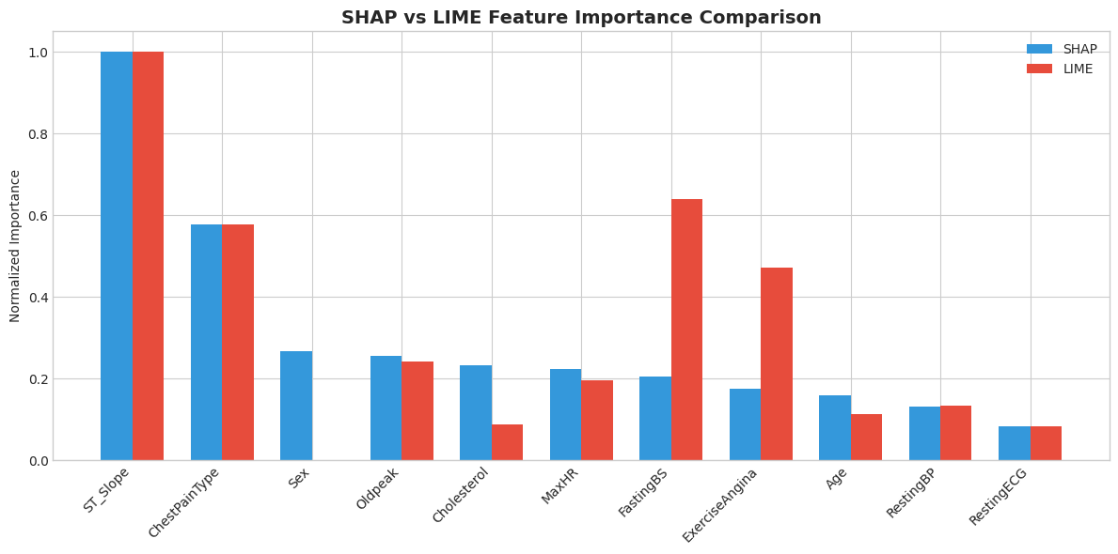
Key Differences Between SHAP and LIME
Aspect | SHAP | LIME
Theoretical basis | Shapley values (game theory) | Local linear approximation
Scope | Global and local explanations | Primarily local explanations
Consistency | Mathematically consistent | May vary between runs
Computation | Can be slow for large datasets | Generally faster
Interpretation | Exact feature contributions | Approximate feature contributions
10. Clinical Interpretation and Summary
# Summary statistics
print("="*70)
print("PROJECT SUMMARY")
print("="*70)

print("\n1. DATASET")
print(f" - Total records: {len(df_clean)}")
print(f" - Features: {len(feature_names)}")
print(f" - Target distribution: {(y==1).sum()} heart disease, {(y==0).sum()} healthy")

print("\n2. MODEL PERFORMANCE")
print(f" - Algorithm: XGBoost Classifier")
print(f" - Accuracy: {accuracy:.2%}")
print(f" - ROC-AUC: {roc_auc:.4f}")
print(f" - F1 Score: {f1:.4f}")

print("\n3. KEY FEATURES (SHAP Analysis)")
for i, row in shap_importance.head(5).iterrows():
print(f" {shap_importance.index.tolist().index(i)+1}. {row['Feature']}")

print("\n4. XAI TECHNIQUES APPLIED")
print(" - SHAP: Global importance, summary plots, force plots, waterfall plots")
print(" - LIME: Local interpretable explanations for individual predictions")

print("\n" + "="*70)
======================================================================
PROJECT SUMMARY
======================================================================

1. DATASET
- Total records: 918
- Features: 11
- Target distribution: 508 heart disease, 410 healthy

2. MODEL PERFORMANCE
- Algorithm: XGBoost Classifier
- Accuracy: 85.87%
- ROC-AUC: 0.9181
- F1 Score: 0.8700

3. KEY FEATURES (SHAP Analysis)
1. ST_Slope
2. ChestPainType
3. Sex
4. Oldpeak
5. Cholesterol

4. XAI TECHNIQUES APPLIED
- SHAP: Global importance, summary plots, force plots, waterfall plots
- LIME: Local interpretable explanations for individual predictions

======================================================================

11. Conclusion
This analysis demonstrates the critical importance of Explainable AI in healthcare applications. By applying SHAP and LIME to a heart disease prediction model, we have shown that:
- Model transparency is achievable: Even complex ensemble models like XGBoost can be made interpretable through post-hoc explanation techniques.
- Clinical relevance: The features identified as most important by both SHAP and LIME align with established medical knowledge about heart disease risk factors.
- Individual explanations matter: Beyond global feature importance, XAI enables patient-specific explanations that can inform clinical decision-making.
- Multiple perspectives: SHAP and LIME provide complementary views of model behaviour, with SHAP offering mathematical consistency and LIME providing intuitive local approximations.
For clinical deployment, these explanation techniques would enable healthcare professionals to:
- Understand why a patient is classified as high or low risk
- Identify which factors are most influential for each individual case
- Build trust in AI-assisted diagnosis
- Meet regulatory requirements for algorithmic transparency

