  - NEET-SS + ICP PAEDIATRICS

DAY 11 — RETINOPATHY OF PREMATURITY, IVH, PVL & NEURODEVELOPMENTAL FOLLOW-UP
Friday, 9 October 2026 • FINAL V7 • Nelson 22e primary conceptual reference • Cloherty & Stark 9e neonatal management cross-reference • IAP/IAP-NNF + AIIMS Indian clinical overlay • Current authoritative international protocols
75 base MCQs + 3 separately scored notebook retests (Q1–Q78) | 6 visual stations | 8 question-linked visual/data items | No calculation drill on odd-numbered Day 11
Role | Reference | How it is used in this document
Primary conceptual framework | Nelson Textbook of Pediatrics, 22nd Edition | Core pathophysiology, disease framework, examination concepts and broad management principles.
Neonatal bedside / management cross-reference | Cloherty and Stark's Manual of Neonatal Care, 9th Edition (Hansen, Stark, Eichenwald, Martin; Wolters Kluwer/LWW, 2022) | NICU-oriented evaluation, monitoring, stabilization and practical neonatal management cross-read. It does not override newer named guidelines.
Topic-specific depth | Cloherty 9e: Chapter 54 Intracranial Hemorrhage and White Matter Injury/PVL; Chapter 67 Retinopathy of Prematurity; Chapter 68 Hearing Health in NICU Graduates | Used as chapter-level cross-reading for today's IVH/PVL, ROP and hearing-follow-up topics.
Neurology depth | Volpe's Neurology of the Newborn | Mechanism and neuroimaging depth for GMH-IVH, PVHI, PHVD and white-matter injury.
Current protocol layer | ICROP3, ETROP/AAP, NHM India, CPS, JCIH, ELVIS and other named current guidance | Current thresholds, screening intervals, treatment criteria and follow-up rules. When these differ from textbook/manual frameworks, the named current protocol is stated explicitly.
India-specific paediatric reference | Indian Academy of Pediatrics (IAP) Standard Treatment Guidelines | Use current IAP topic-specific guidance for Indian exam/practice context. Day 11 particularly uses IAP STG 144 Retinopathy of Prematurity and IAP STG 123 Early Detection and Early Intervention of a High-Risk Neonate.
India-specific neonatal reference | IAP–NNF Quick Reference Guidelines in Neonatology 2026 | Use the relevant neonatal quick-reference topics, especially Preterm Brain Injury and Neuroprotection and Posthemorrhagic Hydrocephalus in Preterm Neonates, plus oxygen/pain/cord-management guidance where relevant.
India tertiary-NICU practical reference | AIIMS Protocols in Neonatology / WHO Collaborating Centre for Training and Research in Newborn Care, AIIMS New Delhi | Use for Indian tertiary-NICU bedside algorithms, ROP prevention/screening/treatment logistics, preterm stabilization, oxygen administration, pain management and follow-up; adapt to local setting as AIIMS itself advises.
Source-discipline rule: Nelson 22e remains the primary conceptual source. Cloherty & Stark 9e provides neonatal bedside/management cross-reference. IAP and IAP–NNF guidance provide India-specific paediatric/neonatal exam and practice framing. AIIMS neonatal protocols provide tertiary-NICU practical context. Current named protocols (NHM, ICROP3, ETROP/AAP, CPS, JCIH, ELVIS and others) control current thresholds/schedules when newer than textbooks/manuals. Recommendations are labelled by framework and are not silently blended.

REFERENCE HIERARCHY FOR DAY 11
Clinical education only. Guideline cutoffs and follow-up intervals are explicitly source-labelled; unit protocols and specialist judgment govern patient care.

TODAY’S LEARNING OBJECTIVES
- Interpret ICROP3 zone, stage, plus/preplus and aggressive ROP; decide Type 1 treatment versus Type 2 surveillance.
- Use Indian NHM and AAP screening rules without silently mixing eligibility and first-exam dates.
- Grade GMH–IVH, recognize PVHI and evolving PVL on serial cranial ultrasound, and escalate PHVD using measurements.
- Design corrected-age, vision, hearing, motor, cognitive and language follow-up; apply R1/R2/R3 to documented notebook errors.

SECTION A — CONCEPTUAL & CLINICAL NOTES

A1. ROP: pathogenesis, classification and visual recognition
The immature retinal vascular network normally advances from posterior to peripheral retina. Premature birth interrupts this process; oxygen fluctuations, VEGF suppression and later hypoxia-driven angiogenesis can produce ROP. Oxygen exposure is a modifiable contributor, not a necessary condition. Lower gestational age, poor postnatal growth, severe illness, sepsis and transfusion correlate with risk; the magnitude and causality of individual associations vary.
Descriptor | Exam anchor | Discriminator
Zone I | Circle centered on disc, radius twice disc–macula distance | Most posterior; severe disease can require treatment without plus.
Zone II | Annulus from zone I to nasal ora serrata | Zone II stage 3 without plus is Type 2.
Zone III | Residual temporal crescent | Usually lower risk, but not an automatic stopping rule.
Stage 1 | Flat demarcation line | No elevated ridge.
Stage 2 | Elevated ridge | No extraretinal neovascularization.
Stage 3 | Extraretinal neovascular proliferation, including flat lesions | Can be present without a classic ridge.
Stage 4A / 4B | Partial detachment without / with foveal involvement | Foveal status changes prognosis.
Stage 5A / 5B / 5C | Total detachment: open funnel with disc visible / closed funnel / total detachment with anterior-segment changes | ICROP3 subdivisions refine anatomy and prognosis; all are advanced disease.
Plus / preplus | Posterior dilation+tortuosity; spectrum under ICROP3 | Plus changes Type 1 thresholds; preplus is not automatically plus.
A-ROP | Rapid progression, often flat posterior neovascularization and severe plus | May bypass orderly stages.
TYPE 1 (treatment-requiring, ETROP): zone I any stage WITH plus; zone I stage 3 WITHOUT plus; zone II stage 2 or 3 WITH plus. TYPE 2 (close observation): zone I stage 1 or 2 without plus; zone II stage 3 without plus. Timing: specialist treatment ideally within about 72 hours of Type 1 confirmation; clinical urgency may be greater for A-ROP.
Laser ablates avascular peripheral retina and remains a durable standard for much zone II treatment, but can increase myopia and peripheral field loss. Anti-VEGF is especially useful in very posterior Zone I/A-ROP or when laser is technically difficult; persistent avascular retina and late reactivation require prolonged surveillance. In Indian practice, bevacizumab is widely discussed and may be used off-label in selected tertiary centres because of familiarity and lower cost, whereas ranibizumab/aflibercept availability and cost vary. NHM operational material does not recommend routine neonatal bevacizumab; all anti-VEGF use is specialist-led with informed consent, systemic-safety counselling and prolonged follow-up. Propranolol is NOT routine ROP prophylaxis or treatment: evidence is inconsistent and systemic adverse effects include bradycardia, hypotension, bronchospasm and hypoglycemia.

A1A. ROP trial anchors — know the question each trial answered
ETROP established the Type 1 treatment framework for high-risk prethreshold ROP. BEAT-ROP found bevacizumab superior to conventional laser for recurrence in Zone I stage 3+ disease, without the same clear advantage in Zone II. RAINBOW supported ranibizumab as an effective anti-VEGF option compared with laser, and FIREFLEYE supported aflibercept efficacy in treatment-requiring ROP. These trials do NOT make anti-VEGF universally superior: posterior anatomy, recurrence/reactivation profile, systemic-safety uncertainty, follow-up reliability, licensing and local access all matter.
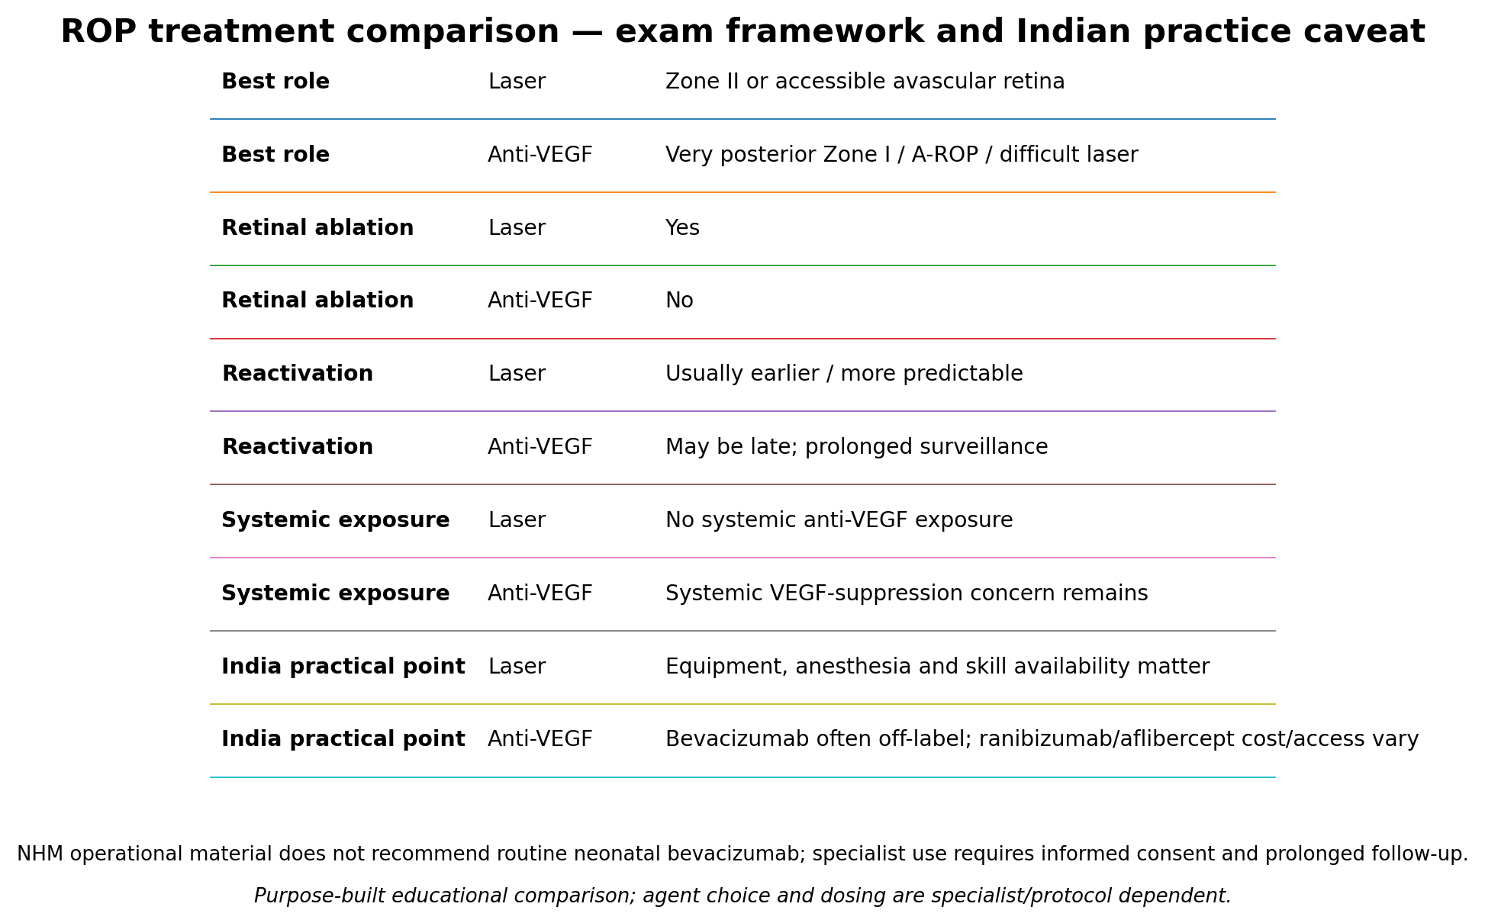
Purpose-built educational comparison; agent choice and dosing are specialist/protocol dependent.

A2. Screening — India and international protocols must remain separate
Framework | Eligibility | First examination | Follow-up / stopping
India NHM / operational Indian exam anchor | GA ≤34 weeks OR BW ≤2000 g is the widely quoted Indian operational/exam anchor; 34–36 weeks with risk factors and unstable high-risk infants are also screened. Important source-version caveat: the currently linked revised NHM PDF uses the words '<34 weeks' and '<2000 g', while the older NHM 'Final' summary and Indian operational summaries use '≤'. Do not construct or answer a boundary-only stem without naming the source version. | By about 4 weeks; very high-risk infants (<28 weeks or <1200 g in NHM text) at 2–3 weeks. | Document zone/stage/plus and the exact next date; missed follow-up is a preventable cause of blindness.
AAP 2018 US framework | BW ≤1500 g OR GA ≤30 weeks; selected 1500–2000 g or older unstable infants | PMA- and GA-based table: 24-week infant → 31 weeks PMA (7 weeks PNA); 28-week infant → 32 weeks PMA (4 weeks PNA) | Zone I stage 1–2 usually ≤1 week; zone II stage 2 1–2 weeks; zone II stage 1 ~2 weeks; post anti-VEGF surveillance often ≥65 weeks PMA.
EXAM/PRACTICE DIFFERENCE: Indian sources are not perfectly uniform at the exact 34-week/2000-g boundary. The older NHM final summary and Indian operational review use ≤34 weeks and ≤2000 g, while the currently linked revised NHM PDF text says <34 weeks and <2000 g. For NEET-SS, use the explicitly named source/framework and avoid boundary-only reasoning unless the stem specifies the document. AAP 2018 remains a separate US framework with its own eligibility and PMA-based first-exam table.

A3. ROP decision algorithm
1. Identify eligibility and ensure a named ophthalmologist and dated first exam.
2. At each exam record zone, stage, extent, plus/preplus, A-ROP, regression and treatment history.
3. Type 1 or A-ROP → urgent retina specialist treatment assessment; document treatment date.
4. Type 2 → close interval follow-up by zone/stage (often ≤1 week posteriorly).
5. After laser → early review (often 3–7 days) and confirm regression; after anti-VEGF → extended reactivation surveillance.
6. After acute ROP resolution → assess refractive error, amblyopia, strabismus and visual development.

A3A. ROP examination practicalities — high-yield bedside safety
NHM screening guidance emphasizes comfort, monitoring and asepsis. Before examination: confirm consent, warm/swaddle the infant, dilate pupils with the correct neonatal preparation, and use pulse-oximetry for sick infants. Topical proparacaine is used before the speculum; oral sucrose may be considered for analgesia. During the exam, monitor heart rate and oxygen saturation and interrupt the procedure for significant bradycardia, apnea or severe desaturation until recovery. Use sterile instruments for each infant with hand hygiene/glove change between examinations. Wide-field digital imaging can support documentation and tele-ROP pathways, especially where ophthalmology access is limited, but NHM guidance treats it as an adjunct rather than a complete replacement for expert indirect ophthalmoscopy when image quality or disease severity is uncertain.
AIIMS practical cross-read: for ROP treatment, AIIMS protocols emphasize cardiorespiratory monitoring and adequate analgesia/sedation; topical anesthesia alone is insufficient for treatment procedures such as laser. AIIMS also stresses prolonged observation after sedative/analgesic regimens and contextual adaptation to unit resources. This is a treatment-procedure issue and should not be confused with the simpler comfort measures used for routine screening examinations.
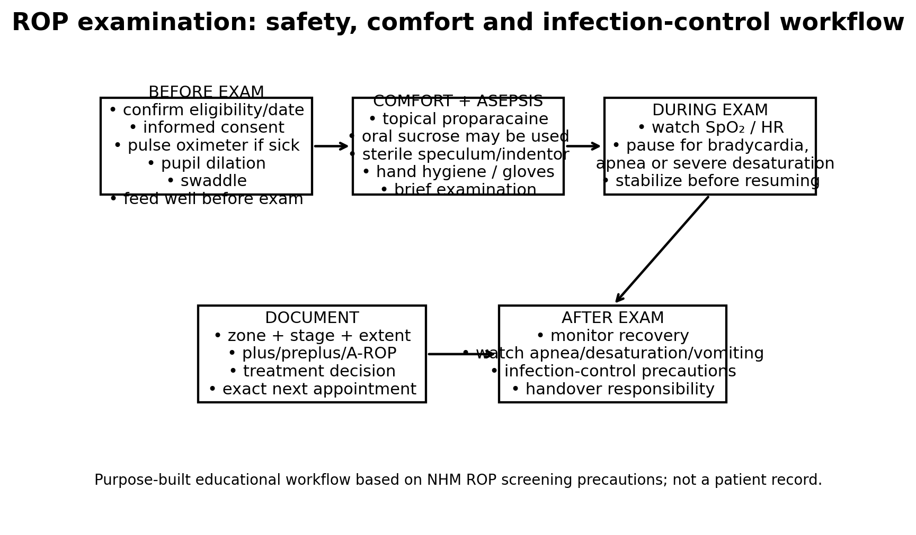
Purpose-built educational workflow; not a patient image.

A4. Germinal-matrix hemorrhage, IVH, PVHI and cranial ultrasound
Fragile germinal-matrix vessels at the caudothalamic groove rupture especially in the first 72 hours of extreme prematurity. Hemodynamic instability, fluctuating cerebral perfusion, coagulopathy and very low gestation increase risk. Serial cranial ultrasound detects GMH–IVH, evolving ventricular enlargement and cystic white-matter injury. Mastoid views improve posterior-fossa detection.
Pattern | Imaging finding | Interpretation
Grade I | Hemorrhage confined to caudothalamic germinal matrix | No ventricular blood.
Grade II | Intraventricular blood WITHOUT dilatation | Serial scans needed for evolution.
Grade III | Intraventricular blood WITH ventricular dilatation | Higher PHVD risk.
PVHI (old “grade IV”) | Unilateral/asymmetric wedge-shaped parenchymal hemorrhagic venous infarction | Not simply ventricular blood extending into brain.
Cystic PVL | Delayed bilateral periventricular cysts after persistent echogenicity | White-matter injury, not an IVH grade.
Noncystic WMI | Subtle diffuse white-matter injury; MRI may detect more than US | Normal US does not exclude this pattern.
CPS (reaffirmed 12 Jan 2026): routine HUS for ≤31+6 weeks at 4–7 days and again 4–6 weeks; grade II+ IVH or WMI → repeat 7–10 days; progressive ventricular dilation → at least weekly initially and often more frequently. At <26 weeks, term-equivalent HUS is advised. For 32–36+6 weeks, selective imaging is appropriate with severe illness or neurologic risk.

A5. PHVD: serial measurement and escalation
PHVD can progress before head circumference accelerates or the fontanelle bulges. Measure ventricular index (VI), anterior horn width (AHW), and thalamo-occipital distance (TOD) on consistent serial planes. ELVIS low threshold: VI >97th centile with AHW >6 mm and/or TOD >25 mm; high threshold: VI >97th centile +4 mm with AHW >10 mm. These are trial pathways, not universal automatic-drainage orders. In some published pathways, 2–3 lumbar punctures aim to remove about 10 mL/kg CSF; this is protocol-dependent, not a universal volume prescription. Progressive disease may require a ventricular reservoir or ventriculosubgaleal shunt, with VP shunt timing individualized by weight, CSF quality, ventricular trajectory, infection status and local neurosurgical practice.
Evidence calibration: the original ELVIS primary composite (death or VP shunt) was not significantly different between randomized thresholds, but MRI and later developmental analyses favored earlier measurement-led intervention. The 2026 Pediatric Research Bayesian reanalysis is now verified: delaying intervention had >90% posterior probability of harm for death or moderate/severe neurodevelopmental impairment, with an estimated absolute risk difference of 16% and NNT about 7 under the reported analysis. This strengthens the case for early ultrasound-guided escalation, but does not make every low-threshold crossing an automatic operation.

A5A. PHVD drainage safety and permanent-shunt caveats
IAP–NNF 2026 cross-read: 'Posthemorrhagic Hydrocephalus in Preterm Neonates' is the preferred current Indian quick-reference overlay for practical escalation. AIIMS neonatal practice resources are used for NICU execution and transfer/neurosurgical coordination. ELVIS/Volpe remain the evidence/imaging anchors for VI/AHW/TOD interpretation.
Temporizing drainage is not benign. Reservoir/VSGS pathways require strict asepsis, trained operators and slow controlled removal; one review recommends reservoir drainage no faster than about 1 mL/min. Important complications include infection, obstruction, CSF leak, skin problems, revision and rare intracranial hemorrhage. Repeated drainage is burdensome and removes protein-containing CSF, so prolonged pathways require attention to nutrition, electrolytes and overall growth. A CSF protein threshold such as <1.5 g/L before VP shunting appears in some published pathways, but it is NOT a universal criterion and should be presented only as a centre-/study-dependent example, not an exam-wide rule.
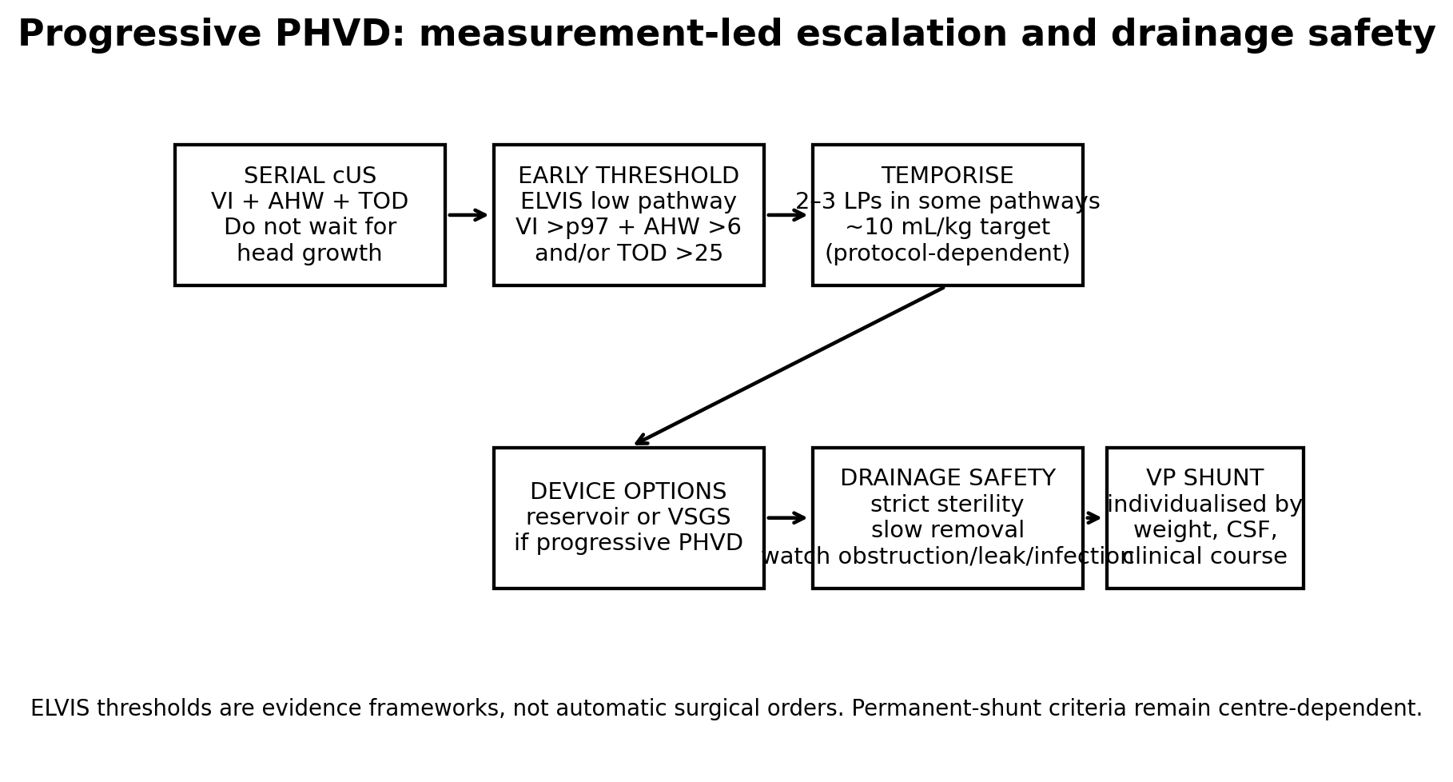
Purpose-built educational PHVD escalation schematic; not a patient record.

A6. PVL and long-term developmental sequelae
Periventricular white-matter injury may follow inflammation, ischemia, infection or hemodynamic instability. Persistent periventricular echogenicity can precede cystic PVL at 2–6 weeks; small cysts may later resolve, leaving volume loss or ex-vacuo ventriculomegaly. MRI at term-equivalent age is more sensitive for noncystic WMI but is selective, not mandatory for every preterm infant. Cystic PVL raises risk of spastic diplegia; cerebellar injury and diffuse WMI may contribute to motor, cognitive, language and executive-function difficulties.

A7. Neurodevelopmental follow-up — Nelson 22e framework; Cloherty & Stark 9e bedside follow-up cross-read; JCIH/current protocols for hearing
Domain | What to assess | Escalation trigger
Motor | Tone, posture, asymmetry, General Movements Assessment (fidgety 3–5 months CA) and HINE when trained examiners are available. | Absent fidgety movements, persistent asymmetry/scissoring, or low HINE (e.g. <57 at 3–4 months in one large cohort) → early CP pathway; do not wait for a definitive label.
Cognition/language | Communication, attention, problem solving, Bayley-type standardized assessment where available | Regression, persistent language delay, poor interaction.
Hearing | Newborn screen plus JCIH risk-factor surveillance; NICU stay >5 days warrants comprehensive follow-up by about 9 months even after an earlier pass. | Any caregiver concern, speech/language delay, ototoxic exposure or inconsistent sound response → diagnostic audiology.
Vision | ROP completion + refraction, strabismus, amblyopia and cerebral visual function after PVL/WMI. | Visual inattention, crowding/face-recognition difficulty, high refractive error, strabismus or late ROP reactivation.
Feeding/growth | Growth trajectory, oral motor feeding, micronutrient adequacy | Aspiration signs, poor weight gain, oral aversion.
Family / services | Caregiver concerns, accessible early intervention, follow-up attendance | Any red flag; do not wait for definitive CP diagnosis.
Corrected age = chronological age − (40 weeks − gestational age at birth), typically used for developmental interpretation through approximately 24 months. PMA = GA at birth + postnatal age; it is used for neonatal schedules and is not corrected age. Prognosis is probabilistic: combine imaging, neurologic examination, clinical course and repeated developmental assessment.

A7A. Early CP, hearing and vision follow-up — calibrated thresholds
IAP overlay: use IAP STG 123 'Early Detection and Early Intervention of a High-Risk Neonate' for India-specific surveillance/referral framing. This complements, rather than replaces, validated tools such as GMA/HINE and current JCIH hearing-risk guidance.
General Movements Assessment (especially absent fidgety movements at 3–5 months corrected age), HINE and neuroimaging can identify high risk for cerebral palsy before 6 months corrected age. A HINE total score <57 at 3–4 months corrected age had strong predictive performance in a large high-risk cohort; a 2026 meta-analysis used <58 at 3 months. Treat these as study-derived predictive cut-offs, not a stand-alone diagnostic definition of CP. JCIH 2019/2024 FAQ guidance supports risk-factor audiology follow-up by about 9 months for infants with NICU stay >5 days even if an earlier diagnostic assessment was passed; additional follow-up is individualized. Visual follow-up should include refraction, strabismus/amblyopia and cerebral visual impairment, especially after PVL/WMI.

A8. Management, complications, evidence levels
- ROP: prevention includes safe oxygen targeting, avoidance of unnecessary hyperoxia and reliable screening; no single oxygen target eliminates risk, and overly restrictive oxygenation may increase mortality. Anti-VEGF long-term systemic safety is still an area of uncertainty.
- IVH prevention/risk modification: antenatal corticosteroids and gentle delivery-room/cardiorespiratory stabilization are well-supported. Avoid large or rapid volume boluses, major blood-pressure swings, large PaCO₂ fluctuations and unnecessarily aggressive ventilation because unstable cerebral blood flow increases hemorrhage risk. Hypotension, a hemodynamically important PDA, sepsis and ventilator-related CO₂ swings are clinical risk modifiers, but association does not prove that routine PDA closure prevents IVH. Delayed cord clamping is recommended where appropriate for preterm transition and has clearer evidence for mortality/transfusion benefit; its specific effect on severe IVH is mixed/low-certainty and should not be overstated. Routine indomethacin prophylaxis reduces severe IVH in some trials but has not shown a corresponding improvement in survival free of neurodevelopmental disability and remains unit-dependent.
- PVL/PHVD: monitor early complications (seizures, ventricular enlargement, feeding instability) and later motor/cognitive outcomes; prompt imaging-based referral can prevent delayed intervention.
- India overlay: follow national NHM screening and locally available NNF/IAP/AIIMS neurodevelopment services; exact ultrasound follow-up intervals and rehabilitation access may vary by unit. The international CPS schedule is presented as a named exam framework, not as an Indian national mandate.

A9. Integrated management algorithms
ROP pathway: screen → zone/stage/plus/A-ROP → Type 1 (urgent treat) OR Type 2 (close surveillance) → confirm regression → late reactivation/refractive follow-up.
IVH pathway: stabilize cardiorespiratory physiology → bedside HUS → grade GMH/IVH and describe PVHI separately → repeat at 7–10 days if grade II+ → serial VI/AHW/TOD if PHVD → neurosurgical discussion.
PVL pathway: first HUS → repeat 4–6 weeks after birth / after severe illness → persistent echogenicity/cysts → selective MRI if needed → early intervention and longitudinal development surveillance.
Discharge pathway: written ROP appointment + cranial imaging plan + corrected-age high-risk clinic + hearing/vision/feeding assessment + family contact and missed-appointment recovery.
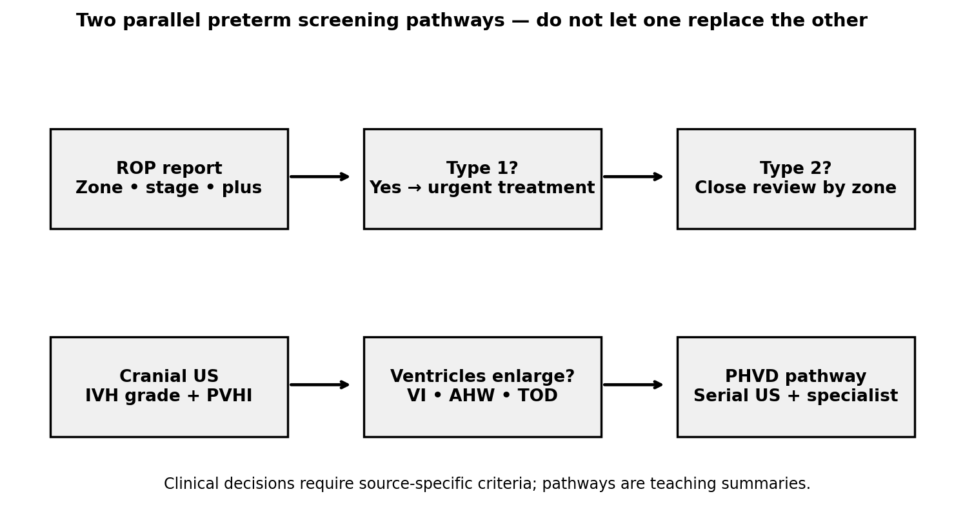
Purpose-built decision-flow schematic; educational only.

SECTION A — VISUAL / DATA INTERPRETATION STATIONS

Visual Station 1 — Line versus ridge (Visual A)
Question: A fundus-like teaching image shows a peripheral junctional lesion. Which panel is stage 1 and which is stage 2?
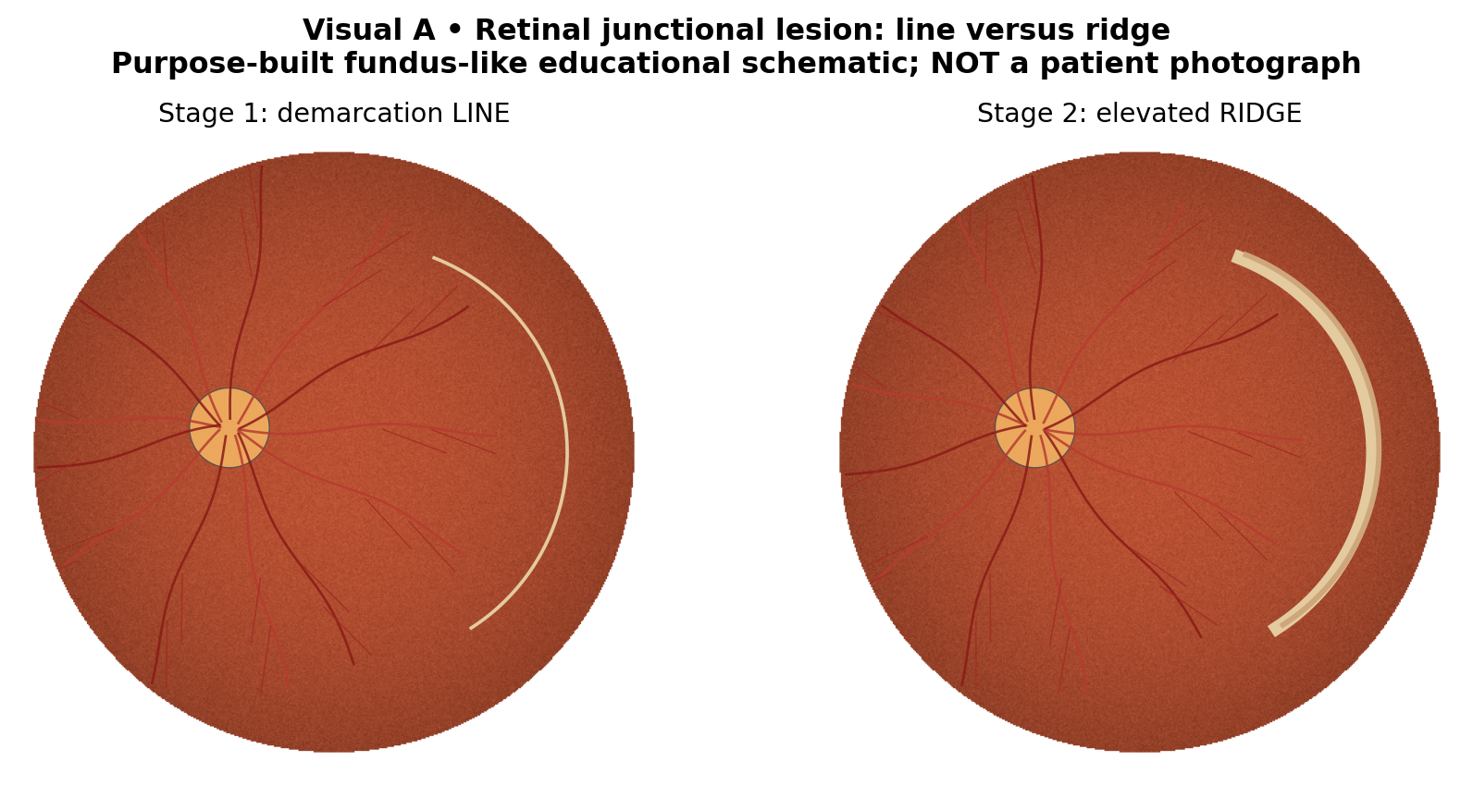
Purpose-built educational schematic; not a clinical patient image or recording.
Interpretation: Left = stage 1 demarcation line; right = stage 2 elevated ridge.
Decisive visual/data features: The right panel has visible elevated junctional tissue; the left has a thin demarcation only.
Closest distractor / discriminator: Extraretinal neovascular proliferation, not just a thicker ridge, would make stage 3.
Next management step: Record full zone/stage/plus; schedule review rather than treating stage alone.
Exam trap: A ridge does not automatically mean Type 1 ROP.
Trace-back: A1; Q1, Q2, Q31, Q51.

Visual Station 2 — Plus spectrum and aggressive ROP (Visual B)
Question: The right panel has very tortuous dilated vessels and flat posterior neovascularization. What risk phenotype is suggested?
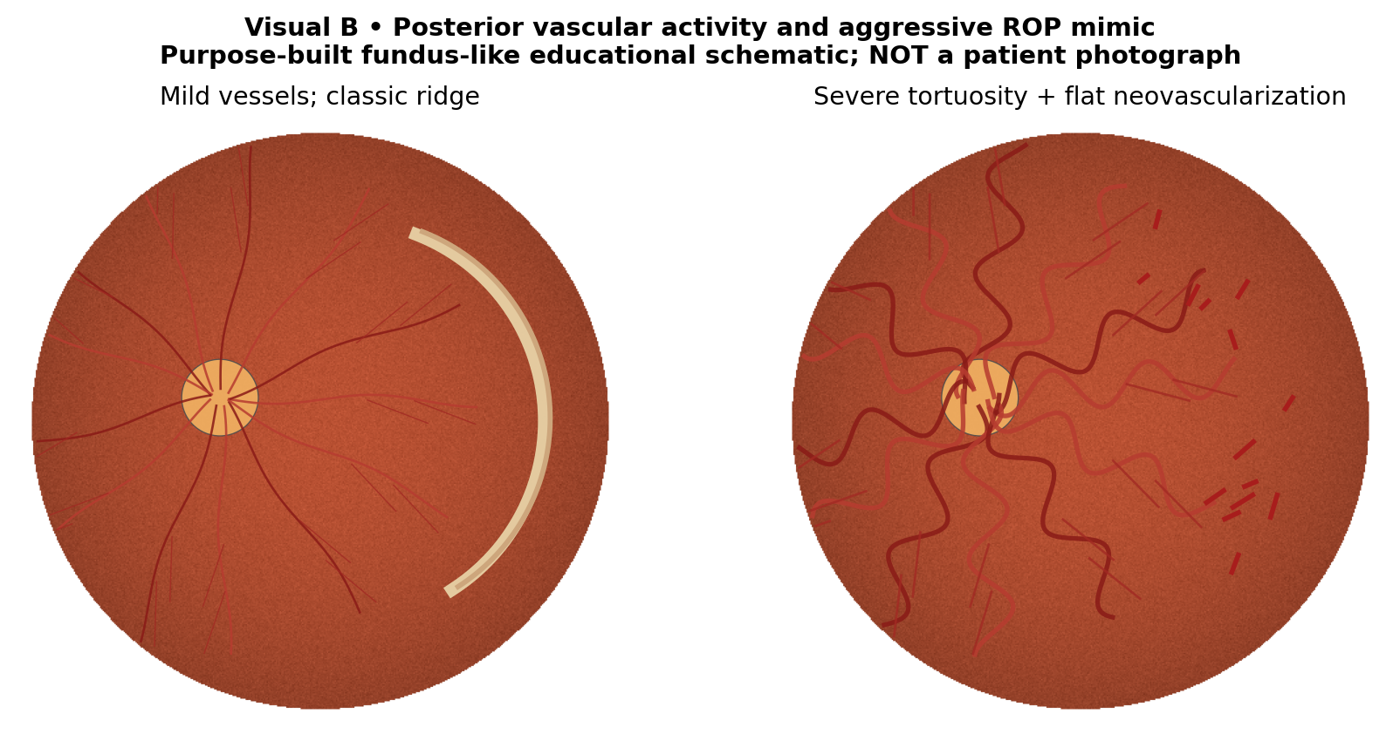
Purpose-built educational schematic; not a clinical patient image or recording.
Interpretation: Aggressive ROP phenotype, requiring urgent specialist assessment.
Decisive visual/data features: Marked posterior vascular dilation/tortuosity with flat neovascular tissue and rapid progression.
Closest distractor / discriminator: Preplus has vascular change below the plus threshold; an ordinary stage 2 ridge alone lacks flat neovascular proliferation.
Next management step: Urgent Type 1/A-ROP treatment-oriented ophthalmic evaluation.
Exam trap: Do not demand orderly stage 1→2→3 progression in aggressive ROP.
Trace-back: A1/A3; Q22, Q48, Q50.

Visual Station 3 — Grade I/II/III versus PVHI (Visual C)
Question: Compare the four cranial US panels. Which one has a parenchymal venous infarct rather than only ventricular hemorrhage?
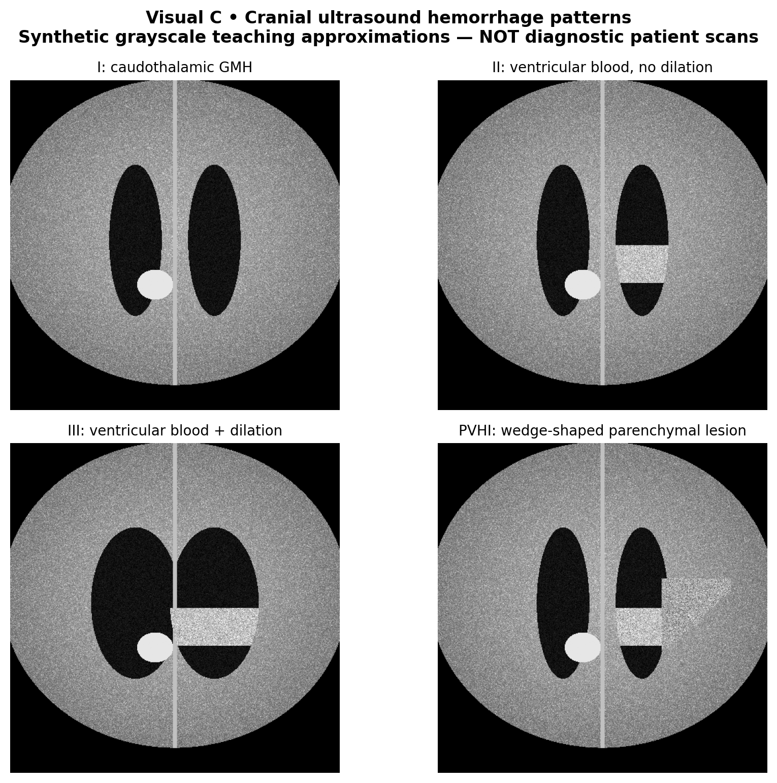
Purpose-built educational schematic; not a clinical patient image or recording.
Interpretation: Bottom right demonstrates PVHI; top left grade I; top right grade II; bottom left grade III.
Decisive visual/data features: PVHI adds a wedge-like echogenic periventricular lesion to ventricular hemorrhage.
Closest distractor / discriminator: Grade III is ventricular blood with dilation but lacks a parenchymal wedge.
Next management step: Repeat HUS and monitor PHVD; involve neonatal neurology as indicated.
Exam trap: “Grade IV IVH” obscures PVHI mechanism.
Trace-back: A4; Q5, Q33–36, Q55.

Visual Station 4 — Ventricular enlargement and ELVIS cutoffs (Visual D)
Question: The right panel shows enlarged ventricles. Which quantitative indices and thresholds change management?
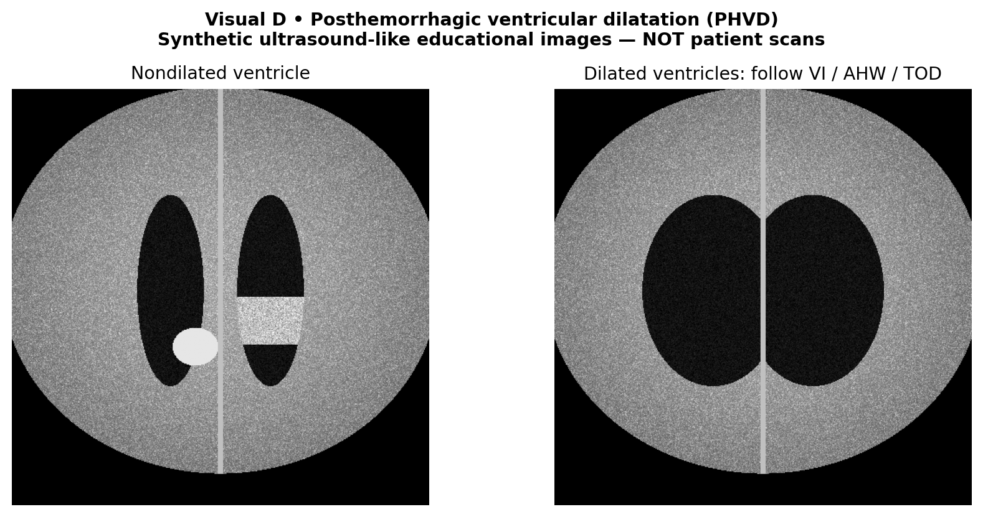
Purpose-built educational schematic; not a clinical patient image or recording.
Interpretation: Use serial VI, AHW, TOD; ELVIS low VI>p97, AHW>6 mm and/or TOD>25 mm; high VI>p97+4 mm and AHW>10 mm.
Decisive visual/data features: Visible ventricular expansion must be quantified consistently on serial planes.
Closest distractor / discriminator: A soft fontanelle or normal head circumference does not exclude progressive PHVD.
Next management step: Increase scan frequency and discuss early neurosurgical pathway if progressive.
Exam trap: A single enlarged ventricle without trajectory/context does not dictate shunt placement.
Trace-back: A5; Q41, Q59–61, Q73.

Visual Station 5 — Evolving PVL on serial US (Visual E)
Question: Why might a day-5 ultrasound be normal or show only echogenicity while a 5-week scan shows cysts?
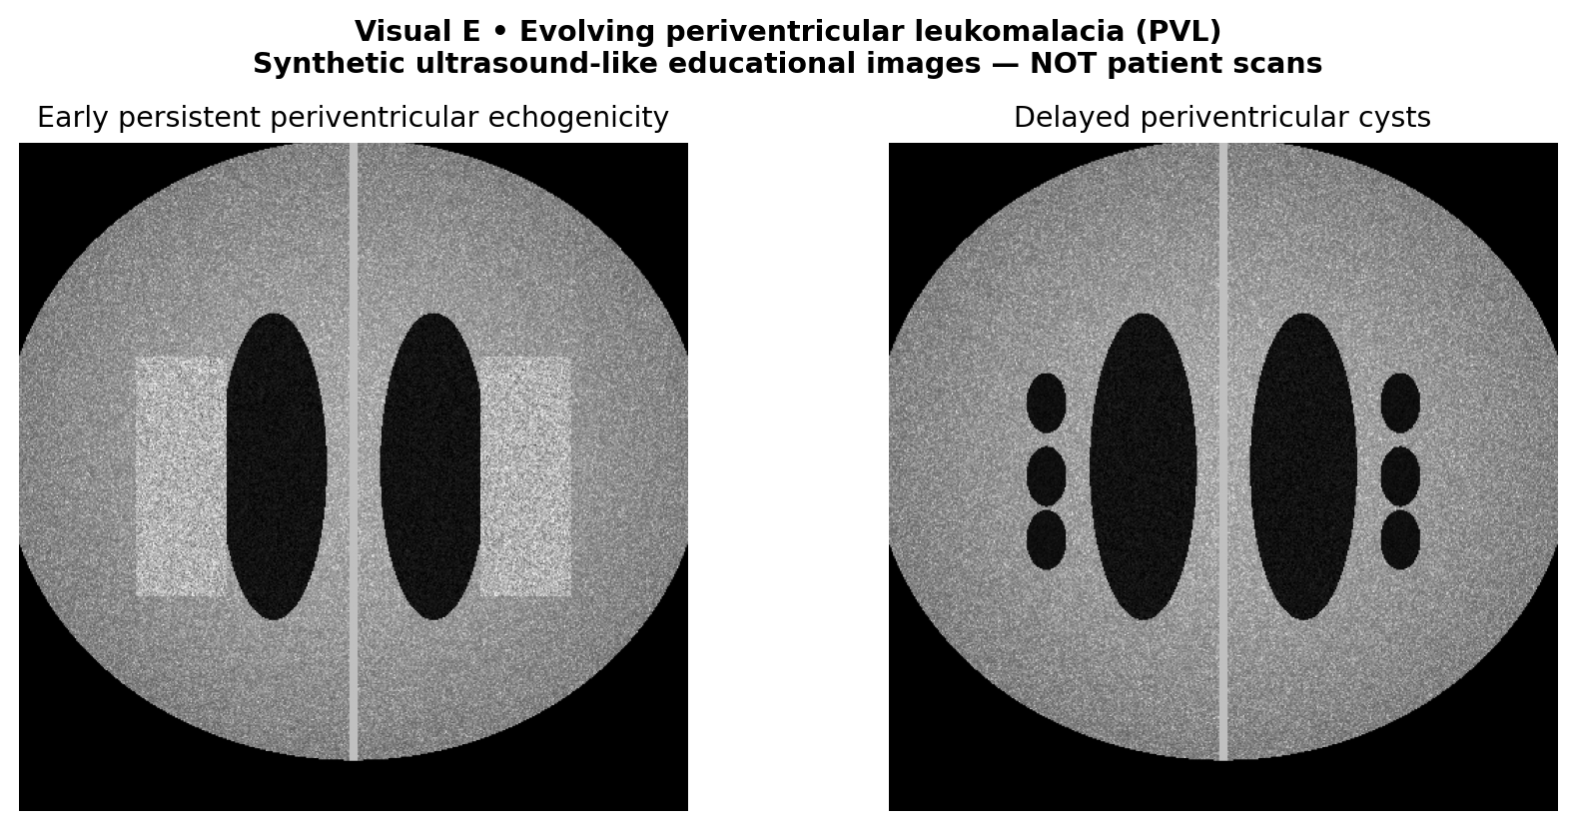
Purpose-built educational schematic; not a clinical patient image or recording.
Interpretation: Cystic PVL can evolve over 2–6 weeks after an inflammatory/ischemic insult.
Decisive visual/data features: Later bilateral periventricular cystic spaces differ from early echogenic flare.
Closest distractor / discriminator: Grade I GMH is caudothalamic, while PVL is white-matter injury adjacent to ventricles.
Next management step: Arrange high-risk developmental follow-up, motor assessment and early intervention.
Exam trap: No cysts on day 5 does not exclude later PVL.
Trace-back: A4/A6; Q37, Q43, Q68.

Visual Station 6 — ROP examination safety and tele-ROP workflow
Purpose-built educational workflow; not a patient image or recording.
Question: During an ROP examination a preterm infant develops bradycardia and marked desaturation. What should happen immediately, and what measures reduce recurrence?
Interpretation: Stop/pause the eye examination, allow recovery and stabilize cardiorespiratory status before deciding whether to resume.
Decisive visual/data features: ROP screening can provoke short-term HR/SpO₂ instability; continuous monitoring matters in sick infants.
Closest distractor / discriminator: Completing the retinal view is important, but it never outranks immediate physiologic stability.
Next management step: Reassess oxygenation/HR, optimize swaddling/analgesia, and resume only when stable with trained staff present.
Exam trap: Wide-field imaging can support tele-ROP, but image transfer does not remove the need for expert interpretation or bedside safety precautions.
Trace-back: A3A; NHM ROP examination precautions.

ACTIVE RECALL — PROMPTS
1. List all three ETROP Type 1 ROP categories.
2. What makes stage 1, 2 and 3 morphologically different?
3. What separates stage 4A from 4B?
4. How does ICROP3 treat plus versus preplus?
5. Which Type 2 patterns demand close follow-up?
6. Which India NHM infants qualify for ROP screening?
7. What is the Indian first-screen rule for <28 weeks or <1200 g?
8. AAP 2018: first exam for 24-week infant?
9. What is the anti-VEGF surveillance trap?
10. Where is the germinal matrix on ultrasound?
11. Define grade I/II/III IVH.
12. What is PVHI and why avoid “grade IV IVH”?
13. CPS 2026 HUS schedule for ≤31+6 weeks?
14. Which infant routinely needs term-equivalent HUS under CPS?
15. State VI, AHW and TOD.
16. State ELVIS low and high PHVD thresholds.
17. Why should PHVD not await a bulging fontanelle?
18. When do PVL cysts typically appear?
19. Which modality better detects noncystic WMI?
20. What is the typical motor phenotype after cystic PVL?
21. Calculate corrected age for GA 27 weeks at 16 weeks PNA.
22. What is PMA for GA 24 weeks at 7 weeks PNA?
23. Visual pattern: what separates stage 1 from stage 2 in Visual A?
24. Visual pattern: what indicates aggressive ROP in Visual B?
25. Visual pattern: what identifies PVHI in Visual C?
26. Visual pattern: what serial change indicates PVL in Visual E?
27. Notebook recall: in DOPE, a disconnected ventilator circuit is which component?
28. Notebook recall: Jensen BPD on noninvasive positive-pressure support at 36 weeks PMA?
29. Notebook recall: DAT-negative severe unconjugated jaundice with modest anemia suggests?
30. What is the NHM 34-week/2000-g boundary caveat across Indian source versions?
31. Name four practical measures that reduce pain/instability during ROP screening.
32. What is the role of tele-ROP/wide-field digital imaging in current Indian guidance?
33. Is propranolol routine prevention or treatment for ROP?
34. How should delayed cord clamping be worded with respect to IVH prevention?
35. What does a HINE score <57 at 3–4 months corrected age mean?
36. What JCIH follow-up is recommended for an infant with NICU stay >5 days who passed earlier testing?
37. Which PHVD drainage/shunt numbers are protocol-dependent rather than universal?

ACTIVE RECALL — ANSWERS
1. Zone I any stage with plus; zone I stage 3 without plus; zone II stage 2 or 3 with plus.
2. Stage 1 line; stage 2 elevated ridge; stage 3 extraretinal neovascular proliferation (including flat).
3. 4A spares the fovea; 4B involves the fovea.
4. A posterior vessel dilation/tortuosity continuum; preplus does not automatically equal ETROP plus.
5. Zone I stage 1/2 without plus; zone II stage 3 without plus.
6. Indian operational exam anchor is commonly written GA ≤34 weeks or BW ≤2000 g, but the current revised NHM PDF text uses <34/<2000; name the source if the equality boundary matters.
7. By 2–3 weeks of postnatal life.
8. 31 weeks PMA, approximately 7 weeks PNA.
9. Late reactivation/persistent avascular retina; follow-up often to ≥65 weeks PMA under AAP 2018.
10. At the caudothalamic groove.
11. I confined GMH; II ventricular blood without dilatation; III ventricular blood with dilatation.
12. Hemorrhagic venous parenchymal infarction, often unilateral wedge-shaped, not simple ventricular blood extension.
13. First at 4–7 days; repeat at 4–6 weeks; grade II+ IVH/WMI → repeat 7–10 days.
14. Born <26 weeks; others if moderate/severe abnormalities or risk factors.
15. Ventricular index; anterior horn width; thalamo-occipital distance.
16. Low VI>p97 and AHW>6 mm and/or TOD>25 mm; high VI>p97+4 mm and AHW>10 mm.
17. Preterm skull compliance makes clinical signs late; serial US detects expansion earlier.
18. Over about 2–6 weeks after injury; a day-5 scan may miss them.
19. MRI, selectively at term-equivalent age in high-risk infants.
20. Increased risk of spastic diplegia; outcome is not certain from imaging alone.
21. 16−(40−27)=3 weeks corrected age.
22. 31 weeks PMA.
23. A flat line versus an elevated ridge.
24. Marked plus-spectrum tortuosity with flat neovascularization and rapid progression.
25. A unilateral/asymmetric wedge-like parenchymal echogenic lesion accompanying IVH.
26. Persistent echogenicity evolving into periventricular cysts weeks later.
27. Equipment failure.
28. Grade 2.
29. G6PD deficiency among the key nonimmune causes.
30. Older NHM/Indian operational summaries use ≤34 weeks or ≤2000 g; the currently linked revised NHM PDF text uses <34/<2000. Name the source and avoid equality-boundary-only reasoning.
31. Pulse-oximetry/physiologic monitoring, swaddling, topical proparacaine, oral sucrose if used locally, sterile instruments/hand hygiene, and interrupting the exam for significant bradycardia/apnea/desaturation.
32. Wide-field imaging is useful for documentation and telemedicine/remote expert review, but NHM treats it as an adjunct rather than a full replacement for expert indirect ophthalmoscopy in all cases.
33. No. Evidence remains insufficient/inconsistent for routine propranolol and adverse effects are clinically important.
34. DCC is appropriate for preterm transition and has stronger mortality/transfusion evidence; a specific reduction in severe IVH is mixed/low-certainty and should not be overclaimed.
35. It is a study-derived high-risk predictive cut-off for CP, not a stand-alone diagnostic definition; combine GMA, HINE, imaging and serial examination.
36. Risk-factor audiologic follow-up by about 9 months is still advised; an earlier diagnostic test does not replace that surveillance.
37. Examples include ~10 mL/kg CSF removal in some LP pathways and CSF protein <1.5 g/L in some shunt pathways; both are centre-/study-dependent, not universal.

SECTION B — MCQs Q1–Q78 (75 BASE + 3 EXTRA NOTEBOOK RETESTS)
Instructions: attempt all base MCQs before Section C. Q16, Q42 and Q63 are separately scored extra notebook retests; they do not replace any of the 75 base questions. Educational visuals in Section A are available for image-linked questions.
Q1. [Basic/Recall] In ICROP3, the anatomical lesion defining stage 1 ROP is:
A. Extraretinal fibrovascular proliferation
B. Partial retinal detachment
C. An elevated ridge
D. A demarcation line at the vascular–avascular junction
Q2. [Basic/Recall] The ROP stage indicating extraretinal neovascular proliferation is:
A. Stage 2
B. Stage 3
C. Stage 4
D. Stage 1
Q3. [Basic/Recall] A partial retinal detachment sparing the fovea is classified as:
A. Stage 4A ROP
B. Stage 4B ROP
C. Stage 5 ROP
D. Stage 3 ROP
Q4. [Basic/Recall] The most common anatomical origin of preterm germinal-matrix hemorrhage is:
A. Cerebellar vermis
B. Occipital cortex
C. Caudothalamic groove
D. Choroid plexus of the fourth ventricle
Q5. [Basic/Recall] In Papile/Volpe-style ultrasound grading, IVH with ventricular dilatation is classically:
A. Grade III
B. Grade I
C. Periventricular hemorrhagic infarction only
D. Grade II
Q6. [Basic/Recall] The bedside imaging modality used for serial routine screening of IVH in very preterm infants is:
A. MR angiography at birth
B. Plain skull radiography
C. Cranial ultrasonography
D. CT for every infant
Q7. [Basic/Recall] Postmenstrual age (PMA) is calculated as:
A. Chronological age minus gestational age
B. Gestational age plus corrected age
C. Birth weight divided by age
D. Gestational age at birth plus chronological age
Q8. [Conceptual] Why does plus disease change management even when ROP stage appears relatively low?
A. It can occur only with stage 3
B. It reflects severe posterior vascular dilation and tortuosity associated with progression
C. It means the retina is already completely detached
D. It proves that screening can stop
Q9. [Conceptual] Why are Indian ROP screening eligibility thresholds broader than traditional US thresholds?
A. Clinically important ROP can occur in larger and more mature sick infants
B. The retinal zones are anatomically different in Indian infants
C. US recommendations require screening all term newborns
D. ROP never occurs below 1500 g in India
Q10. [Conceptual] What distinguishes Type 1 from Type 2 ROP in ETROP-based treatment decisions?
A. Type 2 never progresses
B. Type 1 requires stage 5 disease
C. Type 2 always means retinal detachment
D. Type 1 crosses treatment criteria; Type 2 needs close surveillance
Q11. [Conceptual] Why must anti-VEGF-treated ROP infants receive prolonged retinal follow-up?
A. Retinal detachment is impossible after anti-VEGF
B. Recurrence occurs only within the first 24 hours
C. Peripheral avascular retina can persist and late reactivation can occur
D. Anti-VEGF permanently destroys all peripheral retina
Q12. [Conceptual] Why is a flat posterior neovascular lesion with marked plus disease concerning for aggressive ROP?
A. Absence of a ridge excludes ROP
B. Aggressive ROP may progress rapidly without orderly stage 1→2→3 evolution
C. Only a prominent peripheral ridge can progress rapidly
D. It is invariably normal vascular maturation
Q13. [Conceptual] Why is routine cranial ultrasound repeated at 4–6 weeks in very preterm infants after an early normal scan?
A. Cystic white-matter injury can evolve over weeks after the initial scan
B. The second scan is only to measure skull size
C. Early US cannot detect any hemorrhage
D. All PVL cysts are present on day 1
Q14. [Conceptual] Why is the historical label “grade IV IVH” less precise than PVHI?
A. It always affects both hemispheres symmetrically
B. It is identical to grade I GMH
C. It means no hemorrhage occurred
D. Parenchymal injury often represents venous infarction secondary to obstruction, not simple ventricular blood extension
Q15. [Conceptual] Why can a rapidly enlarging ventricular index precede a bulging fontanelle in preterm PHVD?
A. Preterm fontanelles are always closed
B. High cranial compliance permits ventricular expansion before overt pressure signs
C. PHVD occurs only after discharge
D. Ultrasound cannot measure ventricular width
Q16. EXTRA NOTEBOOK RETEST — NOT PART OF THE BASE 75. A 26-week ventilated infant abruptly desaturates. Chest excursion disappears and the ventilator circuit is visibly detached at the Y-piece. Which DOPE category is the immediate cause?
A. Pneumothorax
B. Obstruction of the endotracheal tube
C. Equipment failure
D. Displacement of the endotracheal tube
Q17. [Conceptual] Why is MRI superior to cranial ultrasound for many noncystic white-matter lesions?
A. MRI detects subtle diffuse injury and maturation abnormalities beyond US resolution
B. Ultrasound cannot detect cystic PVL
C. MRI is required daily for all preterm infants
D. MRI can always predict an individual child’s IQ accurately
Q18. [Conceptual] Why does cystic PVL often predispose to spastic diplegia?
A. PVL selectively destroys peripheral motor nerves
B. Periventricular descending motor fibers serving the legs are vulnerable
C. Cystic PVL affects only the cerebellum
D. Spastic diplegia is caused by retinal neovascularization
Q19. [Conceptual] Why should early-intervention services be initiated for a high-risk preterm infant before a definitive CP diagnosis?
A. A normal neonatal neurological examination excludes later motor impairment
B. CP is reliably diagnosed by ultrasound grade alone
C. Therapy can begin only after school age
D. Developmental plasticity and evolving deficits make early therapy time-sensitive
Q20. [Conceptual] Why is corrected age preferable to chronological age for early developmental interpretation in a 27-week infant?
A. Chronological age must never be recorded
B. Corrected age is irrelevant before two years
C. Prematurity shifts expected maturational milestones relative to the due date
D. Corrected age equals PMA in weeks
Q21. [Conceptual] Why is a negative routine cranial ultrasound insufficient to exclude cerebellar hemorrhage in an extremely preterm infant?
A. Posterior fossa lesions may require mastoid-window ultrasound or MRI
B. Cerebellar injury never affects outcome
C. Anterior-fontanel imaging is universally 100% sensitive
D. Cerebellar hemorrhage is always visible on skull X-ray
Q22. [Clinical/Application] A 29-week, 1120-g infant is 4 weeks old. Fundus examination shows a demarcation line in zone II without plus disease. What is the best classification and plan? Refer to Visual Station 1.
A. Zone I stage 1; immediate anti-VEGF
B. Zone II stage 3; urgent laser
C. Mature retina; stop surveillance
D. Zone II stage 1, no plus; review in about 2 weeks
Q23. [Clinical/Application] A 26-week infant at 34 weeks PMA has zone I stage 3 ROP without plus. What is the next step?
A. Stop screening because plus is absent
B. Observe for three weeks
C. Arrange urgent Type 1 ROP treatment assessment
D. Wait until 45 weeks PMA
Q24. [Clinical/Application] A 31-week, 1350-g infant has zone II stage 3 ROP without plus at 36 weeks PMA. Which management is best?
A. Urgent treatment is mandatory for all stage 3 lesions
B. Close ophthalmic surveillance, commonly within 1 week
C. Discharge from screening
D. Routine follow-up after 6 weeks
Q25. [Clinical/Application] A 27-week infant has zone II stage 2 ROP with unequivocal plus disease. What should be recommended?
A. Two-to-three-week observation only
B. Screening cessation at 37 weeks
C. Prompt Type 1 treatment assessment
D. No treatment unless stage 3 appears
Q26. [Clinical/Application] A 28-week infant at 33 weeks PMA has zone I stage 2 ROP without plus. What is the best interval?
A. Immediate laser is required in all stage 2 zone I cases
B. Stop examinations after a normal pupil response
C. Wait 4 weeks
D. Ophthalmic review within one week
Q27. [Clinical/Application] A 33-week, 1820-g infant in an Indian NICU had sepsis and prolonged oxygen exposure. Which screening approach is best?
A. No screen because birth weight exceeds 1500 g
B. Schedule ROP screening under Indian risk-based criteria
C. Screen only if visual fixation is abnormal
D. Wait until the infant is walking
Q28. [Clinical/Application] A 27-week, 980-g infant in India is clinically stable at day 14. Which first-screening plan is consistent with NHM high-risk timing?
A. Perform first ROP examination around 2–3 weeks of life
B. No screening if oxygen has stopped
C. Screen only when the child reaches 40 weeks PMA
D. Delay all screening to 6 weeks of life
Q29. [Clinical/Application] A 24-week infant is now 7 weeks old. What is the PMA for ROP scheduling?
A. 17 weeks PMA
B. 31 weeks PMA
C. 40 weeks PMA
D. 24 weeks PMA
Q30. [Clinical/Application] A 29-week infant received intravitreal anti-VEGF for posterior Type 1 ROP. At 48 weeks PMA the retina looks quiet but remains avascular peripherally. What is appropriate?
A. Stop follow-up because the fundus is quiet
B. Treat every quiet avascular retina with emergency vitrectomy
C. Continue specialist retinal surveillance for reactivation
D. Assume complete retinal vascularization at 48 weeks
Q31. [Clinical/Application] During indirect ROP screening of a 26-week infant on low-flow oxygen, the baby develops marked desaturation and bradycardia after the speculum is inserted. The pupils are fully dilated but the temporal retina has not yet been seen. What is the safest next step? Refer to Visual Station 6.
A. Continue rapidly because completing the peripheral examination prevents blindness
B. Increase phenylephrine and continue, because inadequate dilation is the likely cause
C. Remove monitoring leads to reduce stimulation, then finish the exam
D. Pause the examination, allow cardiorespiratory recovery, stabilize the infant, and resume only when safe
Q32. [Clinical/Application] A 27-week infant has retinal photographs showing a thin junctional line but no elevation. Which image interpretation is best? Refer to Visual A. Refer to Visual Station 1.
Visual A — purpose-built educational schematic; not a patient image.
A. Stage 1 ROP rather than stage 2
B. Stage 2 ROP
C. Stage 3 ROP
D. Stage 4A ROP
Q33. [Clinical/Application] A 25-week infant has a day-5 cranial ultrasound with an echogenic focus restricted to the caudothalamic groove, no ventricular blood. Grade?
A. Grade III IVH
B. Grade I GMH
C. Grade II IVH
D. PVHI
Q34. [Clinical/Application] A 26-week infant has blood layering in the lateral ventricle without ventricular enlargement on day-6 US. What is the grade? Refer to Visual Station 3.
A. Grade II IVH
B. PVHI
C. Grade I GMH
D. Grade III IVH
Q35. [Clinical/Application] A 25-week infant has intraventricular echogenic clot and visibly enlarged lateral ventricles on ultrasound. Grade?
A. Cystic PVL
B. Grade II IVH
C. Grade III IVH
D. Grade I GMH
Q36. [Clinical/Application] A 24-week infant with grade III IVH develops a unilateral wedge-shaped echogenic periventricular lesion. Most accurate label?
A. Simple grade II IVH
B. Cystic PVL at onset
C. Normal choroid plexus
D. Periventricular hemorrhagic infarction
Q37. [Clinical/Application] A 27-week infant has a normal day-5 cranial US. At 5 weeks, new bilateral periventricular cysts appear. Diagnosis? Refer to Visual Station 5.
A. Cystic periventricular leukomalacia
B. Benign choroid-plexus cysts
C. Grade I GMH
D. Acute grade III IVH
Q38. [Clinical/Application] A 30-week infant is well on day 5 and has no major complications. Under the CPS surveillance framework, when is routine cranial US appropriate?
A. Daily CT through the first week
B. First HUS at 4–7 days and repeat at 4–6 weeks
C. Only term-equivalent MRI
D. No US unless seizures occur
Q39. [Clinical/Application] A 25-week infant in the first 24 hours has recurrent hypotension, repeated rapid saline boluses, a large PaCO₂ swing from 28 to 68 mmHg after ventilator changes, and a hemodynamically important PDA. Which strategy best reduces further IVH risk?
A. Close the PDA routinely solely to prevent IVH, regardless of systemic perfusion
B. Accept wide PaCO₂ fluctuations as long as oxygen saturation remains normal
C. Continue repeated rapid volume boluses until mean arterial pressure exceeds gestational age
D. Stabilize perfusion and ventilation gently, avoid abrupt BP/CO₂ shifts and unnecessary boluses, and manage the PDA according to hemodynamics
Q40. [Clinical/Application] A 25-week infant with grade II IVH on day 5 is otherwise stable. When should the next cranial ultrasound be considered?
A. Never repeat if fontanelle is soft
B. Only at school entry
C. Repeat in about 7–10 days to detect evolution
D. Routine CT at 24 hours for every case
Q41. [Clinical/Application] A 24-week infant with grade III IVH has a rapidly rising ventricular index but no head-growth acceleration. Best next step?
A. Wait for bulging fontanelle
B. Treat with anti-VEGF
C. Discharge because head circumference is stable
D. Intensify serial US measurements and seek early neurosurgical input
Q42. EXTRA NOTEBOOK RETEST — NOT PART OF THE BASE 75. At 36 weeks PMA, an infant born at 26 weeks is receiving noninvasive positive-pressure ventilation but no endotracheal ventilation. Under Jensen BPD classification, which grade applies?
A. Grade 3 BPD
B. Grade 1 BPD
C. Grade 2 BPD
D. No BPD because oxygen concentration is not stated
Q43. [Clinical/Application] A preterm infant has ventricular index above the 97th centile, AHW 7 mm, and TOD 27 mm after severe IVH. Under the ELVIS low-threshold framework, what is indicated? Refer to Visual Station 4.
Visual D — purpose-built educational schematic; not a patient image.
A. Escalate PHVD evaluation and consider early CSF drainage pathway
B. Wait until VI exceeds p97+10 mm
C. Diagnose normal ventricular size
D. Ignore because AHW is below 10 mm
Q44. [Clinical/Application] A 26-week infant has persistent bilateral periventricular echogenicity for >7 days but no cysts. What is the best interpretation? Refer to Visual Station 5.
A. Definite normal scan
B. Possible evolving noncystic white-matter injury requiring follow-up
C. Stage 3 ROP
D. Grade III IVH
Q45. [Clinical/Application] A 26-week infant has an abnormal ultrasound suggesting WMI but no cysts. At term-equivalent age, which study may add value?
A. Selective brain MRI to characterize noncystic injury
B. No imaging can ever be useful
C. Routine skull radiograph
D. CT for all asymptomatic preterms
Q46. [Clinical/Application] A 27-week infant is now 16 weeks old chronologically. What is the approximate corrected age?
A. 43 weeks
B. 13 weeks
C. 16 weeks
D. 3 weeks
Q47. [Clinical/Application] A 25-week infant with prior cystic PVL is 8 months corrected age and shows persistent scissoring and delayed independent sitting. Best action?
A. Wait for age 3 years to diagnose CP
B. Use retinal laser to improve motor tone
C. Prompt developmental-neurology and early-physiotherapy assessment
D. Attribute all signs to prematurity without follow-up
Q48. [Clinical/Application] A 28-week infant had IVH grade III, hearing screen passed before discharge, and now has speech delay at 18 months corrected age. Best next step?
A. Assume hearing is normal forever
B. Formal hearing and developmental-language reassessment
C. Wait until school age without assessment
D. Perform ROP laser as speech treatment
Q49. [Clinical/Application] A preterm infant is being discharged with active zone II stage 2 ROP without plus. What is the safest discharge arrangement?
A. Advise review only if parents notice poor vision
B. Stop screening because the infant leaves the NICU
C. Document a dated ophthalmology follow-up and communicate responsibility
D. Book review at 6 months regardless of findings
Q50. [High-Difficulty] A 27-week infant at 35 weeks PMA has zone I stage 2 ROP with preplus. Forty-eight hours later the ridge is unchanged, vascular tortuosity has increased but still does not meet the plus reference standard, and there is no stage 3 neovascularisation. Which plan best applies ETROP/ICROP3 reasoning? Refer to Visual Station 2.
A. Treat immediately because any worsening posterior tortuosity is Type 1 disease
B. Classify as stage 3 because increasing tortuosity substitutes for extraretinal neovascularisation
C. Stop screening because absence of plus at 35 weeks PMA predicts spontaneous regression
D. Continue very close surveillance as Type 2/posterior high-risk disease, with treatment if plus or qualifying stage progression appears
Q51. [High-Difficulty] A 28-week infant has zone II stage 3 without plus, then two days later develops unequivocal plus. What changed?
A. Observation category converted to Type 1 requiring treatment
B. The prior stage 3 was never true ROP
C. Stage automatically becomes stage 4
D. Zone automatically becomes zone I
Q52. [High-Difficulty] A 29-week infant initially had posterior zone II stage 2 preplus. Forty-eight hours later there is severe plus, flat posterior neovascularisation without a classical ridge, and rapid circumferential progression. Which diagnosis and action best fit ICROP3? Refer to Visual Station 2.
Visual B — purpose-built educational schematic; not a patient image.
A. Conventional zone II stage 2 Type 2 disease; review in two weeks
B. Aggressive ROP phenotype requiring urgent retina-specialist treatment assessment despite the atypical flat morphology
C. Stage 4A tractional detachment because the disease progressed rapidly
D. Normal posterior vascular immaturity because a classical stage-2 ridge is absent
Q53. [High-Difficulty] A 26-week infant with posterior Type 1 ROP is treated with anti-VEGF. At 52 weeks PMA peripheral avascular retina persists, no active ridge. Which follow-up plan is strongest?
A. Continue long-term retinal surveillance with specialist-directed peripheral assessment
B. Treat with immediate vitrectomy for avascularity alone
C. Consider recurrence impossible after 8 weeks
D. Stop all examinations at 45 weeks PMA
Q54. [High-Difficulty] A 30-week, 1700-g infant in India had no oxygen therapy but developed severe NEC and sepsis. Does the NHM ROP screen criterion apply?
A. Only if the infant has visual symptoms
B. No: oxygen therapy is mandatory for screening
C. No: only infants <1500 g qualify in India
D. Yes: birth weight <2000 g independently qualifies
Q55. [High-Difficulty] A 24-week infant born in the US is 4 weeks old (28 weeks PMA). Under the AAP 2018 initial examination table, which statement is correct?
A. Wait until 40 weeks PMA
B. The first routine exam is scheduled at about 31 weeks PMA (7 weeks PNA)
C. Use the Indian 2–3-week rule as if it were AAP
D. Screen immediately at 28 weeks PMA as a universal rule
Q56. [High-Difficulty] A 27-week infant has zone I stage 3 ROP without plus, clear media and persistent avascular posterior retina. One clinician wants to wait for plus; another proposes immediate treatment and asks whether laser or anti-VEGF should be considered. Which response is best?
A. Observation is required because treatment criteria in zone I always require plus disease
B. Laser is prohibited in zone I, so no treatment can be offered until retinal detachment develops
C. This already meets Type 1 criteria without plus; treatment should not wait, while modality is individualized by posterior location, anatomy and specialist protocol
D. The lesion is Type 2 unless stage 4 detachment appears
Q57. [High-Difficulty] A 26-week infant has zone II stage 2 ROP with unequivocal plus, no extraretinal tufts, and a good peripheral view. Which interpretation best integrates threshold and treatment planning?
A. This is Type 1 ROP despite absence of stage 3; prompt treatment assessment is indicated, with laser often favored when zone II avascular retina is accessible
B. It remains Type 2 until stage 3 neovascularisation appears
C. Plus disease automatically converts the retinal stage to stage 3
D. Anti-VEGF is mandatory because any plus disease makes laser ineffective
Q58. [High-Difficulty] An extremely preterm infant has an initial US showing intraventricular clot, then a new echogenic wedge lateral to the ventricle. The report calls it “grade IV IVH.” What is the best correction?
Visual C — purpose-built educational schematic; not a patient image.
A. Call it cystic PVL immediately
B. Describe PVHI separately from the IVH grade
C. Downgrade to isolated grade I GMH
D. Call it normal periventricular flare
Q59. [High-Difficulty] A 25-week infant with IVH has VI above p97 and AHW 8 mm. The fontanelle is soft. Which interpretation best reflects ELVIS?
A. No action until AHW >15 mm
B. Grade III IVH is impossible if the fontanelle is soft
C. Normal because the fontanelle is soft
D. The infant has crossed a studied low-threshold PHVD marker
Q60. [High-Difficulty] A 24-week infant with grade III IVH shows serial ventricular enlargement: VI rises from p97+1 mm to p97+5 mm over 72 hours, AHW is now 11 mm and TOD 31 mm. Head circumference and fontanelle remain normal. Which interpretation and next step best reflect ELVIS-era evidence?
A. Defer action because absence of head-growth acceleration excludes clinically important PHVD
B. Continue routine monthly ultrasound because ventricular measurements alone should never trigger escalation
C. High-threshold measurements and rapid trajectory mandate urgent neonatology-neurosurgery review for temporizing drainage planning; do not wait for pressure signs
D. Insert a permanent VP shunt immediately because any high-threshold crossing proves long-term shunt dependence
Q61. [High-Difficulty] A 26-week infant has day-5 HUS showing grade II IVH, day-14 HUS showing enlarged ventricles, and stable head circumference. Which is the key management change?
A. Move from routine IVH surveillance to PHVD-specific serial measurements
B. Stop scans because IVH grade is only II
C. Replace ultrasound with routine skull X-ray
D. Start retinal laser
Q62. [High-Difficulty] A 29-week infant has bilateral periventricular echogenicity on day 4, resolving by day 6, with normal follow-up. What interpretation is most cautious?
A. Definite grade IV IVH
B. Transient periventricular flare rather than established cystic PVL
C. Definite cystic PVL
D. MRI-proven noncystic WMI
Q63. EXTRA NOTEBOOK RETEST — NOT PART OF THE BASE 75. A term neonate develops bilirubin 22 mg/dL at 60 h, predominantly unconjugated. DAT is negative, hemoglobin only mildly reduced, and there is a family history of neonatal jaundice. Which mechanism deserves specific testing?
A. Physiologic jaundice requiring no evaluation
B. ABO immune hemolysis confirmed by DAT
C. Biliary atresia
D. G6PD deficiency-related nonimmune hemolysis
Q64. [High-Difficulty] A 27-week infant has normal day-5 HUS but develops NEC at day 18. Which imaging approach follows CPS reasoning?
A. Cancel the 4–6-week scan because day 5 was normal
B. No imaging is useful after NEC
C. Consider additional HUS after the acute illness and keep the 4–6-week scan
D. Only obtain MRI if the infant is clinically unstable
Q65. [High-Difficulty] A 25-week infant at term-equivalent age has abnormal tone but normal serial cranial US. Which counseling statement is best?
A. All abnormal tone proves spastic CP
B. Normal US reduces some risks but does not exclude noncystic WMI or later NDI
C. MRI is forbidden if ultrasound is normal
D. Normal US guarantees normal cognition
Q66. [High-Difficulty] A 26-week infant with cystic PVL develops asymmetric lower-limb spasticity at 12 months corrected age. Which finding most warrants action?
A. The absence of neonatal seizures
B. A previously treated ROP lesion
C. A normal newborn hearing screen
D. Persistent abnormal tone and delayed gross motor milestones
Q67. [High-Difficulty] A 27-week infant is 7 months chronological age and 4 months corrected age. A milestone screen shows skills typical of 4 months. How should this be interpreted?
A. Development is consistent with corrected age; continue risk-based follow-up
B. Definite 3-month developmental delay
C. No need for future follow-up
D. Use PMA of 7 months as corrected age
Q68. [High-Difficulty] A 25-week infant with severe IVH had a normal hearing screen at discharge. At 2 years corrected age, language scores fall and caregivers report inconsistent response to sound. What is most appropriate?
A. Treat as isolated autism without hearing assessment
B. Wait until age 5 years
C. Repeat formal audiology and comprehensive developmental assessment
D. Rely on the newborn pass result
Q69. [High-Difficulty] A 28-week infant with severe ROP treated by laser is being discharged. Which surveillance domain remains necessary even if the retina regresses?
A. No eye follow-up after laser scars appear
B. Long-term visual acuity, refractive error and strabismus follow-up
C. Only monitoring for neonatal hypoglycemia
D. Hearing assessment alone
Q70. [High-Difficulty] A 24-week infant has grade III IVH and progressive PHVD. Parents ask whether a ventricular shunt is always inevitable. Best response?
A. A soft fontanelle proves no hydrocephalus
B. MRI alone determines shunt placement
C. Not always; early serial measurement and staged CSF diversion may avoid permanent shunting in some infants
D. Every grade III IVH requires a VP shunt
Q71. [Integrated/Rank-Differentiating] A 25-week, 800-g infant is 3 weeks old in India. Retinal exam shows zone I stage 2 with plus, and day-5 US showed grade II IVH. What are the correct parallel priorities?
A. Urgent Type 1 ROP treatment assessment plus scheduled IVH/PHVD surveillance
B. Treat the IVH with retinal laser
C. Delay all follow-up until term-equivalent age
D. Observe ROP for a month and ignore the IVH
Q72. [Integrated/Rank-Differentiating] A 27-week infant at 35 weeks PMA has zone II stage 3 no plus, progressive VI >p97 and AHW 8 mm after IVH. Which plan is best?
A. Immediate retinal laser and no cranial follow-up
B. Ignore ventricular measures until bulging fontanelle
C. Stop ROP review because brain injury is more important
D. Weekly-or-closer retinal surveillance and PHVD escalation under a low-threshold protocol
Q73. [Integrated/Rank-Differentiating] A 24-week infant in the US is 6 weeks old, 30 weeks PMA; the unit plans the first ROP exam at 31 weeks PMA. A second infant born at 27 weeks in India is 2 weeks old. Which statement is best?
A. The Indian infant should wait until 31 weeks PMA regardless of local guidance
B. The US and India must use identical first-screen dates
C. Both schedules may be appropriate under their separately named national frameworks
D. Neither infant needs screening without oxygen exposure
Q74. [Integrated/Rank-Differentiating] A 26-week infant had normal day-5 HUS, then severe NEC and sepsis at day 17. At day 35, US shows bilateral periventricular cysts and motor asymmetry. Best synthesis?
A. Normal maturation with no follow-up needed
B. Delayed cystic WMI/PVL after critical illness; initiate high-risk neurodevelopmental pathway
C. Acute grade I GMH only
D. Retinal plus disease explains motor findings
Q75. [Integrated/Rank-Differentiating] A 28-week infant had zone I stage 3 without plus treated with anti-VEGF and grade III IVH with PHVD. At 48 weeks PMA, the retina is quiet and the fontanelle is soft. What is the safest plan?
A. Continue long-term retinal surveillance and ventricular/neurodevelopmental follow-up
B. Only measure head circumference and ignore neurodevelopment
C. Stop all follow-up because both examinations are reassuring
D. Only review retina if the child squints
Q76. [Integrated/Rank-Differentiating] A 25-week infant with IVH has US: VI p97+2 mm, AHW 7 mm, TOD 26 mm; clinically stable. Under an ELVIS low-threshold approach, what is the most defensible interpretation?
A. Normal scan because the infant is asymptomatic
B. High-threshold criteria definitely met
C. No follow-up until term-equivalent MRI
D. Low-threshold PHVD criteria are exceeded; intensify monitoring and discuss intervention
Q77. [Integrated/Rank-Differentiating] A 27-week infant at 40 weeks PMA has no cysts on HUS but diffuse MRI white-matter signal changes and poor spontaneous general movements. Which statement best guides counseling?
A. Risk of NDI is increased, but prognosis requires serial functional assessment and early intervention
B. MRI abnormalities prove severe CP in every infant
C. Therapy should wait for Bayley testing at age 2
D. Normal US excludes neurological injury
Q78. [Integrated/Rank-Differentiating] A 29-week infant is discharged at 36 weeks PMA with zone II stage 2 without plus and a history of grade II IVH. Which discharge summary is safest?
A. “Follow up if symptoms occur” without appointments
B. Dated ophthalmic review, planned cranial follow-up if indicated, corrected-age developmental pathway and sensory surveillance
C. “No development review” because IVH was not grade III
D. “No further eye review” because plus is absent

SECTION C — ANSWER KEY & DETAILED OPTION-WISE EXPLANATIONS
Every item is keyed to the identically numbered Section B question. Extra notebook retests remain outside the base 75 score.

Q1. Answer D — Basic/Recall
Core reasoning: ICROP3 stage 1 is a flat demarcation line between vascular and avascular retina.
A. Extraretinal fibrovascular proliferation — Extraretinal proliferation defines stage 3.
B. Partial retinal detachment — A partial detachment defines stage 4.
C. An elevated ridge — An elevated ridge defines stage 2, not stage 1.
D. A demarcation line at the vascular–avascular junction — A thin line without the elevated tissue of a ridge.
Closest-distractor discriminator: Line vs ridge is the closest adjacent-stage discriminator.
EXAM PEARL: Stage 1 line; stage 2 ridge; stage 3 extraretinal neovascular tissue.
WHY THIS QUESTION MATTERS: Avoids upstaging a line to stage 2.

Q2. Answer B — Basic/Recall
Core reasoning: Stage 3 describes extraretinal fibrovascular proliferation, including flat neovascularization in ICROP3.
A. Stage 2 — Stage 2 is an elevated ridge without extraretinal proliferation.
B. Stage 3 — Vessels proliferate beyond the retinal plane at the ridge.
C. Stage 4 — Stage 4 is partial retinal detachment.
D. Stage 1 — Stage 1 is a demarcation line.
Closest-distractor discriminator: A ridge alone is not stage 3; extra-retinal proliferation is required.
EXAM PEARL: ICROP3 permits flat neovascularization in stage 3.
WHY THIS QUESTION MATTERS: Recognizes when a ridge has progressed into treatment-relevant neovascularization.

Q3. Answer A — Basic/Recall
Core reasoning: Stage 4A spares the fovea; 4B involves it.
A. Stage 4A ROP — Stage 4A is partial retinal detachment without foveal involvement.
B. Stage 4B ROP — Stage 4B includes foveal involvement.
C. Stage 5 ROP — Stage 5 is total retinal detachment.
D. Stage 3 ROP — Stage 3 is neovascularization without retinal detachment.
Closest-distractor discriminator: Foveal involvement is the precise 4A/4B separator.
EXAM PEARL: Stage 5 denotes total detachment.
WHY THIS QUESTION MATTERS: Prevents underestimating macular threat in advanced ROP.

Q4. Answer C — Basic/Recall
Core reasoning: The germinal matrix at the caudothalamic groove is highly vascular and vulnerable in prematurity.
A. Cerebellar vermis — Cerebellar hemorrhage is a separate injury pattern.
B. Occipital cortex — A cortical bleed has different anatomy.
C. Caudothalamic groove — Fragile subependymal germinal-matrix vessels lie near the caudothalamic groove.
D. Choroid plexus of the fourth ventricle — This is not the usual source of GMH in very preterm infants.
Closest-distractor discriminator: An echogenic focus at the caudothalamic notch favors GMH over choroid-plexus artifact.
EXAM PEARL: Germinal matrix involutes with increasing gestation.
WHY THIS QUESTION MATTERS: Localizes an echogenic lesion on cranial ultrasound.

Q5. Answer A — Basic/Recall
Core reasoning: Grade III is intraventricular blood accompanied by acute ventricular enlargement.
A. Grade III — Grade III means intraventricular hemorrhage with ventricular enlargement.
B. Grade I — Grade I is confined to the germinal matrix.
C. Periventricular hemorrhagic infarction only — PVHI is a distinct parenchymal venous infarction, not simply grade III.
D. Grade II — Grade II enters the ventricle without dilatation.
Closest-distractor discriminator: Blood without dilatation remains grade II; do not confuse PVHI with simple extension.
EXAM PEARL: The old term grade IV is better described as PVHI.
WHY THIS QUESTION MATTERS: Distinguishes severity and predicts PHVD surveillance needs.

Q6. Answer C — Basic/Recall
Core reasoning: Cranial US is repeatable, accessible and avoids radiation.
A. MR angiography at birth — MRA is not the screening modality for routine GMH–IVH.
B. Plain skull radiography — Skull radiographs do not assess ventricular hemorrhage.
C. Cranial ultrasonography — Portable cranial ultrasound detects GMH–IVH and ventricular size changes repeatedly.
D. CT for every infant — CT adds ionizing radiation and is not routine surveillance.
Closest-distractor discriminator: MRI better detects noncystic white-matter injury but does not replace serial US for routine IVH surveillance.
EXAM PEARL: Cranial US is the workhorse; MRI is selective.
WHY THIS QUESTION MATTERS: Selects the appropriate imaging tool rather than the most advanced tool.

Q7. Answer D — Basic/Recall
Core reasoning: PMA (weeks) = GA at birth (weeks) + elapsed postnatal weeks.
A. Chronological age minus gestational age — Subtraction has no physiological meaning here.
B. Gestational age plus corrected age — Corrected age is a post-term developmental construct.
C. Birth weight divided by age — Weight is unrelated to the PMA formula.
D. Gestational age at birth plus chronological age — PMA combines maturity at delivery with time since birth.
Closest-distractor discriminator: PMA and corrected age are not interchangeable.
EXAM PEARL: A 28-week infant at 5 weeks PNA is 33 weeks PMA.
WHY THIS QUESTION MATTERS: Avoids screening-date and follow-up age errors.

Q8. Answer B — Conceptual
Core reasoning: Plus disease is a posterior vascular activity marker, not a retinal-detachment stage.
A. It can occur only with stage 3 — Plus can accompany stage 1 or 2 and alter treatment urgency.
B. It reflects severe posterior vascular dilation and tortuosity associated with progression — Plus indicates active severe vascular disease and changes Type 1 treatment thresholds.
C. It means the retina is already completely detached — Plus describes vascular abnormality, not detachment.
D. It proves that screening can stop — Plus indicates closer evaluation and often treatment.
Closest-distractor discriminator: Zone I any stage with plus qualifies as Type 1 ROP.
EXAM PEARL: ICROP3 treats normal–preplus–plus as a continuum.
WHY THIS QUESTION MATTERS: Separates morphology severity from activity severity.

Q9. Answer A — Conceptual
Core reasoning: India-specific eligibility accounts for ROP in heavier and older preterm infants with unstable courses.
A. Clinically important ROP can occur in larger and more mature sick infants — Local case mix and oxygen-care variability justify wider national screening eligibility.
B. The retinal zones are anatomically different in Indian infants — Retinal anatomy does not explain the policy difference.
C. US recommendations require screening all term newborns — US eligibility is generally narrower, not universal.
D. ROP never occurs below 1500 g in India — Very small infants remain at high risk.
Closest-distractor discriminator: Do not apply a US <1500 g/≤30-week rule to Indian practice without qualification.
EXAM PEARL: NHM India: <2000 g or <34 weeks; 34–36 weeks with risks; unstable course.
WHY THIS QUESTION MATTERS: Prevents missed screening in a 34-week infant with sepsis.

Q10. Answer D — Conceptual
Core reasoning: Type 1 is treatment-requiring disease; Type 2 is observation with close re-evaluation.
A. Type 2 never progresses — Type 2 may progress to Type 1 and needs scheduled re-exams.
B. Type 1 requires stage 5 disease — Treatment is intended well before detachment.
C. Type 2 always means retinal detachment — Type 2 describes prethreshold observation categories, not stage 4.
D. Type 1 crosses treatment criteria; Type 2 needs close surveillance — Type 1 includes zone I stage 3 without plus or zone II stage 2/3 with plus.
Closest-distractor discriminator: Zone I stage 3 without plus is Type 1; zone II stage 3 without plus is Type 2.
EXAM PEARL: Treatment categories combine zone, stage and plus.
WHY THIS QUESTION MATTERS: Prevents treating or observing based on stage alone.

Q11. Answer C — Conceptual
Core reasoning: Regression after anti-VEGF is not the same as full retinal vascularization.
A. Retinal detachment is impossible after anti-VEGF — Treatment does not eliminate late detachment risk.
B. Recurrence occurs only within the first 24 hours — Late reactivation is well documented.
C. Peripheral avascular retina can persist and late reactivation can occur — Anti-VEGF can suppress disease before complete physiologic vascularization.
D. Anti-VEGF permanently destroys all peripheral retina — Laser ablates peripheral retina; anti-VEGF does not necessarily.
Closest-distractor discriminator: Laser-treated and anti-VEGF-treated infants have different late surveillance demands.
EXAM PEARL: AAP 2018 framework suggests monitoring to at least 65 weeks PMA after anti-VEGF when appropriate.
WHY THIS QUESTION MATTERS: Prevents premature discharge from eye follow-up.

Q12. Answer B — Conceptual
Core reasoning: Aggressive ROP is a tempo/morphology phenotype that can bypass classic staged appearance.
A. Absence of a ridge excludes ROP — ICROP3 explicitly recognizes flat neovascularization.
B. Aggressive ROP may progress rapidly without orderly stage 1→2→3 evolution — A-ROP can show flat neovascularization and severe posterior vascular change.
C. Only a prominent peripheral ridge can progress rapidly — Aggressive disease may have subtle/flat posterior morphology.
D. It is invariably normal vascular maturation — Marked plus and rapid progression are pathologic.
Closest-distractor discriminator: Do not require a stage-2 ridge before suspecting aggressive disease.
EXAM PEARL: A-ROP is not restricted to the posterior pole in ICROP3 terminology.
WHY THIS QUESTION MATTERS: Recognizes an easily missed blinding phenotype.

Q13. Answer A — Conceptual
Core reasoning: PVL may progress from echogenicity to cysts weeks after an insult.
A. Cystic white-matter injury can evolve over weeks after the initial scan — Early imaging detects IVH; delayed imaging captures evolving PVL/WMI.
B. The second scan is only to measure skull size — It assesses parenchymal and ventricular evolution.
C. Early US cannot detect any hemorrhage — Early US is useful for GMH–IVH.
D. All PVL cysts are present on day 1 — Cyst formation is often delayed.
Closest-distractor discriminator: Normal day-5 US does not exclude later WMI.
EXAM PEARL: CPS: first HUS 4–7 days, repeat 4–6 weeks for ≤31+6 weeks.
WHY THIS QUESTION MATTERS: Tests longitudinal rather than single-snapshot imaging.

Q14. Answer D — Conceptual
Core reasoning: PVHI is a periventricular hemorrhagic venous infarction associated with GMH–IVH.
A. It always affects both hemispheres symmetrically — PVHI is often unilateral/asymmetric.
B. It is identical to grade I GMH — Grade I is confined to the germinal matrix.
C. It means no hemorrhage occurred — PVHI is hemorrhagic parenchymal injury.
D. Parenchymal injury often represents venous infarction secondary to obstruction, not simple ventricular blood extension — PVHI has a different pathophysiology and prognosis from grade III IVH.
Closest-distractor discriminator: Distinguish echogenic wedge-shaped parenchymal injury from ventricular blood alone.
EXAM PEARL: Describe PVHI separately rather than simply calling it grade IV.
WHY THIS QUESTION MATTERS: Improves neuroprognostic precision.

Q15. Answer B — Conceptual
Core reasoning: Preterm infants may have clinically silent progressive PHVD.
A. Preterm fontanelles are always closed — They are open and compliant.
B. High cranial compliance permits ventricular expansion before overt pressure signs — Clinical signs are late and insensitive in preterm ventricular dilatation.
C. PHVD occurs only after discharge — PHVD commonly evolves in the NICU.
D. Ultrasound cannot measure ventricular width — VI and AHW are ultrasound measures.
Closest-distractor discriminator: Do not wait for accelerated head growth or apnea to trigger serial ventricular measurement.
EXAM PEARL: VI, AHW and TOD support early surveillance and referral.
WHY THIS QUESTION MATTERS: Prevents delayed neurosurgical assessment.

Q16. Answer C — EXTRA NOTEBOOK RETEST — NOT PART OF THE BASE 75
Core reasoning: The visibly disconnected ventilator circuit is the decisive DOPE Equipment clue; reconnect and verify ventilation immediately.
A. Pneumothorax — A pneumothorax does not cause the observed Y-piece separation.
B. Obstruction of the endotracheal tube — A mucus plug would not explain a visibly separated circuit.
C. Equipment failure — Visible disconnection is a circuit/equipment failure.
D. Displacement of the endotracheal tube — ETT displacement is possible in sudden deterioration but the identified disconnection is at the circuit.
Closest-distractor discriminator: A disconnected circuit differs from displaced ETT; inspect the entire ventilator–patient path.
EXAM PEARL: DOPE = Displacement, Obstruction, Pneumothorax, Equipment.
WHY THIS QUESTION MATTERS: Retests previously missed emergency troubleshooting (Day 5 Q34).
Notebook trace-back (after answering): ERR-D5-Q34 — DOPE; Equipment disconnection; R1 overdue; score separately and log R1 result before scheduling R2/R3.

Q17. Answer A — Conceptual
Core reasoning: MRI adds sensitivity for diffuse noncystic WMI but is a selective adjunct.
A. MRI detects subtle diffuse injury and maturation abnormalities beyond US resolution — Noncystic WMI can be sonographically occult.
B. Ultrasound cannot detect cystic PVL — US is excellent for cystic PVL.
C. MRI is required daily for all preterm infants — Routine daily MRI is impractical and not recommended.
D. MRI can always predict an individual child’s IQ accurately — Prognosis remains probabilistic and multifactorial.
Closest-distractor discriminator: A normal US does not rule out subtle WMI; MRI findings do not guarantee outcome.
EXAM PEARL: Term-equivalent MRI is considered for higher-risk infants, not universally mandated.
WHY THIS QUESTION MATTERS: Tests imaging modality selection and counseling limits.

Q18. Answer B — Conceptual
Core reasoning: Periventricular white-matter injury has characteristic motor consequences.
A. PVL selectively destroys peripheral motor nerves — PVL is central white-matter injury.
B. Periventricular descending motor fibers serving the legs are vulnerable — Injury to periventricular corticospinal pathways affects lower limbs prominently.
C. Cystic PVL affects only the cerebellum — PVL is periventricular cerebral white matter.
D. Spastic diplegia is caused by retinal neovascularization — ROP and PVL are different prematurity complications.
Closest-distractor discriminator: Diplegic spasticity is a long-term risk, not an immediate neonatal examination finding.
EXAM PEARL: Neurodevelopmental follow-up must include tone, posture and motor trajectories.
WHY THIS QUESTION MATTERS: Links neonatal imaging to later neurological phenotype.

Q19. Answer D — Conceptual
Core reasoning: High-risk follow-up is proactive and multidisciplinary.
A. A normal neonatal neurological examination excludes later motor impairment — Early examinations may miss emerging deficits.
B. CP is reliably diagnosed by ultrasound grade alone — Diagnosis requires clinical trajectory and examination.
C. Therapy can begin only after school age — Early referral is appropriate.
D. Developmental plasticity and evolving deficits make early therapy time-sensitive — Waiting for fixed disability wastes a potentially beneficial intervention window.
Closest-distractor discriminator: Risk-based referral does not require diagnostic certainty.
EXAM PEARL: Motor, language, hearing, vision and feeding domains all need surveillance.
WHY THIS QUESTION MATTERS: Connects risk stratification to practical follow-up.

Q20. Answer C — Conceptual
Core reasoning: Corrected age = chronological age − weeks premature relative to 40 weeks.
A. Chronological age must never be recorded — Both ages should be documented for different purposes.
B. Corrected age is irrelevant before two years — It is especially important during early infancy.
C. Prematurity shifts expected maturational milestones relative to the due date — Using chronological age alone may overcall developmental delay in infancy.
D. Corrected age equals PMA in weeks — Corrected age is time since the expected term date.
Closest-distractor discriminator: Use PMA for neonatal scheduling and corrected age for early developmental comparison.
EXAM PEARL: Corrected age commonly used through 24 months; some contexts extend longer.
WHY THIS QUESTION MATTERS: Avoids incorrect labeling of developmental delay.

Q21. Answer A — Conceptual
Core reasoning: Posterior-fossa imaging needs deliberate technique.
A. Posterior fossa lesions may require mastoid-window ultrasound or MRI — Standard anterior-fontanel views can miss small cerebellar bleeds.
B. Cerebellar injury never affects outcome — Cerebellar injury can affect motor/cognitive development.
C. Anterior-fontanel imaging is universally 100% sensitive — Sensitivity depends on window, size and expertise.
D. Cerebellar hemorrhage is always visible on skull X-ray — Radiographs do not visualize parenchymal hemorrhage.
Closest-distractor discriminator: Consider mastoid views when cerebellar injury is suspected.
EXAM PEARL: MRI may detect lesions missed by routine cranial US.
WHY THIS QUESTION MATTERS: Prevents false reassurance from a limited scan.

Q22. Answer D — Clinical/Application
Core reasoning: Line in zone II without plus is mild ROP requiring surveillance.
A. Zone I stage 1; immediate anti-VEGF — The location is zone II, not zone I, and Type 1 criteria are absent.
B. Zone II stage 3; urgent laser — No extraretinal neovascularization or plus is described.
C. Mature retina; stop surveillance — Persistent avascular retina requires follow-up.
D. Zone II stage 1, no plus; review in about 2 weeks — Stage 1 is a line; zone II stage 1 generally needs two-week review.
Closest-distractor discriminator: Stage 1 line vs stage 2 ridge is decisive.
EXAM PEARL: Follow-up interval depends on zone, stage and vascular activity.
WHY THIS QUESTION MATTERS: Practices non-overtreatment while preventing missed progression.

Q23. Answer C — Clinical/Application
Core reasoning: Zone I stage 3 without plus is Type 1 disease.
A. Stop screening because plus is absent — Plus is not required for this Type 1 category.
B. Observe for three weeks — Zone I stage 3 is treatment-requiring even without plus.
C. Arrange urgent Type 1 ROP treatment assessment — Zone I stage 3 without plus meets Type 1 ETROP criteria.
D. Wait until 45 weeks PMA — Delay risks retinal detachment.
Closest-distractor discriminator: Contrast zone II stage 3 without plus, which is Type 2.
EXAM PEARL: Treat Type 1 promptly, ideally within 72 h after confirmation.
WHY THIS QUESTION MATTERS: Prevents the common plus-disease anchoring error.

Q24. Answer B — Clinical/Application
Core reasoning: Zone II stage 3 no plus = Type 2 observation with close follow-up.
A. Urgent treatment is mandatory for all stage 3 lesions — Zone and plus determine Type 1 criteria.
B. Close ophthalmic surveillance, commonly within 1 week — Zone II stage 3 without plus is Type 2, not automatically Type 1.
C. Discharge from screening — Stage 3 disease is active and requires re-examination.
D. Routine follow-up after 6 weeks — Zone II stage 3 can progress quickly.
Closest-distractor discriminator: Zone I stage 3 without plus is the nearby Type 1 trap.
EXAM PEARL: Type 2 can convert to Type 1 at the next examination.
WHY THIS QUESTION MATTERS: Trains management from full ICROP description.

Q25. Answer C — Clinical/Application
Core reasoning: Zone II stage 2 with plus meets treatment criteria.
A. Two-to-three-week observation only — Plus changes the category to treatment-requiring.
B. Screening cessation at 37 weeks — Active plus disease cannot be discharged.
C. Prompt Type 1 treatment assessment — Zone II stage 2 with plus is Type 1.
D. No treatment unless stage 3 appears — Zone II stage 2 plus already qualifies.
Closest-distractor discriminator: Stage 2 with preplus is not equivalent to stage 2 with plus.
EXAM PEARL: Type 1 combines stage, zone and plus.
WHY THIS QUESTION MATTERS: Prevents undertreatment when neovascularization is not yet stage 3.

Q26. Answer D — Clinical/Application
Core reasoning: Zone I stage 2 no plus is Type 2 with weekly-or-less surveillance.
A. Immediate laser is required in all stage 2 zone I cases — Without plus or stage 3, Type 1 criteria are absent.
B. Stop examinations after a normal pupil response — Pupillary response does not assess retinal vascularization.
C. Wait 4 weeks — Posterior disease can progress rapidly.
D. Ophthalmic review within one week — Zone I stage 1–2 without plus warrants very close surveillance.
Closest-distractor discriminator: Posterior location shortens follow-up despite no treatment criterion.
EXAM PEARL: Type 2 is not benign; it is an active surveillance category.
WHY THIS QUESTION MATTERS: Tests the interval as well as the treatment decision.

Q27. Answer B — Clinical/Application
Core reasoning: This infant meets Indian screening eligibility on weight and clinical risk.
A. No screen because birth weight exceeds 1500 g — That applies an inappropriately narrow international threshold.
B. Schedule ROP screening under Indian risk-based criteria — NHM guidance includes 34–36 weeks with risk factors and infants <2000 g.
C. Screen only if visual fixation is abnormal — ROP is asymptomatic in early stages.
D. Wait until the infant is walking — Delayed screening forfeits the treatment window.
Closest-distractor discriminator: The Western ≤1500-g cutoff would miss this infant.
EXAM PEARL: Document the first screening date before discharge.
WHY THIS QUESTION MATTERS: Makes the India-specific policy clinically operational.

Q28. Answer A — Clinical/Application
Core reasoning: NHM calls for earlier screening in the smallest/least mature infants.
A. Perform first ROP examination around 2–3 weeks of life — <28 weeks or <1200 g should receive earlier screening.
B. No screening if oxygen has stopped — Eligibility persists after oxygen is discontinued.
C. Screen only when the child reaches 40 weeks PMA — This is too late for early severe ROP.
D. Delay all screening to 6 weeks of life — Early aggressive disease can be missed.
Closest-distractor discriminator: Do not substitute the US PMA-based initial table for the Indian 2–3-week high-risk rule.
EXAM PEARL: India overlay: <28 weeks or <1200 g → 2–3 weeks.
WHY THIS QUESTION MATTERS: Tests explicit source-specific scheduling.

Q29. Answer B — Clinical/Application
Core reasoning: PMA is gestational age plus elapsed postnatal age.
Calculation: Formula: PMA = GA + PNA. Substitution: 24 + 7 weeks. Units/final answer: 31 weeks PMA. Unit/conversion trap: Do not use corrected age in this formula.
A. 17 weeks PMA — This incorrectly subtracts age.
B. 31 weeks PMA — 24 weeks GA + 7 weeks PNA = 31 weeks PMA.
C. 40 weeks PMA — Term-equivalent age has not been reached.
D. 24 weeks PMA — This ignores chronological age.
Closest-distractor discriminator: A 24-week infant needs 7 weeks to reach 31 weeks PMA.
EXAM PEARL: Always state whether a protocol uses PMA or postnatal age.
WHY THIS QUESTION MATTERS: Prevents arithmetic errors in first-screen scheduling.

Q30. Answer C — Clinical/Application
Core reasoning: Anti-VEGF requires prolonged follow-up and possible delayed peripheral laser depending on findings.
A. Stop follow-up because the fundus is quiet — Late reactivation remains possible.
B. Treat every quiet avascular retina with emergency vitrectomy — Vitrectomy is for tractional detachment, not all avascular retina.
C. Continue specialist retinal surveillance for reactivation — Quiescence after anti-VEGF does not guarantee full vascularization.
D. Assume complete retinal vascularization at 48 weeks — Persistent avascular retina is explicitly described.
Closest-distractor discriminator: Quiet disease vs mature vasculature are different endpoints.
EXAM PEARL: AAP surveillance after anti-VEGF may extend to ≥65 weeks PMA.
WHY THIS QUESTION MATTERS: Prevents late loss to follow-up.

Q31. Answer D — Clinical/Application
Core reasoning: ROP examination itself can provoke short-term bradycardia, apnea and desaturation. Physiologic stability outranks completing the retinal view.
A. Continue rapidly because completing the peripheral examination prevents blindness — The retina must be examined, but not through ongoing cardiorespiratory instability.
B. Increase phenylephrine and continue, because inadequate dilation is the likely cause — The pupils are already dilated; extra sympathomimetic exposure can add systemic risk.
C. Remove monitoring leads to reduce stimulation, then finish the exam — Monitoring is protective in a sick preterm infant and should not be removed.
D. Pause the examination, allow cardiorespiratory recovery, stabilize the infant, and resume only when safe — NHM guidance explicitly allows interruption for significant bradycardia/desaturation.
Closest-distractor discriminator: Urgency of ROP screening never overrides immediate stabilization of apnea, bradycardia or severe desaturation.
EXAM PEARL: Use swaddling, topical anesthetic, optional sucrose, asepsis and physiologic monitoring; keep the examination efficient.
WHY THIS QUESTION MATTERS: Tests a practical complication of ROP screening that is clinically important but often omitted from purely classification-based revision.

Q32. Answer A — Clinical/Application
Core reasoning: The left teaching panel depicts a line rather than a ridge.
A. Stage 1 ROP rather than stage 2 — The line lacks the raised ridge that defines stage 2.
B. Stage 2 ROP — The raised ridge is absent in the left panel.
C. Stage 3 ROP — No extraretinal neovascular tissue is seen.
D. Stage 4A ROP — No retinal detachment is shown.
Closest-distractor discriminator: The adjacent right panel is stage 2; elevation is the discriminator.
EXAM PEARL: Fundus pattern interpretation must separate line and ridge.
WHY THIS QUESTION MATTERS: Visual transfer: stage the lesion, not the infant’s risk factors.

Q33. Answer B — Clinical/Application
Core reasoning: Isolated caudothalamic echogenic focus is grade I GMH.
A. Grade III IVH — Grade III requires ventricular blood with enlargement.
B. Grade I GMH — Hemorrhage confined to the germinal matrix is grade I.
C. Grade II IVH — Grade II requires ventricular blood.
D. PVHI — PVHI is parenchymal venous infarction.
Closest-distractor discriminator: An echogenic choroid plexus is normally more posterior, unlike the caudothalamic notch.
EXAM PEARL: Always describe location before grade.
WHY THIS QUESTION MATTERS: Prevents overcalling mild GMH as IVH.

Q34. Answer A — Clinical/Application
Core reasoning: IVH without ventricular dilatation is grade II.
A. Grade II IVH — Blood within the ventricle without dilation is grade II.
B. PVHI — No parenchymal venous infarct is described.
C. Grade I GMH — Grade I is confined to the germinal matrix.
D. Grade III IVH — Grade III requires ventricular enlargement.
Closest-distractor discriminator: Distinguish grade II from III by ventricular size, not amount of blood alone.
EXAM PEARL: Recheck for progression and PHVD according to severity.
WHY THIS QUESTION MATTERS: Uses the defining imaging discriminator.

Q35. Answer C — Clinical/Application
Core reasoning: Grade III requires both ventricular blood and dilatation.
A. Cystic PVL — PVL involves white matter cysts, not ventricular clot.
B. Grade II IVH — Grade II lacks ventricular enlargement.
C. Grade III IVH — IVH with ventricular dilation is grade III.
D. Grade I GMH — Blood is not confined to the caudothalamic groove.
Closest-distractor discriminator: Blood volume alone does not substitute for a ventricular-size assessment.
EXAM PEARL: Grade III raises risk of PHVD and NDI.
WHY THIS QUESTION MATTERS: Directs serial ventricular measurements.

Q36. Answer D — Clinical/Application
Core reasoning: PVHI is a parenchymal hemorrhagic venous infarction, often asymmetric.
A. Simple grade II IVH — Grade II cannot explain parenchymal injury.
B. Cystic PVL at onset — Cystic PVL evolves over weeks and is often bilateral.
C. Normal choroid plexus — Choroid plexus is intraventricular, not wedge-shaped parenchymal injury.
D. Periventricular hemorrhagic infarction — A unilateral wedge-like parenchymal lesion with IVH suggests venous infarction.
Closest-distractor discriminator: A focal wedge is not merely grade IV ventricular extension.
EXAM PEARL: PVHI can later evolve to a porencephalic cavity.
WHY THIS QUESTION MATTERS: Links morphology to mechanism and prognosis.

Q37. Answer A — Clinical/Application
Core reasoning: PVL cysts often appear weeks after the original insult.
A. Cystic periventricular leukomalacia — Delayed bilateral periventricular cysts indicate cystic WMI.
B. Benign choroid-plexus cysts — The lesions are periventricular white matter, not within plexus.
C. Grade I GMH — GMH is a caudothalamic hemorrhage, not bilateral delayed cysts.
D. Acute grade III IVH — No intraventricular blood or ventricular expansion is described.
Closest-distractor discriminator: A normal early US cannot rule out later cystic WMI.
EXAM PEARL: Repeat US at 4–6 weeks is essential in eligible preterm infants.
WHY THIS QUESTION MATTERS: Tests why the second routine scan exists.

Q38. Answer B — Clinical/Application
Core reasoning: CPS routine imaging is based on gestational age even when clinically stable.
A. Daily CT through the first week — CT adds radiation and is not routine.
B. First HUS at 4–7 days and repeat at 4–6 weeks — CPS recommends serial routine HUS for infants ≤31+6 weeks.
C. Only term-equivalent MRI — This omits early hemorrhage screening.
D. No US unless seizures occur — Routine surveillance is recommended for this gestation.
Closest-distractor discriminator: The first and second scans detect different injury time courses.
EXAM PEARL: Reaffirmed CPS 2026: ≤31+6 weeks routine HUS.
WHY THIS QUESTION MATTERS: Applies a named surveillance protocol.

Q39. Answer D — Clinical/Application
Core reasoning: IVH risk is amplified by unstable cerebral blood flow. Abrupt BP/PaCO₂ changes and rapid volume loading are modifiable physiologic stressors; PDA management should be hemodynamic rather than prophylactic solely for IVH.
A. Close the PDA routinely solely to prevent IVH, regardless of systemic perfusion — PDA is a risk modifier/association, but routine closure solely to prevent IVH is not established.
B. Accept wide PaCO₂ fluctuations as long as oxygen saturation remains normal — Large hypocapnia/hypercapnia swings can alter cerebral blood flow and should be avoided.
C. Continue repeated rapid volume boluses until mean arterial pressure exceeds gestational age — Rapid boluses can worsen hemodynamic fluctuation; treat the cause and perfusion rather than a simplistic BP number.
D. Stabilize perfusion and ventilation gently, avoid abrupt BP/CO₂ shifts and unnecessary boluses, and manage the PDA according to hemodynamics — This best addresses modifiable contributors without overclaiming PDA causality.
Closest-distractor discriminator: Separate a risk modifier from a proven preventive intervention: a PDA may matter hemodynamically, but closure is not an IVH prophylaxis rule.
EXAM PEARL: IVH prevention is physiology-preserving: antenatal steroids, careful transition, stable CO₂/BP and avoidance of unnecessary rapid boluses.
WHY THIS QUESTION MATTERS: Moves IVH prevention from a list of associations to bedside hemodynamic reasoning.

Q40. Answer C — Clinical/Application
Core reasoning: Grade II+ IVH triggers earlier repeat imaging than an uncomplicated normal scan.
A. Never repeat if fontanelle is soft — PHVD can precede clinical signs.
B. Only at school entry — Progression/PHVD may occur in the NICU.
C. Repeat in about 7–10 days to detect evolution — CPS recommends early repeat after grade II or higher IVH.
D. Routine CT at 24 hours for every case — Serial HUS is preferred.
Closest-distractor discriminator: This is different from the routine 4–6-week WMI screen, which is also important.
EXAM PEARL: Escalate imaging frequency if ventricles enlarge.
WHY THIS QUESTION MATTERS: Prevents loss of the PHVD detection window.

Q41. Answer D — Clinical/Application
Core reasoning: PHVD is an imaging-driven complication.
A. Wait for bulging fontanelle — That is a late and unreliable trigger.
B. Treat with anti-VEGF — Retinal therapy does not treat PHVD.
C. Discharge because head circumference is stable — PHVD can progress without head-growth change.
D. Intensify serial US measurements and seek early neurosurgical input — Ultrasound detects PHVD before overt signs of intracranial pressure.
Closest-distractor discriminator: VI/AHW/TOD trends outweigh a reassuring fontanelle.
EXAM PEARL: Early CSF diversion strategy is individualized with neurosurgery.
WHY THIS QUESTION MATTERS: Tests timely escalation before symptomatic hydrocephalus.

Q42. Answer C — EXTRA NOTEBOOK RETEST — NOT PART OF THE BASE 75
Core reasoning: At 36 weeks PMA, noninvasive positive-pressure respiratory support is Jensen grade 2 BPD.
A. Grade 3 BPD — Grade 3 requires invasive mechanical ventilation.
B. Grade 1 BPD — Grade 1 corresponds to nasal cannula ≤2 L/min, not positive-pressure support.
C. Grade 2 BPD — Any noninvasive positive-pressure support at 36 weeks PMA is Jensen grade 2.
D. No BPD because oxygen concentration is not stated — Jensen grading uses respiratory support mode, not an oxygen requirement alone.
Closest-distractor discriminator: Mode of support, not FiO2 alone, separates grades 1–3.
EXAM PEARL: Jensen: ≤2 L/min nasal cannula = grade 1; >2 L/min or noninvasive pressure = grade 2; invasive ventilation = grade 3.
WHY THIS QUESTION MATTERS: Retests prior staging error (Day 5 Q53).
Notebook trace-back (after answering): ERR-D5-Q53 — Jensen BPD severity; R1 overdue; score separately and log R1 result before scheduling R2/R3.

Q43. Answer A — Clinical/Application
Core reasoning: The low-threshold approach detects progression earlier than the high-threshold arm.
A. Escalate PHVD evaluation and consider early CSF drainage pathway — VI >p97 with AHW >6 mm and/or TOD >25 mm meets low-threshold concern.
B. Wait until VI exceeds p97+10 mm — This is later than studied intervention thresholds.
C. Diagnose normal ventricular size — Multiple measures are abnormal.
D. Ignore because AHW is below 10 mm — AHW >6 meets the low-threshold framework.
Closest-distractor discriminator: Do not confuse low-threshold AHW >6 mm with high-threshold >10 mm.
EXAM PEARL: Use serial US and multidisciplinary protocol rather than one number in isolation.
WHY THIS QUESTION MATTERS: Applies trial cutoffs accurately.

Q44. Answer B — Clinical/Application
Core reasoning: Persistent periventricular echogenicity may precede or accompany WMI.
A. Definite normal scan — Persistence beyond a week deserves attention.
B. Possible evolving noncystic white-matter injury requiring follow-up — Persistent echogenicity can indicate WMI even without cyst formation.
C. Stage 3 ROP — Retinal staging is unrelated to brain ultrasound.
D. Grade III IVH — No ventricular blood/dilation is reported.
Closest-distractor discriminator: Transient periventricular flare is less concerning than persistent/asymmetric echogenicity.
EXAM PEARL: MRI may help assess noncystic injury in selected infants.
WHY THIS QUESTION MATTERS: Prevents false reassurance from absent cysts.

Q45. Answer A — Clinical/Application
Core reasoning: Term-equivalent MRI is a selective adjunct in higher-risk preterms.
A. Selective brain MRI to characterize noncystic injury — MRI can reveal diffuse WMI not apparent on ultrasound.
B. No imaging can ever be useful — MRI can inform targeted prognosis and follow-up.
C. Routine skull radiograph — Radiographs do not characterize cerebral white matter.
D. CT for all asymptomatic preterms — CT radiation and lower soft-tissue sensitivity are disadvantages.
Closest-distractor discriminator: MRI is more sensitive for noncystic WMI; routine MRI for every preterm is not mandated.
EXAM PEARL: Interpret imaging together with clinical course and examination.
WHY THIS QUESTION MATTERS: Guides judicious use of advanced imaging.

Q46. Answer D — Clinical/Application
Core reasoning: Corrected age = postnatal age −(40 −GA at birth).
Calculation: Formula: Corrected age = PNA − (40 − GA). Substitution: 16 − (40−27). Units/final answer: 3 weeks. Unit/conversion trap: Do not confuse 43-week PMA with 43-week corrected age.
A. 43 weeks — That is PMA, not corrected age.
B. 13 weeks — That is the prematurity offset, not corrected age.
C. 16 weeks — That is chronological age, not corrected.
D. 3 weeks — Born 13 weeks before term; 16 −13 = 3 weeks corrected.
Closest-distractor discriminator: 43 weeks PMA corresponds to about 3 weeks corrected age.
EXAM PEARL: Document both chronological and corrected age.
WHY THIS QUESTION MATTERS: Prevents misclassification of milestone attainment.

Q47. Answer C — Clinical/Application
Core reasoning: High-risk motor signs need immediate structured evaluation and intervention.
A. Wait for age 3 years to diagnose CP — Risk-based intervention should begin before diagnostic certainty.
B. Use retinal laser to improve motor tone — ROP treatment does not address motor impairment.
C. Prompt developmental-neurology and early-physiotherapy assessment — Abnormal tone and motor trajectory after PVL merit early referral.
D. Attribute all signs to prematurity without follow-up — Persistent abnormal tone is a red flag.
Closest-distractor discriminator: Corrected-age adjustment does not explain persistent pathologic tone.
EXAM PEARL: PVL increases risk of spastic diplegia but does not prove a fixed outcome.
WHY THIS QUESTION MATTERS: Converts prognostic risk into timely care.

Q48. Answer B — Clinical/Application
Core reasoning: High-risk follow-up includes repeat audiology when language concerns arise.
A. Assume hearing is normal forever — Hearing status can change after NICU discharge.
B. Formal hearing and developmental-language reassessment — A newborn hearing pass does not exclude later or progressive hearing deficits.
C. Wait until school age without assessment — Early language delay needs timely evaluation.
D. Perform ROP laser as speech treatment — Eye therapy is not a language intervention.
Closest-distractor discriminator: A single neonatal screening pass is not lifelong clearance.
EXAM PEARL: Use corrected age and multidisciplinary referral.
WHY THIS QUESTION MATTERS: Prevents missed treatable sensory contributors to language delay.

Q49. Answer C — Clinical/Application
Core reasoning: Missed appointments can be more harmful than imperfect inpatient screening.
A. Advise review only if parents notice poor vision — Early progression is clinically silent.
B. Stop screening because the infant leaves the NICU — Discharge does not end retinal vascularization.
C. Document a dated ophthalmology follow-up and communicate responsibility — Active ROP requires a reliable scheduled follow-up pathway.
D. Book review at 6 months regardless of findings — Stage 2 zone II typically needs earlier follow-up.
Closest-distractor discriminator: Clinical stability does not mean retinal maturity.
EXAM PEARL: Put the date, location and contact in the discharge summary.
WHY THIS QUESTION MATTERS: Tests real-world prevention of avoidable blindness.

Q50. Answer D — High-Difficulty
Core reasoning: Zone I stage 2 without true plus remains Type 2 under ETROP; worsening preplus heightens surveillance urgency but does not itself meet the plus threshold.
A. Treat immediately because any worsening posterior tortuosity is Type 1 disease — Preplus exists on a continuum but is not automatically plus for ETROP Type 1.
B. Classify as stage 3 because increasing tortuosity substitutes for extraretinal neovascularisation — Stage is retinal morphology; plus/preplus is posterior vascular status.
C. Stop screening because absence of plus at 35 weeks PMA predicts spontaneous regression — Posterior zone I disease remains high-risk and needs close review.
D. Continue very close surveillance as Type 2/posterior high-risk disease, with treatment if plus or qualifying stage progression appears — This preserves the ETROP threshold while respecting rapid posterior risk.
Closest-distractor discriminator: The close distractor is 'almost plus': greater tortuosity increases concern but treatment classification still requires standardized plus or another Type 1 criterion.
EXAM PEARL: Do not let a continuum concept erase a binary treatment threshold used by the exam framework.
WHY THIS QUESTION MATTERS: Tests serial interpretation, not a single retinal label, and distinguishes morphology from vascular activity.

Q51. Answer A — High-Difficulty
Core reasoning: Plus converts this zone II stage 3 lesion from Type 2 to Type 1.
A. Observation category converted to Type 1 requiring treatment — Zone II stage 3 with plus meets Type 1.
B. The prior stage 3 was never true ROP — Both findings can be sequentially valid.
C. Stage automatically becomes stage 4 — Plus does not imply detachment.
D. Zone automatically becomes zone I — Zone is retinal location, not vascular activity.
Closest-distractor discriminator: The stage can remain 3 while treatment urgency changes.
EXAM PEARL: Record serial zone/stage/plus, not just maximum stage.
WHY THIS QUESTION MATTERS: Recognizes dynamic risk from serial examinations.

Q52. Answer B — High-Difficulty
Core reasoning: Rapid posterior progression, severe plus and flat neovascularisation without orderly stages is the ICROP3 aggressive ROP phenotype.
A. Conventional zone II stage 2 Type 2 disease; review in two weeks — Severe plus and rapid flat neovascularisation are incompatible with routine Type 2 surveillance.
B. Aggressive ROP phenotype requiring urgent retina-specialist treatment assessment despite the atypical flat morphology — Correct; A-ROP may bypass a classical ridge/stage sequence.
C. Stage 4A tractional detachment because the disease progressed rapidly — No retinal detachment or foveal-sparing traction is described.
D. Normal posterior vascular immaturity because a classical stage-2 ridge is absent — ICROP3 specifically recognizes flat neovascularisation in aggressive disease.
Closest-distractor discriminator: Absence of a classical ridge is not reassurance when posterior plus and rapid flat neovascularisation are present.
EXAM PEARL: A-ROP is defined by behavior and posterior vascular severity as much as by conventional stage appearance.
WHY THIS QUESTION MATTERS: Prevents delayed treatment in a blinding phenotype that intentionally defeats stage-by-stage memorization.

Q53. Answer A — High-Difficulty
Core reasoning: Anti-VEGF creates a prolonged surveillance obligation.
A. Continue long-term retinal surveillance with specialist-directed peripheral assessment — Late reactivation after anti-VEGF can occur despite initial regression.
B. Treat with immediate vitrectomy for avascularity alone — Vitrectomy addresses tractional detachment, not simple avascularity.
C. Consider recurrence impossible after 8 weeks — Reactivation can occur substantially later.
D. Stop all examinations at 45 weeks PMA — The AAP stopping rule differs after anti-VEGF treatment.
Closest-distractor discriminator: Do not apply untreated-eye 45-week stopping criteria to anti-VEGF eyes.
EXAM PEARL: At least 65-week PMA follow-up is an AAP 2018 reference anchor.
WHY THIS QUESTION MATTERS: Tests treatment-specific long-term management.

Q54. Answer D — High-Difficulty
Core reasoning: Indian NHM eligibility includes any birth weight <2000 g.
A. Only if the infant has visual symptoms — ROP screening is preventive and presymptomatic.
B. No: oxygen therapy is mandatory for screening — Oxygen is a risk factor, not a mandatory condition.
C. No: only infants <1500 g qualify in India — This imports a narrower US criterion.
D. Yes: birth weight <2000 g independently qualifies — The NHM weight criterion does not require oxygen exposure.
Closest-distractor discriminator: The risk-factor clause is not required when a weight criterion already applies.
EXAM PEARL: National criteria may differ from individual tertiary NICU protocols.
WHY THIS QUESTION MATTERS: Prevents an eligibility logic error.

Q55. Answer B — High-Difficulty
Core reasoning: The AAP table for 24-week GA reaches 31 weeks PMA at 7 weeks PNA.
Calculation: Formula: PNA at first exam = target PMA − birth GA. Substitution: 31 −24. Units/final answer: 7 weeks PNA. Unit/conversion trap: Do not substitute India 2–3-week timing into an AAP-table question.
A. Wait until 40 weeks PMA — This risks missing treatable ROP.
B. The first routine exam is scheduled at about 31 weeks PMA (7 weeks PNA) — For 24-week birth GA, the AAP table specifies 31 weeks PMA, 7 weeks PNA.
C. Use the Indian 2–3-week rule as if it were AAP — National timing frameworks differ.
D. Screen immediately at 28 weeks PMA as a universal rule — This is earlier than the table, absent special indication.
Closest-distractor discriminator: The India high-risk earlier first screen is a different framework.
EXAM PEARL: Name the country/guideline before selecting an examination date.
WHY THIS QUESTION MATTERS: Tests timing without blending protocols.

Q56. Answer C — High-Difficulty
Core reasoning: Zone I stage 3 without plus is already ETROP Type 1. The treatment threshold is separate from the choice of laser versus anti-VEGF.
A. Observation is required because treatment criteria in zone I always require plus disease — Zone I stage 3 is the key exception: plus is not required.
B. Laser is prohibited in zone I, so no treatment can be offered until retinal detachment develops — Posterior disease may be treated; modality is specialist- and anatomy-dependent.
C. This already meets Type 1 criteria without plus; treatment should not wait, while modality is individualized by posterior location, anatomy and specialist protocol — Correct and appropriately separates indication from modality.
D. The lesion is Type 2 unless stage 4 detachment appears — Waiting for traction would miss the established treatment window.
Closest-distractor discriminator: First decide whether treatment is indicated; only then choose laser versus anti-VEGF based on posterior anatomy, visualization and protocol.
EXAM PEARL: Zone I stage 3 is Type 1 even without plus.
WHY THIS QUESTION MATTERS: Upgrades a one-fact ETROP item into a real management sequence.

Q57. Answer A — High-Difficulty
Core reasoning: Zone II stage 2 with plus is Type 1 even without stage 3; with a good peripheral view, laser remains a common durable treatment option, while anti-VEGF is not automatically mandatory.
A. This is Type 1 ROP despite absence of stage 3; prompt treatment assessment is indicated, with laser often favored when zone II avascular retina is accessible — Correct.
B. It remains Type 2 until stage 3 neovascularisation appears — ETROP includes zone II stage 2 with plus in Type 1.
C. Plus disease automatically converts the retinal stage to stage 3 — Plus describes posterior vascular dilation/tortuosity; it does not change the retinal stage.
D. Anti-VEGF is mandatory because any plus disease makes laser ineffective — Agent choice depends on zone, visualization and specialist judgment; plus does not make laser ineffective.
Closest-distractor discriminator: Do not confuse the treatment threshold with the retinal stage or with the choice of treatment modality.
EXAM PEARL: Zone II stage 2 plus = Type 1; stage and plus are independent descriptors.
WHY THIS QUESTION MATTERS: Tests three linked steps: classify, decide to treat, then choose modality.

Q58. Answer B — High-Difficulty
Core reasoning: PVHI has a venous mechanism and may be unilateral.
A. Call it cystic PVL immediately — PVL cysts evolve later and often bilaterally.
B. Describe PVHI separately from the IVH grade — The wedge represents venous infarction and should not be called simple extension.
C. Downgrade to isolated grade I GMH — There is ventricular blood and parenchymal injury.
D. Call it normal periventricular flare — A focal wedge with IVH is abnormal.
Closest-distractor discriminator: PVHI is not the same as ventricular blood volume.
EXAM PEARL: Separate parenchymal injury from intraventricular grade in reports.
WHY THIS QUESTION MATTERS: Improves prognosis and follow-up accuracy.

Q59. Answer D — High-Difficulty
Core reasoning: Low-threshold PHVD is an ultrasound-based trigger.
A. No action until AHW >15 mm — This exceeds the studied high threshold.
B. Grade III IVH is impossible if the fontanelle is soft — Fontanelle exam does not exclude IVH/PHVD.
C. Normal because the fontanelle is soft — Clinical pressure signs can lag behind ultrasound changes.
D. The infant has crossed a studied low-threshold PHVD marker — VI >p97 and AHW >6 mm is the low-threshold definition.
Closest-distractor discriminator: AHW 8 mm is above low but below high threshold (>10 mm).
EXAM PEARL: The trial informs early escalation; exact intervention remains unit/neurosurgery-specific.
WHY THIS QUESTION MATTERS: Tests a close numeric cutoff.

Q60. Answer C — High-Difficulty
Core reasoning: Both high-threshold ventricular measurements and a rapid serial trajectory indicate advanced progressive PHVD. Clinical pressure signs lag and should not be awaited.
A. Defer action because absence of head-growth acceleration excludes clinically important PHVD — Head circumference/fontanelle changes are late in the compliant preterm skull.
B. Continue routine monthly ultrasound because ventricular measurements alone should never trigger escalation — Serial cUS measurements are central to PHVD escalation and should be more frequent during progression.
C. High-threshold measurements and rapid trajectory mandate urgent neonatology-neurosurgery review for temporizing drainage planning; do not wait for pressure signs — Correct.
D. Insert a permanent VP shunt immediately because any high-threshold crossing proves long-term shunt dependence — Temporizing drainage and individualized shunt readiness usually precede permanent shunting.
Closest-distractor discriminator: The closest distractor is immediate VP shunt: crossing ELVIS high thresholds triggers urgent escalation, not automatic permanent hardware.
EXAM PEARL: 2026 ELVIS Bayesian reanalysis strengthens earlier measurement-led intervention, but still supports a pathway rather than a one-number operation rule.
WHY THIS QUESTION MATTERS: Tests serial measurement, evidence interpretation and the distinction between escalation and definitive shunting.

Q61. Answer A — High-Difficulty
Core reasoning: PHVD surveillance depends on evolution, not initial IVH grade alone.
A. Move from routine IVH surveillance to PHVD-specific serial measurements — Ventricular expansion changes the follow-up and neurosurgical risk.
B. Stop scans because IVH grade is only II — PHVD can occur after grade II+ hemorrhage.
C. Replace ultrasound with routine skull X-ray — X-ray cannot quantify ventricular dilatation.
D. Start retinal laser — Eye therapy does not treat ventricular expansion.
Closest-distractor discriminator: Stable head circumference does not exclude ultrasound progression.
EXAM PEARL: Document VI, AHW, TOD serially.
WHY THIS QUESTION MATTERS: Trains trajectory-based escalation.

Q62. Answer B — High-Difficulty
Core reasoning: Transient echogenicity alone is not synonymous with PVL.
A. Definite grade IV IVH — No intraventricular hemorrhage or focal infarct is described.
B. Transient periventricular flare rather than established cystic PVL — Short-lived symmetric echogenicity can be nonspecific.
C. Definite cystic PVL — No cysts or persistent echogenicity are present.
D. MRI-proven noncystic WMI — MRI was not performed.
Closest-distractor discriminator: Persistence >7 days and later cysts raise concern for WMI.
EXAM PEARL: Continue routine surveillance appropriate to gestational age.
WHY THIS QUESTION MATTERS: Avoids overdiagnosing WMI from a single scan.

Q63. Answer D — EXTRA NOTEBOOK RETEST — NOT PART OF THE BASE 75
Core reasoning: Severe indirect jaundice with modest anemia and absent immune evidence is compatible with G6PD deficiency.
A. Physiologic jaundice requiring no evaluation — Bilirubin 22 mg/dL at 60 h is too high to dismiss as physiologic.
B. ABO immune hemolysis confirmed by DAT — A negative DAT and lack of immune evidence weaken this mechanism.
C. Biliary atresia — Biliary atresia causes conjugated cholestasis, not predominantly unconjugated jaundice.
D. G6PD deficiency-related nonimmune hemolysis — G6PD deficiency can cause marked indirect hyperbilirubinemia with modest anemia and negative DAT.
Closest-distractor discriminator: DAT negativity does not exclude nonimmune hemolysis; distinguish from direct hyperbilirubinemia.
EXAM PEARL: G6PD screening can be falsely normal during reticulocytosis; repeat when clinically indicated.
WHY THIS QUESTION MATTERS: Retests prior neonatal jaundice mechanism (Day 6 Q60).
Notebook trace-back (after answering): ERR-D6-Q60 — G6PD and DAT-negative severe jaundice; R1 overdue; score separately and log R1 result before scheduling R2/R3.

Q64. Answer C — High-Difficulty
Core reasoning: New major illness can modify the routine surveillance schedule.
A. Cancel the 4–6-week scan because day 5 was normal — WMI may emerge later.
B. No imaging is useful after NEC — Acute illness can change neurologic risk.
C. Consider additional HUS after the acute illness and keep the 4–6-week scan — NEC/inflammation increases WMI risk and may justify extra surveillance.
D. Only obtain MRI if the infant is clinically unstable — Selective MRI may help later but does not replace serial HUS.
Closest-distractor discriminator: Do not let an earlier normal scan freeze later imaging decisions.
EXAM PEARL: WMI can evolve weeks after infection/inflammation.
WHY THIS QUESTION MATTERS: Integrates prior NEC day with current neuroimaging.

Q65. Answer B — High-Difficulty
Core reasoning: Imaging has only moderate predictive value for individual outcome.
A. All abnormal tone proves spastic CP — Tone can evolve and needs structured assessment.
B. Normal US reduces some risks but does not exclude noncystic WMI or later NDI — US has limited sensitivity for diffuse noncystic WMI.
C. MRI is forbidden if ultrasound is normal — Selective MRI may be reasonable with concerning examination.
D. Normal US guarantees normal cognition — Individual prognosis cannot be guaranteed.
Closest-distractor discriminator: Normal US vs no injury are not synonymous.
EXAM PEARL: Combine neurologic exam, trajectory, sensory status and imaging.
WHY THIS QUESTION MATTERS: Avoids false certainty in counseling.

Q66. Answer D — High-Difficulty
Core reasoning: PVL plus evolving motor signs raises CP risk.
A. The absence of neonatal seizures — Seizures are not required for CP.
B. A previously treated ROP lesion — ROP treatment does not explain motor tone.
C. A normal newborn hearing screen — Hearing screen does not rule out motor disability.
D. Persistent abnormal tone and delayed gross motor milestones — These findings warrant early CP-oriented assessment and intervention.
Closest-distractor discriminator: Imaging alone cannot diagnose CP; longitudinal motor examination matters.
EXAM PEARL: Consider standardized motor assessment and early physiotherapy.
WHY THIS QUESTION MATTERS: Integrates injury pattern with developmental surveillance.

Q67. Answer A — High-Difficulty
Core reasoning: Use corrected age for early milestones but maintain high-risk follow-up.
A. Development is consistent with corrected age; continue risk-based follow-up — A three-month prematurity adjustment is appropriate in infancy.
B. Definite 3-month developmental delay — Chronological age alone overcalls delay.
C. No need for future follow-up — Very preterm birth still warrants surveillance.
D. Use PMA of 7 months as corrected age — PMA and corrected age are different concepts.
Closest-distractor discriminator: Correcting age prevents mislabeling normal maturation as delay.
EXAM PEARL: A normal screen at one visit does not eliminate future risk.
WHY THIS QUESTION MATTERS: Separates screening interpretation from surveillance eligibility.

Q68. Answer C — High-Difficulty
Core reasoning: Neurosensory follow-up is longitudinal.
A. Treat as isolated autism without hearing assessment — Hearing loss must be excluded.
B. Wait until age 5 years — Early detection supports intervention.
C. Repeat formal audiology and comprehensive developmental assessment — Delayed-onset hearing loss can coexist with neurodevelopmental problems.
D. Rely on the newborn pass result — A pass is not a lifelong guarantee.
Closest-distractor discriminator: New hearing concerns supersede a prior screening pass.
EXAM PEARL: Assess hearing, language, cognition and social communication together.
WHY THIS QUESTION MATTERS: Avoids diagnostic anchoring.

Q69. Answer B — High-Difficulty
Core reasoning: Regression of active ROP is not the end of ophthalmic care.
A. No eye follow-up after laser scars appear — Late refractive and visual complications remain.
B. Long-term visual acuity, refractive error and strabismus follow-up — Prematurity/ROP increase myopia and strabismus risk despite acute regression.
C. Only monitoring for neonatal hypoglycemia — This does not replace ophthalmic surveillance.
D. Hearing assessment alone — Vision requires separate follow-up.
Closest-distractor discriminator: Acute screening cessation differs from later visual-development follow-up.
EXAM PEARL: Refractive error and amblyopia can be treatable sequelae.
WHY THIS QUESTION MATTERS: Links acute disease control to long-term outcome.

Q70. Answer C — High-Difficulty
Core reasoning: PHVD management is individualized; neither fatalism nor reassurance is justified.
A. A soft fontanelle proves no hydrocephalus — Clinical signs can lag.
B. MRI alone determines shunt placement — Serial ultrasound and clinical/neurosurgical assessment guide management.
C. Not always; early serial measurement and staged CSF diversion may avoid permanent shunting in some infants — PHVD trajectories vary and some infants stabilize without permanent VP shunt.
D. Every grade III IVH requires a VP shunt — Severity raises risk but does not make shunting universal.
Closest-distractor discriminator: An IVH grade is a risk marker, not a deterministic shunt indication.
EXAM PEARL: Discuss possible temporary drainage, reservoir and permanent shunt pathways.
WHY THIS QUESTION MATTERS: Tests accurate family counseling.

Q71. Answer A — Integrated/Rank-Differentiating
Core reasoning: Retinal and cerebral screening schedules are independent and concurrent.
A. Urgent Type 1 ROP treatment assessment plus scheduled IVH/PHVD surveillance — Zone I any stage plus is Type 1; grade II IVH requires repeat cranial imaging.
B. Treat the IVH with retinal laser — Laser is for retinal disease, not brain hemorrhage.
C. Delay all follow-up until term-equivalent age — Retinal and ventricular complications can progress earlier.
D. Observe ROP for a month and ignore the IVH — Both conditions need time-specific action.
Closest-distractor discriminator: Type 1 eye disease is urgent while grade II IVH requires repeat US, not eye therapy.
EXAM PEARL: Prematurity complications should not be managed sequentially at the expense of another.
WHY THIS QUESTION MATTERS: Tests multi-organ priority-setting.

Q72. Answer D — Integrated/Rank-Differentiating
Core reasoning: A high-risk PHVD finding does not transform Type 2 ROP into Type 1.
A. Immediate retinal laser and no cranial follow-up — Zone II stage 3 no plus is not automatically Type 1.
B. Ignore ventricular measures until bulging fontanelle — PHVD can progress silently.
C. Stop ROP review because brain injury is more important — Both require active surveillance.
D. Weekly-or-closer retinal surveillance and PHVD escalation under a low-threshold protocol — ROP is Type 2; PHVD has crossed low-threshold markers.
Closest-distractor discriminator: Different organ-specific thresholds dictate different actions.
EXAM PEARL: Coordinate ophthalmology, neonatology and neurosurgery.
WHY THIS QUESTION MATTERS: Tests simultaneous application of two close management cutoffs.

Q73. Answer C — Integrated/Rank-Differentiating
Core reasoning: Guideline frameworks are not interchangeable.
A. The Indian infant should wait until 31 weeks PMA regardless of local guidance — That can delay an early Indian high-risk screen.
B. The US and India must use identical first-screen dates — National eligibility/timing protocols differ.
C. Both schedules may be appropriate under their separately named national frameworks — AAP timing for 24-week GA is ~31 weeks PMA; Indian high-risk infants <28 weeks often screen at 2–3 weeks PNA.
D. Neither infant needs screening without oxygen exposure — Gestational age alone qualifies both.
Closest-distractor discriminator: PMA-based AAP schedule and early PNA-based Indian rule can both be correct.
EXAM PEARL: Write the framework in the question answer.
WHY THIS QUESTION MATTERS: Prevents silent cross-country guideline blending.

Q74. Answer B — Integrated/Rank-Differentiating
Core reasoning: A normal early scan does not rule out delayed WMI after NEC.
A. Normal maturation with no follow-up needed — Cysts and asymmetry are abnormal.
B. Delayed cystic WMI/PVL after critical illness; initiate high-risk neurodevelopmental pathway — Delayed cysts after inflammatory illness support PVL despite early normal imaging.
C. Acute grade I GMH only — Cysts in white matter are not confined germinal-matrix hemorrhage.
D. Retinal plus disease explains motor findings — Retinal vascular changes do not cause periventricular cysts.
Closest-distractor discriminator: Delayed cystic evolution separates PVL from transient periventricular flare.
EXAM PEARL: Arrange early therapy and structured follow-up rather than waiting for CP diagnosis.
WHY THIS QUESTION MATTERS: Integrates earlier NEC and neurodevelopmental risk.

Q75. Answer A — Integrated/Rank-Differentiating
Core reasoning: Clinical quiescence is not equivalent to completed surveillance.
A. Continue long-term retinal surveillance and ventricular/neurodevelopmental follow-up — Anti-VEGF reactivation and PHVD/NDI risk persist despite quiet examination.
B. Only measure head circumference and ignore neurodevelopment — PHVD and WMI need multidomain follow-up.
C. Stop all follow-up because both examinations are reassuring — Neither quiet retina nor soft fontanelle excludes delayed complications.
D. Only review retina if the child squints — ROP reactivation can be silent.
Closest-distractor discriminator: Anti-VEGF follow-up and brain-injury follow-up have different endpoints.
EXAM PEARL: Plan ophthalmology, neurology, therapy and sensory assessments.
WHY THIS QUESTION MATTERS: Tests discharge planning across organ systems.

Q76. Answer D — Integrated/Rank-Differentiating
Core reasoning: Low vs high intervention thresholds must be distinguished numerically.
A. Normal scan because the infant is asymptomatic — Symptoms lag imaging changes.
B. High-threshold criteria definitely met — VI is not p97+4 and AHW is not >10.
C. No follow-up until term-equivalent MRI — Progressive PHVD needs immediate serial US.
D. Low-threshold PHVD criteria are exceeded; intensify monitoring and discuss intervention — VI >p97, AHW >6 and TOD >25 all suggest low-threshold concern.
Closest-distractor discriminator: VI p97+2 and AHW 7 are low-threshold, not high-threshold, markers.
EXAM PEARL: Use trial cutoffs as a referral framework, not an automatic universal drainage order.
WHY THIS QUESTION MATTERS: Tests three simultaneous imaging measurements.

Q77. Answer A — Integrated/Rank-Differentiating
Core reasoning: MRI adds information but not deterministic prediction.
A. Risk of NDI is increased, but prognosis requires serial functional assessment and early intervention — MRI and movement findings inform risk but do not predict an individual outcome with certainty.
B. MRI abnormalities prove severe CP in every infant — Individual outcomes vary.
C. Therapy should wait for Bayley testing at age 2 — Early intervention can start on risk-based findings.
D. Normal US excludes neurological injury — Noncystic WMI may be missed on ultrasound.
Closest-distractor discriminator: Concordant functional abnormalities strengthen risk without guaranteeing disability.
EXAM PEARL: Serial motor assessment, sensory testing and family-centered intervention are essential.
WHY THIS QUESTION MATTERS: Integrates imaging with developmental neurology.

Q78. Answer B — Integrated/Rank-Differentiating
Core reasoning: The discharge summary must close each surveillance loop.
A. “Follow up if symptoms occur” without appointments — Both complications may progress silently.
B. Dated ophthalmic review, planned cranial follow-up if indicated, corrected-age developmental pathway and sensory surveillance — Active ROP and IVH each require clear, accountable follow-up.
C. “No development review” because IVH was not grade III — Even grade II IVH and extreme prematurity justify risk-based follow-up.
D. “No further eye review” because plus is absent — Stage 2 ROP still requires surveillance.
Closest-distractor discriminator: Retinal screening, cranial imaging and developmental follow-up are separate responsibilities.
EXAM PEARL: Communicate date, venue, escalation trigger and responsible clinician.
WHY THIS QUESTION MATTERS: Tests a high-stakes systems-of-care failure mode.

RAPID REVISION — INDEPENDENT ONE-PAGE-STYLE SUMMARY
India reference rule: IAP/IAP–NNF = India-specific paediatric/neonatal guidance; AIIMS = tertiary-NICU practical protocols; NHM = national programme/screening framework. If they differ from an international protocol, answer according to the framework explicitly named in the stem.
Reference trace-back: Nelson 22e = conceptual base; Cloherty & Stark 9e = NICU bedside/management cross-read; current named protocols = thresholds/schedules/treatment criteria.
- ICROP3: line = stage 1; ridge = stage 2; extraretinal neovascularization = stage 3; partial retinal detachment sparing fovea = 4A, involving fovea = 4B; total = stage 5.
- ETROP Type 1: zone I any stage PLUS; zone I stage 3 NO PLUS; zone II stage 2/3 PLUS. Type 2: zone I stage 1/2 no plus; zone II stage 3 no plus.
- A-ROP: rapidly progressive disease, flat posterior neovascularization, often marked plus; classic sequential stages may be absent.
- India NHM screening: widely quoted Indian operational/exam anchor is GA ≤34 weeks OR BW ≤2000 g, plus larger/more mature at-risk infants; the currently linked revised NHM PDF uses '<34/<2000' wording. Exact 34-week/2000-g equality is source-version-dependent, so use the named document. Very high-risk timing remains 2–3 weeks for <28 weeks or <1200 g in NHM text.
- AAP 2018: ≤1500 g or ≤30 weeks plus selected unstable larger/older infants; first examination per PMA/GA table. Do not import AAP timing into NHM questions.
- Anti-VEGF: posterior disease option; regression may not mean peripheral vascular maturity. Late recurrence demands prolonged follow-up (AAP 2018 anchor ≥65 weeks PMA).
- GMH at caudothalamic groove. Grade I confined GMH; II intraventricular blood no dilation; III blood with dilation; PVHI is parenchymal venous infarction, not merely grade IV extension.
- CPS reaffirmed 2026: ≤31+6 weeks → HUS at 4–7 days and 4–6 weeks; grade II+ IVH or WMI → repeat in 7–10 days; term-equivalent HUS for <26 weeks.
- PHVD: serial VI, AHW, TOD. ELVIS low VI>p97 + AHW>6 and/or TOD>25; high VI>p97+4 mm + AHW>10. Clinical pressure signs can lag.
- PVL: early persistent periventricular echogenicity; cysts may appear 2–6 weeks later. MRI better for noncystic WMI; cystic PVL raises risk of spastic diplegia.
- Corrected age = PNA − (40−GA); PMA = GA + PNA. Corrected age commonly used through 24 months for milestone interpretation.
- High-risk follow-up: motor tone/asymmetry, vision, hearing, language/cognition, growth/feeding, family concerns; early therapy does not require definitive CP diagnosis.
Early CP/hearing: HINE <57 at 3–4 months is a study-derived predictive cut-off; JCIH risk-factor follow-up by about 9 months remains appropriate after NICU >5 days even after an earlier pass.
PHVD: ~10 mL/kg LP targets and CSF protein <1.5 g/L before VP shunt are examples from some published pathways, not universal rules. Drainage requires strict sterility and slow controlled removal.
IVH prevention: delayed cord clamping has stronger mortality/transfusion evidence than a specific severe-IVH prevention effect; avoid overstating IVH benefit. Avoid BP/PaCO₂ swings and unnecessary rapid boluses.
ROP pharmacology: propranolol is not routine. Bevacizumab use in Indian tertiary practice is off-label/specialist-led; ranibizumab/aflibercept access and cost vary. Anti-VEGF requires prolonged reactivation surveillance.
ROP examination safety: topical anesthetic + swaddling ± sucrose, sterile instruments, pulse-oximetry for sick infants; interrupt for significant bradycardia/apnea/desaturation. Tele-ROP is an adjunct, not a universal replacement for indirect ophthalmoscopy.
- Notebook carryover: DOPE circuit disconnection = Equipment; Jensen BPD noninvasive positive pressure at 36 weeks PMA = grade 2; DAT-negative indirect jaundice can indicate G6PD deficiency.

ERROR NOTEBOOK & SPACED REVIEW TRACKER
Status | Concept | Action today | Next
R1 overdue | ERR-D5-Q34 — DOPE / circuit disconnection | Q16 extra; log correct/incorrect | If passed, R2 ~7 days after R1; R3 ~21 days after R1.
R1 overdue | ERR-D5-Q53 — Jensen BPD grade | Q42 extra; log correct/incorrect | Retain original failure count; advance only after successful fresh stem.
R1 overdue | ERR-D6-Q60 — G6PD/DAT-negative jaundice | Q63 extra; log correct/incorrect | If failed, mark x2 and re-review mechanism.
R1 passed 8 Oct | ERR-D7-Q34 — aEEG/raw EEG | Not due today | R2 approximately 13 Oct; R3 ~27 Oct.
R1 passed 8 Oct | ERR-D8-Q41 — preterm energy/protein | Not due today | R2 approximately 14 Oct; R3 ~28 Oct.
R1 due 10–11 Oct | ERR-D10-Q8/Q15/Q47/Q50 — 4 resolved concepts | Reserved for user-selected window; not inserted early | Fresh extra stems on Day 12 if still due.
Unresolved | ERR-D5-Q4 original concept not recovered | No invented retest | Recover source question before insertion.
Unresolved | ERR-D10-Q65 answer A→D; concept not verified | No invented retest | Recover original stem before insertion.
RAG: GREEN = fresh-stem correct with confident reasoning; AMBER = correct with hesitation or incomplete discriminator; RED = wrong, guessed or unable to justify. A repeated miss increments xTime of failure; passing R1 does not erase the original miss.

SELF-ASSESSMENT
Component | Score | RAG / action
Base MCQs | ____ / 75 | GREEN ≥85%; AMBER 70–84%; RED <70%. Record each difficulty bucket separately.
Notebook Retests — Extra | ____ / 3 | Separate from base score; each result determines R1→R2→R3 or x2 failure.
Visual stations | ____ / 6 | Explain decisive feature, nearest mimic, next management step and one safety/implementation point.
Active Recall | ____ / 37 | Repeat incorrect or hesitant thresholds, safety steps and image patterns.
Calculation Drill | Not scheduled on Day 11 | Alternate-day rule: next extra drill on Day 12; no hidden numerical block today.

REFERENCES / PROTOCOL SOURCE LABELS
Nelson Textbook of Pediatrics, 22nd Edition — primary conceptual reference (chapter-based clinical framework; specific page numbering depends on print/e-book edition).
ICROP3 classification: Chiang MF et al. The International Classification of Retinopathy of Prematurity, Third Edition. Ophthalmology. 2021. https://doi.org/10.1016/j.ophtha.2021.05.031
AAP: Screening Examination of Premature Infants for Retinopathy of Prematurity. Pediatrics 2018. https://publications.aap.org/pediatrics/article/142/6/e20183061/37478/Screening-Examination-of-Premature-Infants-for
NHM India: Guidelines for Universal Eye Screening Including ROP in Newborns. https://nhm.gov.in/images/pdf/programmes/RBSK/Resource_Documents/Revised_ROP_Guidelines-Web_Optimized.pdf
Canadian Paediatric Society: Routine imaging of the preterm neonatal brain, 2020, reaffirmed 12 Jan 2026. https://cps.ca/en/documents/position/routine-imaging-of-preterm-neonatal-brain
ELVIS trial thresholds: de Vries LS et al. Treatment thresholds for intervention in PHVD. Arch Dis Child Fetal Neonatal Ed. https://research.rug.nl/en/publications/treatment-thresholds-for-intervention-in-posthaemorrhagic-ventric/
2026 ELVIS Bayesian reanalysis: https://www.nature.com/articles/s41390-026-05172-4
ROP reactivation after anti-VEGF review, Jan 2026: https://pubmed.ncbi.nlm.nih.gov/40889820/
Propranolol for ROP: systematic reviews/meta-analyses show inconsistent efficacy and clinically relevant adverse events; routine use is not recommended as a standard ROP strategy.
Delayed cord clamping and severe IVH: 2025 systematic review/meta-analysis (PubMed 40009183) supports mortality benefit; evidence for a specific severe-IVH reduction is low/very-low certainty and should be described cautiously.
JCIH 2019 / 2024 Audiology FAQ: infants with NICU stay >5 days require risk-factor follow-up by about 9 months even if earlier diagnostic testing was passed. https://www.jcih.org/docs/JCIH%20Frequently%20Asked%20Questions_Audiology%20%282024%29.pdf
HINE evidence: HINE <57 at 3–4 months corrected age showed strong CP prediction in a large high-risk cohort (PubMed 36126506); 2026 meta-analysis used <58 at 3 months (PubMed 42375103).
Management of PHVD review: https://pmc.ncbi.nlm.nih.gov/articles/PMC8297821/ — examples include 2–3 LPs aiming ~10 mL/kg and strict reservoir-drainage safety; permanent shunt readiness is individualized.
Cizmeci MN et al. ELVIS Bayesian reanalysis. Pediatric Research. Published 9 Jun 2026. https://www.nature.com/articles/s41390-026-05172-4
Canadian Paediatric Society. Routine imaging of the preterm neonatal brain. Reaffirmed 12 Jan 2026: HUS 4–7 days and 4–6 weeks for ≤31+6 weeks; repeat 7–10 days after grade II+ IVH/WMI; term-equivalent HUS for <26 weeks.
NHM older Final ROP summary / Indian operational review: uses ≤34 weeks / ≤2000 g, explaining the boundary-language discrepancy. Operational review: https://pmc.ncbi.nlm.nih.gov/articles/PMC7001189/
NHM India revised ROP operational guideline (current linked resource): https://nhm.gov.in/images/pdf/programmes/RBSK/Resource_Documents/Revised_ROP_Guidelines-Web_Optimized.pdf — text uses <34 weeks / <2000 g; includes examination precautions, sucrose, monitoring, asepsis and telemedicine adjuncts.
ETROP Cooperative Group — early treatment of high-risk prethreshold ROP established the Type 1 framework.
BEAT-ROP — intravitreal bevacizumab versus laser for stage 3+ ROP; key exam signal is the Zone I recurrence advantage.
RAINBOW — ranibizumab compared with laser in ROP; effective anti-VEGF option with ongoing long-term surveillance considerations.
FIREFLEYE — aflibercept versus laser in treatment-requiring ROP; use as a trial anchor, not as a universal agent mandate.

ADDITIONAL TEXTBOOK / MANUAL REFERENCE
Indian Academy of Pediatrics (IAP). Standard Treatment Guidelines — STG 144: Retinopathy of Prematurity; STG 123: Early Detection and Early Intervention of a High-Risk Neonate. Current IAP standard-treatment-guideline index verified October 2026.
Indian Academy of Pediatrics / National Neonatology Forum. IAPNNF Quick Reference Guidelines in Neonatology 2026 — relevant Day 11 topics include 'Preterm Brain Injury and Neuroprotection' and 'Posthemorrhagic Hydrocephalus in Preterm Neonates', with supporting oxygen, pain and cord-management statements.
AIIMS WHO Collaborating Centre for Training and Research in Newborn Care. AIIMS Protocols in Neonatology, 2nd ed. (2019) and freely available newbornwhocc.org clinical protocols. AIIMS states that protocols are designed for its or similar contexts and may require adaptation elsewhere.
AIIMS Protocols in Neonatology — Retinopathy of Prematurity protocol: laser/anti-VEGF/surgery options; NICU treatment logistics; cardiorespiratory monitoring; analgesia/sedation and follow-up considerations.
AIIMS WHO-CC Facility-Based Care of Preterm Infant package (2018–19): modules include optimal oxygen administration, developmentally supportive care/pain management, delivery-room stabilization, infection prevention, nutrition and ROP follow-up.
Guideline verification date: 9 October 2026. Reference stack for Day 11: Nelson 22e (primary concept) + Cloherty & Stark 9e (neonatal bedside cross-read) + IAP/IAP–NNF (India-specific paediatric/neonatal guidance) + AIIMS Protocols in Neonatology/AIIMS WHO-CC resources (Indian tertiary-NICU practice) + current named international/national protocols. When guidance differs, the document names the framework rather than blending it.

