DUL-HAAN Computers

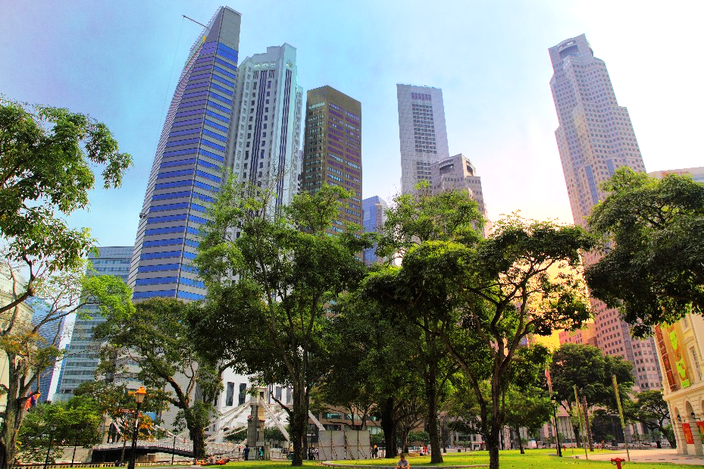

Business Requirement Document

First Draft

[Name], [Title]

[Company]— [Address]

**T:** [Main Telephone] **DD:** [Direct Phone] **E:** [Email]

# Executive Summary

To replace any placeholder text (such as this paragraph) with your own, click to select it and then press any key.

When you add the title on the cover page, the control containing the title remains. This is because there is another title control in the header that will automatically populate with the title you add on the cover page.

To replace the logo on the cover page or in the header, or the photo on the cover page, start by selecting it. When you do, you see a bar across the top—click the icon on that bar to select your own logo or image for replacement. Word automatically sizes and formats your image to fit the space allotted.

The table of contents that follows picks up any text that you format using Heading 1 through Heading 3 styles. To update the table after you add your own information to the document, click in the table of contents and then click the Update button on the bar that appears across the top of it.

**Note**: Body text such as the paragraphs above are formatted using the default Normal syle. This paragraph is formatted using the style named Normal - Space After to create the space between the executive summary and the table of contents.

Contents

Executive Summary 3

Introduction 4

Scope 4

Heading 3 4

Out of Scope 4

Heading 1 4

Heading 2 5

Heading 2 6

# Introduction

This template uses a few tables to create the page structure that follows. A **host** table consisting of just two columns and one row enables the sidebar content to sit beside the text, tables, and diagram on the left without any complicated positioning required. **Nested** tables (a nested table is just one table inside another) in both the left and right column enable you to place text beside the SmartArt graphic, provide the small financial table below left, and provide the sidebar table with a separate cell for the heading text.

The benefit of using nested tables rather than splitting and merging cells is that the nested tables can grow independently, so it’s much easier to place and align content as needed.

|  |  |  |  |  |  |  |  |  |  |  |  |  |  |  |  |  |  |  |  |  |
| --- | --- | --- | --- | --- | --- | --- | --- | --- | --- | --- | --- | --- | --- | --- | --- | --- | --- | --- | --- | --- |
| Scope  |  |  | | --- | --- | | Heading 3 When you click in the SmartArt graphic at right, a Text Pane appears where you can add your own text. When you press Enter in the text pane to add a new bullet, it adds a new shape to the diagram. To change the diagram to a different layout, on the SmartArt Tools Design tab, in the Layouts group, point to options in the layouts gallery to preview them in the document and then click to apply the one you prefer. |  |  Out of Scope The gradient background behind the sidebar at right is created using a shape with a gradient fill. It is formatted with the Behind Text layout to place it behind the table. To easily select that shape, on the Home tab, in the Editing group, click Select and then click Selection Pane. Click the object named Sidebar Background. Heading 5  |  |  |  | | --- | --- | --- | |  | Table Text Centered | Table Text Centered | | Table Row Heading | 000 | 000 | | Table Row Heading | 000 | 000 | | Table Row Heading | 000 | 000 | | Table Row Heading | 000 | 000 | | |  | | --- | | Heading 4 | | * List Bullet   The styles List Bullet and List Bullet Negative provide the up and down arrows shown in this sidebar.   * List Bullet   Sidebar text.   * List Bullet   Sidebar text.   * List Bullet Negative   Sidebar text. | |

Click here to enter text. This text is in the main body of the document, so it can easily continue onto multiple pages as needed.

# 

# High Level Business Flow

**Click here to enter text.**

## Flow

Click here to enter text.

Click here to enter text.

As with the Executive Summary text on page 2, The first paragraph in this placeholder is regular body text that uses the default Normal style. This paragraph uses the style Normal – Space After to create space before the table below.

|  |  |  |
| --- | --- | --- |
| Heading 4 |  |  |
| heading 6 Sidebar text | heading 6 heading 6 | heading 6 heading 6 |

# List of Parties Involved

### Enter Text

# Business Model / Block Diagram

<Shashi>

# Risks / Impediments

< BASU to Enter >

# Market Analysis

< Sandy >

|  |  |
| --- | --- |
| Analysis Views To edit the data for either chart in this document, select the chart and then, on the Chart Tools Design tab, in the Data group, click Edit Data. |  |

|  |  |  |  |
| --- | --- | --- | --- |
| Heading 5 | Heading 5 | Heading 5 | Heading 5 |
| Table Row Heading | Table Text | 000 | Table Text Centered |
| Table Row Heading | Table Text | 000 | Table Text Centered |
| Table Row Heading | Table Text | 000 | Table Text Centered |
| Table Row Heading | Table Text | 000 | Table Text Centered |
| Table Row Heading | Table Text | 000 | Table Text Centered |
| Table Row Heading | Table Text | 000 | Table Text Centered |

# Technology

<TBD>