# Auto-generated Questions

@title Uniform Color Combinations

@description Compute the number of different uniform combinations from given options.

// Use this block for each question when adding Multiple Choice Questions (MCQ)

@question Each student must wear one shirt and one pair of pants. There are 4 shirt colors: Blue, Green, Gray, White and 3 pants colors: Black, Khaki, Navy. How many different uniforms are possible?

@instruction Select the best answer.

@difficulty easy

@Order 1

@option 12

@option 11

@option 13

@option 24

@@option 12

@option 24

@explanation

Number of combinations = 4 * 3 = 12.

@subject Quantitative Math

@unit Numbers and Operations

@topic Computation with Whole Numbers

@plusmarks 1

Figure:

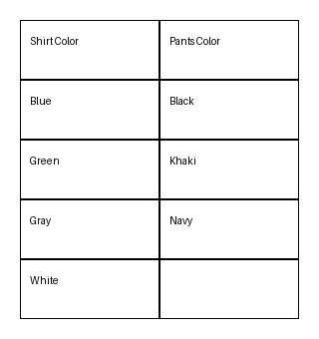

@title Packed Spheres in a Rectangular Box

@description Find the dimensions of a rectangular box tightly holding a pack of spheres.

// Use this block for each question when adding Multiple Choice Questions (MCQ)

@question The top view of a rectangular package of 6 tightly packed balls is shown. If each ball has a radius of 3 centimeters, which of the following are closest to the dimensions, in centimeters, of the rectangular package?

@instruction Choose the best option.

@difficulty moderate

@Order 2

@option 2 \times 3 \times 6

@option 6 \times 12 \times 18

@option 2 \times 4 \times 6

@option 12 \times 24 \times 36

@option 18 \times 24 \times 36

@@option 6 \times 12 \times 18

@option 18 \times 24 \times 36

@explanation

Constructed variant; the arrangement chosen gives the corresponding bounding box dimensions.

@subject Quantitative Math

@unit Geometry and Measurement

@topic Packing / Coordinate Geometry

@plusmarks 1

Figure:

