Hasibul Islam

Physics207-Lab#3-Little g

10/24/2016

**Introduction**

The purpose of this lab is to use several methods to measure the acceleration due to the gravity. The acceleration due to gravity is usually taken as g and has a value of 9.8m.s^2. This value is obtained from the Newton universal law of gravitation. We will calculate the law using…..

* FG= ma= mg= GMEm/r^2E ⇒ g = GME/r2E

**Experiment 1:** A rough measurement

* 1st: Acceleration due to gravity (m/s^2) 5.37
* 2nd: Acceleration due to gravity (m/s^2) 7.69
* 3rd: Acceleration due to gravity (m/s^2) 6.38
* Average
* Acceleration due to gravity (m/s^2) 6.48

**Experiment 2:** Slo-mo free fall

* Acceleration due to gravity (m/s^2) 9.77

**Experiment 3:** Leveling a ramp

* Angle when it begins to move (degrees) 7.06

**Experiment 4:** The Rolling Cart

* Is recording all data

**Experiment 5:** The Rolling Cart at different angles

* Angle 1 (degrees) 14.23

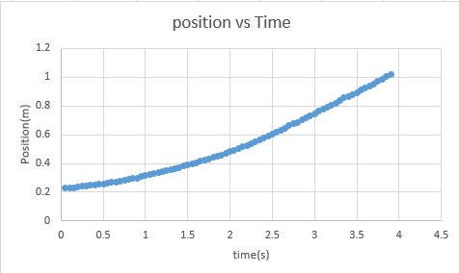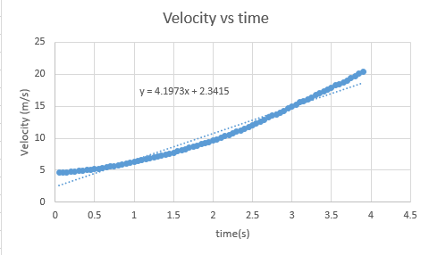

**Experiment 5:** The Rolling Cart at different angles

* Angle 2 (degrees) 21.14

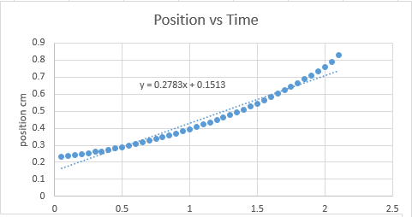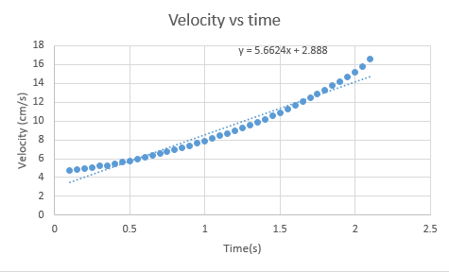

**Experiment 5:** The Rolling Cart at different angles

* Angle 3 (degrees) 27.85

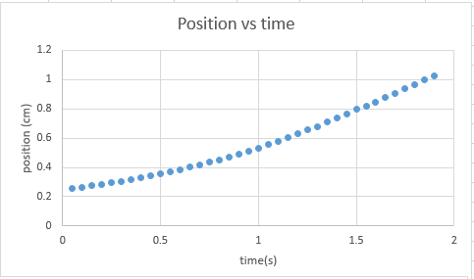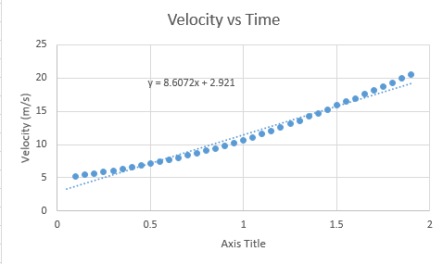

**Experiment 6:** The Rolling Cart with different masses

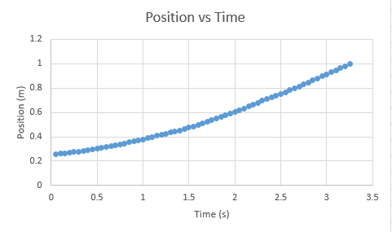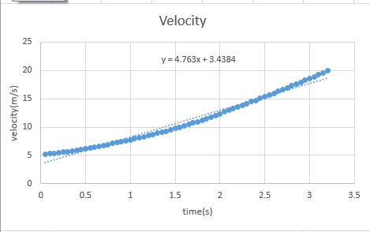

**Lab Question**

1. This method is not very good because there is a uncertainty in the measurement of time from when you drop the block to where it hits the ground. Which is unfairly measured.
2. Experiment 3: Calculation Error
3. Refer to Data and Calculation for graphs.
4. The mass did affected the acceleration because of the cart is more faster than without using the mass of the cart traveled. And based on our understanding kinematics is that the cart is in motion and its has constant velocity

|  |  |
| --- | --- |
| benchID | g m/s^2 |
| GH1-01 | -1.42 |
| GH1-02 | 9.87 |
| GH1-03 | 8.23 |
| GH1-04 | 9.77 |
| GH1-05 | 10.1 |
| GH1-06 | -8.98 |
| GH1-07 | -8.6 |
| GH1-08 | 10 |
| GH1-09 | 9.97229 |
| GH1-10 | 9.801 |
| GH1-11 | 9.88 |
| GH1-13 | -10 |

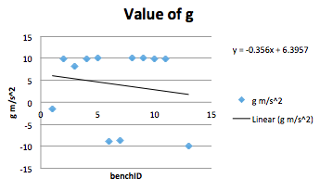

From the graph the result is due to the time measurements, because the acceleration is constant. The average obtained from these measurements is a g of 9.77.

**Conclusion**

Throughout this lab we’re using lot of methods to measure and calculate acceleration of an object due to gravity.