04/26/2017

Hasibul Islam

Physics 208-CC3

Lab 5- Oscilloscope and RC Circuits

**Procedure**

**Apparatus**

* A Tektronix Oscilloscope TDS1002
* A Signal Generator
* Electronic Voltmeter
* Circuit Board
* D.C Power Cord

In the experiment, we follow the instruction to observe and setup the setting.

* SEC/DIV = 1 ms and VOLTS/DIV = 1 V
* Trace on the screen, then set the SEC/DIV to 10ms.
* Repeat the step 3 by changing the setting of 100ms.
* Connect the ground wire from the D.C. power cord to the ground.
* Plug D.C. power cord into special socket.
* Touch the other lead from D.C power cord to the other lead from the oscilloscope momentarily.
* Repeat step 7 with the SEC/DIV set to 1ms.
* Unplug the D.C. power cord and disconnect if from the oscilloscope.
* Set SEC/DIV to 10ms and VOLTS/DIV to 100mV.
* Connect the signal generator as SQUARE WAVVE, be careful to observe that ground leads are connected together.
* Adjust the AMPLITUDE of the generator using TRIGGER LEVEL until you get a pattern that is divisions high on the screen.
* Adjust the frequency of the signal generator until you get one complete cycle of a square wave on the screen.
* Turn off the signal generator.
* Connect the ground wire from the D.C. power cord.
* Plug D.C. power cord into special socket.
* D.C power cord to the other lead from the oscilloscope momentarily.
* Repeat step 7 with the SEC/DIV set to 1ms.
* Unplug the D.C. power cord and disconnect if from the oscilloscope.
* Set SEC/DIV to 10ms and VOLTS/DIV to 100mV.
* Connect the signal generator as SQUARE WAVVE.
* Adjust the AMPLITUDE of the generator using TRIGGER LEVEL until pattern high on the screen.
* Adjust the frequency of the signal generator until complete cycle of a square wave on the screen.
* Turn off the signal generator.

**Data/Calculations/Questions:** Part A

1. SEC/DIV =1 ms, SEC/DIV =10 ms and SEC/DIV =100 ms.
2. You get a line parallel to x-axis but 5.2 volts higher than the original position
3. Because a larger wave appears with bigger amplitude.
4. The frequency of the signal was 100Hz.The reason is because we grounded it by touching it.

* Frequency jumps to 29.5 kHz
* Moving cosin graph in a –x direction.

1. The setting frequency is 100Hz, and the display frequency is around 99.9992Hz, the difference between is about 0.0008Hz.

**Data/Calculations/Questions:** Part B

1. Sketch the pattern, showing a number of times and voltages.

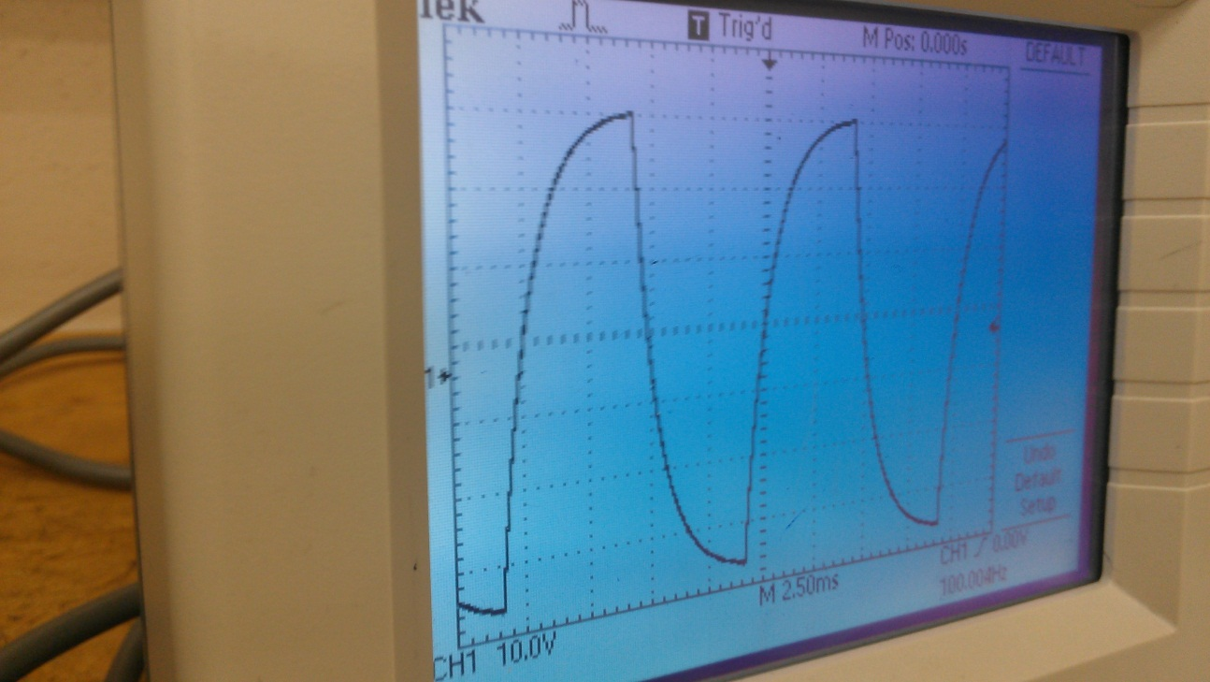

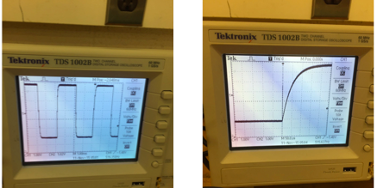

Number of times = 10

Voltages = 1V

1. Describe your reasoning.

* Maximum voltage is 3.78V,
* Time at that point is 0.001s.
$τ=0.001s$

* Voltage is 6V, 63%

1. Do they agree?

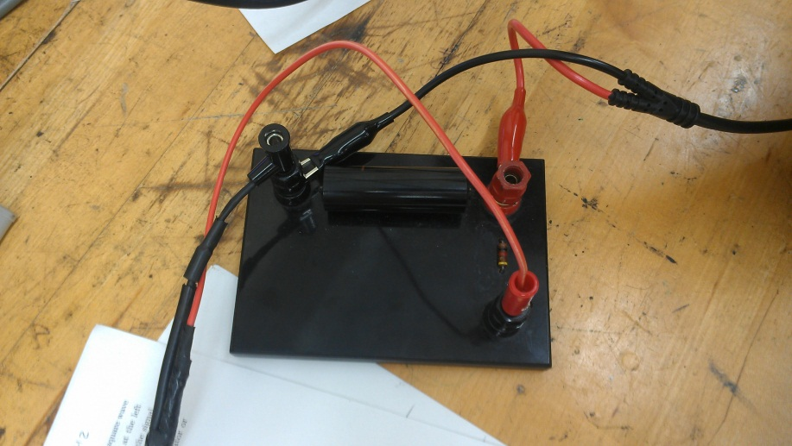

* Yes
* $C=1μF, R=1 kΩ τ=0.001s$.

**Data/Calculations/Questions:** Part C

1. Devise a method to estimate R. Indicate your result and describe your method.

* A small wave appears with low amplitude.

$V= Vf \left(e^{-\frac{t}{RC}}\right)-→R={-t}/{ln⁡(V/V_{f})C}$

Conclusion:

The experiment has provided confirmation of the theory of the electrical behavior of RC circuit as developed above. And there might be little error due to inaccurate reading of the oscilloscope.