02/23/2017

Hasibul Islam Physics 208-CC3

Lab#1 -> Standing Waves in Strings

**Procedures**

In this experiment, we test the wave between two strings; white one is light and red one is heavy, both string are different length and masses. The length and mass of each string were measured and recorded. Following this a known measured mass was hung from one of the strings with the other end attached to the vibrator. The vibrator is then turned on and the number of nodes formed in the string are observed and counted. This information will be used to calculate the average distance and wavelength. This is then repeated with the second string. These sets of data will be used to find the tension (T=mg) and Wavelength (L=2 λ) for both strings. Wavelength graphs must be plotted for each string and used to determine the slope of the (wavelength 2) graph. Then, determine the mass per unit length of the string to calculate the average frequency along with the percentage error in the calculated frequency is determined.

**Organized Data/Calculation: White-Light String**

* m = 4.57x10^-4 g ; l = 1.31m

|  |  |  |  |  |  |  |
| --- | --- | --- | --- | --- | --- | --- |
| M (g) | T (N) | L (cm) | n | d(cm) | **λ** | λ^2 |
| 50 | 0.494 | 99 | 5 | 19.8 | 0.396 | 0.156 |
| 100 | 1.025 | 90 | 3 | 30 | 0.6 | 0.36 |
| 150 | 1.476 | 83 | 2 | 40.5 | 0.81 | 0.656 |
| 200 | 1.966 | 81 | 2 | 45.1 | 0.93 | 0.689 |
| 250 | 2.498 | 75 | 1 | 69 | 1.38 | 1.904 |
| 350 | 2.947 | 69 | 1 | 72 | 1.44 | 2.07 |

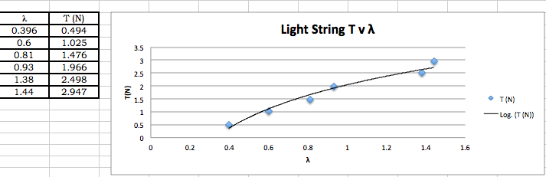

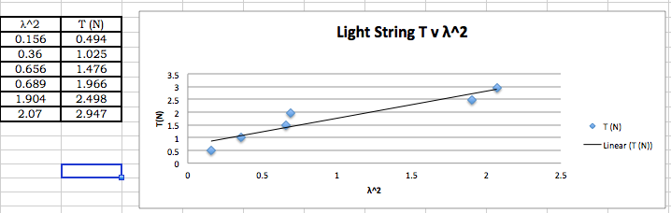

**Organized Data/Calculation: Red- Heavy String**

* m = 2.5x10^-3 g ; l = 1.25m

|  |  |  |  |  |  |  |
| --- | --- | --- | --- | --- | --- | --- |
| M (g) | T (N) | L (cm) | n | d(cm) | **λ** | λ^2 |
| 150 | 1.496 | 89 | 6 | 14.83 | 0.296 | 0.088 |
| 200 | 1.986 | 84 | 5 | 16.8 | 0.336 | 0.113 |
| 250 | 2.477 | 79 | 4 | 19.75 | 0.395 | 0.156 |
| 300 | 2.967 | 69 | 3 | 21.33 | 0.42 | 0.176 |
| 350 | 3.458 | 64 | 3 | 23 | 0.46 | 0.212 |
| 400 | 3.94 | 59 | 2 | 29.5 | 0.51 | 0.260 |

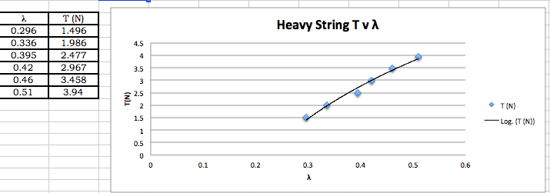

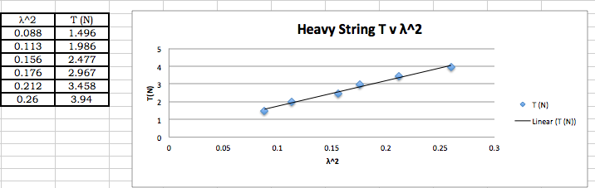

**Analysis/Discussion**

From the experiment it was proven that tension in the string is directly proportional to the square of the wavelength of the waves produced. This was proven in both waves. It also demonstrated that mass and length aren't a factor. I would suggest using a sensitive apparatus to provide more accurate data.