

**INTEGRATED FAMILY PLANNING (FP) DASHBOARD**

User Manual

**PREPARED AND SUBMITTED BY:**

PROJECT TEAM

DEPARTMENT OF COMPUTER SCIENCE AND ENGINEERING

UNIVERSITY OF DAR ES SALAAM AND CLINTON HEALTH ACCESS INITIATIVE

**FOR**

**THE REPRODUCTIVE AND CHILD HEALTH SECTION (RCHS) OF THE MINISTRY OF HEALTH, COMMUNITY DEVELOPMENT, GENDER, ELDERLY AND CHILDREN (MoHCDGEC)**

**April 2016**

|  |  |
| --- | --- |
|  |  |

Table of Contents

1. Introduction to Family Planning Dashboard 6

1.1 General Introduction 6

1.2 FP Dashboard Features in Brief 7

2. How to use the Family Planning Dashboard in HMIS Web-Portal 8

2.1 Opening the HMIS Web-Portal 8

2.2 Opening the Family Planning (FP) Dashboard 8

2.3 Menus and Navigation 9

2.3.1 Navigating the ‘top’ menu 10

2.3.1.1 Selecting period 10

2.3.1.2 Selecting geography 11

2.3.1.3 Selecting FP method 11

2.3.1.4 Updating the chart 11

2.3.2 Navigating the ‘left’ menu and chart options 12

2.3.2.1 Homepage 12

2.3.2.2 Coverage Charts 13

2.3.2.3 Client Charts 17

2.3.2.4 Stock-Outs Charts 22

2.3.2.5 Service Integration Charts 24

2.3.2.6 Report Subscription tab 26

2.3.3 Chart Features 27

2.3.3.1 View as chart or table 28

2.3.3.2 Download data as CSV 29

2.3.3.3 Print or download the chart 29

2.3.3.4 Get description of the chart or table 29

2.3.3.5 Hide and unhide data 29

2.3.3.6 View data label on the chart 30

2.3.4 PDF Reports 30

3. Appendices 31

Appendix 1: Overview of Home Page 32

Appendix 2: Overview of Coverage Charts 33

Appendix 3: Overview of Client Charts 38

Appendix 4: Overview of Stock-Out Charts 40

Appendix 5: Overview of Service Integration Charts 41

Definitions and Acronyms

|  |  |
| --- | --- |
| CBD | Community-Based Distribution |
| CHAI | Clinton Health Access Initiative, Inc. |
| DHIS | District Health Information System |
| DoCSE | The Department of Computer Science and Engineering |
| FP | Family Planning |
| HIS | Health Information System |
| HIV | The human immunodeficiency virus |
| HMIS | Health Management Information System |
| HR | Human Resource |
| HTC | HIV Testing and Counseling |
| HWs | Health Workers |
| ICT | Information and Communication Technology |
| IUCD | Intrauterine Contraceptive Device |
| MoHCDGEC | Ministry of Health, Community Development, Gender, Elderly and Children |
| NSV | No Scalpel Vasectomy |
| cPAC | Comprehensive Post Abortion Care |
| RCHCos | Reproductive Child Health Coordinators |
| RCHS | Reproductive and Child Health Section |
| UDSM | University of Dar es Salaam |
| URL | Universal Resource Locator |

# 1. Introduction to Family Planning Dashboard

The Tanzania Family Planning Dashboard is a web-based tool that maps the human resource capacity at facilities to provide family planning (FP) commodities against the consumption and stock status of these commodities, in order to inform decision-making by government and partners at national and subnational levels. This document is a user manual, providing detailed instructions on how to use the Dashboard.

## 1.1 General Introduction

The Tanzania eHealth Strategy (2013-2018) aims to enable more efficient use of health care resources by replacing paper-intensive processes and providing better information management, supporting the improved communication and information-sharing among clinicians, patients, and caregivers within health sectors and across partner agencies. To this end, the strategy calls for an integration and interoperability of Health Information Systems (HIS) to support more efficient access to data required for policy development and health care delivery.

The Reproductive and Child Health Section (RCHS) of the Ministry of Health, Community Development, Gender, Elderly and Children (MoHCDGEC) is supported by the Clinton Health Access Initiative, Inc. (CHAI)[1] to improve FP program management at the national and sub-national levels through data-driven decision-making. Through this support, an integrated FP dashboard has been developed which allows FP program managers to utilize data, identify gaps and problems, and set evidence-based targets. The aim of the FP Dashboard is to serve as Tanzania’s primary FP program and performance management tool to achieve more targeted and efficient program planning and resource allocation.

The Department of Computer Science and Engineering (DoCSE), University of Dar es Salaam (UDSM) has worked with the MoHCDGEC to develop a web-based portal to display graphical representation of national DHIS2 data and indicators for numerous health programs. The FP dashboard is housed within this web-portal and displays ‘coverage’, ‘client’, ‘stock-outs,’ and ‘service integration’ FP information using data from DHIS2 and the family planning human resource (HR) training database ‘TrainTracker.’ On a monthly basis, the system automatically generates summary reports which are emailed to users.

The FP dashboard, in line with the existing web-portal, is free and open access. It is intended for use by all FP donors, partners, and government program managers in Tanzania and its use is designed to require only limited analytical skills.

The development of the FP Dashboard involved a core group of stakeholders from RCHS, HMIS and ICT units within MoHCDGEC, UDSM and CHAI, who worked collaboratively to ensure that this dashboard system was developed to meet the needs of the users, using existing data without creating a parallel system.

## 1.2 FP Dashboard Features in Brief

CHAI supported RCHS to develop a free and open access FP dashboard in the existing HMIS web-portal. The objective of this dashboard is to provide users with integrated charts and reports using real-time family planning service and human resources data. This is to help monitor and track performance in various strategic and operational areas while strengthening data for decision-making around FP services.

To implement the above main objective, the FP dashboard includes the following features:

* Charts which display service data from DHIS-2 and training data from the ‘Train Tracker’
* National, regional, and district-level reports which are emailed to dashboard users, providing monthly summaries and suggested action points

Details on these FP dashboard features and instructions on how to use the FP dashboard are described in the subsequent sections of this manual.

# 2. How to use the Family Planning Dashboard in HMIS Web-Portal

This section provides instructions and guidance on how to use the Family Planning Dashboard and how to make the most of its features.

## 2.1 Opening the HMIS Web-Portal

This FP Dashboard is a web-based application integrated in the HMIS Web-Portal, thus is available via an Internet browser (an application you use to access internet e.g. Internet Explorer, Mozilla Firefox, Google Chrome, Opera, etc.). To access the application, it is recommended to use Mozilla Firefox and Google Chrome (Use of Internet Explorer is not optimal, but if it is necessary use the latest version of the browser).

To access the Dashboard, open your browser and type in the URL of the HMIS Web-Portal ([www.hmisportal.moh.go.tz](http://www.hmisportal.moh.go.tz)) in the address field. You will see the web-portal screen.

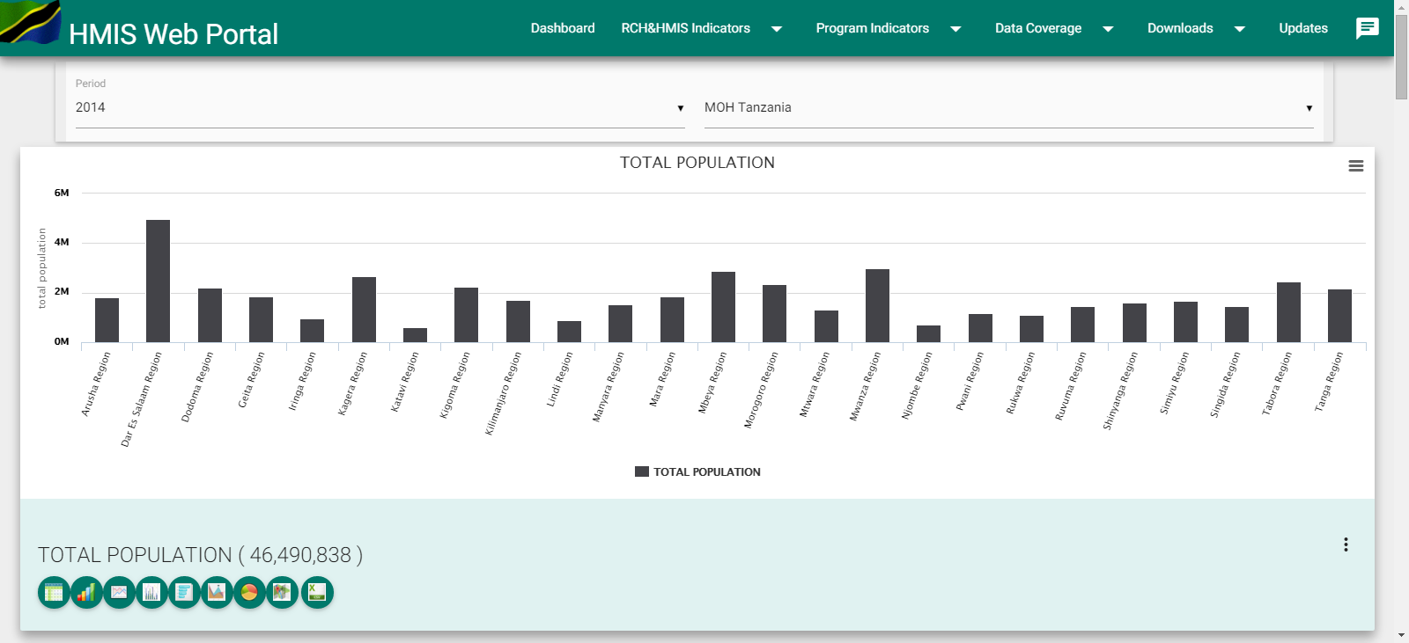

Figure 1: HMIS Web-Portal Screen

## 2.2 Opening the Family Planning (FP) Dashboard

Once you see the HMIS Web-Portal screen, select Family Planning from the Program Indicators to access the FP Dashboard.

*Note: You do not need a username and password to access HMIS Web-Portal or the FP Dashboard.*

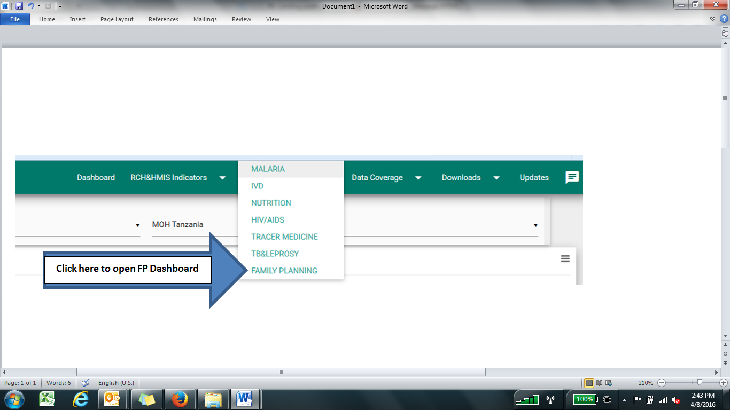

Figure 2: Select Family Planning from Program Indicators to open FP Dashboard

Once you have successfully selected Family Planning from the Program Indicators you will see the FP Dashboard ‘Home’ page, where you can immediately view four charts showing most recent national-level data.

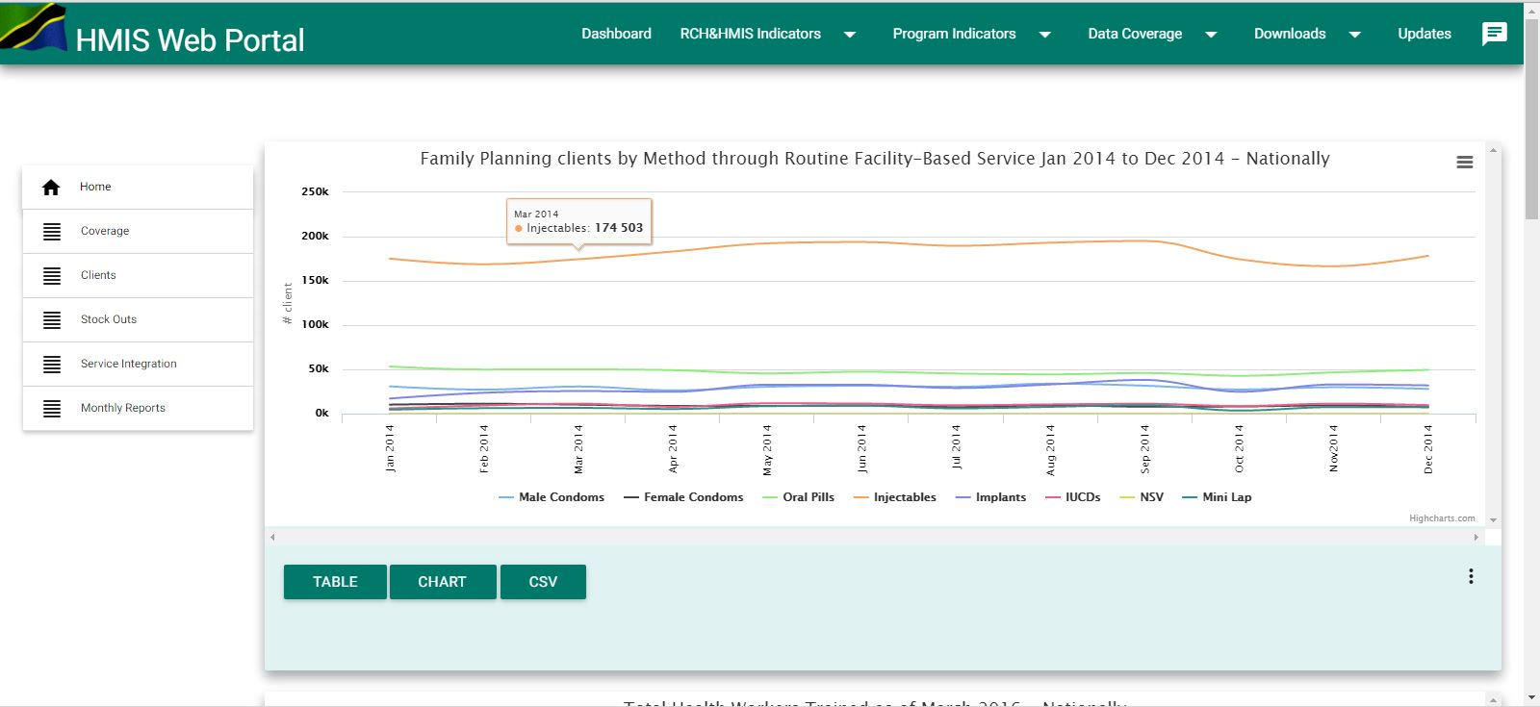

Figure 3: The FP Dashboard ‘Home’ page

You can then choose to display coverage, clients, stock-outs, or service integration information for Family Planning, by using the menu on the left as shown in Figure 4 below.

## 2.3 Menus and Navigation

The FP Dashboard has two menu systems: The left side menu, which is the main menu that allows you to choose the type of FP information you want to display: coverage, client, stock-outs, or service integration.

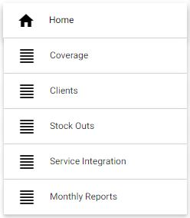

Figure 4: The left-side menu

The menu along the top of the page allows you to change the time period, geography, and FP method, and to update the information displayed on the chart according to your selections.

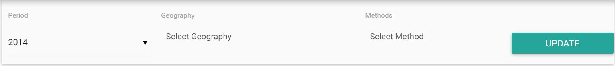

Figure 5: The top menu

### 2.3.1 Navigating the ‘top’ menu

The information displayed for charts is for the default period of time, geography (all seven zones), and FP method (implants) but you can change these selection through navigation on the top menu as follows:

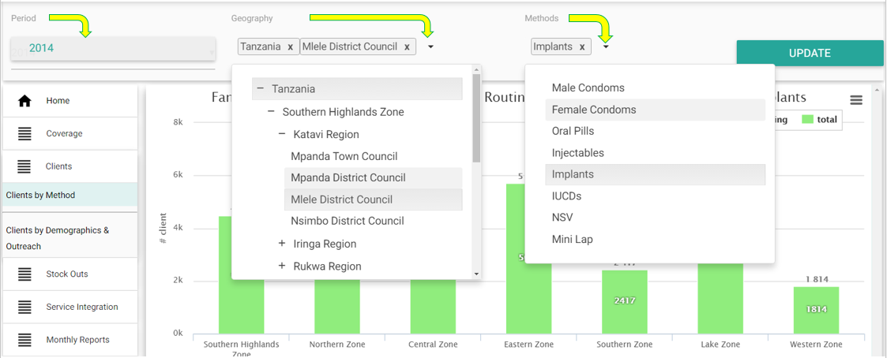

Figure 6: Selecting time period, geography, and FP method

#### 2.3.1.1 Selecting period

The FP Dashboard will be updated every 6 weeks to allow for data entry and cleaning.

The default date for bar charts is always for the most recent month for which data is available.

For all charts that shows a trend over time, the default is to show data from the most recent month of available data and the previous 11 months (showing a full year). For example, if you are viewing the Dashboard in May 2016, you will see data from March 2015-March 2016. You can edit the data period to view data from previous years by using the top left menu to select the period you want from the list of available periods in the drop down. When you select a previous year, it will load data from January-December of that selected year.

#### 2.3.1.2 Selecting geography

Use the second menu from the top left to select the geography you are interested in seeing. Depending on your information needs, there are four levels you can view:

* National-level
* Zonal-level
* Regional-level
* District-level

*Note: You can select any combination of geographic levels to display (up to a maximum of seven total, regardless of level), such as some districts, regions, zones, and national.*

To select/remove geographies:

1. Click on the ‘plus sign’ to expand the tree then click on the respective zone, region or district to select.
2. Each zone, region, or council is added in the list when you click on it.
3. To remove it from the selection, click on the ‘X’ icon after the name in the list.

#### 2.3.1.3 Selecting FP method

For some of the charts, you will also need to specify the FP method you are interested in. Specifically, the following sub-tabs require you to select an FP method:

* Clients by Method, Clients by Demographics & Outreach
* HWs Trained
* Facilities with HWs Trained
* Facilities Providing FP Over Time
* Facilities with HWs Trained Providing FP

For these charts, a third menu option appears at the top where you can select the FP method(s) you are interested in, from the drop down list.

*Note: The system allows multiple selections for one filter only, limiting the selection on the other filter to one. For example, if you select multiple geographies you can only select one method and one period. If you select multiple methods you can only select one geography and one period.*

#### 2.3.1.4 Updating the chart

Once you have selected the period, geography, and-or method you are interested in, you must click on the “Update”button (at the top right) to update the information on the chart(s) accordingly.

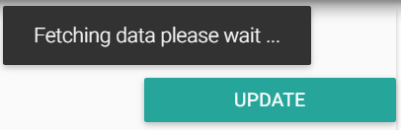

Figure 7: Updating the chart

*Note: Fetching of data might take some time but the message “Fetching data please wait …” indicates it is still working, so please wait for the information to load.*

### 2.3.2 Navigating the ‘left’ menu and chart options

The left side menu is the main menu of the FP dashboard. It allows a user to choose the type of FP information to display on the charts. At first, when you open the FP Dashboard, you will be directed to the homepage where you will see four charts.

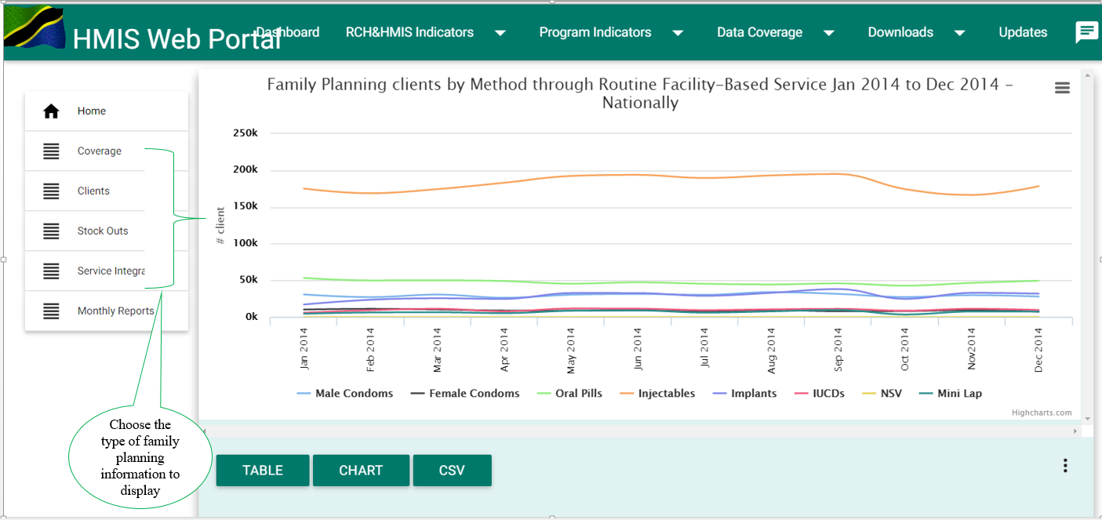

Figure 8: Selecting type of FP information you want to see, from the left-side menu

Depending on your information needs, you can choose to view FP information from any of the following categories: coverage, client, stock-outs, or service integration information.

See Appendices 1-5 for a full description, including interpretation of data, data sources, and numerator and denominators used for each indicator.

*Note: The data displayed after selecting a coverage, client, stock-outs, or service integration chart is the default period (current year), geography (all seven zones), and FP method (implants) but you can change these through navigation on the top menu as explained in section 2.3.1.*

#### 2.3.2.1 Homepage

At first, when you open the FP Dashboard, you will be directed to the homepage where you will see four charts. If you are navigating other pages of the FP Dashboard and you want to be directed back to the homepage, click on the ‘Home’ button where you will see four charts.

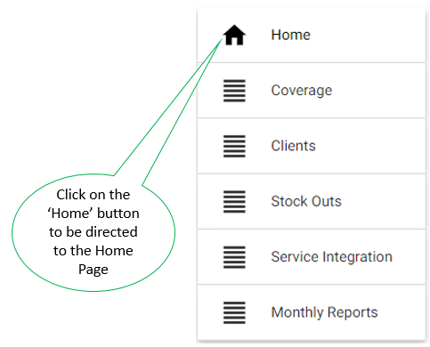

Figure 9: Selecting the ‘Home’ button on the left-side menu

#### 2.3.2.2 Coverage Charts

The coverage section of the Dashboard displays charts that illustrate the coverage of trained health workers and service provision, as well as the coverage of service provision at facilities with trained health workers. These charts are useful for understanding the current service delivery capacity for FP in the country.

There are a total of 11 coverage charts. If you are interested in viewing FP coverage information, click on the “Coverage” button and then, depending of your information need, click on the respective sub-tabs in the coverage tab menu.

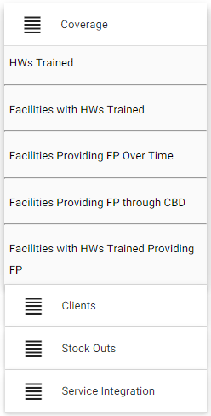

Figure 10: Selecting Family Planning Coverage Information Tab

* **HWs Trained**

This sub-tab displays one chart to view absolute number of providers trained in all FP methods, in selected geographies, to date. The total numbers you see includes the number of health workers trained in the year in addition to the cumulative number of health workers trained up to 10 years prior to that year.

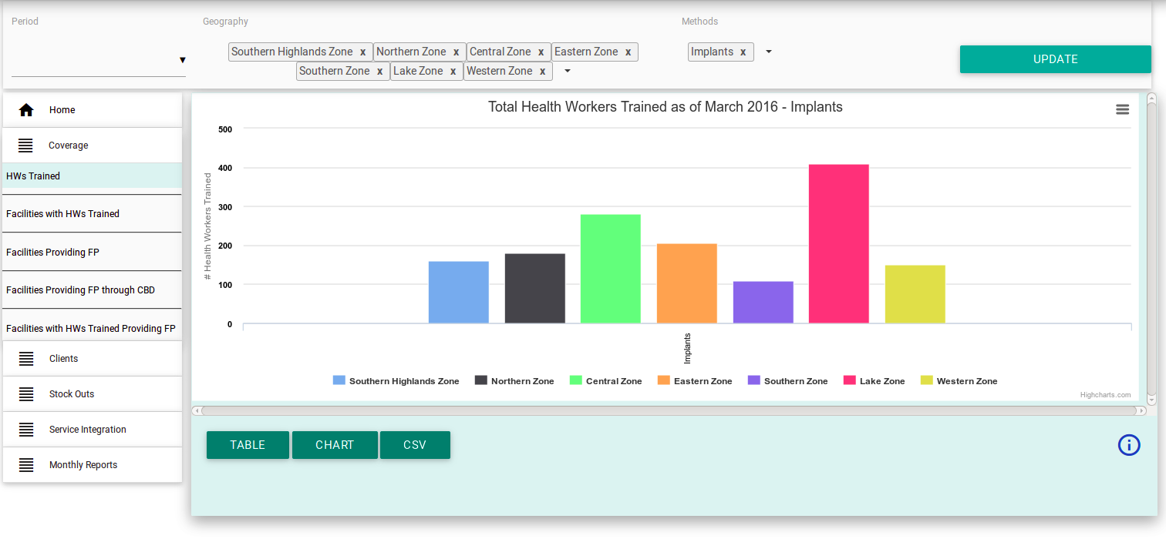

Figure 11: Selecting “Total number of Health Workers Trained in FP methods” chart

*Note: FP training organizers should use the TrainTracker HR system[2] to ensure that the HR data is comprehensive and up to date to most accurately reflect the number of trained health workers in Tanzania.*

* **Facilities with HWs Trained**

This sub-tab displays three charts to view hospitals (1st chart), health centers (2nd chart), and dispensaries (3rd chart) with at least two health workers trained in the selected FP method type, in the specified geography, for the current month to date. You can scroll the page up and down to view all three charts.

These charts show the distribution of trained health workers at reporting facilities (facilities that report in the FP DHIS-2 tool). These charts can easily display the zones, regions, and districts with low coverage of trained health workers and are therefore helpful at the national level for planning trainings and ensuring resources are spent where they are most needed. They can also be used at the regional level to help the Regional RCHCOs direct trainings to particular districts.

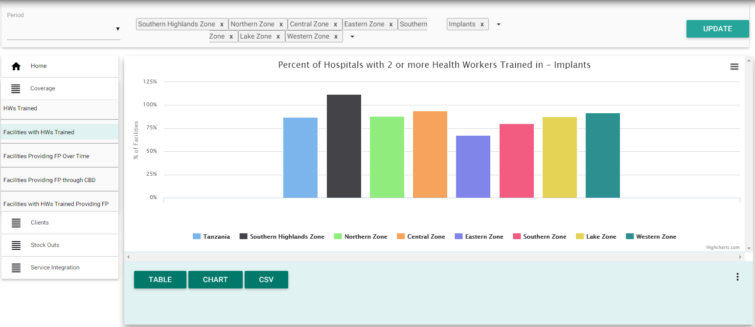

Figure 12: Example of selecting “Percentage of Facilities with HWs Trained in FP methods” chart

* **Facilities Providing FP Over Time:**

This sub-tab displays three charts to view percentage of reporting hospitals (1st chart), health centers (2nd chart), and dispensaries (3rd chart) that provided at least one commodity for the specified FP method, in the specified geography over a 12-month period. You can scroll the page up and down to view all three charts.

This indicator shows the coverage of actual service provision among reporting facilities (facilities that report in the FP DHIS-2 tool) in the specified geographies. The true coverage rate of facilities providing services reflects the impact of lack of training, supply chain bottlenecks, and other barriers to service delivery. The data is displayed over a 12-month period, showing trends. Managers can use this to understand the impact of an intervention on service delivery coverage.

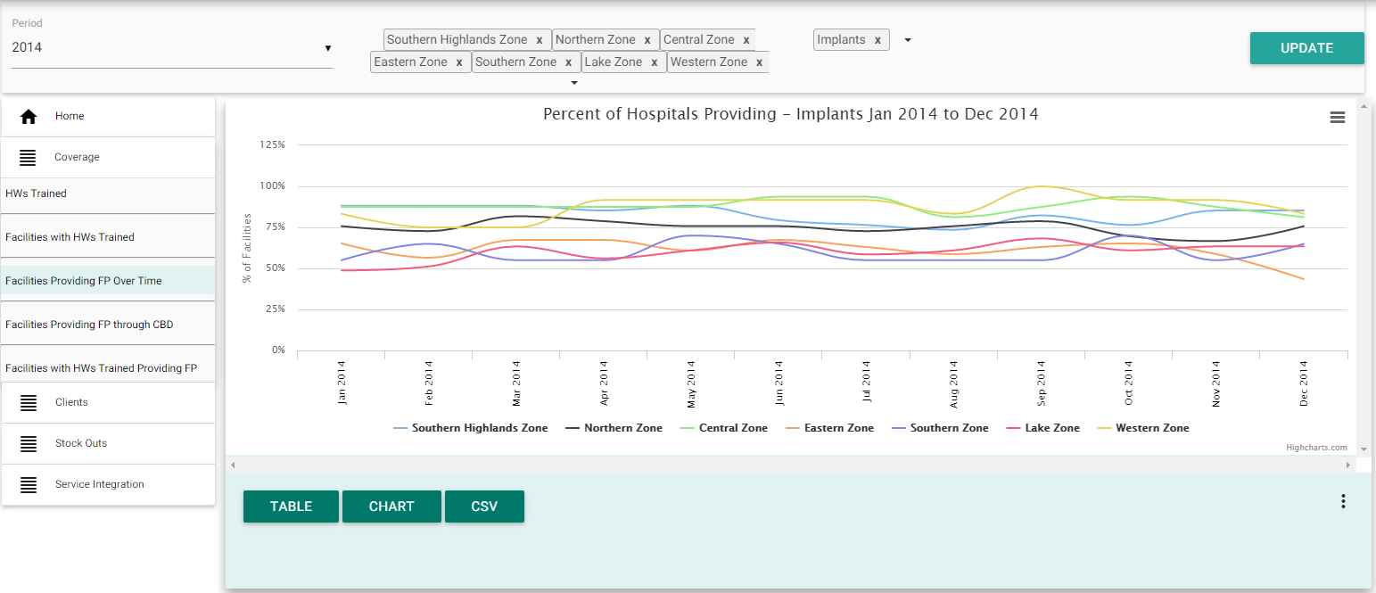

Figure 13: Example of selecting “Percentage of Facilities Providing FP methods over time” chart

* **Facilities Providing FP through** Community-Based Distribution **(CBD)**

This sub-tab displays one chart to view percent of reporting facilities providing condoms or pills through CBD in a specified geography, over the last 12-month period.

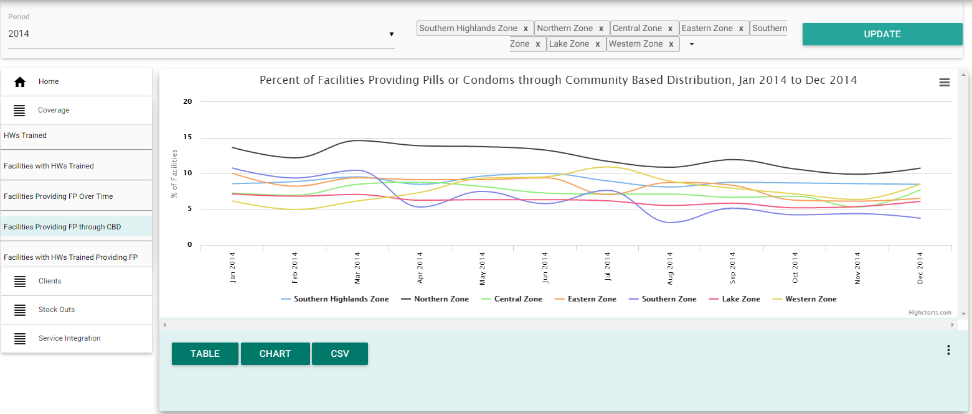

Figure 14: Example of selecting “Percentage of Facilities Providing FP methods through CBD” chart

This indicator shows the coverage of community-based service provision among reporting facilities (those that report in the FP DHIS-2 tool). The CBD coverage rate allows you to monitor community-based service delivery efforts in specified geographies, over time.

* **Facilities with HWs Trained Providing FP:**

This sub-tab displays three charts to view the percentage of reporting hospitals (1st chart), health centers (2nd chart), and dispensaries (3rd chart) with at least one provider trained in an FP method type, *and* providing that FP method, in a specified geography, for the current month. You can scroll the page up and down to view all three charts.

These charts illustrate the proportion of reporting facilities (facilities that report in the FP DHIS-2 tool) that have received training and are actually providing services. In districts where the proportion is low, managers should conduct supportive supervisions to investigate which facilities are not providing services and why. Reasons may include stock-outs of commodities or consumables, or health workers confidence to provide the service.

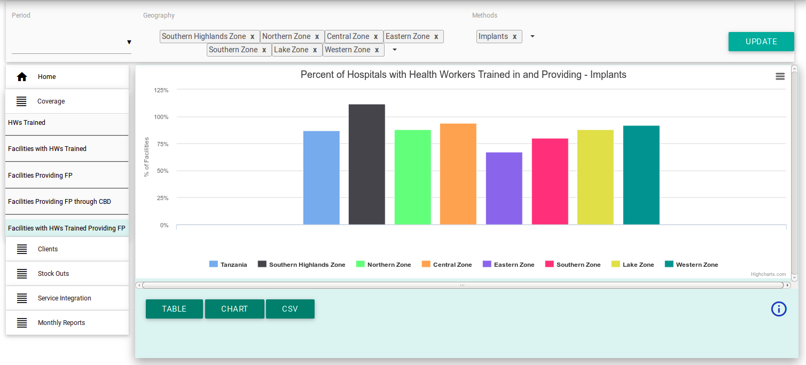

Figure 15: Example of selecting “Percentage of Facilities with HWs Trained in AND Providing FP methods” chart

#### 2.3.2.3 Client Charts

The clients section of the Dashboard displays charts that illustrate total number of FP clients, including data specific to young women and data on outreach vs facility-based clients. These charts are useful for understanding trends over time and current uptake of the different FP methods across geographical areas in the country.

If you are interested in viewing data on FP clients, click on the “Clients’”button. There are a total of four client charts. Depending of your information needs, click on the respective sub-tabs in the clients tab menu.

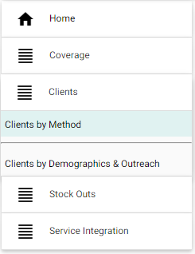

Figure 16: Selecting Family Planning Clients Information Tab

* **Clients by Method:**

This sub-tab includes two charts. You can scroll the page up and down to view both charts.

1. The first chart displays the total number of routine, facility-based clients for a specified FP method and geography, for the most recent month for which data is available.

This chart allows you to compare the number of clients for one method, across multiple geographic areas (e.g. implants across all zones as in Figure 17 below).

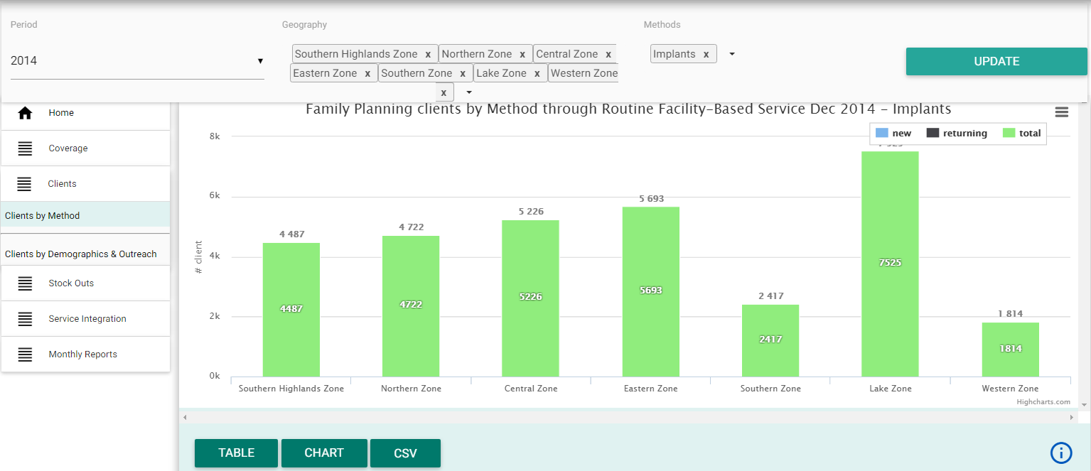

Figure 17: Example of selecting “Implant Client through Routine Facility-Based Service” across all zones, in the current month

Alternatively, you can use this chart to compare the number of clients between FP methods in one geographical area (e.g. all methods in Pwani Region as in Figure 18 below).

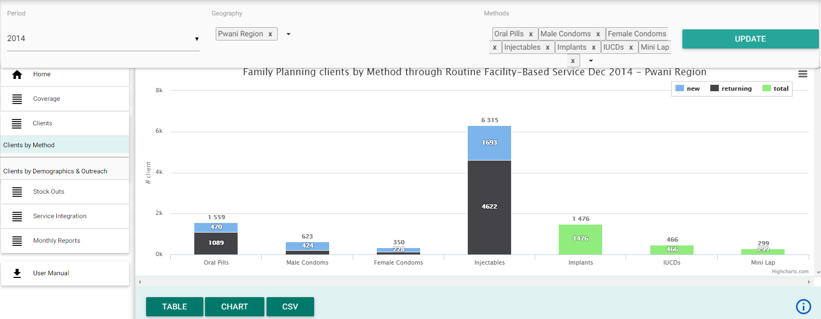

Figure 18: Example of selecting “FP Client through Routine Facility-Based Service in Pwani Region” for all FP methods, in the current month

*Note: This chart shows ‘new’ versus ‘returning’ clients for the short-acting methods (oral pills, male condoms, female condoms, and injectables) but for the long-acting and permanent methods it displays total number of clients only.*

1. The second chart also displays the total number of routine, facility-based clients by FP method, in a specified geography but shows data trends *over time*in a specified 12-month period.

This chart allows you to compare the number of clients for one method, over time, across multiple geographic areas (e.g. implants across all zones as in **Figure 19** below).

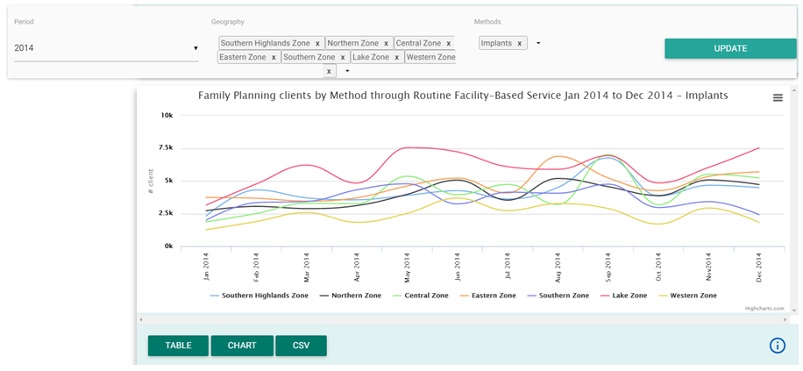

Figure 19: Example of selecting “Implant Clients through Routine Facility-Based Service” across all zones, in the specified 12-month period

Alternatively, you can use this chart to compare the number of clients between FP methods in one geographical area (e.g. all methods in Pwani Region as in **Figure 20** below).

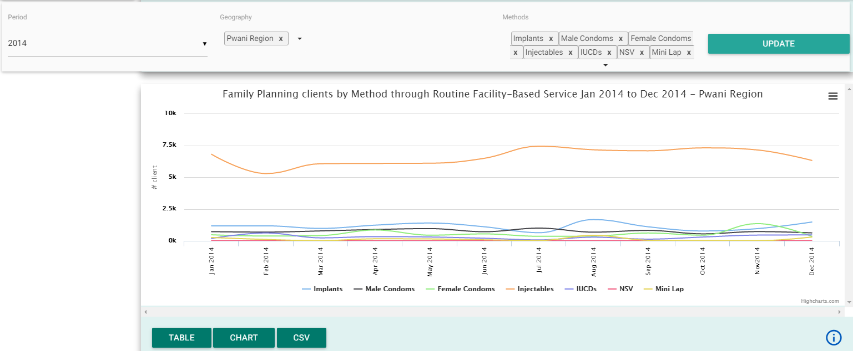

Figure 20: Example of selecting “FP Clients through Routine Facility-Based Service in Pwani Region” for all FP methods, in the specified 12-month period

* **Clients by Demographics & Outreach:**

This sub-tab displays two charts: one that shows number of FP clients under the age of 20 and the other which compares the number of clients by routine vs outreach. You can scroll the page up and down to view both charts.

1. The first chart allows you to view total number of FP clients aged below 20, by selected FP method in the specified geography, over time in a specified 12-month period. This is important in the context of the need to improve youth-friendly FP services.

This chart allows you to compare the number of clients aged below 20 for one method, over time, across multiple geographic areas (e.g. implants across all zones as in **Figure 21** below).

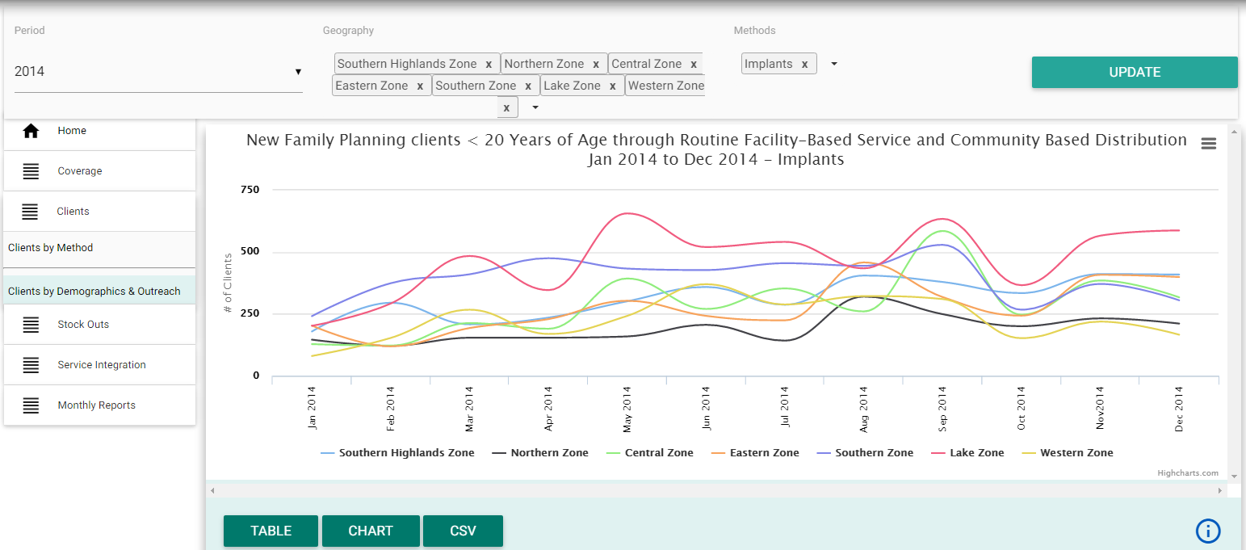

Figure 21: Example of selecting “New Implant clients <20 years of age” across all zones, in the specified 12-month period

Alternatively, you can use this chart compare the number of FP clients aged less than 20, between FP methods in one geographical area (e.g. all methods in Pwani Region as in **Figure 22** below).

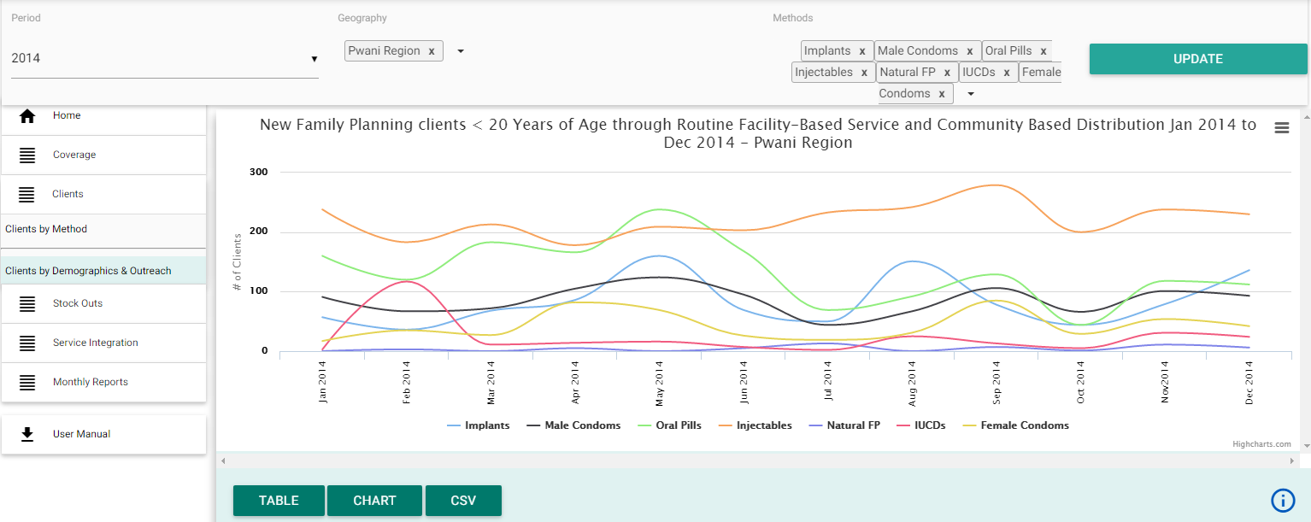

Figure 22: Example of selecting “New FP clients <20 years of age in Pwani Region” for all FP methods, in the specified 12-month period

1. The second chart allows you to view the total number of FP clients for long-acting (IUCDs or implants) and/or permanent (Mini-laparotomy [Mini Lap] or No Scalpel Vasectomy [NSV]) methods, broken down by clients reached through outreach versus routine/facility-based service provision, in the specified geography, for the current month.

This chart allows you to compare the number of clients by service modality (routine vs outreach) for one method, across multiple geographic areas (e.g. implants across all zones as in **Figure 23** below).

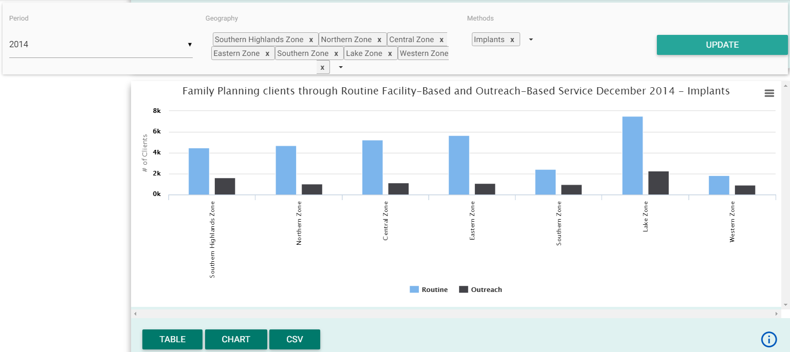

Figure 23: Example of selecting “Implant Clients through Routine vs Outreach-based service” across all zones, in the current month

Alternatively, you can use this chart to compare the number of clients by service modality (routine vs outreach) between FP methods in one geographical area (e.g. all methods in Pwani Region as in Figure 24 below).

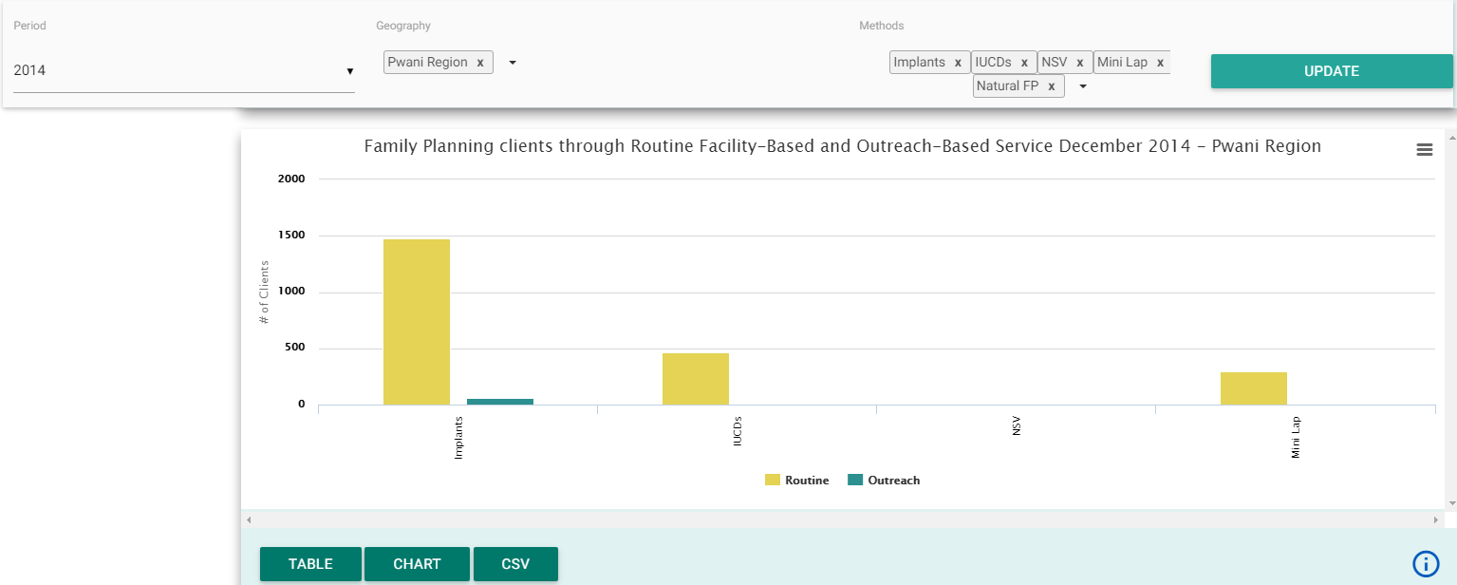

Figure 24 Example of selecting “FP Clients through Routine vs Outreach-based service in Pwani Region” for all long acting and permanent methods, in the current month

*Note: If you select a short-acting method for this chart, no graph will display as these are not offered in outreach services.*

#### 2.3.2.4 Stock-outs Charts

The stock-out section of the Dashboard displays charts that illustrate stock-outs of injectable and oral pill contraceptive commodities in the country, as well as the relation between facilities that are stocked-out and that have trained health workers. These charts are useful for understanding the strength of the FP supply chain in the country and to inform decisions on procurement and distribution planning.

If you are interested in information on stock-out of FP commodities, click on the “Stock-outs” button and then, depending of your information need, you can select to display any of the two stock-out charts by clicking on the respective sub-tabs in the stock-out menu.

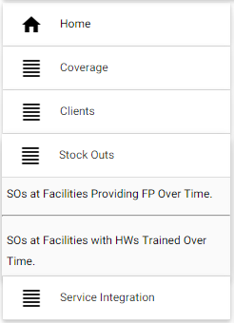

Figure 25: Selecting Family Planning Stock-outs Information Tab

* **Stock-outs at Facilities Providing FP Over Time**

This sub-tab displays one chart which shows the percentage of reporting facilities (facilities that report in the FP DHIS-2 tool) that experienced a stock-out of pills or injectables for any number of days per month, in the specified geography and 12-month period. It can be used to monitor trends over time for a given geographic selection, or to compare trends between multiple regions.

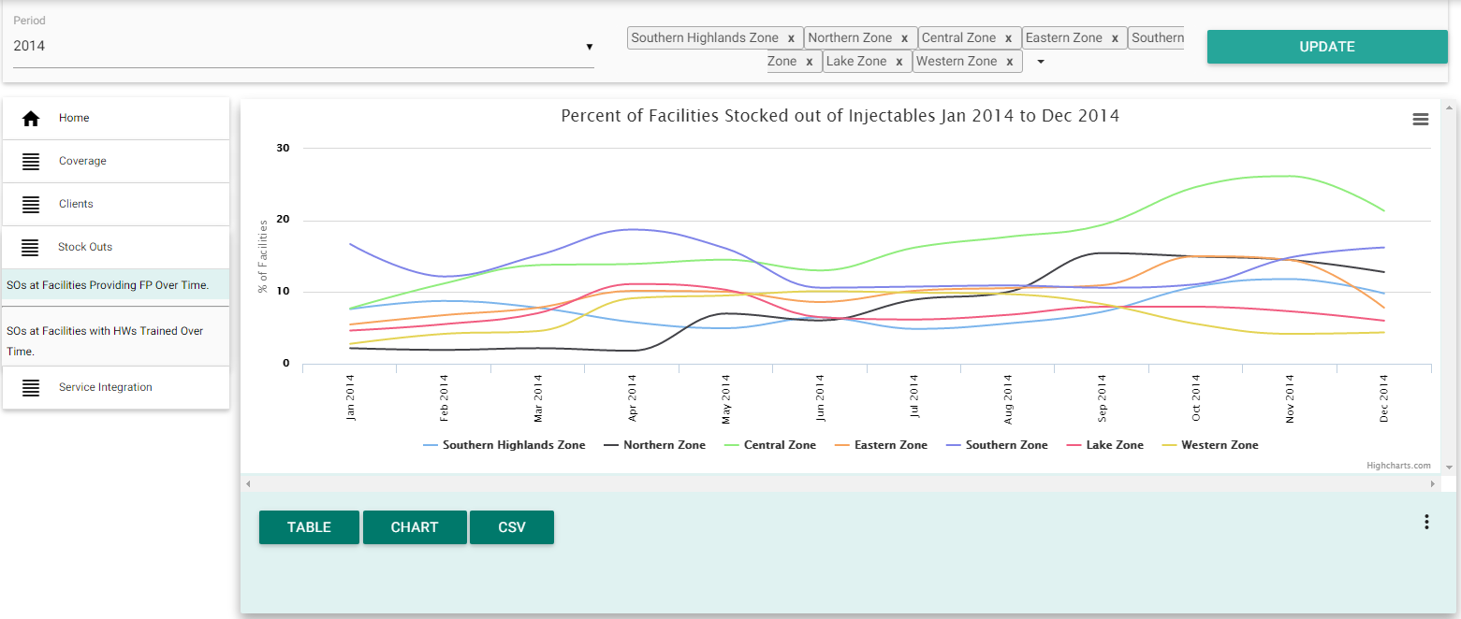

Figure 26: Selecting “Percent of Facilities Stocked-out of Pills or Injectables” chart

* **Stock-outs at Facilities with HWs Trained over Time**

This sub-tab displays one chart which shows the percentage of reporting facilities (facilities that report in the FP DHIS-2 tool) *that have at least one trained provider in short-acting methods* and experienced a stock-out of pills or injectables for any number of days per month, in the specified geography and 12-month period. Unlike the first stock-out chart, this chart now provides information on stock-outs specifically among facilities that should be providing oral pills and injectable contraceptives because they have a trained health worker.

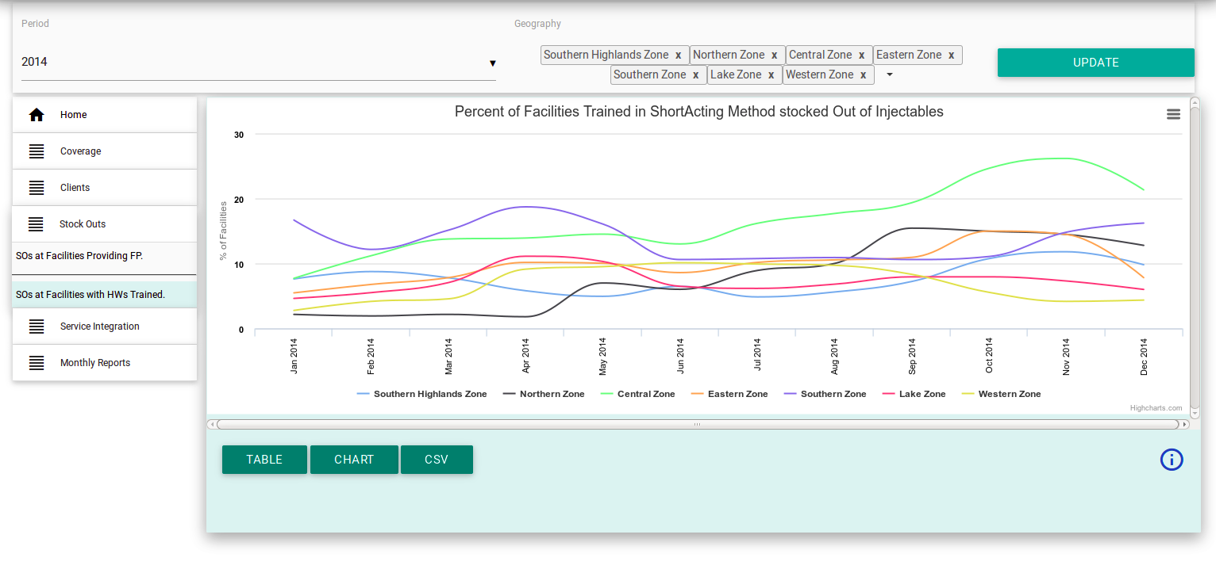

Figure 27: Selecting “Percent of Facilities Trained in Short-Acting Method but stocked out of Pill or injectable” chart

*Note: For 2014 data, these stock-out charts will only show data for injectables as this was the only data collected at the time. For 2015 data and onwards, these charts will show combined data for injectables and contraceptive pills (i.e. facilities stocked out of either method).*

#### 2.3.2.5 Service Integration Charts

The service integration section of the Dashboard displays charts with information on key service areas that are integrated with FP service delivery: post abortion and miscarriage care, post-partum services, and HIV testing and counseling (HTC).

If you are interested in information on integration of FP services, click on the ‘Service Integration’ button and sub-tab to display the three service integration charts.

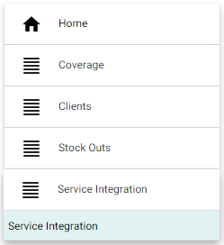

Figure 28: Selecting Family Planning Service Integration Information Tab

This sub tab displays three charts. You can scroll the page up and down to view all charts.

1. The first chart allows you to view trends in the percentage of clients who adopted FP methods after miscarriage or abortion, in the specified geography and 12-month period.

It can be used to monitor trends over time for a given geographic selection, or to compare trends between multiple regions.

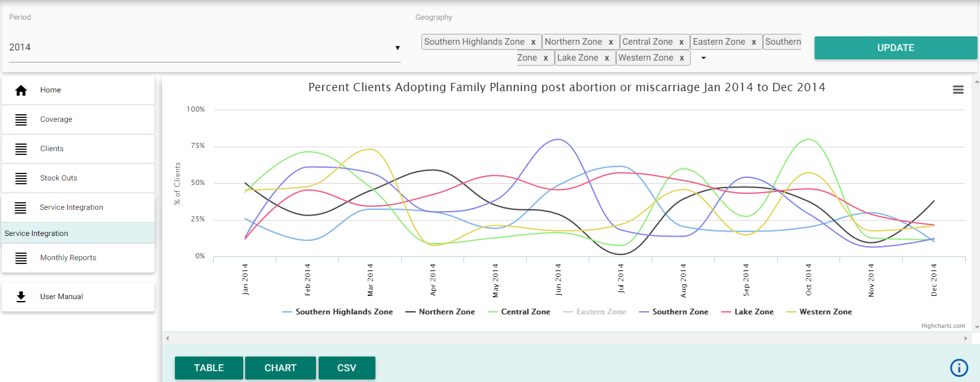

Figure 29: Selecting “Percent Clients Adopting Family Planning post abortion or miscarriage” chart (1st chart in Service Integration tab)

1. The second chart allows you to view trends in the total number of clients adopting FP within 42 days of delivery, in the specified geography and 12-month period.

It can be used to monitor trends over time for a given geographic selection. It can also be used to compare trends between multiple regions but this should be interpreted with caution as the chart shows absolute numbers, not percentages, so the geographic selections may not be comparable without knowledge of the number of deliveries in that geographic area.

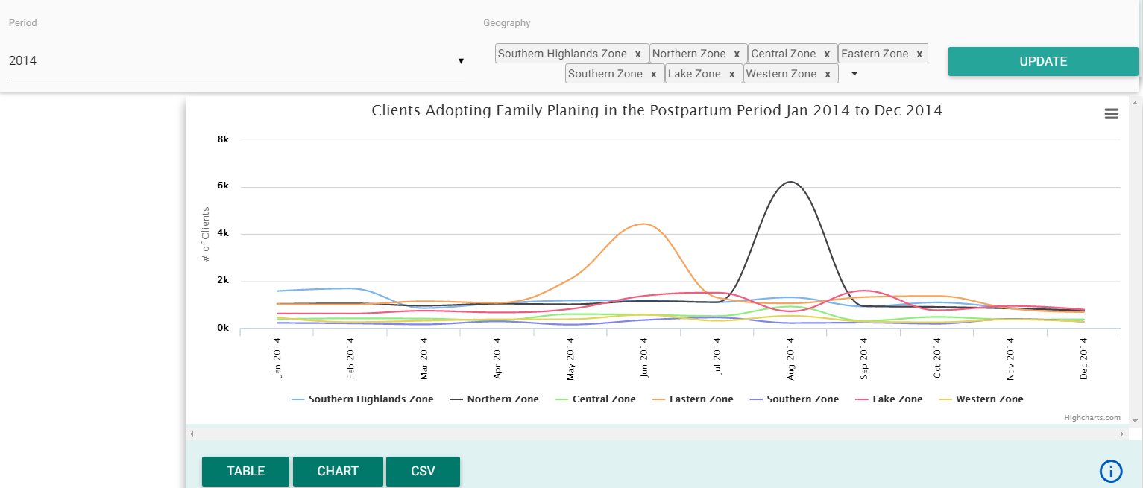

Figure 30: Selecting “Clients Adopting Family Planning in the Postpartum Period” chart (2nd chart in Service Integration tab)

1. The third chart allows you to view trends in percentage of HIV-negative/status-unknown FP clients who were tested for HIV/ adopted HTC, in the specified geography and 12-month period.

It can be used to monitor trends over time for a given geographic selection, or to compare trends between multiple regions.

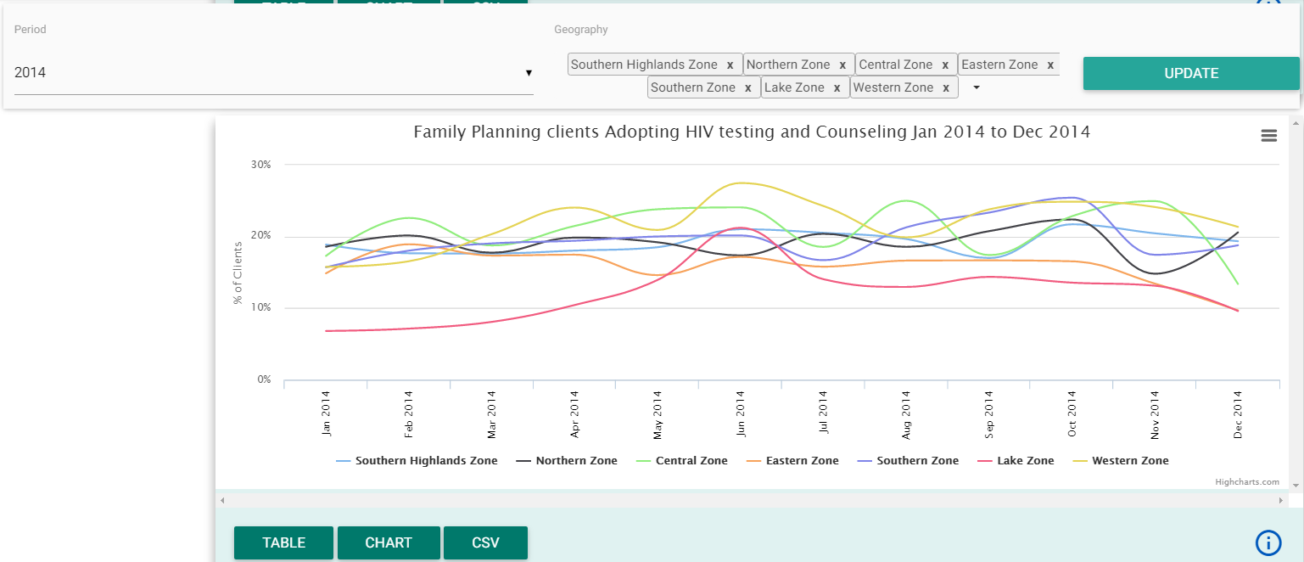

Figure 31: Selecting “Percent Family Planning Clients Adopting HIV Testing and Counselling” chart (2nd chart in Service Integration tab)

#### 2.3.2.6 Report Subscription tab

The FP Dashboard automatically generates monthly reports for national and sub-national users. They summarize key FP indicators and list suggested action items at national, regional, and district levels, specific to each geography.

These reports are automatically sent via email on a monthly basis, to Reproductive and Child Health Coordinators (RCHCos) and other subscribing users, tailored to the geographical area managed. For example, the Regional RCHCo for Pwani Region will receive the Pwani Region report whilst the District RCHCo for Geita District Council will receive the Geita District Council report.

Implementing partners and other NGOs wishing to receive monthly PDF reports can subscribe through the ‘Monthly Reports’ button on the left side menu by doing the following:

1. Enter your name
2. Enter your email address
3. Select report area(s).

* Click on the ‘‘+” sign to expand the tree then click on the respective region, district council, or Tanzania to select.
* Each selection (either Tanzania national report or each regional or district-level report) is added to your list when you click on it. To remove it from the selection, click on the “X” icon after the name in the list.

1. After completing steps 1 to 3 a subscribe button will appear, click on “Subscribe” and you will be receiving monthly report of the selected report area(s).

*Note: You can select any number of reporting areas i.e. district(s), region(s), and/or national and you will receive an email of the monthly PDF report for all selected report area.*

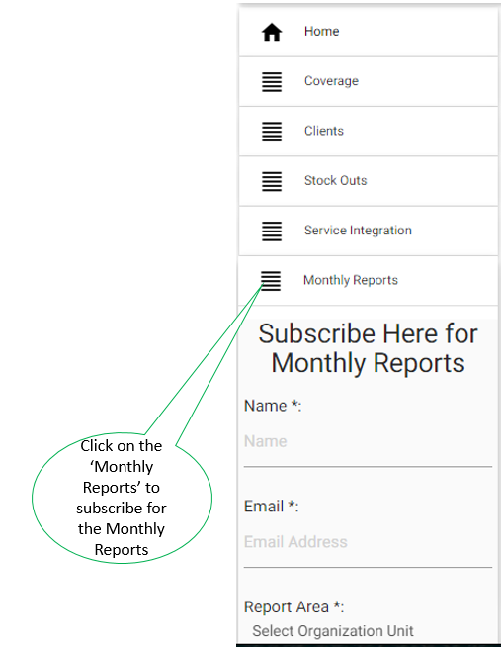

Figure 32: Subscribing for Monthly Reports

## 2.3.3 Chart Features

Each of the charts displayed on the FP dashboard has extra features to help you get the most out of the information presented. These additional features are as follows:

1. You can switch between viewing the data as a chart, a data table, and an excel file (CSV file).
2. You can get a description of the information presented on the chart and how it was calculated.
3. You can download an image of the chart either for printing or for pasting into reports or presentations.
4. You can quickly hide or unhide some data presented on the chart without using the selection menus.

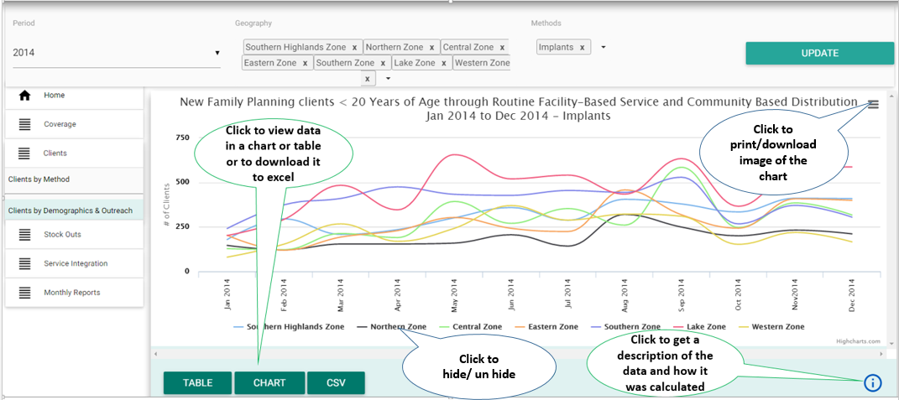

Figure 33: Additional Features

#### 2.3.3.1 View as chart or table

You will notice that seeing the data as a chart is the default presentation of the information selected in the FP dashboard. There can be one to three charts on each page and you may need to scroll the page up and down to view all charts.

If you wish to see the data in numbers, you can:

1. Click on the “TABLE” button at the bottom left of the chart.
2. You can then click on the “CHART” button to switch back to viewing the information in a chart.

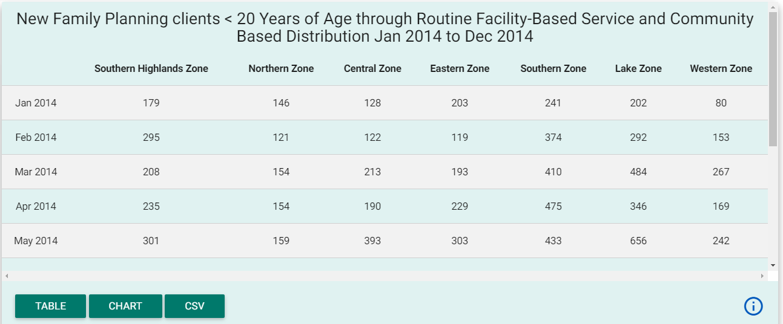

Figure 34: Example of “New FP clients <20 Years of Age” data viewed as a table

#### 2.3.3.2 Download data as CSV

You can also download the information presented in each chart or table as CSV format and manipulate the data using other spreadsheet applications such as Excel. To do this:

1. Select the CSV menu, the third menu at the bottom left of a particular chart, to download data as CSV.
2. Once the file has downloaded, you can open and view the file and data as an Excel spreadsheet.

#### 2.3.3.3 Print or download the chart

You can print or download the chart as an image, to add to presentations or reports. To do this:

1. Select the menu at the top right of the particular chart.
2. If you want to print the chart select print from the list, select printer and then print (the next steps depend on the internet browser).
3. If you want to download an image of the chart, select “Download PNG image,” “Download JPEG image,” “Download PDF document,” or “Download SVG vector image” to download the chart into the respective format according to your needs.

#### 2.3.3.4 Get description of the chart or table

You can view more details about the chart or table, to find out how it can be interpreted, how the data was calculated and the data source. To do this:

1. Click on the “i” icon in the bottom right corner of each chart or table.
2. Click on the “X” icon at the top right of the description screen to close it and return to the chart or table.

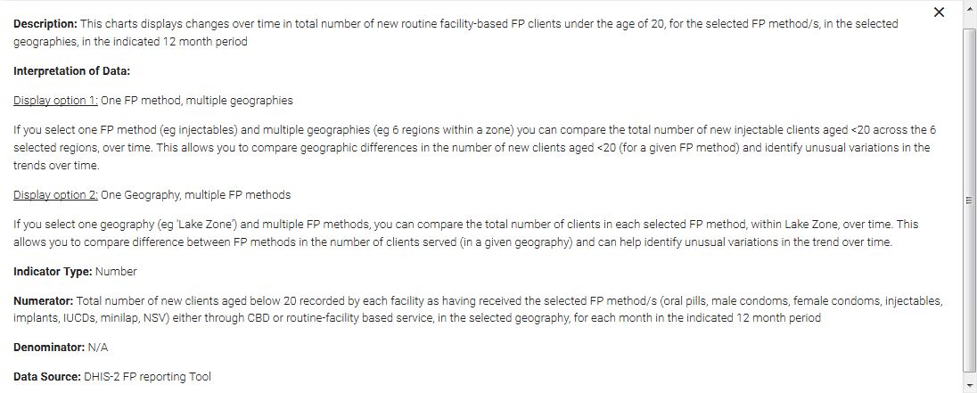

Figure 35: Example of “New FP clients <20 Years of Age” chart information

#### 2.3.3.5 Hide and unhide data

You can quickly hide or unhide data without changing any settings. To do this:

1. Click on the series at the bottom of the chart to hide it from the current chart. If you click on it, the data will be removed from the chart and the legend for the ‘hidden’ data will be ‘greyed out.’
2. To view hidden data again (unhide it), you can click on it again and it will re-appear.

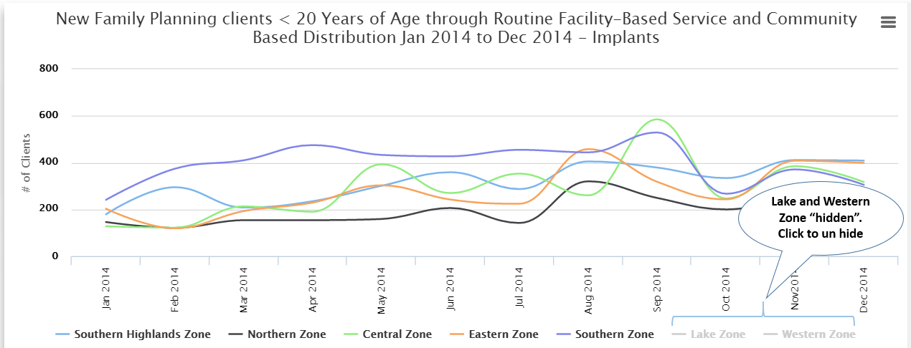

Figure 36: Example of “New FP clients <20 Years of Age” chart with Lake and Western Zone “hidden”

#### 2.3.3.6 View data label on the chart

If you want to view a value of data presented at a particular point of a line or bar on the chart, you can hover on the chart line or bar of your interest and the value of data presented at that particular point or bar of the chart will appear as a label.

## 2.3.4 PDF Reports

The FP Dashboard automatically generates monthly reports for national and sub-national users. They summarize key FP indicators and list suggested action items at national, regional, and district levels, specific to each geography.

These reports are automatically sent via email on a monthly basis, to RCHCos and other subscribing users, tailored to the geographical area managed. For example, the Regional RCHCo for Pwani Region will receive the Pwani Region report whilst the District RCHCo for Geita District Council will receive the Geita District Council report.

Implementing partners and other NGOs wishing to receive monthly PDF reports can subscribe through the ‘Monthly Reports’ button on the left side menu by following steps described in section 2.3.2.6 of this report.

# 

# 3. Appendices

## Appendix 1: Overview of Home Page

|  |  |  |  |  |  |
| --- | --- | --- | --- | --- | --- |
| **Indicator** | **Description** | **Interpretation of Data** | **Indicator type** | **Numerator/Denominator** | **Data Source** |
| Total Health Workers Trained in FP methods, Nationally [Month] [Year] | This charts displays the current total number of health workers trained in each FP method, nationally, in the indicated month | You can use this chart to compare the total number of health workers trained in each FP method, at a National level. This provides a high-level overview of which FP methods have larger gaps in number of health workers trained, nationally. | Number | Numerator: Total number of health workers that have achieved training competency in each FP method (short-acting, implants, IUCDs, minilap, NSV), Nationally, in the indicated month.  Denominator: N/A | TrainTracker |
| Family Planning Clients by Method through Routine Facility-Based Service, Nationally [Month] [Year] to [Month] [Year] | This charts displays changes over time in total number of routine facility-based FP clients for each FP method, nationally, in the indicated 12 month period | You can use this chart to compare the total number of clients in each FP method, Nationally, over time. This allows you to compare National-level difference between FP methods in the number of clients served and can help identify unusual variations in the trend over time. | Number | Numerator: Total number of clients recorded by each facility for each FP method (oral pills, male condoms, female condoms, injectables, implants, IUCDs, minilap, NSV), Nationally, for each month in the indicated 12 month period.   Denominator: N/A | DHIS-2 FP reporting Tool |
| Percent All Facilities with a Health Worker Trained in Short-Acting Methods Stocked Out of Pills or Injectables, Nationally, [Month] [Year] to [Month] [Year] | This charts displays changes over time in the percentage of facilities, nationally, that have a trained health worker in short-acting methods AND reported stock-out of either pills or injectables (as a proportion of all facilities that are eligible to provide FP services), in the indicated 12 month period | You can use this chart to monitor changes over time (an unusual variations in trends) of percentage of facilities that have at least on health worker trained in short-acting methods AND were stocked out of pills or injectables, Nationally. | Percentage | Numerator: Total number of facilities nationally that: (i) are eligible to provide FP services AND (ii) report in the tracer-medicines reporting tool  AND (iii) have one or more healthworkers that have achieved training competency in short-acting FP methods AND iv) reported a stock out of pills OR injectables for any number of days  For each month in the indicated 12 month period   Denominator: Total number of facilities nationally that: (i) are eligible to provide FP services AND (ii) report in the tracer-medicines reporting tool AND (iii) have one or more healthworkers that have achieved training competency in short-acting FP methods In the selected geography, for each month in the indicated 12 month period | TrainTracker and DHIS-2 Tracer Commodity Tool |
| Percent Facilities Providing FP methods, Nationally [Month] [Year] to [Month] [Year] | This charts displays the percentage of all facilities, nationally, that provided each FP method (as a proportion of all facilities that are eligible to provide FP services), in the indicated 12 month period | You can use this chart to compare the percentage of all facilities that provided each FP method over the indicated 12 month-period, nationally. This allows you to monitor high-level changes over time in service provision across FP method types. | Percentage | Numerator: Total number of all facilities nationally, that are eligible to provide FP services and that recorded at least one client (of any age, new or returning) through routine/facility-based services, for each FP method (oral pills, male condoms, female condoms, injectables, implants, IUCDs, minilap, NSV), for each month in the indicated 12 month period .  Denominator: Total number of facilities, nationally, that are eligible to provide FP services, for each month in the indicated 12 month period | DHIS-2 FP reporting Tool |

## Appendix 2: Overview of Coverage Charts

|  |  |  |  |  |  |  |  |
| --- | --- | --- | --- | --- | --- | --- | --- |
| **Sub-tab** | **Indicator** | **Description** | **Display options** | **Interpretation of Data** | **Indicator type** | **Numerator/Denominator** | **Data Source** |
| HWS TRAINED | Total Health Workers Trained in FP method/s, [Month] [Year] | This charts displays the current total number of health workers trained in the selected FP method/s, in the selected geographies, in the indicated month | One FP method, multiple geographies | If you select one FP method (e.g. implants) and multiple geographies (e.g. 6 districts within your region) you can compare the total number of health workers trained in implants across the 6 selected districts. This allows you to identify which districts have the larger gaps in number health workers trained in implants. | Number | Numerator: Total number of health workers that have achieved training competency in selected FP method/s (short-acting, implants, IUCDs, minilap, NSV) in the selected geography in the indicated month  Denominator: N/A | TrainTracker |
| One geography, multiple FP methods | If you select one geography (e.g. 'Pwani Region') and multiple FP methods, you can compare the total number of health workers trained in each selected FP method, within Pwani Region. This allows you to identify which FP methods have the larger gaps in number of health workers trained, in Pwani Region |

|  |  |  |  |  |  |  |  |
| --- | --- | --- | --- | --- | --- | --- | --- |
| **Sub-tab** | **Indicator** | **Description** | **Display options** | **Interpretation of Data** | **Indicator type** | **Numerator/Denominator** | **Data Source** |
| FACILITIES WITH HWS TRAINED | Percent Hospitals with ≥ 2 Health Workers Trained in FP method/s, [Month] [Year] | This charts displays the percentage of hospitals with two or more health workers trained in the selected FP method/s (as a proportion of all hospitals that are eligible to provide FP services) in the selected geographies, in the indicated month | One FP method, multiple geographies | If you select one FP method (e.g. implants) and multiple geographies (e.g. 6 districts within a region) you can compare the total percent of Hospitals with two or more health workers trained in implants across the 6 selected districts. This allows you to identify geographic areas that should be prioritized for implant training.  Note: the national target is for all facilities to have at least two providers trained in each FP method | Percentage | Numerator: Total number of hospitals that are eligible to provide FP services that have two or more healthworkers that have achieved training competency in the selected FP method/s (short-acting, implants, IUCDs, minilap, NSV) in the selected geography in the indicated 12 month period   Denominator: Total number of hospitals that are eligible to provide FP services, in the selected geography for each month in the indicated 12 month period | TrainTracker |
| One geography, multiple FP methods | If you select one geography (e.g. 'Lake Zone') and multiple FP methods, you can compare the percentage of hospital with two or more health workers trained in each selected FP method, within the Lake Zone. This allows you to identify which methods may require further training, in the Lake Zone. Note: the national target is for all facilities to have at least two providers trained in each FP method |
| Percent Health Centers with ≥ 2 Health Workers Trained in FP method/s, [Month] [Year] | This charts displays the percentage of Health Centers with two or more health workers trained in the selected FP method/s (as a proportion of all health centers that are eligible to provide FP services), in the selected geographies, in the indicated month | One FP method, multiple geographies | If you select one FP method (e.g. implants) and multiple geographies (e.g. 6 districts within a region) you can compare the total percent of health centers with two or more health workers trained in implants across the 6 selected districts. This allows you to identify geographic areas that should be prioritized for implant training.  Note: the national target is for all facilities to have at least two providers trained in each FP method | Percentage | Numerator: Total number of health centers that are eligible to provide FP services that have two or more healthworkers that have achieved training competency in the selected FP method/s (short-acting, implants, IUCDs, minilap, NSV) in the selected geography in the indicated 12 month period   Denominator: Total number of health centers that are eligible to provide FP services, in the selected geography for each month in the indicated 12 month period | TrainTracker |
| One geography, multiple FP methods | If you select one geography (e.g. 'Lake Zone') and multiple FP methods, you can compare the percentage of health centers with two or more health workers trained in each selected FP method, within the Lake Zone. This allows you to identify which methods may require further training, in the Lake Zone. Note: the national target is for all facilities to have at least two providers trained in each FP method |
| Percent Dispensaries with ≥ 2 Health Workers Trained in FP method/s, [Month] [Year] | This charts displays the percentage of dispensaries with two or more health workers trained in the selected FP method/s (as a proportion of all dispensaries that are eligible to provide FP services), in the selected geographies, in the indicated month | One FP method, multiple geographies | If you select one FP method (e.g. implants) and multiple geographies (e.g. 6 districts within a region) you can compare the total percent of dispensaries with two or more health workers trained in implants across the 6 selected districts. This allows you to identify geographic areas that should be prioritized for implant training.  Note: the national target is for all facilities to have at least two providers trained in each FP method | Percentage | Numerator: Total number of dispensaries that are eligible to provide FP services that have two or more healthworkers that have achieved training competency in the selected FP method/s (short-acting, implants, IUCDs, minilap, NSV) in the selected geography in the indicated 12 month period  Denominator: Total number of dispensaries that are eligible to provide FP services, in the selected geography for each month in the indicated 12 month period | TrainTracker |
| One geography, multiple FP methods | If you select one geography (e.g. 'Lake Zone') and multiple FP methods, you can compare the percentage of dispensaries with two or more health workers trained in each selected FP method, within the Lake Zone. This allows you to identify which methods may require further training, in the Lake Zone. Note: the national target is for all facilities to have at least two providers trained in each FP method |

|  |  |  |  |  |  |  |  |
| --- | --- | --- | --- | --- | --- | --- | --- |
| **Sub-tab** | **Indicator** | **Description** | **Display options** | **Interpretation of Data** | **Indicator type** | **Numerator/Denominator** | **Data Source** |
| FACILITIES PROVIDING FP OVER TIME | Percent Hospitals Providing FP method/s[Month] [Year] to [Month] [Year] | This charts displays the percentage of hospitals that provided selected FP method/s (as a proportion of all hospitals that are eligible to provide FP services) in the selected geographies, in the indicated 12 month period | One FP method, multiple geographies | If you select one FP method (e.g. IUCDs) and multiple geographies (e.g. 6 districts within a region) you can compare the percentage of hospitals that provided IUCDs across the 6 selected districts, over the indicated 12 month period. This allows you to monitor changes over time in provision of IUCDs in the selected districts. | Percentage | Numerator: Total number of hospitals that are eligible to provide FP services that recorded at least one client (of any age, new or returning) through routine/facility-based services, for selected FP method/s (oral pills, male condoms, female condoms, injectables, implants, IUCDs, minilap, NSV) , in the selected geography for each month in the indicated 12 month period  Denominator: Total number of hospitals that are eligible to provide FP services, in the selected geography for each month in the indicated 12 month period | DHIS-2 FP reporting Tool |
| One geography, multiple FP methods | If you select one geography (e.g. 'Western Zone') and multiple FP methods, you can compare the percentage of hospitals that provided selected FP methods, within the Western Zone. This allows you to monitor changes over time in service provision across FP method types, |
| Percent Health Centers Providing FP method/s, [Month] [Year] to [Month] [Year] | This charts displays the percentage of health centers that provided selected FP method/s (as a proportion of all health centers that are eligible to provide FP services) in the selected geographies, in the indicated 12 month period | One FP method, multiple geographies | If you select one FP method (e.g. IUCDs) and multiple geographies (e.g. 6 districts within a region) you can compare the percentage of health centers that provided IUCDs across the 6 selected districts, over the indicated 12 month period. This allows you to monitor changes over time in provision of IUCDs in the selected districts, to help identify lower performing zones/regions/district for follow-up. | Percentage | Numerator: Total number of health centers that are eligible to provide FP services that recorded at least one client (of any age, new or returning) through routine/facility-based services, for selected FP method/s (oral pills, male condoms, female condoms, injectables, implants, IUCDs, minilap, NSV) , in the selected geography for each month in the indicated 12 month period   Denominator: Total number of health centers that are eligible to provide FP services, in the selected geography for each month in the indicated 12 month period | DHIS-2 FP reporting Tool |
| One geography, multiple FP methods | If you select one geography (e.g. 'Western Zone') and multiple FP methods, you can compare the percentage of health centers that provided selected FP methods, within the Western Zone. This allows you to monitor changes over time in service provision across FP method types. |
| Percent Dispensaries Providing FP method/s, [Month] [Year] to [Month] [Year] | This charts displays the percentage of dispensaries that provided selected FP method/s (as a proportion of all dispensaries that are eligible to provide FP services) in the selected geographies, in the indicated 12 month period | One FP method, multiple geographies | If you select one FP method (e.g. IUCDs) and multiple geographies (e.g. 6 districts within a region) you can compare the percentage of dispensaries that provided IUCDs across the 6 selected districts, over the indicated 12 month period. This allows you to monitor changes over time in provision of IUCDs in the selected districts, to help identify lower performing zones/regions/district for follow-up. | Percentage | Numerator: Total number of dispensaries that are eligible to provide FP services that recorded at least one client (of any age, new or returning) through routine/facility-based services, for selected FP method/s (oral pills, male condoms, female condoms, injectables, implants, IUCDs, minilap, NSV) , in the selected geography for each month in the indicated 12 month period Denominator: Total number of dispensaries that are eligible to provide FP services, in the selected geography for each month in the indicated 12 month period | DHIS-2 FP reporting Tool |
| One geography, multiple FP methods | If you select one geography (e.g. 'Western Zone') and multiple FP methods, you can compare the percentage of dispensaries that provided selected FP methods over the indicated 12 month-period, within the Western Zone. This allows you to monitor changes over time in service provision across FP method types. |

|  |  |  |  |  |  |  |  |
| --- | --- | --- | --- | --- | --- | --- | --- |
| **Sub-tab** | **Indicator** | **Description** | **Display options** | **Interpretation of Data** | **Indicator type** | **Numerator/Denominator** | **Data Source** |
| FACILITIES PROVIDING FP THROUGH CBD | Percent Facilities Providing Pills or Condoms through Community Based Distribution, [Month] [Year] to [Month] [Year] | This charts displays the percentage of facilities that provided either pills or condoms through community-based distribution (as a proportion of all facilities that are eligible to provide FP services) in the selected geographies, in the indicated 12 month period | Geography selection only | You can select the geographical areas of interest to you (e.g. national; zones; regions; districts).This chart allows you to monitor changes over time in community-based distribution of condoms or pills in the selected geographies. This chart This allows you to identify lower performing zones/regions/district and to monitor unusual variations in the trend over time. | Percentage | Numerator: Total number of facilities that are eligible to provide FP services that recorded at least one pill or male or female condoms client (of any age, new or returning) through community-based distribution, in the selected geography for each month in the indicated 12 month period   Denominator: Total number of facilities that are eligible to provide FP services, in the selected geography for each month in the indicated 12 month period | DHIS-2 FP reporting Tool |

|  |  |  |  |  |  |  |  |
| --- | --- | --- | --- | --- | --- | --- | --- |
| **Sub-tab** | **Indicator** | **Description** | **Display options** | **Interpretation of Data** | **Indicator type** | **Numerator/Denominator** | **Data Source** |
| FACILITIES WITH HWS TRAINED IN AND PROVIDING FP | Percent Hospitals with a Health Worker Trained in and Providing FP Method/s, [Month] [Year] | This charts displays the percentage of hospitals that have at least one provider trained in selected FP method/s AND provided selected FP method/s (as a proportion of all hospitals that are eligible to provide FP services) in the selected geographies, in the indicated month | One FP method, multiple geographies | If you select one FP method (e.g. short-acting) and multiple geographies (e.g. 4 regions within a zone) you can compare the percentage of hospitals that have at least one health worker trained in providing short-acting methods AND provided at least one short-acting method across the 4 selected regions, over the indicated 12 month period. This allows you to monitor changes over time in provision of the selected FP method, among facilities with trained providers, in the selected regions. | Percentage | Numerator: Total number of hospitals that are:  (i) eligible to provide FP services AND (ii) have one or more healthworkers that have achieved training competency in the selected FP method/s (short-acting, implants, IUCDs, minilap, NSV)  AND (iii) have recorded at least one client (of any age, new or returning) through routine/facility-based services, for selected FP method/s (short-acting, implants, IUCDs, minilap, NSV)  In the selected geography for each month in the indicated 12 month period.  Denominator: Total number of hospitals that are:  (i) eligible to provide FP services AND (ii) have one or more healthworkers that have achieved training competency in the selected FP method/s (short-acting, implants, IUCDs, minilap, NSV)  In the selected geography for each month in the indicated 12 month period. | TrainTracker and DHIS-2 FP reporting Tool |
| One geography, multiple FP methods | If you select one geography (e.g. 'Kigoma Region') and multiple FP methods, you can compare the percentage of hospitals that have at least one health worker trained in providing the selected FP method/s AND provided at least one of the selected FP method/s, within the Kigoma Region. This allows you to monitor changes over time in service provision across FP method types, among facilities with trained providers |
| Percent Health Centers with a Health Worker Trained in and Providing, [Month] [Year] | This charts displays the percentage of health centers that have at least one provider trained in selected FP method/s AND provided selected FP method/s (as a proportion of all health centers that are eligible to provide FP services) in the selected geographies, in the indicated month | One FP method, multiple geographies | If you select one FP method (e.g. short-acting) and multiple geographies (e.g. 4 regions within a zone) you can compare the percentage of health centers that have at least one health worker trained in providing short-acting methods AND provided at least one short-acting method across the 4 selected regions, over the indicated 12 month period. This allows you to monitor changes over time in provision of the selected FP method, among facilities with trained providers, in the selected regions. | Percentage | Numerator: Total number of health centers that are:  (i) eligible to provide FP services AND (ii) have one or more healthworkers that have achieved training competency in the selected FP method/s (short-acting, implants, IUCDs, minilap, NSV)  AND (iii) have recorded at least one client (of any age, new or returning) through routine/facility-based services, for selected FP method/s (short-acting, implants, IUCDs, minilap, NSV)  In the selected geography for each month in the indicated 12 month period.  Denominator: Total number of health centers that are:  (i) eligible to provide FP services AND (ii) have one or more healthworkers that have achieved training competency in the selected FP method/s (short-acting, implants, IUCDs, minilap, NSV)  In the selected geography for each month in the indicated 12 month period. | TrainTracker and DHIS-2 FP reporting Tool |
| One geography, multiple FP methods | If you select one geography (e.g. 'Kigoma Region') and multiple FP methods, you can compare the percentage of health centers that have at least one health worker trained in providing the selected FP method/s AND provided at least one of the selected FP method/s, within the Kigoma Region. This allows you to monitor changes over time in service provision across FP method types, among facilities with trained providers |
| Percent Dispensaries with a Health Worker Trained in and Providing, [Month] [Year] | This charts displays the percentage of dispensaries that have at least one provider trained in selected FP method/s AND provided selected FP method/s (as a proportion of all dispensaries that are eligible to provide FP services) in the selected geographies, in the indicated month | One FP method, multiple geographies | If you select one FP method (e.g. short-acting) and multiple geographies (e.g. 4 regions within a zone) you can compare the percentage of dispensaries that have at least one health worker trained in providing short-acting methods AND provided at least one short-acting method across the 4 selected regions, over the indicated 12 month period. This allows you to monitor changes over time in provision of the selected FP method, among facilities with trained providers, in the selected regions. | Percentage | Numerator: Total number of dispensaries that are:  (i) eligible to provide FP services AND (ii) have one or more health workers that have achieved training competency in the selected FP method/s (short-acting, implants, IUCDs, minilap, NSV)  AND (iii) have recorded at least one client (of any age, new or returning) through routine/facility-based services, for selected FP method/s (short-acting, implants, IUCDs, minilap, NSV)  In the selected geography for each month in the indicated 12 month period.  Denominator: Total number of dispensaries that are:  (i) eligible to provide FP services AND (ii) have one or more health workers that have achieved training competency in the selected FP method/s (short-acting, implants, IUCDs, minilap, NSV)  In the selected geography for each month in the indicated 12 month period. | TrainTracker and DHIS-2 FP reporting Tool |
| One geography, multiple FP methods | If you select one geography (e.g. 'Kigoma Region') and multiple FP methods, you can compare the percentage of dispensaries that have at least one health worker trained in providing the selected FP method/s AND provided at least one of the selected FP method/s, within the Kigoma Region. This allows you to monitor changes over time in service provision across FP method types, among facilities with trained providers |

## Appendix 3: Overview of Client Charts

| **Sub-tab** | **Indicator** | **Description** | **Display options** | **Interpretation of Data** | **Indicator type** | **Numerator/Denominator** | **Data Source** |
| --- | --- | --- | --- | --- | --- | --- | --- |
| CLIENTS BY METHOD | Family Planning Clients by Method through Routine Facility-Based Service, [Month] [Year] | This charts displays the total number of new and returning routine facility-based FP clients for the selected FP method/s, in the selected geographies, for the indicated month | One FP method, multiple geographies | If you select one FP method (e.g. implants) and multiple geographies (e.g. 6 districts within your region) you can compare the total number of implants clients across the 6 selected districts. This allows you to identify which districts have the larger gaps in number of clients served. | Number | Numerator: Total number of new and returning clients recorded by each facility for the selected FP method/s (oral pills, male condoms, female condoms, injectables, implants, IUCDs, minilap, NSV) in the selected geography in the indicated month  *Note: for long-acting and permanent methods, the data is not disaggregated by 'new' and 'returning' so displays as 'totals'  Denominator: N/A | DHIS-2 FP reporting Tool |
| One geography, multiple FP methods | If you select one geography (e.g. 'Pwani Region') and multiple FP methods, you can compare the total number of clients in each selected FP method, within Pwani Region. This allows you to identify which FP methods have the larger gaps in number of clients served, in a given geography. |
| Family Planning Clients by Method through Routine Facility-Based Service], [Month] [Year] to [Month] [Year] | This charts displays changes over time in total number of routine facility-based FP clients for the selected FP method/s, in the selected geographies, in the indicated 12 month period | One FP method, multiple geographies | If you select one FP method (e.g. IUCDs) and multiple geographies (e.g. 6 regions within a zone) you can compare the total number of IUCD clients across the 6 selected regions, over time. This allows you to compare geographic differences in the number of clients served (for a given FP method) and identify unusual variations in the trend over time. | Number | Numerator: Total number of clients recorded by each facility for the selected FP method/s (oral pills, male condoms, female condoms, injectables, implants, IUCDs, minilap, NSV) in the selected geography, for each month in the indicated 12 month period  Denominator: N/A | DHIS-2 FP reporting Tool |
| One geography, multiple FP methods | If you select one geography (e.g. 'Kigoma Region') and multiple FP methods, you can compare the total number of clients in each selected FP method, within Kigoma Region, over time. This allows you to compare difference between FP methods in the number of clients served (in a given geography) and can help identify unusual variations in the trend over time. |
| CLIENTS BY DEMOGRAPHY AND OUTREACH | New Family Planning Clients < 20 Years of Age through Routine Facility-Based Service and Community Based Distribution (CBD), [Month] [Year] to [Month] [Year] | This charts displays changes over time in total number of new routine facility-based FP clients under the age of 20, for the selected FP method/s, in the selected geographies, in the indicated 12 month period | One FP method, multiple geographies | If you select one FP method (e.g. Injectables) and multiple geographies (e.g. 6 regions within a zone) you can compare the total number of new injectable clients aged <20 across the 6 selected regions, over time. This allows you to compare geographic differences in the number of new clients aged <20 (for a given FP method) and identify unusual variations in the trends over time. | Number | Numerator: Total number of new clients aged below 20 recorded by each facility as having received the selected FP method/s (oral pills, male condoms, female condoms, injectables, implants, IUCDs, minilap, NSV) either through CBD or routine-facility based service, in the selected geography, for each month in the indicated 12 month period  Denominator: N/A | DHIS-2 FP reporting Tool |
| One geography, multiple FP methods | If you select one geography (e.g. 'Lake Zone') and multiple FP methods, you can compare the total number of clients in each selected FP method, within Lake Zone, over time. This allows you to compare difference between FP methods in the number of clients served (in a given geography) and can help identify unusual variations in the trend over time. |
| Family Planning Clients through Routine Facility-Based and Outreach-Based Service, [Month] [Year] | This charts displays the total number of long-acting and/or permanent method FP clients through outreach vs routine service modalities, in the selected geographies, for the indicated month | One FP method, multiple geographies | If you select one long acting or permanent FP method (e.g. implants) and multiple geographies (e.g. 6 districts within your region) you can compare the total number of implant clients by outreach vs routine service modality, across the 6 selected districts. This allows you to compare the number of clients and the service modality across geographic areas, in a given month. | Number | Series 1: ("Routine Facility-Based Services"): Numerator:  Total number of clients recorded by each facility as having received the selected permanent or long acting FP method/s (implants, IUCDs, minilap, NSV) through routine facility-based service modality, in the selected geography, for the indicated month Denominator: N/A  Series 2: ("Outreach-Based Services) Numerator:  Total number of clients recorded by each facility as having received the selected permanent or long acting FP method/s (implants, IUCDs, minilap, NSV) through outreach-based service modality, in the selected geography, for the indicated month Denominator: N/A | DHIS-2 FP reporting Tool |
| One geography, multiple FP methods | If you select one geography (e.g. 'Morogoro District Council') and multiple long acting and/or permanent FP methods, you can compare the total number of clients in each selected FP method, within Morogoro DC. This allows you to compare the total number of clients and the service modality between different FP methods, in a given geography, in a given month. |

## Appendix 4: Overview of Stock-Out Charts

|  |  |  |  |  |  |  |  |
| --- | --- | --- | --- | --- | --- | --- | --- |
| **Sub-tab** | **Indicator** | **Description** | **Display options** | **Interpretation of Data** | **Indicator type** | **Numerator/Denominator** | **Data Source** |
| SOS AT FACILITIES PROVIDING FP | Percent All Facilities Stocked Out of Pills or Injectables , [Month] [Year] to [Month] [Year] | This charts displays changes over time in the percentage of facilities that reported stock-out of either pills or injectable (as a proportion of all facilities that are eligible to provide FP services), in the selected geographies, in the indicated 12 month period | Geography selection only | You can select the geographical areas of interest to you (e.g. national; zones; regions; districts).This chart allows you to monitor changes over time in percentage of facilities stocked out of pills or injectables, in the selected geographies. This chart helps to identify lower performing zones/regions/district and to monitor unusual variations in the trend over time. | Percentage | Numerator: Total number of facilities that are eligible to provide FP services and report in the tracer-medicines reporting tool, that reported a stock out of pills OR injectables for any number of days, in the selected geography, for each month in the indicated 12 month period  Denominator: Total number of facilities that are eligible to provide FP services and report in the tracer-medicines reporting tool, in the selected geography, for each month in the indicated 12 month period | DHIS-2 Tracer Commodity Tool |
| SOS AT FACILITIES WITH HWS TRAINED | Percent All Facilities with a Health Worker Trained in Short-Acting Methods Stocked Out of Pills or Injectables, [Month] [Year] to [Month] [Year] | This charts displays changes over time in the percentage of facilities that have a trained health worker in short-acting methods AND reported stock-out of either pills or injectables (as a proportion of all facilities that are eligible to provide FP services), in the selected geographies, in the indicated 12 month period | Geography selection only | You can select the geographical areas of interest to you (e.g. national; zones; regions; districts).This chart allows you to monitor changes over time in percentage of facilities that have at least on health worker trained in short-acting methods AND were stocked out of pills or injectables, in the selected geographies. This chart helps to identify lower performing zones/regions/district and to monitor unusual variations in the trend over time. | Percentage | Numerator: Total number of facilities that: (i) are eligible to provide FP services AND (ii) report in the tracer-medicines reporting tool AND (iii) have one or more healthworkers that have achieved training competency in short-acting FP methods AND (iv) Reported a stock out of pills OR injectables for any number of days In the selected geography, for each month in the indicated 12 month period   Denominator: Total number of facilities that: (i) are eligible to provide FP services AND (ii) report in the tracer-medicines reporting tool AND (iii) have one or more healthworkers that have achieved training competency in short-acting FP methods In the selected geography, for each month in the indicated 12 month period | TrainTracker and DHIS-2 Tracer Commodity Tool |

## Appendix 5: Overview of Service Integration Charts

|  |  |  |  |  |  |  |  |
| --- | --- | --- | --- | --- | --- | --- | --- |
| **Sub-tab** | **Indicator** | **Description** | **Display options** | **Interpretation of Data** | **Indicator type** | **Numerator/Denominator** | **Data Source** |
| SERVICE INTEGRATION | Percent Clients Adopting Family Planning Post Abortion or Miscarriage, [Month] [Year] to [Month] [Year] | This charts displays changes over time in the percentage of clients that adopted family planning following post abortion or miscarriage care services (at the FP service entry point), in the selected geographies, in the indicated 12 month period | Geography selection only | You can select the geographical areas of interest to you (e.g. national; zones; regions; districts).This chart allows you to monitor changes over time in proportion of cPAC clients who take up an FP method after cPAC services. This chart helps to identify lower performing zones/regions/district and to monitor unusual variations in the trend over time. | Percentage | Numerator: Among facilities that are eligible to provide FP services, the total number of clients that received each family planning method (Jadelle, Implanon, other) after MVA or D+C for miscarriage or abortion; in the selected geography, for each month in the indicated 12 month period   Denominator: Among facilities that are eligible to provide FP services, the total number of clients that received MVA or D+C for miscarriage or abortion; in the selected geography, for each month in the indicated 12 month period | DHIS-2 FP reporting Tool |
| Clients Adopting Family Planning in the Postpartum Period, [Month] [Year] to [Month] [Year] | This charts displays changes over time in the total number of clients that adopted family planning in the Postpartum period (at the FP service entry point), in the selected geographies, in the indicated 12 month period | Geography selection only | You can select the geographical areas of interest to you (e.g. national; zones; regions; districts).This chart allows you to monitor changes over time in the number of post-partum clients who take up an FP method42 days after delivery. Note that this trend line shows total numbers so might fluctuate according to number of live births per month in a given facility, but should be generally increasing. This chart helps to identify lower performing zones/regions/district and to monitor unusual variations in the trend over time. | Number | Numerator: Among facilities that are eligible to provide FP services, the total number of clients that received each family planning method (Jadelle, Implanon, other) within 42 days of delivery; in the selected geography, for each month in the indicated 12 month period   Denominator: N/A | DHIS-2 FP reporting Tool |
| Percent Family Planning Clients Adopting HIV Testing and Counselling (HTC), [Month] [Year] to [Month] [Year] | This charts displays changes over time in the percentage of all HIV- negative or status unknown FP clients that adopted HIV Testing and Counselling, in the selected geographies, in the indicated 12 month period | Geography selection only | You can select the geographical areas of interest to you (e.g. national; zones; regions; districts).This chart allows you to monitor changes over time in the proportion of HIV negative or status unknown FP clients who adopted HTC at the FP service entry point. This chart helps to identify lower performing zones/regions/district and to monitor unusual variations in the trend over time. | Percentage | Numerator: Among facilities that are eligible to provide FP services, the total number of clients of any age that tested for HIV; in the selected geography, for each month in the indicated 12 month period   Denominator: Among facilities that are eligible to provide FP services, the total number of clients of all ages for all FP methods (male condoms, female condoms, pill, injectables, implants, IUCD, minilap, NSV) minus the total number of FP clients who are known to be HIV positive; in the selected geography, for each month in the indicated 12 month period | DHIS-2 FP reporting Tool |

1. ## The Clinton Health Access Initiative, Inc. (CHAI) is a global health organization committed to strengthening integrated health systems and expanding access to care and treatment in the developing world. CHAI’s solution-oriented approach focuses on improving market dynamics for medicines and diagnostics; lowering prices for treatment; accelerating access to lifesaving technologies; and helping governments build the capacity required for high-quality care and treatment programs. Since its inception, CHAI’s programs have helped more than 11.6 million people in more than 70 countries have access to CHAI-negotiated prices for HIV/AIDS medicines and have led to more than US$3 billion in savings for developing countries. For more information, please visit: [www.clintonhealthaccess.org](http://www.clintonhealthaccess.org).

  
2. http://www.rchs.go.tz/traintracker/