BOXPLOTS

BoxPlots of indices by Ipsilateral Breast Events (IBE)

PROGNOSTIC INDEX in the training set

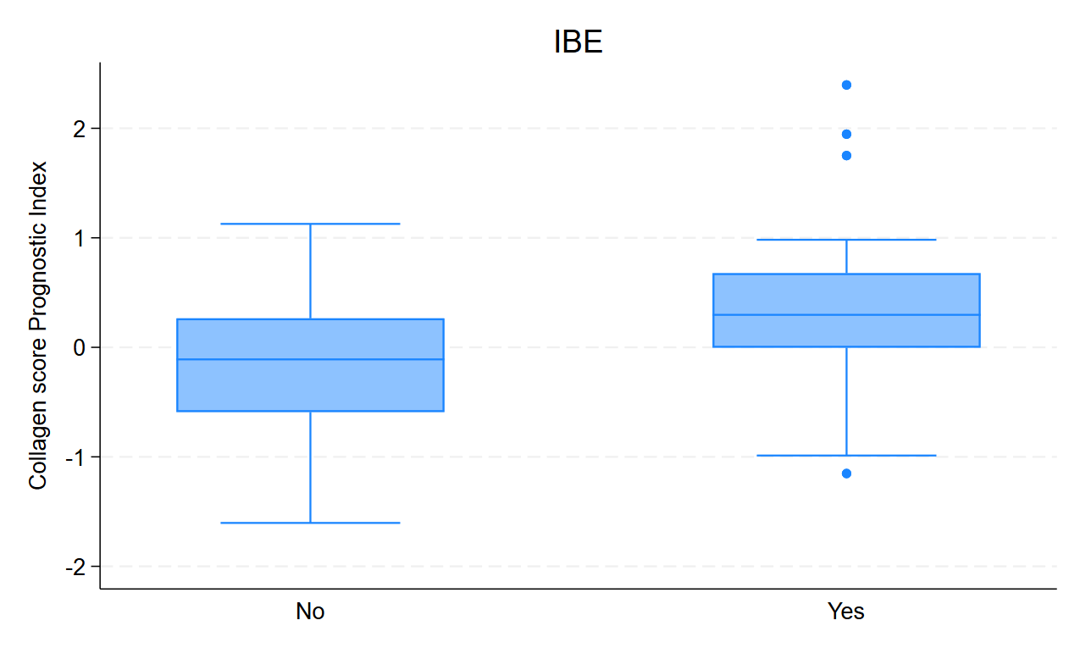

PROGNOSTIC INDEX in the validation set

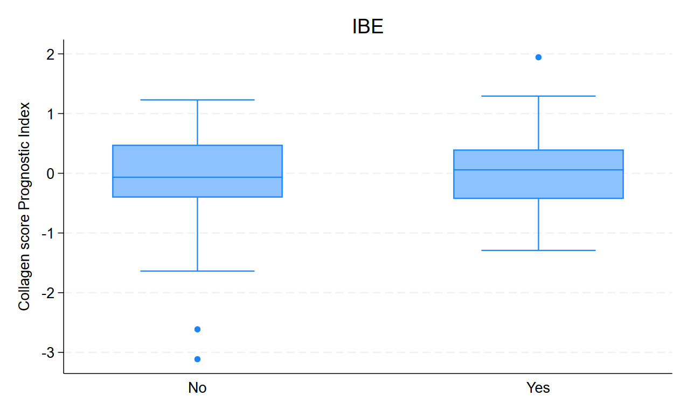

RT INDEX in the training set

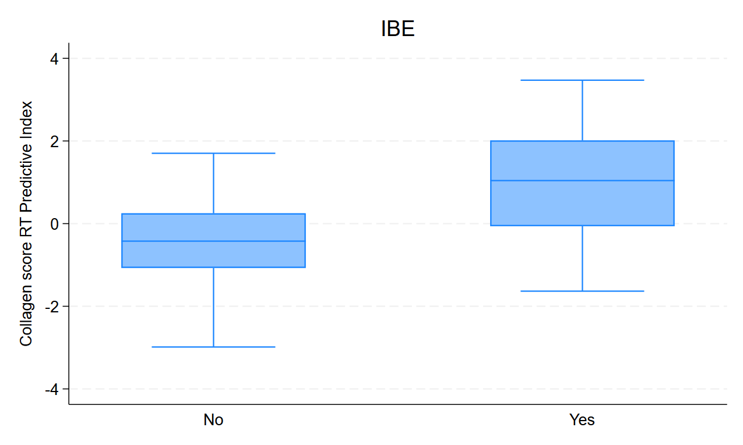

RT INDEX in the validation set

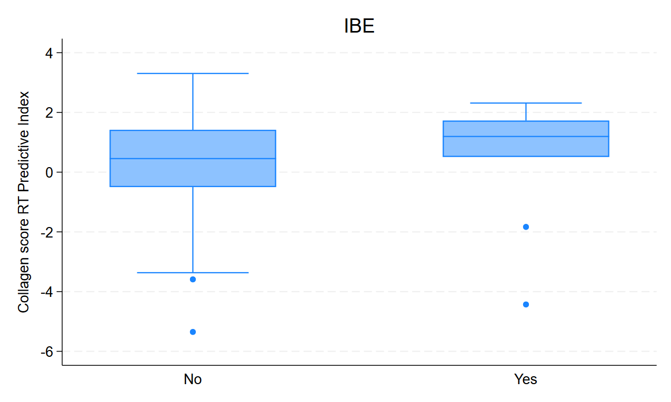

Tamoxifen INDEX in the training set

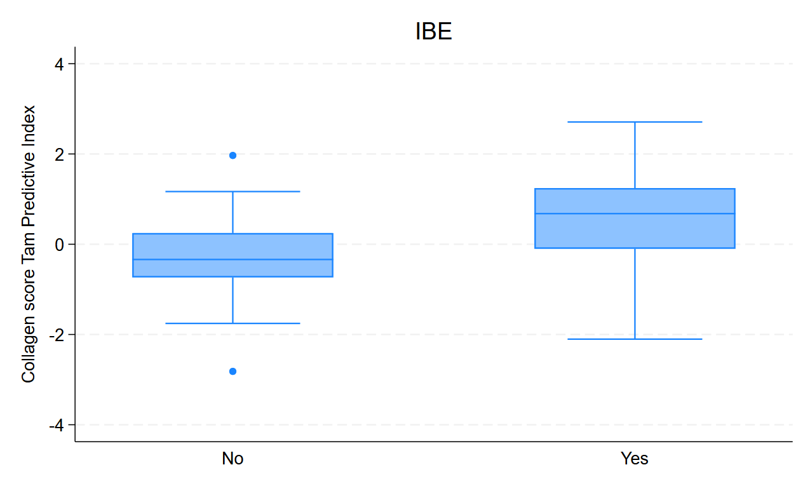

Tamoxifen INDEX in the training set

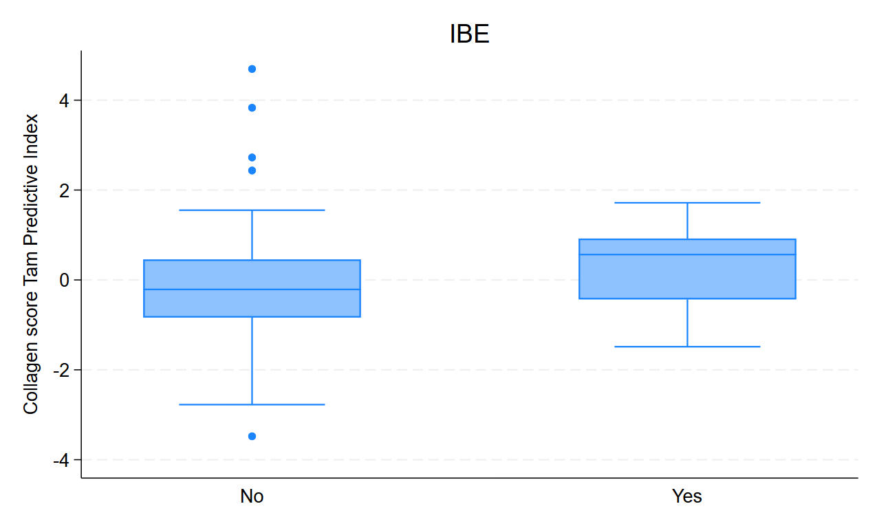

UNIVARIATE ANALYSES

UNIVARIATE ANALYSES of indices ENDPOINT IBE, in TRAINING and VALIDATION sets

# PROGNOSTIC INDEX

## Continuous

PROGNOSTIC INDEX as a Continuous variable in the training set

|  |  |  |  |  |  |  |
| --- | --- | --- | --- | --- | --- | --- |
| _t | Haz. ratio | Std. err. | z | P>|z| | [95% conf. interval] | |
| CollPROGN | 2.96 | 0.74 | 4.35 | 0.0000 | 1.81 | 4.83 |

PROGNOSTIC INDEX as a Continuous variable in the validation set of exact treatment allocation category

|  |  |  |  |  |  |  |
| --- | --- | --- | --- | --- | --- | --- |
| _t | Haz. ratio | Std. err. | z | P>|z| | [95% conf. interval] | |
| CollPROGN | 1.14 | 0.29 | 0.53 | 0.5974 | 0.70 | 1.87 |

## Categorised

PROGNOSTIC INDEX as a CATEGORISED variable in the training set

|  |  |  |  |  |  |  |
| --- | --- | --- | --- | --- | --- | --- |
| _t | Haz. ratio | Std. err. | z | P>|z| | [95% conf. interval] | |
| CollPROGNcat | 3.21 | 1.04 | 3.60 | 0.0003 | 1.70 | 6.06 |

PROGNOSTIC INDEX as a CATEGORISED variable in the validation set of exact treatment allocation category

|  |  |  |  |  |  |  |
| --- | --- | --- | --- | --- | --- | --- |
| _t | Haz. ratio | Std. err. | z | P>|z| | [95% conf. interval] | |
| CollPROGNcat | 0.87 | 0.36 | -0.34 | 0.7331 | 0.39 | 1.94 |

# RADIOTHERAPY INDEX

## Continuous

RT INDEX as a Continuous variable in the training set

|  |  |  |  |  |  |  |
| --- | --- | --- | --- | --- | --- | --- |
| _t | Haz. ratio | Std. err. | z | P>|z| | [95% conf. interval] | |
| CollRT | 2.78 | 0.69 | 4.10 | 0.0000 | 1.71 | 4.54 |

RT INDEX as a Continuous variable in the validation set of exact treatment allocation category

|  |  |  |  |  |  |  |
| --- | --- | --- | --- | --- | --- | --- |
| _t | Haz. ratio | Std. err. | z | P>|z| | [95% conf. interval] | |
| CollRT | 1.05 | 0.23 | 0.20 | 0.8404 | 0.68 | 1.61 |

## Categorised

RT INDEX as a CATEGORISED variable in the training set

|  |  |  |  |  |  |  |
| --- | --- | --- | --- | --- | --- | --- |
| _t | Haz. ratio | Std. err. | z | P>|z| | [95% conf. interval] | |
| CollRTcat | 6.59 | 3.50 | 3.55 | 0.0004 | 2.33 | 18.66 |

RT INDEX as a CATEGORISED variable in the validation set of exact treatment allocation category

|  |  |  |  |  |  |  |
| --- | --- | --- | --- | --- | --- | --- |
| _t | Haz. ratio | Std. err. | z | P>|z| | [95% conf. interval] | |
| CollRTcat | 4.15 | 3.28 | 1.80 | 0.0720 | 0.88 | 19.53 |

## EVENTS BY INDEX CATEGORY

EVENTS BY INDEX CATEGORY in TRAINING and VALIDATION sets (tables to follow)

Training set

|  |  |  |  |
| --- | --- | --- | --- |
|  | IBE |  |  |
| RT index | No | Yes | Total |
| Low | 30 | 5 | 35 |
| % | 85.71 | 14.29 | 100 |
| High | 6 | 13 | 19 |
| % | 31.58 | 68.42 | 100 |
| Total | 36 | 18 | 54 |
| % | 66.67 | 33.33 | 100 |

P <0.0001 (PEARSON)

Validation set

|  |  |  |  |
| --- | --- | --- | --- |
|  | IBE |  |  |
| RT index | No | Yes | Total |
| Low | 103 | 2 | 105 |
| % | 98.1 | 1.9 | 100 |
| High | 96 | 8 | 104 |
| % | 92.31 | 7.69 | 100 |
| Total | 199 | 10 | 209 |
| % | 95.22 | 4.78 | 100 |

P = 0.059 (Fisher’s exact, 2-sided)

# Tamoxifen INDEX

## Continuous

Tamoxifen INDEX as a Continuous variable in the training set

|  |  |  |  |  |  |  |
| --- | --- | --- | --- | --- | --- | --- |
| _t | Haz. ratio | Std. err. | z | P>|z| | [95% conf. interval] | |
| CollTAM | 2.76 | 0.55 | 5.07 | 0.0000 | 1.86 | 4.08 |

Tamoxifen INDEX as a Continuous variable in the validation set of exact treatment allocation category

|  |  |  |  |  |  |  |
| --- | --- | --- | --- | --- | --- | --- |
| _t | Haz. ratio | Std. err. | z | P>|z| | [95% conf. interval] | |
| CollTAM | 1.28 | 0.22 | 1.40 | 0.1628 | 0.91 | 1.80 |

## Categorised

Tamoxifen INDEX as a CATEGORISED variable in the training set

|  |  |  |  |  |  |  |
| --- | --- | --- | --- | --- | --- | --- |
| _t | Haz. ratio | Std. err. | z | P>|z| | [95% conf. interval] | |
| CollTAMcat | 4.54 | 1.60 | 4.29 | 0.0000 | 2.27 | 9.06 |

Tamoxifen INDEX as a CATEGORISED variable in the validation set of exact treatment allocation category

|  |  |  |  |  |  |  |
| --- | --- | --- | --- | --- | --- | --- |
| _t | Haz. ratio | Std. err. | z | P>|z| | [95% conf. interval] | |
| CollTAMcat | 3.46 | 1.58 | 2.71 | 0.0067 | 1.41 | 8.48 |

## EVENTS BY INDEX CATEGORY

EVENTS BY INDEX CATEGORY in TRAINING and VALIDATION sets (tables to follow)

Training set

|  |  |  |  |
| --- | --- | --- | --- |
|  | IBE |  |  |
| Tam index | No | Yes | Total |
| Low | 54 | 13 | 67 |
| % | 80.6 | 19.4 | 100 |
| High | 13 | 22 | 35 |
| % | 37.14 | 62.86 | 100 |
| Total | 67 | 35 | 102 |
| % | 65.69 | 34.31 | 100 |

P < 0.0001

Validation set

|  |  |  |  |
| --- | --- | --- | --- |
|  | IBE |  |  |
| Tam index | No | Yes | Total |
| Low | 89 | 8 | 97 |
| % | 91.75 | 8.25 | 100 |
| High | 31 | 12 | 43 |
| % | 72.09 | 27.91 | 100 |
| Total | 120 | 20 | 140 |
| % | 85.71 | 14.29 | 100 |

P = 0.002

MULTIVARIATE ANALYSES

# Entire Cohort

MULTIVARIATE ANALYSES IN THE ENTIRE COHORT (Training set not removed)

MULTIVARIATE ANALYSES without the interaction terms (ENTIRE COHORT) (**n= 594; events = 126**)

|  |  |  |  |  |
| --- | --- | --- | --- | --- |
| _t | Haz. ratio | P>|z| | [95% conf. interval] | |
| CollRTcat |  |  |  |  |
| High | 1.19 | 0.3296 | 0.84 | 1.70 |
|  |  |  |  |  |
| CollTAMcat |  |  |  |  |
| High | 1.56 | 0.0202 | 1.07 | 2.26 |
|  |  |  |  |  |
| TILcatMED |  |  |  |  |
| High | 1.88 | 0.0034 | 1.23 | 2.87 |
|  |  |  |  |  |
| HER2binIHC |  |  |  |  |
| Positive | 1.57 | 0.0220 | 1.07 | 2.30 |
| Age | 0.98 | 0.1902 | 0.95 | 1.01 |
|  |  |  |  |  |
| ComplExcision |  |  |  |  |
| Uncertain | 1.32 | 0.2432 | 0.83 | 2.10 |
| No | 1.72 | 0.0183 | 1.10 | 2.70 |
|  |  |  |  |  |
| TotalSizeCORR | 1.02 | 0.0345 | 1.00 | 1.04 |
|  |  |  |  |  |
| CytNuclGrade |  |  |  |  |
| Intermediate | 0.79 | 0.6955 | 0.24 | 2.56 |
| High | 0.92 | 0.8902 | 0.29 | 2.89 |
|  |  |  |  |  |
| Necrosis |  |  |  |  |
| Yes | 1.20 | 0.7341 | 0.43 | 3.34 |
|  |  |  |  |  |
| Tam |  |  |  |  |
| Yes | 0.67 | 0.0284 | 0.46 | 0.96 |
|  |  |  |  |  |
| RT |  |  |  |  |
| Yes | 0.32 | 0.0000 | 0.20 | 0.50 |

MULTIVARIATE ANALYSES with the interaction terms included (ENTIRE COHORT) (**n= 594; events = 126**)

|  |  |  |  |  |
| --- | --- | --- | --- | --- |
| _t | Haz. ratio | P>|z| | [95% conf. interval] | |
| CollRTcat |  |  |  |  |
| High | 0.86 | 0.4466 | 0.57 | 1.28 |
|  |  |  |  |  |
| CollTAMcat |  |  |  |  |
| High | 0.81 | 0.4663 | 0.46 | 1.43 |
|  |  |  |  |  |
| TILcatMED |  |  |  |  |
| High | 1.91 | 0.0026 | 1.25 | 2.90 |
|  |  |  |  |  |
| HER2binIHC |  |  |  |  |
| Positive | 1.45 | 0.0576 | 0.99 | 2.13 |
| Age | 0.98 | 0.1390 | 0.94 | 1.01 |
|  |  |  |  |  |
| ComplExcision |  |  |  |  |
| Uncertain | 1.38 | 0.1795 | 0.86 | 2.19 |
| No | 1.77 | 0.0132 | 1.13 | 2.78 |
|  |  |  |  |  |
| TotalSizeCORR | 1.02 | 0.0153 | 1.00 | 1.04 |
|  |  |  |  |  |
| CytNuclGrade |  |  |  |  |
| Intermediate | 0.80 | 0.7081 | 0.24 | 2.61 |
| High | 0.99 | 0.9802 | 0.31 | 3.12 |
|  |  |  |  |  |
| Necrosis |  |  |  |  |
| Yes | 1.08 | 0.8832 | 0.38 | 3.08 |
|  |  |  |  |  |
| CollTAMcat#Tam |  |  |  |  |
| High#Yes | 3.39 | 0.0021 | 1.56 | 7.39 |
|  |  |  |  |  |
| Tam |  |  |  |  |
| Yes | 0.41 | 0.0004 | 0.25 | 0.67 |
|  |  |  |  |  |
| CollRTcat#RT |  |  |  |  |
| High#Yes | 5.16 | 0.0028 | 1.76 | 15.15 |
|  |  |  |  |  |
| RT |  |  |  |  |
| Yes | 0.11 | 0.0000 | 0.05 | 0.29 |

MULTIVARIATE ANALYSES with the interaction terms included but actual indices excluded (ENTIRE COHORT) (**n= 594; events = 126**)

|  |  |  |  |  |
| --- | --- | --- | --- | --- |
| _t | Haz. ratio | P>|z| | [95% conf. interval] | |
| TILcatMED |  |  |  |  |
| High | 1.91 | 0.0026 | 1.25 | 2.90 |
|  |  |  |  |  |
| HER2binIHC |  |  |  |  |
| Positive | 1.45 | 0.0576 | 0.99 | 2.13 |
| Age | 0.98 | 0.1390 | 0.94 | 1.01 |
|  |  |  |  |  |
| ComplExcision |  |  |  |  |
| Uncertain | 1.38 | 0.1795 | 0.86 | 2.19 |
| No | 1.77 | 0.0132 | 1.13 | 2.78 |
|  |  |  |  |  |
| TotalSizeCORR | 1.02 | 0.0153 | 1.00 | 1.04 |
|  |  |  |  |  |
| CytNuclGrade |  |  |  |  |
| Intermediate | 0.80 | 0.7081 | 0.24 | 2.61 |
| High | 0.99 | 0.9802 | 0.31 | 3.12 |
|  |  |  |  |  |
| Necrosis |  |  |  |  |
| Yes | 1.08 | 0.8832 | 0.38 | 3.08 |
|  |  |  |  |  |
| CollTAMcat#Tam |  |  |  |  |
| High#No | 0.81 | 0.4663 | 0.46 | 1.43 |
| High#Yes | 2.75 | 0.0003 | 1.60 | 4.74 |
|  |  |  |  |  |
| Tam |  |  |  |  |
| Yes | 0.41 | 0.0004 | 0.25 | 0.67 |
|  |  |  |  |  |
| CollRTcat#RT |  |  |  |  |
| High#No | 0.86 | 0.4466 | 0.57 | 1.28 |
| High#Yes | 4.42 | 0.0034 | 1.63 | 11.97 |
|  |  |  |  |  |
| RT |  |  |  |  |
| Yes | 0.11 | 0.0000 | 0.05 | 0.29 |

MULTIVARIATE ANALYSES

# Validation Set only

MULTIVARIATE ANALYSES IN THE VALIDATION SET (Training set REMOVED) (**n= 455; events = 78**)

|  |  |  |  |  |
| --- | --- | --- | --- | --- |
| _t | Haz. ratio | P>|z| | [95% conf. interval] | |
| CollRTcat |  |  |  |  |
| High | 1.07 | 0.7675 | 0.68 | 1.70 |
|  |  |  |  |  |
| CollTAMcat |  |  |  |  |
| High | 1.10 | 0.7168 | 0.66 | 1.84 |
|  |  |  |  |  |
| TILcatMED |  |  |  |  |
| High | 2.18 | 0.0056 | 1.26 | 3.78 |
|  |  |  |  |  |
| HER2binIHC |  |  |  |  |
| Positive | 1.66 | 0.0459 | 1.01 | 2.74 |
| Age | 0.98 | 0.4710 | 0.95 | 1.03 |
|  |  |  |  |  |
| ComplExcision |  |  |  |  |
| Uncertain | 1.24 | 0.4765 | 0.69 | 2.23 |
| No | 1.57 | 0.1371 | 0.87 | 2.84 |
|  |  |  |  |  |
| TotalSizeCORR | 1.01 | 0.5456 | 0.98 | 1.03 |
|  |  |  |  |  |
| CytNuclGrade |  |  |  |  |
| Intermediate | 0.43 | 0.2088 | 0.12 | 1.60 |
| High | 0.39 | 0.1541 | 0.11 | 1.42 |
|  |  |  |  |  |
| Necrosis |  |  |  |  |
| Yes | 2.16 | 0.2844 | 0.53 | 8.90 |
|  |  |  |  |  |
| Tam |  |  |  |  |
| Yes | 0.37 | 0.0004 | 0.21 | 0.64 |
|  |  |  |  |  |
| RT |  |  |  |  |
| Yes | 0.13 | 0.0000 | 0.06 | 0.30 |

MULTIVARIATE ANALYSES with the interaction terms included IN THE VALIDATION SET (Training set REMOVED) (**n= 455; events = 78**)

|  |  |  |  |  |
| --- | --- | --- | --- | --- |
| _t | Haz. Ratio | P>|z| | [95% conf. interval] | |
| CollRTcat |  |  |  |  |
| High | 0.91 | 0.7029 | 0.56 | 1.48 |
|  |  |  |  |  |
| CollTAMcat |  |  |  |  |
| High | 0.79 | 0.4577 | 0.42 | 1.48 |
|  |  |  |  |  |
| TILcatMED |  |  |  |  |
| High | 2.19 | 0.0053 | 1.26 | 3.78 |
|  |  |  |  |  |
| HER2binIHC |  |  |  |  |
| Positive | 1.60 | 0.0630 | 0.97 | 2.64 |
| Age | 0.98 | 0.4565 | 0.94 | 1.03 |
|  |  |  |  |  |
| ComplExcision |  |  |  |  |
| Uncertain | 1.28 | 0.4147 | 0.71 | 2.31 |
| No | 1.57 | 0.1361 | 0.87 | 2.85 |
|  |  |  |  |  |
| TotalSizeCORR | 1.01 | 0.4763 | 0.98 | 1.03 |
|  |  |  |  |  |
| CytNuclGrade |  |  |  |  |
| Intermediate | 0.41 | 0.1884 | 0.11 | 1.55 |
| High | 0.39 | 0.1601 | 0.11 | 1.45 |
|  |  |  |  |  |
| Necrosis |  |  |  |  |
| Yes | 2.07 | 0.3194 | 0.49 | 8.64 |
|  |  |  |  |  |
| CollTAMcat#Tam |  |  |  |  |
| High#Yes | 2.95 | 0.0627 | 0.94 | 9.25 |
|  |  |  |  |  |
| Tam |  |  |  |  |
| Yes | 0.24 | 0.0002 | 0.11 | 0.51 |
|  |  |  |  |  |
| CollRTcat#RT |  |  |  |  |
| High#Yes | 6.41 | 0.0991 | 0.70 | 58.28 |
|  |  |  |  |  |
| RT |  |  |  |  |
| Yes | 0.04 | 0.0013 | 0.01 | 0.28 |