NslSoundManager (v1.10)
Things you may not figure out by inspection…

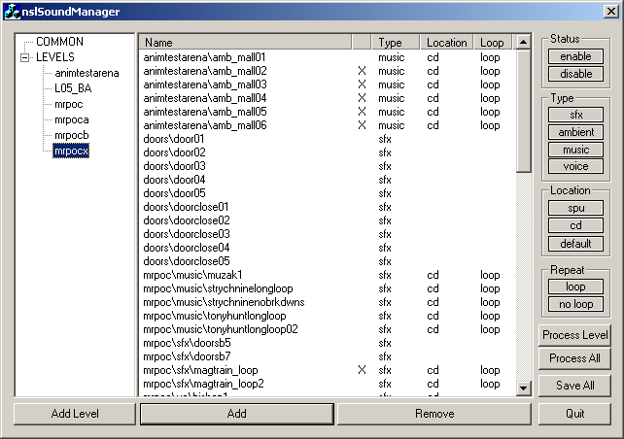

Enable/Disable
Select files and hit “enable” or “disable”- if a sound is disabled, it will not be included in the output and will not be available in the game. It is provided for convenience so that you don’t have to delete the sound from the level to not have the sound in the level. Got it? [for those interested, “disabling” a sound merely comments it out in the input .SND file(s), so when nslSoundTool runs, it ignores the line]

COMMON
Add files here that you want to be included in all levels. Don’t rename “COMMON”.

LEVELS
You can’t add files here. It’s just a placeholder. Don’t rename it, either.

Add Level
You can add a level’s .SND file by hitting “Add Level”- this will make a level called “New Level” that you can rename in the standard Windows way of clicking once on the name.

Renaming
You can rename sound files and even levels by clicking once on the name.

Process Level/Process All
This will save the current level (or all levels) and build the PS2SOUND data. In the future, it will also build xbox and gc data.

The ini file
All relevant settings are stored in nslSoundManager.ini, along with (probably unhelpful) comments. (Check out) and modify as appropriate.

What files to check out…
In order for everything to work correctly, check out:
dev\data\sounds\levels\<levels>.SND
data\PS2SOUND\levels\<levels>.SND
data\PS2SOUND\levels\spu\<levels>.vbc
data\PS2SOUND\levels\stream\stream.*

nslSoundManager is merely a shell for nslSoundTool. See documentation on that for more information.

12/06/2001
Andrew Olson
aolson@

