Pop-up help text for 1940

Sheet, Side

The Sheet or page number is in the upper right corner in the header.

Each census sheet has side A and B.

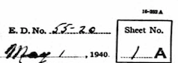

*(image 1940 census sheet side ED)*

Line

Each sheet has 40 lines, they are located in the margin on the left and right side of the sheet. Side A usually contains lines 1-40 and Side B lines 41-80.

Ward

The ward is to the left of the center title “Sixteenth Census of the United States: 1940” in the header. Enter ward as a number.

C:\Users\Bookkeeper\Downloads\1940 census ward.png

*(image 1940 census ward)*

For example, the above would be entered as: Ward 1

Enumeration District

The Enumeration District (ED) is in the upper right corner in the header next to the sheet number. Enter the last 2 digits only.



*(image 1940 census sheet side ED)*

For example, the above would be entered as: ED 20

House No.

Column 2.

If the number includes a fraction leave a space between the number and the fraction. i.e. 102 ½.

If the number indicates rear (as in rear apartment) enter the street number followed by a space and the word Rear, i.e. 313 Rear.

If the number includes a range enter as written, i.e. 102-104.

Prefix

Column 1. North, South, East, West preceding the street name. (Exception: on occasion the street name will include North, South, East or West, as in South Hill Terrace. In this case you would include South in the street address, not the prefix). If you are unsure, check the list of street names or city directory.

Street Name

Column 1. The name of the street itself, i.e. Aurora.

*Note: Street names can change at least once on the sheet. These changes are often indicated by a hand-drawn line across the column separating the buildings on one street from the next.

Suffix

Column 1. Avenue, Road, Street, etc. If you are unsure, check the list of street names or city directory.

Building

There is no corresponding field on the census, however, this field allows us to link the people in the census to a mapped building. From the drop down menu select the building with the same address. If the building is not listed, the street name is properly spelled and there is no space following, click Add building with address.

Household Number

Column 3-The number of household in order of visitation.

Enter as written. *If the first person on the sheet (line 1 or 41) is not the head of household, the household number might not be listed but can be found listed with the head of household on the previous census sheet.

*Note: Household numbers are generally sequential. If it is hard to read the number check those above and below for a pattern.

Home owned or rented

Column 4. For head of household only. Enter as written, generally O-Owned, R-Rented. If the response is Un (see image below), enter as Unknown.

C:\Users\Bookkeeper\Desktop\Annotation 2020-04-08 200907-unknown scribble.png

*(image census-un)*

Value of home or monthly payment

Column 5. For head of household only. Enter as written. If the response is Un (see image below), enter as 999.

C:\Users\Bookkeeper\Desktop\Annotation 2020-04-08 200907-unknown scribble.png

*(image census-un)*

Live on a farm

Column 6. Check box if the response is yes.

Last name, First name, Middle name

Column 7. Names are listed Last, First, Middle. If several members of a family have the same last name, the last name will be listed in the first record and in following records it usually will be replaced by a line. Enter the last name for each individual. If there is no middle name or initial leave the field blank.

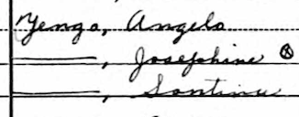

*(image 1940 census name)*

Relation to head

Column 7. This field indicates the relationship of each person to the Head of the household (i.e. Head, Wife, Mother, Father, Son, Daughter, Grandson, Daughter-in-Law, Aunt, Uncle, Nephew, Niece, Boarder, Lodger, Servant, etc.).

Sex

Column 9. Check box that corresponds to the answer indicated.

Color or race

Column 10. Check box that corresponds to the answer indicated.

Age, Age (months)

Column 11 on the census.

A child that is **less than one year of age** will be listed by their age in months i.e. 3/12 or 11/12.

If they are less than 1: Enter 0 in the Age field, then enter the months in Age (months).

Marital status

Column 12. Check box that corresponds to the answer indicated.

Attended school or college

Column 13. Check box if the response is yes.

Highest grade of school completed

Column 14.

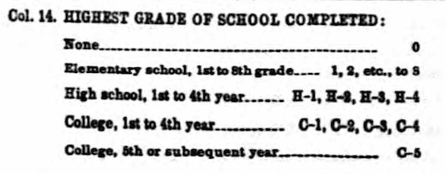

*(image 1940 census Highest grade of school completed)*

Place of birth

Column 15.

New York is the default which can be overwritten. Enter the State/Territory/Country name as written by the enumerator, if the enumerator abbreviated, spell out the place of birth.

Enter US or variants as United States

Enter Washington D.C. as District of Columbia

Make sure to capture whether Canada French or Canada English, Irish Free State or Northern Ireland

Citizenship

Column 16.

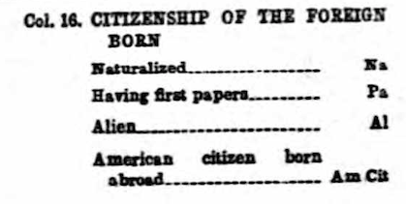

*(image 1940 census Citizenship)*

1935 City

Column 17. Enter as written.

Those who lived in the same house in 1935 will be listed as Same house.

Those who lived in a different house in the same city, town, or village will be listed as Same place.

Those who lived in a Rural area will be listed as R.

1935 County

Column 18. Enter as written.

1935 State

Column 19. Enter as written.

1935 Farm

Column 20. Check box if the response is yes.

Private Work

Column 21. Check box if the response is yes.

Public Emergency Work

Column 22. Check box if the response is yes.

Seeking Work

Column 23. Check box if the response is yes.

Has Work

Column 24. Check box if the response is yes.

No work reason

Column 25. Check box that corresponds to the answer indicated.

Hours Worked Week Prior to Census

Column 26. Enter as written.

Duration of Unemployment

Column 27. Enter as written.

Occupation

Column 28. Enter as written.

Industry

Column 29. Enter as written.

Worker class

Column 30. Check box that corresponds to the answer indicated.

Occupation Code

Column F.

This is a three-figure occupation code followed by a two-figure industry code and a 1-figure worker class code.

The **occupation** can contain a “**V**” or “**X**” as well as numbers.

The **industry** code can contain a “**V**” or “**X**” as well as numbers.

The **worker class** code is a number from 1 to 6.

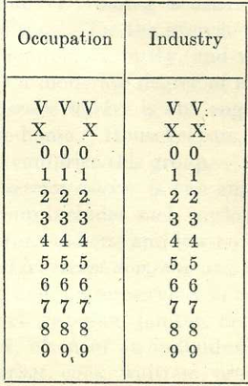

*-Image 1940 census occupation and industry codes*

Weeks Worked in 1939

Column 31. Enter as written.

Income

Column 32. Enter as written.

Other income source

Column 33. Check box if the response is yes.

Farm schedule No.

Column. 34. Enter as written.

**Supplementary questions for Side A lines 14, 29 and Side B lines 55, 68**

Name

Column 35. Enter the name of the person from the line number indicated. Names are listed Last, First, Middle. If there is no middle name or initial leave the field blank.

Place of birth-Father

Column 36. New York is the default which can be overwritten. Enter the State/Territory/Country name as written by the enumerator, if the enumerator abbreviated, spell out the place of birth.

Enter US or variants as United States

Enter Washington D.C. as District of Columbia

Make sure to capture whether Canada French or Canada English, Irish Free State or Northern Ireland

Place of birth-Mother

Column37. New York is the default which can be overwritten. Enter the State/Territory/Country name as written by the enumerator, if the enumerator abbreviated, spell out the place of birth.

Enter US or variants as United States

Enter Washington D.C. as District of Columbia

Make sure to capture whether Canada French or Canada English, Irish Free State or Northern Ireland

Mother tongue

Column 38. Enter as written.

Veteran or veteran-related

Column 39. Check box if the response is yes.

Veteran father dead-should this be Deceased veteran father or Veteran father deceased???

Column 40. Check box if the response is yes.

Military Service

Column 41. Check box that corresponds to the answer indicated.

Social security number

Column 42. Check box if the response is yes.

Old age or railroad insurance

Column 43. Check box if the response is yes.

Other deductions

Column 44. Check box that corresponds to the answer indicated.

Usual Occupation

Column 45. Enter as written.

Usual Industry

Column 46. Enter as written.

Usual worker class

Column 47 Check box that corresponds to the answer indicated.

Usual Code Occupation Industry

Column J.

This is a three-figure occupation code followed by a two-figure industry code and a 1-figure worker class code.

The **occupation** can contain a “**V**” or “**X**” as well as numbers.

The **industry** code can contain a “**V**” or “**X**” as well as numbers.

The **worker class** code is a number from 1 to 6.



*(image 1940 census occupation and industry codes)*

Woman-married more than once

Column 48. Check box if the response is yes.

Woman-age at first marriage

Column 49. Enter as written.

Woman-number of children born

Column 50. Enter as written.