KTP-el App
Software Design Specification

Date: September 14, 2022

1 Introduction

1.1 Writing purpose
This specification is for the detailed design of Android software according to the development requirements specification to meet its requirements. The software structure logic is designed according to the user use process to ensure that the functions are perfect, while optimizing the interface and user experience, it also provides a basis for subsequent development and maintenance.

1.2 design goal
System name: Android demo app
This project is to read the ID card information on the Android device and display the information after successful fingerprint verification.

1.3 Design principles
Follow the object-oriented programming principles, optimize the card reading logic, and conform to the user's usage habits.

2 overall design
MVC general framework is adopted to realize hierarchical structure design, such as database operation layer, presentation layer, and business logic processing layer. A set of independent UI presentation style is defined using user-defined form classes and message notification forms to reflect ZKTeco's enterprise VI.

2.1 Operating environment
Hardware indicators: Android device with OTG function, IM20 card reader terminal
Software indicators: Android 7.0 operating system is recommended

3 Function Details
The app uses the OTG function of Android operating system, reads Indonesian ID card information through SM01 card reading module, and uses 20S fingerprint module for comparison and verification. In English version, the main contents displayed are photos, text contents, signatures, fingerprints (comparison) and other information on Indonesian identity cards. While the basic content can be displayed, the card swiping data needs to be managed and the functions set. Therefore, APP mainly includes two parts: Home and Settings. Strive to achieve excellent performance, fast response and good experience in the process of business processing.

3.1 Sign in

3.1.1 Login Loading Interface
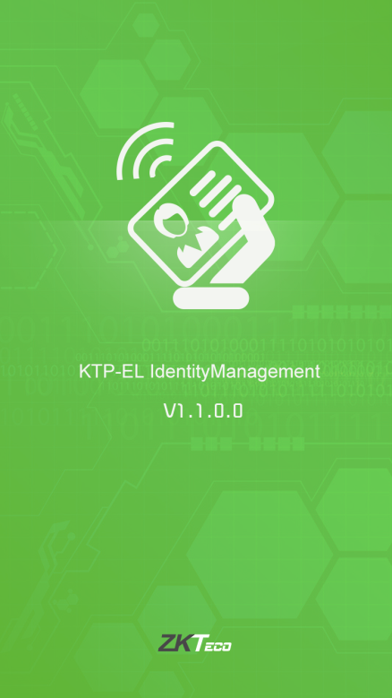

3.1.2 show contents
The content displayed includes logo, version number, APP name and APP icon; The color and background in this figure are temporarily used. After successful loading, directly enter the Home function interface
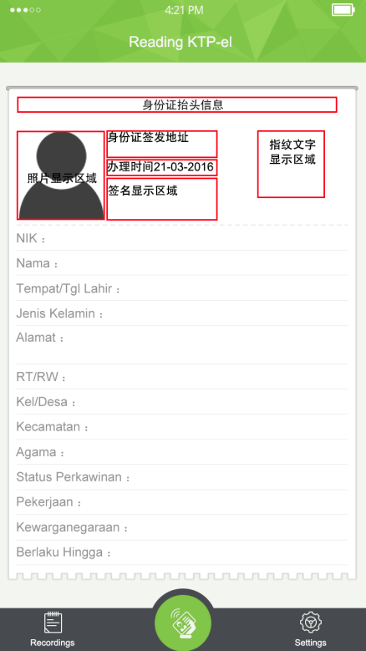

3.2 Home

3.2.1 Business logic
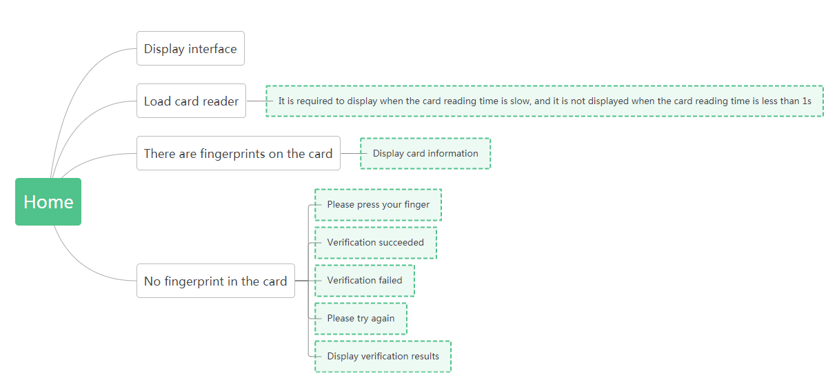

3.2.2Display interface
The display interface before swiping the card is divided into three areas: "top area", "feature area" and "detail area" from top to bottom
1) Top area: The content displayed is the ID card header information, mainly the information of the province and city where the individual is located.
2) Characteristic area: photos, certificate issuing city, certificate issuing time, signature, fingerprint (no fingerprint is displayed).
3) Details area: ID card number NIK, name, gender, region, blood type, street, religion, marriage, etc.

3.2.3 Read card loading
After opening the app, read the CardFragment. After the system detects the permission, power on the fingerprint, and then start the card reading thread ReadTask(); Gradually detect the environment; The flow chart is as follows:
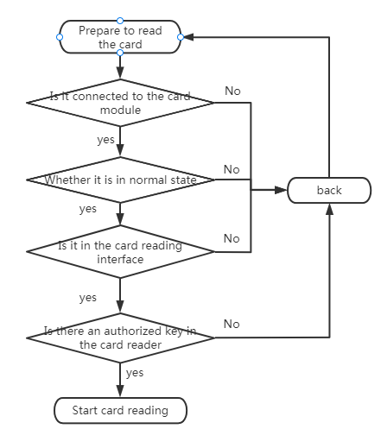
When the module is normal and has passed the authorized key value, read the card. The process is as follows:
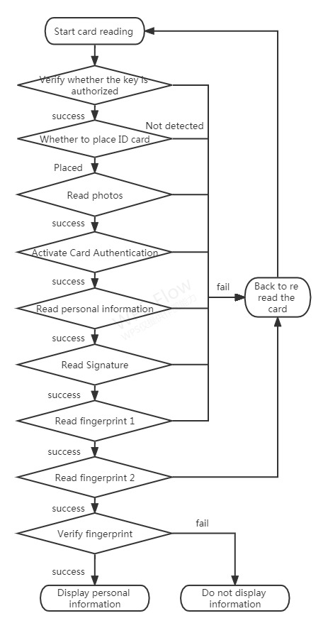
1) When the card reading time is less than 1s, the loading interface is not required
2) When the card reading time is>1s, the loading interface is required as a prompt
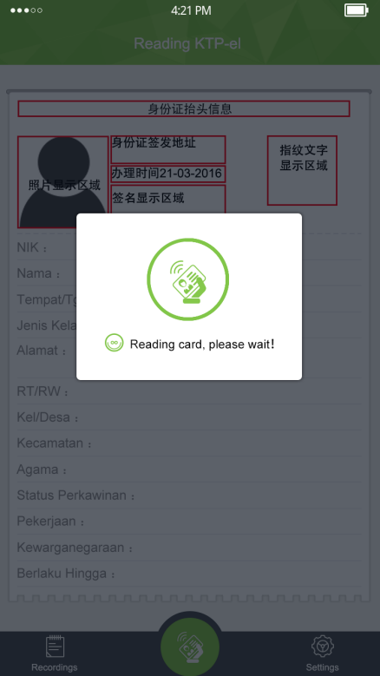

3.2.4 No fingerprint on the card
When swiping the card, when the software detects that there is no fingerprint in the card, it only needs to display the read card information
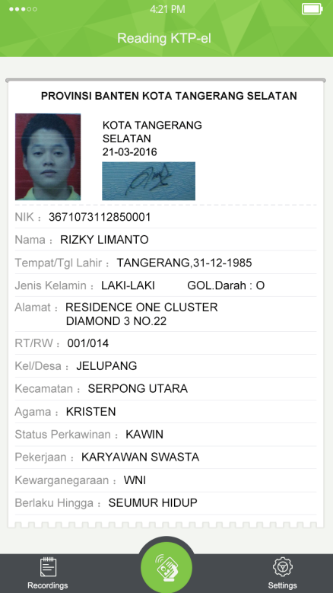
After swiping the card, save the record.

3.2.5 The card has fingerprints
When fingerprints are detected in the card when reading the card, the logical sequence should have two conditions:
A. Press your finger - check successful - display information
- Prompt Please punch your finger, and display the gray fingerprint and prompt text on the right side of the "feature area"
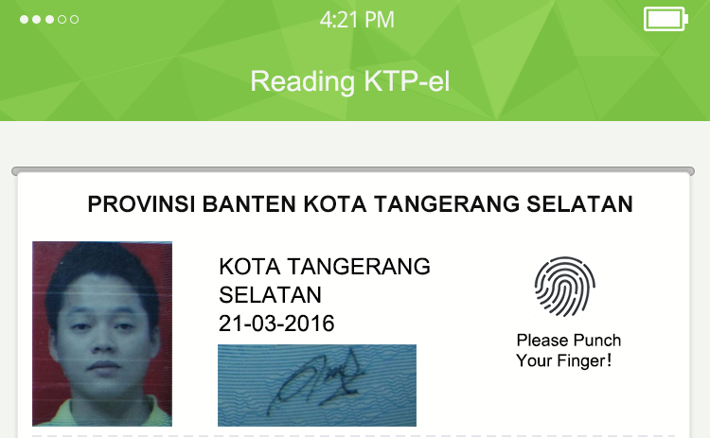

- When the prompt Verify successfully is prompted, the green fingerprint image and prompt text are displayed on the right side of the "feature area"
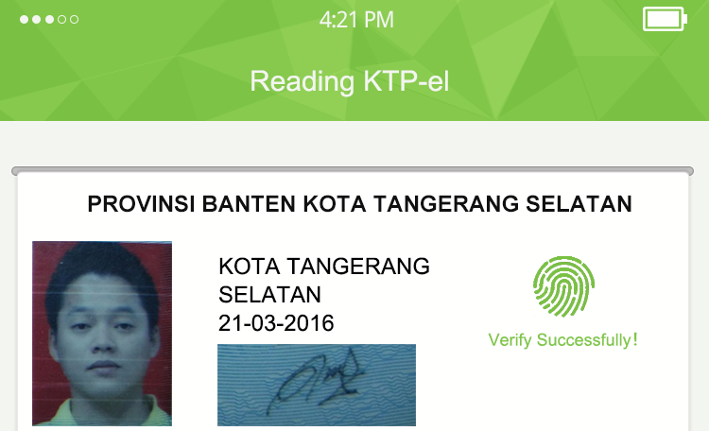

3)Display complete identity information after successful verification
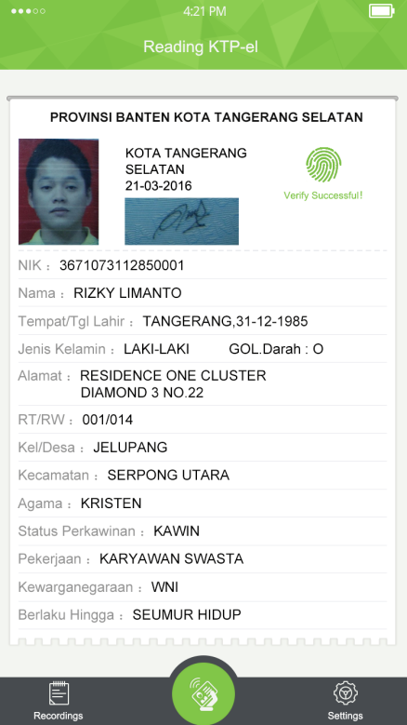
4）Card swiping completed
B. Press your finger - check failed - check again - check succeeded - display information
- Prompt Please punch your finger, and display the gray fingerprint and prompt text on the right side of the "feature area"

- Prompt Verify failed, and display the gray fingerprint and orange prompt text on the right side of the "feature area"
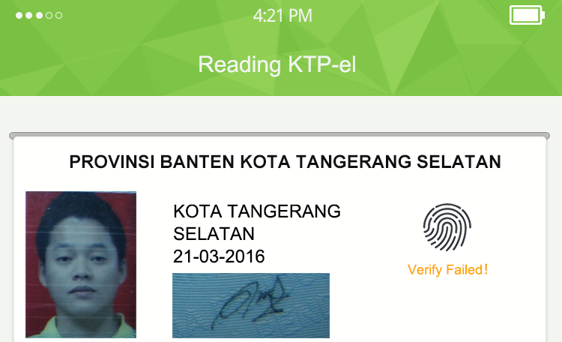

- Please try again is prompted, and gray fingerprints and prompt text are displayed on the right side of the "feature area"
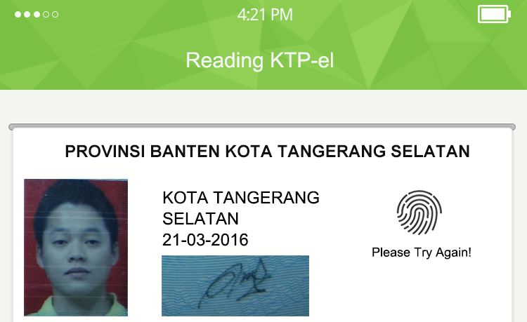

- If the verification fails, please repeat step 3
- When the prompt Verify successfully is prompted, the green fingerprint image and prompt text are displayed on the right side of the "feature area"
6）Card swiping completed.

3.3 Settings
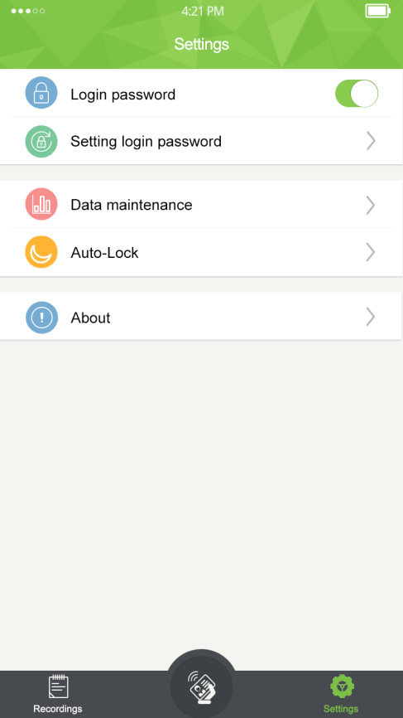

3.3.1 Business logic
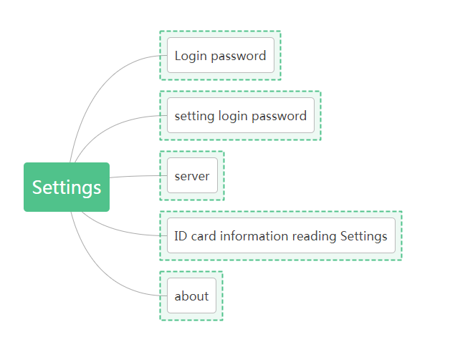

3.4.2 Login password
The login password can be turned on and off
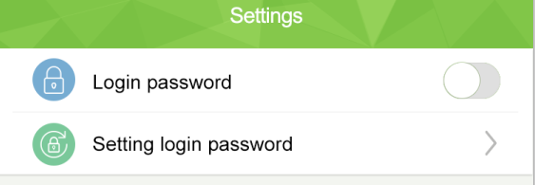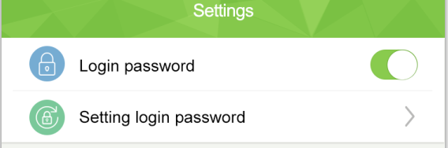

3.4.3 Setting login password
When the login password is enabled, you need to set the login password. There are two cases: first, set the login password for the first time, and second, reset the password.
- Set password for the first time
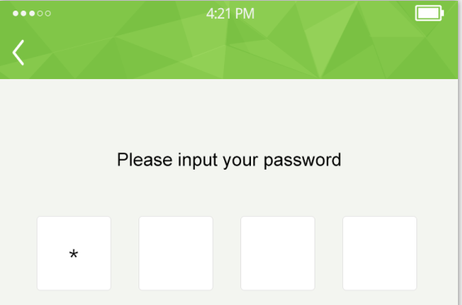
Please input your password
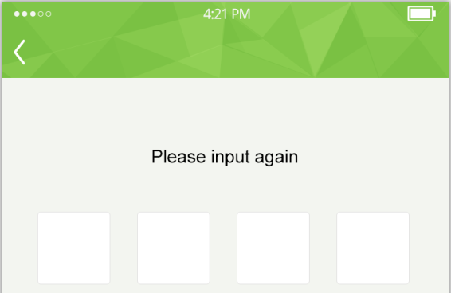
Please input again
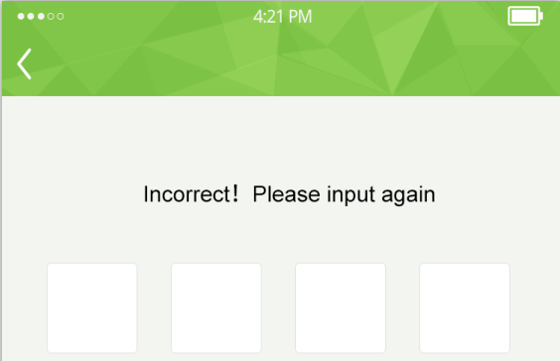
Incorrect！Please input again
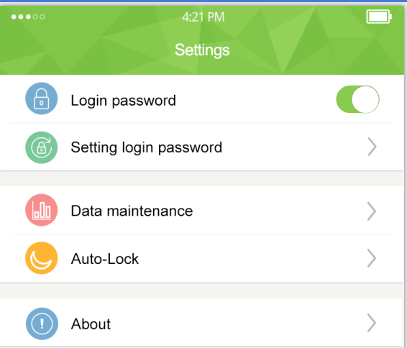
After successful setting, return to Settings homepage directly
- Reset Password
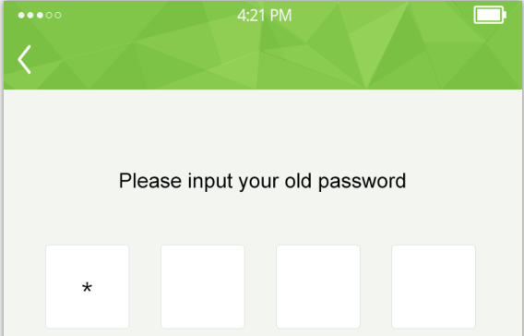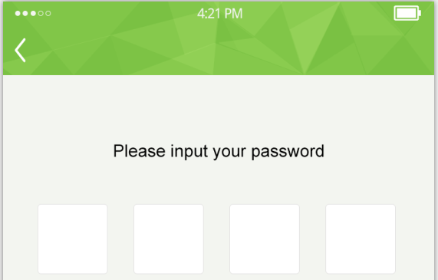
Please input your old password Please input your new password
Please input again Incorrect！Please input again
After successful input, return to the Settings homepage without prompting

3.4.6About
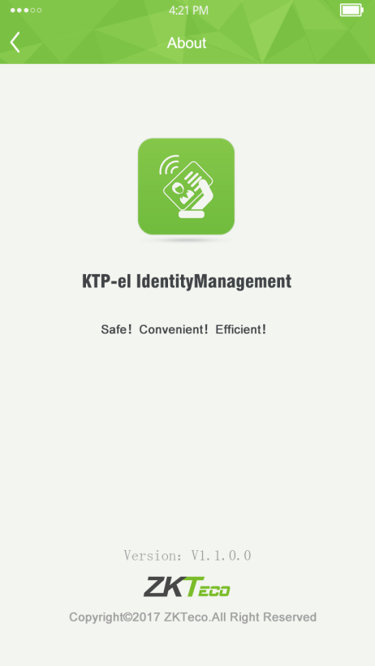

4 Data encryption and security
In order to ensure that the identity information is only read in the authorized and reliable APP, when the APP communicates with the card reading device through the USB interface, sends instructions and receives the ID card information, it encrypts the data, and decrypts the data after receiving it, in order to prevent the third-party APP from illegally capturing the communication data, thereby causing information disclosure.

5 Software test
Ensure that the software function test is correct.

