**THE 2ND XJU-HIT-ENU SCEIENCE AND ENGINEERING WORKSHOP FULL PAPER INSTRUCTIONS FOR AUTHORS USING MS-WORD**

**First Author1*, Second Author2 and Third Author1,2**

***1*** *Hachinohe Institute of Technology, Hachinohe, Japan*

***2*** *Tohoku University, Graduate School of Engineering, Sendai, Japan*

*Correspondence: email address

**Abstract:** Please write abstract here.

**Key words**: word1, word2, word3

# Paper size, margins and paper length

Please, use the standard A4 (210 × 297 mm) paper size. Allow 20 mm left and right margins and 30 mm top and 20 mm bottom margins (use the typing area of 170 × 247 mm). The length of the paper must be between 4 and 10 pages.

# Font size, spacing, title, headings

Times Roman fonts of 12 pt size should be used throughout all the paper with single spacing between lines of text.

**2.1 Subsection**

The title should be centered on all capital characters and bold face. Do not leave any additional space above the title. The title should be followed by authors’ names (bold) and respective affiliations (italic). Leave one l line of 12 pt space between the title and authors’ names and between the affiliation (institution, department, city, and country) and the beginning of the text. In order to save space, the affiliation should not include the full address of your institution.

The section headings should be left aligned with no indentation, set in bold face with extra space of 12 points above and 6 points below. The paragraphs should be left and right justified with 1-cm indentation of the first line.

# Tables and figures

Figures (Figure 1), tables (Table 1) and their captions should be centered and numbered. Leave 12 points below and above the figure/table.

Table 1. Basic table format.

|  |  |  |
| --- | --- | --- |
| Case | Cumulative rainfall | Duration |
| 1 | 310 mm | 10 h |
| 2 | 310 mm | 20 h |
| 3 | 420 mm | 20 h |

# Equations

Displayed equations should be centered and the equation numbers should be placed in brackets at the right margin.

$$\begin{aligned}{\dot{σ}}_{ij}=D_{ijkl }{\dot{ϵ}}_{kl} \#\left(1\right)\end{aligned}$$

For tensorial notation, use bold characters.

$$\begin{aligned}\dot{σ}=D \dot{ϵ} \#\left(2\right)\end{aligned}$$

Sufficient space (at least 6 pt) should be left above and below the equation.

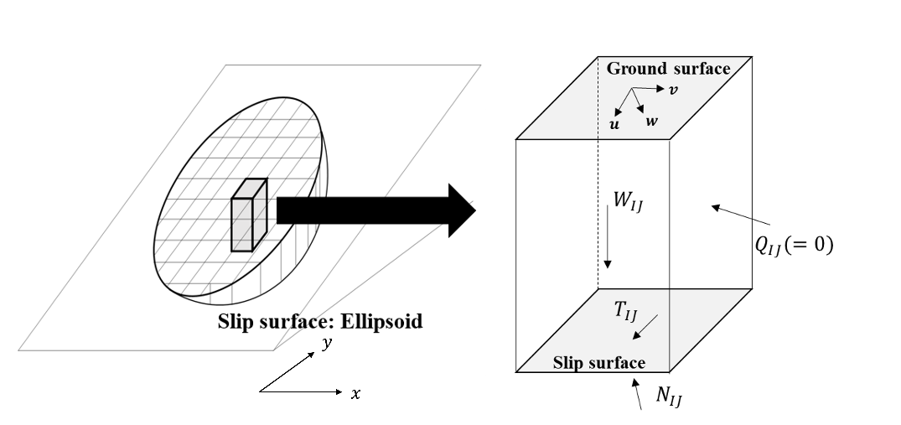

Figure 1. Example of a centred and numbered figure.

# Citing references

Any references should be placed at the end of the paper and referenced in the paper through the number in square brackets, e.g. [1]. The format of sample book and journal references are given below.

# Submission

Please send both MS-Word file and pdf file to secretary by 30 June 2025.

**References:**

[1] Tozato, K., Dolojan, N. L. J., Touge, Y., Kure, S., Moriguchi, S., Kawagoe, S., Kazama, S., and Terada, K., 2022. Limit equilibrium method-based 3D slope stability analysis for wide area considering influence of rainfall. Engineering Geology. 308, 106808.

[2] Strunk Jr., W., White, E.B., 2000. The Elements of Style, fourth ed. Longman, New York.