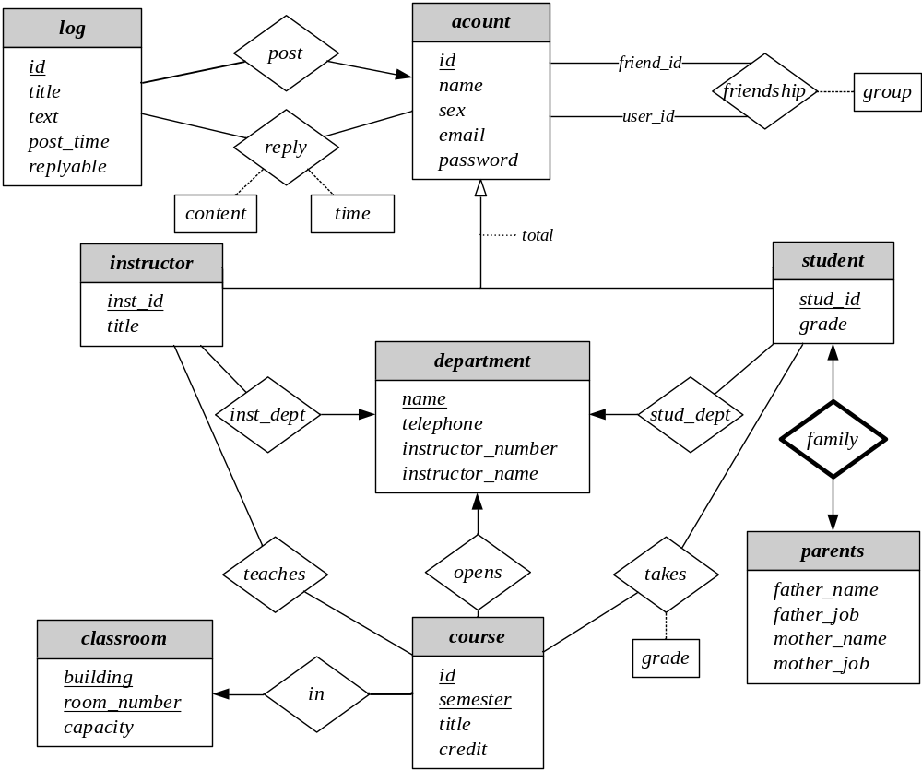

department (name, building, telephone)
instructor (id, name, sex, email, password, title, dept)
student (id, name, sex, email, password, grade, dept)
student_family(id, father_name, father_job, mother_name, mother_job)
course (cno, semester, title, credit, dept, building, room_number)
classroom (building, room_number, capacity)
student_grade (id, cno, semester, grade)
teacher_arrangement (id, cno, semester)
friendship (user_id, friend_id, group)
log (id, author_id, title, text, post_time, replyable)
reply(user_id, log_id, content, time)

department (name, building, telephone)
instructor (inst_id, name, sex, email, password, title, dept)
student (stud_id, name, sex, email, password, grade, dept)
student_family(stud_id, father_name, father_job, mother_name, mother_job)
course (cno, cname, credit, dept, building, room_number)
classroom (room_number, capacity)
student_grade (stud_id, cname, grade)
teacher_arrangement (id, cno)
friendship (user_id, friend_id, group)
log (log_id, author_id, title, text, post_time, replyable)
reply(user_id, log_id, content, time)

